**PRACTICAL 6**

*Apply the what – if Analysis for data visualization. Design and generate necessary reports based on the data warehouse data.*

*Step 1: Open Excel and Enter Your pointers for Semester I to Semester IV.*

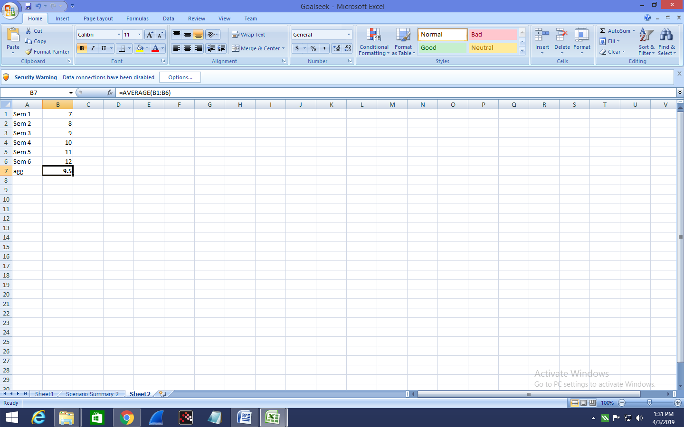

*Step 2: In Excel, On the Data tab, in the Data tools group, click What-If Analysis and select Scenario Manager.*

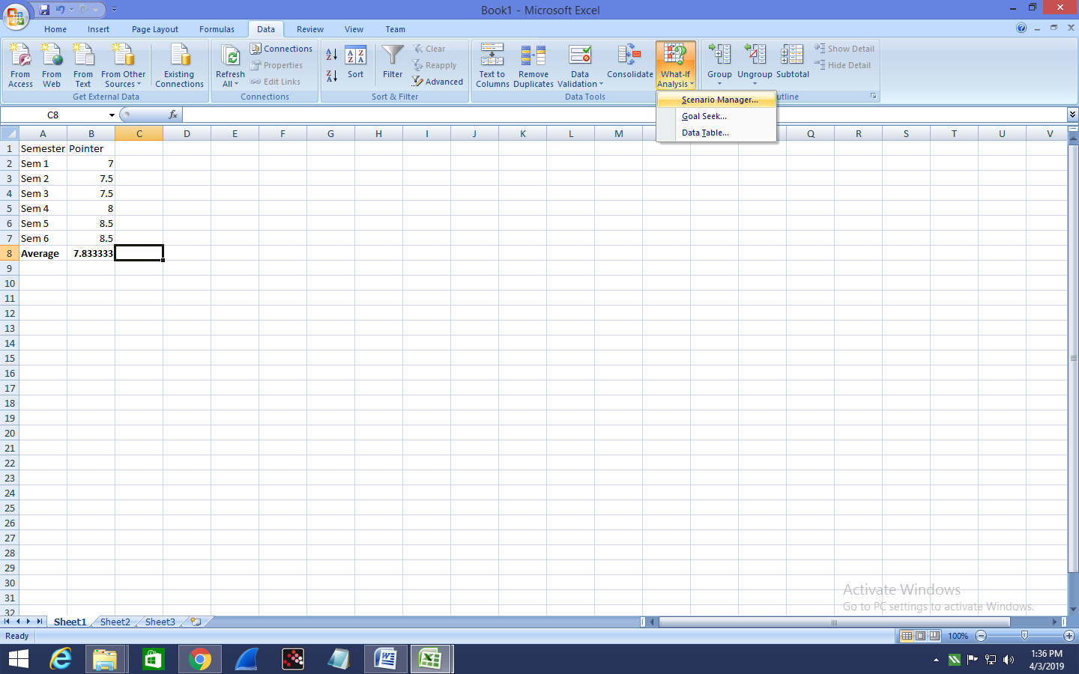

***The Scenario Manager Dialog box appears.***

***Step 3: Add a scenario by clicking on Add.***

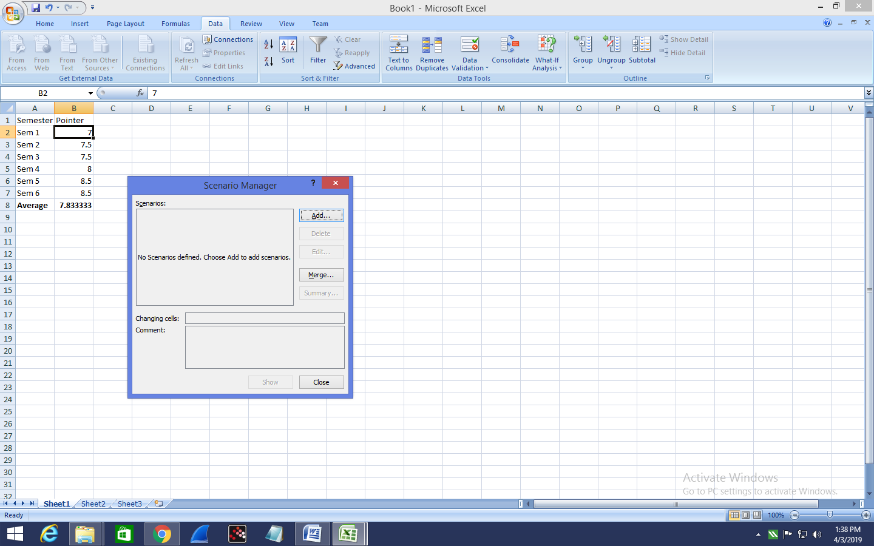

**Step 4 : Add Name To the Scenario and select cells for the Changing Cells and click on OK!**

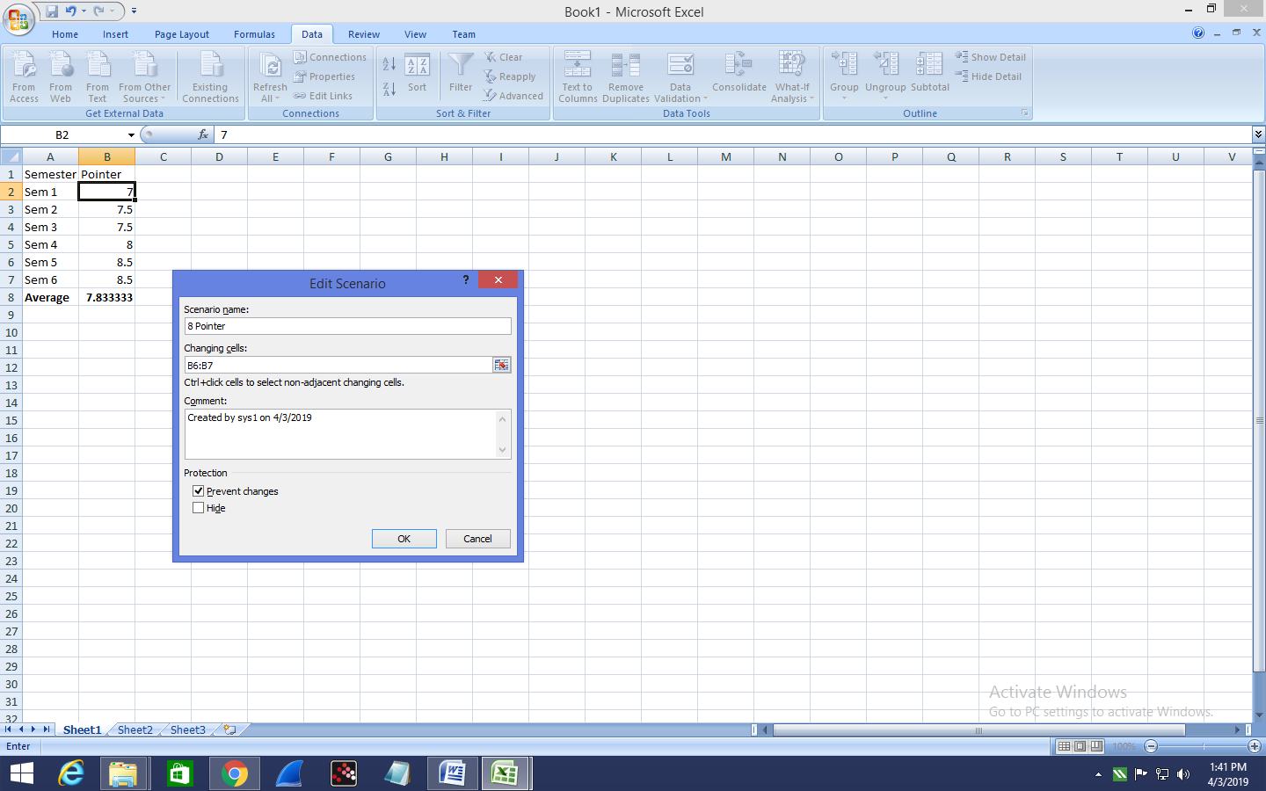

*Step 5 : Add Values for each of the changing cells.*

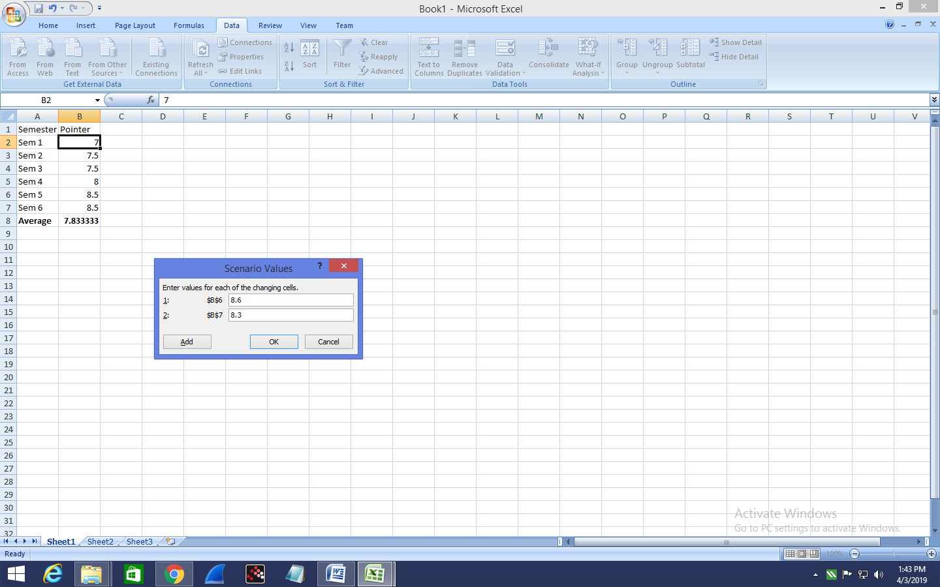

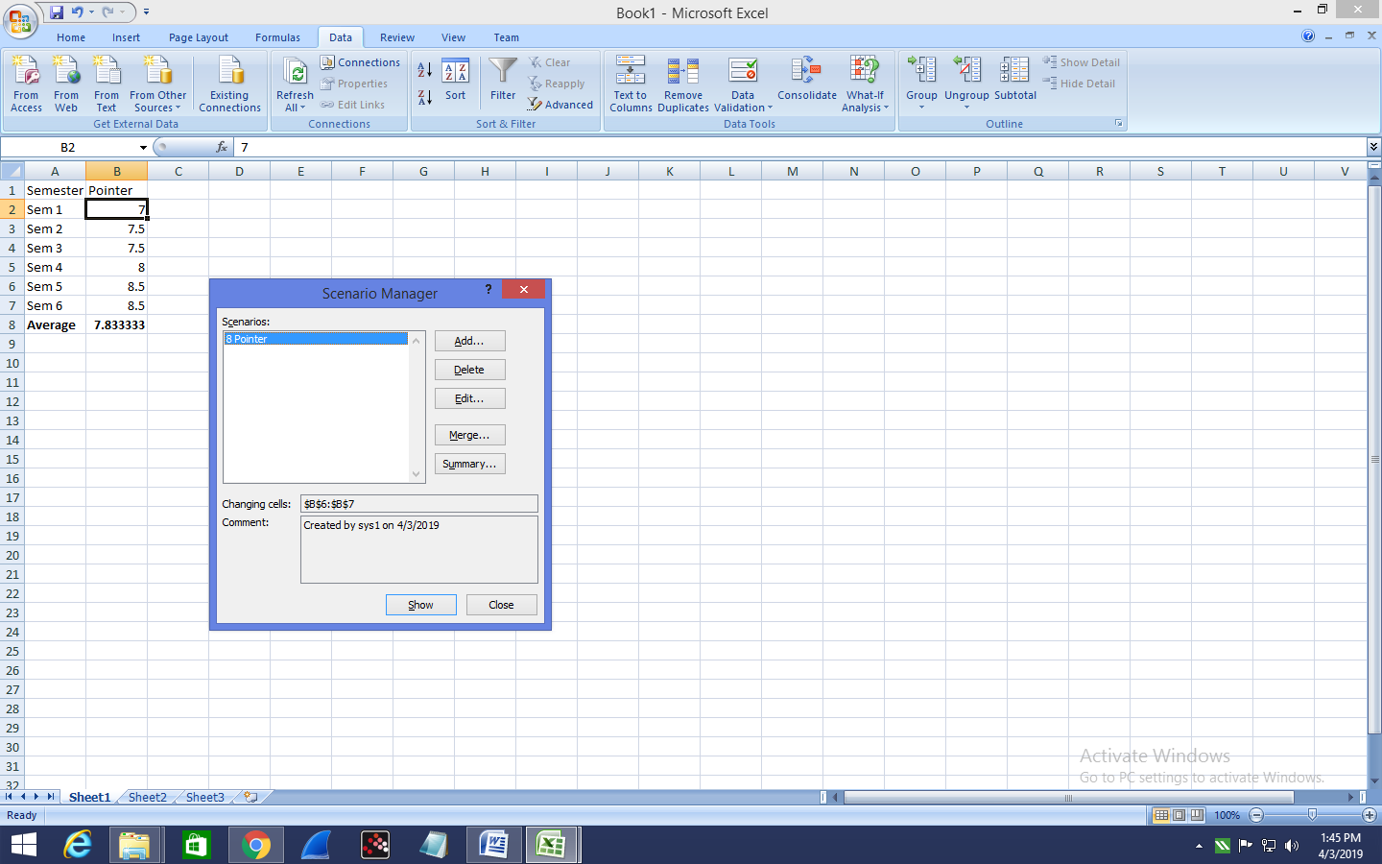

*Step 6 : To apply Scenarios click on show*

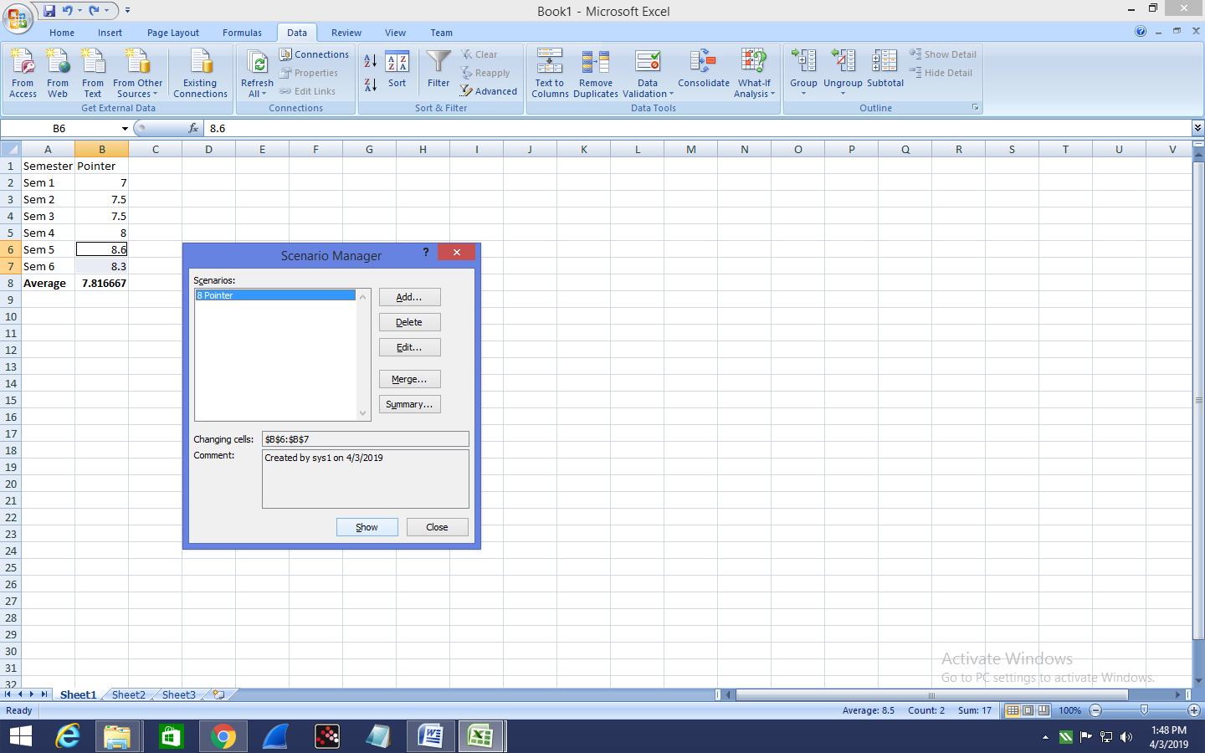

*Step 7 :Now, add other scenarios.*

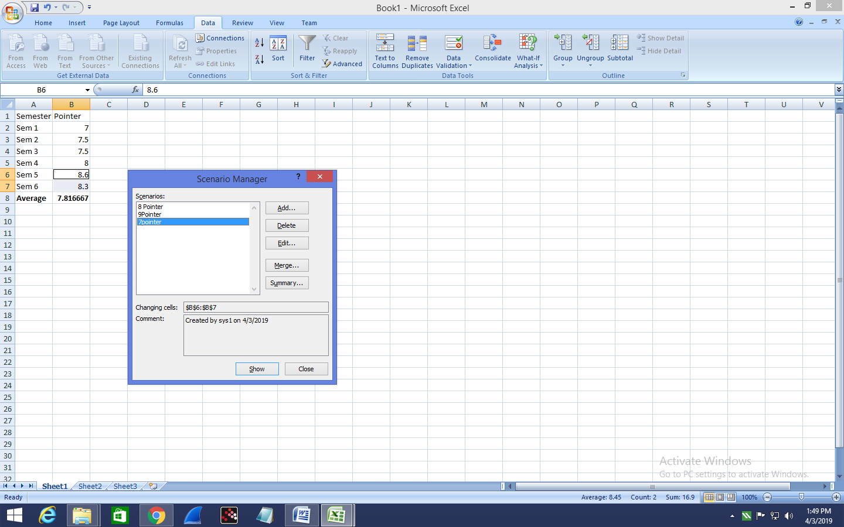

*Step 8 : Finally, Click on summary then select the result cell and click on OK to get the scenario summary.*

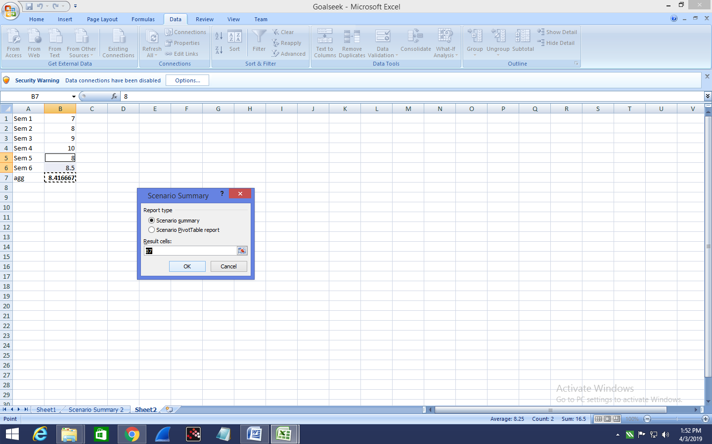

***The Scenario summary is displayed as follows:***

