Practical No:07

Q. Perform the data classification using classification algorithm.

1.Timeseries Algorithm:

* Program:

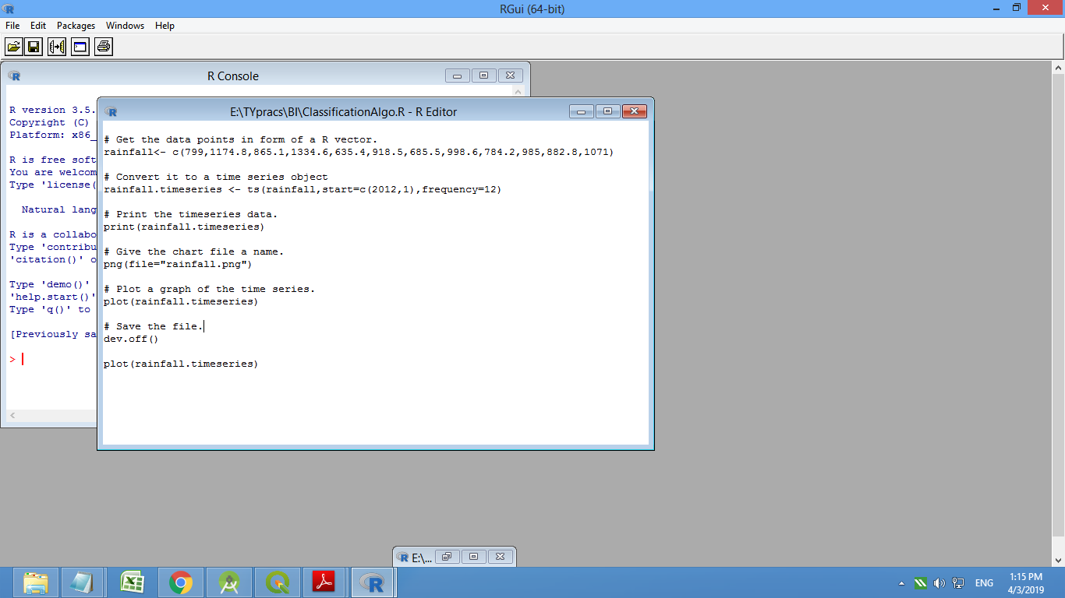

* Output:

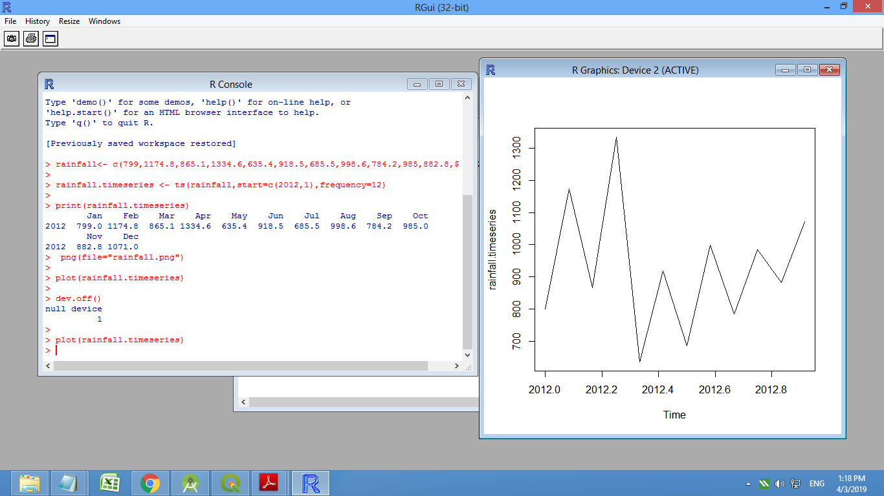

2.Decision-Tree Algorithm:

* program:

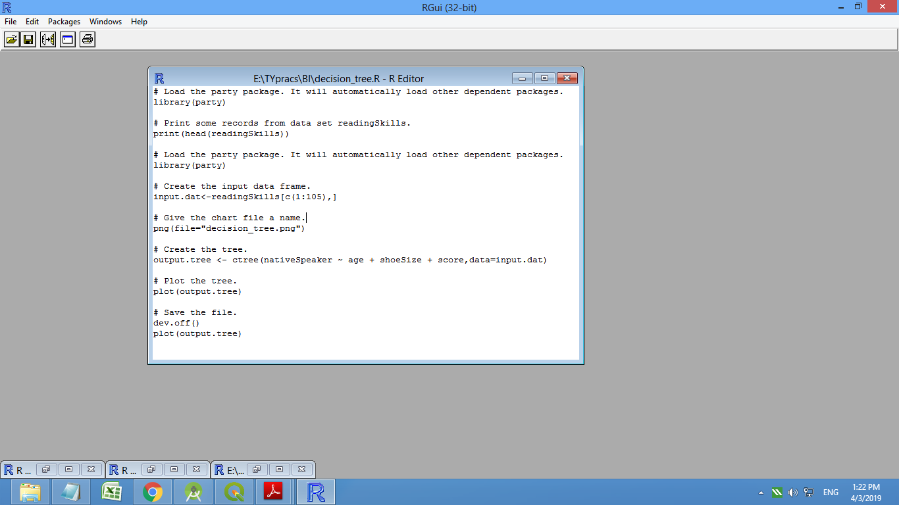

* output:

