**The**

**WORDPLAY GAME**

**Table of Contents**

PROJECT SYNOPSIS 1

CHAPTER 1: INTRODUCTION 3

* 1. BACKGROUND 3
  2. OBJECTIVES 3
  3. PURPOSE, SCOPE AND APPLICABILITY 3
     1. PURPOSE 3
     2. SCOPE 3
     3. APPLICABILITY…………………………………………………. 3

CHAPTER 2: SURVEY OF TECHNOLOGY 4

CHAPTER 3: REQUIREMENTS AND ANALYSIS 6

* 1. Problem definition 6
     1. Problem description 6
     2. Sub-problems: 6
  2. Requirement specification: 6
     1. Requirement Gathering: 6
     2. Requirement analysis: 7
  3. Planning and Scheduling 9
     1. Task Management Table……………………………………………….9
     2. Gantt Chart…………………………………………………………….10
  4. Hardware and Software Requirements .10
  5. Conceptual Models………………………………………………….……... 10
     1. Data Model………………………………………….………….……...11
     2. Data Flow Diagram……………………………………….…….……. 12
     3. Class Diagram……………………………….…………………….…. 14
     4. Use Case Diagram………………………………….……………….…16
     5. Sequence Diagram…………………………………………………….19
     6. Activity Diagram……………………………………………….…...…23
     7. State-Chart Diagram…………………………………….……….….…25

CHAPTER 4: System Design…………………………………………………..…28

4.1 User Interface……………………………………………………….…..….28

4.2 Test Case………………………………………………………………..…31

BIBLIOGRAPHY: ……………………………………………………………..

**List of Table**

|  |  |  |
| --- | --- | --- |
| **Table. No.** | **Table Name** | **Page No.** |
| 3.1 | Task Management Table | 09 |
| 3.2 | Notation for Data Flow diagram | 12 |
| 3.3 | Notations for Class Diagram | 14 |
| 3.4 | Notations for Use Case Diagram | 16 |
| 3.5 | Notations for Sequence Diagram | 19 |
| 3.6 | Notations for Activity Diagram | 23 |
| 3.7 | Notations for State-Chart Diagram | 25 |
| 4.1 | Test case for Registration | 31 |
| 4.2 | Test case for Login | 31 |
| 4.3 | Test case for Game | 32 |
|  | Bibliography | 33 |

**List of Figures**

|  |  |  |
| --- | --- | --- |
| **No.** | **Diagram name** | **Page number** |
| 1.1 | Methodology | 1 |
| 1.2 | Architecture | 2 |
| 3.1 | Gantt chart | 10 |
| 3.2 | Data Model | 11 |
| 3.3 | Context level | 13 |
| 3.4 | DFD level 1 | 13 |
| 3.5 | Class Diagram | 15 |
| 3.6 | Use Case Diagram | 17 |
| 3.7 | Sequence Diagram for Registration | 20 |
| 3.8 | Sequence Diagram for Login | 20 |
| 3.9 | Sequence Diagram for Rules | 22 |
| 3.10 | Sequence Diagram for Score | 22 |
| 3.11 | Sequence Diagram for Game | 22 |
| 3.12 | Activity Diagram | 24 |
| 3.13 | State Chart Diagram for Registration | 25 |
| 3.14 | State Chart Diagram for Login | 26 |
| 3.15 | State Chart Diagram for Score | 26 |
| 3.16 | State Chart Diagram for Rules | 27 |
| 3.17 | State Chart Diagram for Game | 27 |
| 4.1 | User Interface of Home and Login Page | 28 |
| 4.2 | User Interface of Register and Game Page | 29 |
| 4.3 | User Interface of Score/Statistics Page | 30 |

**Synopsis**

1. **Title: -**

WORDPLAY Game

1. **Statement about problem: -**

A strong vocabulary, both written and spoken, requires more than a dictionary. In fact, it requires an educational commitment to overcoming four obstacles: the size of the task (the number of words students need to learn is exceedingly large), the differences between spoken and written English, the limitations of information sources including dictionaries, and the complexity of word knowledge (simple memorization is not enough). Learn more about these challenges to acquiring the 2,500 words a student needs to add each year to their reading vocabulary.

1. **Why this topic: -**

* Promotes word recall and vocabulary building.
* There is a healthy culture around the game with heavy emphasis on not spoiling the day’s word for anyone else.
* An active social media community exists because of the share function, once a word guessed correctly.
* It forces users to think critically about all possibilities. Guessing a five-letter word is harder than it seems!

1. **Objective and Scope of the System: -**

* Objective: -
  + To provide a game which is not addictive and can be played once a day.
  + The game should also be non-time consuming.
  + To provide a well-designed and eye please puzzle game.

1. **Methodology: -** Incremental Model

Incremental model is the suitable methodology for this system.

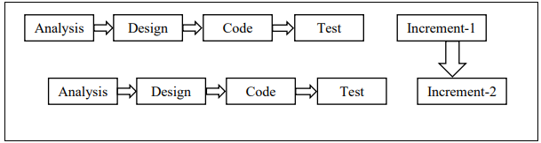

***Fig 1.1 Incremental Model Diagram***

1. **Proposal Architecture: -**

The motive of the system to let user play the game.

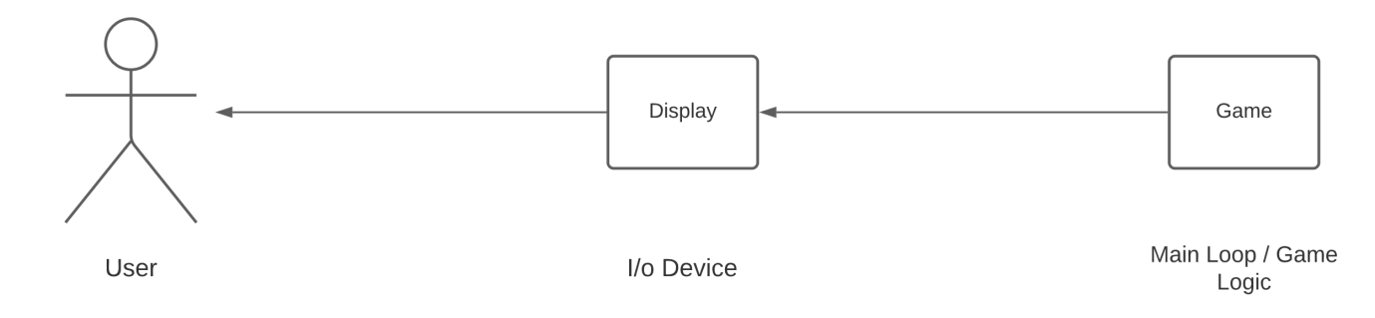

***Fig 1.2 Proposed Architecture***

1. **Requirements: -**

* **Software Requirements:** -
  + **Front-end:** -HTML, CSS, ReactJS
  + **Back-end:** - NodeJS, ExpressJS
  + **Database:** - MongoDB
  + **Operating System:** - Windows, Linux, MacOS
* **Hardware Requirements:** -
  + **Processor:** - Intel Pentium or higher, AMD Ryzen
  + **RAM:** - 1GB or higher
  + **Graphics card:** - Inbuilt Graphics or dedicated graphics card

1. **Platform: -**

Visual Studio Code

1. **Contribution towards Society:** -

The main contribution of this game towards society is in order to keep your memory and your thinking sharp, the key is to really challenge and learning. Those are the one of the only ways that you’re really actually exercising your brain, you’re growing new neural pathways, so the key is you can’t just busy.

**CHAPTER 1:**

**Introduction**

* 1. **Background: -**

Wordplay is a game motivated by wordle game which is an online word-guessing game made up of five by six grid, with a new mystery word for players to guess each day. The five squares across represent a single letter in the five-letter word for the day and the six rows each represent one guess at what that day’s secret word is.

* 1. **Objectives: -**

To play six letter puzzle game.

To compete with other players on the other devices.

Allow to share players result on social media.

* 1. **Purpose, Scope and Applicability: -**
     1. **Purpose: -**

Playing games like Wordplay allows us to use the brain for dynamic activities, rather than something passive. Your brain is working harder when you focus on something that forces your mind to be operating continuously, such as a board game or a book. This is especially true when compared to a more passive activity, such as watching a scripted TV show.

* + 1. **Scope: -**

Works on all type of devices.

Requires internet connectivity.

Will be available for all users.

* + 1. **Applicability: -**

Wordplay, the buzzy daily word game is minimal by design. The game is a website, not an app. It updates every day with new word puzzle, with only one available at a time. Players get six attempts to guess the correct word, and site makes it easy to share the results on social media.

**CHAPTER 2:**

**Survey of Technologies**

1. **MongoDB:**

MongoDB is a No SQL database and it is a cross-platform, open-source and document-oriented database written in C++. MongoDB is an open-source document database that provides high availability, automatic scaling and high performance. MongoDB is suitable for all the modern applications which requires big data, flexible deployment, big data and the older database systems which are not competent enough. Features of MongoDB are Indexing, Replication, Duplication of Data, Supports Map Reduce tools and it is Schema-less database language.

1. **ReactJS:**

ReactJS is one of the most popular JavaScript front-end libraries which has a strong foundation and a large community. ReactJS is a flexible, declarative and efficient JavaScript library for building reusable User Interface (UI) components. ReactJS library is responsible only for the view layer of the application. The main objective of ReactJS is to develop User Interfaces (UI) that improves the speed of the apps. Virtual DOM (JavaScript object) helps ReactJS to improve the performance of the application. JavaScript virtual DOM is faster than the regular DOM. ReactJS can be used on both the client side and the server side and also with the other frameworks. It uses component and data patterns that improve readability and helps to maintain large apps.

1. **GitHub:**

GitHub is an immense platform for code hosting which supports version controlling and collaboration. GitHub helps to host the source code of project in different programming languages and keeps a track of all the changes made by the programmers. It supports version controlling and collaboration and allow developer to work on project together. GitHub provide Distributed Version Control and Source Code Management functionality of Git. Bug Tracking, Feature Requests and Task Management collaboration features are provided for every project. GitHub make is easy to contribute to the open-source projects. Collaboration, Graphical Representation of Branches, Git Repositories Hosting, Project and Team Management, Code Hosting and Track and Assign Tasks are some significant features of GitHub.

1. **AngularJS:**

AngularJS is an open-source JavaScript framework by Google to build web application. It can be used, changed and shared to anyone freely. It is an excellent framework for building single phase applications and line of business applications. AngularJS is designed in such a way that we test right from the start. Hence, it is easy to test any of the components through end-to-end testing and unit testing. It is perfect for Single Page Applications. It is continuously growing and expanding framework which provides better ways for developing web applications.

1. **Flutter:**

Flutter is a User Interface toolkit for building fast, beautiful, natively compiled applications for desktop, web and mobile with one programming language and single codebase. Flutter is open-source and free. Flutter was developed from Google and it is now managed by an ECMA standard. Flutter applications uses Dart programming language for creating an application. Developing a mobile application is a very complex and challenging task and there are many frameworks which provide excellent features to develop mobile applications. Previously, to develop and application for both Android and iOS operating system, we needed to different languages and framework but now there are several frameworks which supports both OS along with desktop applications know and cross-platform. Hence, Flutter was a new framework which was introduced by Google in the cross-platform development family. Flutter uses its own high-performance rendering engine to draw widgets. It gives easy and simple methods to start building beautiful mobile and desktop apps with rich set of material design and widgets.

**Why this language?**

**ReactJS:**

React JS is basically a JavaScript library built and maintained by Facebook. According to the creator of React JS, Jordan Walke, react is an efficient, declarative, and flexible open-source JavaScript library for building simple, fast, and scalable frontends of web applications. Ever since its launch, it has taken the front-end development space by storm.

**MongoDB:**

MongoDB is built on a scale-out architecture that has become popular with developers of all kinds for developing scalable applications with evolving data schemas. As a document database, MongoDB makes it easy for developers to store structured or unstructured data. It uses a JSON-like format to store documents. This format directly maps to native objects in most modern programming languages, making it a natural choice for developers, as they don’t need to think about normalizing data. MongoDB can also handle high volume and can scale both vertically or horizontally to accommodate large data loads.

**CHAPTER 3:**

**Requirements and Analysis**

* 1. **Problem Definition: -**

The goal of the project is to write a web application for playing the game of Wordplay, a popular internet game. The objective of the game is finding a secret word. Like Mastermind, the player makes guess and for each guess, receive some feedback from the program.

The program selected as to develop a system that will promotes your word recall and vocabulary your word recall and vocabulary building. We sometimes find struggling ourself to find a correct word for a specific period of a time. To counter this problem, we are developing this system.

* **Sub problem: -**
  + People face problem in vocabulary.
  + The players are not able to play together in multiplayer mode.
  1. **Requirement Specification: -**
     1. **Requirement Gathering: -**
        1. **Ways of Requirement Gathering: -**
* **One-on-One Interviews: -**Introduce yourself and summarize the project including its scope and any timeline. Prepare some pre-determined questions to ask the interviewee.
* **Group Interviews:** - Group interviews are best for interviewees of same job position or level as they are expert in all those topics.
* **Brainstorming:** - Brainstorming helps gather many ideas as possible from as many people as possible to identify, categorize and assign tasks, opportunities and potential solutions quickly.
* **Survey:** - Survey is preparing a questionnaire which allows us to collect information from many people in a relatively short amount of time. Most of the questions are yes and no questions. Google Forms is one of the best-way to do a survey.
* **Prototyping:** - In prototyping, an early version is created to show to the client on the basis of surveys and brainstorming sessions.
  + - 1. **Technique I used for Requirement Gathering: -**

One-to-one Interview is the most widely used technique of requirement gathering. The clients are interviewed in this technique. Some questions are asked to clients related to system to get the need and expectation of client from the system. According to answers given by the client, analysis is done and system requirements are prepared.

* **Question and Answers: -**

1. What is the need of this Wordplay game?
   * To improve your vocabulary.
2. What things are focused while developing this Game?
   * Playing games like Wordle allows us to use the brain for dynamic activities, rather than something passive.
3. In which manner do you think this game will help you to grow?
   * It’s perfect for those lazy days when you want to relax on your couch and play a quick game or two. Main motive is to improve our word dictionary.
4. How many data space will required for such kind of systems?
   * Not much.
5. What kind of interface should be created for such system?
   * Clean and easily handy interface would be a great option for such kind of systems.
     1. **Requirement Analysis: -**
        1. **Functional Requirements: -**
   * **Login with authentication: -** As a social media website the need for a proper login and logout methods with authentication is needed for safety of user and safer experience.
   * **Knowledge/Information sharing:** - The functionalities of new information added, information changing, knowledge providing, knowledge searching is important for knowledge sharing.
   * **The comment and share system:** - The users will need a way to interact with other users but still be able to maintain the privacy. The liking and comment system will enhance the experience of website using website.

**3.2.2.2 Non-functional Requirements: -**

* + **Performance: -** Performance of a website should be fast and smooth. The website should be quick and not take much time to load after it’s loaded once.
  + Software system need developed easily to add new functionalities and delete unwanted capabilities.
  + **Scalability: -** Website should work as expected even when it scales.
  + **Usability:** - Website’s interface should be clean, good looking and easy to access.

**3.2.2.3 System Requirements: -**

1. **Register: -**

* **Function: -** To register
* **Description:** - To register once to create your account and have necessary information save
* **Inputs:** - ID, password, email, number
* **Output:** - User is registered
* **Destination:** - Database
* **Action:** - All the provided information is saved in database
* **Pre-condition:** - User needs and email or phone number

1. **Login: -**

* **Function: -** To log in to your registered account
* **Description:** - To log into your requirements your previous states and changes saved
* **Input:** - ID, password
* **Output:** - User logged in to the system
* **Destination:** - Database
* **Action:** - User being successfully logged in to system without any errors
* **Pre-condition:** - User needs to provide login ID and password

1. **Keyboard Permission: -**

* **Input: -** Dialogue box for asking access to keyboard
* **Output:** - Display keyboard
* **Source:** - The device currently in use
* **Destination:** - Database
* **Action:** - The current word typed by keyboard and it is sent to backend

1. **Result: -**

* **Input: -** To solve the puzzle
* **Output:** - To show result
* **Function:** - Sharing result option after solving the puzzle
* **Destination:** - Database
* **Action:** - User will get a pop-up window to show the result with other peoples
* **Pre-condition:** - User needs to solve the puzzle
  1. **Planning and Scheduling: -**
     1. **Task Management Table: -**

|  |  |  |  |  |
| --- | --- | --- | --- | --- |
| **Activity No.** | **Chapter No.** | **Chapter Name** | **Start Date** | **End Date** |
| T1 | 0 | Synopsis | 15-06-2022 | 02-07-22 |
| T2 | 1 | Introduction | 20-06-2022 | 02-07-22 |
| 2 | Survey of Technologies |
| T3 | 3 | Requirements and Analysis | 27-06-2022 | 02-07-22 |
| 3.1 | Problem Definition |
| T4 | 3.2 | Requirement Specification | 04-07-2022 | 11-07-22 |
| 3.2.1 | Requirement Gathering |
| 3.2.2 | Requirement Analysis |
| T5 | 3.2.3 | System Requirements | 11-07-2022 | 18-07-22 |
| T6 | 3.3 | Planning and Scheduling | 18-07-2022 | 25-07-22 |
| 3.4 | Software and Hardware Requirements |
| 3.5 | Conceptual Models |
| T7 | 3.5.1 | Data Model | 25-07-2022 | 01-08-22 |
| T8 | 3.5.2 | Data Flow Diagram | 15-08-2022 | 22-08-22 |
| T9 | 3.5.3 | Class Diagram | 22-08-2022 | 29-08-22 |
| T10 | 3.5.4 | Use Case Diagram | 29-08-2022 | 12-09-22 |
| T11 | 3.5.5 | Sequence Diagram | 12-09-2022 | 14-09-22 |
| T12 | 3.5.6 | Activity Diagram | 14-09-2022 | 19-09-22 |
| 3.5.7 | State Diagram |
| T13 | 4.1 | User Interface | 19-09-22 | 26-09-22 |
|  | 4.2 | Test Cases | 19-09-22 | 26-09-22 |

***Table 3.1 Task Management Table***

* + 1. **Gantt Chart: -**

|  |  |  |  |  |  |  |  |  |  |  |  |  |  |  |  |  |  |  |  |  |  |  |  |  |  |  |  |  |  |  |  |  |  |
| --- | --- | --- | --- | --- | --- | --- | --- | --- | --- | --- | --- | --- | --- | --- | --- | --- | --- | --- | --- | --- | --- | --- | --- | --- | --- | --- | --- | --- | --- | --- | --- | --- | --- |
| **Activity No.** | **June** | | | | | | | **July** | | | | | | | | | | **August** | | | | | | | | **September** | | | | | | | |
| 15 | | 20 | | 25 | | 30 | 05 | 10 | | 15 | | 20 | | 25 | 30 | | 05 | 10 | 15 | 20 | | 25 | | 30 | 05 | 10 | | 15 | | 20 | 25 | 30 |
| T1 |  |  |  | |  | |  |  |  | |  | |  | |  |  | |  |  |  |  | |  | |  |  |  | |  | |  |  |  |
|  |  |  | |  | |  |  |  | |  | |  | |  |  | |  |  |  |  | |  | |  |  |  | |  | |  |  |  |
| T2 |  | |  | |  | |  |  |  | |  | |  | |  |  | |  |  |  |  | |  | |  |  |  | |  | |  |  |  |
|  | |  |  |  | |  |  |  | |  | |  | |  |  | |  |  |  |  | |  | |  |  |  | |  | |  |  |  |
| T3 |  | |  | |  |  |  |  |  | |  | |  | |  |  | |  |  |  |  | |  | |  |  |  | |  | |  |  |  |
|  | |  | |  |  |  |  |  | |  | |  | |  |  | |  |  |  |  | |  | |  |  |  | |  | |  |  |  |
| T4 |  | |  | |  | |  |  |  | |  | |  | |  |  | |  |  |  |  | |  | |  |  |  | |  | |  |  |  |
|  | |  | |  | |  |  |  | |  | |  | |  |  | |  |  |  |  | |  | |  |  |  | |  | |  |  |  |
| T5 |  | |  | |  | |  |  |  |  |  | |  | |  |  | |  |  |  |  | |  | |  |  |  | |  | |  |  |  |
|  | |  | |  | |  |  |  |  |  | |  | |  |  | |  |  |  |  | |  | |  |  |  | |  | |  |  |  |
| T6 |  | |  | |  | |  |  |  | |  |  | |  |  |  | |  |  |  |  | |  | |  |  |  | |  | |  |  |  |
|  | |  | |  | |  |  |  | |  |  | | | |  | |  |  |  |  | |  | |  |  |  | |  | |  |  |  |
| T7 |  | |  | |  | |  |  |  | |  | |  | |  |  |  | | | |  | |  | |  |  |  | |  | |  |  |  |
|  | |  | |  | |  |  |  | |  | |  | |  |  | |  |  | |  | |  | |  |  |  | |  | |  |  |  |
| T8 |  | |  | |  | |  |  |  | |  | |  | |  |  | |  |  |  |  |  | |  |  |  |  | |  | |  |  |  |
|  | |  | |  | |  |  |  | |  | |  | |  |  | |  |  |  |  |  |  | |  |  |  | |  | |  |  |  |
| T9 |  | |  | |  | |  |  |  | |  | |  | |  |  | |  |  |  |  | |  | |  | |  | |  | |  |  |  |
|  | |  | |  | |  |  |  | |  | |  | |  |  | |  |  |  |  | |  | |  | |  | |  | |  |  |  |
| T10 |  | |  | |  | |  |  |  | |  | |  | |  |  | |  |  |  |  | |  | |  |  |  |  |  | |  |  |  |
|  | |  | |  | |  |  |  | |  | |  | |  |  | |  |  |  |  | |  | |  |  |  |  |  | |  |  |  |
| T11 |  | |  | |  | |  |  |  | |  | |  | |  |  | |  |  |  |  | |  | |  |  |  | |  |  |  |  |  |
|  | |  | |  | |  |  |  | |  | |  | |  |  | |  |  |  |  | |  | |  |  |  | |  | |  |  |  |
| T12 |  | |  | |  | |  |  |  | |  | |  | |  |  | |  |  |  |  | |  | |  |  |  |  |  | |  |  |  |
|  | |  | |  | |  |  |  | |  | |  | |  |  | |  |  |  |  | |  | |  |  |  |  |  | |  |  |  |
|  |  | |  | |  | |  |  |  | |  | |  | |  |  | |  |  |  |  | |  | |  |  |  |  |  | |  |  |  |
| T13 |  | |  | |  | |  |  |  | |  | |  | |  |  | |  |  |  |  | |  | |  |  |  |  |  | |  |  |  |

***Fig 3.1 Gantt Chart***

**Re-engineered Activity Table**

|  |  |  |  |
| --- | --- | --- | --- |
| **Task No.** | **Task Name** | **Start Date** | **End Date** |
| T 1 | **Chapter 1: Introduction** | 15/11/23 | 18/11/23 |
| T 2 | **Chapter 2: Survey of Technologies** | 18/11/23 | 20/11/23 |
| T 3 | **Chapter 3: Requirement and Analysis** | 21/11/23 | 25/11/23 |
| T 4 | **Chapter 4: System Design** | 25/11/23 | 29/11/23 |
| **Login and Register** | | | |
| T 5 | **Coding** | 06/12/22 | 20/12/22 |
| T 6 | **Testing** |
| T 7 | **Debugging** |
| T 8 | **Unit Testing** |
| **Game Page** | | | |
| T 9 | **Coding** | 24/12/22 | 30/12/22 |
| T 10 | **Testing** |
| T 11 | **Debugging** |
| T 12 | **Unit Testing** |
| T 13 | **Integration Testing** |
| **Advanced Game Page** | | | |
| T 14 | **Coding** | 03/01/23 | 13/01/23 |
| T 15 | **Testing** |
| T 16 | **Debugging** |
| T 17 | **Unit Testing** |
| T 18 | **Integration Testing** |
| **Rule Page** | | | |
| T 19 | **Coding** | 25/01/23 | 07/02/23 |
| T 20 | **Testing** |
| T 21 | **Debugging** |
| T 22 | **Unit Testing** |
| T 23 | **Integration Testing** |

**Gantt Chart**

|  |  |  |  |  |  |  |  |  |  |  |  |  |  |  |  |  |  |  |  |  |  |  |  |  |  |  |  |  |  |  |  |  |  |
| --- | --- | --- | --- | --- | --- | --- | --- | --- | --- | --- | --- | --- | --- | --- | --- | --- | --- | --- | --- | --- | --- | --- | --- | --- | --- | --- | --- | --- | --- | --- | --- | --- | --- |
| **Task No.** | **Nov** | | | | | | | **Dec** | | | | | | | | | | **Jan** | | | | | | | | **Feb** | | | | | | | |
| 15 | | 20 | | 25 | | 30 | 05 | 10 | | 15 | | 20 | | 25 | 30 | | 05 | 10 | 15 | 20 | | 25 | | 30 | 05 | 10 | | 15 | | 20 | 25 | 30 |
| T1 |  |  |  | |  | |  |  |  | |  | |  | |  |  | |  |  |  |  | |  | |  |  |  | |  | |  |  |  |
|  |  |  | |  | |  |  |  | |  | |  | |  |  | |  |  |  |  | |  | |  |  |  | |  | |  |  |  |
| T2 |  | |  | |  | |  |  |  | |  | |  | |  |  | |  |  |  |  | |  | |  |  |  | |  | |  |  |  |
|  | |  |  |  | |  |  |  | |  | |  | |  |  | |  |  |  |  | |  | |  |  |  | |  | |  |  |  |
| T3 |  | |  | |  |  |  |  |  | |  | |  | |  |  | |  |  |  |  | |  | |  |  |  | |  | |  |  |  |
|  | |  | |  |  |  |  |  | |  | |  | |  |  | |  |  |  |  | |  | |  |  |  | |  | |  |  |  |
| T4 |  | |  | |  | |  |  |  | |  | |  | |  |  | |  |  |  |  | |  | |  |  |  | |  | |  |  |  |
|  | |  | |  | |  |  |  | |  | |  | |  |  | |  |  |  |  | |  | |  |  |  | |  | |  |  |  |
| T5 T8 |  | |  | |  | |  |  |  |  |  | |  | |  |  | |  |  |  |  | |  | |  |  |  | |  | |  |  |  |
|  | |  | |  | |  |  |  |  |  | |  | |  |  | |  |  |  |  | |  | |  |  |  | |  | |  |  |  |
| T9 T13 |  | |  | |  | |  |  |  | |  |  | |  |  |  | |  |  |  |  | |  | |  |  |  | |  | |  |  |  |
|  | |  | |  | |  |  |  | |  |  | | | |  | |  |  |  |  | |  | |  |  |  | |  | |  |  |  |
| T14 T18 |  | |  | |  | |  |  |  | |  | |  | |  |  |  | | | |  | |  | |  |  |  | |  | |  |  |  |
|  | |  | |  | |  |  |  | |  | |  | |  |  | |  |  | |  | |  | |  |  |  | |  | |  |  |  |
| T19 T23 |  | |  | |  | |  |  |  | |  | |  | |  |  | |  |  |  |  |  | |  |  |  |  | |  | |  |  |  |
|  | |  | |  | |  |  |  | |  | |  | |  |  | |  |  |  |  |  |  | |  |  |  | |  | |  |  |  |
| T24 T29 |  | |  | |  | |  |  |  | |  | |  | |  |  | |  |  |  |  | |  | |  | |  | |  | |  |  |  |
|  | |  | |  | |  |  |  | |  | |  | |  |  | |  |  |  |  | |  | |  | |  | |  | |  |  |  |
| T30 |  | |  | |  | |  |  |  | |  | |  | |  |  | |  |  |  |  | |  | |  |  |  |  |  | |  |  |  |
|  | |  | |  | |  |  |  | |  | |  | |  |  | |  |  |  |  | |  | |  |  |  |  |  | |  |  |  |
| T31 |  | |  | |  | |  |  |  | |  | |  | |  |  | |  |  |  |  | |  | |  |  |  | |  |  |  |  |  |
|  | |  | |  | |  |  |  | |  | |  | |  |  | |  |  |  |  | |  | |  |  |  | |  |  |  |  |  |
| T32 |  | |  | |  | |  |  |  | |  | |  | |  |  | |  |  |  |  | |  | |  |  |  | |  |  |  |  |  |
|  | |  | |  | |  |  |  | |  | |  | |  |  | |  |  |  |  | |  | |  |  |  | |  |  |  |  |  |

* 1. **Software and Hardware Requirements: -**
     1. **Software Requirements: -**
* **Frontend: -** HTML, CSS, JavaScript
* **Backend: -** Nodejs, ExpresJS
* **Database:** - MongoDB
  + 1. **Hardware Requirements: -**
* **Operating System: -** Windows
* **RAM:** - 2GB or more
* **ROM:** - 500MB of disk space available
* **Processor:** - Intel Duo+ or AMD Ryzen 3+
  1. **Conceptual Models**
     1. **Data Model: -**

The key challenge in data modelling is balancing the needs of the application, the performance characteristics of the database engine, and the data retrieval patterns. When designing data models, always consider the application usage of the data (i.e., queries, updates, and processing of the data) as well as the inherent structure of the data itself.

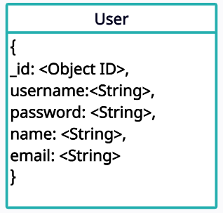

***Fig 3.2 Data Model***

Reference: - Software Engineering 9th Edition by Ion Sommerville

* + 1. **Data Flow Diagram: -**

A Data Flow Diagram maps out the flow of information for any system or process. It uses symbols like circles, rectangles, arrows with short text label, storage points and the routes between each destination. Data Flow Diagrams range from simple i.e., hand-drawn process overviews to in-depth multi-level Data Flow Diagrams that dig progressively deeper into how the data is handled. They can be used to analyses an existing system or model a new one.

Data Flow Diagram works properly for the real-time or data-oriented software and systems. The symbols used to draw a Data Flow Diagram are:

|  |  |  |
| --- | --- | --- |
| **Name** | **Symbol** | **Description** |
| Rectangle |  | A recta1gle is used to show an external entity |
| Rounded Corner Rectangle |  | A rounded corner rectangle is used to define process of data flow |
| Data Store |  | This symbol is used to define the data entity storage |
| Line |  | The line symbol describes flow of data |

***Table 3.2 Data Flow Diagram Symbols***

Reference: - Software Engineering 9th Edition by Ion Sommerville

**Diagram: -**

1. **Context Level: -**

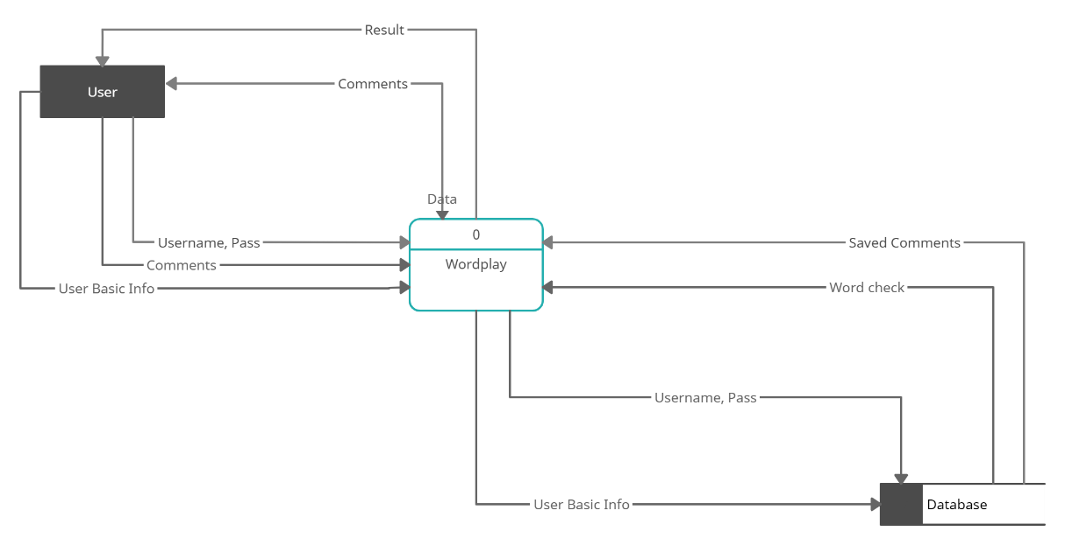

***Fig 3.3 Context level Diagram***

1. **Level 1 Diagram: -**

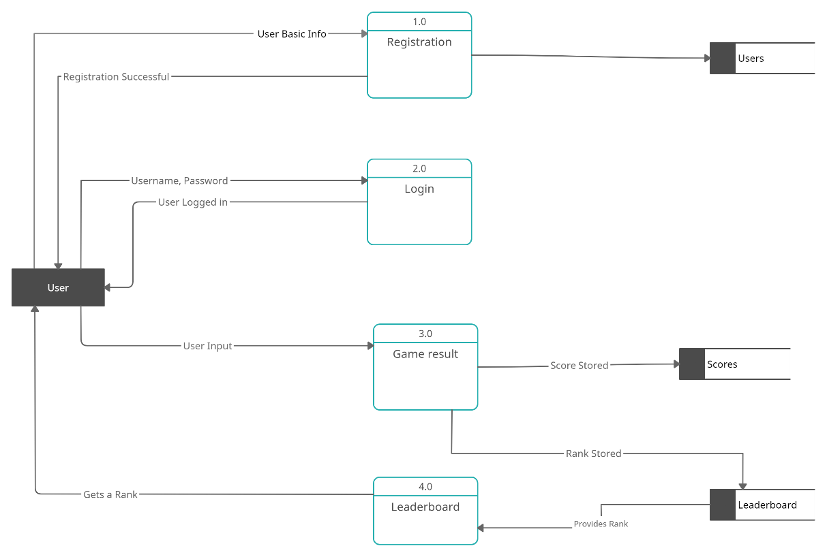

***Fig 3.4 DFD level 1 Diagram***

* + 1. **Class Diagram: -**

Class diagrams are used in developing an object-oriented system model to show the classes in a system and the associations between these classes. An object class is a general definition of one kind of system object. An association is a link between classes that indicates that there is a relationship between these classes. Each class may need to have some knowledge of its associated class. The symbols used in class are as follow:

|  |  |  |
| --- | --- | --- |
| **Name** | **Symbol** | **Description** |
| Class | |  | | --- | | **Name** | | + attribute1: type  - attribute2: type # atrribute3: type  / attribute4: type | | +operation1() | | This box is used to define a class and the attributes and operation are listed in it along with access modifiers |
| Public | + | The plus sign states that attribute can be accessed in any other class |
| Private | - | The dash sign state that attribute cannot be accessed by any other class |
| Composition |  | A composition states the one class is totally depended on the other class |
| Aggregation |  | An aggregation states that one class is partially associated with the other class |
| One | 1 | This describes only one entity participation in the association |
| Many | 1..* | This describes one or more entity participation in the association |

***Table 3.3 Class Diagram Symbols***

Reference: - Software Engineering 9th Edition by Ion Sommerville

**Diagram: -**

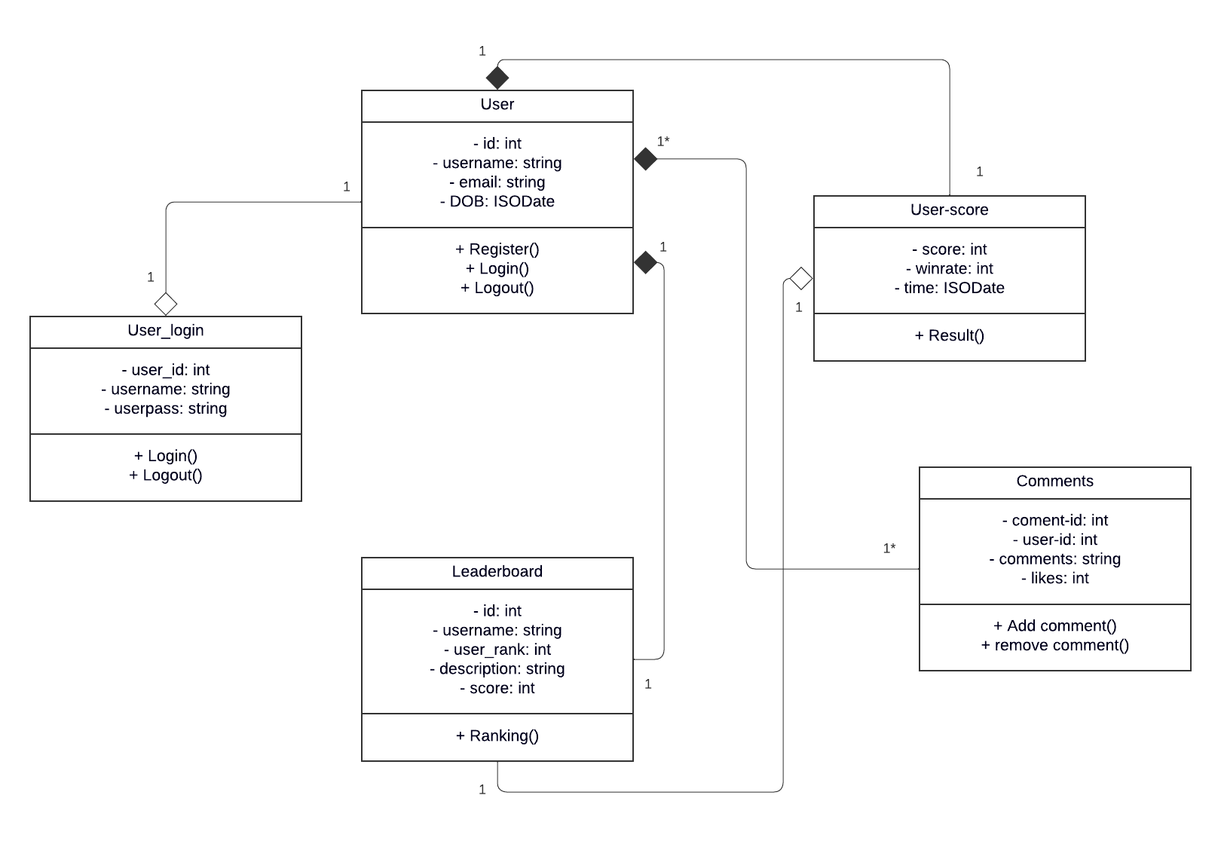

***Fig 3.5 Class Diagram***

* + 1. **Use Case Diagram: -**

Use Case Diagram is used to show interaction between the system and its environment. A use case can be taken as a simple scenario that describes what a user expects from a system. Each use case represents a discrete task that involves external interaction with the system. A use case is shown in ellipse with the actors involved in the use case. Use Case Diagram uses line without arrow and line with arrow indicates the direction of flow of messages. The symbols used to create a Use Case Diagram are as follow:

|  |  |  |
| --- | --- | --- |
| **Name** | **Symbol** | **Description** |
| Actor |  | The actors are used to define the environment interacting with the system |
| Use Case |  | A Use Case describes the functionality of the system |
| Association |  | An association is used to show interaction of actors with use cases |
| Include | <<include>> | This association states that the base use case is executed with the help of include use case |
| Extend | <<extend >> | The extend states that the extend use case will be executed after the execution of base use case but it will not always execute |

### Table 3.4 Use Case Diagram Symbols

Reference: - Software Engineering 9th Edition by Ion Sommerville

### Diagram: -

### 

### Figure 3.6 Use Case Diagram

### Description for Use Cases: -

### Use Case: - Register

### Description –

### User needs to register their account, after which they get the username and password to log in to their account. To register, users will be given a form in which they have to fill in their personal details.

### Actors – User

### Pre-condition –

### User needs to fill all the details asked in the form in the correct format.

### Exception –

### If the format of any detail is incorrect or any required field is kept empty, registration will not be successful.

### Post-condition –

### Registered Successfully. Username Password provided successfully

### Use Case: - Login

### Description –

### This use case describes the login process. The user needs to login to the system after creating an account, with username and password.

### Actors – User

### Pre-condition –

### The user/admin need to provide correct login and password to login to the system.

### Exception –

### If any detail is not correct, the user/admin can’t login to the system and has to try again.

### Post-condition –

### Provided all the details correctly, the user will get logged in to the system.

### Use Case: - How to play

### Description: -

### User will get a screen how to play the given game. To understand the rules this is important.

### Actors: - User

### Pre-condition: -

### User should play the game.

### Post-condition: -

### The how to play (rules) game screen will be displayed.

### Use Case: - Play Game

### Description: -

### User can play the game after knowing the rules.

### Actors: - User

### Pre-condition: -

### User must be logged in

### Post-condition: -

### Game window provided to the user

### Use Case: - View Score

### Description: -

### If user wants to see the score of the games, then user should be logged in. If user is not logged in then the score will not be shown.

### Actors: - User

### Pre-condition: -

### User must be logged in

### Post-condition: -

### If user is logged in score will be shown successfully.

### Sequence Diagram: -

Sequence Diagrams in the UML are used to model the interactions between the actors and the object in system and the interaction between the objects themselves. The UML has a rich syntax for sequence diagrams, which allows many kinds of interaction to be modelled.

A sequence diagram shows the sequence of interactions that take place during a particular use case or use case instance. The objects and actors involved are listed along the top of the diagram with a dotted line drawn vertically from these. Interactions between objects are indicated by annotated arrows. The rectangle of the dotted lines indicates the lifeline of the object concerned i.e., the time that object instance is involved in the computation.

The sequence diagram is read from top to bottom. The annotations on the arrows indicate the calls to the object, their parameters, and the return values. The about symbols are used to draw a sequence diagram.

|  |  |  |  |  |  |
| --- | --- | --- | --- | --- | --- |
| **Name** | **Symbols** | | | | **Description** |
| Objects |  | | | | This symbol is used to define the data objects |
| Actor |  | | | | The actors are used to define the environment interacting with the system |
| Lifeline of the Object |  | | | | The amount of time for which the object instance is involved in the computation. |
|  | |  | |
|  |  | |  |
|  |  |  |  |
|  | | | |
| Message |  | | | | It is used to show the interactions between actor and objects. |
| Return Message |  | | | | It returns a message for a request |
| Alternative Frame |  | | | | This frame is used to show two different conditions and their working. |

### Table 3.5 Sequence Diagram Symbol

Reference: - Software Engineering 9th Edition by Ion Sommerville

### Diagram: -

### Register:

### 

### Fig 3.7 Sequence Diagram for Registration

### Login:

### 

### Fig 3.8 Sequence Diagram for Login

### How to play (Rules):

### 

### Fig 3.9 Sequence Diagram for Rules

### Score:

### 

### Fig 3.10 Sequence Diagram for Score

### Game:

### 

### Fig 3.11 Sequence Diagram for Playing Game

### Activity Diagram: -

An Activity Diagram show the activities involved in a process or in data processing. Activity Diagrams are intended to show the activities that make up a system process and the flow of control from one activity to another. The start of a process is indicated by a filled circle and the end by a filled circle inside another circle. Rectangles with round corners represent activities i.e., the specific sub-processes that must be carried out. An arrow is used to represent the flow of work form one activity to another.

### A solid bar is used to indicate activity coordination. When the flow from more than one activity leads to a solid bar then all of these activities must be complete before progress is possible. When the flow from solid var leads to several activities, these may be executed in parallel. The symbols used in an Activity Diagram are:

|  |  |  |
| --- | --- | --- |
| **Name** | **Symbol** | **Description** |
| Start |  | This symbol indicates start of an activity |
| End |  | This symbol indicates end of an activity |
| Activity |  | This symbol indicated the activities of a particular system. |
| Flow of Work |  | This symbol is used to show the flow of work from activity to activity |
| Decision |  | This symbol represents the decision parameter and used where a decision is need to be taken |

### Table 3.6 Activity Diagram Symbols

Reference: - Software Engineering 9th Edition by Ion Sommerville

### Diagram:

### 

### Fig 3.12 Activity Diagram

### State Chart Diagram: -

A State-Chart Diagram show system states and events that cause transitions from one state to another. They do not show the flow of data within the system but may include additional information on the computation carried out in each state. In State Chart Diagrams, rounder rectangles represent system states. They may include brief description of the actions taken in that state by using do keyword. The labelled arrow represents stimuli that force a transition from one state to another. It shows the states of a system and the events that trigger a transition from one state to another. The symbols used to draw a State-Chart Diagrams are:

|  |  |  |
| --- | --- | --- |
| **Name** | **Symbol** | **Description** |
| Start |  | This symbol indicates start of an activity |
| End |  | This symbol indicates end of an activity |
| Activity |  | This symbol indicated the activities of a particular system. |
| Flow of Work |  | This symbol is used to show the flow of work from activity to activity |

### Table 3.7 State Chart Diagram Symbols

Reference: - Software Engineering 9th Edition by Ion Sommerville

### Diagram:

### Register:

### 

### Fig 3.13 State-Chart Diagram for Register

### Login:

### 

### Fig 3.14 State-Chart Diagram for login

### Score:

### 

### Fig 3.15 State-Chart Diagram for Score

### Rules:

### 

### Fig 3.16 State-Chart Diagram for Rules

### Game:

### 

### Fig 3.17 State-Chart Diagram for Playing the game

### Chapter 4:

### System Design

### 4.1 User Interface: -

### Home Page:

### 

### Fig 4.1 User interface of Home Page

### Rule Page:

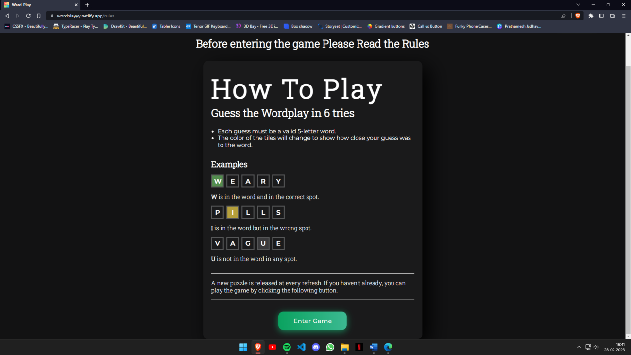

### Fig 4.2 User interface of Rule Page

### Main Game Page:

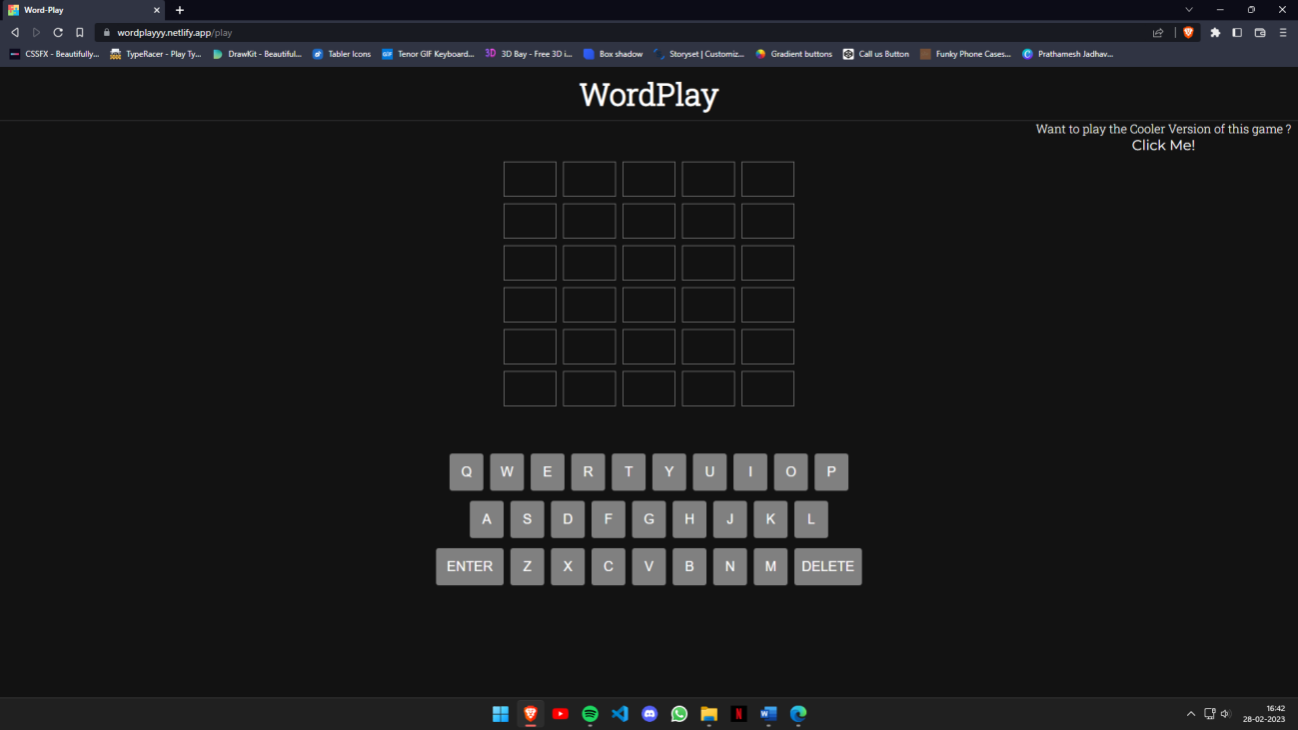

### Fig 4.3 User interface of Game Page

* **Advanced Game Page (Select Number of Letters):**

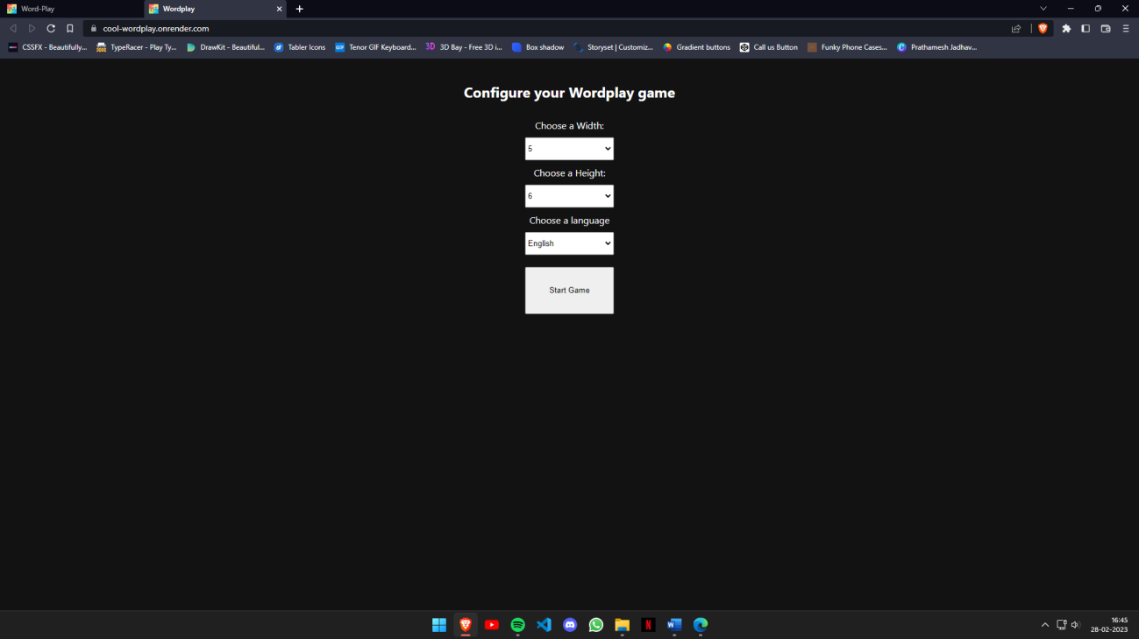

### Fig 4.4 User interface of Advanced Game Page (Select No. of Letters)

* **Advanced Game Page (Main Page):**

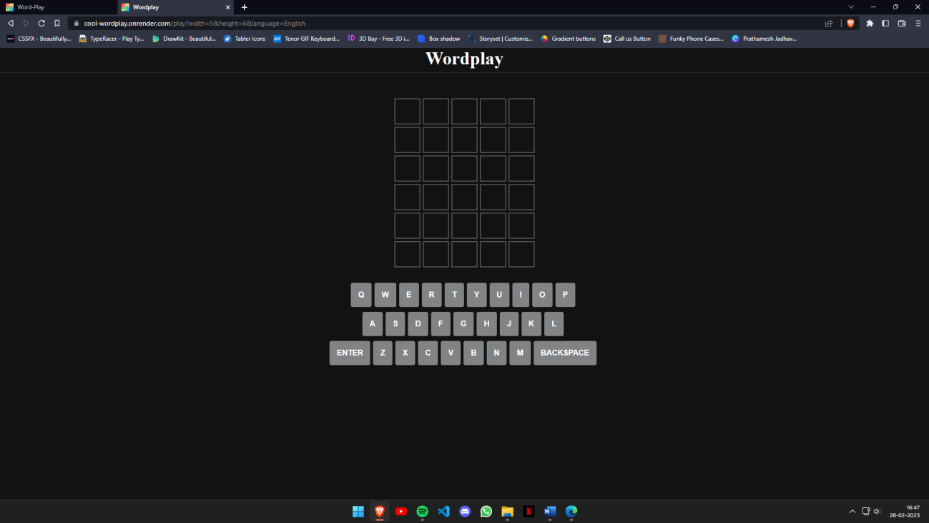

### Fig 4.4 User interface of Advanced Game Page (Select No. of Letters)

* **Login Page:**

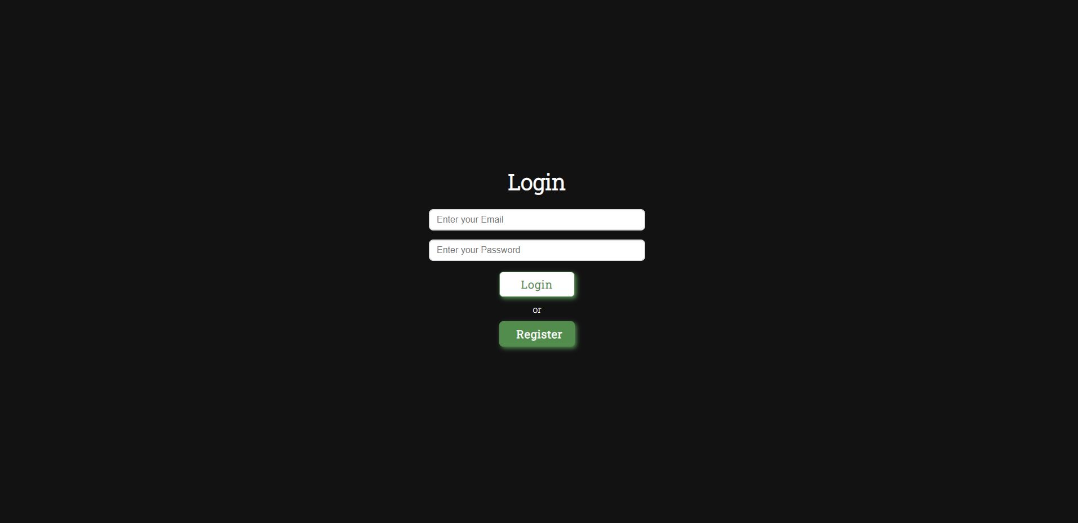

### Fig 4.5 User interface of Login Page

* **Register Page:**

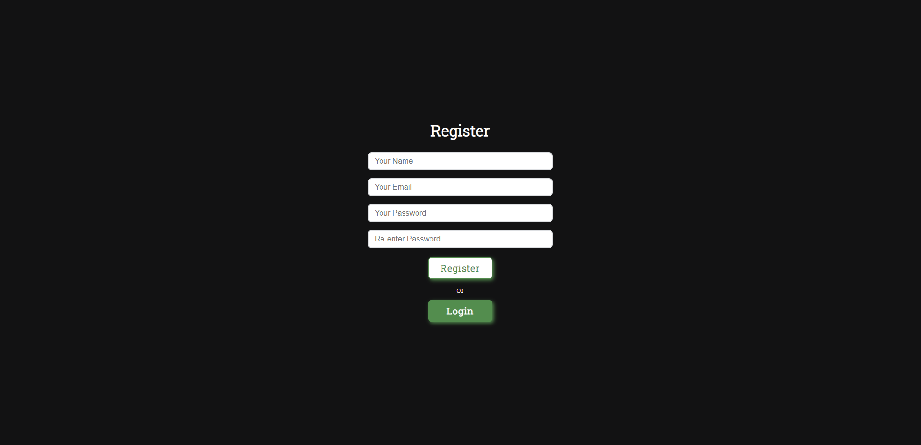

### Fig 4.6 User interface of Register Page

* 1. **Test Cases: -**
     1. **Registration: -**

|  |  |  |  |  |
| --- | --- | --- | --- | --- |
| **SN NO** | **NAME** | **EXPECTED OUTPUT** | **ACTUAL OUTPUT** | **REMARK** |
| 1 | Email: pop@gmail.com  Username: Poke038  Phone No: 91XXXX  Password:12@Ph34  C-Password :1234  Address: B-8, Mulund. | Register  Successfully. |  |  |
| 2 | Email: popgmailcom | Invalid  Email. |  |  |
| 3 | Email: pop@gmail.com  Password:1234 | Password must contain  Special character. |  |  |
| 4 | Password:12@pH34  C-Password: 12@Ph34 | Password Doesn’t match. |  |  |
| 5 | Email: pop@gmail.com  Username: Poke038 | User Already  Exist. |  |  |
| 6 | NULL | Please  Enter  Details. |  |  |

***Table 4.1 Test Case for Registration***

* + 1. **Login: -**

|  |  |  |  |  |
| --- | --- | --- | --- | --- |
| **SN NO** | **NAME** | **EXPECTED OUTPUT** | **ACTUAL OUTPUT** | **REMARK** |
| 1 | Username: Poke038  Password:12@Ph34 | Login  Successfully. |  |  |
| 2 | Username: Poke038  Password:12@Ph35 | Password  Invalid |  |  |
| 3 | Username: Poke038 | Invalid Details |  |  |
| 4 | NULL | Please fill all details. |  |  |

***Table 4.2 Test Case for Login***

* + 1. **Game: -**

|  |  |  |  |  |
| --- | --- | --- | --- | --- |
| **SN NO** | **NAME** | **EXPECTED OUTPUT** | **ACTUAL OUTPUT** | **REMARK** |
| 1 | Enter Word | Word entered Successfully |  |  |
| 2 | User enters half word | Invalid word |  |  |
| 3 | User presses Enter | Cursor will go to next line |  |  |
| 4 | User presses Enter without  Entering word | Cursor will not go to next line |  |  |
| 5 | User enters wrong word which is not in word list | Not in word list |  |  |
| 6 | User Enters right letter with right position | Background color will change to green |  |  |
| 7 | User Enters right letter  with wrong position | Background color will change to yellow |  |  |
| 8 | User Enters wrong letter  which is not in word | Background color will remain the same |  |  |
| 9 | User Enters number | Invalid input |  |  |
| 10 | User allows Keyboard Permission | Thanks!! Enjoy your game |  |  |
| 11 | User denies Keyboard Permission | OOPS!! The keyboard needed to play the game |  |  |

***Table 4.2 Test Case for Game***

### Chapter 5:

### Coding and Implementation

**5.1** **Implementation Approaches:**

This project was implemented using the Iterative model. In incremental methodology, the model is designed, implemented and tested incrementally. If in case there is a change in the requirements of the user then that part can be redesigned, re-implemented and tested again iteratively. This model allows us to update the system at each increment and we can add new functionalities as well.

The interfaces are designed and created using Visual Studio Code. After the user interfaces were created, database connectivity was performed. I connect my system to the MongoDB database at free remote database site “https://mongodb.com/atlas/database”. The coding part of my project is done in JavaScript language. The project was divided into modules. These modules were created one by one and after completion of each module, unit testing was performed on that module. When the module fulfils its requirements, it was integrated into the main project. After integration, each functionality was checked which can also be said to be as integration testing. After adding all the modules to my project, finally system testing was performed to check whether the system is working accordingly or not.

I have used validation wherever it was required. The system is made by considering all the problems into the view and the final project should be fulfilling all the requirements.

**5.2 Coding and Efficiency**

**5.2.1 Coding:**

**Actual logic of Main Game Page -**

**App.jsx**

import "./App.scss";

import Board from "./components/Board";

import Keyboard from "./components/Keyboard";

import { boardDefault, generateWordSet } from "./Words";

import React, { useState, createContext, useEffect } from "react";

import GameOver from "./components/GameOver";

export const AppContext = createContext();

function App() {

const [board, setBoard] = useState(boardDefault);

const [currAttempt, setCurrAttempt] = useState({ attempt: 0, letter: 0 });

const [wordSet, setWordSet] = useState(new Set());

const [correctWord, setCorrectWord] = useState("");

const [disabledLetters, setDisabledLetters] = useState([]);

const [gameOver, setGameOver] = useState({

gameOver: false,

guessedWord: false,

});

useEffect(() => {

generateWordSet().then((words) => {

setWordSet(words.wordSet);

setCorrectWord(words.todaysWord);

});

}, []);

const onEnter = () => {

if (currAttempt.letter !== 5) return;

let currWord = "";

for (let i = 0; i < 5; i++) {

currWord += board[currAttempt.attempt][i];

}

if (wordSet.has(currWord.toLowerCase())) {

setCurrAttempt({ attempt: currAttempt.attempt + 1, letter: 0 });

} else {

alert("Word not found");

}

if (currWord === correctWord) {

setGameOver({ gameOver: true, guessedWord: true });

return;

}

console.log(currAttempt);

if (currAttempt.attempt === 5) {

setGameOver({ gameOver: true, guessedWord: false });

return;

}

};

const onDelete = () => {

if (currAttempt.letter === 0) return;

const newBoard = [...board];

newBoard[currAttempt.attempt][currAttempt.letter - 1] = "";

setBoard(newBoard);

setCurrAttempt({ ...currAttempt, letter: currAttempt.letter - 1 });

};

const onSelectLetter = (key) => {

if (currAttempt.letter > 4) return;

const newBoard = [...board];

newBoard[currAttempt.attempt][currAttempt.letter] = key;

setBoard(newBoard);

setCurrAttempt({

attempt: currAttempt.attempt,

letter: currAttempt.letter + 1,

});

};

console.log(correctWord);

return (

<div className="game-App">

<nav className="nav">

<h1>WordPlay</h1>

</nav>

<AppContext.Provider

value={{

board,

setBoard,

currAttempt,

setCurrAttempt,

correctWord,

onSelectLetter,

onDelete,

onEnter,

setDisabledLetters,

disabledLetters,

gameOver,

}}

>

<div className="game">

<Board />

{gameOver.gameOver ? <GameOver /> : <Keyboard />}

</div>

</AppContext.Provider>

</div>

);

}

export default App;

**Keyboard.jsx**

import React, { useCallback, useEffect, useContext } from "react";

import Key from "./Key";

import { AppContext } from "../App";

function Keyboard() {

const keys1 = ["Q", "W", "E", "R", "T", "Y", "U", "I", "O", "P"];

const keys2 = ["A", "S", "D", "F", "G", "H", "J", "K", "L"];

const keys3 = ["Z", "X", "C", "V", "B", "N", "M"];

const {

board,

disabledLetters,

currAttempt,

gameOver,

onSelectLetter,

onEnter,

onDelete,

} = useContext(AppContext);

const handleKeyboard = useCallback(

(event) => {

if (gameOver.gameOver) return;

if (event.key === "Enter") {

onEnter();

} else if (event.key === "Backspace") {

onDelete();

} else {

keys1.forEach((key) => {

if (event.key.toLowerCase() === key.toLowerCase()) {

onSelectLetter(key);

}

});

keys2.forEach((key) => {

if (event.key.toLowerCase() === key.toLowerCase()) {

onSelectLetter(key);

}

});

keys3.forEach((key) => {

if (event.key.toLowerCase() === key.toLowerCase()) {

onSelectLetter(key);

}

});

}

},

[currAttempt]

);

useEffect(() => {

document.addEventListener("keydown", handleKeyboard);

return () => {

document.removeEventListener("keydown", handleKeyboard);

};

}, [handleKeyboard]);

return (

<>

<div className="keyboard" onKeyDown={handleKeyboard}>

<div className="line1">

{keys1.map((key) => {

return (

<Key keyVal={key} disabled={disabledLetters.includes(key)} />

);

})}

</div>

<div className="line2">

{keys2.map((key) => {

return (

<Key keyVal={key} disabled={disabledLetters.includes(key)} />

);

})}

</div>

<div className="line3">

<Key keyVal={"ENTER"} bigKey />

{keys3.map((key) => {

return (

<Key keyVal={key} disabled={disabledLetters.includes(key)} />

);

})}

<Key keyVal={"DELETE"} bigKey />

</div>

</div>

<div className="new-game">

Want to play the Cooler Version of this game ?{" "}

<button className="content-btn2">

<span className="btn-rule">

<a href="https://cool-wordplay.onrender.com" target="_blank">

Click Me!

</a>

</span>

</button>

</div>

</>

);

}

export default Keyboard;

**Letter.jsx**

import React, { useContext, useEffect } from "react";

import { AppContext } from "../App";

function Letter({ letterPos, attemptVal }) {

const { board, setDisabledLetters, currAttempt, correctWord } =

useContext(AppContext);

const letter = board[attemptVal][letterPos];

const correct = correctWord.toUpperCase()[letterPos] === letter;

const almost =

!correct && letter !== "" && correctWord.toUpperCase().includes(letter);

const letterState =

currAttempt.attempt > attemptVal &&

(correct ? "correct" : almost ? "almost" : "error");

useEffect(() => {

if (letter !== "" && !correct && !almost) {

console.log(letter);

setDisabledLetters((prev) => [...prev, letter]);

}

}, [currAttempt.attempt]);

return (

<div className="letter" id={letterState}>

{letter}

</div>

);

}

export default Letter;

**5.2.2 Code Efficiency**

Efficient code is essential for achieving peak performance in software development. To achieve this, code repetition has been avoided by using components base approach, various callback functions and states. The high quality coding methodologies have been used to make application completely asynchronous. By using these techniques, unnecessary duplication has been avoided and improved the readability and maintainability of their code.

**5.3 Testing Approach:**

To test a game website, a testing approach should include functional testing to ensure that all features work correctly, usability testing to evaluate how user-friendly the website is, and performance testing to measure the website's performance. The functional testing should include user should be able to play the game smoothly without any errors or problems. The usability testing should focus on navigation. Performance testing should check the website's speed and responsiveness.

**5.3.1 Unit Testing:**

Unit testing is a software testing technique that tests individual components of a software system in isolation from the rest of the system. It helps ensure that each component of the software functions as expected and meets the requirements. Unit testing involves creating test cases for each unit of code, executing them, and verifying the results. It helps detect and fix bugs early in the development cycle, making the software more reliable and easier to maintain.

1. **Register For Users:**

|  |  |  |  |  |
| --- | --- | --- | --- | --- |
| **SN NO** | **NAME** | **EXPECTED OUTPUT** | **ACTUAL OUTPUT** | **REMARK** |
| 1 | Email: pop@gmail.com  Username: Poke038  Phone No: 91XXXX  Password:12@Ph34  C-Password :1234 | Register  Successfully. | Register Successfully. | Pass |
| 2 | Email: popgmailcom | Invalid  Email. | Invalid Email | Pass |
| 3 | Email: pop@gmail.com  Password:1234 | Password must contain  Special character. | Error | Pass |
| 4 | Password:12@pH34  C-Password: 12@Ph34 | Password Doesn’t match. | Password Doesn't match | Pass |
| 5 | Email: pop@gmail.com  Username: Poke038 | User Already  Exist. | User Already Exist | Pass |
| 6 | NULL | Invalid Input | Invalid Input | Pass |

1. **Login for Users:**

|  |  |  |  |  |
| --- | --- | --- | --- | --- |
| **SN NO** | **NAME** | **EXPECTED OUTPUT** | **ACTUAL OUTPUT** | **REMARK** |
| 1 | Username: Poke038  Password:12@Ph34 | Login  Successfully. | Login Successfully | Pass |
| 2 | Username: Poke038  Password:12@Ph35 | Password  Invalid | Invalid Input | Pass |
| 3 | Username: Poke038 | Invalid Details | Invlaid Input | Pass |
| 4 | NULL | Please fill all details. | Invalid Input | Pass |

1. **Game for Users**

|  |  |  |  |  |
| --- | --- | --- | --- | --- |
| **SN NO** | **NAME** | **EXPECTED OUTPUT** | **ACTUAL OUTPUT** | **REMARK** |
| 1 | Enter Word | Word entered Successfully | Word entered Successfully | Pass |
| 2 | User enters half word | Invalid word | Invalid word | Pass |
| 3 | User presses Enter | Cursor will go to next line | Cursor will go to next line | Pass |
| 4 | User presses Enter without  Entering word | Cursor will not go to next line | Cursor will not go to next line | Pass |
| 5 | User enters wrong word which is not in word list | Not in word list | Not in word list | Pass |
| 6 | User Enters right letter with right position | Background color will change to green | Background color will change to green | Pass |
| 7 | User Enters right letter  with wrong position | Background color will change to yellow | Background color will change to yellow | Pass |
| 8 | User Enters wrong letter  which is not in word | Background color will remain the same | Background color wil remain the same | Pass |
| 9 | User Enters number | Invalid input | Invalid Input | Pass |

**5.3.2 Beta Testing:**

The first step would be to identify the scope of the testing and the objectives to be achieved. Then, a list of test scenarios can be created based on the identified scope and objectives. These scenarios should cover different aspects of the documentation, such as clarity, completeness, and accuracy. Next, a group of beta testers can be selected, who can represent the target audience for the documentation. The testers can then execute the test scenarios and provide feedback on their experience and observations. The feedback can be collected in a structured format, such as a survey or a feedback form. Finally, the feedback can be analyzed, and the necessary changes can be incorporated into the documentation. This iterative process can be repeated until the documentation meets the desired quality standards.

**5.4 Modifications and Improvements:**

After complete testing, bugs introduced which causing inappropriate behavior of application, have been resolved. Some pages causing slow-loading was improved by reducing number of unnecessary database queries, code re-usability by making functions. Some functionalities were difficult to find on use, so user interface has been optimized further. Some loading issues were there, because of the large file which is provided for fetching the different words for user to play the game later that file changed to the lighter version and efficient version.

**Failed Test Cases:**

Adding email into database without validating them.

**Module:**

Advanced Game

**Modification Code:**

const getLanguageConfigs = () => {

return {

English: {

keyboard: [

["Q", "W", "E", "R", "T", "Y", "U", "I", "O", "P"],

["A", "S", "D", "F", "G", "H", "J", "K", "L"],

["ENTER", "Z", "X", "C", "V", "B", "N", "M", "BACKSPACE"],

],

wordsUrl: "./english.json",

},

};

};

export default getLanguageConfigs;

**Chapter 6:**

**Result and Discussion**

**6.1 Test Reports:**

The testing part in project development is a very important phase. This phase helps to know whether all the functionalities are being performed the way that they are supposed to be executing.

When it comes to software development, testing is a crucial part of the process. It ensures that the project meets the required quality standards and performs as expected. In this project, various modules like Schedule,Attendance, Review, Login, and Register were tested to ensure their functionality.

Unit Testing was performed to test the smallest testable parts of the project individually. A total of 20 test cases were executed for all the modules, and all of them passed without any errors. This is a significant achievement as it indicates that the project has been thoroughly tested and is ready for deployment.

In case there were any failed test cases, further modifications would have been needed to resolve the issue. However, since all the test cases passed, no further modifications were required in the respective modules. It is important to note that testing is an ongoing process, and it is essential to conduct regular testing to ensure that the project continues to meet the required quality standards.

I performed Unit Testing for this project.

Total Test Cases: 20

Passed Test Cases: 20

Failed Test Cases: 0

There are currently no failed test cases I myself resolve all the test cases in the modification process.

**6.2 User Documentation:**

1. The first page occurs when we open the website is Login or Register Page. User needs to login or register to play the game.



***Fig 6.1 Login Page***

2. If user is not register user needs to register the account by clicking on register button, after clicking register button register page will appear.



***Fig 6.2 Register Page***

3. After registration of user, user will be redirect to the login page. User needs to use the credentials to login which are used while registration.

4. After login, home page appears.

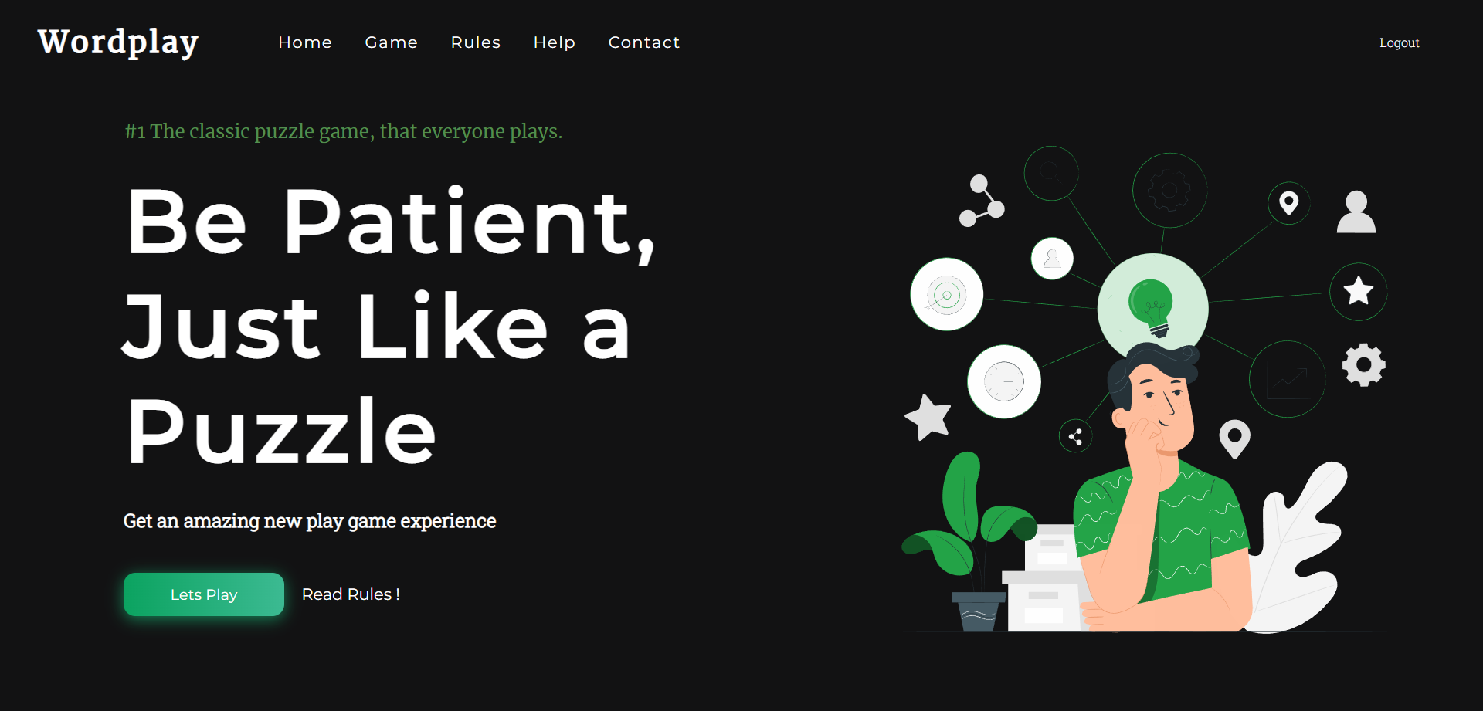

***Fig 6.3 Home Page***

5. After clicking the `Lets Play` button user will redirect to the rules page.

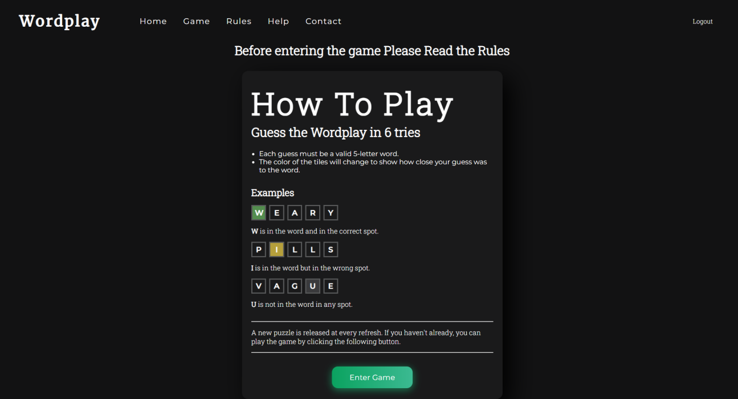

***Fig6.4 Rules Page***

1. User need to read the rules to understand the game and find the answer. To play the game Press the button Enter Game.

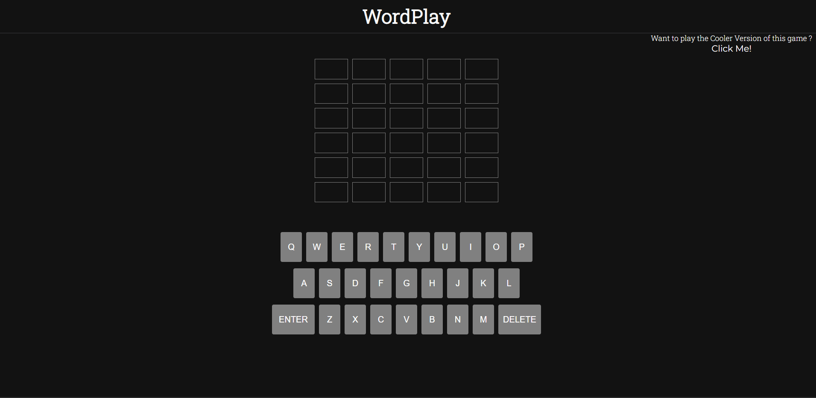

***Fig 6.5 Main-game Page***

1. If user wants to play a harder game and then click on the `Click me!` button which is on the right side of the page.
2. After clicking that user will redirect to the different page.
3. On this page game will ask the user how many letter game he wants to play and in how many tries.



***Fig 6.5 Advanced Game page(Select number of letters)***

1. After clicking on the `Start Game` button game page a new page appears which will be the same as the main game page user will have to crack the game.

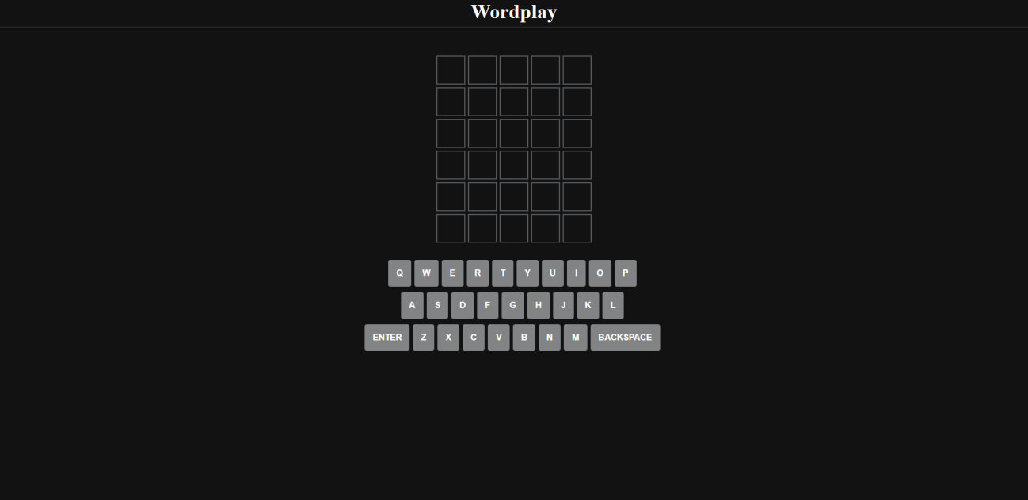

***Fig 6.6 Advance Game Page***

1. For logging out from website click on the logout button which is in navbar.
2. After clicking on the logout button user will redirect to the login page and will lose all the data.

**Chapter 7:**

**Conclusion**

**7.1 Conclusion:**

The game involves trying to guess a five-letter word by inputting different letter combinations, and using the feedback given to narrow down the possibilities until the correct word is found. It can be a challenging yet satisfying experience, and can also help improve vocabulary and critical thinking skills.

Several Reasons to play the this game :-

Improve vocabulary: The game involves guessing a five-letter word, which means players must consider a range of different letter combinations. This can help improve their vocabulary and introduce them to new words.

Enhance critical thinking skills: The feedback provided by the game requires players to use deduction and logic to narrow down the possibilities of the chosen word. This can help enhance their critical thinking skills and problem-solving abilities.

Relaxation and entertainment: Playing games can be a fun way to relax and unwind. The Wordplay game is an engaging and enjoyable game that can provide a welcome break from daily routines and responsibilities.

Social connection: Wordplay can be played with friends and family, making it a great way to connect with loved ones and spend quality time together.

Overall, playing the game can be a fun and educational way to spend time, whether it's alone or with others

Ultimately, the conclusion of the game will depend on the individual player's experience and whether they were able to successfully guess the correct word within the allotted number of attempts.

**7.2 Limitations:**

1. This game is only available in the English language, which may make it difficult for people who do not understand English to play.

2. Players with color blindness may have difficulty guessing the word since the game relies on the use of colors, specifically green, yellow, and gray, to provide feedback on each guess.

**7.3 Future Scope:**

**Improvements in gameplay:** As the game continues to gain popularity, there may be opportunities to make improvements to the gameplay. For example, there could be new game modes, additional difficulty levels, or other features added to the game.

**Integration with social media:** The Game could be integrated with social media platforms such as Facebook or Twitter. This would allow players to share their progress and scores with their friends, adding an element of competition and social interaction to the game.

**Development of mobile apps:** Although the game can be played on a web browser, there is potential for the development of mobile apps for this game. This would make the game more accessible and convenient for people who prefer to play on their smartphones or tablets.

**Localization in other languages:** Currently, the game is only available in English, but there is potential for it to be localized in other languages. This would allow people from all over the world to enjoy the game, which could increase its popularity even further.

# **BIBLIOGRAPHY: -**

**WEBSITES: -**

* <https://www.zenflowchart.com/guides/data-flow-diagram>

as of 01/09/22

* <https://www.newthinktank.com/2019/01/latex-tutorial/>

as of 28/06/22

* [https://online.visual-paradigm.com/drive/#diagram:proj=0&type=GanttChart&workspace=mhujsaxv&id=2](https://online.visual-paradigm.com/drive/" \l "diagram:proj=0&type=GanttChart&workspace=mhujsaxv&id=2)

as of 12/07/22

* <https://www.lucidchart.com/pages>

as of 16/08/22

* <https://www.mongodb.com/docs/manual/core/data-modeling-introduction/>

as of 15/08/22

* <https://www.lucidchart.com/pages/uml-use-case-diagram>

as of 21/08/22

* <https://www.lucidchart.com/pages/uml-sequence-diagram>

as of 22/08/22

* <https://www.lucidchart.com/pages/data-flow-diagram>

as of 23/08/22

* <https://www.lucidchart.com/pages/uml-state-machine-diagram>

as of 21/08/22

* <https://www.lucidchart.com/pages/uml-activity-diagram>

as of 20/08/22

* <https://youtu.be/WnMQ8HlmeXc>

as of 07/09/22

**REFERENCE BOOKS:**

* Practical MongoDB: Architecting, Developing, and Administering MongoDB

Author : [Shakuntala Gupta Edward](https://www.pdfdrive.com/search?q=Shakuntala+Gupta+Edward) & [Navin Sabharwal](https://www.pdfdrive.com/search?q=Navin+Sabharwal) as of 16/07/22

* Software Engineering 9th Edition

Author : Ian Sommerville as of 19/06/22

* Learning Node.js Development: Learn the fundamentals of Node.js, and deploy and test Node.js applications on the web

Author :  [Andrew Mead](https://www.amazon.in/s/ref=dp_byline_sr_book_1?ie=UTF8&field-author=Andrew+Mead&search-alias=stripbooks)  as of 20/08/22

* Beginning Node.js, Express & MongoDB Development

Author : Greg Lim  as of 22/08/22

* Fundamentals of Creating a Great UI/UX

Author: - Creative Tim as of 23/08/22