Project 3 — Web Application Security Assessment
1. Executive Summary

This project presents a controlled web application security assessment performed against Damn Vulnerable Web Application (DVWA) running locally on Kali Linux.

The objective was to gain practical experience in web application penetration testing using Burp Suite and to validate common web vulnerabilities in a deliberately vulnerable environment.

Three vulnerabilities were successfully validated:

SQL Injection
Reflected Cross-Site Scripting (XSS)
OS Command Injection

All testing was performed against the local DVWA instance and was conducted in an intentionally vulnerable environment.

2. Project Information
Item Details
Project Web Application Security Assessment
Target Damn Vulnerable Web Application (DVWA)
Platform Kali Linux
Web Server Nginx
Application DVWA
Testing Tool Burp Suite
Security Level Low
Target Address 127.0.0.1:42001
Assessment Type Controlled vulnerability assessment
3. Objectives

The objectives of this project were to:

Set up a deliberately vulnerable web application.
Understand the basic workflow of a web application security assessment.
Configure Burp Suite as an interception proxy.
Capture HTTP requests and responses.
Test application inputs for common vulnerabilities.
Validate vulnerabilities using controlled payloads.
Collect HTTP evidence.
Assess the security impact of identified vulnerabilities.
Recommend appropriate remediation measures.
Document the complete assessment.
4. Lab Environment

The assessment was performed entirely within Kali Linux.

Components

Kali Linux
|
Browser
|
Burp Suite
|
DVWA
127.0.0.1:42001

The application was intentionally kept local rather than exposed to the Internet.

5. Target Application
Damn Vulnerable Web Application

DVWA is an intentionally vulnerable PHP/MySQL web application designed for learning and practicing web application security.

The Kali package provides a local DVWA service that can be started using:

sudo dvwa-start

The application was accessed at:

http://127.0.0.1:42001

The DVWA security level was configured to:

Low

This was selected because the purpose of the project was to demonstrate vulnerability identification and HTTP-level testing.

6. Tools Used
Burp Suite

Burp Suite was used as the primary web application security testing tool.

It was used to:

Intercept HTTP requests
Inspect HTTP responses
Modify request parameters
Send requests to Repeater
Validate application behavior
Collect evidence
DVWA

DVWA was used as the intentionally vulnerable target.

Browser

The browser was used to interact with the application and observe the effects of test payloads.

7. Methodology

The assessment followed a simplified penetration-testing workflow:

Lab Setup
↓
Application Discovery
↓
Burp Suite Configuration
↓
Request Interception
↓
Input Testing
↓
Vulnerability Validation
↓
Evidence Collection
↓
Risk Assessment
↓
Remediation

The assessment was limited to the local DVWA application.

8. Burp Suite Configuration

Burp Suite was configured as the HTTP proxy between the browser and DVWA.

The local proxy configuration used:

Proxy Host: 127.0.0.1
Proxy Port: 8080

Traffic was then visible in Burp Suite under:

Proxy → HTTP history

Requests could subsequently be sent to:

Repeater

for controlled modification and testing.

9. Finding F-01 — SQL Injection
9.1 Description

SQL Injection occurs when untrusted user input is incorporated into a database query without appropriate parameterization or validation.

The DVWA SQL Injection functionality was tested at:

/vulnerabilities/sqli/
9.2 Test Input

The following input was used:

1' OR '1'='1

The request was intercepted using Burp Suite.

9.3 Evidence

The application returned multiple database records.

The response included:

ID: 1' OR '1'='1
First name: admin
Surname: admin

ID: 1' OR '1'='1
First name: Gordon
Surname: Brown

ID: 1' OR '1'='1
First name: Hack
Surname: Me

ID: 1' OR '1'='1
First name: Pablo
Surname: Picasso

ID: 1' OR '1'='1
First name: Bob
Surname: Smith

The HTTP response returned:

HTTP/1.1 200 OK
9.4 Analysis

The application did not treat the input strictly as a user ID.

Instead, the supplied input altered the SQL query's logical condition, resulting in multiple records being returned.

This confirms that user-controlled input was being incorporated into the SQL query in an unsafe manner.

9.5 Impact

In a real application, SQL Injection could potentially allow an attacker to:

Read unauthorized database information
Bypass application logic
Modify database records
Delete database information
Potentially execute database-level administrative operations

The actual impact depends on database privileges and application architecture.

9.6 Severity

High

The severity is assigned based on the demonstrated ability to manipulate the database query and retrieve multiple records in the vulnerable application.

9.7 Remediation

Recommended mitigations include:

Use parameterized queries/prepared statements.
Never concatenate user input directly into SQL queries.
Apply server-side input validation.
Use least-privilege database accounts.
Avoid exposing database errors to users.
Implement appropriate security testing during development.
Evidence

Screenshot: 01-sqli-confirmed.png

10. Finding F-02 — Reflected Cross-Site Scripting
10.1 Description

Reflected Cross-Site Scripting occurs when user-controlled input is returned in an HTTP response without appropriate output encoding, allowing browser-executable content to be interpreted as HTML/JavaScript.

The DVWA functionality tested was:

/vulnerabilities/xss_r/
10.2 Test Payload

The following controlled payload was used:

<script>alert('XSS')</script>
10.3 Evidence

The server returned the supplied script directly in the HTML response:

<pre>Hello <script>alert('XSS')</script></pre>

The response returned:

HTTP/1.1 200 OK

The browser executed the JavaScript and displayed the test alert.

10.4 Additional Observation

The response included:

X-XSS-Protection: 0

However, this header was not used as the primary evidence.

The vulnerability was established because the user-controlled script was reflected into the HTML response without appropriate output encoding.

10.5 Impact

Depending on application context, reflected XSS could allow an attacker to execute JavaScript in a victim's browser.

Potential consequences include:

Manipulation of webpage content
Phishing through modified page content
Performing actions using the victim's browser session
Access to information available to client-side JavaScript
User redirection or malicious script execution
10.6 Severity

Medium

The severity depends on the affected page, authentication context, browser protections, and what sensitive actions or information are available to JavaScript.

10.7 Remediation

Recommended mitigations include:

Context-aware output encoding.
HTML escaping of untrusted input.
Server-side validation.
Use safe templating mechanisms.
Implement an appropriate Content Security Policy.
Avoid inserting untrusted content directly into HTML or JavaScript contexts.
Evidence

Screenshot: 02-xss-confirmed.png

11. Finding F-03 — OS Command Injection
11.1 Description

OS Command Injection occurs when user-controlled input is incorporated into operating-system commands without appropriate validation or safe command execution.

The DVWA functionality tested was:

/vulnerabilities/exec/
11.2 Test Input

The following controlled input was used:

127.0.0.1; whoami

The intention was to provide a normal loopback address followed by a harmless command demonstrating whether command execution was possible.

11.3 Evidence

The response contained normal ping output:

PING 127.0.0.1 (127.0.0.1) ...

followed by:

_dvwa

The _dvwa output corresponds to the result of the whoami command.

The HTTP response returned:

HTTP/1.1 200 OK
11.4 Analysis

The application processed the supplied input as part of an operating-system command.

The successful execution of whoami demonstrates that the input was not restricted to a valid IP address and that additional shell commands could be executed.

11.5 Impact

In a real application, command injection could potentially allow an attacker to execute operating-system commands with the privileges of the web-server process.

Depending on those privileges, this could result in:

Unauthorized file access
System information disclosure
Modification of files
Execution of malicious programs
Further compromise of the host

The demonstrated lab result does not by itself establish compromise of a real system.

11.6 Severity

High

The finding is rated High because successful OS command execution can provide significant control over the underlying host when the vulnerable process has meaningful privileges.

11.7 Remediation

Recommended mitigations include:

Avoid passing user input directly to shell commands.
Use safe APIs that do not invoke a shell.
Strictly validate input against an allowlist.
Validate IP addresses using dedicated networking libraries.
Run web applications with the minimum required privileges.
Apply operating-system-level isolation where appropriate.
Evidence

Screenshot: 03-command-injection.png

12. Risk Summary
ID Finding Severity Status
F-01 SQL Injection High Confirmed
F-02 Reflected XSS Medium Confirmed
F-03 OS Command Injection High Confirmed

13. Overall Risk Assessment

The assessment identified three significant vulnerabilities in the intentionally vulnerable DVWA application.

The highest-risk findings were:

SQL Injection
OS Command Injection

Both demonstrate the potential for attacker-controlled input to influence backend operations.

Reflected XSS was also successfully demonstrated, showing that untrusted input could be returned to the browser as executable HTML/JavaScript.

However, these findings should not be interpreted as vulnerabilities in the Kali operating system itself or in a production application. DVWA is intentionally designed to contain these weaknesses for security training.

14. Evidence Summary
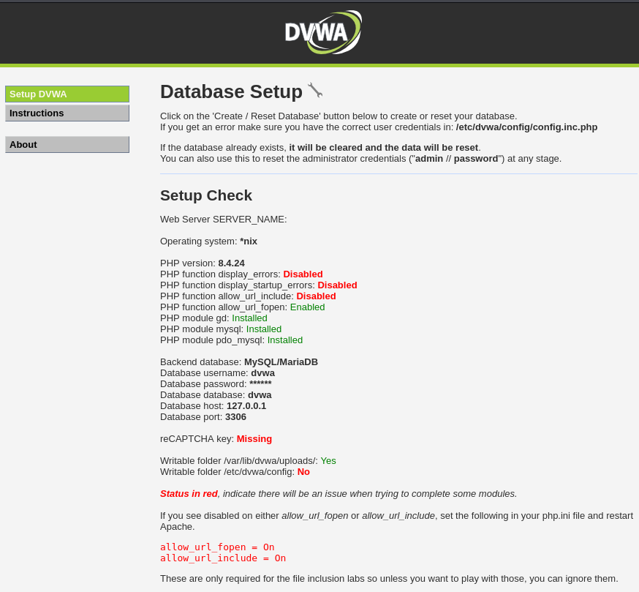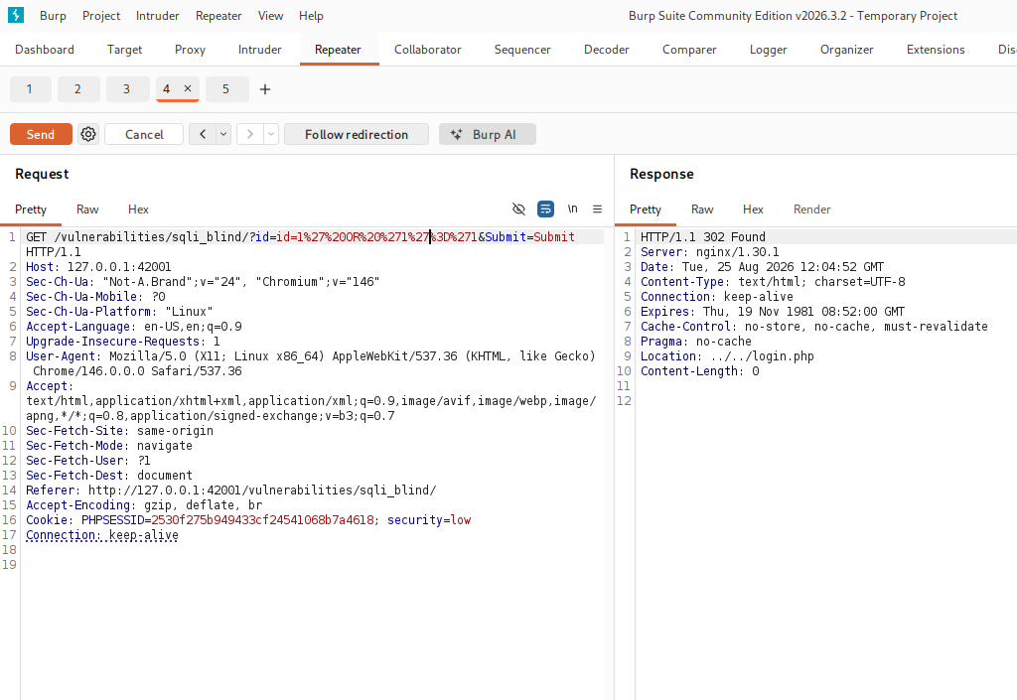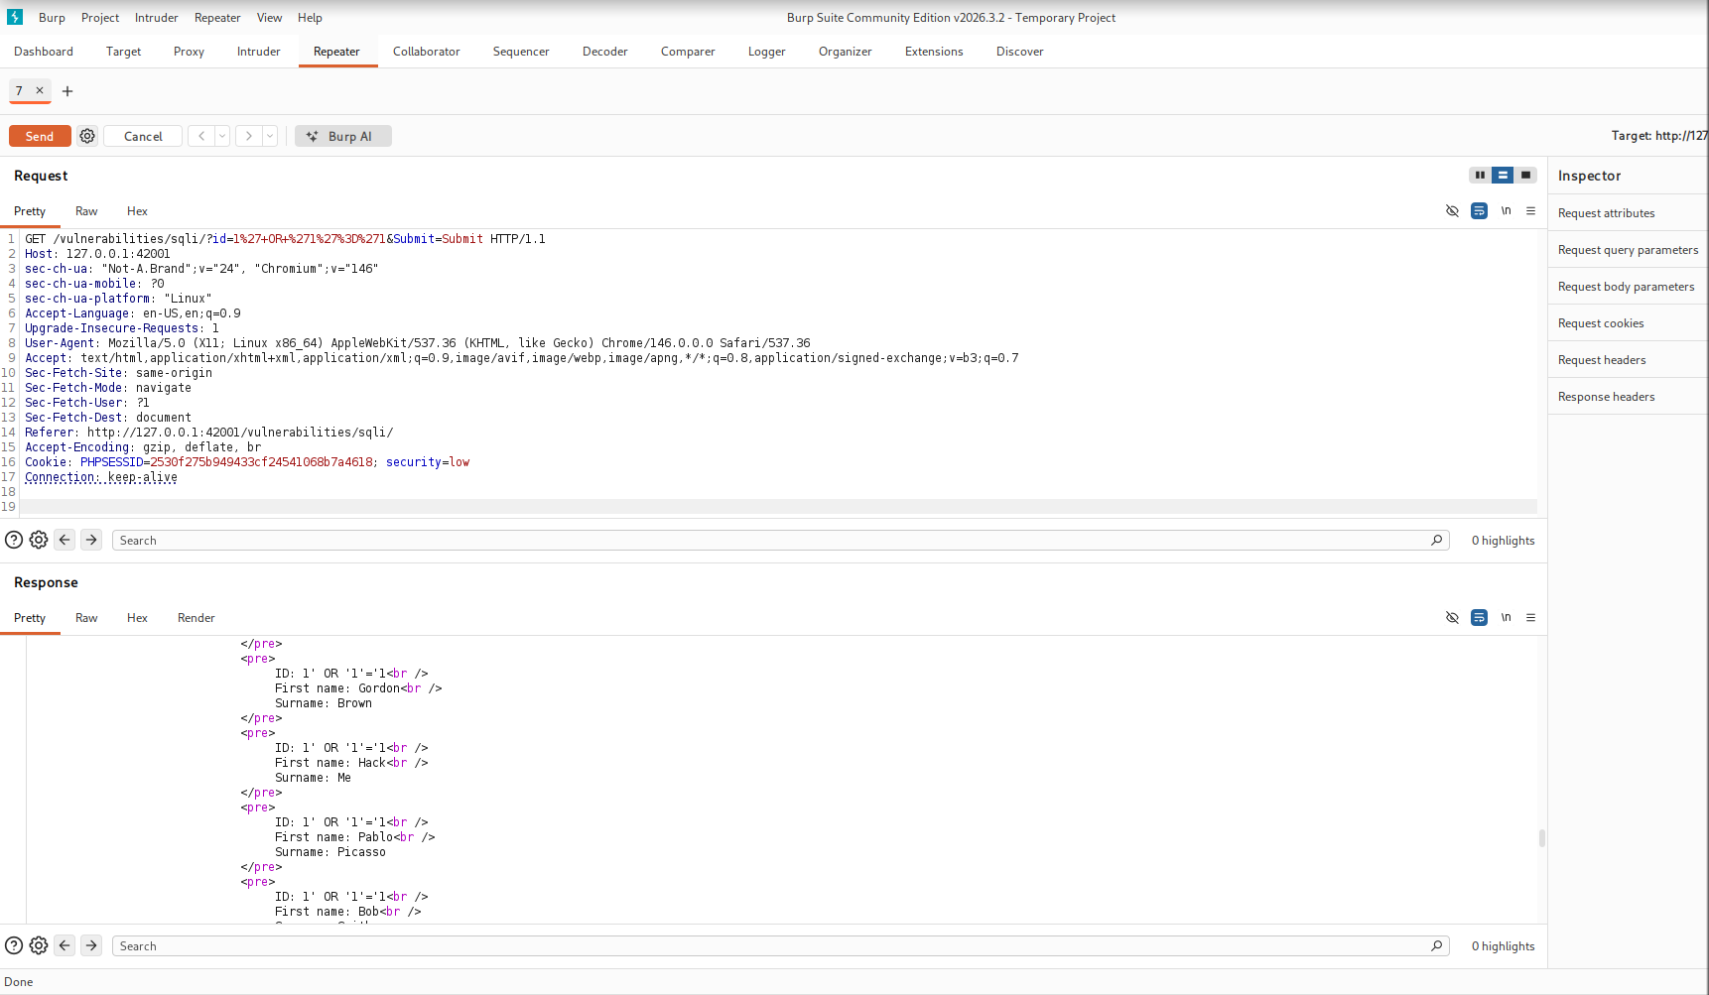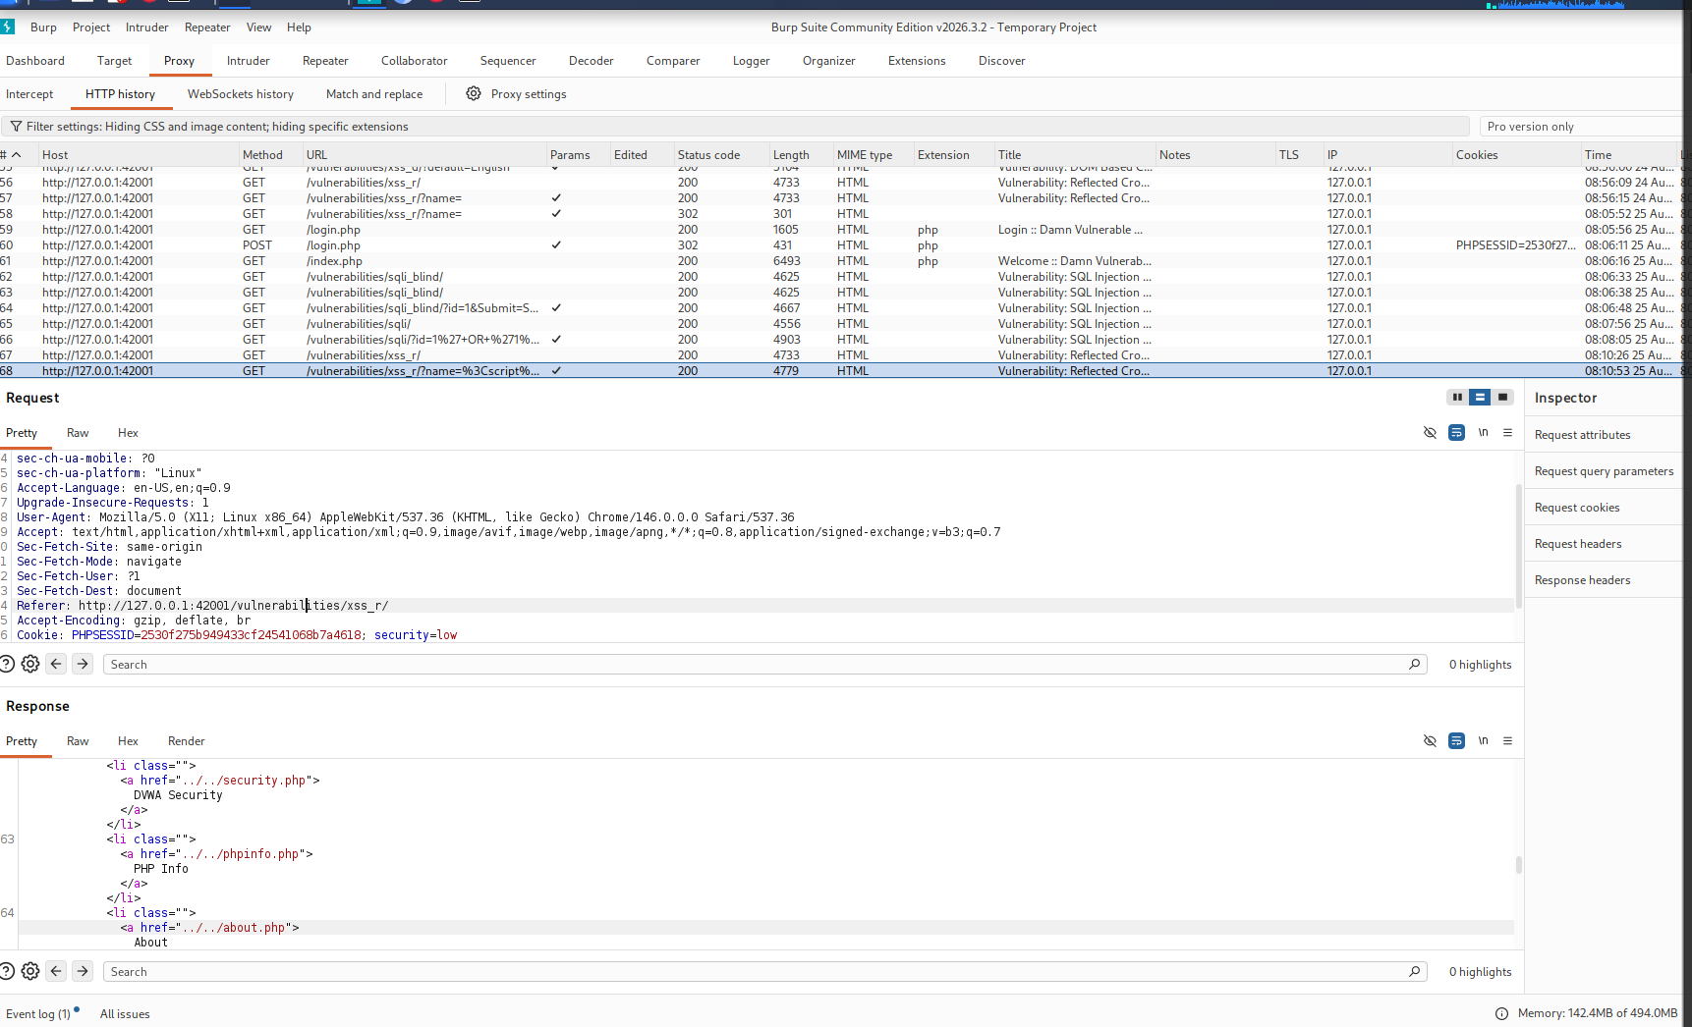

15. Limitations
This assessment has several limitations:
- The target was an intentionally vulnerable application.
- Testing was performed locally.
- DVWA security level was set to Low.
- Only three vulnerabilities were assessed.
- No production application was tested.
- No automated exploitation was performed.
- No persistence or post-exploitation activity was performed.
- No real user data was involved.
- No Internet-facing target was assessed.
Therefore, the findings demonstrate security testing techniques, rather than evidence of an actual compromise.

16. Ethical Considerations
All testing was performed against a deliberately vulnerable application running locally on Kali Linux.
The project was conducted for educational and cybersecurity skill-development purposes.
No unauthorized systems, websites, accounts, or networks were targeted.
The vulnerable application should remain restricted to a controlled laboratory environment and should not be exposed to the public Internet.

17. Skills Demonstrated
This project demonstrates practical experience with:
- Web application security testing
- Burp Suite
- HTTP request/response analysis
- HTTP parameter manipulation
- SQL Injection testing
- Cross-Site Scripting testing
- Command Injection testing
- Vulnerability validation
- Evidence collection
- Risk assessment
- Security remediation
- Technical reporting
- Ethical security testing

18. Lessons Learned
The project demonstrated several important principles:
1. HTTP requests are valuable evidence
Rather than relying only on what appears in a browser, examining the underlying HTTP request and response provides much stronger evidence.
2. Input validation is critical
All three findings involved application behavior being influenced by user-controlled input.
3. Vulnerability confirmation requires evidence
A suspicious input alone is not enough. The application's response must demonstrate the security impact.
4. Severity should be contextual
A vulnerability should not automatically be given the highest severity simply because the vulnerability class sounds serious. The actual impact and application context matter.
5. Vulnerable applications should remain isolated
Training applications such as DVWA are intentionally insecure and should not be exposed to untrusted networks.

19. Conclusion
This project provided practical experience in conducting a controlled web application security assessment.
Using Kali Linux, DVWA, and Burp Suite, three vulnerabilities were successfully identified and validated:
- SQL Injection
- Reflected XSS
- OS Command Injection
The assessment followed a structured process from request interception through vulnerability validation, evidence collection, risk assessment, and remediation recommendations.
The project demonstrates the ability to move beyond simply running security tools and instead analyze application behavior, validate vulnerabilities, collect evidence, and communicate security findings in a professional format.

