Online Retail Application Database Project Report

1. Introduction

1.1 Problem Statement

The project addresses the need for a robust database management system to support an online retail application. The challenges include managing product catalogs, customer profiles, and order history efficiently. Additionally, generating insightful reports for informed decision-making is crucial for the success of the online retail business.

2. Database Design

2.1 Entity-Relationship Diagram (ERD)

An Entity-Relationship Diagram (ERD) was crafted to model the relationships between entities in the database. This visual representation ensures a clear understanding of the database structure, facilitating efficient data retrieval and management.

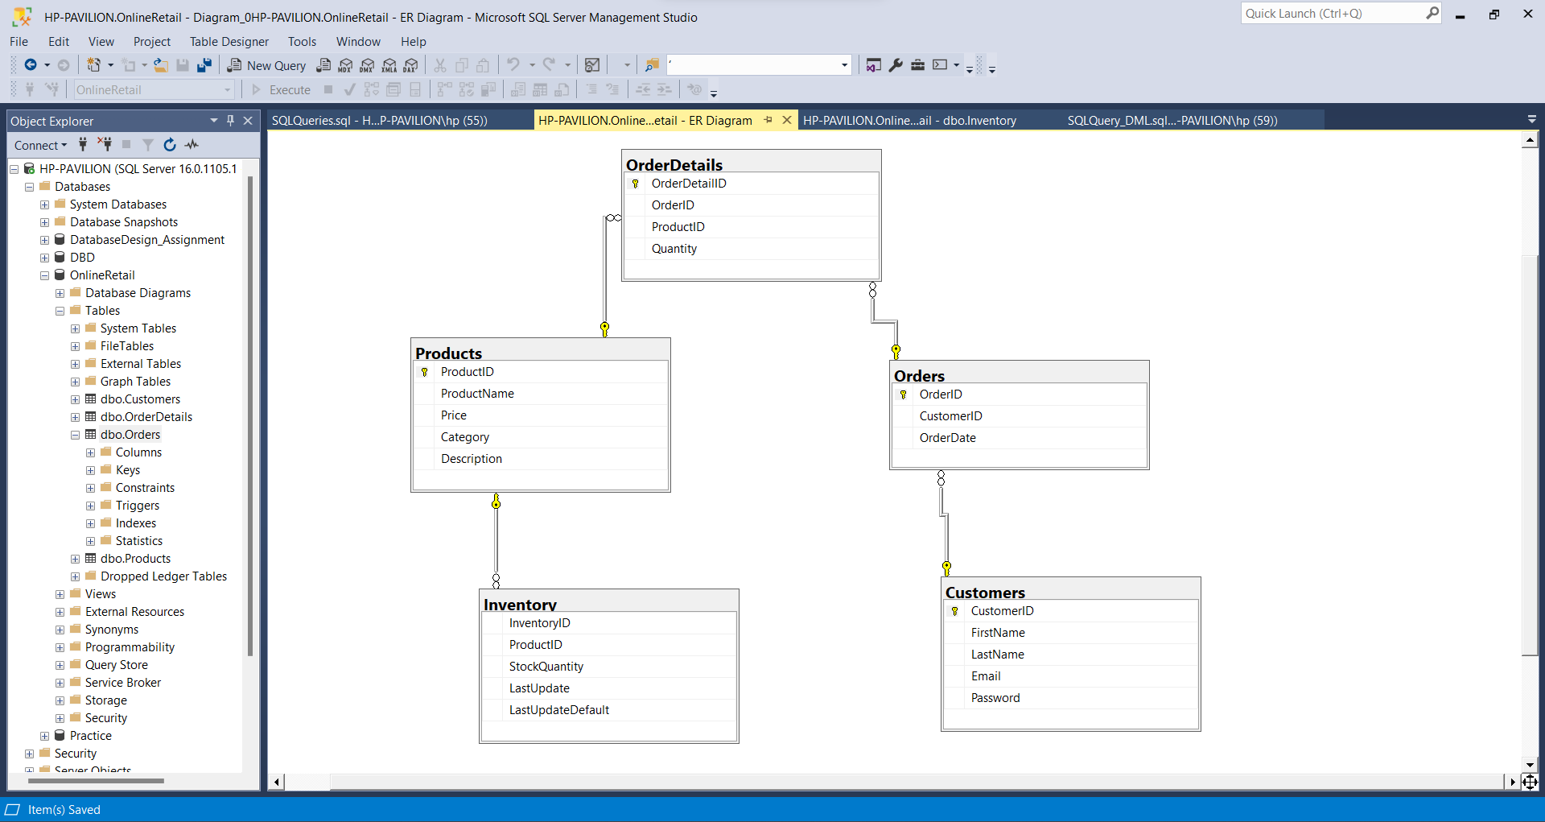

2.2 Schema Definition

The database tables were designed following normalization principles to eliminate data redundancy, improve data integrity, and streamline database operations. Key tables include:

Products: ProductID (PK), ProductName, CategoryID (FK), Price, ...

Customers: CustomerID (PK), FirstName, LastName, Email, ...

Orders: OrderID (PK), CustomerID (FK), OrderDate, TotalAmount, ...

Inventory: InventoryID (PK), ProductID (FK), StockQuantity, LastUpdate, ...

3. Data Collection

3.1 Data Sources

Data was collected from various sources including product catalogs, customer profiles, and order history. Preprocessing steps were applied to ensure data consistency and accuracy, creating a reliable foundation for the database.

4. SQL Queries

4.1 Sample Queries

A variety of SQL queries were developed to address different aspects of the online retail business:

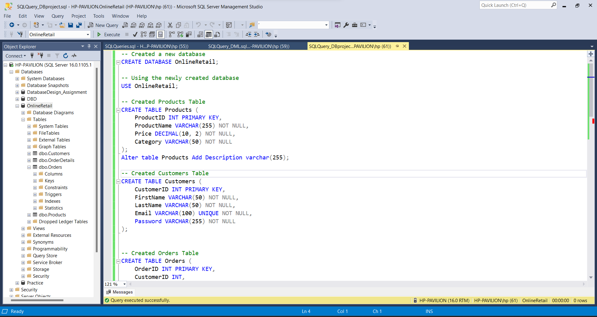

5. Techniques Employed

5.1 Relational Database Management System (RDBMS)

MySQL was selected as the RDBMS for its reliability, scalability, and robust feature set, providing a solid foundation for the online retail database.

5.2 Normalization

Normalization techniques were applied to the database design, ensuring efficient data storage, eliminating redundancies, and improving data integrity.

5.3 Indexing and Optimization

Indexes were strategically implemented to enhance query performance. This optimization ensures efficient data retrieval even as the application experiences increased traffic and data volume.

5.4 Security Measures

To protect sensitive customer and transaction data, various security measures were incorporated, including user authentication, data encryption, and access control.

6. Goals and Achievements

6.1 Efficient Database Management

The database was successfully implemented, providing efficient management of product catalogs, customer profiles, order history, and real-time inventory updates.

6.2 Data Analysis and Insights

SQL queries were employed to generate reports and insights into sales trends, popular products, customer behavior, and other key performance indicators. These insights support informed decision-making and strategic planning.

6.3 Inventory Control

A system for real-time inventory tracking was implemented, ensuring accurate stock levels and automatic inventory updates when orders are placed.

6.4 Performance Optimization

The database's performance was optimized to handle increased traffic and data volume, ensuring scalability as the application grows.

7. Limitations

7.1 Scalability

While the database was optimized for performance, scalability may become a challenge as the application grows. Regular monitoring and adjustments will be necessary to accommodate increasing data and user loads.

7.2 Security

Although security measures were implemented, continuous monitoring and updates are required to address emerging threats and vulnerabilities. Regular security audits should be conducted to ensure data integrity and customer trust.

7.3 Data Volume

Handling extremely large volumes of data may pose challenges in terms of performance and storage capacity. Regular data archiving and optimization strategies should be considered to mitigate potential issues.

This comprehensive report provides an overview of the project's objectives, methodologies, and outcomes. It addresses key aspects of database design, data collection, SQL query development, and the application of various techniques to achieve project goals. The limitations section highlights areas for future consideration and improvement.