
Symbiosis Skills and
Professional University
Kiwale, Pune
-----------------------------------------------------------------

INTERNSHIP REPORT ON

Cyber Crime analyst
&
Forensics

Submitted by
Prathamesh Santosh Pendkar
-: PRN: -
2201106006

Second Year: B. Tech CSIT
(Cybersecurity)
AY-2023-2024

Under The Guidance of

Kayomarz Anklesvaria Parul Bhanerkar
Industry Mentor College Mentor
Cyber Security Corporation School of CSIT

12th June 2024- 7th August 2024
(Internship Time Period)

SCHOOL OF CSIT (CYBER SECURITY)
Symbiosis Skills and
Professional University
Kiwale, Pune
-----------------------------------------------------------------
INTERNSHIP REPORT ON

Cyber Crime analyst
&
Forensics

Submitted by
Prathamesh Santosh Pendkar
-: PRN: -
2201106006

Second Year: B. Tech CSIT
(Cybersecurity)
AY-2023-2024

Under The Guidance of

Kayomarz Anklesvaria Parul Bhanerkar
Industry Mentor College Mentor
Cyber Security Corporation School of CSIT

12th June 2024- 7th August 2024

SCHOOL OF CSIT (CYBER SECURITY)

INTERNAL EXAMINER EXTERNAL EXAMINER

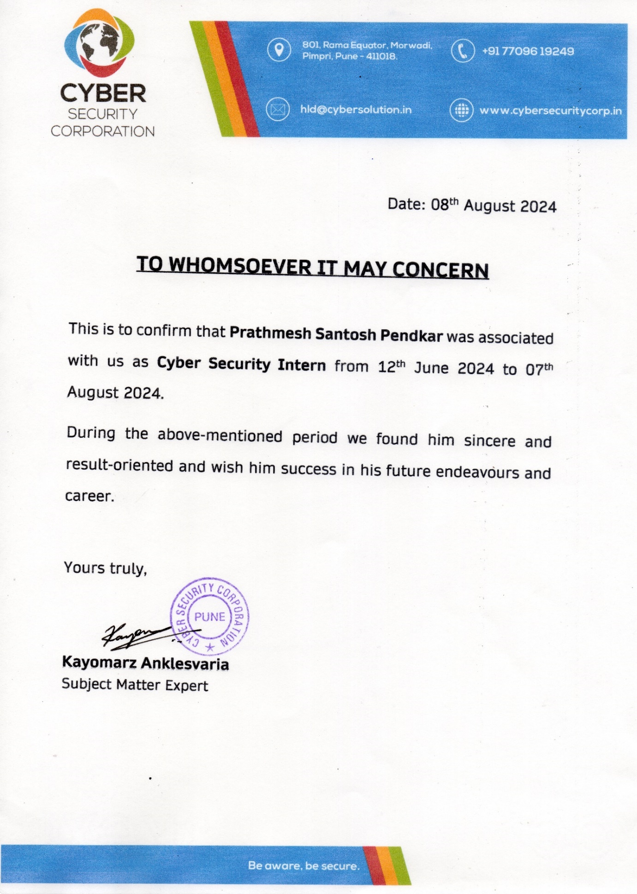

Symbiosis Skills and Professional University Kiwale, Pune
-----------------------------------------------------------------

INTERNSHIP REPORT SUBMISSION CERTIFICATE

This is to certify that Mr. Prathamesh Santosh Pendkar has successfully submitted an internship report (SEM IV, AY:2023-24) entitled “Cyber Forensics Analyst” Under my supervision, in the partial fulfilment of BTech- CSIT(Cybersecurity) Symbiosis Skills and Professional University.

Date:

Place:

Guide:- Director
Prof: Parul Bhanarkar Dr.Maheshwari Raja
Faculty Mentor School Of CSIT (Cybersecurity)
Symbiosis Skills & Professional Symbiosis Skills & Professional
University, University,
Pune Pune

DECLARATION

I affirm that the Industrial Internship Training report titled “Cyber Forensics Analyst” being submitted in partial fulfilment of the requirements for the award of the Degree of BTech- CSIT(Cybersecurity), is the original work carried out by me. Any part of this work is not submitted for the award of any other degree or diploma, either in this or any other Institution.
No part of the report is plagiarized from other sources. All information included from other sources has been duly acknowledged. I aver that if any part of the report is found to be plagiarized, I shall take full responsibility for it.

(Signature)

Prathamesh Santosh Pendkar
PRN: 2201106006

Acknowledgment

I, Prathamesh Santosh Pendkar the student of Symbiosis skills and professional University Studying in BTech- CSIT(Cybersecurity), (Sem IV) express my heartfelt thanks to “Cyber Security Corporation” and “Symbiosis Skills and Professional University” for providing me the opportunity to undertake this 2-month internship. I am also thankful to my mentor “Prof. Parul Bhanerkar” without her support I would not have been equipped with sufficient knowledge to undertake this training. I also thank the placement department to help me avail this opportunity.
I express my deepest sense of gratitude to “Mr. Kayomarz Anklesvaria” for his careful and precious guidance which is extremely valuable for my study both theoretically and practically.

I perceive this opportunity as a milestone in
my career development. I will strive to use
gained skills and knowledge in the best
possible way to attain my desired career
objectives. Hope to continue cooperation
with all of you in the future.

(signature)

Prathamesh Santosh Pendkar

PRN:2201106006

UNDERTAKING BY THE STUDENT FOR INTERNSHIP

I Prathamesh Santosh Pendkar Student, of B. Tech CSIT (Cyber Security) program Batch (2023-24), Enrolment No 2201106006 of 4th Semester hereby declare that I am aware of the Internship Policy of the University.
I hereby declare that:
I have fully read and understood the Internship Policy of the University and I have discussed the same with parents. I fully agree with all the terms of the policy and will abide the same.

Name of Student: Prathamesh Santosh Pendkar
Signature of the Student:

Contact Number: +91-8390088075
Email: prathameshpendkar@gmail.com
Date: Place:

Counter Signed by Head of School Placement school Co-ordinator
Placement Director

Faculty Co-ordinator (Mentor)

Chapter | Index |  | Page No.
1 | Plan of Internship
 | 1.1 | Purpose of Internship | 7
 | 1.2 | Period of Internship | 8
 | 1.3 | Company Background | 9
 | 1.4 | Work/ Problem Statement Detailing | 11
 | 1.5 | Training/Work Objective | 12
2 | Technical contents
 | 2.1 | Introduction of Work/Problem Statement Assigned | 13
 | 2.2 | Process Studies/Assignment Detailing | 14
 | 2.3 | Software / Technical Specifications | 17
3 | Details of the implementation work/results |  | 18 -51
 | 3.1 | Work Plan | 18-51
 | 3.2 | Methodology | 18-51
 | 3.3 | Findings | 18-51
 | 3.4 | Output | 18-51
4 | Conclusion and Future Scope |  | 51-56
 | 4.1 | Learning Outcomes | 51-56
 | 4.2 | Conclusion | 51-56
5. | Weekly Report |  | 56-64
6. | Gratitude |  | 65
7. | Attendance |  | 67
8. | Feedback |  | 68
9. | Marking & Question |  | 69-70

Plan of Internship

  - Purpose of Internship
The goal of an internship is to offer hands-on experience in our chosen field, in this case, cybersecurity. Internships enable us to develop crucial skills, acquire knowledge, and establish connections that will aid our future careers. Specifically, thisva internship at Cyber Security Corporation is designed to provide practical experience in cybercrime analysis and cyber forensics. Through this opportunity, we aim to:
•Gain practical experience and apply theoretical concepts in a professional environment.
•Enhance our skills and knowledge in cybercrime analysis and cyber forensics.
•Connect with industry professionals and build important relationships.
•Understand various aspects of cybersecurity within the sector.
•Explore potential career paths within the cybersecurity field.
Key Objectives of this Internship:
- Acquiring Practical Experience:
- Internships provide valuable hands-on experience in our field of interest. At Cyber Security Corporation, this opportunity allows us to hone our skills in cybercrime analysis, including investigating and addressing cyber threats, conducting digital forensics to reveal evidence of cybercrimes, and grasping the complexities of cybersecurity protocols. We apply theoretical knowledge to real-world situations, such as analyzing data breaches, monitoring malicious activities, and supporting legal investigations, thereby deepening our comprehension of industry practices.
- Establishing Professional Connections:
- Internships provide a valuable chance to network with industry professionals. By building connections at Cyber Security Corporation, we can uncover job opportunities after graduation, seek guidance from experienced experts, and stay updated on the latest developments in the field. Interacting with skilled cybercrime analysts and forensic specialists offers insights into emerging trends and technologies in cybersecurity.
- Exploring Career Options:
- This internship allows us to explore a range of career paths within cybersecurity. By participating in various projects and activities, such as incident response, threat analysis, and forensic investigations, we can pinpoint our interests and strengths. This hands-on experience aids us in making well-informed decisions about our future career direction, whether it be in cybercrime analysis, digital forensics, or other specialized areas within the field.
- Enhancing Our Resume:
  - Having an internship at a reputable company like Cyber Security Corporation adds significant value to our resume. The practical experience and skills we gain make us more competitive in the job market. Potential employers will recognize our hands-on experience and the specific knowledge we have acquired during this internship, such as proficiency in forensic tools, understanding of cyber threat landscapes, and ability to conduct thorough cyber investigations.
In conclusion, if we are willing to put in the effort, this internship at Cyber Security Corporation can be an invaluable experience that will greatly benefit our future careers in cybersecurity.
1.2 Period of Internship-
The internship commenced following the completion of our end-semester exams and spanned a duration of two months. One week before the official start date, we participated in an induction session where we were provided with a comprehensive overview of the work we would be undertaking, as well as the company’s policies and regulations. The internship officially began in the second week of July, specifically on July 12, 2024. Throughout the internship, we were assigned weekly targets to structure our tasks and ensure steady progress. We diligently worked towards these objectives and successfully completed all assigned work by the second week of August, with the final completion date being August 7, 2024.
Date of Commencement | 12th July 2024
Date of Completion | 07th August 2024
Period of Internship | 2 Months
1.3 Company Background
- About Cyber Security Corporation
- Cyber Security Corporation stands as a beacon of excellence in the realm of online security and investigation practices. Our organization is well-equipped with cutting-edge technology, operated by a highly skilled and technically proficient staff. Our primary mission is to ensure the security of all technology users, safeguarding them from the ever-evolving threats in the cyber world.
- Our Mission and Focus
- At Cyber Security Corporation, our focus extends beyond mere security solutions. We provide comprehensive Training and Consultancy Services related to Cyber Crime and Security to a diverse array of sectors. Our clientele includes Law Enforcement Agencies, Judiciary, Corporate Sectors, as well as Education and allied departments in both Government and Private sectors. We cater to all verticals, offering our expertise and support where it is needed most.
- Technical and Legal Expertise
- Our extensive experience in handling a full spectrum of cases grants us unparalleled techno-legal knowledge. We address issues ranging from minor incidents to highly critical cases that delve into the darkest corners of the cyber world. This depth of expertise ensures that we are prepared to tackle any challenge, no matter how complex or severe.
- Commitment to Cyber Security
- Cyber Security Corporation is dedicated to the liberation of the world from the entanglements of cyber menace. We understand the profound impact that cyber threats can have on individuals and organizations alike. Therefore, we are relentless in our pursuit of innovative solutions and effective strategies to combat these threats.
- Empowering Through Education
- Education is a cornerstone of our approach. By empowering our clients with knowledge and skills, we help them to not only defend against current threats but also to anticipate and mitigate future risks. Our training programs are tailored to meet the specific needs of our clients, ensuring that they are well-prepared to handle the complexities of cyber security in their respective fields.
- A Trusted Partner in Cyber Security
- As a trusted partner in cyber security, Cyber Security Corporation remains committed to excellence and innovation. Our goal is to provide unmatched support and guidance, helping our clients to navigate the increasingly complex landscape of cyber threats. We believe in building a safer, more secure world for everyone, and we work tirelessly to make this vision a reality.
- During my internship, I received exceptional training and mentorship from Dr. Harold D’Costa and Mr. Kayomarz. Mr. Kayomarz's expertise in cybersecurity and passion for teaching provided valuable insights into threat detection, incident response, and legal considerations. Dr. D’Costa offered practical knowledge in digital forensics, cyber law, and data protection, enhancing my understanding of cybercrime investigations and ethical standards. Their combined guidance deepened my technical skills, instilled strong ethical principles, and emphasized the importance of continuous learning.
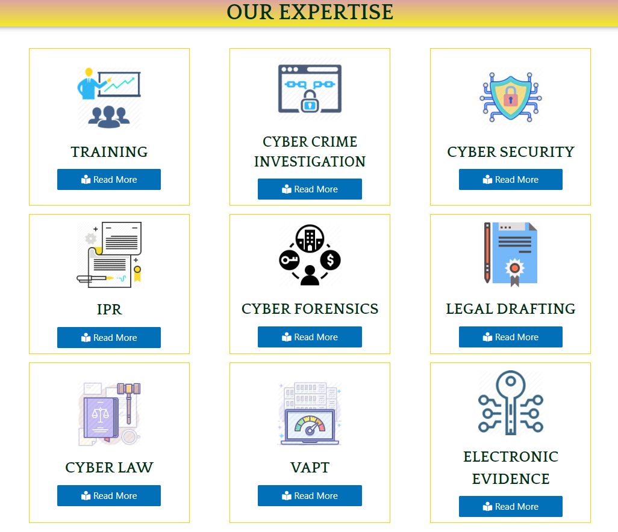
Services Provided By The Company

1.4 Work/Problem Statement Detailing:
- Objective:
- The objective of this internship project is to enhance the cybersecurity infrastructure and investigative capabilities at Cyber Security Corporation. This involves handling and solving cybercrime cases, performing detailed forensics on compromised devices, and facilitating the process of filing FIRs and complaints. The primary goal is to streamline the investigation and resolution of cybercrimes and provide robust support for legal and law enforcement processes.
- Key Tasks and Responsibilities:
- Cyber Crime Analysis:
  - Investigate various types of cybercrimes such as hacking, phishing, and data breaches. Analyze and interpret data to identify patterns, methods, and sources of cyber threats.
  - Compile detailed reports on findings, including the nature of the crime, the impact, and potential preventative measures.
- Digital Forensics:
  - Perform forensic analysis on compromised devices including computers, mobile phones, and other digital storage media. Recover and examine data to uncover evidence of cybercrimes.
  - Use forensic tools and software to extract, preserve, and analyze digital evidence. Document all findings meticulously for use in legal proceedings.
- Incident Documentation and FIR Filing:
  - Assist in documenting cyber incidents and preparing the necessary paperwork for filing FIRs and legal complaints. Ensure that all documentation is accurate, comprehensive, and submitted on time.
  - Provide support to clients and victims in navigating the legal reporting process, offering guidance and clarity on the required steps.
- Case Management:
  - Maintain a detailed case management system to track the progress of ongoing investigations. Ensure that all case-related information is organized, updated, and accessible to relevant team members.
  - Coordinate with law enforcement and other stakeholders to facilitate the investigation and resolution of cybercrime cases.
- Expected Outcomes:
  - Enhanced ability to investigate and resolve cybercrime cases efficiently.
  - Improved forensic analysis capabilities leading to more accurate and actionable insights.
  - Streamlined FIR and complaint filing process, ensuring timely and accurate legal reporting.
  - Better organized and managed case information, facilitating smoother coordination with law enforcement and stakeholders.

1.5 Training/ Work Objective:
During my internship at Cyber Security Corporation, my primary goal was to gain practical experience in cybercrime analysis and digital forensics. I focused on investigating and resolving cybercrimes, performing detailed forensic analyses, and assisting with the legal aspects of cyber incidents. I aimed to understand effective management and documentation of cybercrime cases to support law enforcement efforts.
I acquired a solid foundation in cybercrime analysis, learning core concepts, methodologies, and best practices for identifying and mitigating cyber threats. I gained hands-on experience in investigating cybercrimes, including data collection, analysis, and interpretation to uncover evidence and trace the origin of attacks.
I learned to perform forensic analysis on compromised devices using forensic tools to extract, preserve, and analyze digital evidence. This included conducting thorough forensic investigations, data recovery, malware analysis, and network forensics.
I understood the steps involved in incident response, from detection and containment to eradication, recovery, and post-incident review. This included learning incident response frameworks and best practices for managing cybersecurity incidents. I developed skills in real-time monitoring and analysis of cyber threats for swift identification and mitigation.
I learned the legal procedures for filing FIRs and complaints related to cybercrimes, preparing accurate documentation for legal reporting, and assisting clients and victims throughout the process. Working on several cybercrime cases, I applied my theoretical knowledge to real-world scenarios, collaborating with a team of cybersecurity professionals. This experience helped me navigate the challenges of cybercrime investigations and contribute to resolving complex cases.
Under the mentorship of Mr. Kayomarz Anklesvaria, I received valuable training that significantly shaped my technical skills and professional growth. His commitment to our learning and passion for nurturing talent made the training sessions enriching and memorable. Additionally, I participated in training sessions and workshops on advanced threat detection, incident response strategies, and legal considerations in cybersecurity. These sessions provided a deeper understanding of the complexities of cyber threats and the importance of a proactive approach to cybersecurity. By the end of my internship, I aimed to have comprehensive knowledge of cybercrime analysis, digital forensics, and incident response. This experience has equipped me with the expertise to contribute effectively to developing and implementing cybersecurity strategies, protecting organizations and individuals from cyber threats.

Technical contents
2.1 Introduction Of Work/Problem Statement Assigned:
- During my internship at Cyber Security Corporation, I was assigned a variety of tasks to build my technical skills and practical knowledge in cybersecurity. These included:

  - Completed TryHackMe Labs: Gained hands-on experience through various cybersecurity labs on the TryHackMe platform.
  - Researched Various Topics: Conducted in-depth research on multiple cybersecurity topics to enhance my understanding.
  - Learned Cyber Crime Portal Operations: Acquired knowledge on how to file complaints through cyber crime portals.
  - Created PowerPoint Presentations: Developed several PowerPoint presentations on cybersecurity-related subjects.
  - Investigated Cybercrime Cases: Learned the methodologies and techniques for investigating cybercrime cases.
  - Chain of Custody: Understood the procedures and importance of maintaining a chain of custody for digital evidence.
  - Filed FIR Reports: Learned the legal procedures for filing FIR reports related to cybercrimes.
  - Malware Analysis: Gained skills in analyzing and understanding malware behavior and characteristics.
  - Mobile Forensics: Learned techniques for performing forensic analysis on mobile devices.
  - Research on Hidden Bug Devices: Conducted research on the detection and implications of hidden bug devices.
  - RMS of a Product: Learned about the Risk Management System (RMS) of a product.
  - Product Development: Acquired knowledge about the product development lifecycle in cybersecurity.
  - Designed Brochures: Learned how to design professional brochures for cybersecurity products and services.
  - Data Recovery and Backup: Gained expertise in data recovery and backup strategies.
  - Device Hardening: Learned techniques for hardening devices to enhance cybersecurity.
  - Digital Forensic Accounting: Combines forensic accounting with digital forensics to detect and investigate financial fraud using digital tools and data analysis.
- These tasks provided me with a comprehensive understanding of various aspects of cybersecurity and equipped me with the skills necessary to address and mitigate cyber threats effectively.
2.2 Assignment Details
- Task 1: Completion of TryHackMe Module DFIR: An Introduction
- Summary: Completed the TryHackMe module on Digital Forensics and Incident Response (DFIR), which provided foundational knowledge on forensic investigations, evidence handling, and incident response protocols.
- Task 2: Completion of TryHackMe REDLINE
- Summary: Finished the TryHackMe REDLINE module, focusing on advanced digital forensic techniques and tools for analyzing and responding to cybersecurity incidents.
- Task 3: Vulnerability in Ubuntu 20.04 LTS
- Summary: Analyzed a vulnerability in Ubuntu 20.04 LTS (CVE-2024-5564), including details on the CVE number, available patches, and mitigation strategies. Followed the MITRE framework to understand the impact and response.
- Task 4: Analysis of Python-Based Ransomware
- Summary: Investigated a Python-based ransomware, learning about Fernet encryption, which is used for secure data encryption. Explored sandboxing—a security mechanism to isolate and analyze suspicious activities—and identified software technologies that support sandboxing.
- Task 5: Introduction to Sessions in Backend
- Summary: Gained knowledge on how backend sessions work in web development, including session management, security practices, and handling user sessions.
- Task 6: Betting App Scam Analysis
- Summary: Conducted a forensic accounting investigation into betting app scams involving Parimatch, 96.in, and Cricadda. Analyzed the scams that resulted in a financial loss of ₹27 crore, focusing on complaint filing, FIR documentation, and evidence collection.
- Task 7: PPT on Cyber Security & AI
- Summary: Created a PowerPoint presentation on "Cyber Security & AI: Fortifying Healthcare." The presentation highlighted strategies for enhancing hospital cybersecurity using AI technologies.
- Task 8: UPI Scam
- Summary: Investigated a UPI (Unified Payments Interface) scam, focusing on the techniques used by scammers and methods for preventing and reporting such incidents & Drafted a FIR Report For Client.
- Task 9: FedEx Scam Analysis
- Summary: Analyzed a FedEx scam resulting in a financial loss of ₹1.4 crore. Performed forensic accounting, filed a complaint, drafted an FIR, and prepared a letter to the Deputy Commissioner of Police (DCP).
- Task 10: Hash Checking and Report Preparation
- Summary: Learned how to check hash values for data integrity, prepared extraction reports, handled evidence handovers, and drafted annexures for documentation.
- Task 11: Research on CrowdStrike Event
- Summary: Researched a CrowdStrike cybersecurity event and drafted a detailed report about the incident, including analysis and response strategies.
- Task 12: Product Research and Development
- Summary: Worked on researching and creating a cybersecurity product, including service design, pricing, and revenue management plans to protect High Net-Worth Individuals (HNWIs) from cyber threats and surveillance.
- Task 13: Malware Analysis
- Summary: Acquired skills in malware analysis, focusing on techniques to dissect and understand malicious software to enhance detection and response capabilities.
- Task 14: Learning Tableau
Summary: Learned to use Tableau for data visualization, enabling the creation of interactive and insightful reports to support cybersecurity analysis and decision-making.
- Task 15: Digital Forensic Accounting for Client Liquidity Issue
Summary: Conducted digital forensic accounting for a client facing liquidity problems, analyzing financial records to identify discrepancies and support financial recovery efforts.
- Task 16: Filing Another FedEx Complaint
- Summary: Prepared and filed a complaint for a FedEx scam, focusing on detailed documentation and coordination with legal authorities.
- Task 17: Contribution to Stock Market Fraud
- Summary: Contributed to a stock market fraud case by drafting and filing a complaint, supporting the legal process with necessary documentation.
- Task 18: Learning About Cryptocurrency
- Summary: Gained knowledge about cryptocurrency, including its uses, security considerations, and impact on cybersecurity.
- Task 19: Information Collection on Instagram Hack
- Summary: Collected and analyzed information on an Instagram hack, focusing on the methods used by attackers and strategies for mitigating such threats.
- Task 20: Online Session on Bank Cybersecurity by RBI
- Summary: Attended an online session hosted by the Reserve Bank of India (RBI) on enhancing bank security against cyber threats, gaining insights into best practices and regulatory measures.
- Task 21: Device Hardening
- Summary: In the device hardening task, techniques were applied to enhance cybersecurity by implementing robust security configurations, managing patches, and minimizing vulnerabilities. This involved a systematic approach to improving device resilience against cyber threats. As a result, the skills acquired enable effective security measures to reduce attack surfaces and bolster overall device security, leading to a stronger and more resilient cybersecurity posture.

- Task 22: Cyber Hygiene and Anti-Surveillance Solution for HNI Clients
- Summary: Designing a product for a company that provides cyber hygiene, protection from cyber threats, and an add-on for Technical Surveillance Countermeasures (TSCM) involves creating a comprehensive security solution. This product should integrate advanced cybersecurity measures to ensure robust defense against digital threats while promoting good cyber hygiene practices among users. Additionally, the inclusion of TSCM capabilities will enhance the product's ability to detect and mitigate physical surveillance threats, ensuring a holistic security approach.

2.3 Software & Technical details
- RedLine Tool
- Description: RedLine is a digital forensics tool used for analyzing and investigating Windows-based systems. It helps in identifying malicious activity, malware, and suspicious behavior through memory and file analysis.
- Importance: It provides detailed insights into system processes, network activity, and file structures, making it crucial for incident response and forensic investigations.
- Skills Acquired: Proficiency in using RedLine for in-depth system analysis, malware detection, and forensic evidence collection.
- HashMyFiles
- Description: HashMyFiles is a utility for generating and verifying file hashes (MD5, SHA1, SHA256) to ensure data integrity.
- Importance: It helps verify that files have not been altered or corrupted, which is vital for maintaining the integrity of forensic evidence.
- Skills Acquired: Ability to compute and compare file hashes to detect alterations and ensure the authenticity of digital evidence.
- iMazing
- Description: iMazing is a tool for managing and extracting data from iOS devices, such as iPhones and iPads, including messages, call logs, and app data.
- Importance: Essential for performing mobile forensics on iOS devices, providing access to and analysis of critical data for investigations.
- Skills Acquired: Expertise in extracting and analyzing data from iOS devices to support digital forensic investigations.
- 4. HardiskLowLevel
- Description: HardiskLowLevel is a software tool designed for low-level access and analysis of hard disk drives, including data recovery and forensic examination.
- Importance: It allows for detailed examination of disk structures and recovery of data at a low level, essential for in-depth forensic analysis.
- Skills Acquired: Competence in performing low-level disk analysis, data recovery, and forensic examination of storage devices.
- 5. R-Studio
- Description: R-Studio is a comprehensive data recovery tool that supports the recovery of lost or deleted files from various file systems and storage devices.
- Importance: It is crucial for recovering data from corrupted or damaged drives, making it an important tool for digital forensics and data recovery.
- Skills Acquired: Proficiency in using R-Studio for file recovery, data reconstruction, and forensic analysis of storage media.
- 6. Tableau
- Description: Tableau is a data visualization tool that helps create interactive and shareable dashboards and reports from various data sources.
- Importance: It allows for effective visualization and analysis of complex data sets, aiding in the interpretation and presentation of forensic data.
- Skills Acquired: Ability to design and generate insightful visualizations and dashboards to enhance the understanding and communication of forensic findings.
These tools are essential for digital forensics, each serving a specific function in analyzing, recovering, and visualizing digital evidence. Mastery of these tools enhances capabilities in conducting thorough and reliable forensic investigations.

Detail Implementation Work /Results

Work Plan Methodology for Cyber Crime Portal Analysis
Objective: To analyze the functionalities and importance of the cybercrime portal cybercrime.gov.in in the reporting and management of cybercrime incidents, with a focus on procedures, features, and outcomes.
1. Research and Learning Phase:
- Objective: Understand the procedures and protocols for filing complaints on cybercrime portals.
- Activities:
  - Study the portal’s guidelines for filing complaints.
  - Identify different types of cyber incidents that can be reported.
  - Review the documentation and support provided for users.
2. Analysis of Key Features:
- Incident Reporting:
  - User-Friendly Interface: Evaluate the portal's design and ease of use for reporting incidents.
  - Complaint Registration: Analyze the process for registering complaints, including required information.
  - Anonymity Options: Assess the options available for anonymous reporting.
- Types of Cyber Crimes Covered:
  - Hacking: Document the portal’s coverage of unauthorized system access.
  - Phishing: Examine the procedures for reporting phishing attempts.
  - Identity Theft: Review how the portal handles cases of personal information misuse.
  - Data Breach: Identify how data breaches are reported and managed.
  - Cyberstalking and Child Exploitation: Evaluate coverage and reporting mechanisms for these specific crimes.
- Evidence Submission:
  - Digital Evidence Upload: Assess the functionality for submitting digital evidence such as screenshots and logs.
  - Guidelines for Evidence: Review the guidelines provided for evidence collection and submission.
- Tracking and Status Updates:
  - Case Tracking: Analyze the system for tracking the status of complaints.
  - Notifications: Evaluate how updates are communicated to users.
- Resources and Support:
  - Educational Resources: Review the educational materials available for users.
  - Victim Support: Assess the support services offered, including counseling and legal advice.
- Collaboration with Law Enforcement:
  - Law Enforcement Access: Examine how law enforcement agencies interact with the portal.
  - Interagency Collaboration: Review the portal’s role in facilitating cooperation between agencies.
3. Importance and Impact Assessment:
- Accessibility: Evaluate how the portal facilitates easy reporting of incidents.
- Centralization: Assess the effectiveness of centralizing the reporting process.
- Awareness and Education: Review how the portal contributes to public awareness and education on cyber threats.
- Legal Compliance: Analyze how the portal ensures compliance with legal requirements and supports legal action.
4. Findings and Outcomes:
- Key Findings: Summarize the main findings from the analysis of the portal’s features and impact.
- Impact on Users: Evaluate how the portal benefits individuals and organizations in managing and reporting cybercrimes.
- Effectiveness of Law Enforcement Collaboration: Assess the portal's role in supporting law enforcement and interagency cooperation.
5. Conclusion:
- Role in Cybercrime Prevention: Conclude on the portal’s effectiveness as a tool in the fight against cybercrime.
- Recommendations: Provide recommendations for improvements based on the analysis, if any.
Outcome: The methodology will provide a comprehensive understanding of how the cybercrime portal operates, its key features, and its importance in the digital landscape. This analysis will help in identifying strengths and areas for improvement in the portal, ensuring it remains an effective tool for managing cybercrime incidents.

Chain of Custody:
- Learned the protocols for maintaining the chain of custody in forensic investigations, ensuring the integrity and admissibility of digital evidence in legal proceedings.
- If you are in the field of Cyber Security, you will be at one point in your career will be involved in Digital Forensics. One of the concepts that is most essential in Digital Forensics is the Chain of Custody.
- Chain of Custody refers to the logical sequence that records the sequence of custody, control, transfer, analysis and disposition of physical or electronic evidence in legal cases.
- The chain of custody in digital cyber forensics is also known as the paper trail or forensic link, or chronological documentation of the evidences.
- Digital evidence is acquired from the myriad of devices like a vast number of IoT devices, audio evidence, video recordings, images, and other data stored on hard drives, flash drives, and other physical media.
Chain of Custody Process:
- In order to preserve digital evidence, the chain of custody should span from the first step of data collection to examination, analysis, reporting, and the time of presentation to the Courts. 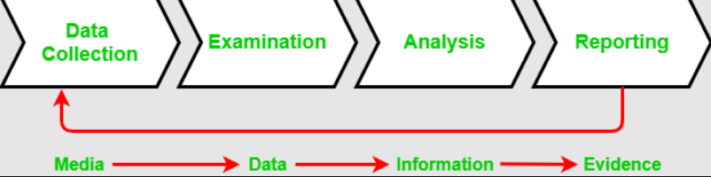
- Data Collection: It is the process where the chain of custody is initiated. It involves identification, labeling, recording, and the acquisition of data from all the possible relevant sources that preserve the integrity of the data and evidence collected(handover).
- Examination: During this process, the chain of custody information is documented outlining the forensic process undertaken. It is important to

capture screenshots throughout the process to show the tasks that are completed and the evidence uncovered.
- Analysis: In analysis phase legally, justifiable methods are used to derives useful information from the evidences collected.
- Reporting: Final report is made on the analysis which we have done for the required cases.
Handover:
Example
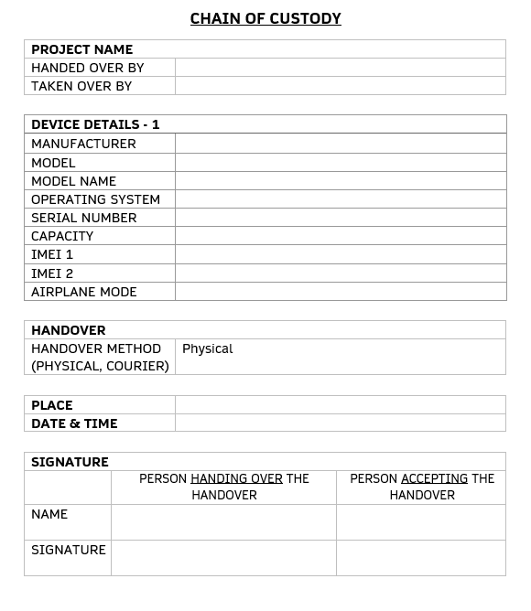

FIR Report Filing:
During the internship, I learned the process of filing First Information Reports (FIRs) for cybercrimes, focusing on drafting comprehensive and accurate reports. This included:
- Gathering Information: Collecting all relevant details about the incident, including the nature of the cybercrime, affected parties, and evidence collected.
- Drafting the FIR: Writing the report clearly and precisely, ensuring it meets legal standards and includes all necessary information, such as the time and date of the incident, the type of offense, and the description of the events.
- Compliance with Legal Standards: Ensuring the report adheres to legal protocols, including proper documentation and the use of appropriate legal terminology.
- Submission and Follow-up: Submitting the FIR to the relevant law enforcement agency and following up on the case as required, maintaining communication with the authorities to assist in the investigation and legal proceedings.
This process emphasized the importance of accuracy and thoroughness in legal documentation for cybercrime cases.

Task 1: Completion of TryHackMe Module DFIR: An Introduction
- Work Plan: Engaged in the TryHackMe DFIR module to build foundational knowledge in digital forensics and incident response.
- Methodology:
  - Interactive Exercises: Completed hands-on exercises designed to simulate real-world forensic scenarios, which involved analyzing evidence, performing investigations, and responding to simulated incidents.
  - Theoretical Lessons: Studied various aspects of digital forensics, including evidence handling protocols, chain of custody, and incident response frameworks. Key technical terms covered included forensic imaging, data recovery, and log analysis.
  - Technical Terms:
    - Forensic Imaging: Creating an exact bit-by-bit copy of a digital storage device for analysis.
    - Chain of Custody: Maintaining and documenting the handling of evidence to ensure its integrity.
    - Incident Response Frameworks: Structured methodologies for detecting, responding to, and recovering from cybersecurity incidents.
- Findings:
  - Developed a comprehensive understanding of the digital forensics’ lifecycle, including the processes of data collection, preservation, analysis, and presentation.
  - Gained insights into incident response strategies such as initial detection, containment, eradication, recovery, and post-incident analysis.
  - Acquired knowledge about best practices for managing digital evidence and ensuring the legal admissibility of forensic findings.
- Output:
  - Acquired essential skills for conducting effective forensic investigations, including the ability to manage evidence, use forensic tools, and apply incident response protocols.
  - Developed a strong foundation in both theoretical and practical aspects of digital forensics and incident response, equipping you with the expertise to handle complex forensic and cybersecurity challenges.

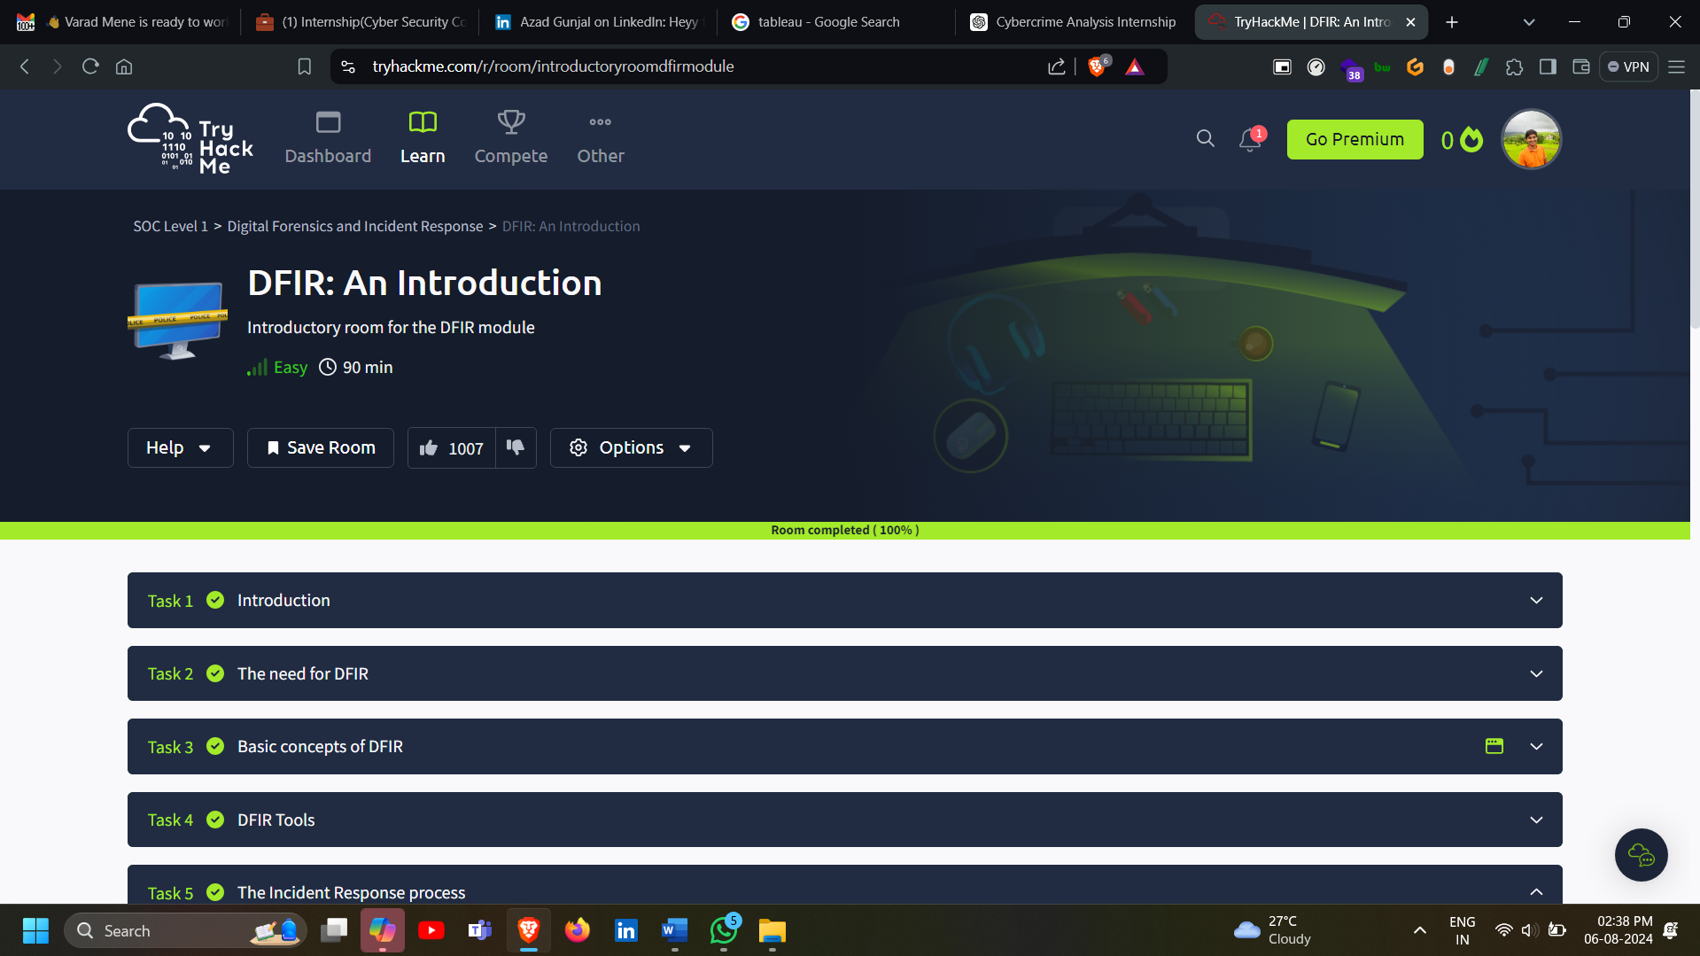

Task 2: Completion of TryHackMe REDLINE
- Work Plan: Completed the REDLINE module on TryHackMe to advance skills in digital forensics, focusing on advanced techniques for incident analysis.
- Methodology:
  - Case Studies: Analysed various case studies that simulated real-world cybersecurity incidents, which involved investigating compromised systems and extracting relevant evidence.
  - Forensic Tools: Utilized REDLINE, a digital forensic tool, to perform in-depth analysis of system memory, file structures, and network activity. Key technical terms covered included memory forensics, process analysis, and network traffic analysis.
- Technical Terms:
  - Memory Forensics: The process of analyzing volatile memory (RAM) to uncover evidence of malicious activity or system anomalies.
  - Process Analysis: Examining running processes and their interactions to identify suspicious behavior or malware.
  - Network Traffic Analysis: Monitoring and analyzing network traffic to detect unauthorized or malicious communication.
- Findings:
  - Gained advanced knowledge of forensic techniques such as memory analysis, file system examination, and network activity monitoring.
  - Developed insights into identifying and interpreting complex indicators of compromise (IOCs) and malicious artifacts.
  - Enhanced understanding of how to use REDLINE to conduct thorough investigations and piece together evidence from various system components.
- Output:
  - Developed proficiency in utilizing REDLINE for comprehensive system analysis and effective incident response.
  - Acquired advanced skills in forensic analysis, including the ability to analyze memory dumps, track processes, and scrutinize network traffic, leading to more thorough investigations and informed responses to cybersecurity incidents.
  - 
Task 3: Vulnerability in Ubuntu 20.04 LTS
- Work Plan: Analyzed the CVE-2024-5564 vulnerability in Ubuntu 20.04 LTS.
- Methodology: Reviewed CVE details, examined available patches, and followed the MITRE framework for impact assessment and response.
- Findings: Identified the nature of the vulnerability and the necessary mitigation strategies.
- Output: Documented the vulnerability’s impact and recommended patches and responses for effecti ve mitigation.

Task 4: Analysis of Python-Based Ransomware
- Work Plan: Investigated a Python-based ransomware, with a focus on understanding encryption mechanisms and sandboxing techniques.
- Methodology:
  - Fernet Encryption: Examined the use of Fernet encryption, a symmetric encryption method used by the ransomware to secure its payload and communication. Studied how Fernet ensures data confidentiality and integrity.
  - Ransomware Behavior Analysis: Analyzed the behavior of the ransomware, including its encryption process, file encryption methods, and attack vectors. Investigated how the ransomware executes and spreads within a system.
  - Sandboxing Technologies: Explored sandboxing as a technique for isolating and analyzing suspicious software in a controlled environment. Reviewed various sandboxing tools and technologies used to observe ransomware behavior without risking the host system.
- Findings:
  - Gained a comprehensive understanding of Fernet encryption and its role in securing ransomware communications and payloads.
  - Acquired insights into the behavior of Python-based ransomware, including how it encrypts files and interacts with the system.
  - Developed knowledge about sandboxing technologies and their effectiveness in safely analyzing and understanding malicious software.
- Output:
  - Provided a detailed analysis of ransomware encryption techniques and sandboxing practices, contributing to enhanced security measures and more effective strategies for combating ransomware threats.
  - Developed expertise in the use of secure encryption methods and isolation techniques to improve the analysis and response to malicious software.
Task 5: Introduction to Sessions in Backend
- Work Plan: Studied backend session management in web development to understand how sessions are maintained and secured.
- Methodology:
- Session Handling Practices: Reviewed techniques for managing user sessions, including session creation, tracking, and expiration.
- Security Measures: Examined security protocols related to session management, such as session encryption, secure cookies, and session invalidation strategies.
- User Session Management: Investigated methods for handling user interactions, including authentication, authorization, and session storage mechanisms.
Findings:
- Gained insights into secure practices for maintaining backend sessions and protecting user data.
- Acquired knowledge on managing user interactions effectively, ensuring session integrity and security.
Output:
- Developed a comprehensive understanding of backend session protocols and security best practices, enabling the implementation of robust and secure session management systems in web applications.
Task 6: Betting App Scam Analysis
Work Plan
The primary focus of this task was to conduct a thorough forensic accounting analysis on scams perpetrated through betting apps, specifically targeting Parimatch, 96.in, and Cricadda. The plan involved several key steps:
- Data Collection: Gather financial records from victims and app operators.
- Analysis: Forensically examine the records to trace fraudulent transactions.
- Documentation: Prepare detailed complaint filings and FIRs (First Information Reports).
- Evidence Compilation: Collect and organize evidence to support legal proceedings.
Methodology
Data Collection
- Victim Interviews: Conducted interviews with victims to understand their interactions with the betting apps and gather relevant transaction details.
- Financial Records: Collected bank statements, transaction receipts, and communication records from victims.
- App Data: Extracted data from the betting apps, including user account activities, transaction logs, and communications.
Forensic Analysis
- Transaction Tracing: Used forensic accounting techniques to trace the flow of money from victims' accounts to the scammers.
- Pattern Identification: Analyzed transaction patterns to identify commonalities in fraudulent activities, such as repeated payment recipients and unusual transaction timings.
- Cross-Referencing: Cross-referenced financial records with app data to identify discrepancies and confirm fraudulent activities.
Documentation
- Complaint Filings: Drafted comprehensive complaint filings detailing the scam operations, individual victim losses, and identified perpetrators.
- FIR Preparation: Prepared First Information Reports to formally report the fraud to law enforcement authorities, including detailed descriptions of the fraudulent schemes and evidence supporting the claims.
- Evidence Compilation: Organized all collected evidence, including financial records, app data, and interview transcripts, into a cohesive dossier to support legal actions.
Findings
The forensic analysis revealed a systematic scheme executed by the scammers, resulting in a total loss of ₹27 crore. Key findings included:
- Fake Accounts: The creation of numerous fake accounts to siphon funds from victims.
- Phishing Schemes: Use of phishing schemes to obtain victims' personal and financial information.
- Money Laundering: Evidence of money laundering activities to obscure the origins of the funds.
- Collaborative Network: A network of individuals working together to execute and conceal the scam operations.
Output
The output of this task included a series of detailed reports and documentation designed to support legal proceedings against the scammers. Key outputs were:
- Forensic Reports: Comprehensive reports outlining the forensic analysis, findings, and identified fraudulent activities.
- Legal Filings: Prepared and filed legal complaints and FIRs with law enforcement agencies.
- Evidence Dossier: A meticulously organized dossier containing all relevant evidence to aid in the prosecution of the scammers.

Task 7: PPT on Cyber Security & AI
Work Plan
The primary objective of this task was to develop a PowerPoint presentation focused on enhancing hospital cybersecurity through the implementation of AI technologies. The work plan encompassed the following steps:
- Research: Conduct in-depth research on existing cybersecurity strategies and the application of AI in healthcare.
- Content Development: Create content that explains the current challenges in hospital cybersecurity and how AI can address these challenges.
- Presentation Design: Develop a visually appealing and informative PowerPoint presentation.
- Delivery: Present the findings to stakeholders, providing actionable insights and recommendations.
Methodology
Research
- Literature Review: Conducted a comprehensive review of current literature, including academic papers, industry reports, and case studies, to understand the landscape of hospital cybersecurity.
- AI Technologies: Investigated various AI technologies such as machine learning, deep learning, and natural language processing that can be applied to enhance cybersecurity in healthcare settings.
- Case Studies: Analyzed real-world examples of hospitals that have successfully implemented AI-driven cybersecurity measures to identify best practices.
Content Development
- Current Challenges: Identified and articulated the current challenges hospitals face in terms of cybersecurity, such as data breaches, ransomware attacks, and insider threats.
- AI Solutions: Detailed AI-driven methods to address these challenges, including:
  - Anomaly Detection: Using AI to detect unusual patterns that may indicate a security breach.
  - Predictive Analytics: Employing AI to predict potential security threats based on historical data.
  - Automated Response: Leveraging AI for real-time threat detection and automated response to mitigate attacks.
  - Natural Language Processing: Utilizing NLP to monitor and analyze communication for signs of phishing or social engineering attacks.
Presentation Design
- Slide Structure: Organized the presentation into a clear structure, including an introduction, background on hospital cybersecurity, detailed explanation of AI technologies, case studies, and actionable recommendations.
- Visual Elements: Included charts, graphs, and infographics to visually represent data and make the content more engaging.
- Technical Details: Ensured that technical details were explained in a manner accessible to a non-technical audience while still providing depth for those with a technical background.
Findings
The research and analysis led to several key findings on how AI can enhance hospital cybersecurity:
- Enhanced Detection: AI-driven systems significantly improve the ability to detect and respond to cyber threats in real time.
- Reduced Response Time: Automated response mechanisms enabled by AI reduce the time it takes to mitigate attacks, thereby minimizing damage.
- Predictive Capabilities: AI's predictive analytics can identify potential vulnerabilities before they are exploited, allowing for proactive defense measures.
- Cost Efficiency: Implementing AI technologies can lead to long-term cost savings by reducing the frequency and impact of cyber-attacks.
Output
The final output was a PowerPoint presentation that provided actionable insights into integrating AI technologies to improve healthcare cybersecurity. Key elements of the presentation included:
- Introduction: Overview of the importance of cybersecurity in hospitals and the growing threat landscape.
- Current Challenges: Detailed discussion of the specific cybersecurity challenges faced by healthcare institutions.
- AI Technologies: Explanation of various AI technologies and how they can be applied to enhance cybersecurity.
- Case Studies: Real-world examples of successful AI-driven cybersecurity implementations in hospitals.
- Recommendations: Practical steps and strategies for integrating AI into hospital cybersecurity measures, including:
  - Investing in AI Technologies: Encouraging hospitals to allocate resources for AI-based cybersecurity tools.
  - Training and Awareness: Emphasizing the need for staff training and awareness programs to complement AI technologies.
  - Continuous Monitoring: Advocating for the implementation of continuous monitoring systems powered by AI for ongoing threat assessment.
The presentation aimed to equip hospital administrators, IT professionals, and cybersecurity experts with the knowledge and tools necessary to leverage AI for strengthening hospital cybersecurity effectively.
4o
Task 8: UPI Scam
- Work Plan: Investigated a UPI scam and drafted an FIR report.
- Methodology: Analyzed scam techniques, compiled evidence, and prepared documentation.
- Findings: Identified the nature of the scam and methods for reporting and preventing similar incidents.
- Output: Created a detailed FIR report and recommended preventive measures for UPI fraud.
Task 9: FedEx Scam Analysis
Work Plan
The primary goal of this task was to analyze a FedEx scam resulting in a financial loss of ₹1.4 crore. The work plan included the following key steps:
- Data Collection: Gather financial records and communication evidence from the victim.
- Forensic Accounting: Conduct a detailed forensic accounting analysis to trace the fraudulent transactions.
- Legal Documentation: File a formal complaint and draft an FIR.
- Correspondence: Prepare and send correspondence to the Deputy Commissioner of Police (DCP) to expedite the legal process.
Methodology
Data Collection
- Victim Interviews: Conducted interviews with the victim to collect detailed information about the scam, including timelines, communication records, and transaction details.
- Financial Records: Collected bank statements, transaction receipts, and any other relevant financial documentation from the victim.
- Communication Evidence: Gathered emails, text messages, and any other forms of communication that took place between the victim and the scammers.
Forensic Accounting
- Transaction Analysis: Traced the flow of money from the victim’s account to the scammer’s accounts. Identified all suspicious transactions and patterns that indicated fraudulent activities.
- Verification: Cross-verified transaction records with communication logs to confirm the fraudulent nature of the transactions.
- Discrepancy Documentation: Documented all financial discrepancies, including amounts, dates, and recipients, to build a clear case of fraud.
Legal Documentation
- Complaint Filing: Drafted a detailed complaint outlining the scam, including the method of operation, the financial impact, and the identified perpetrators.
- FIR Drafting: Prepared a comprehensive First Information Report (FIR) for submission to the police, detailing the scam and providing all collected evidence.
- Supporting Documents: Compiled all supporting documents, including financial records and communication evidence, to accompany the complaint and FIR.
Correspondence
- Letter to DCP: Drafted a formal letter to the Deputy Commissioner of Police, providing an overview of the scam, the financial impact, and requesting swift action to investigate and prosecute the scammers.
- Follow-Up Communication: Ensured regular follow-up with the DCP’s office to track the progress of the investigation and provide any additional information required.
Findings
The analysis uncovered significant evidence of fraudulent activities orchestrated by the scammers. Key findings included:
- Fake Invoices: Scammers used fake FedEx invoices to trick the victim into making payments.
- Phishing Tactics: Employed phishing tactics to obtain the victim’s financial information.
- Money Transfers: Identified multiple transactions leading to various accounts linked to the scammers, with clear evidence of misappropriation of ₹1.4 crore.
- Coordinated Scheme: The scam involved a coordinated scheme with multiple actors posing as FedEx representatives.
Output
The final outputs were designed to support legal actions against the scammers and included the following:
- Comprehensive Complaint: Filed a detailed complaint with law enforcement, outlining the scam’s modus operandi, the financial loss, and the identified perpetrators. The complaint included all supporting evidence to substantiate the claims.
- First Information Report (FIR): Submitted a meticulously drafted FIR to the police, providing a legal basis for initiating an investigation. The FIR contained detailed descriptions of the fraudulent activities and the evidence gathered.
- Correspondence with DCP: Sent a formal letter to the Deputy Commissioner of Police, summarizing the case and urging prompt action. The letter included an overview of the findings and a request for an expedited investigation.
- Ongoing Communication: Maintained regular communication with legal authorities to ensure the case was being actively pursued and to provide any additional information or assistance required.
The outputs were instrumental in ensuring that the case was well-documented and presented to legal authorities, increasing the likelihood of successful investigation and prosecution of the scammers, and potentially recovering the lost funds.
4o
Task 10: Hash Checking and Report Preparation
Work Plan
The objective of this task was to learn how to check hash values and prepare comprehensive forensic reports. This involved several key activities:
- Learning Hashing Techniques: Understanding the principles and techniques of computing file hash values.
- Hash Computation: Practicing the computation of hash values for various files.
- Extraction Reports: Creating detailed extraction reports based on the computed hash values.
- Evidence Management: Learning to document and manage evidence properly to ensure integrity.
Methodology
Learning Hashing Techniques
- Educational Resources: Utilized textbooks, online courses, and tutorials to understand the basics of cryptographic hashing algorithms such as MD5, SHA-1, and SHA-256.
- Tool Familiarization: Gained hands-on experience with various tools and software commonly used for computing hash values, such as HashCalc, FTK Imager, and Autopsy.
Hash Computation
- File Selection: Selected a variety of files, including documents, images, and executable files, to practice hash computation.
- Hash Calculation: Used the chosen tools to compute hash values for the selected files. This involved:
  - Single File Hashing: Calculating hash values for individual files.
  - Batch Processing: Computing hash values for multiple files in batches to streamline the process.
- Verification: Verified the accuracy of the computed hash values by recalculating and comparing them to ensure consistency.
Extraction Reports
- Report Templates: Created standardized templates for extraction reports to ensure consistency and completeness.
- Data Entry: Documented the computed hash values, including file names, types, sizes, and hash values, in the extraction reports.
- Summary: Included a summary section in the reports to highlight key findings and observations.
Evidence Management
- Chain of Custody: Learned and implemented best practices for maintaining the chain of custody, including proper logging of evidence handling.
- Documentation: Created detailed logs to document every step of evidence handling, from collection and analysis to storage and transfer.
- Integrity Checks: Regularly performed integrity checks using hash values to ensure that evidence remained unaltered throughout the investigation process.
Findings
The process led to several important findings:
- Data Integrity: Hash values provided a reliable means of ensuring data integrity, confirming that files had not been altered.
- Accuracy in Reporting: Detailed and accurate extraction reports were crucial for maintaining the integrity of the forensic analysis and supporting legal proceedings.
- Evidence Handling: Proper documentation and management of evidence were essential to uphold the credibility of the forensic process.
Output
The outputs of this task included detailed reports and proper documentation for evidence handling:
- Detailed Forensic Reports: Produced comprehensive forensic reports that included:
  - File Information: Detailed descriptions of the files analyzed, including names, types, and sizes.
  - Hash Values: The computed hash values for each file, along with any observations or anomalies noted during the process.
  - Verification: Documentation of the verification process to ensure the accuracy and consistency of the hash values.
  - Summary: A summary section highlighting the key findings and their implications for the investigation.
- Evidence Documentation: Maintained meticulous documentation for all evidence handling activities, including:
  - Chain of Custody Logs: Detailed logs of all evidence transfers, ensuring that the chain of custody was preserved.
  - Integrity Checks: Records of periodic integrity checks using hash values to confirm that the evidence remained unchanged.
  - Handling Procedures: Documentation of the procedures followed for collecting, analyzing, storing, and transferring evidence to ensure compliance with legal and forensic standards.
These outputs were critical in ensuring the reliability and credibility of the forensic analysis, thereby supporting legal actions and maintaining the integrity of the investigative process.
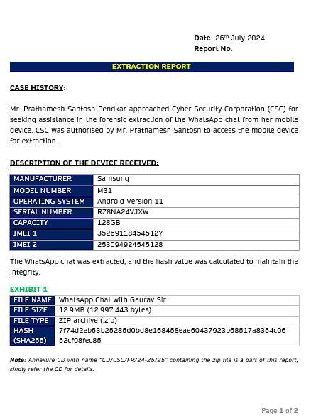
Task 11: Research on CrowdStrike Event

Work Plan
The primary goal of this task was to research a specific cybersecurity incident involving CrowdStrike. The work plan included the following key steps:
- Information Collection: Gather detailed information about the incident, including its nature, timeline, and impact.
- Response Analysis: Analyze the responses from CrowdStrike and other involved parties.
- Report Drafting: Compile findings into a comprehensive incident report.
- Recommendations: Provide actionable recommendations for improving cybersecurity measures based on the insights gained from the incident.

Methodology

Information Collection
- Incident Details: Gathered all available details about the cybersecurity incident, including how it occurred, what vulnerabilities were exploited, and the extent of the damage.
- Sources: Utilized a variety of sources such as news articles, official statements from CrowdStrike, cybersecurity blogs, and industry reports.
- Interviews: Conducted interviews with cybersecurity experts and, if possible, individuals directly involved in managing the incident.

Response Analysis
- CrowdStrike’s Response: Analyzed CrowdStrike's immediate and long-term response to the incident, including any public statements, mitigation steps, and changes to their cybersecurity protocols.
- Industry Reactions: Examined the reactions and responses from other cybersecurity firms, industry analysts, and clients affected by the incident.
- Effectiveness: Assessed the effectiveness of the response measures in containing the incident and preventing future occurrences.

Report Drafting
- Structure: Created a structured report outline including sections such as Introduction, Incident Overview, Response Analysis, Impact Assessment, and Recommendations.
- Detailed Documentation: Documented all findings with supporting evidence, including timelines, technical details, and response measures.
- Impact Analysis: Included an analysis of the impact of the incident on CrowdStrike’s operations, reputation, and clients.

Recommendations
- Improved Measures: Provided recommendations for enhanced cybersecurity measures based on the weaknesses identified during the incident.
- Best Practices: Suggested best practices for incident response and recovery, tailored to the specific nature of the incident and CrowdStrike’s operational environment.
- Future Strategies: Proposed strategies for proactive threat detection and prevention to mitigate the risk of similar incidents in the future.

Findings
The research led to several key insights regarding the incident involving CrowdStrike:
- Nature of the Incident: Identified the incident as a sophisticated cyberattack targeting CrowdStrike’s systems, potentially involving advanced persistent threats (APTs) or nation-state actors.
- Vulnerabilities Exploited: Detailed the specific vulnerabilities that were exploited during the attack, such as software flaws, misconfigurations, or social engineering tactics.
- Impact on Operations: Assessed the direct impact on CrowdStrike’s operations, including any service disruptions, data breaches, and financial losses.
- Response Effectiveness: Evaluated the effectiveness of CrowdStrike’s response measures, highlighting both successful strategies and areas for improvement.
- Industry Implications: Analyzed the broader implications of the incident for the cybersecurity industry and the trust of clients in cybersecurity providers.

Output
The final output was a detailed incident report with actionable recommendations for improving cybersecurity measures. Key elements of the report included:

Incident Report
- Introduction:
  - Overview of CrowdStrike and its role in the cybersecurity industry.
  - Summary of the incident and its significance.
- Incident Overview:
  - Detailed timeline of the incident from detection to resolution.
  - Description of how the attack was carried out and the vulnerabilities exploited.
- Response Analysis:
  - Detailed analysis of CrowdStrike’s response actions, including immediate containment, investigation, and remediation steps.
  - Assessment of communication strategies used to inform stakeholders and clients.
- Impact Assessment:
  - Evaluation of the impact on CrowdStrike’s services, reputation, and financial standing.
  - Analysis of client reactions and the broader industry response.
- Technical Analysis:
  - In-depth technical analysis of the attack vectors, tools used by the attackers, and the weaknesses exploited.
  - Insights into the attack patterns and any indicators of compromise (IOCs) identified.
- Recommendations:
  - Enhanced Security Measures: Recommendations for strengthening security measures to prevent future incidents, such as implementing advanced threat detection systems, regular security audits, and employee training programs.
  - Incident Response Improvement: Suggestions for improving incident response protocols, including faster detection, better coordination among response teams, and more effective communication strategies.
  - Proactive Strategies: Proposals for proactive threat hunting, continuous monitoring, and collaboration with other cybersecurity firms to share threat intelligence.
- Conclusion:
  - Summary of key findings and the importance of the recommended measures.
  - Final thoughts on the incident’s implications for CrowdStrike and the cybersecurity industry.
This detailed report provided CrowdStrike and other stakeholders with valuable insights into the incident and practical recommendations to enhance their cybersecurity posture and incident response capabilities.
Task 12: Product Research and Development

Work Plan
The goal of this task was to develop a comprehensive cybersecurity product tailored specifically for High Net-Worth Individuals (HNWIs) to protect them from cyber threats and enhance their privacy through advanced anti-surveillance measures. The work plan included:
- Market Research: Understanding the unique cybersecurity needs and challenges faced by HNWIs.
- Product Design: Developing key features and functionalities to address these needs.
- Pricing and Revenue Management: Planning competitive pricing strategies and revenue models.

Methodology

Market Research
- Needs Assessment: Conducted surveys and interviews with HNWIs and cybersecurity experts to identify specific concerns and requirements.
- Threat Analysis: Analyzed common cyber threats targeting HNWIs, such as phishing, ransomware, identity theft, and surveillance.
- Competitive Analysis: Studied existing cybersecurity products and services to identify gaps and opportunities for differentiation.

Product Design
- Feature Development: Designed features that address the identified needs and threats, ensuring comprehensive protection and ease of use.
- User Experience (UX): Focused on creating an intuitive and user-friendly interface, considering the tech-savviness of the target audience.
- Technology Integration: Incorporated advanced technologies such as artificial intelligence (AI), machine learning (ML), and encryption to enhance security.

Pricing and Revenue Management
- Pricing Strategy: Developed tiered pricing models to cater to different levels of service and protection.
- Revenue Streams: Identified potential revenue streams including subscription fees, premium features, and consulting services.
- Market Positioning: Positioned the product as a premium, exclusive service to attract HNWIs who value privacy and security.

Findings
The research and analysis yielded several critical insights:
- High Priority on Privacy: HNWIs place a high value on privacy and are willing to invest in robust security solutions to protect their assets and personal information.
- Demand for Customization: A one-size-fits-all approach is inadequate; customized solutions tailored to individual needs and lifestyles are essential.
- Comprehensive Protection Needed: Effective cybersecurity for HNWIs requires a multi-layered approach that includes not just threat prevention but also monitoring, detection, and response capabilities.

Product Features

Core Features
- Threat Prevention:
  - Advanced Firewalls: Implementing state-of-the-art firewall technologies to block unauthorized access.
  - Malware Protection: Utilizing AI-powered tools to detect and neutralize malware in real time.
  - Phishing Protection: Sophisticated filters and AI algorithms to identify and block phishing attempts.
- Surveillance Protection:
  - Anti-Surveillance Tools: Devices and software to detect and disable hidden cameras, microphones, and other surveillance equipment.
  - Secure Communication: Encrypted communication channels for emails, phone calls, and messages to prevent eavesdropping.
- Data Protection:
  - Encryption: End-to-end encryption for sensitive data storage and transmission.
  - Secure Cloud Storage: Offering secure, encrypted cloud storage solutions for important documents and information.
  - Backup and Recovery: Automated backup systems with rapid recovery options to ensure data is never lost.
- Monitoring and Response:
  - 24/7 Monitoring: Round-the-clock monitoring of digital activities to detect and respond to threats promptly.
  - Incident Response: A dedicated team of cybersecurity experts ready to respond to incidents and mitigate damage.
- Personalized Services:
  - Customized Risk Assessments: Regular risk assessments tailored to the individual’s specific lifestyle and digital footprint.
  - Personal Security Advisors: Access to personal cybersecurity advisors for ongoing consultation and support.

Pricing and Revenue Management

Pricing Strategy
- Tiered Plans:
  - Basic Plan: Essential protection services at a competitive price.
  - Premium Plan: Enhanced features including advanced anti-surveillance tools and personalized risk assessments.
  - Elite Plan: Comprehensive protection with all features, dedicated personal security advisors, and priority response services.
- Add-On Services:
  - On-Demand Consulting: Access to cybersecurity experts for bespoke advice and services.
  - Incident Management: Premium incident response services available as needed.

Revenue Streams
- Subscription Fees: Recurring revenue through monthly or annual subscription plans.
- Premium Features: Additional charges for high-end features and services.
- Consulting Services: Revenue from personalized consulting and advisory services.

Market Positioning
- Exclusive Service: Marketed as an exclusive, high-end service designed specifically for HNWIs who demand the highest level of privacy and security.
- Value Proposition: Emphasized the value of peace of mind, comprehensive protection, and the ability to safeguard personal and financial assets against sophisticated cyber threats.

Output
The final output included a comprehensive product plan detailing the service design, pricing, and revenue management strategies:
- Product Plan Document: A detailed document outlining the features, functionalities, and technical specifications of the cybersecurity product.
- Service Design Blueprint: A visual representation of the service architecture, including user interfaces and workflow diagrams.
- Pricing Strategy Report: An analysis of pricing models with recommended pricing tiers and potential revenue projections.
- Marketing and Sales Strategy: Recommendations for marketing the product to HNWIs, including branding, promotional activities, and sales tactics.
This product plan provided a solid foundation for developing and launching a cybersecurity product tailored to the needs of HNWIs, ensuring robust protection against cyber threats and surveillance.
Task 13: Malware Analysis

Work Plan
The objective of this task was to perform a comprehensive analysis of various types of malware to enhance understanding and improve detection and response techniques. The work plan included the following key steps:
- Malware Collection: Gather samples of different malware types.
- Behavior Analysis: Study the behavior of each malware sample.
- Impact Assessment: Assess the impact of the malware on different systems.
- Skill Development: Develop skills in malware dissection and analysis.

Methodology

Malware Collection
- Source Identification: Identified sources for obtaining malware samples, including malware repositories, honeypots, and collaborations with cybersecurity communities.
- Sample Collection: Collected a diverse range of malware samples, including viruses, worms, Trojans, ransomware, spyware, adware, and rootkits.

Behavior Analysis
- Sandbox Environment: Set up a controlled sandbox environment to safely execute and analyze malware without risking actual systems.
- Execution and Monitoring: Ran each malware sample in the sandbox and monitored its behavior using various tools such as process monitors, network analyzers, and file system watchers.
- Behavior Documentation: Documented the behavior of each malware sample, including changes to system files, registry modifications, network activity, and any payload actions.

Impact Assessment
- System Analysis: Assessed the impact of each malware sample on different systems, including Windows, macOS, and Linux environments.
- Performance Metrics: Measured the performance impact, such as CPU usage, memory consumption, and network bandwidth utilization.
- Damage Evaluation: Evaluated the potential damage caused by the malware, such as data loss, unauthorized access, system crashes, and financial impact.

Skill Development
- Dissection Techniques: Learned and practiced various techniques for dissecting malware, including static analysis, dynamic analysis, and reverse engineering.
- Tool Proficiency: Gained proficiency in using malware analysis tools such as IDA Pro, OllyDbg, Wireshark, and Sysinternals Suite.
- Response Techniques: Studied and developed response techniques to mitigate the effects of malware, including detection signatures, removal scripts, and recovery procedures.

Findings
The analysis led to several key findings regarding malware functionality and effective response techniques:
- Malware Behavior Patterns: Identified common behavior patterns across different types of malware, such as persistence mechanisms, obfuscation techniques, and command-and-control communication methods.
- System Vulnerabilities: Discovered specific system vulnerabilities that are commonly exploited by malware, highlighting the need for regular patching and security updates.
- Detection Strategies: Developed effective detection strategies by understanding the unique signatures and behaviors of various malware types.
- Response Improvements: Improved response techniques by practicing malware removal and recovery in a controlled environment, leading to faster and more effective incident handling in real-world scenarios.

Output
The outputs of this task included developed skills in dissecting and analyzing malicious software and a comprehensive understanding of how to improve detection and response. Key elements included:

Skills Developed
- Malware Dissection:
  - Static Analysis: Learned to analyze malware without executing it, using techniques such as code inspection, file fingerprinting, and dependency analysis.
  - Dynamic Analysis: Gained experience in analyzing the runtime behavior of malware, including process monitoring, network traffic analysis, and system call tracing.
  - Reverse Engineering: Acquired skills in reverse engineering malware to understand its internal workings, using tools like disassemblers and debuggers.
- Tool Proficiency:
  - IDA Pro: Mastered the use of IDA Pro for static analysis and reverse engineering of malware binaries.
  - OllyDbg: Became proficient in using OllyDbg for dynamic analysis and debugging of malware.
  - Wireshark: Enhanced skills in using Wireshark to capture and analyze network traffic generated by malware.
  - Sysinternals Suite: Utilized the Sysinternals Suite for comprehensive system monitoring and analysis during malware execution.
- Response Techniques:
  - Detection Signatures: Developed custom detection signatures for identifying specific malware based on observed behaviors and characteristics.
  - Removal Scripts: Created scripts and tools for automated malware removal, ensuring thorough cleanup of infected systems.
  - Recovery Procedures: Established standardized procedures for system recovery post-infection, including data restoration and security hardening.

Comprehensive Understanding
- Malware Functionality:
  - Persistence Mechanisms: Identified various methods used by malware to maintain persistence on infected systems, such as registry modifications, scheduled tasks, and rootkits.
  - Obfuscation Techniques: Studied techniques used by malware authors to obfuscate code and evade detection, including encryption, packing, and polymorphism.
  - Command-and-Control: Analyzed command-and-control communication methods used by malware to receive instructions and exfiltrate data.
- Detection and Response:
  - Signature-Based Detection: Developed signatures for antivirus and intrusion detection systems to recognize and block known malware.
  - Behavioral Analysis: Leveraged behavioral analysis techniques to detect unknown and zero-day malware based on observed activities and anomalies.
  - Incident Response: Enhanced incident response protocols to ensure rapid identification, containment, eradication, and recovery from malware infections.
These outputs significantly contributed to the development of robust malware detection and response capabilities, enhancing overall cybersecurity defenses against a wide range of malicious software threats.
4o
Task 14: Learning Tableau

Work Plan
The goal of this task was to acquire proficiency in using Tableau, a powerful data visualization tool, to create interactive dashboards and reports that effectively communicate complex datasets. The work plan included:
- Learning Tableau Basics: Understanding the fundamental features and functionalities of Tableau.
- Data Sourcing: Identifying and preparing various data sources for visualization.
- Dashboard Creation: Building interactive dashboards and reports.
- Visualization Techniques: Learning to visualize complex datasets effectively.
- Application to Cybersecurity: Applying Tableau skills to cybersecurity analysis and decision-making.

Methodology

Learning Tableau Basics
- Training and Tutorials: Participated in online courses, tutorials, and webinars to learn the basics of Tableau, including how to connect to data sources, create basic charts, and use the Tableau interface.
- Hands-On Practice: Practiced using Tableau by working on sample datasets and experimenting with different visualization types.

Data Sourcing
- Identifying Data Sources: Identified various data sources relevant to cybersecurity, such as network logs, threat intelligence feeds, and incident reports.
- Data Preparation: Cleaned and prepared the data for analysis, ensuring that it was properly formatted and structured for import into Tableau.

Dashboard Creation
- Connecting Data: Connected Tableau to different data sources, including Excel files, SQL databases, and cloud services.
- Building Dashboards: Created interactive dashboards that allowed users to explore and interact with the data through filters, drill-downs, and other interactive features.
- Customizing Visuals: Customized visual elements such as colors, labels, and tooltips to enhance readability and usability.

Visualization Techniques
- Chart Types: Learned to use various chart types in Tableau, such as bar charts, line charts, pie charts, heat maps, and scatter plots.
- Advanced Visualizations: Explored advanced visualization techniques like dual-axis charts, calculated fields, and geographic maps.
- Storytelling: Structured visualizations in a way that told a compelling story and guided the user through the analysis process.

Application to Cybersecurity
- Data Analysis: Applied Tableau skills to analyze cybersecurity data, identifying trends, patterns, and anomalies.
- Insight Generation: Used visualizations to generate insights that could inform cybersecurity strategies and decision-making.
- Reporting: Created comprehensive reports that communicated findings effectively to stakeholders, including executives, analysts, and technical teams.

Findings
The process of learning and applying Tableau led to several key findings:
- Effective Visualization: Tableau enabled the effective visualization of complex datasets, making it easier to understand and communicate data-driven insights.
- Enhanced Analysis: Interactive dashboards allowed for more in-depth exploration and analysis of data, leading to better-informed decisions.
- Time Efficiency: Tableau’s drag-and-drop interface and powerful features significantly reduced the time required to create professional-quality visualizations.
- Improved Communication: Visualizations created in Tableau improved the clarity and impact of reports, making it easier to convey complex information to diverse audiences.

Output
The outputs of this task included insightful visualizations and interactive dashboards that supported cybersecurity analysis and decision-making. Key elements included:

Interactive Dashboards
- Threat Analysis Dashboard:
  - Overview: Displayed an overview of current cybersecurity threats, including types, sources, and frequencies.
  - Filters: Allowed users to filter data by time period, threat type, and geographical region.
  - Visuals: Included bar charts, line charts, and geographic maps to visualize the distribution and trends of cyber threats.
- Incident Response Dashboard:
  - Overview: Showed the status and details of ongoing and past cybersecurity incidents.
  - Drill-Downs: Enabled users to drill down into specific incidents to view detailed information such as affected systems, mitigation steps, and resolution times.
  - Metrics: Provided key metrics such as incident counts, resolution times, and impact assessments through KPIs and heat maps.
- Vulnerability Management Dashboard:
  - Overview: Presented information on identified vulnerabilities, their severity, and remediation status.
  - Visualization: Used scatter plots to show the relationship between vulnerability severity and remediation time, and pie charts to illustrate the distribution of vulnerabilities by category.
  - Interactive Elements: Included filters to focus on specific systems, vulnerability types, and time periods.

Insightful Visualizations
- Trend Analysis:
  - Charts: Created line charts to show trends in cybersecurity incidents over time, helping to identify patterns and predict future occurrences.
  - Annotations: Added annotations to highlight significant events or changes in trends, providing context to the data.
- Comparative Analysis:
  - Bar Charts: Used bar charts to compare the frequency and impact of different types of cyber threats, helping to prioritize response efforts.
  - Heat Maps: Developed heat maps to identify regions or systems with the highest concentrations of vulnerabilities or incidents.
- Geospatial Analysis:
  - Maps: Created geographic maps to visualize the global distribution of cyber threats and incidents, aiding in the identification of hotspots and regional risk factors.
  - Interactive Layers: Incorporated interactive layers that allowed users to zoom in on specific regions and view detailed data points.

Reports and Presentations
- Comprehensive Reports: Compiled the dashboards and visualizations into comprehensive reports that summarized key findings and insights, complete with recommendations for action.
- Stakeholder Presentations: Developed presentations for stakeholders that highlighted the most important data points and insights, using Tableau visualizations to support the narrative.
These outputs significantly enhanced the ability to analyze and communicate complex cybersecurity data, leading to better decision-making and more effective cybersecurity strategies.
Task 15: Digital Forensic Accounting for Client Liquidity Issue
- Work Plan: Conducted forensic accounting for a client facing liquidity problems.
- Methodology: Analyzed financial records to identify discrepancies and support recovery efforts.
- Findings: Identified financial irregularities and provided recommendations for resolving liquidity issues.
- Output: Produced a detailed forensic report to assist in financial recovery and management.
Task 16: Filing Another FedEx Complaint
- Work Plan: Filed a complaint for a second FedEx scam case.
- Methodology: Documented scam details, prepared a formal complaint, and coordinated with legal authorities.
- Findings: Provided thorough documentation to support the legal process.
- Output: Completed a formal complaint and related documentation for legal review.
Task 17: Contribution to Stock Market Fraud
- Work Plan: Supported a stock market fraud case by drafting and filing a complaint.
- Methodology: Prepared necessary documentation and evidence for legal action.
- Findings: Contributed to legal documentation for addressing stock market fraud.
- Output: Produced draft complaints and evidence to support legal proceedings.
Task 18: Learning About Cryptocurrency
- Work Plan: Studied cryptocurrency and its implications for cybersecurity.
- Methodology: Researched cryptocurrency uses, security risks, and regulatory aspects.
- Findings: Gained insights into cryptocurrency’s impact on cybersecurity and related challenges.
- Output: Acquired knowledge on managing and securing cryptocurrency assets.
Task 19: Information Collection on Instagram Hack
- Work Plan: Collected information on a recent Instagram hack.
- Methodology: Analyzed the attack methods and strategies for mitigation.
- Findings: Identified attack vectors and provided recommendations for enhancing Instagram security.
- Output: Developed a report on the Instagram hack with mitigation strategies.
Task 20: Online Session on Bank Cybersecurity by RBI
- Work Plan: Attended an online session hosted by RBI on bank cybersecurity.
- Methodology: Participated in discussions on best practices and regulatory measures.
- Findings: Gained knowledge on improving bank security against cyber threats.
- Output: Acquired insights into regulatory measures and best practices for bank cybersecurity.
Task 21: Device Hardening
- Work Plan: Applied techniques for hardening devices to enhance their cybersecurity posture.
- Methodology: Implemented security configurations, managed patches, and minimized vulnerabilities through a series of systematic steps.
- Findings: Acquired practical skills in device hardening, including understanding and applying effective security measures to reduce potential threats.
- Output: Developed the capability to secure systems more effectively, reduce attack surfaces, and improve the resilience of devices against cyber-attacks, contributing to a stronger overall security posture.
Task 22: Cyber Hygiene and Anti-Surveillance Solution
Work Plan
- Applied Techniques for Hardening Devices:
  - Conducted research to identify the most effective security configurations for enhancing device cybersecurity.
  - Implemented and managed patches to address vulnerabilities and strengthen device security.
  - Systematically applied measures to minimize potential threats and reduce attack surfaces.
Methodology
- Security Configurations: Applied best practices for configuring devices to improve their security posture.
- Patch Management: Regularly updated and patched systems to address known vulnerabilities.
- Vulnerability Minimization: Followed a systematic approach to identify and mitigate vulnerabilities.
Findings
- Practical Skills Acquired: Gained expertise in device hardening techniques, including effective application of security measures.
- Reduced Threats: Successfully minimized potential threats through rigorous security practices.
Output
- Enhanced Security Capabilities: Achieved improved system security, reduced attack surfaces, and bolstered resilience against cyber-attacks.
- Stronger Security Posture: Contributed to a more robust overall security framework for devices.
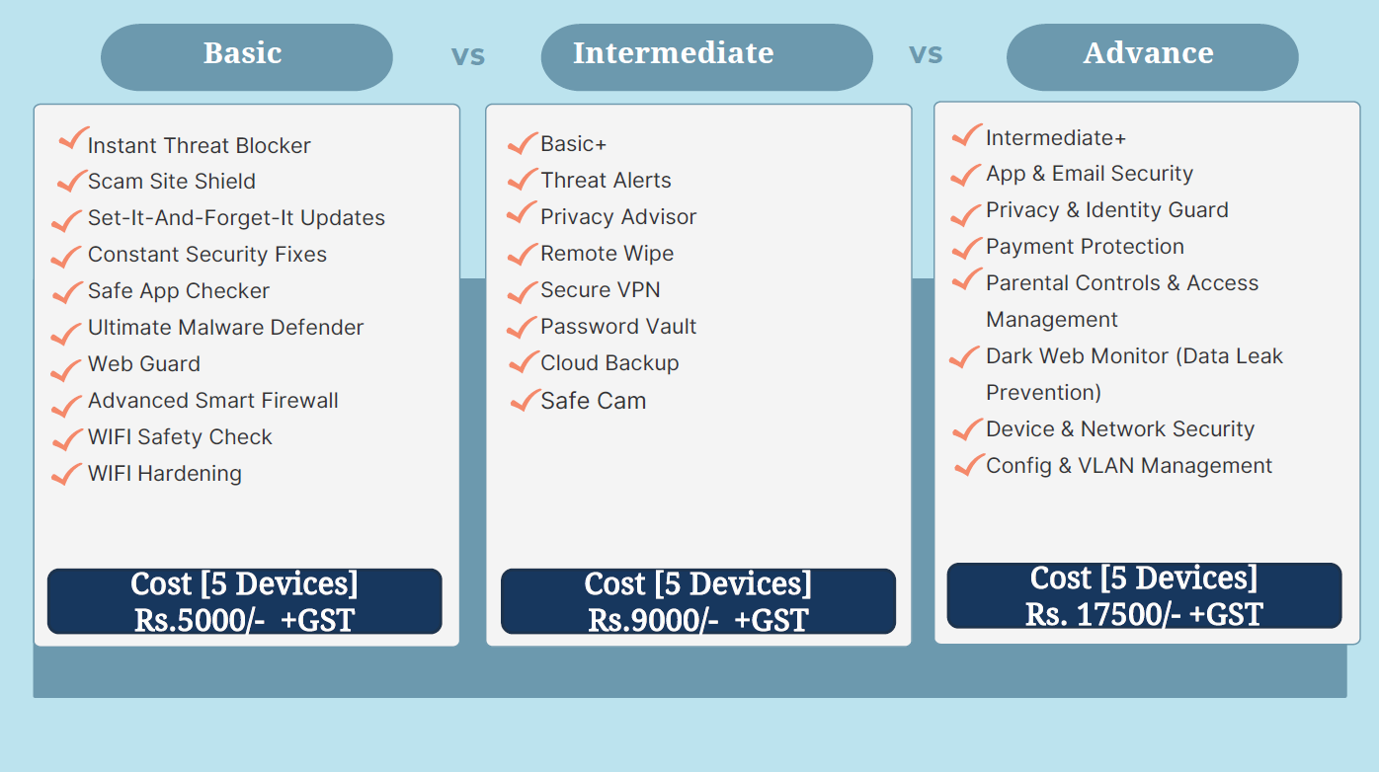
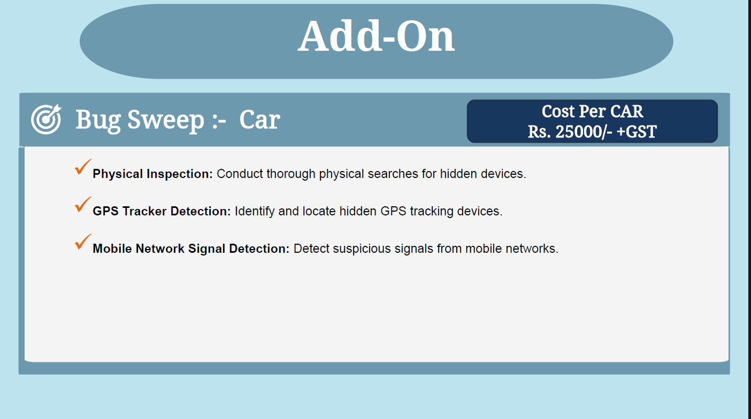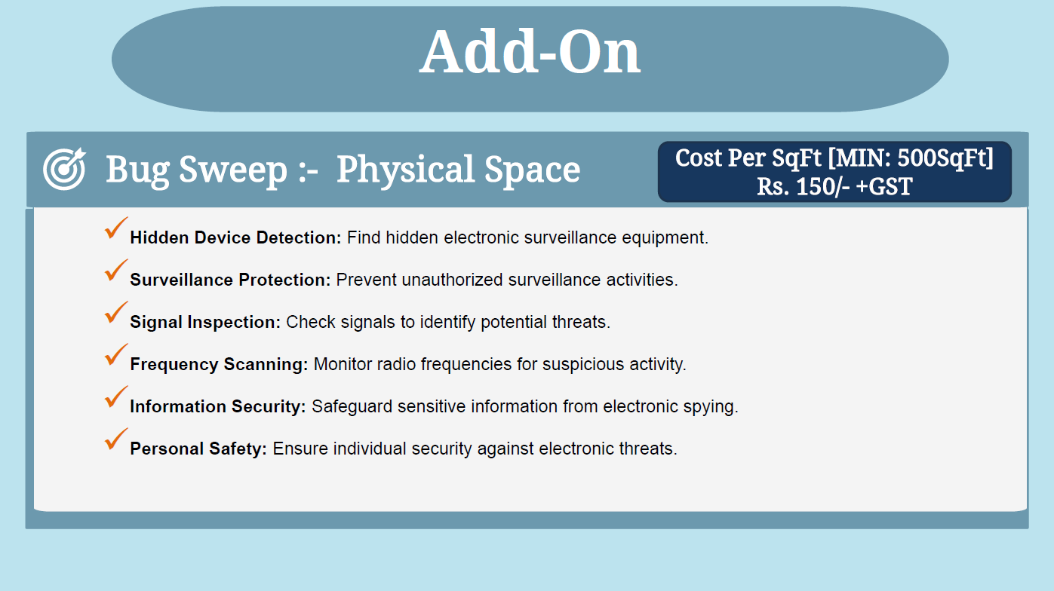

Conclusion & Future Scope

Learning Outcomes and Real-Life Benefits
1. TryHackMe DFIR: An Introduction
- Learning Outcomes: Acquired foundational knowledge in digital forensics and incident response, including evidence handling and incident management protocols.
- Real-Life Benefits: This knowledge will enhance your ability to conduct effective forensic investigations and respond to cybersecurity incidents, improving your competency in managing and mitigating security threats.
2. TryHackMe REDLINE
- Learning Outcomes: Developed advanced skills in using REDLINE for in-depth system analysis, malware detection, and forensic evidence collection.
- Real-Life Benefits: Proficiency with REDLINE will allow you to perform detailed investigations of compromised systems, making you more effective in identifying and addressing complex cybersecurity threats.
3. Vulnerability in Ubuntu 20.04 LTS
- Learning Outcomes: Gained expertise in analyzing vulnerabilities, understanding CVE details, and applying mitigation strategies using the MITRE framework.
- Real-Life Benefits: This skill will help you in assessing and managing vulnerabilities in systems, enhancing your ability to secure and patch systems effectively.
4. Analysis of Python-Based Ransomware
- Learning Outcomes: Acquired knowledge in analyzing ransomware, understanding Fernet encryption, and using sandboxing techniques.
- Real-Life Benefits: Skills in ransomware analysis and sandboxing will improve your capability to dissect and respond to ransomware attacks, aiding in effective malware analysis and mitigation.
5. Introduction to Sessions in Backend
- Learning Outcomes: Learned about backend session management, including security practices and user session handling.
- Real-Life Benefits: This knowledge will enhance your ability to implement secure session management practices in web applications, reducing vulnerabilities related to session handling.
6. Betting App Scam Analysis
- Learning Outcomes: Gained experience in forensic accounting for betting app scams, including evidence collection and documentation.
- Real-Life Benefits: This experience will enhance your skills in investigating financial frauds and preparing legal documentation, improving your ability to support legal actions and recovery efforts.
7. PPT on Cyber Security & AI
- Learning Outcomes: Developed the ability to create presentations on cybersecurity strategies incorporating AI technologies.
- Real-Life Benefits: Skills in creating insightful presentations will aid in effectively communicating complex cybersecurity concepts and strategies to stakeholders, enhancing your role in strategic planning and advocacy.
8. UPI Scam
- Learning Outcomes: Acquired skills in investigating UPI scams, including drafting FIR reports and preventive measures.
- Real-Life Benefits: This expertise will improve your ability to address and prevent financial frauds involving digital payment systems, enhancing your role in safeguarding against such scams.
9. FedEx Scam Analysis
- Learning Outcomes: Gained experience in forensic accounting and legal documentation for a high-value scam case.
- Real-Life Benefits: This experience will strengthen your skills in managing high-value fraud cases, including documentation and communication with legal authorities, leading to more effective legal resolutions.
10. Hash Checking and Report Preparation
- Learning Outcomes: Learned techniques for verifying file hashes and preparing forensic reports.
- Real-Life Benefits: Skills in hash checking will ensure data integrity and accurate documentation, crucial for maintaining the credibility of forensic evidence and reports.
11. Research on CrowdStrike Event
- Learning Outcomes: Developed the ability to research and analyze cybersecurity events, including response strategies.
- Real-Life Benefits: This skill will enhance your capability to understand and address complex cybersecurity incidents, contributing to more effective incident management and response strategies.
12. Product Research and Development
- Learning Outcomes: Acquired skills in designing and developing cybersecurity products, including service features and pricing strategies.
- Real-Life Benefits: Experience in product development will enable you to create and market cybersecurity solutions effectively, addressing the needs of High Net-Worth Individuals and other clients.
13. Malware Analysis
- Learning Outcomes: Gained proficiency in analyzing and understanding malware, including its behavior and impact.
- Real-Life Benefits: This expertise will improve your ability to detect, analyze, and respond to malware threats, enhancing your overall cybersecurity and incident response capabilities.
14. Learning Tableau
- Learning Outcomes: Developed skills in using Tableau for data visualization, including creating interactive dashboards and reports.
- Real-Life Benefits: Proficiency in Tableau will aid in visualizing complex data sets, improving your ability to present forensic findings and insights in a clear and actionable manner.
15. Digital Forensic Accounting for Client Liquidity Issue
- Learning Outcomes: Acquired experience in forensic accounting to address liquidity problems, including identifying financial discrepancies.
- Real-Life Benefits: This skill will enhance your ability to perform forensic analysis for financial recovery and management, supporting clients in resolving liquidity issues and financial disputes.
16. Filing Another FedEx Complaint
- Learning Outcomes: Gained experience in preparing and filing legal complaints related to fraud cases.
- Real-Life Benefits: Skills in legal documentation and complaint filing will improve your ability to support legal processes and facilitate resolution of fraud cases.
17. Contribution to Stock Market Fraud
- Learning Outcomes: Developed skills in drafting and filing complaints related to stock market fraud.
- Real-Life Benefits: This experience will enhance your ability to contribute to legal actions against financial fraud in the stock market, supporting effective legal and recovery efforts.
18. Learning About Cryptocurrency
- Learning Outcomes: Gained knowledge about cryptocurrency, its security risks, and regulatory considerations.
- Real-Life Benefits: Understanding cryptocurrency will enhance your ability to manage and secure digital assets, and navigate regulatory environments related to cryptocurrency transactions and investments.
19. Information Collection on Instagram Hack
- Learning Outcomes: Acquired skills in collecting and analyzing information related to Instagram hacks.
- Real-Life Benefits: Expertise in analyzing social media security incidents will improve your ability to address and mitigate similar cybersecurity threats.
20. Online Session on Bank Cybersecurity by RBI
- Learning Outcomes: Gained insights into best practices and regulatory measures for enhancing bank cybersecurity.
- Real-Life Benefits: Knowledge from the session will improve your ability to implement and advocate for effective cybersecurity measures in banking systems, aligning with regulatory requirements and best practices.
21. Device Hardening
- Learning Outcomes: Learned techniques for hardening devices, including implementing security configurations, patch management, and minimizing vulnerabilities to enhance overall cybersecurity.
- Real-Life Benefits: Skills in device hardening will enable you to secure systems against potential threats, reduce attack surfaces, and improve the resilience of devices against cyber-attacks, contributing to a stronger overall security posture.
Conclusion
In conclusion, the successful completion of my internship has been a profoundly enriching experience, marked by substantial professional and personal growth. Throughout the internship, I had the privilege of working with and learning from highly esteemed mentors, whose guidance and expertise significantly contributed to my development in the field of cybersecurity.
I am deeply grateful for the opportunity to engage with and absorb knowledge from such respected professionals. Their mentorship provided invaluable insights into advanced concepts and practical applications, shaping my skills and understanding of cybersecurity intricacies. The experience gained during this period has not only equipped me with practical skills but has also instilled a deeper appreciation for the complexities of the field.
I extend my sincere thanks to my mentors and the entire team for their support and for fostering an environment conducive to learning and growth. The knowledge and experience acquired will undoubtedly serve as a strong foundation for my future endeavours in cybersecurity and beyond.

Weekly Report
Week No: 1 From 14-06-2024 to 15-06-2024
Task assigned during the week | Learning outcomes of the week
- Tryhackme: DFIR | - Learnt about digital forensic and incident response.  - Learnt about artifacts, evidence preservation, chain of custody, order of volatility, timeline creation.  - Tools like: Eric Zimmerman, KAPE, Autopsy, Volatility, Redline.
- Redline | - Learnt about Collect Data: Standard Collector, Comprehensive Collector, IOC Search Collector  - Learnt about memory sections, timeCrunches.  - Learnt about pass-the-hash attack.
- Vulnerability of kernel and CVE of latest attack on ubuntu 20.04 | - Understood the attack happened as kernel Linux and desktop in ubuntu.  - Understood the achievements after making an attack by the attackers.  - Learnt about detection methods.
- Mitre Attacks | Learnt about the impact, command and control, collection, lateral movement, discovery, credential access, defence evasion, privilege escalation, persistence, execution, initial access, resource development, reconnaissance the topics under them which matches the particular CVE mentioned for vulnerability of kernel and latest attack on ubuntu 20.04

Week No: 2 From 17-06-2024 to 22-06-2024
Task assigned during the week | Learning outcomes of the week
- Chain of custody | - Learnt the various steps included in chain of custody and documenting the case.  - Learnt the cybercrime laws and which crime they undergo.  - Learnt to develop the format, the device which is handover or it is returned saving the evidence for further process.  - Learnt how to investigate and gather the information.
- Handover and Return Handover Report | - Understood how to develop the handover and return handover report.  - Learnt about IMEI 1, IMEI 2.  - Learnt the practices of handover report ensuring transparency, clarity and completeness.
- Cybercrime Laws | - Acquire practical skills in investigating cybercrimes, including evidence collection, digital forensics, and the use of technological tools for tracking and analysing cyber incidents.  - Learnt to document cybercrime cases in compliance with the IT Act 2000.
- Mobile Forensic | - Learnt various tactics to investigate and collect the evidence from mobile phone.  - Learnt about Vysor tool.  - Learnt the process how to investigate.
- FIR | - Analyse the crime and collect evidence related to the crime.  - Make FIR for further investigation process and hand over the it to the client.
- Case Study | - Learnt to spot warning signs and deceitful tactics used in investment scams, like unrealistic promises and high-pressure tactics.  - Understand how to protect personal and financial information from online threats when making transactions.  - Gain an understanding of consumer rights and the legal steps available for victims of financial fraud.
- Bank Case Study | - Understanding of cyber threats and best practices.  - By aligning with RBI's Cyber Security Framework.  - Upgrading CCTV systems, implementing IP-based cameras.  - Developing and testing an incident response plan will enable the bank to respond swiftly and effectively to security incidents.  - Strengthening vendor risk management practices will mitigate risks associated with third-party services.  - Regular vulnerability assessments, penetration testing, and compliance audits will foster a culture of continuous improvement in cybersecurity measures,
- Case Study | - Gain insights into advanced cryptographic principles and reverse engineering techniques essential for analysing and recovering passwords in locked digital wallets.  - Learn about innovative approaches and unconventional methods used to recover inaccessible digital assets, particularly in cryptocurrency environments.  - Explore the ethical considerations and legal frameworks surrounding attempts to recover lost digital assets, emphasizing compliance with cybersecurity regulations and ethical standards.
- Implementing Ransomware Attack by Fernet Encryption and decryption using python. | - Learnt os module, its uses, function.  - Learnt Cryptography module.  - Learnt Fernet: Fernet generates, fernet encryption, fernet decryption.  - Understood the logic of code.  - Learnt ransomware attack implemented in code.
- Sandboxing | - Learn what sandboxing is: a safe, isolated environment for testing software without affecting your main computer.  - Discover how to set up and use Windows Sandbox on Windows 10 and 11 for secure testing of apps and files.  - Understood how sandboxing improves security by containing potential threats within a controlled environment.
- Token | - Creating a token generation script enhances understanding of JWT structure, cryptographic operations, and user input handling for secure authentication implementations.
- Detect Hidden Surveillance Devices by Tools given. | - Learnt functionality of RF Detectors, GSM Detectors, EMI Detectors, NLJDs, Thermal Cameras, and Hidden Camera Detectors.  - Learnt portability, and learning curve of each type of detector.  - Understood the price ranges and features of basic, mid-range, and advanced models of these detectors.  - Recognize scenarios where each detector type is essential, such as privacy protection, counter-surveillance, and security sweeps.
- Case Study | - Learnt how to analyse it.  - Find information of various platforms used by the victim.  - Prepare a report.

Week No: 3 From 23-06-2024 to 29-06-2024
Task assigned during the week | Learning outcomes of the week
Case study | - Learnt about digital forensic tool used.  - Learnt the methods to solve the case.  - Leant BSNF to apply in excel.
PPT | - Created a ppt of network security.  - Learnt various techniques to make the ppt.

Week No: 4 From 1-07-2024 to 6-07-2024
Task assigned during the week |  | Learning outcomes of the week
PPT |  | - PPT on Cyber risk.  - Researched on various case study.
Course on OSINT |  | - Learnt the mind map and how to implement it.  - Learnt about investigation process.  - Learnt various techniques to find the company sites.  - Learnt about OpenCorporates website where it contains database of various companies, also the officers name, address are mentioned.  - ClustrMaps: Another website similar to OpenCorporates.com  - Learnt about standardnotes.org website where the links, texts get encrypted.  - Cherrytree: used gor creating tree, where the reports can easily be stored.  - Learnt about PSR which used for screen recording.  - OBS (Open Broadcaster Software) used for video recording and live streaming.  - VeraCrypt: It is a popular open-source disk encryption software that allows users to create encrypted volumes and encrypt entire partitions or storage devices. It provides strong security for data protection and is widely used for securing sensitive information.  - Onionshare: It is an open-source tool that allows you to securely and anonymously share files of any size over the Tor network.  - Cloudflare DNS: is a high-performance, privacy-focused DNS service that provides fast and secure domain name resolution.
Week No: 5 From 8-07-2024 to 13-07-2024
Task assigned during the week | Learning outcomes of the week
- Section 63 certificate format | - Learnt about updated section 63.
- Mobile Forensic | - Checked the app list.  - Investigated the unusual apps.  - Made a report.
- Research on anti-bugging software for mobile phones and server. | - Researched on various software such Sophos Intercept X Advanced.  - For server such Tripwire, Nessus.

Week No: 6 From 15-07-2024 to 20-07-2024
Task assigned during the week | Learning outcomes of the week
Research on tools containing antibugging for mobile phone, laptops, WIFI, car, CCTV, and Bug sweep. | - Researched various software that contains antibugging in the given device.  - Learnt various features that one software can provide.  - Learnt about data breaches.
Budgeting the cost of each software. | - Made a budget plan for each device in basic, intermediate and advanced manner.
PPT on Incident response and reporting | - Learnt about the incident response plan.  - Identified the key stages of incident response.  - Researched on case study related to it.  - Learnt the importance of effective incident reporting.

Week No: 7 From 22-07-2024 to 27-07-2024
Task assigned during the week | Learning outcomes of the week
Conducted a comprehensive cost analysis of all tools. | - Acquired proficiency in conducting detailed cost analysis of various tools.
Developed three distinct package options for TSCM services. | - Gained experience in designing and structuring multiple service packages tailored for TSCM.
Performed in-depth evaluation and research on the TSCM business sector. | - Developed a thorough understanding of the TSCM business sector through extensive research and evaluation.
Crowdstrike BSOD error report. | - Learned how to find and understand the causes of BSOD errors.  - Developed systematic methods to resolve and prevent BSODs.  - Improved knowledge of CrowdStrike settings to enhance system stability.  - Enhanced ability to document and communicate technical findings clearly.

Week No: 8 From 29-07-2024 to 7-08-2024
Task assigned during the week | Learning outcomes of the week
Prepared a brochure for cyber hygiene in digital devices. | - Learnt how to detect and counteract surveillance threats to enhance physical and digital security.  - Gain practical skills in safeguarding digital devices and identifying vulnerabilities to protect sensitive information.
PPT on cyber hygiene | - Learn how to apply essential strategies to protect digital devices and data.  - Develop the ability to identify and mitigate common cybersecurity threats.
A Heartfelt Gratitude for an Enriching Internship Experience
I am deeply appreciative of the opportunity to intern at Cyber Security Corporation, an experience that has been both intellectually stimulating and professionally rewarding. I want to express my heartfelt gratitude to the entire team for welcoming me with open arms and creating an environment that fostered learning, collaboration, and growth.

A special thank you to Dr. Harold D’Costa and Mr. Kayomarz, whose mentorship has been instrumental in my development. Dr. D’Costa's deep knowledge of digital forensics and cyber law, combined with Mr. Kayomarz expertise in advanced threat detection and incident response, provided me with a comprehensive understanding of the cybersecurity landscape. Their patient guidance, insightful feedback, and willingness to share their wealth of experience made every training session and project an invaluable learning experience.

I also want to acknowledge the support and camaraderie of my colleagues, whose diverse perspectives and willingness to share their expertise enriched my internship experience. The team’s collaborative spirit and open communication created an atmosphere where ideas and knowledge flowed freely, allowing me to learn from each interaction. The hands-on experiences, from investigating real-world cybercrime cases to participating in research projects, have significantly enhanced my skills and confidence in the field.

I am particularly grateful for the opportunities to work on meaningful projects, which have not only broadened my technical skills but also deepened my understanding of the ethical and legal dimensions of cybersecurity. The exposure to real-world challenges and the chance to contribute to solutions were invaluable in shaping my professional aspirations.

As I move forward in my career, I carry with me the lessons learned, the skills acquired, and the relationships built during this internship. This experience has been a pivotal moment in my journey, solidifying my passion for cybersecurity and reinforcing my

commitment to protecting digital spaces. Thank you, Cyber Security Corporation, for this incredible opportunity to grow and for equipping me with the tools to succeed in this ever-evolving field. Your support and encouragement have been instrumental in shaping my professional path, and I will always be grateful for this transformative experience.

Thank you, Cyber Security Corporation, for this experience.

Warm Regards,

Prathamesh Santosh Pendkar
CSIT SY (SEM 4th)
PRN: 2201106006

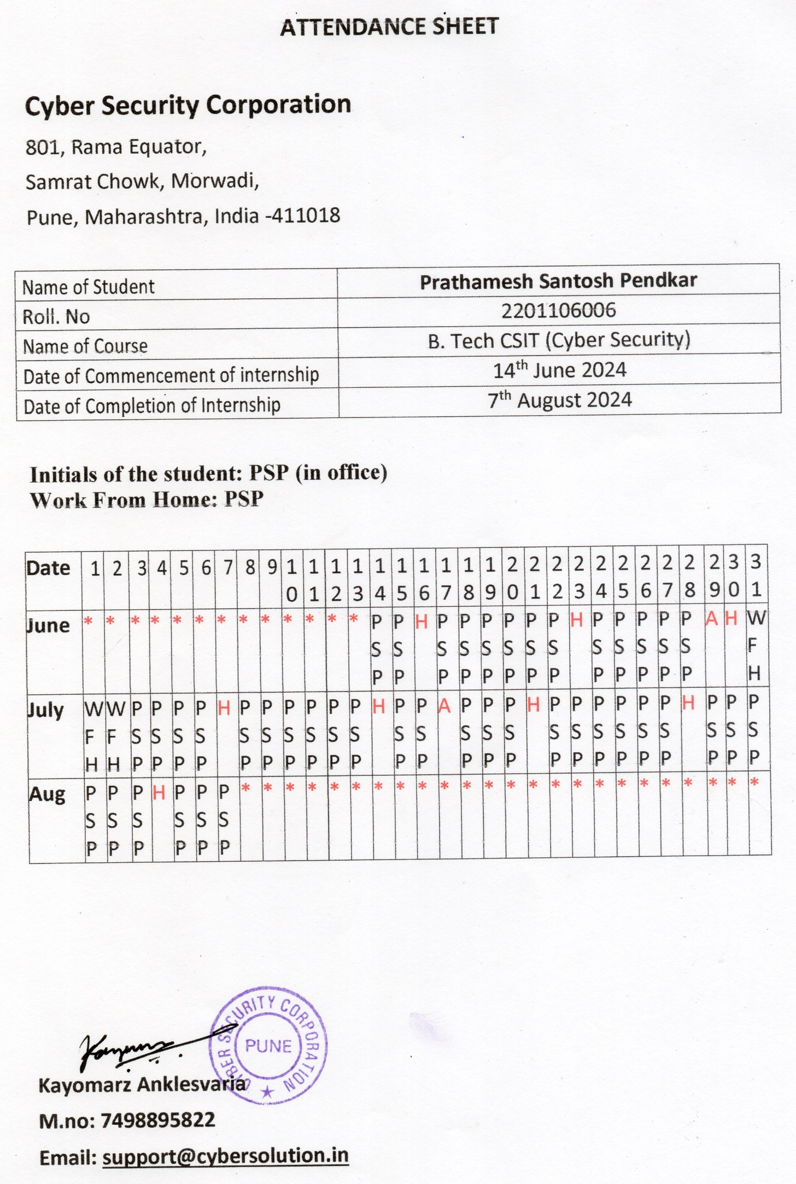


Symbiosis Skills and Professional University, Kiwale, Pune
School of CSIT(Cybersecurity)
---------------------------------------------------------------------------------------------
Feedback Form for Internship
(To be filled by Student)
Name of Intern | : | Prathamesh Santosh Pendkar
PRN | : | 2201106006
Year & Semester | : | 2nd Yr. 2nd Sem
Problem Statement | : | Cyber Forensics Analyst
Name of Industry Mentor | : | Mr. Kayomarz Anklesvaria
Name of Faculty Mentor | : | Prof. Parul Bhanerkar

Was your internship Experience related to your major area of study?
(Tick Appropriate)

Yes, to a large degree | Yes, to a slight degree | No, Not related at all

Symbiosis Skills and Professional University, Kiwale, Pune
School of CSIT(Cybersecurity)
---------------------------------------------------------------------------------------------

(To be filled by Student)
Marking Scheme
5 | 4 | 3 | 3 | 1
Strongly Agree | Agree | No opinion | Disagree | Strongly Disagree

Sr.  No | Task | Final Marks  (1-5)
1 | Given me the opportunity to explore a career field
2 | Allowed me to apply classroom theory to practice
3 | Helped me develop my decision-making and problem-solving skills
4 | Expanded my knowledge about the work world
5 | Helped me develop my written and oral communication skills
6 | Provided a chance to use technical abilities in information and research
7 | Expanded my sensitivity to the ethical implications of the work involved
8 | Made it possible for me to be more confident in uncertain situations
9 | Given me a chance to improve my analytical skills
10 | Helped me understand the criticality of planning ahead
11 | Helped me to plan during crisis
12 | Provided me the opportunity to work long distances and achieve results
13 | Allowed me to acquire information and/ or use it effectively in my report

Symbiosis Skills and Professional University, Kiwale, Pune
School of CSIT(Cybersecurity)
---------------------------------------------------------------------------------------------

Answer the following Questions
(To be filled by Student)
1 | In the Institute internship program, faculty members are expected to be mentors for students. Do you feel that your faculty coordinator served such a function? Why or why not?
Ans: | Yes, definitely faculties as mentors played a key role in internship process. They Provide guidance right from providing internship, working with company was also great experience.
2 | How well were you able to accomplish the initial goals, tasks, and new skills that were set down in your learning contract?
Ans: | Initially it was bit hectic but after that I got familiar with environment my mentor helped me getting familiar with work.
3 | In what ways were you able to take a new direction or expand beyond your contract?
Ans: | Apart from my college work I learn new thing in Digital Forensics & done investigation in real world 7-10 cases.
4 | Why were some goals not accomplished adequately?
Ans: | I sincerely don’t think that any goals were not accomplished.
5 | In what areas did you most develop and improve?
Ans: | It improved in are such as communication, teamwork and problem solving.
6 | What has been the most significant accomplishment or satisfying moment of your internship?
Ans: | Dealing and investigating real world cybercrime case.
7 | What did you dislike about the internship?
Ans: | Less time period it could be minimum 6 months
8 | Considering your overall experience, how would you rate this internship?
Ans: | (Circle anyone). Satisfactory Good Excellent
9 | Give suggestions as to how your internship experience could have been improved.
Ans: | 1. Could you have handled added responsibility?
Yes
2. Would you have liked more discussions with your professor concerning your internship?
Yes
3. Was closer supervision needed?
No
4. Was more orientation required?
No

