

Task 2
PYTHON DEVELOPER INTERNSHIP

Code :
"""
ToDo.py - Simple console-based persistent to-do list manager.

Commands:
add <task> Add a new task
remove <number> Remove task by its number (from list)
list Show all tasks
clear Remove all tasks
help Show this help
exit / quit Save and exit
"""

from pathlib import Path

# DATA_FILE will store tasks in a text file next to this script (e.g., ToDo.txt)
DATA_FILE = Path(__file__).with_suffix('.txt')

# ---------------------- Load tasks from file ----------------------
def load_tasks():
"""Load all saved tasks from the text file into a list."""
if not DATA_FILE.exists():
return []
with DATA_FILE.open('r', encoding='utf-8') as f:
# Strip newlines and ignore empty lines
return [line.strip() for line in f if line.strip()]

# ---------------------- Save tasks to file ----------------------
def save_tasks(tasks):
"""Save the current list of tasks to the file."""
with DATA_FILE.open('w', encoding='utf-8') as f:
for t in tasks:
f.write(t + '\n')

# ---------------------- List all tasks ----------------------
def list_tasks(tasks):
"""Display all tasks with numbering."""
if not tasks:
print("No tasks.")
return
for i, t in enumerate(tasks, start=1):
print(f"{i}. {t}")

# ---------------------- Add a new task ----------------------
def add_task(tasks, text):
"""Add a new task to the list and save it."""
text = text.strip()
if not text:
print("Cannot add an empty task.")
return
tasks.append(text)
save_tasks(tasks)
print("Task added.")

# ---------------------- Remove a task ----------------------
def remove_task(tasks, index_str):
"""Remove a specific task by its number."""
try:
idx = int(index_str)
except ValueError:
print("Provide the task number to remove, e.g. remove 2")
return

if not (1 <= idx <= len(tasks)):
print("Task number out of range.")
return

removed = tasks.pop(idx - 1)
save_tasks(tasks)
print(f"Removed: {removed}")

# ---------------------- Clear all tasks ----------------------
def clear_tasks(tasks):
"""Delete all tasks after user confirmation."""
confirm = input("Are you sure you want to delete all tasks? (y/N): ").strip().lower()
if confirm == 'y':
tasks.clear()
save_tasks(tasks)
print("All tasks cleared.")
else:
print("Canceled.")

# ---------------------- Show help ----------------------
def print_help():
"""Print help instructions (from the docstring)."""
print(__doc__)

# ---------------------- Main Function ----------------------
def main():
"""Main loop: continuously accept user commands and perform actions."""
tasks = load_tasks()
print("Simple To-Do List (type 'help' for commands)")

while True:
try:
raw = input("> ").strip()
except (EOFError, KeyboardInterrupt):
print("\nExiting.")
break

if not raw:
continue # Ignore empty input

parts = raw.split(maxsplit=1)
cmd = parts[0].lower()
arg = parts[1] if len(parts) > 1 else ""

if cmd in ('exit', 'quit'):
break
elif cmd == 'help':
print_help()
elif cmd == 'list':
list_tasks(tasks)
elif cmd == 'add':
if arg:
add_task(tasks, arg)
else:
todo = input("Task: ").strip()
add_task(tasks, todo)
elif cmd == 'remove':
if arg:
remove_task(tasks, arg)
else:
num = input("Task number to remove: ").strip()
remove_task(tasks, num)
elif cmd == 'clear':
clear_tasks(tasks)
else:
print("Unknown command. Type 'help' for usage.")

# Save tasks again before exiting
save_tasks(tasks)
print("Goodbye!")

# ---------------------- Program Entry Point ----------------------
if __name__ == "__main__":
main()

Output:-

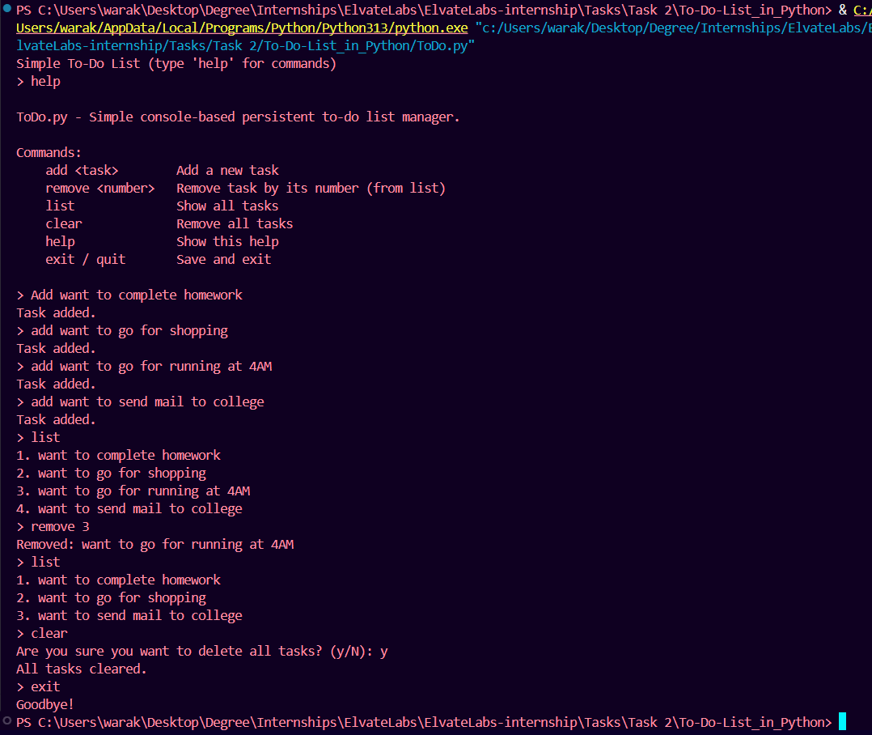
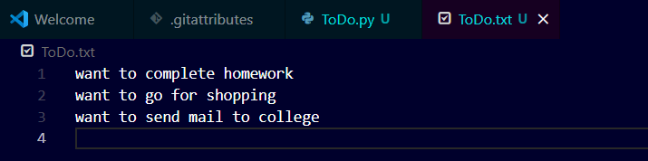

Interview Questions
1. How do you open and write to a file in Python?
You use the built-in open() function and typically write using the .write() or .writelines() methods. It's best practice to use a with statement to ensure the file is automatically closed:
Python
with open('my_file.txt', 'w') as f:
f.write('Hello, world!\n')

2. What are common file modes?
The most common file modes are:
- 'r': Read (default)
- 'w': Write (overwrites existing file or creates new)
- 'a': Append (adds to the end of the file)
- 'x': Exclusive creation (fails if the file already exists)
- 'b': Binary mode (e.g., 'rb', 'wb')
- 't': Text mode (default, e.g., 'rt', 'wt')
- '+': Updating (read and write, e.g., 'r+', 'w+')

3. What's the use of .strip()?
The .strip() string method is used to remove leading and trailing whitespace (spaces, newlines, tabs) from a string. You can also pass a string of characters to remove specified characters instead of just whitespace.

4. How do lists work in Python?
Lists are ordered, mutable collections of items (which can be of different data types). They are defined using square brackets [] and allow duplicate members. They are dynamic arrays, supporting operations like indexing, slicing, and methods for modification.

5. What is the difference between append() and insert()?
- list.append(item) adds the item to the end of the list.
- list.insert(index, item) adds the item at a specified index in the list.

6. How can you remove elements from a list?
- .remove(value): Removes the first occurrence of a specified value.
- .pop(index): Removes and returns the element at a specified index (removes the last item if no index is given).
- del list[index/slice]: Deletes the element at a specific index or slice.

7. What are context managers (with statement)?
Context managers are objects that define actions to be executed when entering and exiting a context. The with statement automatically handles the setup and teardown (e.g., opening and closing a file, or acquiring and releasing a lock), making code cleaner and more reliable.

8. How do you loop through a file line by line?
The most idiomatic and memory-efficient way is to directly iterate over the file object:
Python
with open('my_file.txt', 'r') as f:
for line in f:
print(line.strip())
9. What is a data structure?
A data structure is a specialized format for organizing, managing, and storing data in a computer so that it can be used and processed efficiently (e.g., lists, dictionaries, stacks, queues, trees).

10. What happens if the file doesn't exist?
- If opening in read mode ('r'), a FileNotFoundError is raised.
- If opening in write mode ('w') or append mode ('a'), a new, empty file is created.
- If opening in exclusive creation mode ('x'), a FileExistsError is raised if the file already exists.

