**AI CHATBOT IN PYTHON**

A Project Report

Submitted in Partial Fulfillment of the Requirement for the Award of the Degree of

**BACHELOR OF TECHNOLOGY**

**(Computer Science Engineering)**

To



**APJ ABDUL KALAM TECHNICAL UNIVERSITY** **LUCKNOW, INDIA**

**By**

**SHIVANJAY PANDEY ROLL NO- 2003490100031**

Under the Guidance of

**Mr. SUBASH KUMAR MAURYA**



DEPARTMENT OF COMPUTER SCIENCE TECHNOLOGY

**MAHARANA PRATAP ENGINEERING COLLEGE**

**September-2022**

**CANDIDATE’S DECLARATION**

We hereby certify that the work which is being presented in the project report entitled **“Chatbot in PYTHON”** in partial fulfillment of the requirement for the award of the Degree of Bachelor of Technology and submitted in the Department of Computer Science Engineering of Maharana Pratap Engineering College, Kanpur is an authentic record of our own work carried out during a period from August 2022 to September 2022 under the supervision of

**Mr. Subhash Kumar Maurya** Department of Computer Science Engineering of Maharana Pratap Engineering College, Kanpur

The matter presented in this report has not been submitted by us for the award of any other degree of this or any other Institute/University.

Student name

## SHIVANJAY PANDEY

This is to certify that the above statement made by the candidate is correct to the best of my knowledge.

Date: **Mr. Subhash Kumar Maurya**

# ACKNOWLEDGEMENT

It is indeed a great pleasure to express our sincere thanks to our august supervisor **Mr. Subhash Kumar Maurya** , Department of Computer Science Engineering of Maharana Pratap Engineering College, Kanpur for his continuous support in this project. He was always there to listen and to give advice. He showed us different ways to approach a research problem and the need to be persistent to accomplish any goal. He taught us how to write academic paper, had confidence in us when we doubted ourselves, and brought out the good ideas in us. He was always there to meet and talk about our ideas, to proofread and mark up our paper, and to ask us good questions to help us think through our problems. Without his encouragement and constant guidance, we could not have finished this project.

**Prof Subhash Kumar Maurya of Maharana Pratap Engineering College, Kanpur and Dr. Sourabh Chandra , Head of Computer Science Engineering Department really deserves** our heartiest honor for providing us all the administrative support.

We are thankful to our family whose unfailing love, affection, sincere prayers and best wishes had been a constant source of strength and encouragement.

Last, but not least, we thank our parents, for giving us life in the first place, for educating us with aspects from both arts and sciences, for unconditional support and encouragement to

pursue our interests. We dedicate this work to our parents who will feel very proud of us. They deserve real credit for getting us this far, and no words can ever repay for them.

# SHIVANJAY PANDEY

## INTRODUCTION

**ABSTRACT**

A chatbot is a computer program that can converse with humans using artificial intelligence in messaging platforms. The goal of the project is to add a chatbot feature and API for Yioop. discussion groups, blogs, wikis etc. Yioop provides all the basic features of web search portal. It has its own account management system with the ability to set up groups that have discussions boards. Groups are collections of users that have access to a group feed. The user who creates a group is set as the initial group owner. Posts are grouped by thread in a group containing the most recent activity at the top. The chatbot API for Yioop will allow developers to create new chatbots, powered by rules or artificial intelligence, that can interact like a human with users in a groups feed page. Example chatbots that can be developed with this API is weather chatbots or book flight chatbots. Over past few years, messaging applications have become more popular than Social networking sites. People are using messaging applications these days such as Facebook Messenger, Skype, Viber, Telegram, Slack etc. This is making other businesses available on messaging platforms leads to proactive interaction with users about their products.

To interact on such messaging platforms with many users, the businesses can write a computer program that can converse like a human which is called a chatbot.

Chatbots come in two kinds:

* Limited set of rules
* Machine learning

Chatbot that uses limited set of rules

This kind of bots are very limited to set of texts or commands. They have ability to respond only to those texts or commands. If user asks something different or other than the set of texts or commands which are defined to the bot, it would not respond as desired since it does not understand or it has not trained what user asked. These bots are not very smart when compared to other kind of bots.

# REQUIREMENTS AND SPECIFICATION

## Hardware Requirements:

Processor Hard Disk RAM

## Software Requirements:

Operating System

:Intel Core (i3 10th generation)

:256 GB

:8 GB

: Windows or Linux

Technology : PYTHON

**ER DIAGRAM OF CHATBOT**

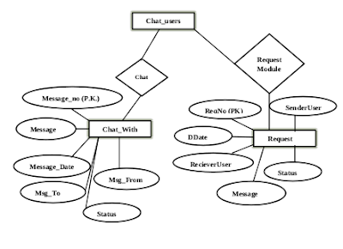

**OUTPUT**

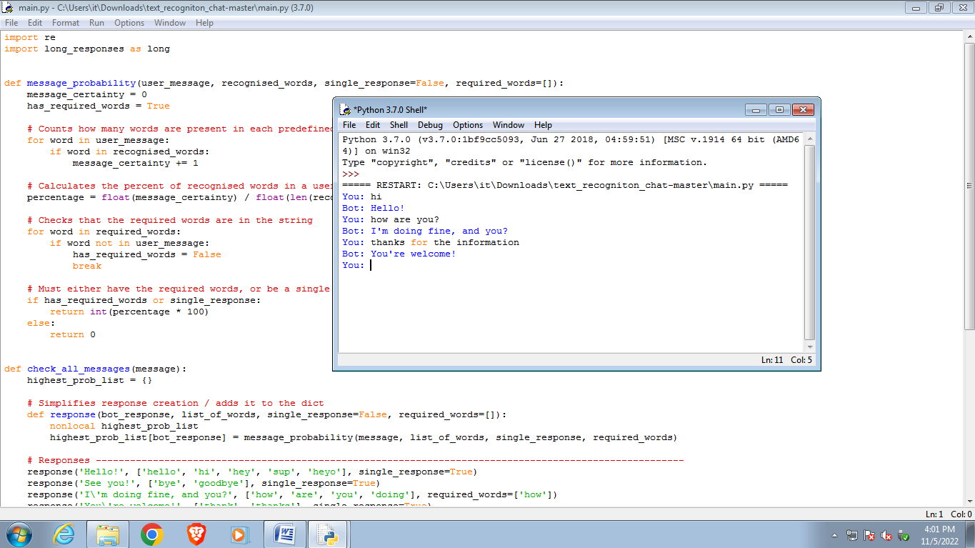

**CONCLUSION**

With a chatbot, your organization can easily offer high-quality support and conflict resolution any time of day, and for a large quantity of customers simultaneously. According to Microsoft, 90% of consumers expect an online portal for customer service.

As a significant aspect of business evolution, the need for AI-powered chatbots will only continue to rise. Now is the time to deploy a chatbot solution so that your company doesn’t get left behind.

It's a messaging platform which perform attractive distribution and user interface. Coversational apps should not reduced to NLP/AI chatbots, in which removing friction is a key.