**Linux Assignment**

1. Create a new directory called Linux-assignment in your home directory.

Ans –

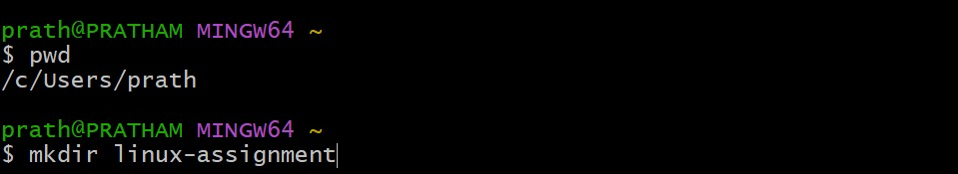

1. Navigate into the Linux-assignment directory.

Ans –

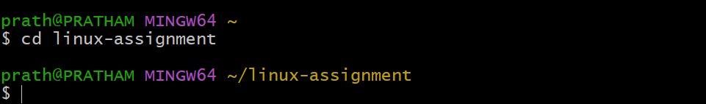

1. Create a new file called instructions.txt.

Ans –



1. Write "Hello, World!" into instructions.txt using a command-line text editor like nano, vi, or emacs.

Ans –



1. Display the contents of instructions.txt using a command.

Ans –

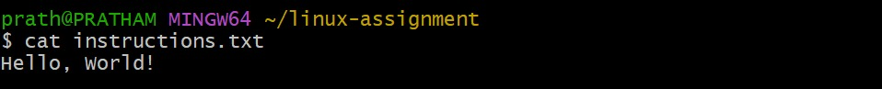

1. Rename instructions.txt to greetings.txt.

Ans –

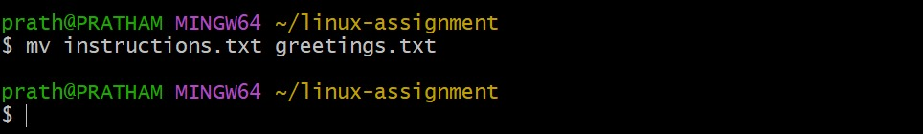

1. Copy greetings.txt to a new file called salutations.txt.

Ans –

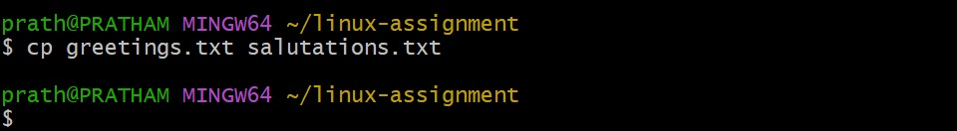

1. Delete greetings.txt.

Ans –

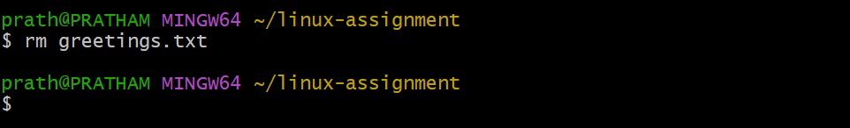

1. Create a new directory called archive.

Ans –

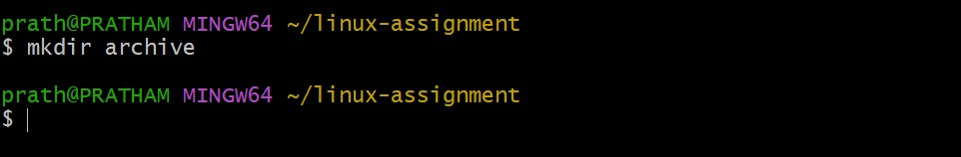

1. Move salutations.txt to the archive directory.

Ans –

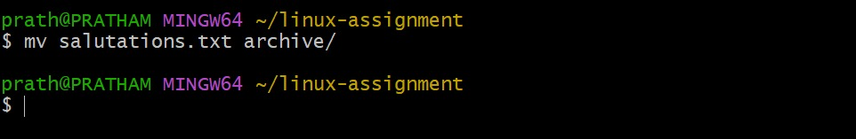

1. Display the current working directory to confirm that salutations.txt is now in the archive directory.

Ans –

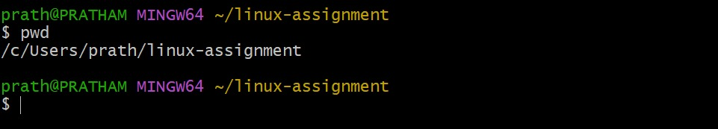

1. Navigate back to the Linux-assignment directory and create three new empty files named file1.txt, file2.txt, and file3.txt.

Ans –

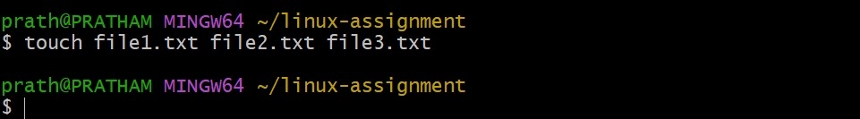

1. Display the list of files in the Linux-assignment directory to confirm the creation of the new files.

Ans –



1. Create a new text file in your home directory named linux-assignment-commands.txt and write down all the commands you used in this assignment.

Ans - 