ML From Scratch
Week 2 Report: Regression Models & Gradient Descent
WNCC, IIT Bombay

1. Overview
This report covers Week 2 of the ML From Scratch project: regression models and the gradient descent algorithm. Three models were implemented from scratch in NumPy, without using scikit-learn, in order to build intuition for the underlying mathematics before relying on library implementations.
- LinearRegression — Ordinary Least Squares (OLS) solved via the Normal Equation
- LinearRegression2 — Linear Regression trained with Batch Gradient Descent
- LogisticRegression — Binary classification trained with Gradient Descent

2. Linear Regression — Normal Equation (OLS)

2.1 Theory
Linear regression models the relationship between input features X and a continuous target y with a linear hypothesis:
y_hat = X @ w
The cost function is the Mean Squared Error (scaled by 1/2m for convenience when differentiating):
J(w) = (1 / 2m) * ||X w - y||^2
Since J(w) is convex and differentiable, setting its gradient to zero gives a closed-form solution known as the Normal Equation:
w = (X^T X)^(-1) X^T y
This directly computes the optimal weights in one step, without iteration. It is efficient for small to moderate numbers of features, but becomes computationally expensive (O(n^3) for the matrix inversion) as the feature count n grows large, and fails if X^T X is singular or near-singular.

2.2 Implementation
Implemented in linear_regression_ols.py. Key steps:
- Prepend a column of ones to X to account for the bias/intercept term
- Compute weights using the pseudo-inverse (np.linalg.pinv) for numerical stability, rather than a direct inverse
- Evaluate fit quality using Mean Squared Error and the R^2 score
self.weights = np.linalg.pinv(X_b.T @ X_b) @ X_b.T @ y

2.3 Results
Tested on a synthetic dataset generated as y = 4 + 3x + noise (100 samples). The model recovered weights close to the true values of 4 and 3, confirming a correct implementation.
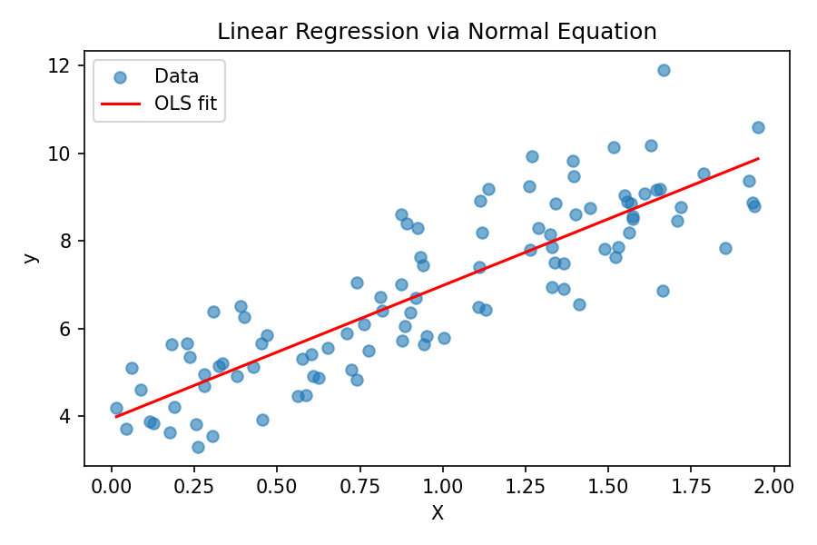
Figure 1: Linear Regression fit using the Normal Equation

3. Linear Regression — Gradient Descent (LinearRegression2)

3.1 Theory
Gradient Descent minimizes the same MSE cost function iteratively instead of solving for it directly. This is essential when the Normal Equation is too expensive (very large feature counts) or when extending to models, like logistic regression, that have no closed-form solution.
The gradient of the cost function with respect to the weights is:
dJ/dw = (1/m) * X^T (X w - y)
Weights are updated repeatedly in the direction that reduces the cost, scaled by a learning rate alpha:
w := w - alpha * dJ/dw
Feature scaling (standardization) was applied before training, since unscaled features with very different ranges cause gradient descent to converge slowly or oscillate.

3.2 Implementation
Implemented in linear_regression_gd.py. The training loop runs for a fixed number of iterations, recomputing the gradient and updating weights at each step, while tracking the cost history for diagnosing convergence:
for i in range(self.n_iters):
preds = X_b @ self.weights
error = preds - y
gradient = (1/m) * (X_b.T @ error)
self.weights -= self.lr * gradient

3.3 Results
Using a learning rate of 0.5 over 500 iterations on standardized features, the cost converges within roughly 100 iterations and the resulting fit closely matches the OLS solution, with an R^2 score around 0.77 on the synthetic dataset.
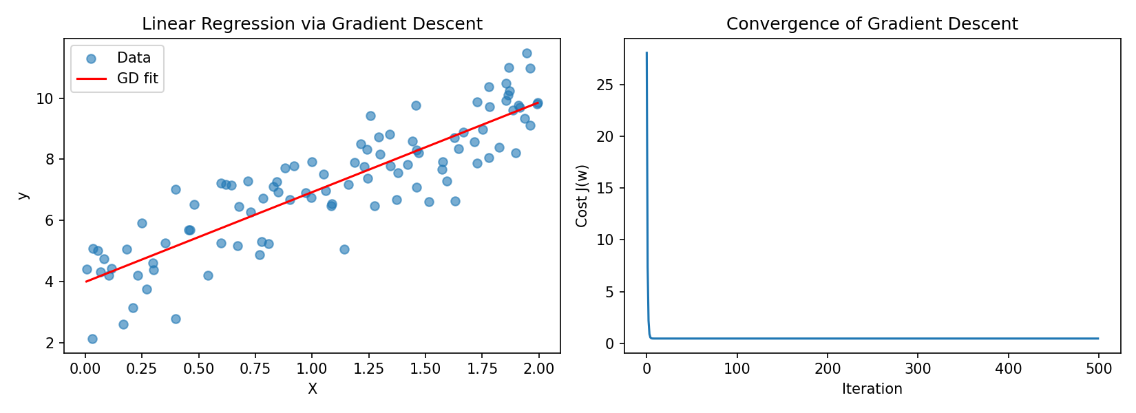
Figure 2: Gradient Descent fit (left) and cost convergence curve (right)

4. Logistic Regression

4.1 Theory
Logistic Regression extends the linear model to binary classification by passing the linear combination of inputs through the sigmoid function, which squashes outputs into the range (0, 1) so they can be interpreted as probabilities:
sigmoid(z) = 1 / (1 + e^(-z))
h(x) = sigmoid(X w)
Mean Squared Error is not used here because it produces a non-convex cost surface for this hypothesis. Instead, Binary Cross-Entropy (log loss) is used, which is convex and penalizes confident wrong predictions heavily:
J(w) = -(1/m) * sum( y*log(h) + (1-y)*log(1-h) )
Remarkably, differentiating this cost with respect to w yields a gradient with the exact same form as linear regression, just with the sigmoid hypothesis substituted in:
dJ/dw = (1/m) * X^T (h - y)

4.2 Implementation
Implemented in logistic_regression.py. The sigmoid function clips its input to avoid numerical overflow, and a small epsilon is added inside the log terms of the cost function to avoid log(0):
def sigmoid(z):
z = np.clip(z, -500, 500)
return 1 / (1 + np.exp(-z))
Predictions are thresholded at 0.5 to assign a class label, and a separate accuracy() helper measures classification performance.

4.3 Results
Tested on a synthetic 2D dataset with two well-separated Gaussian clusters (200 samples). After 500 iterations with a learning rate of 0.5, the model achieved 100% training accuracy and the log loss converged to a very low value, and the learned linear decision boundary cleanly separates the two classes.
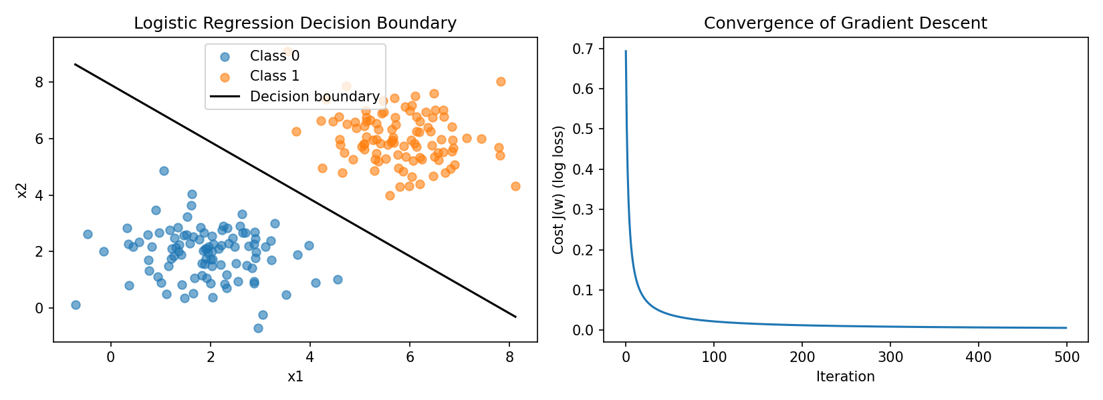
Figure 3: Logistic Regression decision boundary (left) and log-loss convergence (right)

5. Key Takeaways
- The Normal Equation gives an exact, one-shot solution for linear regression but scales poorly with feature count.
- Gradient Descent is an iterative alternative that generalizes to models without closed-form solutions, but requires tuning the learning rate and benefits greatly from feature scaling.
- Logistic Regression reuses the same gradient descent machinery as linear regression, only swapping the hypothesis (sigmoid) and the cost function (log loss instead of MSE).
- Monitoring the cost history at each iteration is a simple but effective way to verify that an implementation of gradient descent is correct and has converged.

6. Files Submitted
- linear_regression_ols.py — Normal Equation based Linear Regression
- linear_regression_gd.py — Gradient Descent based Linear Regression (LinearRegression2)
- logistic_regression.py — Gradient Descent based Logistic Regression
- Week2_Report.docx — this report

