SUMANTH REDDY PATHI

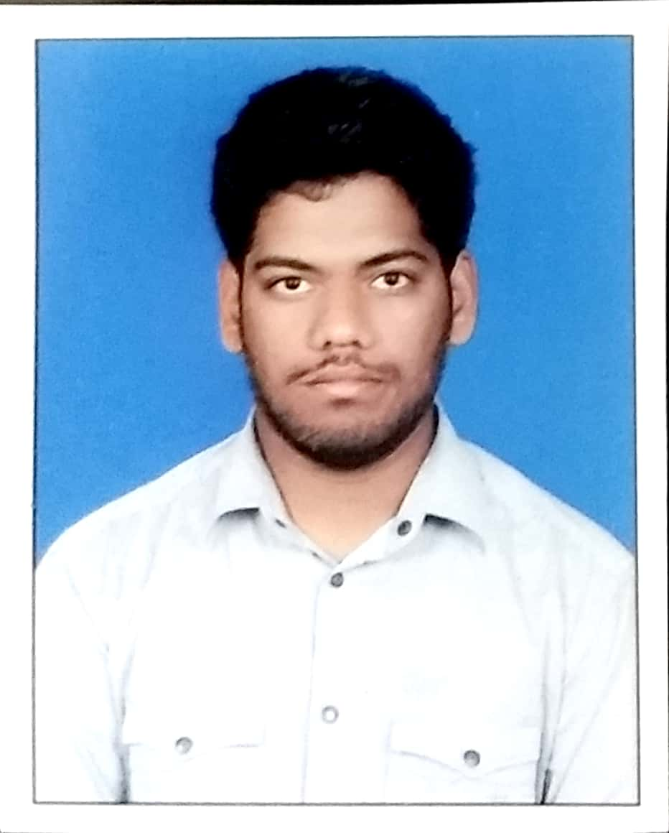**Personal Information:**

**Name:** *Sumanth Reddy*

**Date of Birth:** *28-03-1998*

**Address:** *Lb.Nagar ,Hyderabad 500 072*

**Mobile:** *8008089900*

**E-Mail:** *sumanthreddypathi3366@gmail.com*

**Linkedin:** *linkedin.com/in/sumanth-reddy-pathi-854623148*

**Profile:**

*As a fresher, I want to put to use my creative skills, technologies that I am familiar with, innovative thoughts that will benefit the Organization in the long run and also help me in building my professional career as a Programmer or Developer.*

**Education:**

**2015 – 2019 B.Tech, Computer Science and Engineering**

*Vignan Institute of Technology and Science*

* Percentage: 60%(still pursuing)
* Projects: StudentFeed, CMS

**2013 – 2015 XI-XII, Board of Intermediate Education AP**

*Sai Chaitanya Junior College*

* Percentage: 88.7%

**2012 – 2013 X, Secondary School Certificate AP**  
 *Alphores High School*

* Grade: 8.8/10

**Workshops & Activities:**

* *Participated in a three day workshop on* ***INTERNET OF THINGS & IT’S APPLICATIONS*** *held at* ***Vignan Institute of technology and science*** *during 21st - 23rd December, 2017 organized by Department of CSE in association with* ***Brain O Vision****.*
* *Completed a 5 credit courses titled* ***Programming in Java and program*** *and* ***Developing Web Applications Using Servlets and JSP – Level 1*** *by the Academic Council of* ***NIIT*** *and received certificate on October 3rd , 2017.*
* *Participated in* ***ETHICAL HACKING*** *Workshop conducted by* ***CyberCure Technologies Pvt. Ltd.*** *On 14th - 16th October at* ***ATMOS 2016****, The National-Management festival of* ***BITS Pilani*** *Hyderabad Campus.*

**Projects:**

**2018 College Management System**

*College Minor Project*

* ***Description****: It is web-app which makes the present working system of the college more efficient & easy.*
* ***Languages and Software Used****: HTML5/CSS3, javaScript, jquery, PHP, MySQL, Xampp or Lampp, Atom IDE.*

**2017 Student Feed**

*College Innovative Project*

* ***Description****: It is a student Facebook related day-to-day activities in College.*
* ***Languages and Software Used****: HTML5/CSS3, javaScript, jquery, PHP, MySQL, Xampp or Lampp, Atom IDE.*

**2017 E-Commerce**

*NIIT Course Project*

* ***Description***: A usual day to day e-commerce Clone like flipkart, amazon etc..,
* ***Languages and Software Used***: HTML5/CSS3, javaScript, jquery, Java2EE, Oracle, Tomcat, NetBeans.

**Skills:**

* ***Languages Known****: C(Fluent), Java(Fluent), Python & R(Beginner), PHP(Prior Experience).*
* ***Softwares****:MS Excel, Atom IDE, NetBeans, Eclipse, Rstudio.*
* ***Operating Systems****:Windows, Linux(Ubuntu-Distribution).*
* ***Personal Skills****:* 
  + *Good at Problem Solving and Decision Making*
  + *Ability to work independently or as part of team*

**Personal Details:**

**Father’s Name:** *Devender Reddy*

**Date of Birth:** *28-03-1998*

**Gender:** *M*

**Languages Known:** *English/Telugu/Hindi*