ONLINE SHOPPING SYSTEM
A DBMS Capstone Project Report submitted in partial fulfillment of the requirements for the award of the degree of
BACHELOR OF TECHNOLOGY
in
ARTIFICIAL INTELLIGENCE AND MACHINE LEARNING
Submitted By
ALA YUGANDHAR – 25B11AI26
BOYA PRATHAP – 25B11AI156
PITCHUKA RAVI RAJ – 25B11AI961
VELPUKONDA MANOJ PRASAD – 25B11AIC31
Under the esteemed guidance of
Mr.T.Srinivasulu M.Tech,(Ph.D)
Assistant Professor

DEPARTMENT OF ARTIFICIAL INTELLIGENCE AND MACHINE LEARNING
ADITYA UNIVERSITY
(Formerly Aditya Engineering College (A))
Aditya Nagar, ADB Road, Surampalem, Andhra Pradesh, India
2026 – 2027


Aditya Nagar, ADB Road, Surampalem, Andhra Pradesh, India

DEPARTMENT OF ARTIFICIAL INTELLIGENCE AND MACHINE LEARNING

CERTIFICATE
This is to certify that the DBMS Capstone Project report entitled “Online Shopping System” is being submitted by ALA YUGANDHAR (Roll No. 25B11AI26), BOYA PRATHAP (Roll No. 25B11AI156), PITCHUKA RAVI RAJ (Roll No. 25B11AI961) and VELPUKONDA MANOJ PRASAD (Roll No. 25B11AIC31) in partial fulfillment of the requirements for the award of the B.Tech. degree in Artificial Intelligence and Machine Learning. The work documented in this report was carried out as part of the Capstone Project for the course Database Management Systems (2501IT05) during the academic year 2026–2027, and records the database design, implementation, and documentation undertaken by the team.

Project Guide  Mr.T.Srinivasulu M.Tech,(Ph.D)  Assistant Professor | Head of the Department  Dr. K. Naga Bhargavi, M. Tech, Ph.D.  Associate Professor & HOD

External Examiner

DECLARATION
We hereby declare that the DBMS Capstone Project entitled “Online Shopping System” is a genuine work carried out by us. The database design, SQL implementation, queries and documentation presented in this report are our own work, completed under the guidance of Mr.T.Srinivasulu, Department of Artificial Intelligence and Machine Learning, Aditya University, Surampalem. We further declare that this work has not been submitted, in full or in part, for the award of any degree of this or any other educational institution.

Project Associates
ALA YUGANDHAR (25B11AI26)
BOYA PRATHAP (25B11AI156)
PITCHUKA RAVI RAJ (25B11AI961)
VELPUKONDA MANOJ PRASAD (25B11AIC31)
Date:30 September 2026
Place: Surampalem

ACKNOWLEDGEMENT
It is with immense pleasure that we express our indebted gratitude to our project guide Mr.T.Srinivasulu, Department of Artificial Intelligence and Machine Learning, who guided us throughout the capstone project. We are thankful for the constant encouragement and valuable suggestions received at every review stage.
We are grateful to Dr. K. Naga Bhargavi, Head of the Department, for inspiring us and for arranging the facilities and resources needed for this project.
We extend our sincere thanks to the Management, Dr. M. Sreenivasa Reddy, Deputy Pro-Chancellor, Dr. M. B. Srinivas, Vice-Chancellor, and Dr. A. Ramesh, Pro Vice-Chancellor (Engineering & Sciences), for providing an excellent academic environment.
Not to forget, we thank the Teaching and Non-Teaching Staff, our parents and our friends, who have directly or indirectly supported us in completing this project on time.

Project Associates
ALA YUGANDHAR (25B11AI26)
BOYA PRATHAP (25B11AI156)
PITCHUKA RAVI RAJ (25B11AI961)
VELPUKONDA MANOJ PRASAD (25B11AIC31)

1. ABSTRACT
Online Shopping System is a relational database project designed to manage the core activities of an online shopping platform. The database provides a centralized and structured way to store, manage and retrieve shopping information related to customers, sellers, products, categories, shopping carts, orders, product reviews and product returns.
The system consists of eight main entities: Customer, Seller, Category, Product, Cart, Orders, Review, and Return, connected through primary key and foreign key relationships to maintain data consistency. Integrity is further protected through UNIQUE, NOT NULL and CHECK constraints that restrict ratings, prices, discounts, stock, quantities, order statuses and return statuses to valid values.
The project implements Data Definition Language (DDL), Data Manipulation Language (DML) and Data Query Language (DQL) operations, along with CRUD operations, joins, aggregate functions, GROUP BY / HAVING, subqueries, views, set operations, Data Control Language (DCL) and Transaction Control Language (TCL).
PostgreSQL is used for implementation, dbfiddle.dev for testing, draw.io for designing the ER and relational schema diagrams, and GitHub for version control and documentation. The final outcome is a normalized and validated relational database for an online shopping environment.

TABLE OF CONTENTS
Chapter | Title | Page No.
 | Certificate | i
 | Declaration | ii
 | Acknowledgement | iii
1 | ABSTRACT | iv
 | List of Figures | vi
 | List of Tables | vi
2 | INTRODUCTION | 1
 | 2.1 Background | 1
 | 2.2 Purpose of the Database | 1
3 | PROBLEM STATEMENT | 1
4 | OBJECTIVES | 1
5 | TOOLS & TECHNOLOGIES USED | 2
6 | DATABASE DESIGN | 3
 | 6.1 Identified Entities | 3
 | 6.2 Entity Attributes | 3
 | 6.3 ER Diagram | 5
 | 6.4 Relationships & Cardinality | 5
 | 6.5 Relational Database Schema | 6
 | 6.6 Normalization | 8
7 | DATABASE IMPLEMENTATION | 10
 | 7.1 DDL — Database and Table Creation | 10
 | 7.2 Sample Data — DML | 11
 | 7.3 Constraints & Data Integrity | 12
 | 7.4 SQL Operations & Queries | 12
 | 7.5 Sample Outputs / Screenshots | 13
8 | MODULES & FUNCTIONALITIES | 20
9 | GITHUB REPOSITORY & TEAM RESPONSIBILITIES | 21
10 | ENHANCEMENTS & FUTURE IMPROVEMENTS | 22
11 | CONCLUSION | 22
12 | REFERENCES | 22
 | APPENDIX | 23
 | A. Complete SQL Script | 23
 | B. Additional Screenshots / Outputs | 24

LIST OF FIGURES
Figure No. | Title of the Figure | Page No.
6.3 | ER Diagram | 5
6.5 | Relational Database Schema Diagram | 8
Figure 1 | Filtering and LIKE output | 14
Figure 2 | CRUD operations (INSERT / UPDATE / DELETE) output | 15
Figure 3 | Join output | 16
Figure 4 | Aggregate / GROUP BY / HAVING output | 17
Figure 5 | Subquery output | 17
Figure 6 | View and set operation output | 18
Figure 7 | DCL and TCL output | 19

LIST OF TABLES
Table No. | Title of the Table | Page No.
5 | TOOLS & TECHNOLOGIES USED | 2
6.1 | Identified Entities | 3
6.2 | Entity Attributes | 3
6.4 | Relationships & Cardinality | 5
6.5 | Relational Database Schema | 6
6.6 | Primary & Foreign Keys | 9
7.2 | Sample Data — DML | 11
7.3 | Constraints & Data Integrity | 12
7.4 | SQL Operations & Queries | 12
8 | MODULES & FUNCTIONALITIES | 20
9 | GITHUB REPOSITORY & TEAM RESPONSIBILITIES | 21

2. INTRODUCTION

2.1 Background
Online shopping platforms handle large amounts of structured information related to customers, sellers, product categories, products, shopping carts, orders, customer reviews and product returns. A relational database is required to store this information consistently and to maintain the relationships between the different records. In this project, the online shopping domain is represented using eight related tables: Customer, Seller, Category, Product, Cart, Orders, Review and Return.
The schema separates data into appropriate entities and uses primary keys, foreign keys and constraints to reduce duplication and protect data integrity. SQL queries are then used to retrieve, update, aggregate and analyse the stored information.

2.2 Purpose of the Database
The database provides a centralized structure for managing customer identity and contact information, seller shop details, product catalogue and stock, product categories, cart items, order details and delivery status, customer reviews and ratings, and return and refund requests.
It can support administrators and sellers who need to look up products, track orders, monitor stock, analyse ratings and process returns. The relationships between the tables allow related information to be accessed through SQL joins and subqueries instead of maintaining disconnected records.

3. PROBLEM STATEMENT
A structured relational database is required to manage customers, sellers, products, orders, reviews and returns while preserving data integrity.
Without a centralized database, online shopping records can suffer from duplicate customer information, inconsistent product and stock details, difficulty in tracking orders and delivery status, and unreliable review and return data.
The proposed system centralizes customer, seller, category, product, cart, order, review and return information into a single relational database. It provides structured data management, referential integrity, validation and SQL-based reporting for efficient online shopping operations.

4. OBJECTIVES
- Objective 1: Design a relational schema containing eight related online shopping entities.
- Objective 2: Maintain primary key and foreign key relationships between the tables.
- Objective 3: Apply NOT NULL, UNIQUE and CHECK constraints for data validation and integrity.
- Objective 4: Populate the database with representative customer, seller, product, order, review and return records.
- Objective 5: Demonstrate DDL, DML, DQL, CRUD operations, joins, aggregate functions, GROUP BY/HAVING, subqueries, views, set operations, DCL and TCL.
- Objective 6: Produce consistent documentation, diagrams and a presentation for the project.

5. TOOLS & TECHNOLOGIES USED
Table 5: Tools & Technologies Used
Category | Tool / Technology Used
Database Server | PostgreSQL
Query Language | SQL (DDL, DML, DQL, DCL, TCL)
Query / Testing Tool | dbfiddle.dev (online SQL environment)
Diagram Design Tool | draw.io (ER diagram and relational schema)
Front-end (if any) | Not applicable – database-only project
Version Control | GitHub
Documentation / Presentation | Microsoft Word, Microsoft PowerPoint

6. DATABASE DESIGN

6.1 Identified Entities
Table 6.1: Identified Entities
S.No | Entity Name | Description
1 | Customer | Stores customer identity, e-mail, phone number and registration date.
2 | Seller | Stores seller shop details, GST number, rating, total sales and bank account; each seller is linked to a registered customer.
3 | Category | Stores product category names used to classify products.
4 | Product | Stores products with seller, category, price, discount, final price and stock.
5 | Cart | Stores products added to a customer’s cart with quantity and date added.
6 | Orders | Stores customer orders with order date, total amount, order status and estimated delivery.
7 | Review | Stores customer ratings and comments for products with review date.
8 | Return | Stores return requests for orders with reason, date, status and refund amount.

6.2 Entity Attributes
Table 6.2: Entity Attributes
Entity | Attribute | Data Type | Key (PK/FK/—) | Attribute Type
Customer | customer_id | INTEGER | PK | Simple
Customer | first_name | VARCHAR(50) | — | Simple
Customer | last_name | VARCHAR(50) | — | Simple
Customer | email | VARCHAR(100) | — | Simple
Customer | phone_no | VARCHAR(15) | — | Simple
Customer | registration_date | DATE | — | Derived/Default
Seller | seller_id | INTEGER | PK | Simple
Seller | customer_id | INTEGER | FK | Simple
Seller | shop_name | VARCHAR(100) | — | Simple
Seller | gst_number | VARCHAR(20) | — | Simple
Seller | rating | REAL | — | Simple
Seller | total_sales | INTEGER | — | Derived
Seller | bank_account | VARCHAR(20) | — | Simple
Category | category_id | INTEGER | PK | Simple
Category | category_name | VARCHAR(100) | — | Simple
Product | product_id | INTEGER | PK | Simple
Product | seller_id | INTEGER | FK | Simple
Product | product_name | VARCHAR(200) | — | Simple
Product | category_id | INTEGER | FK | Simple
Product | price | REAL | — | Simple
Product | discount_pct | REAL | — | Simple
Product | final_price | REAL | — | Derived
Product | stock | INTEGER | — | Simple
Cart | cart_id | INTEGER | PK | Simple
Cart | customer_id | INTEGER | FK | Simple
Cart | product_id | INTEGER | FK | Simple
Cart | quantity | INTEGER | — | Simple
Cart | added_at | DATE | — | Derived/Default
Orders | order_id | INTEGER | PK | Simple
Orders | customer_id | INTEGER | FK | Simple
Orders | order_date | DATE | — | Derived/Default
Orders | total_amount | REAL | — | Simple
Orders | order_status | VARCHAR(30) | — | Simple
Orders | estimated_delivery | DATE | — | Simple
Review | review_id | INTEGER | PK | Simple
Review | product_id | INTEGER | FK | Simple
Review | customer_id | INTEGER | FK | Simple
Review | rating | INTEGER | — | Simple
Review | comment_text | VARCHAR(1000) | — | Simple
Review | review_date | DATE | — | Derived/Default
Return | return_id | INTEGER | PK | Simple
Return | order_id | INTEGER | FK | Simple
Return | customer_id | INTEGER | FK | Simple
Return | reason | VARCHAR(1000) | — | Simple
Return | return_date | DATE | — | Derived/Default
Return | status | VARCHAR(20) | — | Simple
Return | refund_amount | REAL | — | Simple
Note: Attributes drawn with dotted ovals in the ER diagram (registration_date, added_at, order_date, review_date, return_date, final_price and total_sales) are marked as Derived/Default attributes.

6.3 ER Diagram
The Entity-Relationship (ER) diagram below shows the eight entities of the Online Shopping System, their attributes and the relationships between them with their cardinalities. Rectangles represent entities, ellipses represent attributes, dotted ellipses represent derived attributes and diamonds represent relationships.
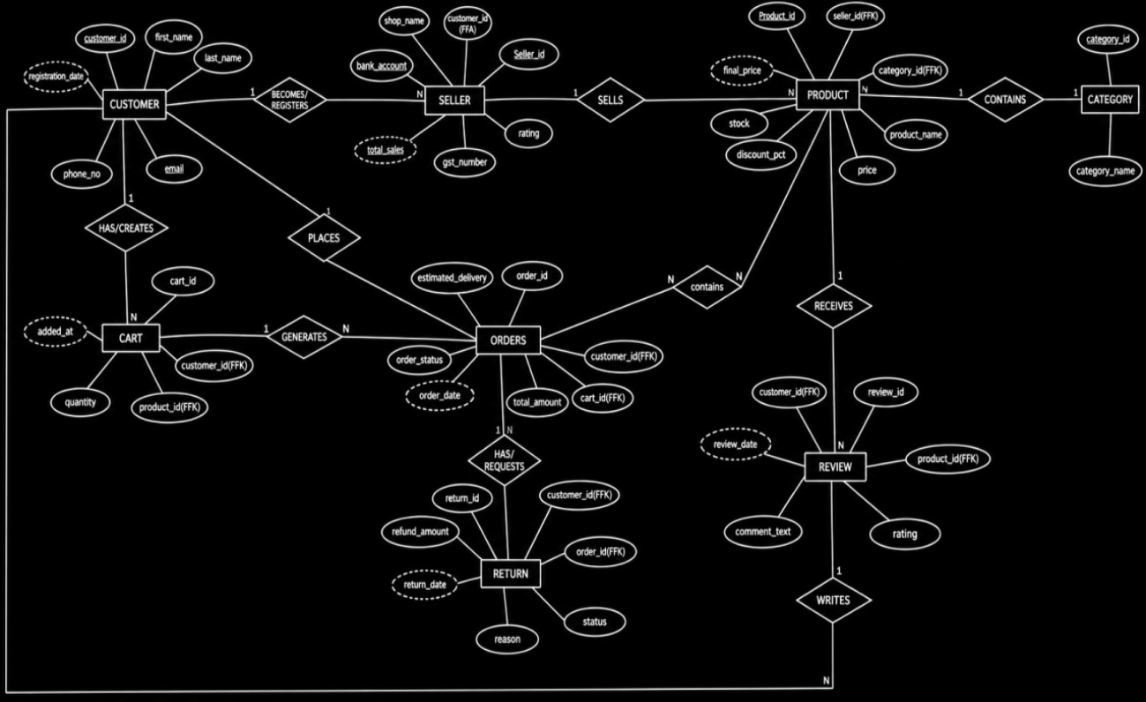
Figure 6.3: ER Diagram of the Online Shopping System

6.4 Relationships & Cardinality
Table 6.4: Relationships & Cardinality
Entity 1 | Relationship | Entity 2 | Cardinality (1:1 / 1:N / M:N)
Customer | becomes / registers as | Seller | 1:N
Seller | sells | Product | 1:N
Category | contains | Product | 1:N
Customer | has / creates | Cart | 1:N
Customer | places | Orders | 1:N
Cart | generates | Orders | 1:N
Orders | contains | Product | M:N
Product | receives | Review | 1:N
Customer | writes | Review | 1:N
Orders | has / requests | Return | 1:N
Customer | requests | Return | 1:N
Note: The relationships Cart–Orders and Orders–Product are logical relationships shown in the ER diagram. In the implemented DDL, cart items are linked to customers and products through Cart.customer_id and Cart.product_id, and every order is linked to its customer through Orders.customer_id.

6.5 Relational Database Schema
Table 6.5: Relational Database Schema
Table Name | Column Name | Data Type | PK/FK/— | Constraints
Customer | customer_id | INTEGER | PK | PRIMARY KEY
Customer | first_name | VARCHAR(50) | — | NOT NULL
Customer | last_name | VARCHAR(50) | — | NOT NULL
Customer | email | VARCHAR(100) | — | NOT NULL, UNIQUE
Customer | phone_no | VARCHAR(15) | — | NULL allowed
Customer | registration_date | DATE | — | NOT NULL
Seller | seller_id | INTEGER | PK | PRIMARY KEY
Seller | customer_id | INTEGER | FK | NOT NULL, FOREIGN KEY → Customer
Seller | shop_name | VARCHAR(100) | — | NOT NULL, UNIQUE
Seller | gst_number | VARCHAR(20) | — | UNIQUE
Seller | rating | REAL | — | CHECK 0–5
Seller | total_sales | INTEGER | — | CHECK ≥ 0
Seller | bank_account | VARCHAR(20) | — | NULL allowed
Category | category_id | INTEGER | PK | PRIMARY KEY
Category | category_name | VARCHAR(100) | — | NOT NULL, UNIQUE
Product | product_id | INTEGER | PK | PRIMARY KEY
Product | seller_id | INTEGER | FK | NOT NULL, FOREIGN KEY → Seller
Product | product_name | VARCHAR(200) | — | NOT NULL
Product | category_id | INTEGER | FK | NOT NULL, FOREIGN KEY → Category
Product | price | REAL | — | NOT NULL, CHECK ≥ 0
Product | discount_pct | REAL | — | CHECK 0–100
Product | final_price | REAL | — | NULL allowed
Product | stock | INTEGER | — | CHECK ≥ 0
Cart | cart_id | INTEGER | PK | PRIMARY KEY
Cart | customer_id | INTEGER | FK | NOT NULL, FOREIGN KEY → Customer
Cart | product_id | INTEGER | FK | NOT NULL, FOREIGN KEY → Product
Cart | quantity | INTEGER | — | NOT NULL, CHECK > 0
Cart | added_at | DATE | — | NULL allowed
Orders | order_id | INTEGER | PK | PRIMARY KEY
Orders | customer_id | INTEGER | FK | NOT NULL, FOREIGN KEY → Customer
Orders | order_date | DATE | — | NOT NULL
Orders | total_amount | REAL | — | CHECK ≥ 0
Orders | order_status | VARCHAR(30) | — | CHECK Placed/Shipped/Delivered/Cancelled
Orders | estimated_delivery | DATE | — | NULL allowed
Review | review_id | INTEGER | PK | PRIMARY KEY
Review | product_id | INTEGER | FK | NOT NULL, FOREIGN KEY → Product
Review | customer_id | INTEGER | FK | NOT NULL, FOREIGN KEY → Customer
Review | rating | INTEGER | — | NOT NULL, CHECK 1–5
Review | comment_text | VARCHAR(1000) | — | NULL allowed
Review | review_date | DATE | — | NULL allowed
Return | return_id | INTEGER | PK | PRIMARY KEY
Return | order_id | INTEGER | FK | NOT NULL, FOREIGN KEY → Orders
Return | customer_id | INTEGER | FK | NOT NULL, FOREIGN KEY → Customer
Return | reason | VARCHAR(1000) | — | NULL allowed
Return | return_date | DATE | — | NULL allowed
Return | status | VARCHAR(20) | — | CHECK Requested/Approved/Refunded
Return | refund_amount | REAL | — | CHECK ≥ 0

The relational schema diagram below shows each table with its primary keys (PK), foreign keys (FK) and the 1:M relationships between the tables.
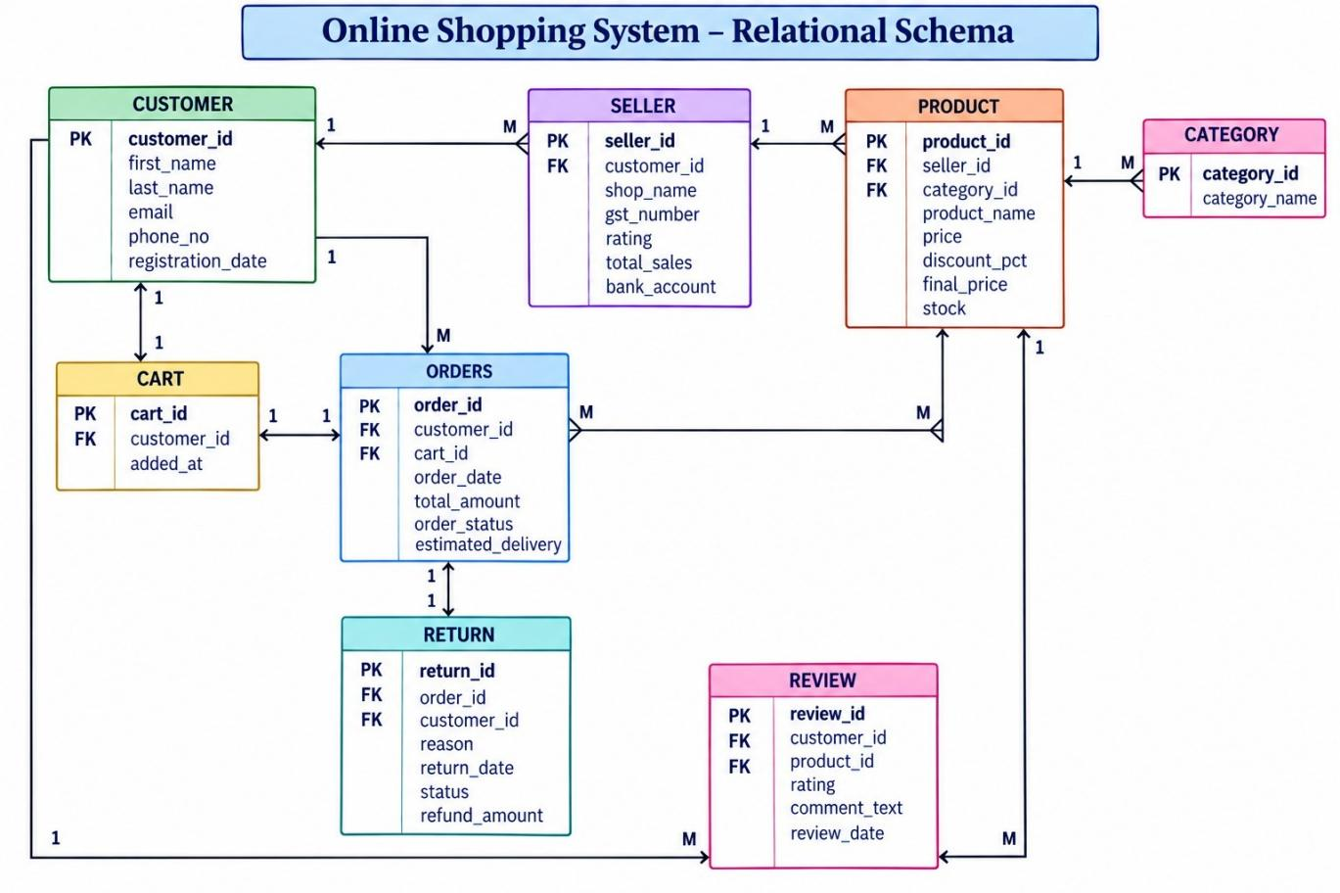
Figure 6.5: Relational Schema of the Online Shopping System

6.6 Normalization
UNF → 1NF → 2NF → 3NF
Un-Normalized Form (UNF): Online shopping information could be represented as one large combined record containing customer, seller, shop, product, category, cart, order, review and return details together. Such a record would contain repeating groups (many products per order, many reviews per product) and repeated seller, customer and category details.
First Normal Form (1NF): Repeating groups are removed and every attribute holds atomic values. For example, the customer name is split into first_name and last_name, and each product, cart item, review and return is stored as a separate row identified by its own key.
Second Normal Form (2NF): Each entity is separated into its own table with a single-column primary key (customer_id, seller_id, category_id, product_id, cart_id, order_id, review_id, return_id), so every non-key attribute depends on the complete primary key. No partial dependencies remain.
Third Normal Form (3NF): Relationships are represented using foreign keys, so seller details, category names, customer details and order details are stored only once in their own tables instead of being repeated in product, cart, review or return rows. This removes transitive dependencies and reduces update, insertion and deletion anomalies.
Note: final_price in Product and total_sales in Seller are stored as derived values for faster reporting, as defined in the supplied schema.
Table 6.6: Primary & Foreign Keys
Table | Primary Key | Foreign Key | References
Customer | customer_id | — | —
Seller | seller_id | customer_id | Customer(customer_id)
Category | category_id | — | —
Product | product_id | seller_id | Seller(seller_id)
Product | — | category_id | Category(category_id)
Cart | cart_id | customer_id | Customer(customer_id)
Cart | — | product_id | Product(product_id)
Orders | order_id | customer_id | Customer(customer_id)
Review | review_id | product_id | Product(product_id)
Review | — | customer_id | Customer(customer_id)
Return | return_id | order_id | Orders(order_id)
Return | — | customer_id | Customer(customer_id)

7. DATABASE IMPLEMENTATION

7.1 DDL — Database and Table Creation
The following PostgreSQL DDL script creates all eight tables with their primary keys, foreign keys and constraints.
-- 1. CUSTOMER
CREATE TABLE Customer (
customer_id INTEGER PRIMARY KEY,
first_name VARCHAR(50) NOT NULL,
last_name VARCHAR(50) NOT NULL,
email VARCHAR(100) NOT NULL UNIQUE,
phone_no VARCHAR(15),
registration_date DATE NOT NULL
);

-- 2. SELLER
CREATE TABLE Seller (
seller_id INTEGER PRIMARY KEY,
customer_id INTEGER NOT NULL,
shop_name VARCHAR(100) NOT NULL UNIQUE,
gst_number VARCHAR(20) UNIQUE,
rating REAL,
total_sales INTEGER,
bank_account VARCHAR(20),
CONSTRAINT fk_seller_customer
FOREIGN KEY (customer_id) REFERENCES Customer(customer_id),
CONSTRAINT chk_seller_rating CHECK (rating BETWEEN 0 AND 5),
CONSTRAINT chk_seller_sales CHECK (total_sales >= 0)
);

-- 3. CATEGORY
CREATE TABLE Category (
category_id INTEGER PRIMARY KEY,
category_name VARCHAR(100) NOT NULL UNIQUE
);

-- 4. PRODUCT
CREATE TABLE Product (
product_id INTEGER PRIMARY KEY,
seller_id INTEGER NOT NULL,
product_name VARCHAR(200) NOT NULL,
category_id INTEGER NOT NULL,
price REAL NOT NULL,
discount_pct REAL,
final_price REAL,
stock INTEGER,
CONSTRAINT fk_product_seller
FOREIGN KEY (seller_id) REFERENCES Seller(seller_id),
CONSTRAINT fk_product_category
FOREIGN KEY (category_id) REFERENCES Category(category_id),
CONSTRAINT chk_product_price CHECK (price >= 0),
CONSTRAINT chk_product_discount CHECK (discount_pct BETWEEN 0 AND 100),
CONSTRAINT chk_product_stock CHECK (stock >= 0)
);

-- 5. CART
CREATE TABLE Cart (
cart_id INTEGER PRIMARY KEY,
customer_id INTEGER NOT NULL,
product_id INTEGER NOT NULL,
quantity INTEGER NOT NULL,
added_at DATE,
CONSTRAINT fk_cart_customer
FOREIGN KEY (customer_id) REFERENCES Customer(customer_id),
CONSTRAINT fk_cart_product
FOREIGN KEY (product_id) REFERENCES Product(product_id),
CONSTRAINT chk_cart_quantity CHECK (quantity > 0)
);

-- 6. ORDERS
CREATE TABLE Orders (
order_id INTEGER PRIMARY KEY,
customer_id INTEGER NOT NULL,
order_date DATE NOT NULL,
total_amount REAL,
order_status VARCHAR(30),
estimated_delivery DATE,
CONSTRAINT fk_order_customer
FOREIGN KEY (customer_id) REFERENCES Customer(customer_id),
CONSTRAINT chk_order_amount CHECK (total_amount >= 0),
CONSTRAINT chk_order_status CHECK (
order_status IN ('Placed', 'Shipped', 'Delivered', 'Cancelled'))
);

-- 7. REVIEW
CREATE TABLE Review (
review_id INTEGER PRIMARY KEY,
product_id INTEGER NOT NULL,
customer_id INTEGER NOT NULL,
rating INTEGER NOT NULL,
comment_text VARCHAR(1000),
review_date DATE,
CONSTRAINT fk_review_product
FOREIGN KEY (product_id) REFERENCES Product(product_id),
CONSTRAINT fk_review_customer
FOREIGN KEY (customer_id) REFERENCES Customer(customer_id),
CONSTRAINT chk_review_rating CHECK (rating BETWEEN 1 AND 5)
);

-- 8. RETURN
CREATE TABLE Return (
return_id INTEGER PRIMARY KEY,
order_id INTEGER NOT NULL,
customer_id INTEGER NOT NULL,
reason VARCHAR(1000),
return_date DATE,
status VARCHAR(20),
refund_amount REAL,
CONSTRAINT fk_return_order
FOREIGN KEY (order_id) REFERENCES Orders(order_id),
CONSTRAINT fk_return_customer
FOREIGN KEY (customer_id) REFERENCES Customer(customer_id),
CONSTRAINT chk_return_status CHECK (
status IN ('Requested', 'Approved', 'Refunded')),
CONSTRAINT chk_refund_amount CHECK (refund_amount >= 0)
);

7.2 Sample Data — DML
Each table was populated with representative sample records using INSERT statements. A sample of the insert statements is shown below.
Table 7.2: Sample Data — DML
Table | No. of Records | Sample Data / Screenshot Reference
Customer | 10 | dml.sql — Customer seed records
Seller | 10 | dml.sql — Seller seed records
Category | 10 | dml.sql — Category seed records
Product | 10 | dml.sql — Product seed records
Cart | 10 | dml.sql — Cart seed records
Orders | 10 | dml.sql — Orders seed records
Review | 10 | dml.sql — Review seed records
Return | 10 | dml.sql — Return seed records

7.3 Constraints & Data Integrity
Table 7.3: Constraints & Data Integrity
Constraint / Validation | Applied On | Purpose | Evidence / Screenshot
PRIMARY KEY | All eight tables | Uniquely identifies each record and prevents duplicate key values. | ddl.sql
FOREIGN KEY | Seller, Product, Cart, Orders, Review, Return | Maintains valid relationships between related tables. | ddl.sql
NOT NULL | Required fields across tables | Prevents missing values in required attributes. | ddl.sql
UNIQUE | Customer.email; Seller.shop_name, gst_number; Category.category_name | Prevents duplicate unique identifiers and names. | ddl.sql
CHECK | Seller.rating (0–5), total_sales ≥ 0; Product.price ≥ 0, discount_pct (0–100), stock ≥ 0; Cart.quantity > 0; Review.rating (1–5); Orders.total_amount ≥ 0, order_status; Return.status, refund_amount ≥ 0 | Restricts invalid or out-of-range values. | ddl.sql

7.4 SQL Operations & Queries
Table 7.4: SQL Operations & Queries
S.No | Operation / Query | Purpose | SQL Query / Screenshot Ref.
1 | Basic SELECT — all customers | Retrieve customer records. | queries.sql Q1
2 | Filtered SELECT — affordable products | Find products with final price below 5000, ordered by price. | queries.sql Q2
3 | LIKE filtering | Search customers by name or e-mail pattern. | queries.sql Q3
4 | Filtered SELECT — delivered orders | List all orders with status Delivered. | queries.sql Q4
5 | CREATE — INSERT | Register a new customer. | queries.sql Q5
6 | UPDATE | Change the stock of product 1001 to 20. | queries.sql Q6
7 | DELETE | Remove cart entry 301. | queries.sql Q7
8 | AVG aggregate | Calculate the average product review rating. | queries.sql Q8
9 | JOIN (3 tables) | Display products with seller shop name and category. | queries.sql Q9
10 | JOIN | Display orders with customer names and status. | queries.sql Q10
11 | GROUP BY + aggregates | Count products and average price per category. | queries.sql Q11
12 | GROUP BY + HAVING | Find order statuses having two or more orders. | queries.sql Q12
13 | Subquery | Find products priced above the average price. | queries.sql Q13
14 | Subquery (IN) | Find customers who received a refund. | queries.sql Q14
15 | VIEW | Create and query a product details view. | queries.sql Q15
16 | Set operation — UNION | Combine laptops and products priced under 1000. | queries.sql Q16
17 | DCL — GRANT / REVOKE | Grant and revoke read access on Product. | queries.sql Q17
18 | TCL — SAVEPOINT / ROLLBACK | Run a transaction and roll back part of it. | queries.sql Q18
The complete SQL text of all eighteen queries is given in Appendix A.

7.5 Sample Outputs / Screenshots
The following figures show the output of the SQL operations listed in Table 7.4. Screenshots are to be taken from the same PostgreSQL environment used for the DDL and DML scripts.
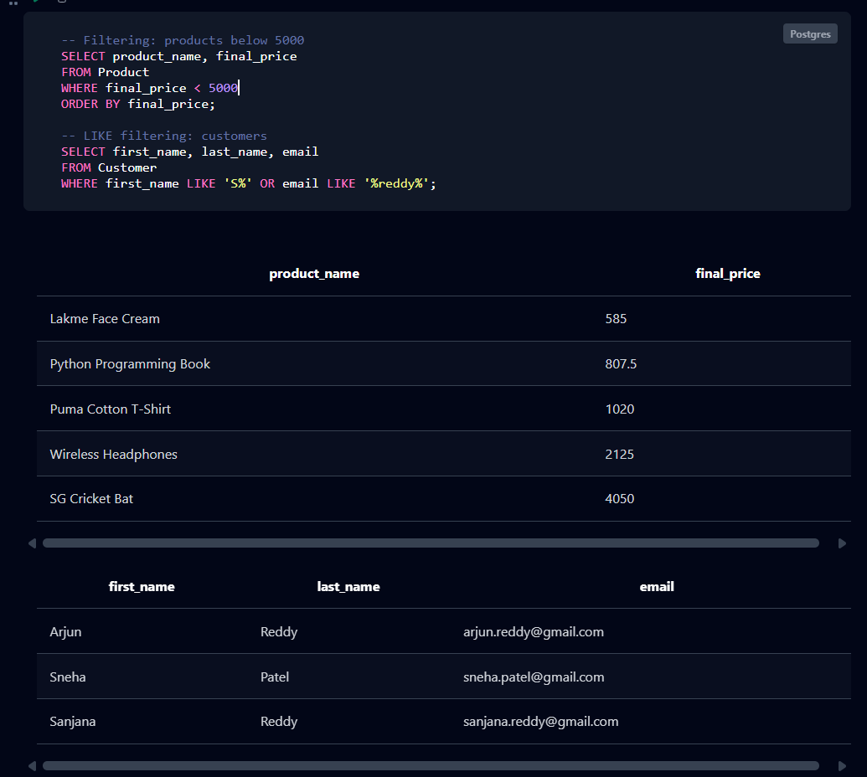

Figure 1: Filtering and LIKE output

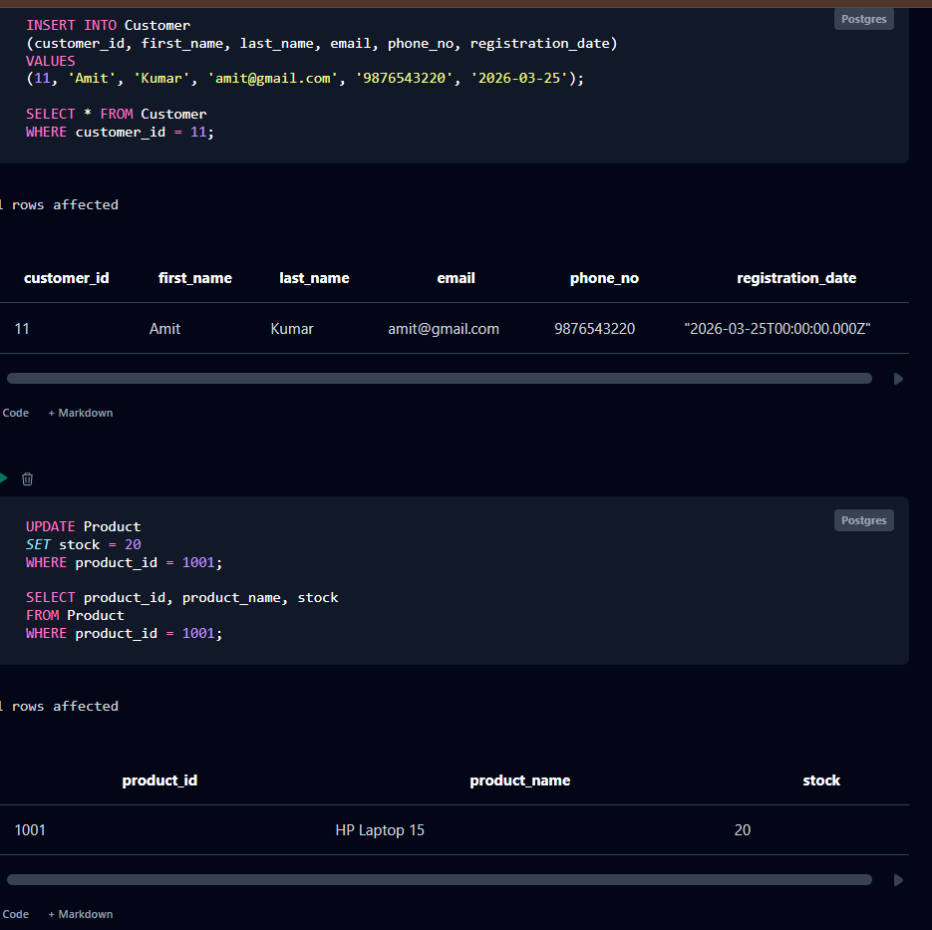
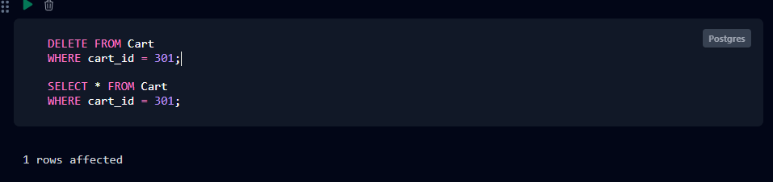
Figure 2: CRUD operations (INSERT / UPDATE / DELETE) output

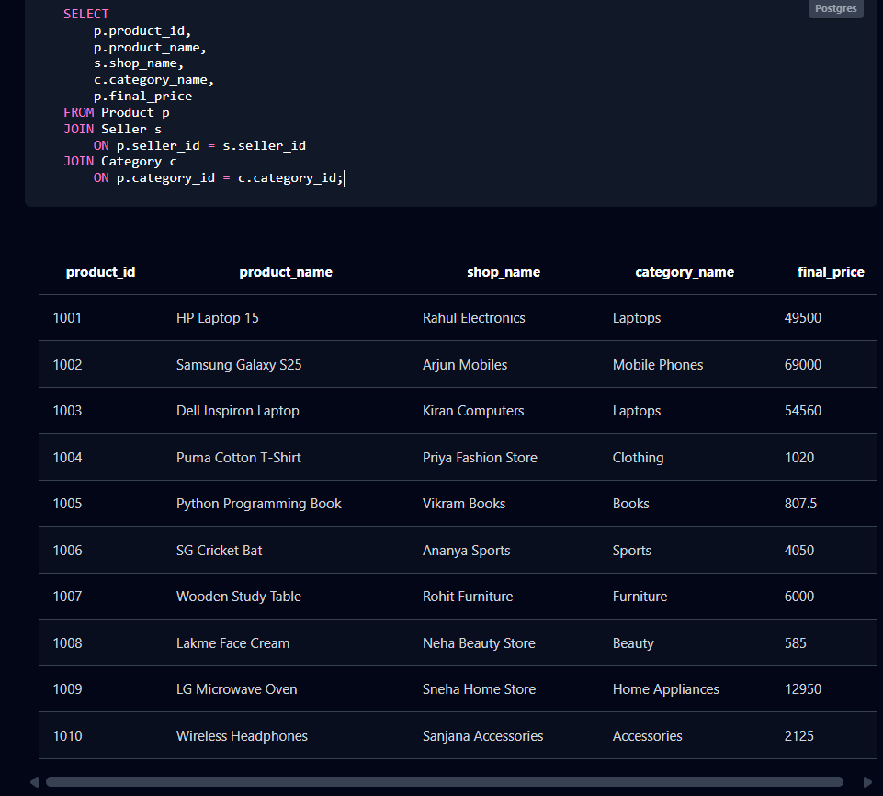
Figure 3: Join output

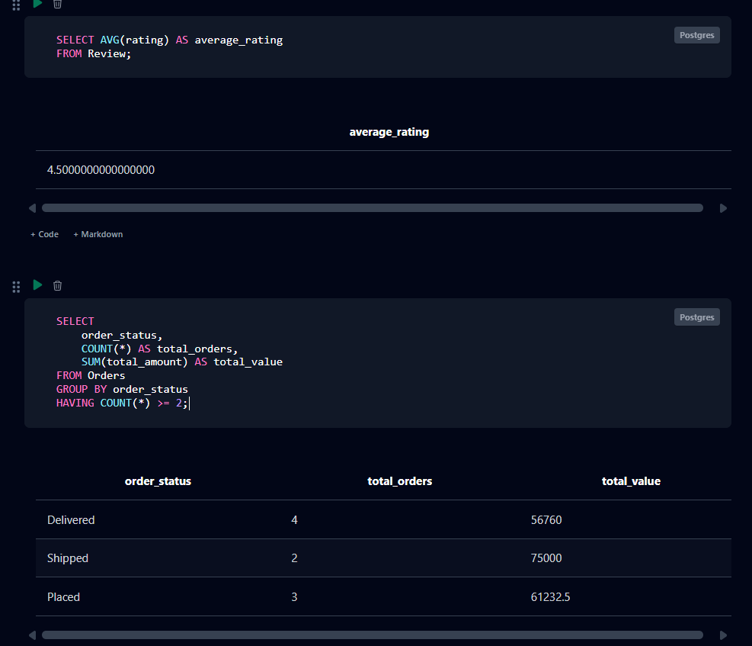
Figure 4: Aggregate / GROUP BY / HAVING output
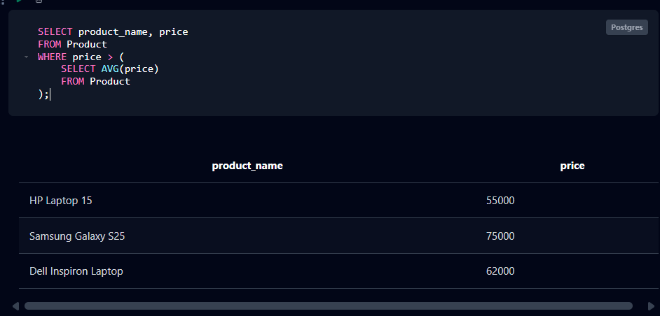
Figure 5: Subquery output

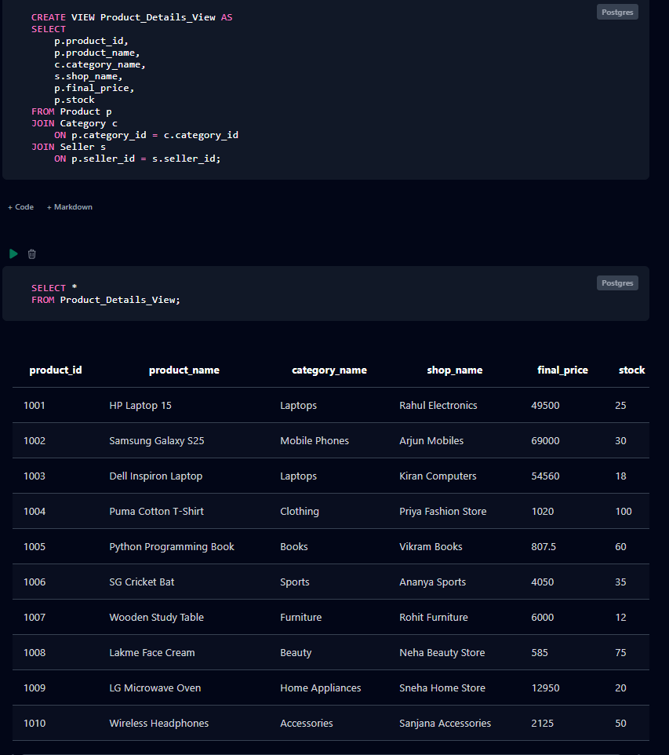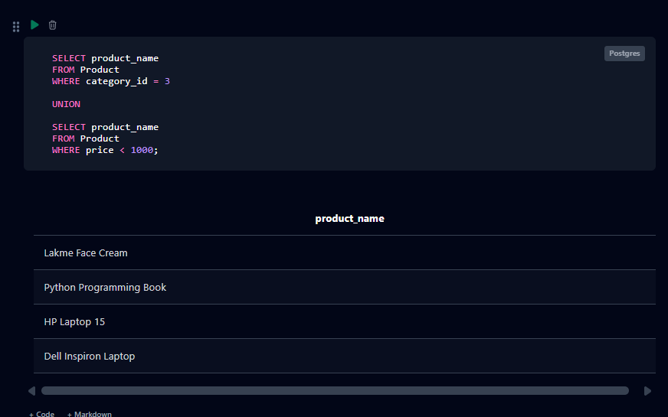
Figure 6: View and set operation output

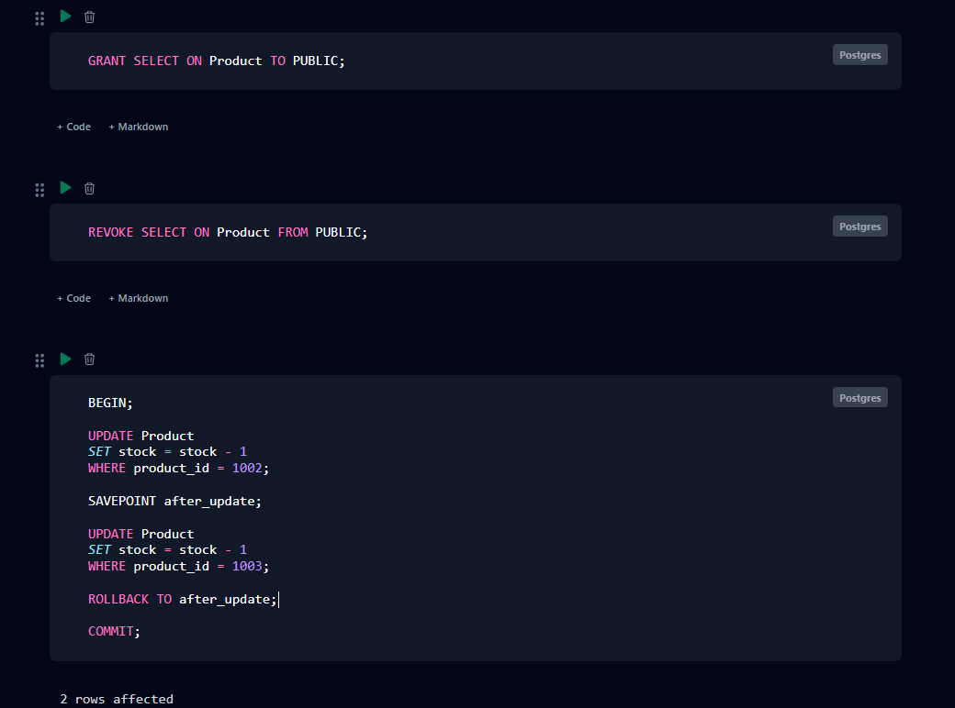
Figure 7: DCL and TCL output

8. MODULES & FUNCTIONALITIES
Table 8: Modules & Functionalities
S.No | Module Name | Functionality
1 | Customer Management | Maintains customer identity, e-mail, phone number and registration details.
2 | Seller Management | Stores seller shop details, GST number, rating, total sales and bank account linked to a customer.
3 | Category Management | Organizes products into categories such as Electronics, Books, Clothing and Sports.
4 | Product Management | Stores product details, price, discount, final price and available stock.
5 | Cart Management | Records products added to a customer’s cart along with quantity and date.
6 | Order Management | Stores orders with date, total amount, status and estimated delivery date.
7 | Review Management | Stores customer ratings and comments for products.
8 | Return & Refund Management | Tracks return requests, reasons, return status and refund amounts.

9. GITHUB REPOSITORY & TEAM RESPONSIBILITIES
Repository Link: https://github.com/Prathap1003/online-shopping-system-dbms.git
The repository contains the DDL SQL, DML SQL, DQL / SQL queries, ER diagram, project documentation and presentation (PPT).
Table 9: GitHub Repository & Team Responsibilities
Student Name | Roll Number | Role / Responsibility | Contribution Status
ALA YUGANDHAR | 25B11AI26 | Database design & documentation | Completed
BOYA PRATHAP | 25B11AI156 | ER diagram & relational schema design | Completed
PITCHUKA RAVI RAJ | 25B11AI961 | SQL – DDL, DML & queries | Completed
VELPUKONDA MANOJ PRASAD | 25B11AIC31 | Testing & presentation | Completed

10. ENHANCEMENTS & FUTURE IMPROVEMENTS
Future improvements can extend the current database with delivery tracking, richer analytics and reporting dashboards, user authentication and role-based access for customers and sellers, a front-end web or mobile interface, stronger audit logging and security features, stored procedures and triggers (for example, to reduce stock automatically when an order is placed), an order-items table to support multiple products per order, and indexing for frequently queried columns. These features are not part of the current submission and are proposed enhancements only.

11. CONCLUSION
The Online Shopping System successfully models the main entities of an online shopping environment using a relational database structure. The DDL defines eight tables — Customer, Seller, Category, Product, Cart, Orders, Review and Return — with primary keys, foreign keys, NOT NULL, UNIQUE and CHECK constraints. The DML script supplies representative records for all tables. The SQL queries demonstrate selection and filtering, CRUD operations, joins, aggregate functions, GROUP BY/HAVING, subqueries, views, set operations, DCL and TCL.
The project therefore meets its core objectives of relational design, data integrity, sample-data population and practical SQL analysis. The key learning outcomes are relational modeling, PK/FK integrity, constraints, SQL querying and normalization. The team divided the work across database design and documentation, ER/schema design, SQL development, and testing and presentation.

12. REFERENCES
- Project DDL script: ddl.sql.
- Project DML / sample-data script: dml.sql.
- Project SQL query script: queries.sql.
- PostgreSQL Documentation – https://www.postgresql.org/docs/
- Aditya University – DBMS Capstone Project documentation template.
- GitHub repository: Online Shopping System (project repository).

APPENDIX

A. Complete SQL Script
The final SQL implementation is supplied through the project files:
- ddl.sql — database table definitions, keys, foreign keys and constraints (listed in Section 7.1).
- dml.sql — sample data for all eight tables.
- queries.sql — representative SQL operations and queries (listed below).
Repository: https://github.com/Prathap1003/online-shopping-system-dbms.git
SQL Queries (queries.sql)
-- Q1: Basic SELECT - all customers
SELECT * FROM Customer;

-- Q2: Filtered SELECT - products with final price below 5000
SELECT product_name, final_price
FROM Product
WHERE final_price < 5000
ORDER BY final_price;

-- Q3: LIKE filtering - search customers by name or e-mail
SELECT first_name, last_name, email
FROM Customer
WHERE first_name LIKE 'S%' OR email LIKE '%reddy%';

-- Q4: Filtered SELECT - delivered orders
SELECT * FROM Orders
WHERE order_status = 'Delivered';

-- Q5: CREATE (INSERT) - register a new customer
INSERT INTO Customer
(customer_id, first_name, last_name, email, phone_no, registration_date)
VALUES (11, 'Amit', 'Kumar', 'amit@gmail.com', '9876543220', '2026-03-25');

-- Q6: UPDATE - change stock of product 1001
UPDATE Product
SET stock = 20
WHERE product_id = 1001;

-- Q7: DELETE - remove a cart entry
DELETE FROM Cart
WHERE cart_id = 301;

-- Q8: AVG aggregate - average product rating
SELECT AVG(rating) AS average_rating FROM Review;

-- Q9: JOIN - products with seller and category
SELECT p.product_id, p.product_name, s.shop_name,
c.category_name, p.final_price
FROM Product p
JOIN Seller s ON p.seller_id = s.seller_id
JOIN Category c ON p.category_id = c.category_id;

-- Q10: JOIN - orders with customer names
SELECT o.order_id, c.first_name, c.last_name,
o.total_amount, o.order_status
FROM Orders o
JOIN Customer c ON o.customer_id = c.customer_id
ORDER BY o.order_id;

-- Q11: GROUP BY - products and average price per category
SELECT c.category_name,
COUNT(p.product_id) AS total_products,
AVG(p.price) AS average_price
FROM Category c
LEFT JOIN Product p ON c.category_id = p.category_id
GROUP BY c.category_name
ORDER BY c.category_name;

-- Q12: GROUP BY + HAVING - order statuses with 2 or more orders
SELECT order_status,
COUNT(*) AS total_orders,
SUM(total_amount) AS total_value
FROM Orders
GROUP BY order_status
HAVING COUNT(*) >= 2;

-- Q13: Subquery - products priced above the average price
SELECT product_name, price
FROM Product
WHERE price > (SELECT AVG(price) FROM Product);

-- Q14: Subquery (IN) - customers who received a refund
SELECT first_name, last_name
FROM Customer
WHERE customer_id IN
(SELECT customer_id FROM Return WHERE status = 'Refunded');

-- Q15: VIEW - product details view
CREATE VIEW Product_Details_View AS
SELECT p.product_id, p.product_name, c.category_name,
s.shop_name, p.final_price, p.stock
FROM Product p
JOIN Category c ON p.category_id = c.category_id
JOIN Seller s ON p.seller_id = s.seller_id;

SELECT * FROM Product_Details_View;

-- Q16: Set operation (UNION) - laptops or products under 1000
SELECT product_name FROM Product WHERE category_id = 3
UNION
SELECT product_name FROM Product WHERE price < 1000;

-- Q17: DCL - grant and revoke read access
GRANT SELECT ON Product TO PUBLIC;
REVOKE SELECT ON Product FROM PUBLIC;

-- Q18: TCL - transaction with SAVEPOINT and ROLLBACK
BEGIN;
UPDATE Product SET stock = stock - 1 WHERE product_id = 1002;
SAVEPOINT after_update;
UPDATE Product SET stock = stock - 1 WHERE product_id = 1003;
ROLLBACK TO after_update;
COMMIT;

B. Additional Screenshots / Outputs
Additional evidence can include SQL execution screenshots showing table creation, sample data for every table, constraint errors, CRUD results, joins, GROUP BY/HAVING results, subquery outputs, views and transaction control.

