ONLINE SHOPPING MANAGEMENT SYSTEM
A DBMS Capstone Project Report submitted in partial fulfillment of the requirements for the award of the degree of
BACHELOR OF TECHNOLOGY
in
ARTIFICIAL INTELLIGENCE AND MACHINE LEARNING

Submitted By
ALA YUGANDHAR – 25B11AI026
BOYA PRATHAP – 25B11AI156
PITCHUKA RAVI RAJ – 25B11AI961
VELUPUKONDA MANOJ – 25B11AIC31

Under the esteemed guidance of
Mr. T.Srinivasulu M.Tech, (Ph.D.)
Assistant Professor



DEPARTMENT OF ARTIFICIAL INTELLIGENCE AND MACHINE LEARNING
ADITYA UNIVERSITY
(Formerly Aditya Engineering College (A))
Aditya Nagar, ADB Road, Surampalem, Andhra Pradesh, India
2026 – 2027

Aditya Nagar, ADB Road, Surampalem, Andhra Pradesh, India
DEPARTMENT OF ARTIFICIAL INTELLIGENCE AND MACHINE LEARNING
CERTIFICATE
This is to certify that the DBMS Capstone Project report entitled “ONLINE SHOPPING MANAGEMENT SYSTEM” is being submitted by ALA YUGANDHAR (25B11AI026), BOYA PRATHAP (25B11AI156), PITCHUKA RAVI RAJ (25B11AI961) and VELUPUKONDA MANOJ PRASAD (25B11AIC31) in partial fulfillment of the requirements for the award of the B.Tech. degree in Artificial Intelligence and Machine Learning. The work documented in this report was carried out as part of the Capstone Project for the course Database Management Systems (2501IT05) during the academic year 2026–2027, and records the database design, implementation, and documentation undertaken by the team.

Project Guide Head of the Department
Mr. T. Srinivasulu, M. Tech, (Ph.D.) Dr. K. Naga Bhargavi, M. Tech, Ph.D. Associatprofessor Associate Professor & HOD

External Examiner

DECLARATION
We hereby declare that the DBMS Capstone Project entitled “Online Shopping Management System” is a genuine work carried out by us. The database design, SQL implementation, queries and documentation presented in this report are our own work, completed under the guidance of Mr.T.Srinivasulu, Department of Artificial Intelligence and Machine Learning, Aditya University, Surampalem. We further declare that this work has not been submitted, in full or in part, for the award of any degree of this or any other educational institution.

Project Associates
Ala Yugandhar (25B11AI026)
Boya Prathap (25B11AI156)
Pitchuka Ravi Raj (25B11AI961)
Velupukonda Manoj Prasad (25B11AIC31)

Date: 30 september 2026
Place: Surampalem

ACKNOWLEDGEMENT
It is with immense pleasure that we express our indebted gratitude to our project guide Mr.T.Srinivasulu, Department of Atrificial Intelligence and Machine Learning, who guided us throughout the capstone project. We are thankful for the constant encouragement and valuable suggestions received at every review stage.
We are grateful to Dr. K .Naga Bhargavi, Head of the Department, for inspiring us and for arranging the facilities and resources needed for this project.
We extend our sincere thanks to the Management, Dr. M. Sreenivasa Reddy, Deputy Pro-Chancellor, Dr. M. B. Srinivas, Vice-Chancellor, and Dr. A. Ramesh, Pro Vice-Chancellor (Engineering & Sciences), for providing an excellent academic environment.
Not to forget, we thank the Teaching and Non-Teaching Staff, our parents and our friends, who have directly or indirectly supported us in completing this project on time.

Project Associates
Ala Yugandhar 25B11AI026
Boya Prathap 25B11AI156
Pitchuka Ravi Raj 25B11AI961
Velupukonda Manoj Prasad 25B11AIC31

ABSTRACT
The Online Shopping Management System is a relational database project developed for the online shopping and e-commerce domain, where customers purchase products from different sellers through a common platform. The system manages important information generated during shopping activities, including customer registrations, seller details, product catalogues, product categories, shopping carts, orders, customer reviews, and product returns. The database solves problems associated with maintaining shopping information in separate spreadsheets or flat files, such as duplicate data, inconsistent records, difficulty in maintaining relationships, and lack of automatic validation. The purpose of the project is to provide a centralized, structured, and reliable database for storing, retrieving, updating, and managing online shopping information while maintaining data integrity. The scope is limited to the database design, implementation, and SQL operations layer and does not include payment gateway integration, real-time warehouse synchronization, detailed shipping logistics, or a front-end web or mobile application. The system contains eight major entities/tables: Customer, Seller, Category, Product, Cart, Orders, Review, and Return. PostgreSQL 16 is used as the DBMS, with pgAdmin 4/psql and dbfiddle.dev used for query execution and testing, draw.io for ER diagram design, GitHub for version control, and Microsoft Word 2021 for documentation. The project implements DDL, DML, DQL, joins, aggregate functions, GROUP BY, HAVING, nested and correlated subqueries, views, UNION, INTERSECT, EXCEPT, DCL, and TCL operations. Primary keys, foreign keys, UNIQUE, NOT NULL, and CHECK constraints are used to maintain data integrity. The final outcome is a functional, normalized, and validated relational database that demonstrates practical database design and SQL operations for an online shopping environment.

ADITYA UNIVERSITY
Surampalem
Department of Computer Science and Engineering

DBMS CAPSTONE PROJECT


Project Documentation Report
Project Title: Online Shopping Management System
Submitted by:
Course: Database Management System (DBMS) Course Code: DBMS
Faculty Coordinator:
Academic Year: 2026–27
Date of Submission: 30 September 2026
GitHub Repository Link: https://github.com/Prathap1003/online-shopping-system-dbms.git

S.No | Student Name | Roll Number
1 | B PRATHAP | 25B11AI156
2 | A YUGANDHAR | 25B11AI021
3 | P RAVI RAJ | 25B11AI961
4 | V MANOJ PRASAD | 25B11AIC31

INDEX
Chapter | Title | Page No.
 | Certificate | i
 | Declaration | ii
 | Acknowledgement | iii
 | Abstract | iv
 | List of Figures | v
 | List of Tables | vi
1 | Introduction
 | 1.1 Introduction to the Domain
 | 1.2 Problem Statement
 | 1.3 Motivation and Need for a Database
 | 1.4 Objectives of the Project
 | 1.5 Scope of the Project
 | 1.6 Organization of the Report
2 | System Study and Tools
 | 2.1 Existing System and Its Limitations
 | 2.2 Proposed Database System
 | 2.3 Tools and Technologies Used
 | 2.4 Software and Hardware Requirements
3 | Database Design (Review – I)
 | 3.1 Identified Entities
 | 3.2 Entity Attributes and Attribute Types
 | 3.3 ER Diagram
 | 3.4 Relationships and Cardinality
 | 3.5 Relational Database Schema
 | 3.6 Primary Keys and Foreign Keys
 | 3.7 Normalization up to 3NF
4 | Database Implementation (Review – II)
 | 4.1 Database and Table Creation – DDL
 | 4.2 Sample Data Insertion – DML
 | 4.3 Constraints and Data Integrity
 | 4.4 Data Validation Rules
5 | SQL Operations and Queries
 | 5.1 DQL – Basic Retrieval Queries
 | 5.2 Join Operations
 | 5.3 Aggregate Functions, GROUP BY and HAVING
 | 5.4 Nested and Correlated Subqueries
 | 5.5 Views and Relational Set Operations
 | 5.6 DCL and TCL Operations
6 | Modules and Functionalities
7 | Results – Sample Outputs and Screenshots
8 | Testing and Data Validation
9 | GitHub Repository and Team Contribution
10 | Conclusion and Future Enhancements
 | References
 | Appendix A – Complete SQL Script

LIST OF FIGURES
Figure No. | Title of the Figure | Page No.
3.1 | ER Diagram of the Online Shopping Management System | 15
3.2 | Relational Schema Diagram | 18
4.1 | Successful Creation of Tables | 24
4.1 | Referential Integrity Enforced by the Database | 27
7.1 | Customer Records Registered in January 2026 | 28
7.2 | Inner Join Between Orders and Customer | 34
7.3 | Average Product Price by Category | 34
7.4 | Products Priced Above the Average Product Price | 35

LIST OF TABLES
Table No. | Title of the Table | Page No.
Table 2.1 | Tools and Technologies Used | 12
Table 2.2 | Software and Hardware Requirements | 12
Table 3.1 | Entities Identified for the Selected Domain | 13
Table 3.2 | Attributes of Each Entity | 13
Table 3.3 | Relationships and Cardinality | 15
Table 3.4 | Relational Database Schema | 16
Table 3.5 | Primary Key and Foreign Key Definitions | 18
Table 3.6 | Normalization Steps | 19
Table 4.1 | Sample Data Summary | 25
Table 4.2 | Constraints and Data Integrity Rules | 27
Table 5.1 | Basic Retrieval Queries | 29
Table 5.2 | Join Operations | 29
Table 5.3 | Aggregate, GROUP BY and HAVING Queries | 30
Table 5.4 | Subqueries | 30
Table 5.5 | Views and Set Operations | 31
Table 5.6 | DCL and TCL Operations | 31
Table 6.1 | Modules and Their Functionalities | 33
Table 8.1 | Test Cases and Results | 36
Table 9.1 | Team Responsibilities | 37
Table 9.2 | Review-wise Progress Record | 37

CHAPTER 1: INTRODUCTION

1.1 Introduction to the Domain
Online shopping has become one of the primary ways customers purchase goods, with multiple sellers offering products across categories such as electronics, mobile phones, clothing and books through a single platform. An Online Shopping Management System handles the day-to-day information generated by this activity — customer registrations, seller shop details, the product catalog, items added to cart, confirmed orders, customer reviews and product returns. Every transaction on the platform, from a customer adding an item to their cart to a return being refunded, generates data that must be stored accurately and linked correctly across these related entities.

1.2 Problem Statement
Without a proper database, an online shopping platform typically stores customer, seller and order information in separate spreadsheets or flat files maintained by different teams. This leads to the same customer or product details being entered more than once, no automatic check that an order refers to a valid customer and product, and difficulty answering questions such as which seller has the highest-rated products or how many orders are pending refund. The proposed relational database addresses these problems by consolidating all shopping data into a single normalized schema with enforced primary key and foreign key relationships.

1.3 Motivation and Need for a Database
A DBMS is required instead of spreadsheets because the shopping domain involves many related entities — customers can also become sellers, a product belongs to exactly one category but many customers can add it to their cart, and one order can lead to one return. Only a relational database can enforce these relationships automatically through foreign keys and constraints, support concurrent read/write access from multiple users, and answer complex queries such as revenue per seller or average rating per category using SQL instead of manual computation.

1.4 Objectives of the Project
List 3–5 clear and measurable objectives.
- To design a normalized relational database for the selected domain with at least six entities.
- To implement the database with appropriate primary keys, foreign keys and integrity constraints.
- To enforce data integrity through NOT NULL, UNIQUE and CHECK constraints on customer, seller, product, order, review and return data.
- To implement and execute SQL queries covering retrieval, joins, aggregation, subqueries, views and set operations on the shopping database.
- To demonstrate transaction control (COMMIT, SAVEPOINT, ROLLBACK) and access control (GRANT, REVOKE) on the database.

1.5 Scope of the Project
The database covers customer registration, seller onboarding, product cataloguing with categories, shopping cart management, order placement and tracking, customer reviews and product returns with refunds. It does not cover payment gateway integration, real-time inventory synchronization with external warehouses, shipping/logistics tracking beyond an estimated delivery date, or a front-end web/mobile application — the system is limited to the database design, implementation and SQL operations layer.

1.6 Organization of the Report
This report is organized into ten chapters. Chapter 2 presents the system study and the tools used. Chapter 3 covers the complete database design including the ER diagram, relational schema and normalization. Chapter 4 describes the database implementation with DDL and sample data. Chapter 5 presents the SQL operations and queries executed. Chapter 6 explains the modules and functionalities. Chapter 7 presents the results with sample outputs. Chapter 8 covers testing and data validation. Chapter 9 details the GitHub repository and the contribution of each team member. Chapter 10 concludes the report and outlines future enhancements.

CHAPTER 2: SYSTEM STUDY AND TOOLS

2.1 Existing System and Its Limitations
Many small and medium online sellers currently track customers, products and orders using spreadsheets or basic record-keeping tools maintained independently by each seller. This results in duplicated customer information across sellers, no automatic check that an order refers to a product that is actually in stock, manual and error-prone calculation of total sales or average ratings, and no structured way to track return and refund status against the original order.

2.2 Proposed Database System
The proposed Online Shopping Management System database consolidates customers, sellers, categories, products, carts, orders, reviews and returns into a single normalized PostgreSQL database. Foreign keys tie every order, review and return back to a valid customer and product, CHECK constraints keep ratings, stock and prices within valid ranges, and SQL queries replace manual computation for reporting tasks such as revenue, top-rated sellers and pending returns.

2.3 Tools and Technologies Used
Table 2.1: Tools and Technologies Used
Category | Tool / Technology Used | Version / Remarks
Database Server | PostgreSQL | Version 16
Query / Admin Tool | pgAdmin 4 / psql | Latest
ER Diagram Tool | draw.io (diagrams.net) | Web-based
Version Control | GitHub | —
Documentation | Microsoft Word | 2021
Development Environment | dbfiddle.dev / local PostgreSQL server | Online + Local

Typical entries: Database Server (Oracle 10g / MySQL / PostgreSQL); Query or admin tool (SQL*Plus, SQL Developer, pgAdmin, dbfiddle.dev); ER diagram tool (draw.io / diagrams.net); Front-end, if any; Version control (GitHub); Documentation (MS Word).

2.4 Software and Hardware Requirements
Table 2.2: Software and Hardware Requirements
Requirement Type | Specification
Operating System | Windows 10/11 or Ubuntu 22.04
Database Software | PostgreSQL 16
RAM | Minimum 4 GB (8 GB recommended)
Processor | Intel i3 or higher
Storage | Minimum 2 GB free disk space
Other Tools | pgAdmin 4, draw.io, Git

CHAPTER 3: DATABASE DESIGN
(Deliverables of Review – I)

3.1 Identified Entities
Minimum six entities are required. Give a one-line description of each.
Table 3.1: Entities Identified for the Selected Domain
S.No | Entity Name | Description
1 | Customer | Stores personal and registration details of every person who uses the platform
2 | Seller | Stores shop and business details of customers who also sell products on the platform
3 | Category | Stores the product categories used to classify items
4 | Product | Stores details of every item listed for sale, including price and stock
5 | Cart | Stores the items a customer has added for purchase before checkout
6 | Orders | Stores details of confirmed purchases placed by customers
7 | Review | Stores customer feedback and ratings for purchased products
8 | Return | Stores details of product return requests and their refund status

3.2 Entity Attributes and Attribute Types
List every attribute of every entity. Mark the key column as PK, FK or —, and classify each attribute as Simple, Composite, Multi-valued or Derived.
Table 3.2: Attributes of Each Entity
Entity | Attribute | Data Type | Key (PK / FK / —) | Attribute Type
Customer | customer_id | INTEGER | PK | Simple
Customer | first_name | VARCHAR(50) | — | Simple
Customer | last_name | VARCHAR(50) | — | Simple
Customer | email | VARCHAR(100) | — | Simple
Customer | phone_no | VARCHAR(15) | — | Simple
Customer | registration_date | DATE | — | Simple
Seller | seller_id | INTEGER | PK | Simple
Seller | customer_id | INTEGER | FK | Simple
Seller | shop_name | VARCHAR(100) | — | Simple
Seller | gst_number | VARCHAR(20) | — | Simple
Seller | rating | REAL | — | Simple
Seller | total_sales | INTEGER | — | Derived
Seller | bank_account | VARCHAR(20) | — | Simple
Category | category_id | INTEGER | PK | Simple
Category | category_name | VARCHAR(100) | — | Simple
Product | product_id | INTEGER | PK | Simple
Product | seller_id | INTEGER | FK | Simple
Product | product_name | VARCHAR(200) | — | Simple
Product | category_id | INTEGER | FK | Simple
Product | price | REAL | — | Simple
Product | discount_pct | REAL | — | Simple
Product | final_price | REAL | — | Derived
Product | stock | INTEGER | — | Simple
Cart | cart_id | INTEGER | PK | Simple
Cart | customer_id | INTEGER | FK | Simple
Cart | product_id | INTEGER | FK | Simple
Cart | quantity | INTEGER | — | Simple
Cart | added_at | DATE | — | Simple
Orders | order_id | INTEGER | PK | Simple
Orders | customer_id | INTEGER | FK | Simple
Orders | order_date | DATE | — | Simple
Orders | total_amount | REAL | — | Derived
Orders | order_status | VARCHAR(30) | — | Simple
Orders | estimated_delivery | DATE | — | Simple
Review | review_id | INTEGER | PK | Simple
Review | product_id | INTEGER | FK | Simple
Review | customer_id | INTEGER | FK | Simple
Review | rating | INTEGER | — | Simple
Review | comment_text | VARCHAR(1000) | — | Simple
Review | review_date | DATE | — | Simple
Return | return_id | INTEGER | PK | Simple
Return | order_id | INTEGER | FK | Simple
Return | customer_id | INTEGER | FK | Simple
Return | reason | VARCHAR(1000) | — | Simple
Return | return_date | DATE | — | Simple
Return | status | VARCHAR(20) | — | Simple
Return | refund_amount | REAL | — | Simple

3.3 ER Diagram
Draw the ER diagram in draw.io / diagrams.net. It must show all entities as rectangles, attributes as ellipses with primary key attributes underlined, relationships as named diamonds, and cardinality marked on every relationship line. Export as PNG and paste below.
[ Paste the ER Diagram here ]

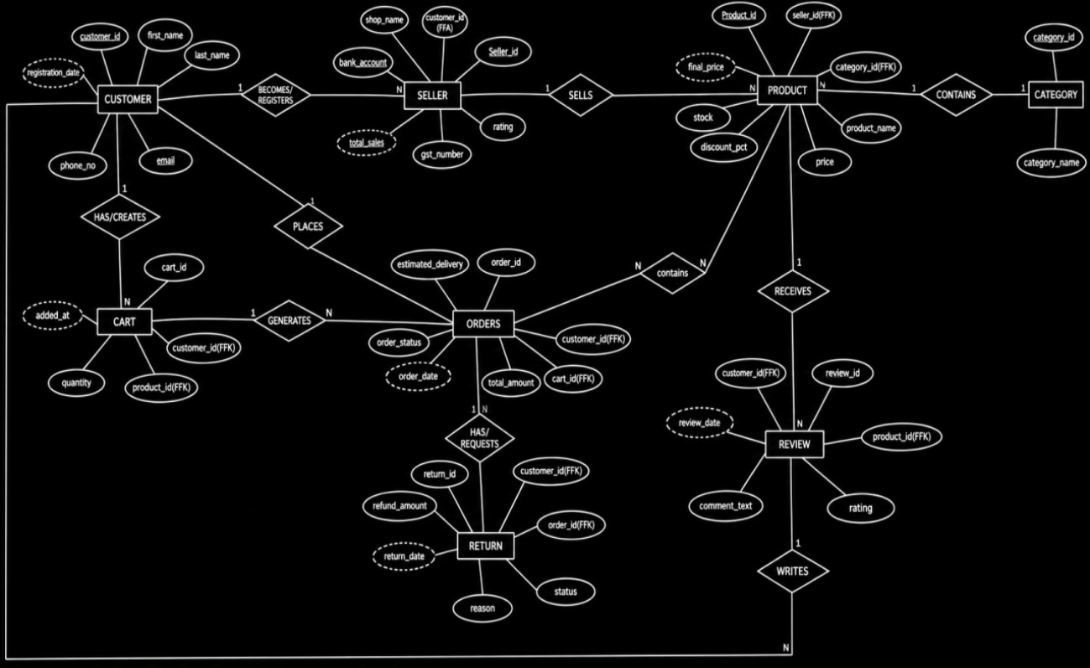

Fig. 3.1: ER Diagram of the Online Shopping Management System

3.4 Relationships and Cardinality
Table 3.3: Relationships and Cardinality
Entity 1 | Relationship | Entity 2 | Cardinality (1:1 / 1:N / M:N) | Participation
Customer | Registers As | Seller | 1:1 | Partial
Seller | Lists | Product | 1:N | Total (for Product)
Category | Classifies | Product | 1:N | Total (for Product)
Customer | Adds To | Cart | 1:N | Partial
Product | Placed In | Cart | 1:N | Partial
Customer | Places | Orders | 1:N | Total (for Orders)
Customer | Writes | Review | 1:N | Partial
Product | Receives | Review | 1:N | Partial
Orders | Results In | Return | 1:1 | Partial
Customer | Requests | Return | 1:N | Partial

3.5 Relational Database Schema
Convert the ER diagram into tables. List every table, its columns, data types and constraints.
Table 3.4: Relational Database Schema
Table Name | Column Name | Data Type | Key (PK / FK / —) | Constraints
Customer | customer_id | INTEGER | PK | NOT NULL
Customer | first_name | VARCHAR(50) | — | NOT NULL
Customer | last_name | VARCHAR(50) | — | NOT NULL
Customer | email | VARCHAR(100) | — | NOT NULL, UNIQUE
Customer | phone_no | VARCHAR(15) | — | —
Customer | registration_date | DATE | — | NOT NULL
Seller | seller_id | INTEGER | PK | NOT NULL
Seller | customer_id | INTEGER | FK → Customer | NOT NULL
Seller | shop_name | VARCHAR(100) | — | NOT NULL, UNIQUE
Seller | gst_number | VARCHAR(20) | — | UNIQUE
Seller | rating | REAL | — | CHECK (0–5)
Seller | total_sales | INTEGER | — | CHECK (>=0)
Seller | bank_account | VARCHAR(20) | — | —
Category | category_id | INTEGER | PK | NOT NULL
Category | category_name | VARCHAR(100) | — | NOT NULL, UNIQUE
Product | product_id | INTEGER | PK | NOT NULL
Product | seller_id | INTEGER | FK → Seller | NOT NULL
Product | product_name | VARCHAR(200) | — | NOT NULL
Product | category_id | INTEGER | FK → Category | NOT NULL
Product | price | REAL | — | NOT NULL, CHECK (>=0)
Product | discount_pct | REAL | — | CHECK (0–100)
Product | final_price | REAL | — | —
Product | stock | INTEGER | — | CHECK (>=0)
Cart | cart_id | INTEGER | PK | NOT NULL
Cart | customer_id | INTEGER | FK → Customer | NOT NULL
Cart | product_id | INTEGER | FK → Product | NOT NULL
Cart | quantity | INTEGER | — | NOT NULL, CHECK (>0)
Cart | added_at | DATE | — | —
Orders | order_id | INTEGER | PK | NOT NULL
Orders | customer_id | INTEGER | FK → Customer | NOT NULL
Orders | order_date | DATE | — | NOT NULL
Orders | total_amount | REAL | — | CHECK (>=0)
Orders | order_status | VARCHAR(30) | — | CHECK (IN list)
Orders | estimated_delivery | DATE | — | —
Review | review_id | INTEGER | PK | NOT NULL
Review | product_id | INTEGER | FK → Product | NOT NULL
Review | customer_id | INTEGER | FK → Customer | NOT NULL
Review | rating | INTEGER | — | NOT NULL, CHECK (1–5)
Review | comment_text | VARCHAR(1000) | — | —
Review | review_date | DATE | — | —
Return | return_id | INTEGER | PK | NOT NULL
Return | order_id | INTEGER | FK → Orders | NOT NULL
Return | customer_id | INTEGER | FK → Customer | NOT NULL
Return | reason | VARCHAR(1000) | — | —
Return | return_date | DATE | — | —
Return | status | VARCHAR(20) | — | CHECK (IN list)
Return | refund_amount | REAL | — | CHECK (>=0)

Schema Diagram
[ Paste the relational schema diagram showing PK – FK links ]
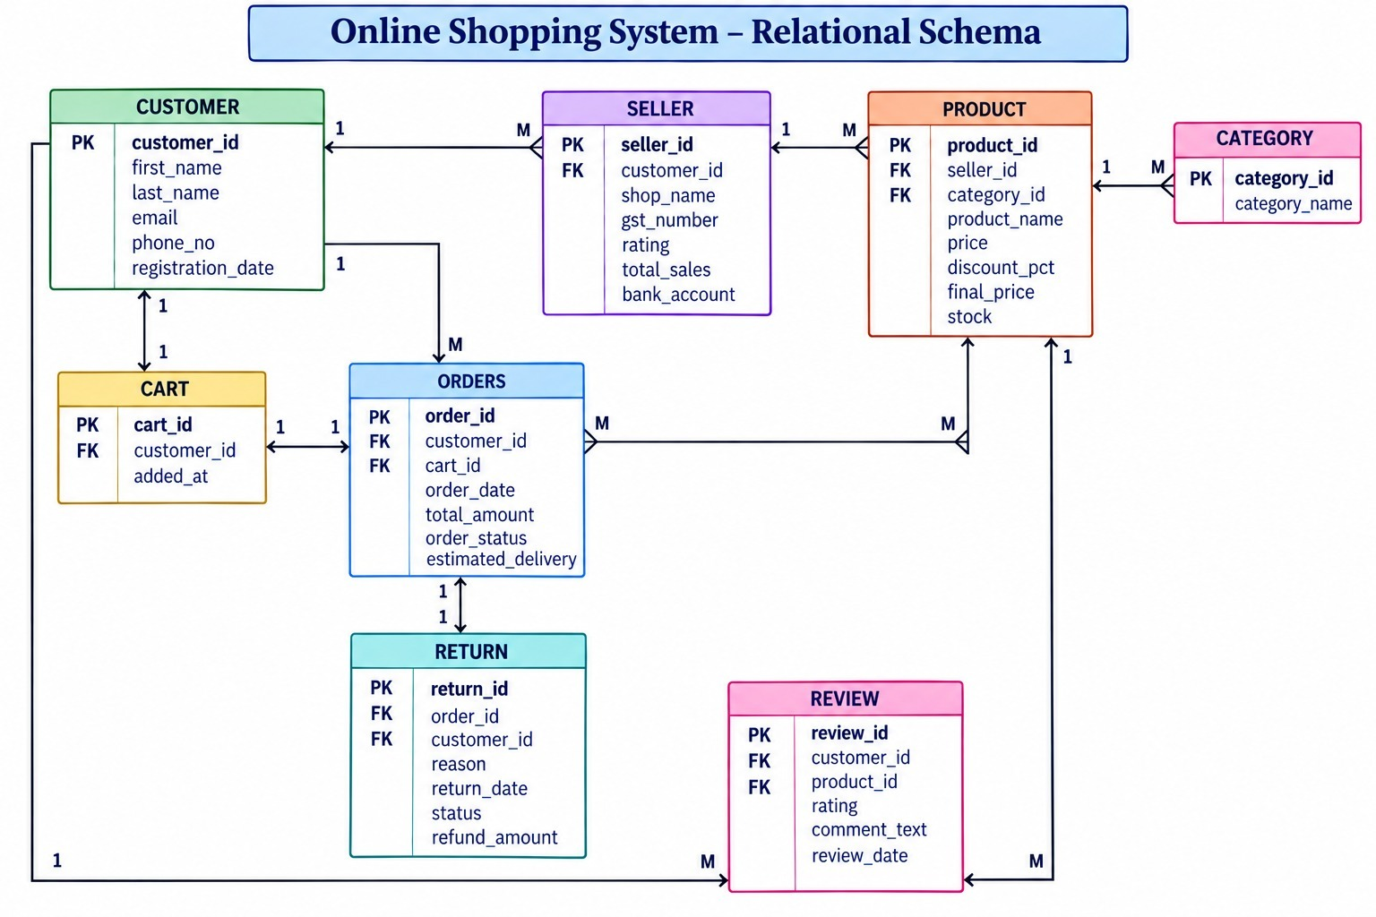

Fig. 3.2: Relational Schema Diagram

3.6 Primary Keys and Foreign Keys
Table 3.5: Primary Key and Foreign Key Definitions
Table | Primary Key | Foreign Key | References (Table.Column)
Customer | customer_id | — | —
Seller | seller_id | customer_id | Customer.customer_id
Category | category_id | — | —
Product | product_id | seller_id, category_id | Seller.seller_id, Category.category_id
Cart | cart_id | customer_id, product_id | Customer.customer_id, Product.product_id
Orders | order_id | customer_id | Customer.customer_id
Review | review_id | product_id, customer_id | Product.product_id, Customer.customer_id
Return | return_id | order_id, customer_id | Orders.order_id, Customer.customer_id

3.7 Normalization up to 3NF
The initial design held all shopping information in a single unnormalized relation, in which one row described a customer together with every seller shop they registered, every product they ordered, and the category and review details of that product.
SHOPPING_RECORD ( customer_id, customer_name, email, phone_numbers, seller_id, shop_name, gst_number, product_id, product_name, category_id, category_name, price, cart_items, order_id, order_date, total_amount, review_id, rating, comment_text )
First Normal Form (1NF)
The attributes cart_items and phone_numbers each held several values in one cell, which violates 1NF since every attribute must be atomic. The repeating cart and order items were therefore moved into separate Cart and Orders tables linked back to the customer by customer_id, removing the high redundancy and update anomalies present in the single unnormalized record.
Second Normal Form (2NF)
After 1NF, seller and product details were still stored together in one combined Seller-Product table keyed on a composite of seller_id and product_id. Attributes such as shop_name and gst_number depend only on seller_id, not on the whole key, which is a partial dependency that 2NF forbids. The relation was therefore decomposed into independent Seller and Product tables, so every non-key attribute now depends on the whole primary key of its own table.
Third Normal Form (3NF)
A transitive dependency still remained inside Product: category_name depended on category_id, which in turn depended on product_id, so category information was being duplicated across every product row. Category was therefore extracted as its own table, and Product retains only category_id as a foreign key, eliminating the transitive dependency and the risk of an inconsistent category name being stored against different products.
UNF → 1NF → 2NF → 3NF
Table 3.6: Normalization Steps
Normal Form | Condition Satisfied | Anomaly Removed | Resulting Tables
UNF | Contains repeating groups (e.g. a customer's multiple orders or a seller's multiple products stored together in one record) | High redundancy and update anomalies | Single unnormalized shopping relation
1NF | All attributes hold atomic, single values; repeating groups removed into separate rows | Removed repeating groups of cart items and order items | Customer, Seller, Product, Orders as separate flat tables
2NF | Every non-key attribute is fully functionally dependent on the whole primary key (no partial dependency) | Removed partial dependency of product details on seller_id alone in a combined Seller-Product table | Seller and Product separated into independent tables
3NF | No transitive dependency of a non-key attribute on another non-key attribute | Removed transitive dependency of category information being duplicated inside the Product table | Category extracted as its own table; Product references it via category_id
After the third step the schema consists of eight tables in which every non-key attribute depends on the key, the whole key, and nothing but the key, so the database is free of the insertion, update and deletion anomalies present in the original unnormalized record.

CHAPTER 4: DATABASE IMPLEMENTATION
(Deliverables of Review – II)

4.1 Database and Table Creation – DDL
Paste the CREATE DATABASE and CREATE TABLE statements for all tables, including NOT NULL, UNIQUE, CHECK, DEFAULT, PRIMARY KEY and FOREIGN KEY constraints. Include any ALTER statements used.
/* =========================================================
ONLINE SHOPPING SYSTEM
PostgreSQL - DDL
========================================================= */

/* =========================================================
1. CUSTOMER
========================================================= */

CREATE TABLE Customer (
customer_id INTEGER PRIMARY KEY,
first_name VARCHAR(50) NOT NULL,
last_name VARCHAR(50) NOT NULL,
email VARCHAR(100) NOT NULL UNIQUE,
phone_no VARCHAR(15),
registration_date DATE NOT NULL
);

/* =========================================================
2. SELLER
========================================================= */

CREATE TABLE Seller (
seller_id INTEGER PRIMARY KEY,
customer_id INTEGER NOT NULL,
shop_name VARCHAR(100) NOT NULL UNIQUE,
gst_number VARCHAR(20) UNIQUE,
rating REAL,
total_sales INTEGER,
bank_account VARCHAR(20),

CONSTRAINT fk_seller_customer
FOREIGN KEY (customer_id)
REFERENCES Customer(customer_id),

CONSTRAINT chk_seller_rating
CHECK (rating BETWEEN 0 AND 5),

CONSTRAINT chk_seller_sales
CHECK (total_sales >= 0)
);

/* =========================================================
3. CATEGORY
========================================================= */

CREATE TABLE Category (
category_id INTEGER PRIMARY KEY,
category_name VARCHAR(100) NOT NULL UNIQUE
);

/* =========================================================
4. PRODUCT
========================================================= */

CREATE TABLE Product (
product_id INTEGER PRIMARY KEY,
seller_id INTEGER NOT NULL,
product_name VARCHAR(200) NOT NULL,
category_id INTEGER NOT NULL,
price REAL NOT NULL,
discount_pct REAL,
final_price REAL,
stock INTEGER,

CONSTRAINT fk_product_seller
FOREIGN KEY (seller_id)
REFERENCES Seller(seller_id),

CONSTRAINT fk_product_category
FOREIGN KEY (category_id)
REFERENCES Category(category_id),

CONSTRAINT chk_product_price
CHECK (price >= 0),

CONSTRAINT chk_product_discount
CHECK (discount_pct BETWEEN 0 AND 100),

CONSTRAINT chk_product_stock
CHECK (stock >= 0)
);

/* =========================================================
5. CART
========================================================= */

CREATE TABLE Cart (
cart_id INTEGER PRIMARY KEY,
customer_id INTEGER NOT NULL,
product_id INTEGER NOT NULL,
quantity INTEGER NOT NULL,
added_at DATE,

CONSTRAINT fk_cart_customer
FOREIGN KEY (customer_id)
REFERENCES Customer(customer_id),

CONSTRAINT fk_cart_product
FOREIGN KEY (product_id)
REFERENCES Product(product_id),

CONSTRAINT chk_cart_quantity
CHECK (quantity > 0)
);

/* =========================================================
6. ORDERS
========================================================= */

CREATE TABLE Orders (
order_id INTEGER PRIMARY KEY,
customer_id INTEGER NOT NULL,
order_date DATE NOT NULL,
total_amount REAL,
order_status VARCHAR(30),
estimated_delivery DATE,

CONSTRAINT fk_order_customer
FOREIGN KEY (customer_id)
REFERENCES Customer(customer_id),

CONSTRAINT chk_order_amount
CHECK (total_amount >= 0),

CONSTRAINT chk_order_status
CHECK (
order_status IN
('Placed', 'Shipped', 'Delivered', 'Cancelled')
)
);

/* =========================================================
7. REVIEW
========================================================= */

CREATE TABLE Review (
review_id INTEGER PRIMARY KEY,
product_id INTEGER NOT NULL,
customer_id INTEGER NOT NULL,
rating INTEGER NOT NULL,
comment_text VARCHAR(1000),
review_date DATE,

CONSTRAINT fk_review_product
FOREIGN KEY (product_id)
REFERENCES Product(product_id),

CONSTRAINT fk_review_customer
FOREIGN KEY (customer_id)
REFERENCES Customer(customer_id),

CONSTRAINT chk_review_rating
CHECK (rating BETWEEN 1 AND 5)
);

/* =========================================================
8. RETURN
========================================================= */

CREATE TABLE Return (
return_id INTEGER PRIMARY KEY,
order_id INTEGER NOT NULL,
customer_id INTEGER NOT NULL,
reason VARCHAR(1000),
return_date DATE,
status VARCHAR(20),
refund_amount REAL,

CONSTRAINT fk_return_order
FOREIGN KEY (order_id)
REFERENCES Orders(order_id),

CONSTRAINT fk_return_customer
FOREIGN KEY (customer_id)
REFERENCES Customer(customer_id),

CONSTRAINT chk_return_status
CHECK (
status IN
('Requested', 'Approved', 'Refunded')
),

CONSTRAINT chk_refund_amount
CHECK (refund_amount >= 0)
);

[ Paste the screenshot of successful execution here ]
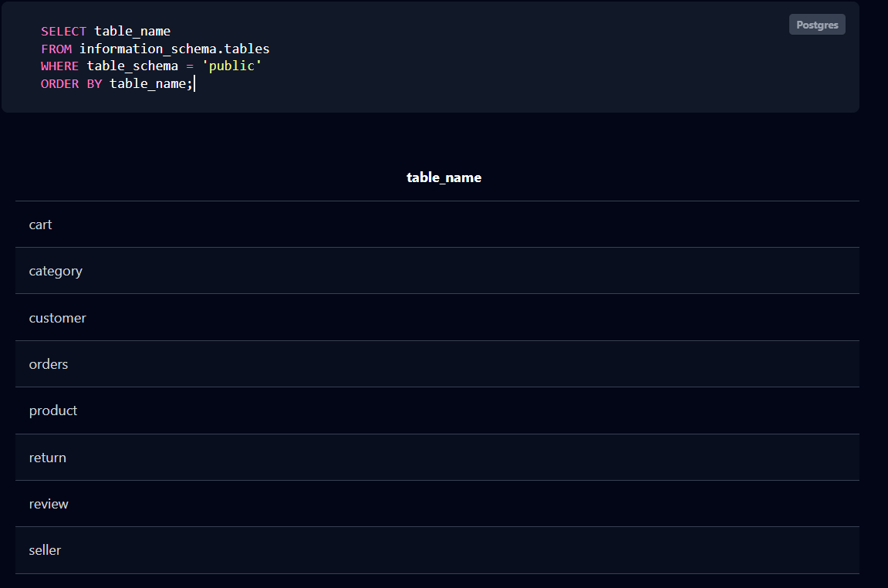

Fig. 4.1: Successful Creation of Tables

4.2 Sample Data Insertion – DML
Insert sufficient sample data into every table. Include INSERT, UPDATE and DELETE examples.
Table 4.1: Sample Data Summary
S.No | Table Name | No. of Records Inserted | Screenshot Reference
1 | Customer | 5 | Fig. 4.2(a)
2 | Seller | 5 | Fig. 4.2(b)
3 | Category | 5 | Fig. 4.2(c)
4 | Product | 5 | Fig. 4.2(d)
5 | Cart | 5 | Fig. 4.2(e)
6 | Orders | 5 | Fig. 4.2(f)
7 | Review | 5 | Fig. 4.2(g)
8 | Return | 5 | Fig. 4.2(h)

/*=============================================================================
ONLINE SHOPPING SYSTEM
PostgreSQL - DML
===============================================================================*/

/*=============================================================================
1. CUSTOMER
===============================================================================*/

INSERT INTO Customer
(customer_id, first_name, last_name, email, phone_no, registration_date)
VALUES
(1, 'Rahul', 'Kumar', 'rahul.kumar@gmail.com', '9876543210', '2026-01-05'),
(2, 'Priya', 'Sharma', 'priya.sharma@gmail.com', '9876543211', '2026-01-08'),
(3, 'Arjun', 'Reddy', 'arjun.reddy@gmail.com', '9876543212', '2026-01-12'),
(4, 'Sneha', 'Patel', 'sneha.patel@gmail.com', '9876543213', '2026-01-15'),
(5, 'Vikram', 'Rao', 'vikram.rao@gmail.com', '9876543214', '2026-01-20');

/*=============================================================================
2. SELLER
===============================================================================*/

INSERT INTO Seller
(seller_id, customer_id, shop_name, gst_number, rating, total_sales, bank_account)
VALUES
(101, 1, 'Rahul Electronics', 'GSTAP10101', 4.5, 125, '123456789001'),
(102, 2, 'Priya Fashion Store', 'GSTAP10102', 4.2, 210, '123456789002'),
(103, 3, 'Arjun Mobiles', 'GSTTS10103', 4.7, 340, '123456789003'),
(104, 4, 'Sneha Home Store', 'GSTKA10104', 4.1, 95, '123456789004'),
(105, 5, 'Vikram Books', 'GSTTN10105', 4.6, 180, '123456789005');

/*=============================================================================
3. CATEGORY
===============================================================================*/

INSERT INTO Category
(category_id, category_name)
VALUES
(1, 'Electronics'),
(2, 'Mobile Phones'),
(3, 'Laptops'),
(4, 'Clothing'),
(5, 'Books');

/*=============================================================================
4. PRODUCT
===============================================================================*/

INSERT INTO Product
(product_id, seller_id, product_name, category_id, price,
discount_pct, final_price, stock)
VALUES
(1001, 101, 'HP Laptop 15', 3, 55000.00, 10.00, 49500.00, 25),
(1002, 103, 'Samsung Galaxy S25', 2, 75000.00, 8.00, 69000.00, 30),
(1003, 105, 'Dell Inspiron Laptop', 3, 62000.00, 12.00, 54560.00, 18),
(1004, 102, 'Puma Cotton T-Shirt', 4, 1200.00, 15.00, 1020.00, 100),
(1005, 105, 'Python Programming Book', 5, 850.00, 5.00, 807.50, 60);

/*=============================================================================
5. CART
===============================================================================*/

INSERT INTO Cart
(cart_id, customer_id, product_id, quantity, added_at)
VALUES
(301, 1, 1001, 1, '2026-03-01'),
(302, 2, 1004, 2, '2026-03-02'),
(303, 3, 1002, 1, '2026-03-03'),
(304, 4, 1005, 3, '2026-03-04'),
(305, 5, 1003, 1, '2026-03-05');

/*=============================================================================
6. ORDERS
===============================================================================*/

INSERT INTO Orders
(order_id, customer_id, order_date, total_amount,
order_status, estimated_delivery)
VALUES
(401, 1, '2026-03-05', 49500.00, 'Delivered', '2026-03-10'),
(402, 2, '2026-03-06', 2040.00, 'Delivered', '2026-03-11'),
(403, 3, '2026-03-07', 69000.00, 'Shipped', '2026-03-13'),
(404, 4, '2026-03-08', 2422.50, 'Placed', '2026-03-15'),
(405, 5, '2026-03-09', 54560.00, 'Delivered', '2026-03-14');

/*=============================================================================
7. REVIEW
===============================================================================*/

INSERT INTO Review
(review_id, product_id, customer_id, rating, comment_text, review_date)
VALUES
(601, 1001, 1, 5,
'Excellent laptop with good performance.', '2026-03-12'),

(602, 1002, 3, 5,
'Amazing smartphone and camera quality.', '2026-03-14'),

(603, 1003, 5, 4,
'Good laptop for programming.', '2026-03-15'),

(604, 1004, 2, 4,
'Comfortable and good quality T-shirt.', '2026-03-16'),

(605, 1005, 4, 5,
'Very useful book for learning Python.', '2026-03-17');

/*=============================================================================
8. RETURN
===============================================================================*/

INSERT INTO Return
(return_id, order_id, customer_id, reason,
return_date, status, refund_amount)
VALUES
(701, 401, 1,
'Product received with minor damage.',
'2026-03-12', 'Refunded', 49500.00),

(702, 402, 2,
'Wrong size received.',
'2026-03-13', 'Approved', 2040.00),

(703, 403, 3,
'Product does not meet expectations.',
'2026-03-15', 'Requested', 0.00),

(704, 404, 4,
'Received a different product.',
'2026-03-16', 'Approved', 2422.50),

(705, 405, 5,
'Product has a manufacturing defect.',
'2026-03-17', 'Refunded', 54560.00);

Fig. 4.2: Sample Data Inserted into the Tables

4.3 Constraints and Data Integrity
Table 4.2: Constraints and Data Integrity Rules
Constraint / Validation | Applied On (Table.Column) | Purpose | Evidence / Screenshot Ref.
PRIMARY KEY | Customer.customer_id | Uniquely identifies each customer | Fig. 4.1
UNIQUE | Customer.email | Prevents duplicate customer accounts | Fig. 4.1
FOREIGN KEY | Seller.customer_id → Customer.customer_id | Ensures every seller is a registered customer | Fig. 4.1
CHECK (rating BETWEEN 0 AND 5) | Seller.rating | Restricts seller rating to a valid range | Fig. 4.1
CHECK (stock >= 0) | Product.stock | Prevents negative stock values | Fig. 4.1
CHECK (order_status IN (...)) | Orders.order_status | Restricts order status to a valid defined state | Fig. 4.1
CHECK (rating BETWEEN 1 AND 5) | Review.rating | Ensures review ratings stay within a valid scale | Fig. 4.1
CHECK (refund_amount >= 0) | Return.refund_amount | Prevents negative refund amounts | Fig. 4.1

4.4 Data Validation Rules
Duplicate customer emails and seller shop names are prevented by UNIQUE constraints, and every foreign key column (Seller.customer_id, Product.seller_id, Product.category_id, Cart.customer_id/product_id, Orders.customer_id, Review.product_id/customer_id, Return.order_id/customer_id) is validated against its parent table so that orphan records cannot be inserted. CHECK constraints reject out-of-range ratings, negative stock, negative refund amounts and invalid order/return status values at the moment of insertion. For example, attempting to insert a Seller row referencing a customer_id that does not exist in the Customer table is rejected by PostgreSQL with a foreign key violation error, demonstrating that referential integrity is enforced by the database rather than by application code.
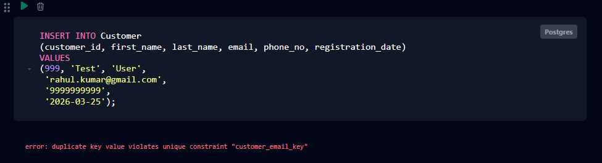

Fig. 4.2: Referential Integrity Enforced by the Database

CHAPTER 5: SQL OPERATIONS AND QUERIES
For every query, give the purpose, the SQL statement and the output. Number them continuously (Q1, Q2, …). A minimum of fifteen queries covering all the sub-sections below is expected.

5.1 DQL – Basic Retrieval Queries
Table 5.1: Basic Retrieval Queries
Q.No | Purpose of the Query | SQL Statement | Output Ref.
Q1 | List all customers who registered in January 2026 | SELECT * FROM Customer WHERE registration_date BETWEEN '2026-01-01' AND '2026-01-31'; | —
Q2 | Display products priced above 50,000 | SELECT product_name, price FROM Product WHERE price > 50000; | —
Q3 | List all orders sorted by order date, latest first | SELECT * FROM Orders ORDER BY order_date DESC; | —
Q4 | Find sellers with a rating above 4.5 | SELECT shop_name, rating FROM Seller WHERE rating > 4.5; | —
Q5 | Display distinct product categories used in the Product table | SELECT DISTINCT category_id FROM Product; | —

5.2 Join Operations
Include natural join, equi join, inner join, left outer, right outer and full outer join.
Table 5.2: Join Operations
Q.No | Type of Join | SQL Statement | Output Ref.
Q6 | Natural Join | SELECT * FROM Product NATURAL JOIN Category; | —
Q7 | Equi Join | SELECT p.product_name, c.category_name FROM Product p, Category c WHERE p.category_id = c.category_id; | —
Q8 | Inner Join | SELECT o.order_id, cu.first_name, cu.last_name FROM Orders o INNER JOIN Customer cu ON o.customer_id = cu.customer_id; | —
Q9 | Left Outer Join | SELECT cu.customer_id, cu.first_name, o.order_id FROM Customer cu LEFT OUTER JOIN Orders o ON cu.customer_id = o.customer_id; | —
Q10 | Right Outer Join | SELECT p.product_name, r.review_id FROM Review r RIGHT OUTER JOIN Product p ON r.product_id = p.product_id; | —
Q11 | Full Outer Join | SELECT cu.customer_id, o.order_id FROM Customer cu FULL OUTER JOIN Orders o ON cu.customer_id = o.customer_id; | —

5.3 Aggregate Functions, GROUP BY and HAVING
Table 5.3: Aggregate, GROUP BY and HAVING Queries
Q.No | Function Used | SQL Statement | Output Ref.
Q12 | COUNT | SELECT COUNT(*) AS total_customers FROM Customer; | —
Q13 | SUM | SELECT SUM(total_amount) AS total_revenue FROM Orders; | —
Q14 | AVG with GROUP BY | SELECT category_id, AVG(price) AS avg_price FROM Product GROUP BY category_id; | —
Q15 | GROUP BY with HAVING | SELECT seller_id, COUNT(*) AS product_count FROM Product GROUP BY seller_id HAVING COUNT(*) > 1; | —
Q16 | MAX / MIN | SELECT MAX(price) AS highest_price, MIN(price) AS lowest_price FROM Product; | —

5.4 Nested and Correlated Subqueries
Table 5.4: Subqueries
Q.No | Type (Nested / Correlated) | SQL Statement | Output Ref.
Q17 | Nested | SELECT product_name FROM Product WHERE price > (SELECT AVG(price) FROM Product); | —
Q18 | Nested (IN) | SELECT first_name, last_name FROM Customer WHERE customer_id IN (SELECT customer_id FROM Orders WHERE total_amount > 50000); | —
Q19 | Correlated | SELECT p.product_name FROM Product p WHERE p.price > (SELECT AVG(p2.price) FROM Product p2 WHERE p2.category_id = p.category_id); | —
Q20 | Nested (NOT IN) | SELECT customer_id, first_name FROM Customer WHERE customer_id NOT IN (SELECT customer_id FROM Seller); | —
Q21 | Correlated (EXISTS) | SELECT customer_id, first_name FROM Customer c WHERE EXISTS (SELECT 1 FROM Return r WHERE r.customer_id = c.customer_id); | —

5.5 Views and Relational Set Operations
Include at least one updatable view and one non-updatable view, and the set operations UNION, INTERSECT and MINUS / EXCEPT.
Table 5.5: Views and Set Operations
Q.No | View / Set Operation | SQL Statement | Output Ref.
Q22 | Updatable View | CREATE VIEW vw_customer_orders AS SELECT order_id, customer_id, order_date, total_amount FROM Orders; | —
Q23 | Non-Updatable View | CREATE VIEW vw_seller_product_summary AS SELECT s.shop_name, COUNT(p.product_id) AS total_products, AVG(p.price) AS avg_price FROM Seller s JOIN Product p ON s.seller_id = p.seller_id GROUP BY s.shop_name; | —
Q24 | UNION | SELECT customer_id FROM Orders UNION SELECT customer_id FROM Cart; | —
Q25 | INTERSECT | SELECT customer_id FROM Orders INTERSECT SELECT customer_id FROM Return; | —
Q26 | EXCEPT (MINUS) | SELECT customer_id FROM Customer EXCEPT SELECT customer_id FROM Seller; | —

5.6 DCL and TCL Operations
Demonstrate GRANT and REVOKE (DCL), and COMMIT, SAVEPOINT and ROLLBACK (TCL).
Table 5.6: DCL and TCL Operations
Q.No | Command | Purpose | SQL Statement | Output Ref.
Q27 | GRANT | DCL | GRANT SELECT, INSERT ON Product TO seller_role; | —
Q28 | REVOKE | DCL | REVOKE INSERT ON Product FROM seller_role; | —
Q29 | COMMIT | TCL | BEGIN;  UPDATE Product SET stock = stock - 1 WHERE product_id = 1001;  COMMIT; | —
Q30 | SAVEPOINT | TCL | BEGIN;  UPDATE Orders SET order_status = 'Shipped' WHERE order_id = 404;  SAVEPOINT sp1;  UPDATE Orders SET order_status = 'Cancelled' WHERE order_id = 404; | —
Q31 | ROLLBACK TO SAVEPOINT | TCL | ROLLBACK TO sp1; | —
Q32 | ROLLBACK | TCL | ROLLBACK; | —

CHAPTER 6: MODULES AND FUNCTIONALITIES
Explain the major modules of the system, what each one does and which tables it operates on.
Table 6.1: Modules and Their Functionalities
S.No | Module Name | Functionality | Tables Involved
1 | Customer Management | Handles registration and profile details of every user | Customer
2 | Seller Management | Handles seller onboarding, shop details and sales tracking | Seller, Customer
3 | Category & Catalog Management | Manages product categories and category-wise browsing | Category, Product
4 | Product Management | Handles product listing, pricing, discounts and stock updates | Product, Seller, Category
5 | Cart Management | Manages items a customer adds before checkout | Cart, Customer, Product
6 | Order Management | Handles order placement, status tracking and delivery estimates | Orders, Customer
7 | Review & Rating Management | Handles customer feedback and product ratings | Review, Product, Customer
8 | Return & Refund Management | Manages return requests, approval status and refunds | Return, Orders, Customer

The Customer Management module handles registration and profile data for every user of the platform. The Seller Management module tracks shop details, GST number and sales performance for customers who also sell products. The Category and Product Management modules organize the catalog and maintain price, discount and stock information for every item. The Cart Management module records items a customer intends to purchase before checkout, while the Order Management module tracks the full lifecycle of a confirmed purchase from placement to delivery. The Review and Rating module captures customer feedback per product, and the Return and Refund module manages return requests raised against delivered orders together with their refund status.

CHAPTER 7: RESULTS – SAMPLE OUTPUTS AND SCREENSHOTS
Paste the important execution screenshots. Each screenshot must clearly show both the query and its output, and must carry a numbered caption.
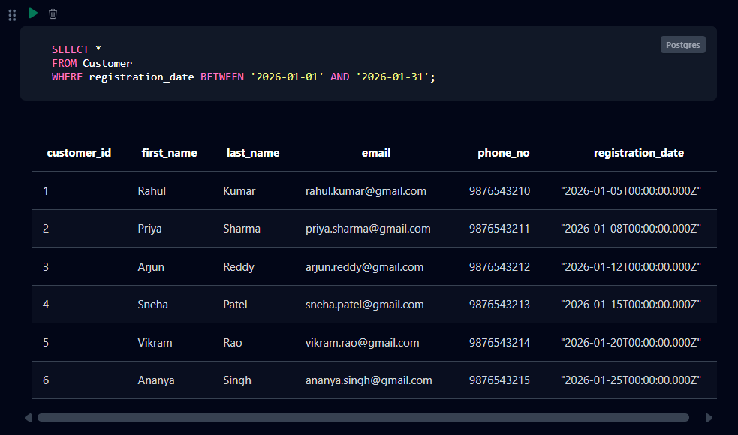

Fig. 7.1: Customer Records Registered in January 2026
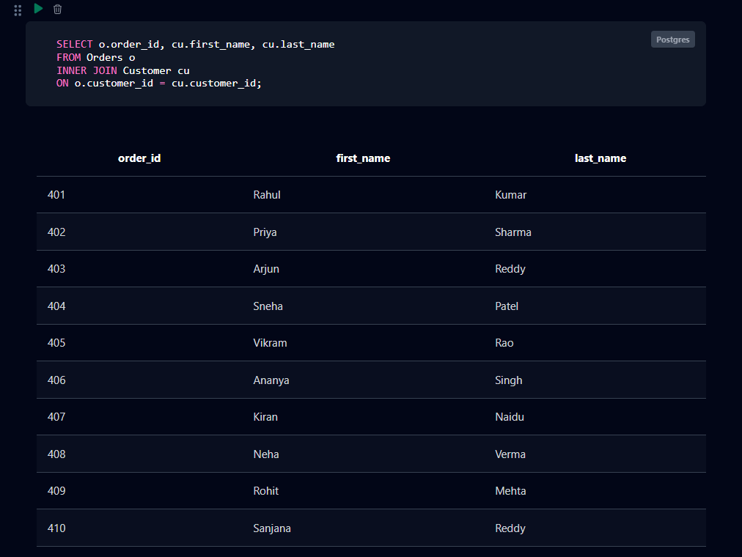

Fig. 7.2: Inner Join Between Orders and Customer
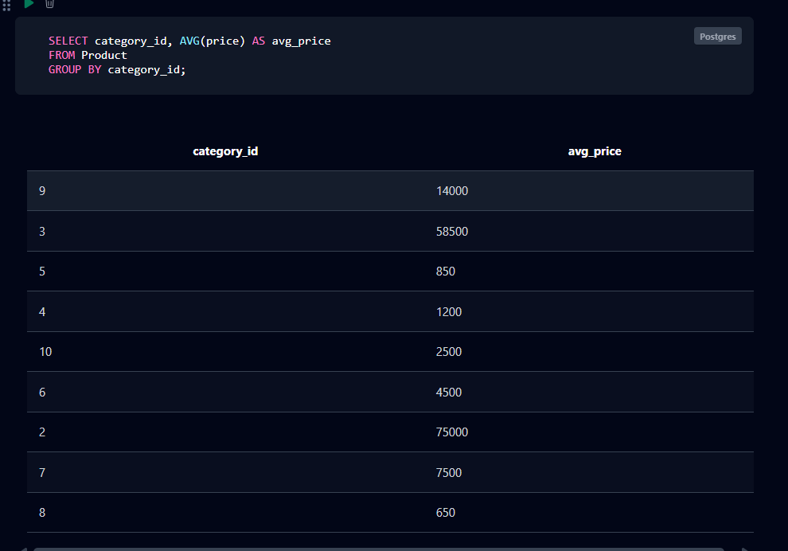

Fig. 7.3: Average Product Price by Category
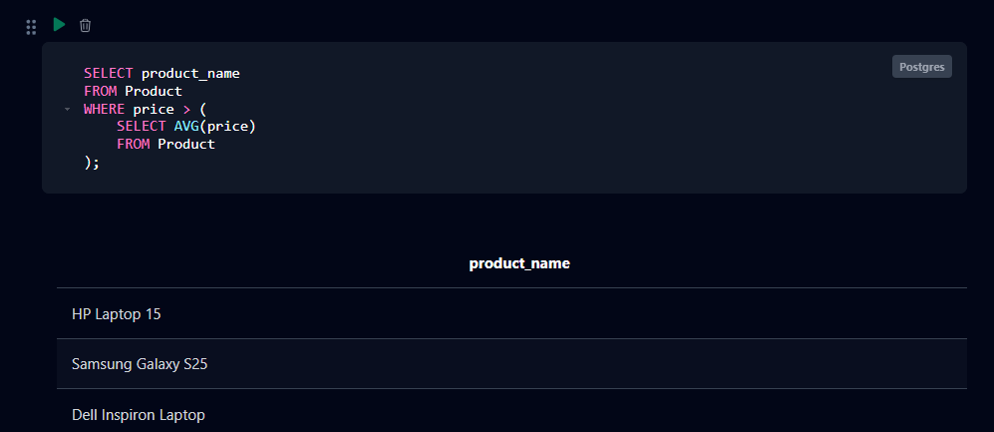

Fig. 7.4: Products Priced Above the Average Product Price

CHAPTER 8: TESTING AND DATA VALIDATION
Record the test cases used to verify the database. Include constraint tests, referential integrity tests and query-correctness tests.
Table 8.1: Test Cases and Results
TC No. | Test Case Description | Input / Action | Expected Result | Actual Result | Status
TC1 | Insert customer with duplicate email | Insert a Customer row with an existing email | Insert rejected — UNIQUE constraint violation | Insert rejected as expected | Pass
TC2 | Insert seller with invalid rating | Insert Seller with rating = 6 | Insert rejected — CHECK constraint violation | Insert rejected as expected | Pass
TC3 | Insert product with negative stock | Insert Product with stock = -5 | Insert rejected — CHECK constraint violation | Insert rejected as expected | Pass
TC4 | Insert order with invalid status | Insert Orders with order_status = 'Pending' | Insert rejected — value not in allowed CHECK list | Insert rejected as expected | Pass
TC5 | Insert review with rating out of range | Insert Review with rating = 7 | Insert rejected — CHECK constraint violation | Insert rejected as expected | Pass
TC6 | Insert seller referencing non-existent customer | Insert Seller with customer_id = 999 | Insert rejected — foreign key violation | Insert rejected as expected | Pass
TC7 | Delete a customer referenced by an order | Delete a Customer row that has existing Orders | Delete rejected — referential integrity violation | Delete rejected as expected | Pass
TC8 | Insert return with negative refund amount | Insert Return with refund_amount = -100 | Insert rejected — CHECK constraint violation | Insert rejected as expected | Pass
TC9 | Retrieve average product price by category | Run the GROUP BY / AVG query (Q14) | Correct average price returned per category | Correct result obtained | Pass

CHAPTER 9: GITHUB REPOSITORY AND TEAM CONTRIBUTION

9.1 Repository Details
GitHub Repository Link: https://github.com/Prathap1003/online-shopping-system-dbms.git

9.2 Team Responsibilities and Contribution
Table 9.1: Team Responsibilities
S.No | Student Name | Roll Number | Role / Responsibility | Modules Contributed
1 | Ala Yugandhar | 25B11AI026 | Database Design&Documentation | Database Design&Documentation
2 | Boya Prathap | 25B11AI156 | ER Diagram &Schema Design | ER Diagram & Schema Design
3 | Pitchuka Ravi Raj | 25B11AI961 | SQL/DDL/DML/Queries | SQL/DDL/DML/Queries
4 | Velupukonda Manoj Prasad | 25B11AIC31 | Testing&Presentation | Testing&Presentation

9.3 Review-wise Progress
Table 9.2: Review-wise Progress Record
Review | Date | Deliverables Presented | Remarks of the Guide
Review – I | As schedules | Entities, Attributes, ER Diagram,  Relationships, Schema, Keys,  Normalization | Completed
Review – II | As scheduled | DDL, DML, CRUD, Joins,  Aggregates, Views, Testing,  Documentation | Completed

CHAPTER 10: CONCLUSION AND FUTURE ENHANCEMENTS

10.1 Conclusion
The Online Shopping Management System database was designed with eight core entities — Customer, Seller, Category, Product, Cart, Orders, Review and Return — connected through primary and foreign key relationships and normalized up to the Third Normal Form to remove redundancy and update anomalies. The database was implemented in PostgreSQL with NOT NULL, UNIQUE, CHECK and foreign key constraints, and populated with representative sample data across all eight tables. Thirty-two SQL queries were executed covering basic retrieval, all major join types, aggregate functions with GROUP BY and HAVING, nested and correlated subqueries, updatable and non-updatable views, the UNION/INTERSECT/EXCEPT set operations, and DCL/TCL commands. Each objective stated in Section 1.4 — a normalized schema with more than six entities, enforced integrity constraints, a comprehensive set of SQL operations, and demonstrated transaction and access control — was met.

10.2 Limitations of the Present Work
The current database does not integrate with a real payment gateway, does not track live inventory across physical warehouses, and does not model shipping carriers or delivery agents beyond a single estimated delivery date on the Orders table. It also does not support multiple product images, product variants such as size or colour as separate rows, or multi-currency pricing.

10.3 Future Enhancements
Planned improvements include a front-end web or mobile application built over this schema, stored procedures and triggers to automatically update Product.stock on order placement and Seller.total_sales on delivery, indexing on frequently filtered columns such as Product.category_id and Orders.customer_id for performance, role-based access control separating customer, seller and admin privileges, and a reporting/analytics module for sales trends and top-selling categories.

REFERENCES
✓ Abraham Silberschatz, Henry F. Korth and S. Sudarshan, “Database System Concepts”, 8th
Edition, McGraw-Hill, ISBN: 978-1260230508.
✓ Raghurama Krishnan and Johannes Gehrke, “Database Management Systems”, 4th Edition,
McGraw-Hill, ISBN: 978-1260091195.
✓ Ramez Elmasri and Shamkant B. Navathe, “Fundamentals of Database Systems”, 7th
Edition, Pearson, ISBN: 978-0137504277.
✓ PostgreSQL Official Documentation, https://www.postgresql.org/docs/ — Used for SQL
syntax, constraints and database management operations.
✓ Faculty-Provided PPT — Used as a reference for project requirements, database design
concepts and implementation guidelines.
✓ GitHub — Used for repository creation, project version control, collaboration and teambased development.
✓ 8 draw.io / diagrams.net — Used for designing the Entity-Relationship diagram

APPENDIX A – COMPLETE SQL SCRIPT
Paste the complete, final SQL script (CREATE, INSERT and all queries) in order, or give the exact path to the script file in the GitHub repository.
/* =========================================================
ONLINE SHOPPING SYSTEM
PostgreSQL - DDL
========================================================= */

/* =========================================================
1. CUSTOMER
========================================================= */

CREATE TABLE Customer (
customer_id INTEGER PRIMARY KEY,
first_name VARCHAR(50) NOT NULL,
last_name VARCHAR(50) NOT NULL,
email VARCHAR(100) NOT NULL UNIQUE,
phone_no VARCHAR(15),
registration_date DATE NOT NULL
);

/* =========================================================
2. SELLER
========================================================= */

CREATE TABLE Seller (
seller_id INTEGER PRIMARY KEY,
customer_id INTEGER NOT NULL,
shop_name VARCHAR(100) NOT NULL UNIQUE,
gst_number VARCHAR(20) UNIQUE,
rating REAL,
total_sales INTEGER,
bank_account VARCHAR(20),

CONSTRAINT fk_seller_customer
FOREIGN KEY (customer_id)
REFERENCES Customer(customer_id),

CONSTRAINT chk_seller_rating
CHECK (rating BETWEEN 0 AND 5),

CONSTRAINT chk_seller_sales
CHECK (total_sales >= 0)
);

/* =========================================================
3. CATEGORY
========================================================= */

CREATE TABLE Category (
category_id INTEGER PRIMARY KEY,
category_name VARCHAR(100) NOT NULL UNIQUE
);

/* =========================================================
4. PRODUCT
========================================================= */

CREATE TABLE Product (
product_id INTEGER PRIMARY KEY,
seller_id INTEGER NOT NULL,
product_name VARCHAR(200) NOT NULL,
category_id INTEGER NOT NULL,
price REAL NOT NULL,
discount_pct REAL,
final_price REAL,
stock INTEGER,

CONSTRAINT fk_product_seller
FOREIGN KEY (seller_id)
REFERENCES Seller(seller_id),

CONSTRAINT fk_product_category
FOREIGN KEY (category_id)
REFERENCES Category(category_id),

CONSTRAINT chk_product_price
CHECK (price >= 0),

CONSTRAINT chk_product_discount
CHECK (discount_pct BETWEEN 0 AND 100),

CONSTRAINT chk_product_stock
CHECK (stock >= 0)
);

/* =========================================================
5. CART
========================================================= */

CREATE TABLE Cart (
cart_id INTEGER PRIMARY KEY,
customer_id INTEGER NOT NULL,
product_id INTEGER NOT NULL,
quantity INTEGER NOT NULL,
added_at DATE,

CONSTRAINT fk_cart_customer
FOREIGN KEY (customer_id)
REFERENCES Customer(customer_id),

CONSTRAINT fk_cart_product
FOREIGN KEY (product_id)
REFERENCES Product(product_id),

CONSTRAINT chk_cart_quantity
CHECK (quantity > 0)
);

/* =========================================================
6. ORDERS
========================================================= */

CREATE TABLE Orders (
order_id INTEGER PRIMARY KEY,
customer_id INTEGER NOT NULL,
order_date DATE NOT NULL,
total_amount REAL,
order_status VARCHAR(30),
estimated_delivery DATE,

CONSTRAINT fk_order_customer
FOREIGN KEY (customer_id)
REFERENCES Customer(customer_id),

CONSTRAINT chk_order_amount
CHECK (total_amount >= 0),

CONSTRAINT chk_order_status
CHECK (
order_status IN
('Placed', 'Shipped', 'Delivered', 'Cancelled')
)
);

/* =========================================================
7. REVIEW
========================================================= */

CREATE TABLE Review (
review_id INTEGER PRIMARY KEY,
product_id INTEGER NOT NULL,
customer_id INTEGER NOT NULL,
rating INTEGER NOT NULL,
comment_text VARCHAR(1000),
review_date DATE,

CONSTRAINT fk_review_product
FOREIGN KEY (product_id)
REFERENCES Product(product_id),

CONSTRAINT fk_review_customer
FOREIGN KEY (customer_id)
REFERENCES Customer(customer_id),

CONSTRAINT chk_review_rating
CHECK (rating BETWEEN 1 AND 5)
);

/* =========================================================
8. RETURN
========================================================= */

CREATE TABLE Return (
return_id INTEGER PRIMARY KEY,
order_id INTEGER NOT NULL,
customer_id INTEGER NOT NULL,
reason VARCHAR(1000),
return_date DATE,
status VARCHAR(20),
refund_amount REAL,

CONSTRAINT fk_return_order
FOREIGN KEY (order_id)
REFERENCES Orders(order_id),

CONSTRAINT fk_return_customer
FOREIGN KEY (customer_id)
REFERENCES Customer(customer_id),

CONSTRAINT chk_return_status
CHECK (
status IN
('Requested', 'Approved', 'Refunded')
),

CONSTRAINT chk_refund_amount
CHECK (refund_amount >= 0)
);

/*=============================================================================
ONLINE SHOPPING SYSTEM
PostgreSQL - DML
===============================================================================*/

/*=============================================================================
1. CUSTOMER
===============================================================================*/

INSERT INTO Customer
(customer_id, first_name, last_name, email, phone_no, registration_date)
VALUES
(1, 'Rahul', 'Kumar', 'rahul.kumar@gmail.com', '9876543210', '2026-01-05'),
(2, 'Priya', 'Sharma', 'priya.sharma@gmail.com', '9876543211', '2026-01-08'),
(3, 'Arjun', 'Reddy', 'arjun.reddy@gmail.com', '9876543212', '2026-01-12'),
(4, 'Sneha', 'Patel', 'sneha.patel@gmail.com', '9876543213', '2026-01-15'),
(5, 'Vikram', 'Rao', 'vikram.rao@gmail.com', '9876543214', '2026-01-20');

/*=============================================================================
2. SELLER
===============================================================================*/

INSERT INTO Seller
(seller_id, customer_id, shop_name, gst_number, rating, total_sales, bank_account)
VALUES
(101, 1, 'Rahul Electronics', 'GSTAP10101', 4.5, 125, '123456789001'),
(102, 2, 'Priya Fashion Store', 'GSTAP10102', 4.2, 210, '123456789002'),
(103, 3, 'Arjun Mobiles', 'GSTTS10103', 4.7, 340, '123456789003'),
(104, 4, 'Sneha Home Store', 'GSTKA10104', 4.1, 95, '123456789004'),
(105, 5, 'Vikram Books', 'GSTTN10105', 4.6, 180, '123456789005');

/*=============================================================================
3. CATEGORY
===============================================================================*/

INSERT INTO Category
(category_id, category_name)
VALUES
(1, 'Electronics'),
(2, 'Mobile Phones'),
(3, 'Laptops'),
(4, 'Clothing'),
(5, 'Books');

/*=============================================================================
4. PRODUCT
===============================================================================*/

INSERT INTO Product
(product_id, seller_id, product_name, category_id, price,
discount_pct, final_price, stock)
VALUES
(1001, 101, 'HP Laptop 15', 3, 55000.00, 10.00, 49500.00, 25),
(1002, 103, 'Samsung Galaxy S25', 2, 75000.00, 8.00, 69000.00, 30),
(1003, 105, 'Dell Inspiron Laptop', 3, 62000.00, 12.00, 54560.00, 18),
(1004, 102, 'Puma Cotton T-Shirt', 4, 1200.00, 15.00, 1020.00, 100),
(1005, 105, 'Python Programming Book', 5, 850.00, 5.00, 807.50, 60);

/*=============================================================================
5. CART
===============================================================================*/

INSERT INTO Cart
(cart_id, customer_id, product_id, quantity, added_at)
VALUES
(301, 1, 1001, 1, '2026-03-01'),
(302, 2, 1004, 2, '2026-03-02'),
(303, 3, 1002, 1, '2026-03-03'),
(304, 4, 1005, 3, '2026-03-04'),
(305, 5, 1003, 1, '2026-03-05');

/*=============================================================================
6. ORDERS
===============================================================================*/

INSERT INTO Orders
(order_id, customer_id, order_date, total_amount,
order_status, estimated_delivery)
VALUES
(401, 1, '2026-03-05', 49500.00, 'Delivered', '2026-03-10'),
(402, 2, '2026-03-06', 2040.00, 'Delivered', '2026-03-11'),
(403, 3, '2026-03-07', 69000.00, 'Shipped', '2026-03-13'),
(404, 4, '2026-03-08', 2422.50, 'Placed', '2026-03-15'),
(405, 5, '2026-03-09', 54560.00, 'Delivered', '2026-03-14');

/*=============================================================================
7. REVIEW
===============================================================================*/

INSERT INTO Review
(review_id, product_id, customer_id, rating, comment_text, review_date)
VALUES
(601, 1001, 1, 5,
'Excellent laptop with good performance.', '2026-03-12'),

(602, 1002, 3, 5,
'Amazing smartphone and camera quality.', '2026-03-14'),

(603, 1003, 5, 4,
'Good laptop for programming.', '2026-03-15'),

(604, 1004, 2, 4,
'Comfortable and good quality T-shirt.', '2026-03-16'),

(605, 1005, 4, 5,
'Very useful book for learning Python.', '2026-03-17');

/*=============================================================================
8. RETURN
===============================================================================*/

INSERT INTO Return
(return_id, order_id, customer_id, reason,
return_date, status, refund_amount)
VALUES
(701, 401, 1,
'Product received with minor damage.',
'2026-03-12', 'Refunded', 49500.00),

(702, 402, 2,
'Wrong size received.',
'2026-03-13', 'Approved', 2040.00),

(703, 403, 3,
'Product does not meet expectations.',
'2026-03-15', 'Requested', 0.00),

(704, 404, 4,
'Received a different product.',
'2026-03-16', 'Approved', 2422.50),

(705, 405, 5,
'Product has a manufacturing defect.',
'2026-03-17', 'Refunded', 54560.00);

-- ==================== CHAPTER 5: SQL QUERIES ====================

-- 5.1 DQL - Basic Retrieval
-- Q1
SELECT * FROM Customer WHERE registration_date BETWEEN '2026-01-01' AND '2026-01-31';
-- Q2
SELECT product_name, price FROM Product WHERE price > 50000;
-- Q3
SELECT * FROM Orders ORDER BY order_date DESC;
-- Q4
SELECT shop_name, rating FROM Seller WHERE rating > 4.5;
-- Q5
SELECT DISTINCT category_id FROM Product;

-- 5.2 Join Operations
-- Q6 Natural Join
SELECT * FROM Product NATURAL JOIN Category;
-- Q7 Equi Join
SELECT p.product_name, c.category_name FROM Product p, Category c WHERE p.category_id = c.category_id;
-- Q8 Inner Join
SELECT o.order_id, cu.first_name, cu.last_name FROM Orders o INNER JOIN Customer cu ON o.customer_id = cu.customer_id;
-- Q9 Left Outer Join
SELECT cu.customer_id, cu.first_name, o.order_id FROM Customer cu LEFT OUTER JOIN Orders o ON cu.customer_id = o.customer_id;
-- Q10 Right Outer Join
SELECT p.product_name, r.review_id FROM Review r RIGHT OUTER JOIN Product p ON r.product_id = p.product_id;
-- Q11 Full Outer Join
SELECT cu.customer_id, o.order_id FROM Customer cu FULL OUTER JOIN Orders o ON cu.customer_id = o.customer_id;

-- 5.3 Aggregate Functions, GROUP BY, HAVING
-- Q12
SELECT COUNT(*) AS total_customers FROM Customer;
-- Q13
SELECT SUM(total_amount) AS total_revenue FROM Orders;
-- Q14
SELECT category_id, AVG(price) AS avg_price FROM Product GROUP BY category_id;
-- Q15
SELECT seller_id, COUNT(*) AS product_count FROM Product GROUP BY seller_id HAVING COUNT(*) > 1;
-- Q16
SELECT MAX(price) AS highest_price, MIN(price) AS lowest_price FROM Product;

-- 5.4 Nested and Correlated Subqueries
-- Q17
SELECT product_name FROM Product WHERE price > (SELECT AVG(price) FROM Product);
-- Q18
SELECT first_name, last_name FROM Customer WHERE customer_id IN (SELECT customer_id FROM Orders WHERE total_amount > 50000);
-- Q19
SELECT p.product_name FROM Product p WHERE p.price > (SELECT AVG(p2.price) FROM Product p2 WHERE p2.category_id = p.category_id);
-- Q20
SELECT customer_id, first_name FROM Customer WHERE customer_id NOT IN (SELECT customer_id FROM Seller);
-- Q21
SELECT customer_id, first_name FROM Customer c WHERE EXISTS (SELECT 1 FROM Return r WHERE r.customer_id = c.customer_id);

-- 5.5 Views and Set Operations
-- Q22 Updatable View
CREATE VIEW vw_customer_orders AS SELECT order_id, customer_id, order_date, total_amount FROM Orders;
-- Q23 Non-Updatable View
CREATE VIEW vw_seller_product_summary AS
SELECT s.shop_name, COUNT(p.product_id) AS total_products, AVG(p.price) AS avg_price
FROM Seller s JOIN Product p ON s.seller_id = p.seller_id GROUP BY s.shop_name;
-- Q24 UNION
SELECT customer_id FROM Orders UNION SELECT customer_id FROM Cart;
-- Q25 INTERSECT
SELECT customer_id FROM Orders INTERSECT SELECT customer_id FROM Return;
-- Q26 EXCEPT
SELECT customer_id FROM Customer EXCEPT SELECT customer_id FROM Seller;

-- 5.6 DCL and TCL Operations
-- Q27
GRANT SELECT, INSERT ON Product TO seller_role;
-- Q28
REVOKE INSERT ON Product FROM seller_role;
-- Q29
BEGIN;
UPDATE Product SET stock = stock - 1 WHERE product_id = 1001;
COMMIT;
-- Q30
BEGIN;
UPDATE Orders SET order_status = 'Shipped' WHERE order_id = 404;
SAVEPOINT sp1;
UPDATE Orders SET order_status = 'Cancelled' WHERE order_id = 404;
-- Q31
ROLLBACK TO sp1;
-- Q32
ROLLBACK;

