**NAME : PRATHAPANI SATWIKA**

**REG.NO. : 20BCD7160**

**EXPERIMENT NO. – 6 – Ordinary Differential**

**Equations**

**1.**

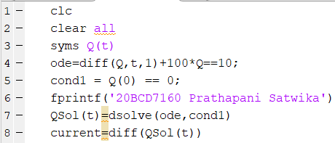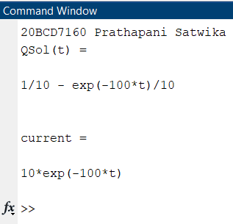

**2.**

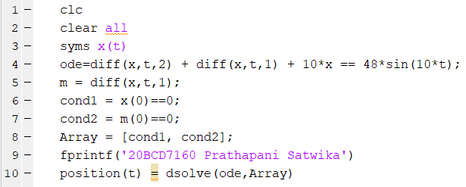

**Output :**

**20BCD7160 Prathapani Satwika**

**position(t) =**

**(12*exp(-t/2)*cos((39^(1/2)*t)/2))/205 - cos((39^(1/2)*t)/2)*((6*cos(10*t - (39^(1/2)*t)/2))/205 + (6*cos(10*t + (39^(1/2)*t)/2))/205 + (54*sin(10*t - (39^(1/2)*t)/2))/205 + (54*sin(10*t + (39^(1/2)*t)/2))/205 + (22*39^(1/2)*cos(10*t - (39^(1/2)*t)/2))/2665 - (22*39^(1/2)*cos(10*t + (39^(1/2)*t)/2))/2665 + (362*39^(1/2)*sin(10*t - (39^(1/2)*t)/2))/2665 - (362*39^(1/2)*sin(10*t + (39^(1/2)*t)/2))/2665) - (16*39^(1/2)*sin((39^(1/2)*t)/2)*((sin(t*(39^(1/2)/2 - 10))/2 - cos(t*(39^(1/2)/2 - 10))*(39^(1/2)/2 - 10))/((39^(1/2)/2 - 10)^2 + 1/4) - (sin(t*(39^(1/2)/2 + 10))/2 - cos(t*(39^(1/2)/2 + 10))*(39^(1/2)/2 + 10))/((39^(1/2)/2 + 10)^2 + 1/4)))/13 - (1448*39^(1/2)*exp(-t/2)*sin((39^(1/2)*t)/2))/(65*(39^(1/2) - 11)*(39^(1/2) + 11))**

**>>**