**NAME : PRATHAPANI SATWIKA**

**REG.NO. : 20BCD7160**

**EXPERIMENT NO. -7**

**Objective :** To study the input and output characteristics of semiconductor diodes

**Software Used :**NI Multisim 14.0

**Theory :**

A semiconductor diode is a combination of p and n type semiconductors which in forward bias at which the flow of current during the PN Junction begins increasing rapidly is known as **cut**-in **voltage .** After achieving cutting voltage the increase in current is almost exponential . A diode in reverse bias conducts negligible amount of current in the order of micro amperes .

**I = I0 (e^(v/(ηv T ) - 1)**

**Where ,**

I = current flowing through the diode

I0 = reverse saturation current,

q = charge on the electron,

V = voltage applied across the diode,

η = ideality factor (Ge = 1 and Si = 2 ) .

T is the absolute temperature in Kelvin.

The configuration in which the emitter is connected between the collector and base is known as a common emitter configuration. The input circuit is connected between emitter and base , and the output circuit is taken from the collector and emitter **.**

**Circuit Diagram :**

**1 . Diode in Forward Bias :**

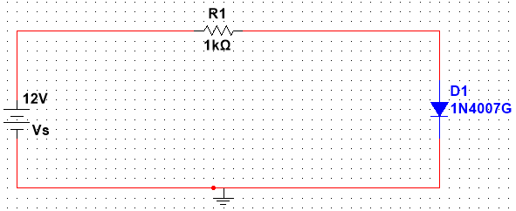

**2 . Diode in Reverse Bias :**

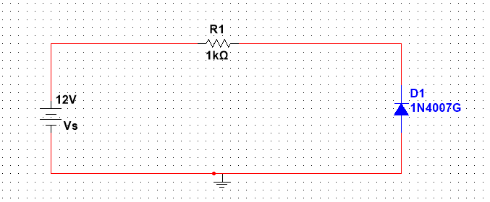

**3 . Common Emitter Configuration :**

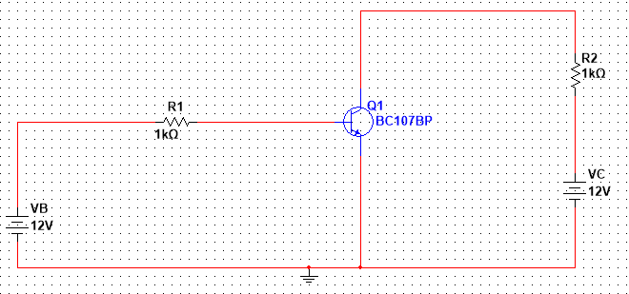

**Results &Observations :**

**1 . Diode is in Forward Bias :**

The Cutting Voltage for the diode is 0.3 V .

Therefore the diode is a Germanium Diode .

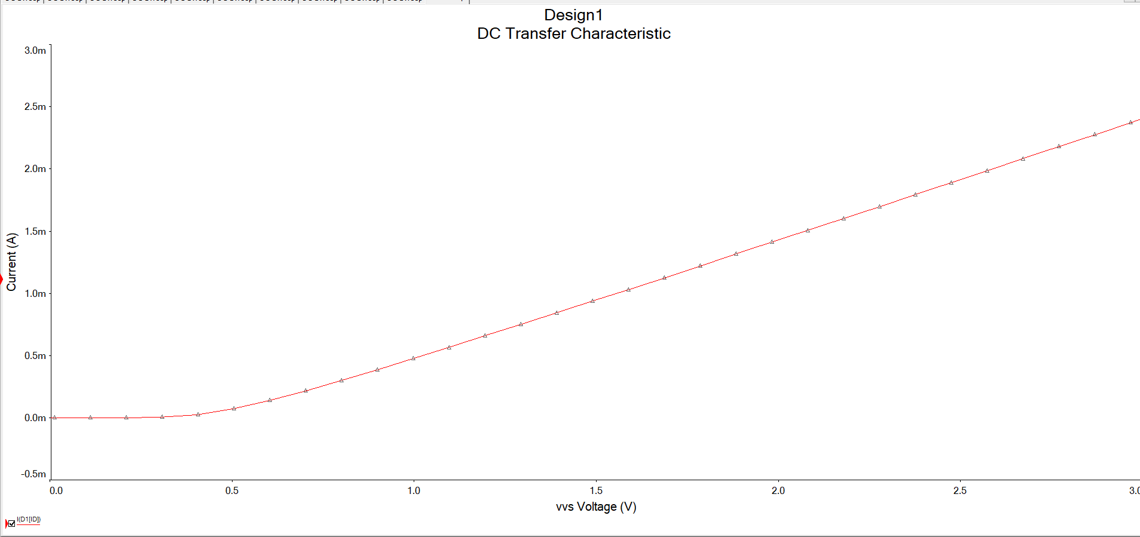

**2 . Diode is in Reverse Bias :**

The leakage current is negligible or zero .

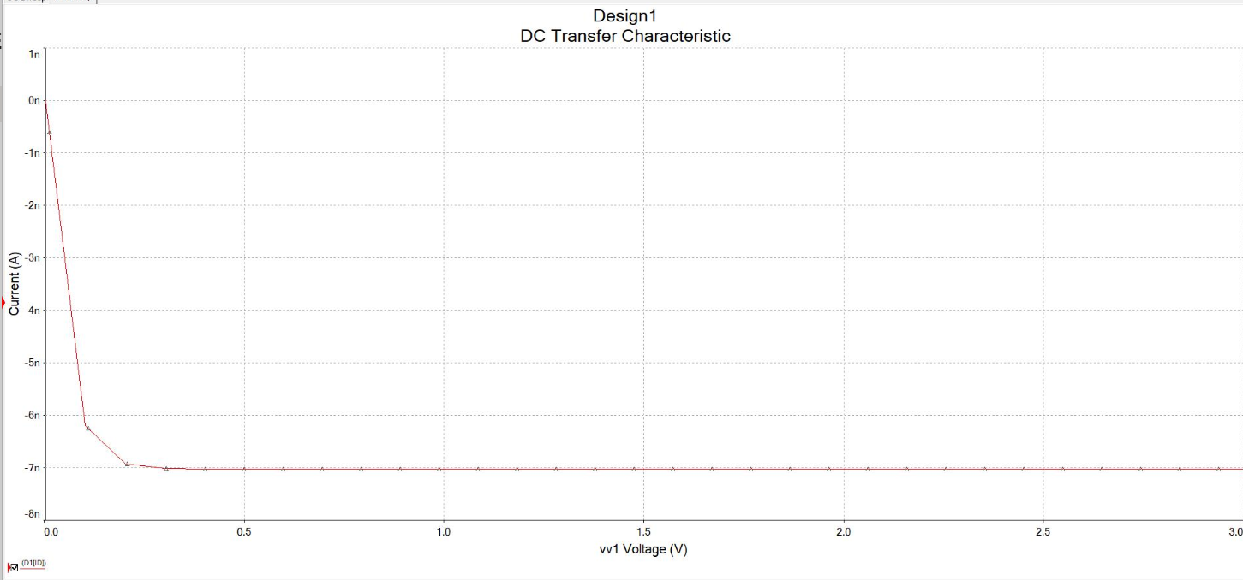

**3 . Common Emitter Configuration Input Characteristics :**

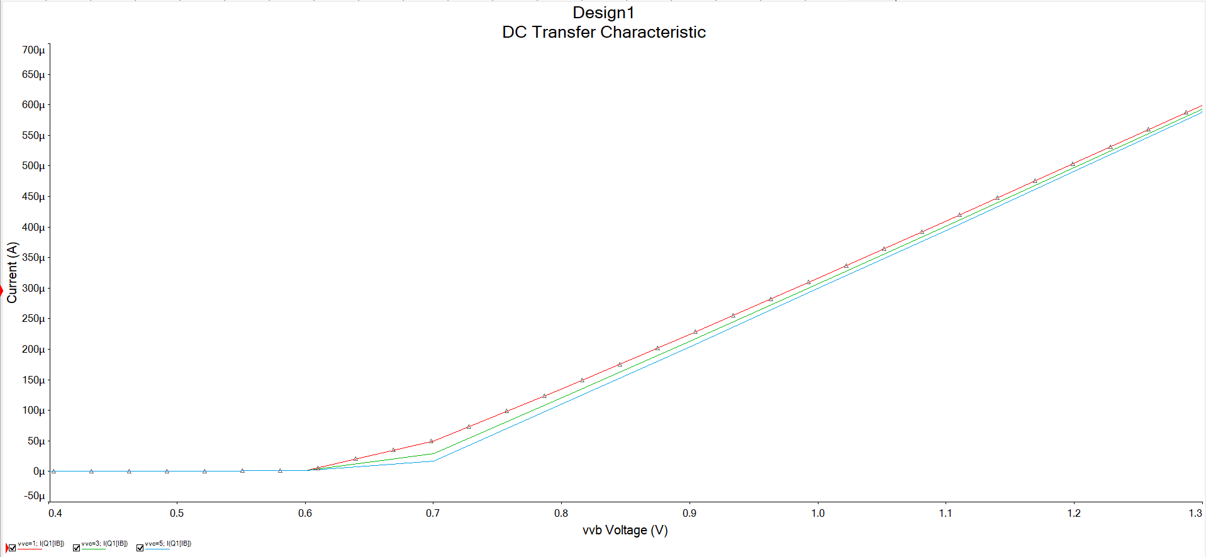

|  |  |  |  |
| --- | --- | --- | --- |
|  | **Voltage (VC)** | | |
| **1V** | **3V** | **5V** |
| **Cutting Voltage (Vℽ)** | **0.500V** | **0.506V** | **0.510V** |
|  |  |  |  |
|  |  |  |  |
|  |  |  |  |

**4 . Common Emitter Configuration Output Characteristics :**

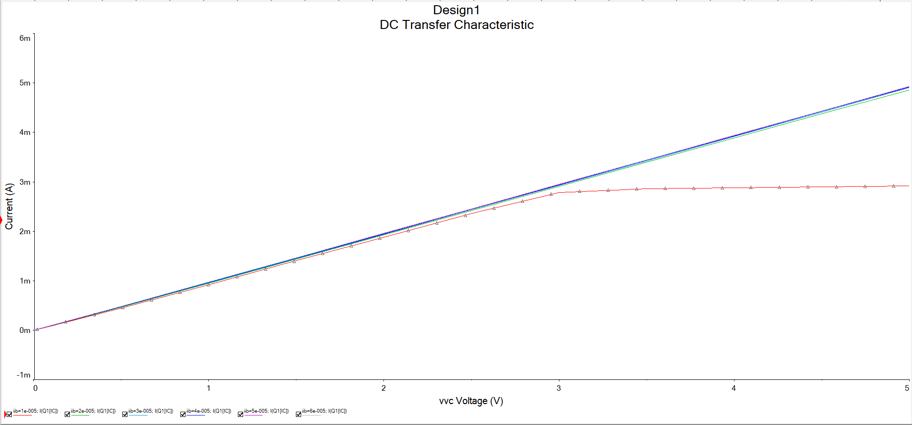

|  |  |  |  |
| --- | --- | --- | --- |
|  | **Base Current (IB)** | | |
| **10µA** | **30µA** | **50µA** |
| **Collector Current (IC)** | **2.77mA** | **8.74mA** | **14.46mA** |

**EXPERIMENT NO. – 8**

**Objective :** To design and simulate the half wave rectifier and full wave rectifier.

**Software used :** NI Multisim

**Theory :**

A rectifier is a circuit that converts the Alternating Current (AC) input power into a Direct Current (DC) output power.

Half wave rectifiers use one diode, while a [full wave rectifier](https://www.electrical4u.com/full-wave-rectifiers/) uses multiple diodes.

**“**  The power diode in a half-wave rectifier circuit passes just one half of each complete sine wave of the AC supply to convert it into a DC supply. Then this type of circuit is called a **“ Half-wave rectifier ”**, because it passes only half of the incoming AC power supply **” .**

During each **“** positive **”** half cycle of the AC sine wave, the diode is forward biased as the anode is positive concerning the cathode resulting in current flowing through the diode. During each **“** negative **”** half cycle of the AC sinusoidal input waveform, the diode is reverse biased as the anode is negative concerning the cathode. Therefore, NO current flows through the diode or circuit .

**“** **Full**-**wave rectifier** rectifies the negative component of the input voltage to a positive voltage then converts it into DC current utilizing a diode **bridge** configuration **”** **.**

**“ Bridge rectifier** can be defined as a type of full-wave rectifier that uses four or more diodes in a bridge circuit configuration to efficiently convert alternating (AC) current to a direct (DC) current **” .**

**Circuit Diagram :**

**1 . Half Wave Rectifier :**

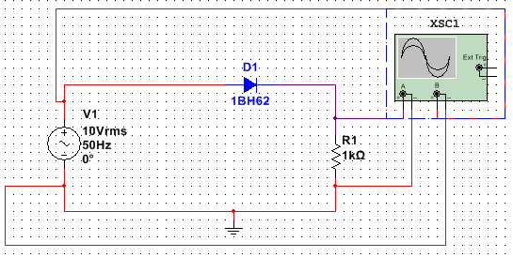

**Graph :**

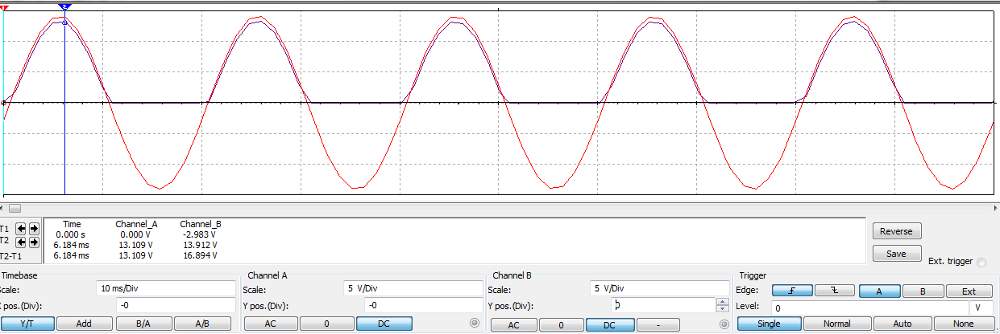

**2 . Full Wave Rectifier :**

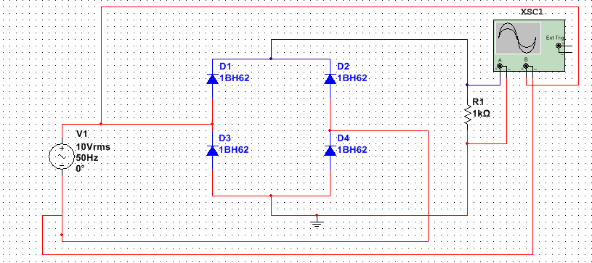

**Graph :**

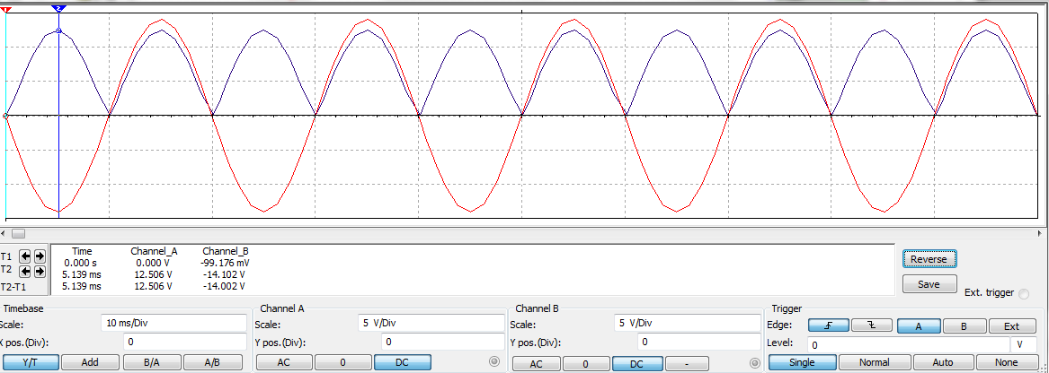

**Results & observations :**

**Half wave Rectifier :**

**Theoretical values : Experimental Values :**

Vm = 10√2 V Vm = 13.109 V

Vrms = Vm/2 = 10√2/2 =7.07 V Vrms = Vm/2 = 13.109/2 = 6.55 V

VDC = Vm/π =14.14/ π = 4.50 V VDC = Vm/π = 13.109//π = 4.172 V

γ = √(Vrms/VDC)^2 – 1 γ = √(Vrms/VDC)^2 – 1

= 1.211 = 1.210

**Full Wave Rectifier :**

**Theoretical values : Experimental Values :**

Vm = 10√2 = 14.14 V Vm = 12.506 V

Vrms = Vm/√2 = 10 V Vrms = Vm/√2 = 12.506//√2=8.84 V

VDC = 2Vm/ π = 9.003 V VDC = 2Vm/ π = 7.961 V

γ = √(Vrms/VDC)^2 – 1 γ = √(Vrms/VDC)^2 – 1

= 0.483 = 0.482

|  |  |  |  |  |  |  |  |  |
| --- | --- | --- | --- | --- | --- | --- | --- | --- |
|  | **Vm** | | **Vrms** | | **VDC** | | **γ** | |
| **Half-wave Rectifier** | **Theoretical** | **Multisim** | **Theoretical** | **Multisim** | **Theoretical** | **Multisim** | **Theoretical** | **Multisim** |
| 14.14V | 13.109V | 7.07V | 6.55V | 4.50V | 4.172V | 1.211V | 1.210V |
| **Full-wave Rectifier** | **Theoretical** | **Multisim** | **Theoretical** | **Multisim** | **Theoretical** | **Multisim** | **Theoretical** | **Multisim** |
| 14.14V | 12.506V | 10V | 8.84V | 9.003V | 7.961V | 0.483V | 0.482V |