**SECURITY AND VOICE CONTROL HOME AUTOMATION**

**Submitted by:**

Kotrike Rishika - 20BCE7240

Prathapani Satwika - 20BCD7160

Mekala Poornimai - 20BCD7167

Gonuguntla Rohini - 20BCD7174

Yendluri Sruthi - 20BCE7396

Hema Varshini Dasari - 20BCE7424

**UNDER THE GUIDANCE OF:**

Dr. Sheela Jayachandran,

Assistant Professor Senior Grade 1,

School of Computer Science and Engineering



VIT-AP University,

Amaravati,

Andhra Pradesh

**ABSTRACT:**

Home Automation performs an increasingly vital role in daily experience and global economy. Engineers strive to combine automated devices with mathematical and organizational tools to create complex systems for a rapidly expanding range of applications and human activities. Home automation is a network of hardware, communication, and electronic interfaces that work to integrate everyday devices with one another via the Internet. Home automation is one of the major growing industries that can change the way people live. Some of these home automation systems target those seeking luxury and sophisticated home automation platforms; others target those with special needs like the elderly and the disabled, leaking of gas has been the cause of a great number of accidents. Since the vast majority of parents now are working, it is much simpler for them to avoid worrying about their families and themselves in the event that there is a gas leak or another emergency at their residence. Typical wireless home automation system allows one to control house hold appliances from a centralized control unit which is wireless. The developed system can be integrated as a single portable unit and allows one to wirelessly control lights, fans, air conditioners, television sets, security cameras, electronic doors, computer systems, audio/visual equipment etc. The system is portable and constructed in a way that is easy to install, configure, run, and maintain. In addition, our system includes a sensor for detecting gas. In the scenario that there is a gas leak, it will sound an alarm buzzer. The perfect user interface still does not exist at present and to build a good interface requires knowledge of both sociology and technology fields. In our case we use an android application built in MIT app inventor to control the home appliances.

**INDEX**

|  |  |  |
| --- | --- | --- |
| **S.NO.** | **TABLE OF CONTENTS** | **PAGE NO.** |
| 1 | Introduction | 4 |
| 2 | Background | 5 |
| 3 | Problem Definition | 5 |
| 4 | Objectives | 6 |
| 5 | Methodology | 7 |
| 6 | Procedure | 11 |
| 7 | Results and Discussion | 15 |
| 8 | Conclusion | 16 |
| 9 | Future Scope | 17 |
| 10 | References | 18 |
| 11 | Codes in Appendix | 19 |

**INTRODUCTION:**

Today's homes demand sophisticated technological gadget control. This changed home automation. Connected home appliances boost affordability and simplicity. Smart phones may communicate with other devices in an ad hoc network using Bluetooth. With mobile phones, mobile app development has exploded. Mobile phones can be connected to electronic equipment in a home to automate tasks for a smart home. Android by Google Inc. is the platform for Android smartphone apps. Home automation system is an Android app aimed for the public.

The modern human person's surrounding environment can be automated, which provides for an increase in the job productivity and comfort of the modern human being. There has been a substantial amount of progress made in the field of an individual's normal chores, and such tasks are now capable of being automated. The majority of individuals, in this day and age, spend the most of their time clinging to their mobile phones and other smart devices throughout the day. As a result, some of the day-to-day chores that need to be done around the house can be completed with the assistance of his buddy, a mobile phone, by personifying the use of the mobile phone.

When looking at the current state of the market for smart phones, it has been found that first-time mobile users prefer Android-based phones. In common parlance, it is now commonly used as an alternative phrase for a mobile phone. The Home Automation System (HAS) was developed for mobile phones that run on the Android platform in order to automate an 8-bit Bluetooth-interfaced microcontroller. This microcontroller is responsible for controlling a variety of home appliances, including lights, fans, bulbs, and many more by means of an on/off relay. This project demonstrates an automated technique of controlling the appliances and gadgets found in a home, which, in comparison to the more conventional method of using the switch, may simplify certain duties. The automation of this system makes advantage of Bluetooth, which is widely recognised as the most effective technology available for wireless communication over short distances. The Household Appliances Switching system (HAS) is a step toward making duties easier for Android users, since it can operate anywhere from one to twenty-four different appliances simultaneously in any home environment.

**BACKGROUND:**

Research has been done on a number of different home automation systems that are operated remotely. By utilising Bluetooth technology to facilitate wireless communication between the Arduino BT and a mobile phone, it enabled complete control over home appliances that could be operated from a distance. A home appliance and a Symbian OS application on a cell phone were both used to operate an Arduino BT board that was linked to the appliance. The Symbian OS mobile phone can only handle scripts written in the Python language, and this operating system does not enable Java-based apps. Java is the predominant language used in the development of smartphone applications nowadays.

In this article, we discuss and demonstrate a cell phone-based home automation system that is versatile, low-cost, and secure. The Arduino BT board has connections made to the various home appliances. Wireless communication is used to transmit data between the mobile phone and the Arduino BT board.

It is possible to connect more devices to the system with relatively few necessary adjustments. Because the script for the mobile phone was developed in C, it is portable and may be executed on any platform that uses the Symbian Operating System.

The suggested system is comprised of hardware and software, its two primary components. The smartphone, the Arduino board, and the Bluetooth module make up the three primary components that make up the hardware part. The software component includes the Arduino integrated development environment (IDE) as well as the Bluetooth terminal smartphone application. The latter is what enables wireless communication to take place between the smartphone and the Arduino board. The sensor is responsible for determining whether or not there is a gas leak. In the event that there is a breach in the security of the building involving gas, an alarm buzzer will be activated.

**PROBLEM STATEMENT:**

Security and voice control home automation ,those who are elderly, incapacitated, frequently away from home, or in any other similar situation are now able to control their homes over the phone without having to worry about the possibility of a gas or smoke leak. Our solution consists of a computer-based system that is able to read directions that are delivered orally. In addition, the implanted sensors detect smoke infiltration or gas leakage, which warns us of the accident. It is not difficult to get to from any given area. For the purpose of controlling this system, we make use of Bluetooth rather than cords. The features of the project is mentioned below.

* Managing all of the electronic devices in your home from a single location.
* The degree of convenience offered here is really high.
* Adaptability to newly developed gadgets and home appliances.
* Ensuring the highest level of safety at home
* Control of many house features via remote.
* Increased effectiveness in conserving energy
* Enhanced performance of the home appliance.

**OBJECTIVES:**

A voice-controlled, wireless smart home system has been developed for individuals with disabilities and the elderly. The idea that a person's voice may be used to control household appliances is fascinating. The system that is being proposed is comprised of two primary elements: (a) a voice recognition system, and (b) a wireless system.

A voice-activated Android application is used by this system to operate various home appliances. It is now much simpler for a user to access and operate their home appliances from a remote location thanks to the proliferation of personal computers (PCs), the internet, mobile phones, and wireless technologies.

The primary goal of our system is to develop the most ideal companion possible for someone who spends their time at home. In general, research into home automation focused on a variety of demands, such as the development of applications that satisfy criteria for luxury and intelligence, while other studies shed light on the unique requirements of older people and people with disabilities, among other groups. Our system is a computer-based system that is capable of recognising voice orders and carrying them out. We are able to turn any gadget on or off using the system. In addition to that, our system comes equipped with a sensor for determining the presence of gas. In the event that there is a gas leak, an alarm buzzer will be triggered.

**METHODLOGY:**

Home automation describes a system of networked, controllable device that work together to make your home more comfortable, customized, efficient and secure.

In this device there are seven main parts

* Arduino,
* Bluetooth module,
* Relay drivers,
* Android application,
* step down transformer,
* MQ-2 Sensor,
* Buzzer.

Firstly, we provide power to the stepdown transformer, it will stepdown the input voltage and given to the Arduino with VIN pin. The Bluetooth module is also connected with Arduino to Rx and Tx pin that provides the information to the microcontroller. Microcontroller reads the information and send to the relay drivers which work as switch. In Arduino we upload the program as per requirement then it performs some mathematical and logical operation to control the relay drivers.

**COMPONENTS REQUIRED:**

* + **SOFTWARE DETAILS:**

* + - Proteus
    - Arduino IDE
    - MIT Android App

* + **HARDWARE DETAILS:**

* + - Solderless Breadboard
    - Arduino NANO
    - HC-05 Bluetooth Module
    - 4-Channel 5v Relay Module
    - 5v 2Amp Power Adapter
    - Bulb Holder
    - 220v LED Bulb
    - AC Fan 220v
    - Lamp
    - Socket
    - Jumper Cables
    - Buzzer
    - MQ-2 Senor

**BLOCK DIAGRAM:**

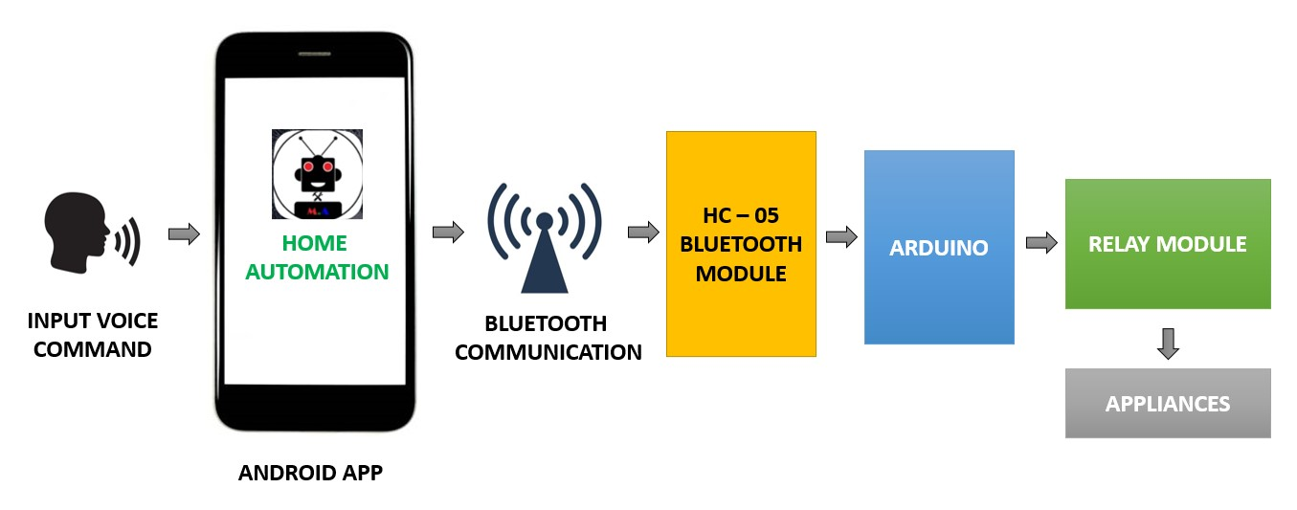

Figure 1: Block diagram

# SOFTWARE MODULE

In this project we used proteus, Arduino IDE and android application to control the components (Home appliances) present inside the circuit of proteus through Bluetooth module.

• **Arduino NANO:**

A miniature version of the Arduino board, the Arduino Nano uses either an ATmega328P or ATmega628 Microcontroller.

One definition of a Nano board describes it as a microcontroller board that is eco-friendly, compact, reliable, and versatile. In contrast to the size of the UNO board, this one is quite compact. The Arduino (Integrated Development Environment), which is capable of running on a number of different platforms, is used to arrange the Arduino Nano. Integrated Development Environment is abbreviated as IDE in this context.

The Arduino IDE and a small USB cable are the tools that are essential for getting our projects with the Arduino Nano board off the ground. The Arduino Software Development Environment (IDE) needs to be set up on either our desktop or laptop computer. The code is transferred from the PC to the Arduino Nano board through the tiny USB cable.

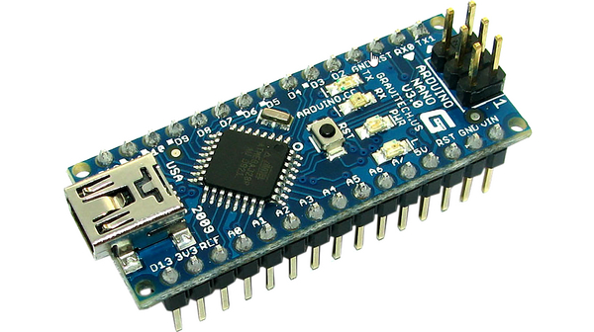

Figure 2: Arduino nano

* **Arduino IDE:**

The Arduino Integrated Development Environment contains a text editor for writing code, a message area, a text console, a toolbar with buttons for common functions and a series of menus. It connects to the Arduino and Genuino hardware to upload programs and communicate with them. In this project Arduino IDE is crucial because we are simulating the circuit in proteus. Arduino ide is generally used to upload the code to the Arduino hardware but in our case we are using an Arduino module inside proteus.

We type the code to the editor compile and in this case we generate a .hex file. This .hex file is a temporary file which is stored. We give the path of the .hex file to the virtual Arduino present inside the proteus software.

* **Bluetooth Module**

HC-05 Bluetooth Module is an easy-to-use Bluetooth SPP (Serial Port Protocol) module, designed for transparent wireless serial connection setup. Its communication is via serial communication which makes an easy way to interface with controller or PC.

•Bluetooth module acts as an interface between the app and Arduino.

•It receives the signal from the phone and transmits it into Arduino.

•It enables the wireless control of our circuit by accessing the Bluetooth of the laptop.

•Inside the circuit the transmission pin of the Bluetooth module is connected to pin no ‗0‘and the receiver pin is connected to pin no ‗1‘of the Arduino.

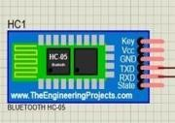

Figure 3: Bluetooth module

• **Relay switching circuit**

Relay switching circuit acts as a virtual switch to our circuit. It contains relay module a npn-transistor, diode and a dc voltage source.

One end of the relay switching circuit is connected to Arduino, when the Arduino give high output to the switching circuit the transistor switches on as a result max current flows through the relay coil which causes it to switch on and the required power is delivered to home appliances (in this case LED and dc motor).

When the Arduino gives low output the transistor moves into the cut off region which moves the relays witch back to initial position and the diode is used to discharge the coil. In our circuit we operate two relay switching circuit which are connected to pin 5‘and 6‘of the Arduino.

•Relay switching circuit acts as a virtual switch for our appliances.

•It is connected to Arduino which controls the action of the circuit. •We use two relay switching circuits in our project to control the appliances.

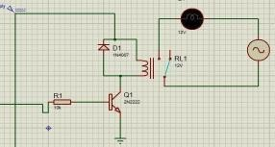

Figure 4: Relay Switching circuit

**PROCEDURE:**

We have conducted the simulation within the Proteus environment. At this time, the Bluetooth module that is housed within Proteus activates the com-port so that it may communicate with the phone. Once we have successfully activated Bluetooth on the mobile phone that is running our application, we will need to connect to our computer so that we may continue using the programme.

To begin, we have to activate the microphone by pressing the button designated for that purpose. When we provide a command, the application's built-in voice-to-text client transforms what we say into text and then sends it to the Bluetooth module housed within the circuit. The Bluetooth module will send the command to the Arduino in the form of text. The Arduino will then access the code and compare our command to the ones that are provided in the code.

Because of this, we are able to operate all of the equipment inside the house with just one device, which is our phone. We accomplish operations by connecting all of our household appliances, including our phone, to a network. A gas leak that is greater than a particular threshold level is detected, and the other member of the household is alerted with a buzzer.

**CIRCUIT DIAGRAM:**

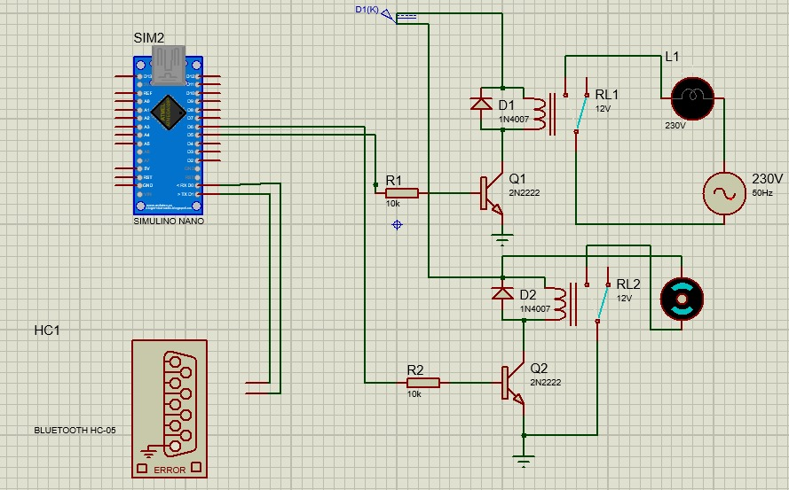

Figure 5: circuit diagram

**CODE:**

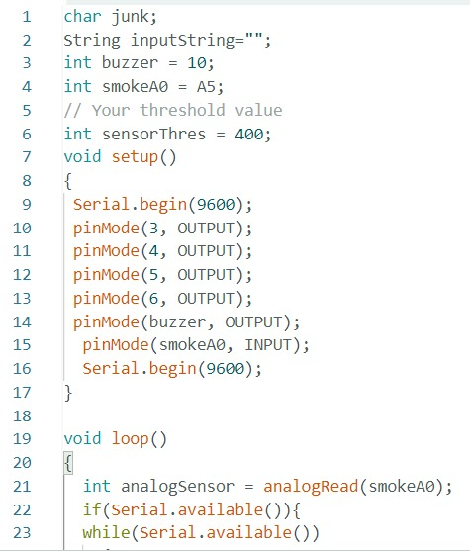 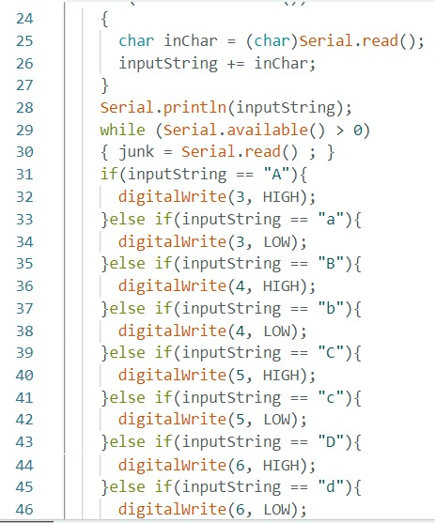

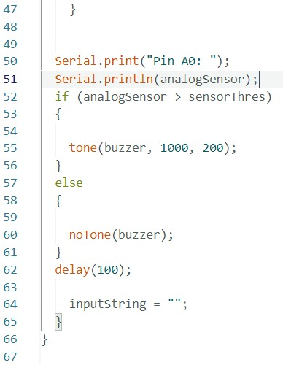

**ANDROID APP FOR SOFTWARE:**

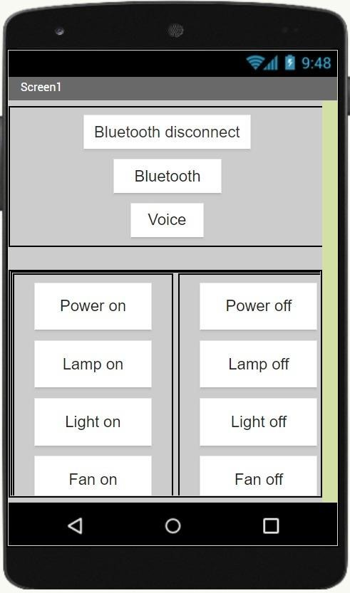

Figure 6: Android app

**CODE BLOCKS FOR THE APP:**

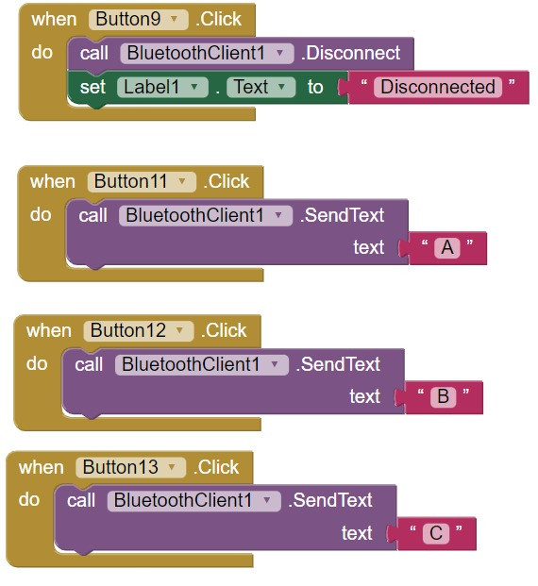 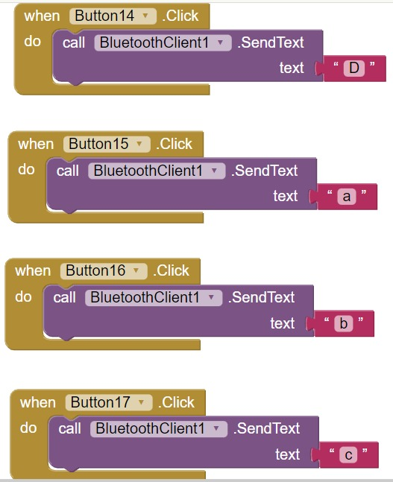

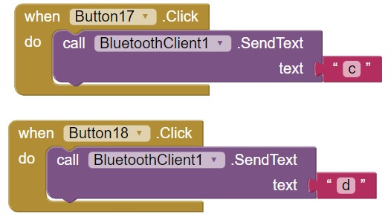 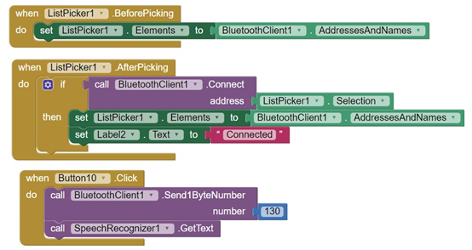

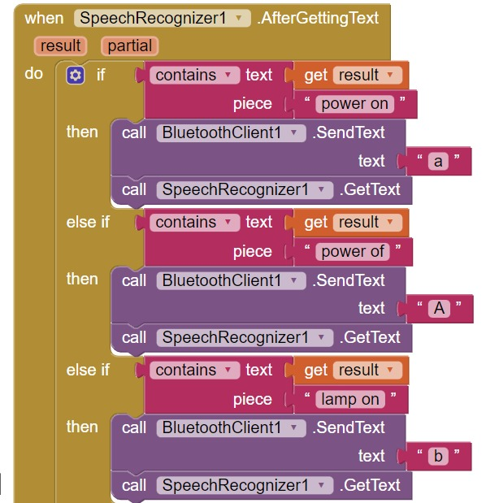 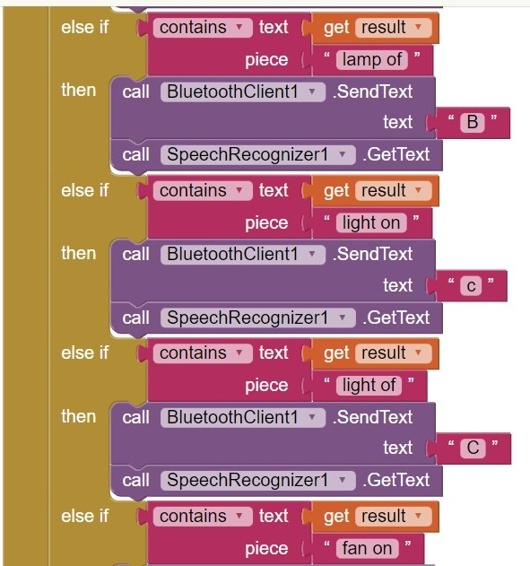

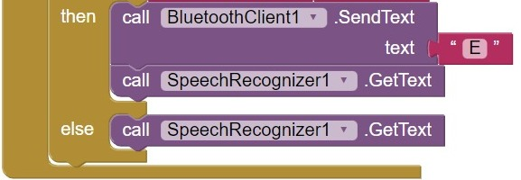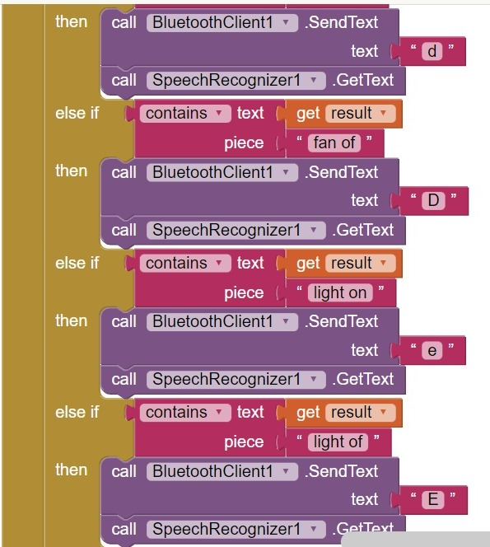

**RESULTS AND DISCUSSION:**

Once the button ON or OFF is pressed it changes its state i.e., ON to OFF or OFF to ON.

Similarly, according to the voice command the labels change in the App.

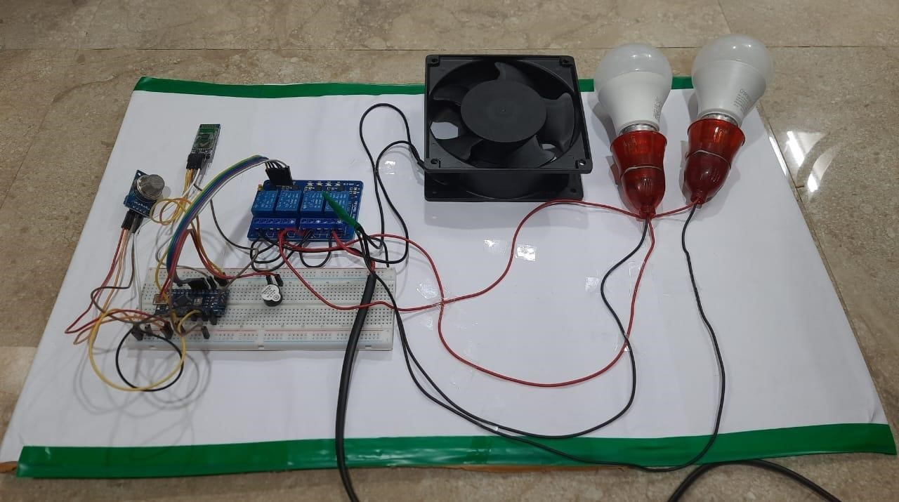

Figure 7: Working prototype

**LIGHT AND LAMP ON:**

**Turn on light:**

Light can be turned on by either giving voice command **“TURN ON LIGHT”** or by manually operating mobile phone. The relay connected to the light gets closed and the bulb glows.

**Turn on lamp:**

Lamp can be turned on by either giving voice command **“TURN ON LAMP”** or by manually operating mobile phone. The relay connected to the light gets closed and the lamp glows.

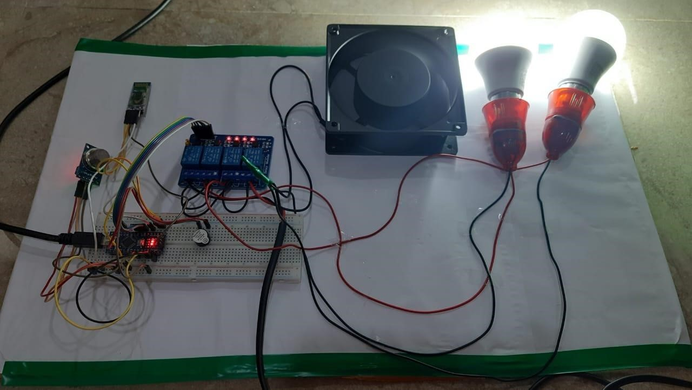

Figure 8: working prototype when light and lamp are on

**FAN ON:**

**Turn on fan:**

Fan can be turned on by either giving voice command **“TURN ON FAN”** or by manually operating mobile phone.

The relay connected to the fan gets closed and the fan rotates.

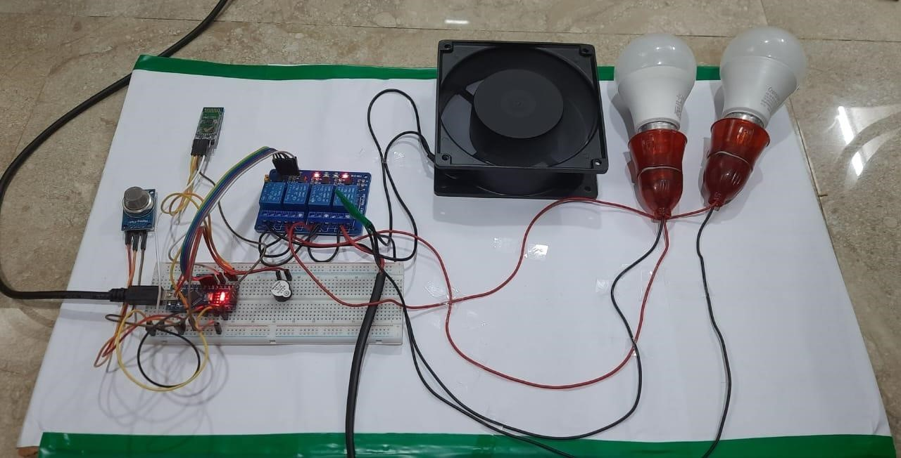

Figure 9: working prototype when fan is on

**GAS SENSOR:**

The implanted sensors detect smoke infiltration or gas leakage, which warns us of the accident. It is not difficult to get to from any given area. Our system includes a sensor for detecting gas. In the scenario that there is a gas leak, it will sound an alarm buzzer.

**CONCLUSION:**

It has been experimentally demonstrated that the home automation system works adequately by connecting sample appliances to it, and it has also been successfully demonstrated that the appliances can be managed from a wireless mobile device. [Citation needed] The purpose of the experiment was to demonstrate that the system functions in an acceptable manner. It was demonstrated that the Bluetooth client is portable and is compatible with a wide variety of mobile phones by the fact that it worked properly on a wide variety of mobile phones made by a variety of manufacturers. This was done in order to demonstrate that the Bluetooth client is compatible with a wide variety of mobile phones. We were able to create and put into action a home automation system with the assistance of this project, making it possible for us to do so in a way that was not only inexpensive but also wireless, versatile, and adaptable. Because it has been secured, the system will be inaccessible to any user or intruder who attempts to use it. Customers will be required to receive a pairing password for both their mobile phone and their Arduino BT device in order to gain access to the home appliances they have purchased for their homes. This offers an additional line of defence against users who are not authorised to access it. As a direct consequence of this, we were free from any obstacles when it came to the planning and execution of the installation of a home automation system.

Because of the rise in popularity of home automation systems, the discipline of control systems had become an increasingly important field. The implementation of such systems has been continuously expanding, particularly in connection with the movement toward standardising the methods that they use. In point of fact, one of the most important considerations is the ability of various types of technological apparatus to collaborate, communicate with one another, and operate in a high degree of harmony with one another. These gadgets could have been produced by any one of a number of distinct companies. In addition, the complex procedures and multiple solutions that are provided have the aim of lowering the prices of smart homes and making the integrated system that much simpler, easier to handle, and capable of achieving higher permanent degrees of security. These goals were established in order to achieve the goal of bringing down the cost of smart homes.

The core population that will be targeted by the home automation system that is now in the planning stages is comprised of individuals such as the elderly, people who have impairments, disabled persons, and other people. This one-of-a-kind master board has the ability to regulate the ON/OFF switches of a wide variety of home appliances by making use of relays. If the gas leak goes above a specified threshold level, a buzzer will alert the other members of the family. Despite the fact that our system was developed for people who may require significant efforts to move, it is adaptable to the needs of other users and has the capacity to add a number of functionalities as well as a variety of modalities. Although it was designed for people who may require significant efforts to move, it may also require significant efforts to move. In spite of this, it is a method that can also be utilised in healthcare facilities such as hospitals, hospices, and health care centres.

**FUTURE SCOPE:**

In IOT an open-source cloud platform is used for e.g., “Thing Speak: IOT Analytics”. The appliances are connected to this cloud by using a Wi-Fi receiver which in turn passes the command to these appliances over the cloud. IOT has been in a boom recently and is a fast-growing field.

1. Voice base home automation system can be further modified for even controlling speed of the fan and intensity of light
2. We can replace Bluetooth by GSM modem so that we can achieve device controlling by Sending SMS using GSM modem. We can also use Wifi module instead of Bluetooth for home automation approach.
3. If safety is a concern, a smoke detector could be installed in the building at some point in the future.

**REFERENCES:**

[1] Umer, M., & Khan, M. M. (2020). Smart home automation using ATMEGA328. *Adv. J. Sci. Eng*, *1*(3), 86-90.

[2] Easwaran, K., Koli, S. R., Kokare, S. G., Barun, D. C., & Bhave, S. (2020). *App/Bluetooth Based Home Automation* (No. 2906). EasyChair.

[3] Ranjan, R., & Sharma, A. (2020, April). Voice-controlled IoT devices framework for smart home. In *Proceedings of First International Conference on Computing, Communications, and Cyber-Security (IC4S 2019)* (pp. 57-67). Springer, Singapore.

[4] Vishwakarma, S. K., Upadhyaya, P., Kumari, B., & Mishra, A. K. (2019, April). Smart energy efficient home automation system using IOT. In *2019 4th international conference on internet of things: Smart innovation and usages (IoT-SIU)* (pp. 1-4). IEEE.

[5] Hamdan, O., Shanableh, H., Zaki, I., Al-Ali, A. R., & Shanableh, T. (2019, January). IoT-based interactive dual mode smart home automation. In *2019 IEEE international conference on consumer electronics (ICCE)* (pp. 1-2). IEEE.

[6] Asadullah, M., & Ullah, K. (2017, April). Smart home automation system using Bluetooth technology. In *2017 International Conference on Innovations in Electrical Engineering and Computational Technologies (ICIEECT)* (pp. 1-6). IEEE.

[7] Das, S., Ganguly, S., Ghosh, S., Sarker, R., & Sengupta, D. (2016, October). A bluetooth based sophisticated home automation system using smartphone. In *2016 International Conference on Intelligent Control Power and Instrumentation (ICICPI)* (pp. 236-240). IEEE.

[8] Evalina, N., & Azis, H. A. (2020, April). Implementation and design gas leakage detection system using ATMega8 microcontroller. In *IOP Conference Series: Materials Science and Engineering* (Vol. 821, No. 1, p. 012049). IOP Publishing.

[9] Bogdan, M. (2018). „Gas Detector Using Arduino and LabVIEW”. In *Proceedings of the 13th International Conference on Virtual Learning ICVL* (pp. 315-318).

**CODES IN APPENDIX:**

char junk;

String inputString="";

int buzzer = 10;

int smokeA0 = A5;

// Your threshold value

int sensorThres = 400;

void setup() {

Serial.begin(9600);

pinMode(3, OUTPUT);

pinMode(4, OUTPUT);

pinMode(5, OUTPUT);

pinMode(6, OUTPUT);

pinMode(buzzer, OUTPUT);

pinMode(smokeA0, INPUT);

Serial.begin(9600);

}

void loop(){

int analogSensor = analogRead(smokeA0);

if(Serial.available()){

while(Serial.available() {

char inChar = (char)Serial.read();

inputString += inChar;

}

Serial.println(inputString);

while (Serial.available() > 0)

{ junk = Serial.read() ; }

if(inputString == "A"){

digitalWrite(3, HIGH);

}else if(inputString == "a"){

digitalWrite(3, LOW);

}else if(inputString == "B"){

digitalWrite(4, HIGH);

}else if(inputString == "b"){

digitalWrite(4, LOW);

}else if(inputString == "C"){

digitalWrite(5, HIGH);

}else if(inputString == "c"){

digitalWrite(5, LOW);

}else if(inputString == "D"){

digitalWrite(6, HIGH);

}else if(inputString == "d"){

digitalWrite(6, LOW);

}

Serial.print("Pin A0: ");

Serial.println(analogSensor);

if (analogSensor > sensorThres){

tone(buzzer, 1000, 200);

} else{

noTone(buzzer);

}

delay(100);

inputString = "";

  }