

**QUESTION PAPER**

**Q1. 15 M**

Assume the feature map comprises of 5 x 5 and the filer is of 3 X 3, when stride=1 is applied, find the output feature map.

|  |  |  |  |  |
| --- | --- | --- | --- | --- |
| 9 | 2 | 1 | 5 | 6 |
| 3 | 4 | 2 | 3 | 0 |
| 5 | 0 | 7 | 10 | 2 |
| 1 | 3 | 1 | 0 | 5 |
| 4 | 1 | 0 | 0 | 3 |

|  |  |  |
| --- | --- | --- |
| 0 | 1 | 0 |
| 1 | -2 | 1 |
| 0 | 1 | 0 |

Ans :

|  |  |  |
| --- | --- | --- |
| -1 | 11 | 11 |
| 19 | -2 | -8 |
| -3 | -8 | 16 |

B. If padding has to be done for the above feature map, find out the required padding size to be done. Why do we need to pad the input feature map?

Ans. To calculate the required padding size, **input_size + 2 * padding_size-(filter_size-1)**

=5+(2*1) -(3-1)

=7-2=5

Padding (p)= f=filter

C. Apply Average pooling on the feature map by considering stride=2.

|  |  |  |  |
| --- | --- | --- | --- |
| 12 | 1 | 5 | 1 |
| 6 | 9 | 7 | 0 |
| 8 | 7 | 2 | 5 |
| 6 | 0 | 3 | 4 |

|  |  |
| --- | --- |
| 7 | 3 |
| 17 | 4 |

Q2. **20 M**

Consider the Artificial Neural Network with the following values

X1=0.15, x2=0.20, w11=0.15,w12=0.20,w21=0.25,w22=0.30,w4=0.40,w5=0.45,b1=0.35 to h1 and h2 and bias b2 to O1 =0.60. Assume the actual output=0.01. find the predicted output. Find the error and through backpropagation, find out the **updated weights of w4 and w5** provided learning rate =0.5.

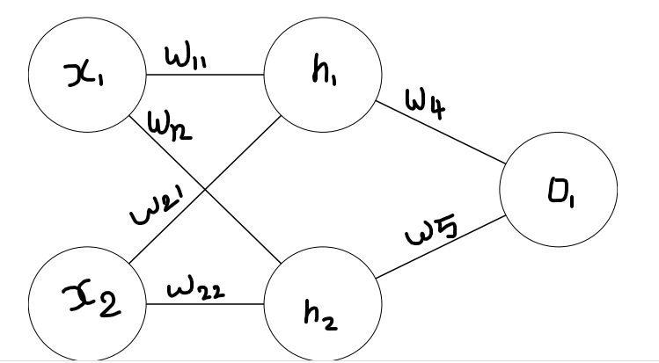

Neth1=0.4225 neth2= 0.44 outh1=0.604 outh2=0.608

Q3. 10 M

Find out the transition matrix from the below diagram. Assume the initial probabilities for sleeping, eating and playing are denoted as π = {0.25,0.25,0.50} .

a. Find the probability of the series. Baby is sleeping, sleeping, eating, playing, playing, sleeping.

b. Find the probability of baby playing given baby is eating. c. Draw the HMM model.

|  |  |  |  |
| --- | --- | --- | --- |
|  | Eating | Sleeping | Playing |
| Eating | 0.3 | 0.4 | 0.3 |
| sleeping | 0.2 | 0.3 | 0.5 |
| Playing | 0.1 | 0.3 | 0.6 |

4. Apply Viterbi algorithm and find the best sequence 10 M

|  |  |  |  |
| --- | --- | --- | --- |
|  | Call | Nocall | End |
| Start | 0.7 | 0.3 | 0 |
| Call | 0.2 | 0.7 | 0.1 |
| Nocall | 0.7 | 0.2 | 0.1 |

|  |  |  |  |
| --- | --- | --- | --- |
|  | St | Near | Far |
| Start | 1 | 0 | 0 |
| Call | 0 | 0.7 | 0.3 |
| Nocall | 0 | 0.4 | 0.6 |

Transition Probabilities Emission Probabilities

Find the hidden state sequence for (Near Far Far).

. Find the Probability for P(K = 1|a = 1 ∧ b = 1 ∧ c = 0) and P(K = 0|a = 1 ∧ b = 1)

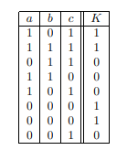

5. Apply Bayesian Belief network and solve it. 10 Marks

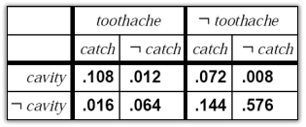

Find the probability for the following

1. P( Toothache )
2. P(cavity ∨ toothache)
3. P(¬cavity|toothache)
4. P(cavity|toothache)

6. An aptitude test and statistics tests was conducted randomly for 5 students and the scores were depicted in the table. 5M

|  |  |  |
| --- | --- | --- |
| Student | Aptitude score | Statistics score |
| 1 | 60 | 70 |
| 2 | 70 | 85 |
| 3 | 80 | 65 |
| 4 | 85 | 95 |
| 5 | 95 | 70 |

Based on math aptitude ratings, which linear regression equation best predicts statistics performance?

What grade would we anticipate a student to get in statistics if the student scored an 80 on the aptitude test?

Q7. Suppose we have height, weight and T-shirt size of some customers and we need to predict

the T-shirt size of a new customer given only height and weight information we have. Data

including height, weight and T-shirt size information is shown below -

Height (in

cms) Weight (in kgs) T Shirt

Size

158 58 M

158 59 M

158 63 M

160 59 M

160 60 M

163 60 M

163 61 M

160 64 L

163 64 L

165 61 L

165 62 L

165 65 L

168 62 L

168 63 L

168 66 L

170 63 L

170 64 L

170 68 L

Use K-NN algorithm and find for the customer named &#39;Ram&#39; has height 161cm and

weight 61kg with K=5. (Manhattan, Euclidean, Hamming)

Q8 How to work on ReLu/Sigmoid/Softmax functions ? Give examples.

. In the following, we consider the data set in which the task is to describe whether a person is ill. We use a representation based on four features per subject to describe an individual person. These features are “running nose”, “coughing”, “reddened skin”, and “fever”, each of which can take the value true (‘+’) or false (‘–’).

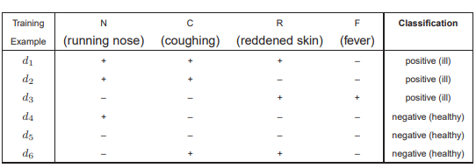

1. Given the data set in the table , determine all probabilities required to apply the naive Bayes classifier for predicting whether a new person is ill or not [5marks]
2. Apply your naive Bayes classifier to the test patterns corresponding to the following subjects: a person who is coughing and has fever, a person whose nose is running and who suffers from fever, and a person with a running nose and reddened skin [10 marks]