1. Suppose we have a convolutional neural network with input image as shown below.  **15M**

Input Image Kernel/Filter

|  |  |  |  |  |
| --- | --- | --- | --- | --- |
| 1 | 1 | 1 | 0 | 0 |
| 0 | 1 | 1 | 1 | 0 |
| 0 | 0 | 1 | 1 | 1 |
| 0 | 0 | 1 | 1 | 0 |
| 0 | 1 | 1 | 0 | 0 |

|  |  |  |
| --- | --- | --- |
| 1 | 0 | 0 |
| 0 | 1 | 0 |
| 1 | 0 | 1 |

1. Calculate the feature Maps after the convolution using Filter with a stride of 1, where no padding is involved.
2. For the above convolutional neural network input image, calculate the feature maps after the convolution using the filters with a stride of 1, where padding=1.
3. For the given feature map calculate the result of a 2*2 max pooling and the result of a 2*2 mean pooling and 2*2 Sum Pooling respectively.

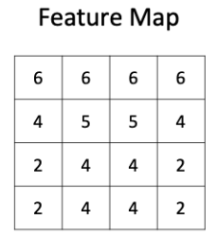

2.

Given the training data in the table below (*Tennis* dataset), predict the new example using Naïve Bayes classification: outlook=overcast, temperature=60, humidity=62, windy=false.



3.

**a)** Consider the Artificial Neural Network with the following values

X1=1,x2=0, w11=0.20,w12=0.10,w21=0.25,w22=0.1,w4=0.3,w5=0.4,bias b1 to h1 and h2=1 and bias b2 to O1=1. Assume the actual output=0.95. Find the predicted output. Find the error and through backpropagation, find out the new weights of w4 and w5 only provided learning rate =0.5.

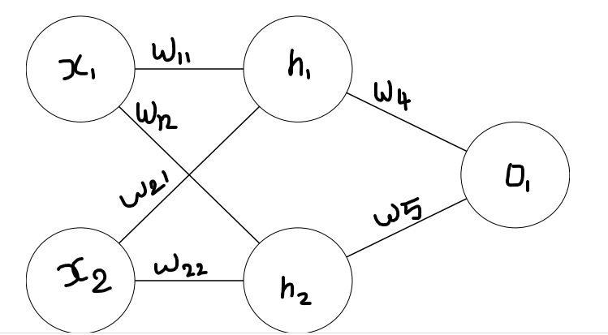

**b)** Consider a neural network with 5 input features x1 to x5 and output of the Neural Network has values Z1=2.33,Z2= -1.46,Z3=0.6.The Target output of the function is [1,0,1] Calculate the probabilities using Soft Max Function and estimate the loss using cross- entropy.