**PHASE -2 INNOVATION**

**SMART PARKING SYSTEM**

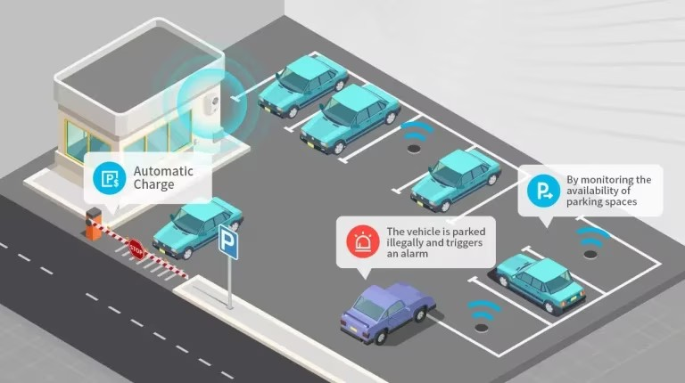

**SMART PARKING SYSTEM**

**PHASE -2 INNOVATION**

**INTRODUCTION**

Smart parking system using IoT. This is a great system and project for techies, hobbyists, and project makers.

What do you need to make this system and how you can make it we will share all the details. We have uploaded a lot of projects before from our smart irrigation system using Arduino.

**DESIGN PRINCIPLE**

As mentioned above, the proposed smart parking lot circuit will be equipped with several sensors, inexpensive microcontrollers and Wi-Fi module using which a car / any vehicle owner can check if there is vacant space in a parking lot using his / her phone or tablet or even on computer.

The number of vacant spaces in the smart parking lot can be viewed from anywhere in the world using a URL link or the user can scan a QR code. The scanned / shared URL can be browsed on any web browser to know how many empty parking spot exist in real time.

**BLOCK DIAGRAM:**

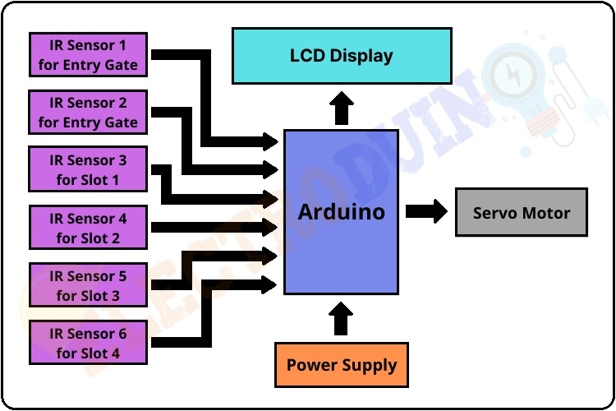

**COMPONENTS :**

1 NodeMCU (ESP-8266)

2 ARDUINO UNO

3 Ultrasonic Sensor SRF- 04

4 Servo Motor SG90

5 Infrared Sensor (IR)

**SOFTWARE DEVELOPMENT:**

1 Arduino IDE

2 Blynk Platform

**WORKING PRINCIPLE :**

After assembling all components according to the circuit diagram and uploading the code to the Arduino board. Now place the sensors and servo motor at accurate positions.

There are four parking slots in this project, IR sensor-3, 4, 5, and 6 are placed at slot-1, 2, 3, and 4 respectively. IR sensor-1 and 2 are placed at the entry and exit gate respectively and a servo motor is used to operate the common single entry and exit gate. The LCD display is placed near the entry gate.The system used IR

sensor-3, 4, 5, and 6 to detect whether the parking slot is empty or not and IR sensor-1, and 2 for detecting vehicles arriving or not at the gate.

In the beginning, when all parking slots are empty, then the LCD display shows all slots are empty.

When a vehicle arrives at the gate of the parking area then the IR sensor-1 detects the vehicle and the system allowed to enter that vehicle by opening the servo barrier. After entering into the parking area when that vehicle occupies a slot then the LED display shows that the slot is full. In this way, this system allows 4 vehicles.

In case the parking is full, the system blocked the entrance gate by closing the servo

barrier. And the LED display shows that slot-1, 2, 3, and 4 all are full.

When a vehicle leaves a slot and arrives at the gate of the parking area then the IR sensor-2 detects that vehicle and the system open the servo barrier. Then the LED display shows that the slot is empty. Again the system will allow entering a new vehicle.

**CONCLUSION :**

The development of the Internet of Things and cloud technology opens up new opportunities for smart cities. Smart parking has always been the backbone of building smart cities. IoT-based smart parking system offers real-time slots, parking procedures, information and improves users’ ability to save time on proper parking. It helps to solve growing traffic congestion concerns. As for future work, users can book parking in a remote location. GPS, reservations, and license plate scanners can be included in the future.