EtherCAT

- Working Principle:

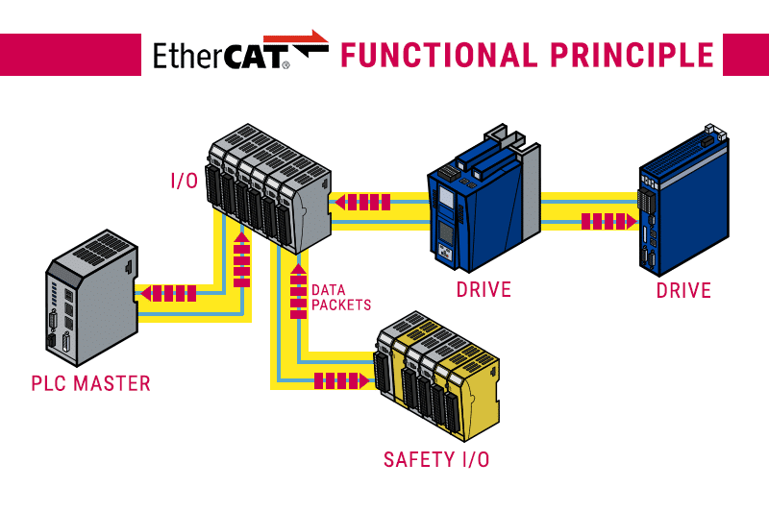

- The EtherCAT Main Device sends a telegram that passes through each node. Each EtherCAT Sub Device reads the data addressed to it “on the fly” and inserts its data in the frame as the frame is moving downstream. The frame is delayed only by hardware propagation delay times. The last node in a segment (or drop line) detects an open port and sends the message back to the Main Device using Ethernet technology’s full duplex feature.
- EtherCAT is a real-time industrial Ethernet technology originally developed by Beckhoff Automation.

- Attack Vectors:
Suffix:
- AMS – Automation Message Specification
ADS – Automation Device Specification
EAP – EtherCAT Automation Protocol
PCAP – Packet Capture
POU – Program Organisation Units

Attack Vector | What It Means | What Happens If This Attack Occurs (Effect)
Packet Injection | An attacker inserts forged EtherCAT frames into the bus. | Devices receive manipulated I/O values, causing wrong actuator movements, incorrect sensor data, or unsafe behaviour in the process.
Man-in-the-Middle (MITM) | Frames are intercepted and altered while traveling between the master and slaves. | The system continues running but on falsified data, leading to silent process manipulation, unexpected outputs, and potential equipment damage.
Rogue Slave / Device Spoofing | An unauthorized device pretends to be a valid EtherCAT slave. | The attacker can read all traffic, block legitimate updates, or feed fake values back into the bus.
MAC Spoofing / Identity Imitation | The attacker copies the MAC address of a master or slave. | Slaves may treat the attacker as the real master, allowing complete takeover of control communication.
Cycle-Time / Timing Disruption | EtherCAT’s real-time frame timing is intentionally delayed or disturbed. | The deterministic cycle breaks — causing missed I/O updates, jitter, motion faults, PLC errors, and potential process shutdown.
Unauthorized Command Message (EAP / T0855) | Altering controller-to-controller data such as water level or tank status. | The PLC reacts to falsified values (e.g., turning pumps on when they shouldn’t), creating unsafe operating conditions.
Operating Mode Manipulation (AMS / T0858) | Replaying captured AMS packets to change PLC mode. | PLC is forced from RUN to CONFIG mode, stopping control logic and allowing further tampering.
PLC Restart or Shutdown (AMS / T0816) | Using replayed state-change messages from PCAP. | The PLC unexpectedly restarts or shuts down, stopping the process and causing downtime or hazards.
Denial of Service (DoS / T0814) | Flooding AMS or EtherCAT traffic using tools like tcpreplay. | Communication becomes overloaded; PLCs and slaves become unresponsive and the process halts.
Control Logic Manipulation (T0833 / T0831) | Capturing POU files, editing them, and re-uploading altered logic. | The PLC executes attacker-modified logic, leading to long-term sabotage or incorrect process sequences.
Network Sniffing (T0842) | Monitoring AMS/EAP traffic using a tap or analysis tool. | The attacker learns exact commands, variable changes, and state transitions, enabling precise replay or manipulation attacks later.

- Attacks in the Past:
- As the protocol is still new and developed in 2003 by the EtherCAT Technology Group, there no evident records on how the past attacks have taken place.

- Measures taken to curb such attacks:
- Attack detection using a EtherCAT preprocessor:
For the decoding of the Ethernet frame payload, the Snort rule base has been extended with EtherCAT specific rule options: (1) ecat: Detection related to the datagram header, (2) ecat_data: Analysis of the datagram payload field, (3) ecat_fmmu: Detection of Fieldbus Memory Management Unit (FMMU) manipulations, and (4) ecat_count: Frame count as a threshold for triggering alerts.

- Sources:
- https://github.com/Pratheek19014/OT_Security/blob/main/LiteratureStudyGroup/Group_4/Literature/Research_paper.pdf
- https://github.com/Pratheek19014/OT_Security/blob/main/LiteratureStudyGroup/Group_4/Literature/IntrusionDetectionoftheICSProtocolEtherCAT.pdf
- https://www.ethercat.org/en/technology.html
- https://de.wikipedia.org/wiki/Snort

