VPN (virtual private network)
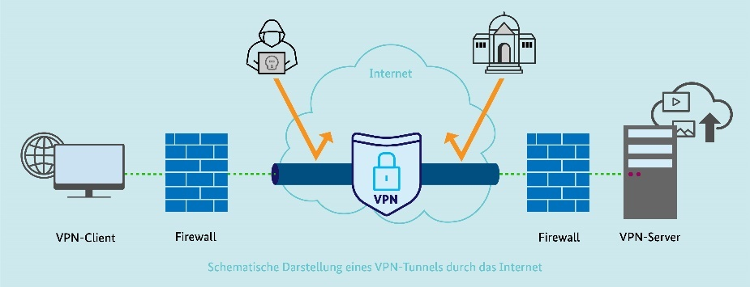
1.1 Introduction
A VPN, or virtual private network, creates a secure and encrypted connection over the internet, protecting your data and privacy. It works by routing your internet traffic through a remote server, which encrypts your data and masks your IP address, making your online activity unreadable to others and your location appear different. This allows you to safely use public Wi-Fi, bypass censorship and geo-restrictions, and protect sensitive information from being intercepted.
VPN security is quantified for different choices of parameters such as key length, mode of operation, number of users and maintenance frequency.
1.2 Working:
- Establishes an encrypted tunnel: A VPN creates a private "tunnel" for your data to travel through, similar to a secure passageway over the public internet.
- Encrypts your data: All the data transmitted between your device and the VPN server is encrypted, making it unreadable to anyone who might try to intercept it, such as hackers on public Wi-Fi.
- Masks your IP address: The VPN server's IP address replaces your own, making it appear as though you are browsing from the server's location rather than your own.

1.3 VPN in manufacturing plant (example scenario):
Plant network (Germany), Engineer network (Italy)
- Establishing the VPN tunnel
  - The engineer opens a VPN client and connects to the plant’s VPN gateway (SCALANCE S615 or similar).
  - The plant’s firewall authenticates the connection (certificate, username/password, or multi-factor).
  - Once verified, a secure encrypted tunnel (IPsec or OpenVPN) is created between the engineer’s laptop and the plant gateway.
- Secure communication inside the plant
  - Now that the tunnel is active, the engineer’s laptop virtually becomes part of the plant network.
  - The PLCs in the plant (e.g., 192.168.10.5) can now be reached as if the engineer were physically on-site.
- Data encryption and IP masking
  - Every packet of data exchanged between the laptop and the PLC (e.g., programming commands, status messages) is encrypted by the VPN software.
  - If someone tries to intercept the data on the internet, it will appear as random encrypted bits.
  - The public IP seen by outsiders is that of the VPN server (the plant gateway), not the engineer’s device — protecting both sides’ real IPs.

1.4 Possible holes in a secure plant network through VPN:
When a VPN connection is established, it leads to creating a direct, encrypted bridge into the internal plant network. This means, if anything goes wrong on the client side of the bridge (e.g. a compromised laptop, misconfiguration or weak policy), attackers can walk right into the plant through the same encrypted tunnel.
By hijacking router control, attackers can achieve "four-dimensional penetration": lateral infiltration of other devices on the same network, vertical breaches of corporate intranets and production systems, tampering with critical control commands, and stealing core process data. (source)
The numbers are staggering: ransomware attacks on manufacturing surged 46% in just one quarter. In Q1 2025 alone, 2,472 ransomware victims were documented. That’s a 71% jump from last year. Manufacturing cybersecurity challenges are now driving record downtime and financial losses across the industry. (source)
- Compromised remote device (infected laptop or pc):
Once VPN is connected, the malware has direct network-level access to PLCs, HMIs, and SCADA servers — no firewall or IDS can see it, because the traffic is encrypted and trusted.
Consequence:
- Malware spreads into the OT network.
- PLCs might be halted, reprogrammed, or wiped.
- SCADA servers could be encrypted by ransomware.
Real example:
The EKANS ransomware family specifically targets industrial control systems — and several infections started from compromised remote access points.
- Stolen VPN Credentials or Certificates:
An attacker obtains the VPN credentials of a legitimate engineer (via phishing, leaked passwords, or a stolen laptop). They log in as a “trusted user” and gain the same access level as a real engineer. Since the VPN traffic is encrypted and authenticated, most defenses treat it as normal.
Consequence:
- Attacker can issue commands to PLCs or modify programs.
- They can plant backdoors or change setpoints without detection.
- They could pivot into the IT side via the VPN tunnel.
Real example:
This is similar to the 2021 Oldsmar Water Plant attack, where remote access credentials were misused to change chemical dosing parameters.
- Overexposed Network Access (No Segmentation):

The VPN configuration allows the engineer’s laptop to see the entire 192.168.10.0/24 network instead of just the PLC. Attackers or misconfigured software can scan, probe, or access other devices — like safety PLCs, historian servers, or engineering workstations.

Consequence:
  - Unauthorized access to critical devices.
  - Configuration leaks or data theft.
  - Disruption of safety-critical logic or process values.

- VPN Gateway Vulnerabilities:
The VPN router/firewall (e.g., SCALANCE, FortiGate, or Cisco) runs outdated firmware with known exploits. Attackers scan the internet for exposed VPN endpoints, exploit a flaw (like Fortinet CVE-2023-27997), and gain control.

Consequence:
- Attackers can intercept or hijack VPN sessions.
- They can deploy malware directly inside the OT gateway.

- Username enumeration vulnerability:
The common username enumeration vulnerability refers to an implementation flaw in which the username/password authentication mechanism responds differently to invalid usernames and passwords. By exploiting this vulnerability, an attacker can identify valid usernames that can be used later in password discovery.
When an incorrect username is received, many VPN implementations send an error message, send a packet with NULL PSK or do not respond at all. This enables an attacker to infer whether or not a username exists by sending a single packet (enumerate username). Upon discovering the first username, the attacker can generate likely usernames with the same pattern (e.g., first letter of the first name concatenated with the last name).

1.4 CISA - Known exploited Vulnerabilities Catalog
For the benefit of the cybersecurity community and network defenders—and to help every organization better manage vulnerabilities and keep pace with threat activity—CISA maintains the authoritative source of vulnerabilities that have been exploited in the wild. Organizations should use the KEV catalog as an input to their vulnerability management prioritization framework.
- CISA - Cybersecurity Infrastructure Security Agency
- CVE – Common Vulnerabilities and exploitations
- CWE – Common weakness Enumeration

- CVE-2024-8069 - Citrix Session Recording Deserialization of Untrusted Data Vulnerability
CWE-502: Deserialization of Untrusted Data
CRITIX || Session Recording
Citrix Session Recording contains a deserialization of untrusted data vulnerability that allows limited remote code execution with privilege of a Network Service Account access. Attacker must be an authenticated user on the same intranet as the session recording server.
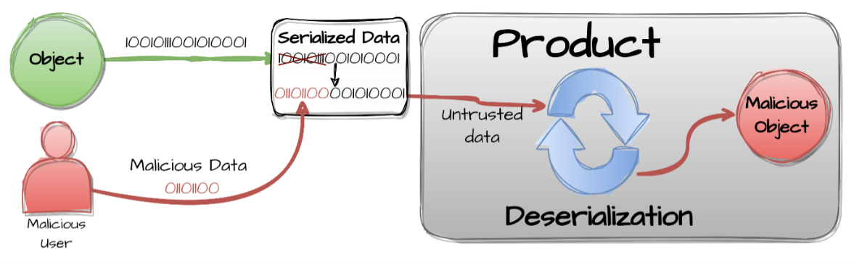
The product deserializes untrusted data without sufficiently ensuring that the resulting data will be valid.

- CVE-2024-0769 - D-Link DIR-859 Router Path Traversal Vulnerability
CWE-22: Improper Limitation of a Pathname to a Restricted Directory ('Path Traversal')
D-Link || DIR-859 Router
D-Link DIR-859 routers contain a path traversal vulnerability in the file /hedwig.cgi of the component HTTP POST Request Handler. Manipulation of the argument service with the input ../../../../htdocs/webinc/getcfg/DHCPS6.BRIDGE-1.xml allows for the leakage of session data potentially enabling privilege escalation and unauthorized control of the device. This vulnerability affects legacy D-Link products. All associated hardware revisions have reached their end-of-life (EOL) or end-of-service (EOS) life cycle and should be retired and replaced per vendor instructions.
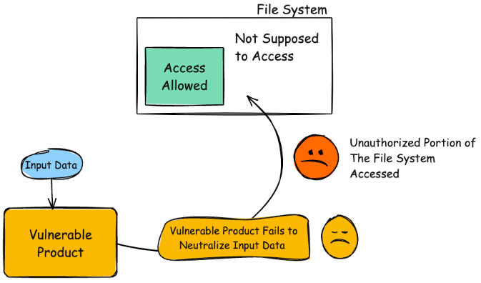
- CVE-2024-20353 – Cisco ASA and FTD Denial of Service Vulnerabilities
CWE-835: Loop with Unreachable Exit Condition (‘Infinite Loop’)
CISCO || Adaptive Security Appliance (ASA) and Firepower threat Defense
Cisco Adaptive Security Appliance (ASA) and Firepower Threat Defense (FTD) contain an infinite loop vulnerability that can lead to remote denial of service condition.
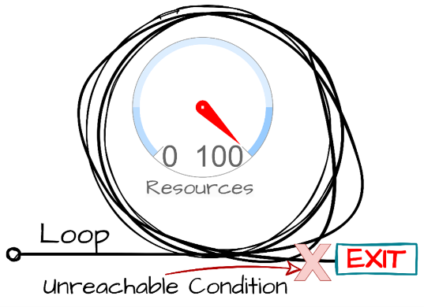
The product contains an iteration or loop with an exit condition that cannot be reached, i.e., an infinite loop.

- CVE-2025-20362 - Cisco Secure Firewall Adaptive Security (ASA) Appliance and Secure Firewall Threat Defense (FTD) Missing Authorization Vulnerability
CWE-862: Missing Authorization
CISCO || Secure Firewall Adaptive Security Appliance and Secure Firewall Threat Defense
Cisco Secure Firewall Adaptive Security (ASA) Appliance and Secure Firewall Threat Defense (FTD) Software VPN Web Server contain a missing authorization vulnerability. This vulnerability could be chained with CVE-2025-20333.
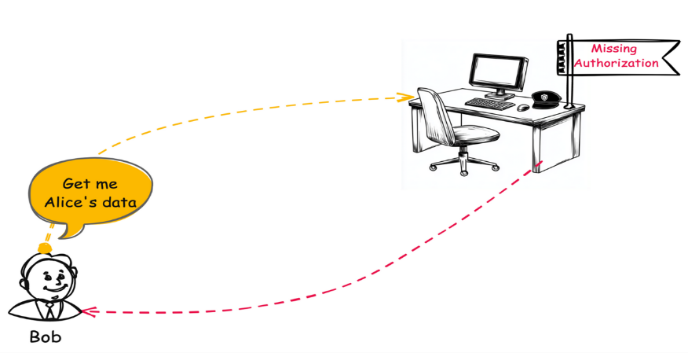
The product does not perform an authorization check when an actor attempts to access a resource or perform an action.

Resources:
- https://www.manufacturing.net/cybersecurity/blog/22930765/vpns-and-critical-infrastructure-risks.
- https://www.bacsit.com/how-your-vpn-just-became-a-2-4m-liability-expert-insights-for-manufacturing-it-leaders/.
- https://www.pusr.com/blog/What-challenges-does-the-security-of-industrial-VPNrouters-face.
- https://www.darkreading.com/ics-ot-security/chinese-apt-vpn-bug-worldwide-ot-orgs.
- Analysis of the security of VPN configurations in industrial control environments.
Additional attacks info:
This is how attacker can get access to username and password
This is how attacker can access the confidential data through a vulnerable application or software.
This is how an attacker can gain higher privilege through a product with improper privilege management.
Products with wrong authentication schemes can be subjected to spoofing attacks.
APT41 (aka Winnti)
May 31, 2024: Arbitrary File Read in Check Point VPN Gateways [CVE-2024-24919]
The Global Impact of CVE-2024-24919 in CheckPoint VPN Gateways
CheckPoint attack – shadowpad and nailaolocker
Cyberdefense
Updated Shadowpad Malware Leads to Ransomware Deployment
Labs (CVE-2024-24919) (in-depth breakdown of the bug and attack)

