1.Write a C program to perform the following a) Linear search b) Binary search.
#include <stdio.h>
int main()
{
int arr[100], n, k, i, f = 0;
printf("Enter number of elements: ");
scanf("%d", &n);

printf("Enter %d elements:\n", n);
for(i = 0; i < n; i++) {
scanf("%d", &arr[i]);
}
printf("Enter element to search: ");
scanf("%d", &k);
for (i = 0; i < n; i++) {
if(arr[i] == k) {
printf("Element found at position %d\n", i+1);
f = 1;
break;
} }
if(!f) {
printf("Element not found in the array.\n");
}
return 0;
}

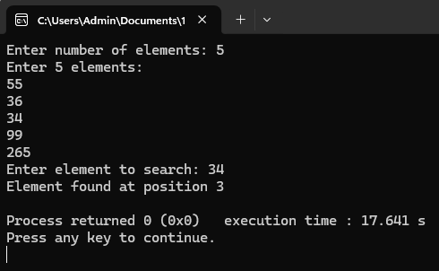

#include <stdio.h>

int main() {
int arr[100], n, k, l, h, m, f = 0, i;
printf("Enter number of elements: ");
scanf("%d", &n);
printf("Enter %d elements in sorted order:\n", n);
for(i = 0; i < n; i++) {
scanf("%d", &arr[i]);
}
printf("Enter element to search: ");
scanf("%d", &k);
l = 0;
h = n - 1;
while(l <= h) {
m = (l + h) / 2;
if(arr[m] == k) {
printf("Element found at position %d\n", m+1);
f = 1;
break;
}
else if(arr[m] < k) {
l = m + 1;
}
else {
h = m - 1;
}
}
if(!f) {
printf("Element not found in the array.\n");
}
return 0;
}

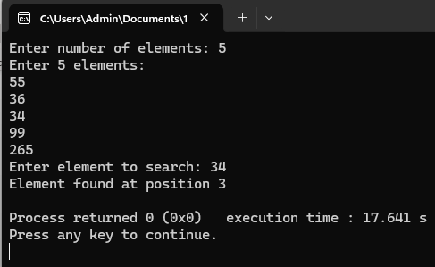

2. Write a C program to print the smallest number and its position in an
array of size n.

#include <stdio.h>

int main() {
int arr[100], n, i;
int s, pos;
printf("Enter number of elements: ");
scanf("%d", &n);
printf("Enter %d elements:\n", n);
for(i = 0; i < n; i++) {
scanf("%d", &arr[i]);
}
s = arr[0];
pos = 1;

for(i = 1; i < n; i++) {
if(arr[i] < s) {
s = arr[i];
pos = i + 1;
}
}

printf("Smallest element is %d at position %d\n", s, pos);

return 0;
}

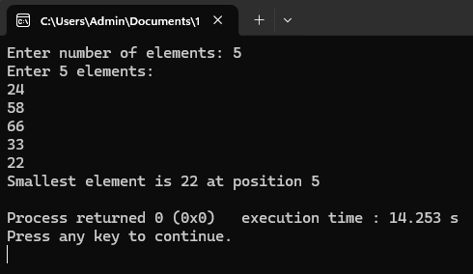

3. Write a C program to find if there are duplicates in an array.

#include <stdio.h>

int main () {
int arr[100], n, i, j, f = 0;
printf("Enter number of elements: ");
scanf("%d", &n);

printf("Enter %d elements:\n", n);
for(i = 0; i < n; i++) {
scanf("%d", &arr[i]);
}

for(i = 0; i < n; i++) {
for(j = i + 1; j < n; j++) {
if(arr[i] == arr[j]) {
printf("Duplicate found: %d\n", arr[i]);
f = 1;
}
}
}

if(!f) {
printf("No duplicates found.\n");
}

return 0;
}

