COLLEGE MANAGEMENT SYSTEM

-- Creating CollegeMangement database
CREATE DATABASE college_management;
USE college_management;
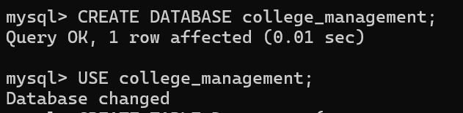
--1.create Student table
CREATE TABLE Student(
student_id INT PRIMARY KEY,
name VARCHAR(50),
department_id INT,
year INT,
email VARCHAR(100),
FOREIGN KEY(department_id)
REFERENCES Department(department_id)
);
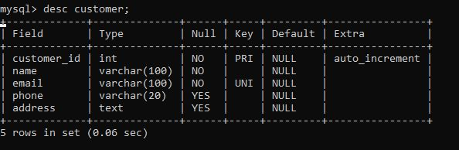

-- 2. DEPARTMENT TABLE
CREATE TABLE Department(
department_id INT PRIMARY KEY,
department_name VARCHAR(50)
);
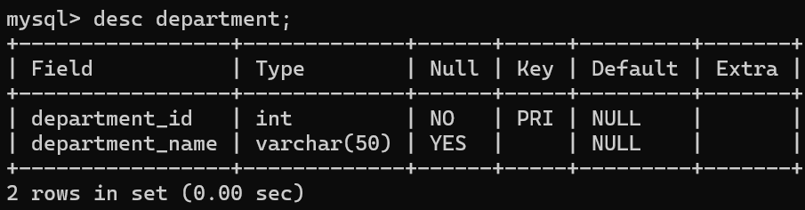

-- 3. FACULTY TABLE
CREATE TABLE Faculty(
faculty_id INT PRIMARY KEY,
name VARCHAR(50),
department_id INT,
designation VARCHAR(50),
FOREIGN KEY(department_id)
REFERENCES Department(department_id)
);
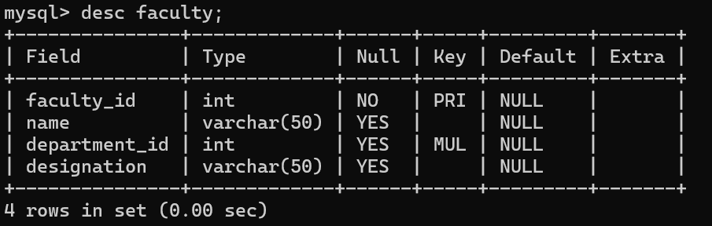
--4.COURSE TABLE
CREATE TABLE Course(
course_id INT PRIMARY KEY,
course_name VARCHAR(50),
credits INT,
department_id INT,
FOREIGN KEY(department_id)
REFERENCES Department(department_id)
);
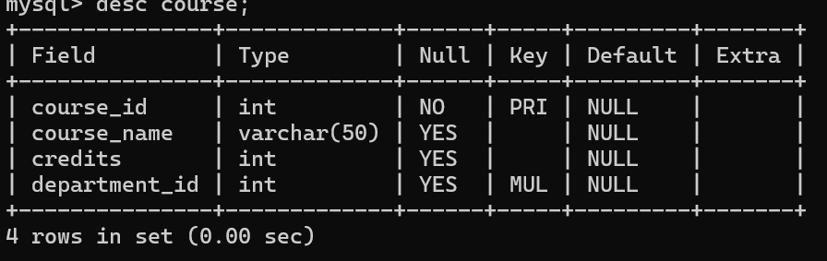

-- 5. ENROLLMENT TABLE
CREATE TABLE Enrollment(
enrollment_id INT PRIMARY KEY,
student_id INT,
course_id INT,
semester VARCHAR(20),
grade CHAR(2)
);
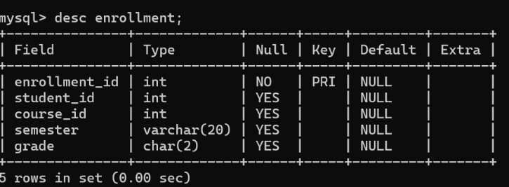

-- 6. ATTENDANCE TABLE
CREATE TABLE Attendance(
attendance_id INT PRIMARY KEY,
student_id INT,
course_id INT,
attendance_percentage DECIMAL(5,2)
);
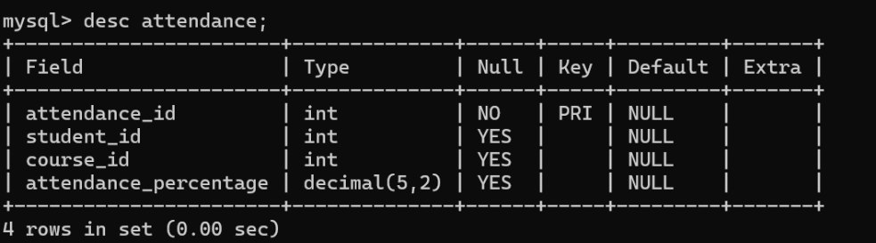

INSERT OPERATION:
--INSERT INTO DEPARTMENT
INSERT INTO Department VALUES(1,'CSE');
INSERT INTO Department VALUES(2,'ISE');
INSERT INTO Department VALUES(3,'ECE');
INSERT INTO Department VALUES(4,'MECH');
INSERT INTO Department VALUES(5,'CIVIL');
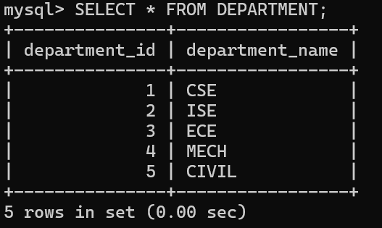
-- INSERT INTO STUDENT
INSERT INTO Student VALUES(101,'Rahul',1,3,'rahul@gmail.com');
INSERT INTO Student VALUES(102,'Priya',1,2,'priya@gmail.com');
INSERT INTO Student VALUES(103,'Amit',2,4,'amit@gmail.com');
INSERT INTO Student VALUES(104,'Sneha',3,1,'sneha@gmail.com');
INSERT INTO Student VALUES(105,'Kiran',4,3,'kiran@gmail.com');
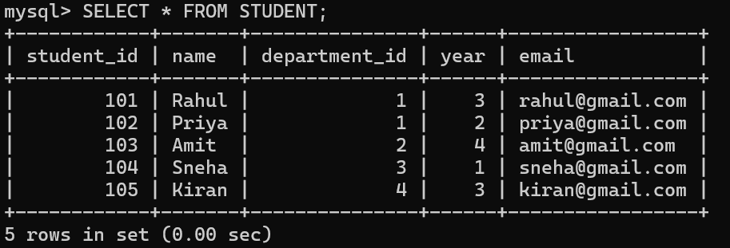

-- INSERT INTO FACULTY
INSERT INTO Faculty VALUES(201,'Dr Sharma',1,'Professor');
INSERT INTO Faculty VALUES(202,'Dr Kumar',2,'Associate Professor');
INSERT INTO Faculty VALUES(203,'Dr Rao',3,'Assistant Professor');
INSERT INTO Faculty VALUES(204,'Dr Reddy',4,'Professor');
INSERT INTO Faculty VALUES(205,'Dr Singh',5,'HOD');
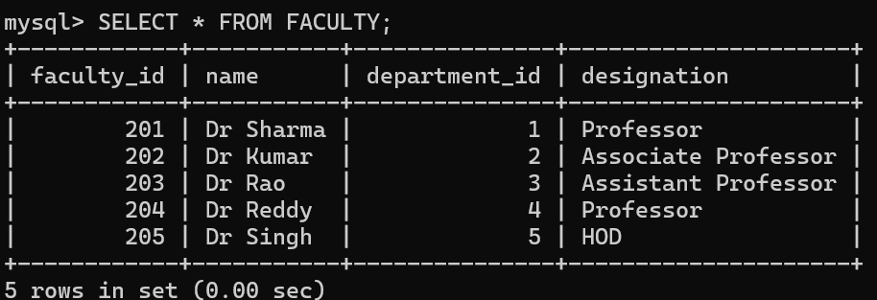
-- INSERT INTO COURSE

INSERT INTO Course VALUES(301,'DBMS',4,1);
INSERT INTO Course VALUES(302,'Operating Systems',4,1);
INSERT INTO Course VALUES(303,'Computer Networks',3,2);
INSERT INTO Course VALUES(304,'Digital Electronics',4,3);
INSERT INTO Course VALUES(305,'Thermodynamics',4,4);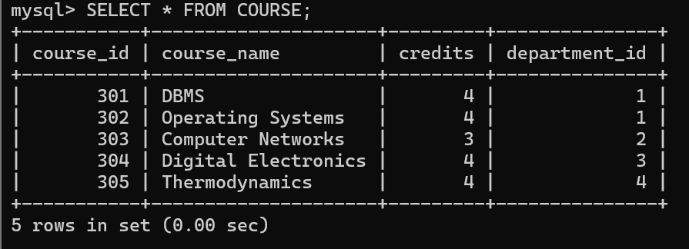
--INSERT INTO ENROLLMENT
INSERT INTO Enrollment VALUES(401,101,301,'5th Sem','A');
INSERT INTO Enrollment VALUES(402,102,302,'3rd Sem','B');
INSERT INTO Enrollment VALUES(403,103,303,'7th Sem','A');
INSERT INTO Enrollment VALUES(404,104,304,'1st Sem','B');
INSERT INTO Enrollment VALUES(405,105,305,'5th Sem','A');
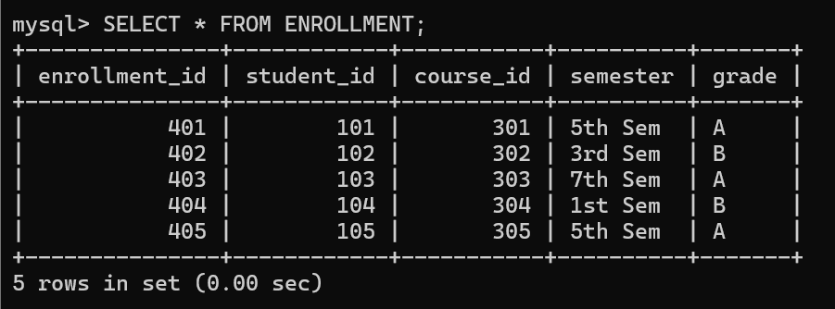
-- INSERT INTO ATTENDANCE
INSERT INTO Attendance VALUES(501,101,301,92.5);
INSERT INTO Attendance VALUES(502,102,302,88.0);
INSERT INTO Attendance VALUES(503,103,303,95.0);
INSERT INTO Attendance VALUES(504,104,304,85.5);
INSERT INTO Attendance VALUES(505,105,305,90.0);
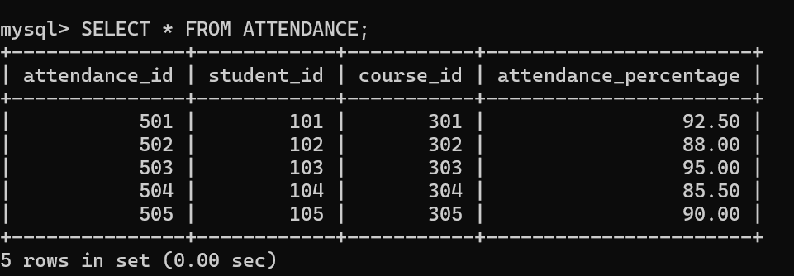
Execute stored procedure
DELIMITER //
CREATE PROCEDURE GetStudents()
BEGIN
SELECT * FROM Student;
END //
DELIMITER ;
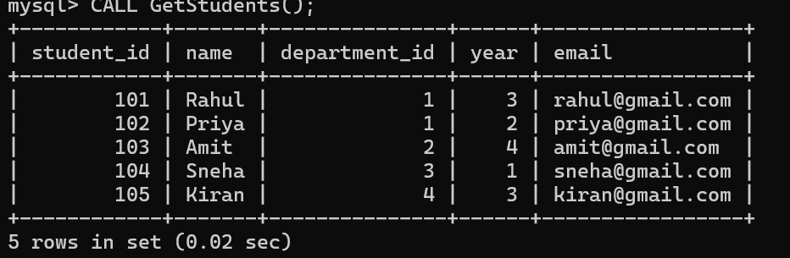
CREATE TRIGGER
--CREATE LOG TABLE
CREATE TABLE Student_Log(
log_id INT AUTO_INCREMENT PRIMARY KEY,
student_name VARCHAR(50),
action_time TIMESTAMP DEFAULT CURRENT_TIMESTAMP
);
--TRIGGER CREARTION
DELIMITER //

CREATE TRIGGER student_insert_trigger
AFTER INSERT ON Student
FOR EACH ROW
BEGIN
INSERT INTO Student_Log(student_name)
VALUES(NEW.name);
END //
DELIMITER ;
Test trigger:
INSERT INTO Student
VALUES(109,'Arun',1,2,'arun@gmail.com');
CHECK LOG:
