**Ex. No. 1**

**INSTALLATION OF VIRTUAL MACHINE IN VIRTUAL BOX**

**AIM:**

To configure a Virtual Machine using Virtual Box and Launch to execute a simple

program

**PROCEDURE:**

1. Launch a Virtual Box

2. Create new virtual machine

3. Customize the set-up

4. Set username and password

5. Browse for .iso file of an operating system

6. Configure the hardware capacity

7. Finish and power on the VM

8. Install C or PYTHON OR JAVA Compiler and execute a simple program

**OUTPUT:**

Download and run the VirtualBox installer

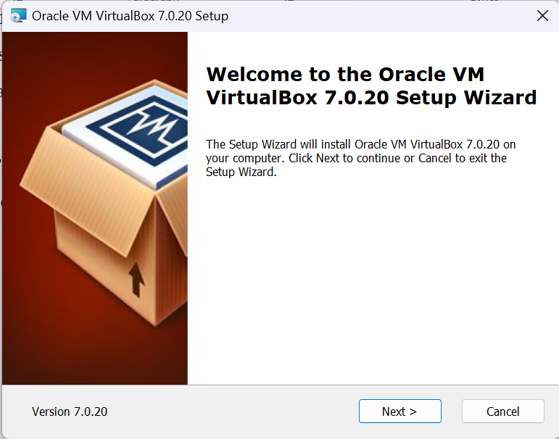

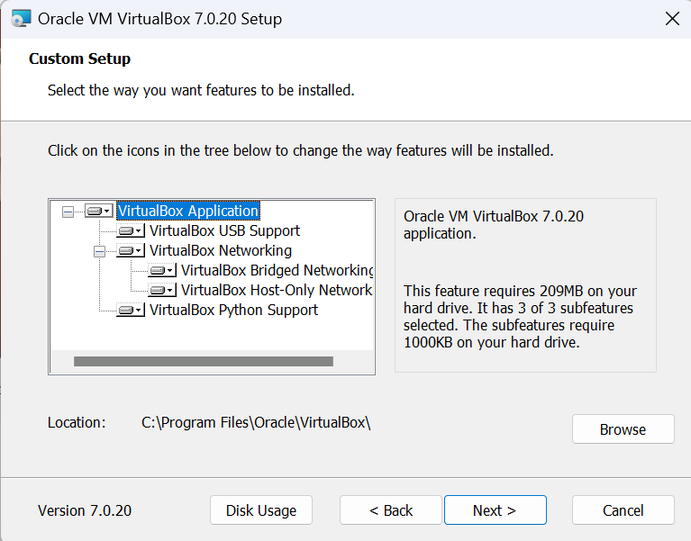

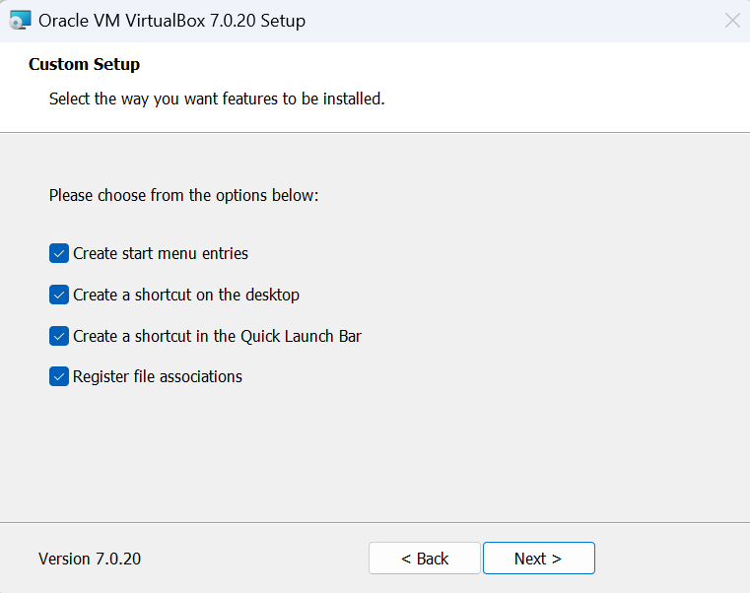

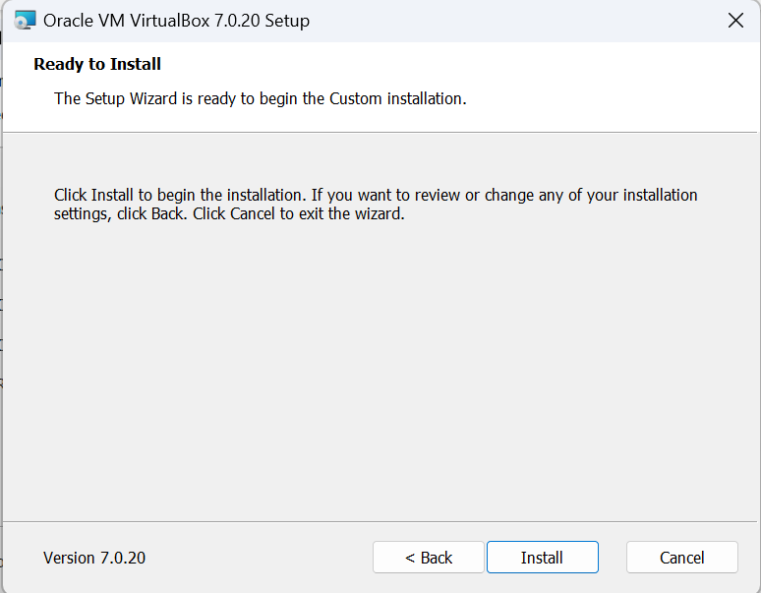

Open Oracle VM VirtualBox

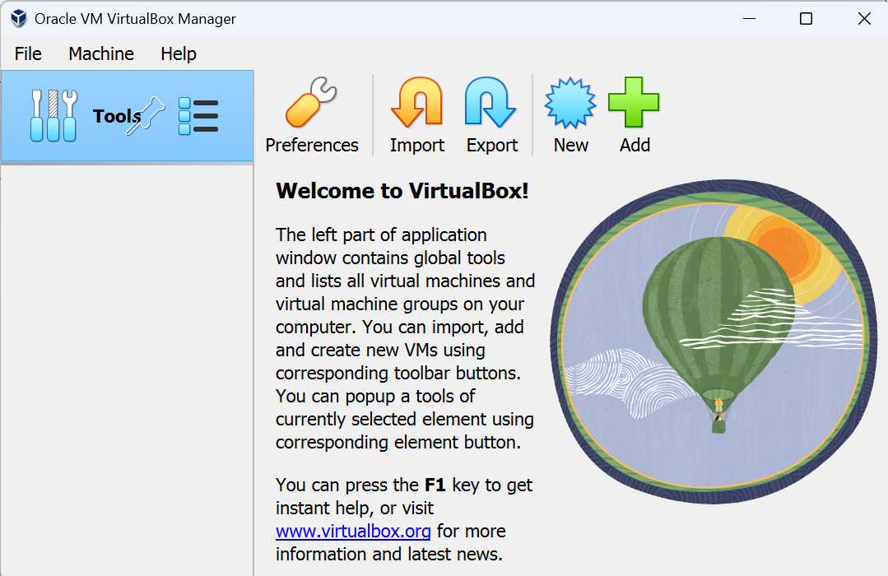

Click on ‘New’ and create a new virtual machine

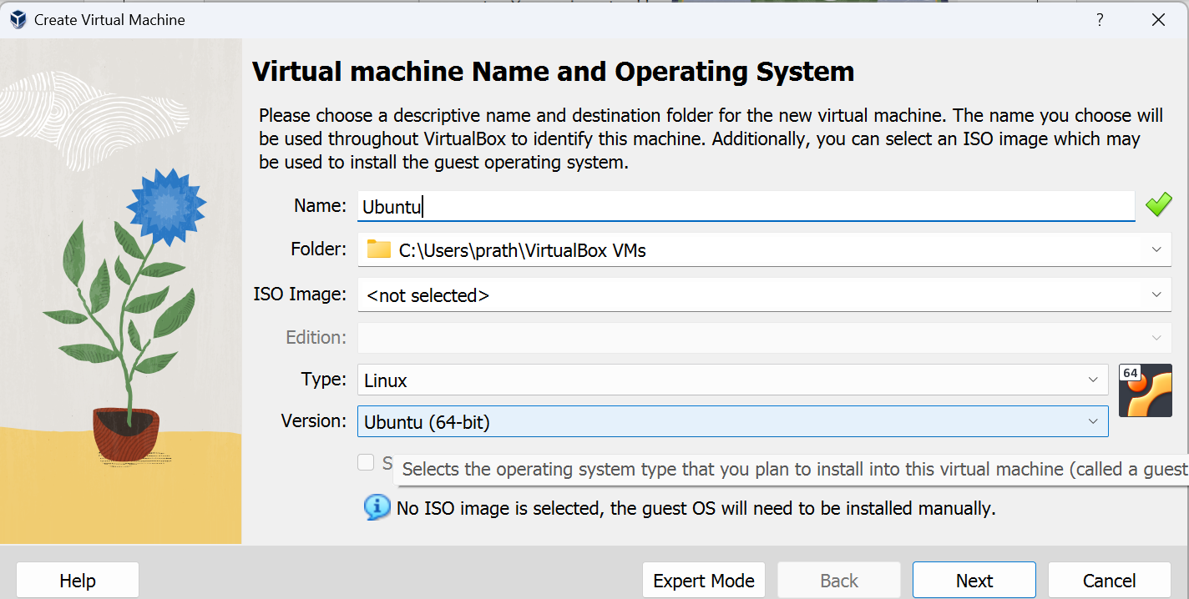

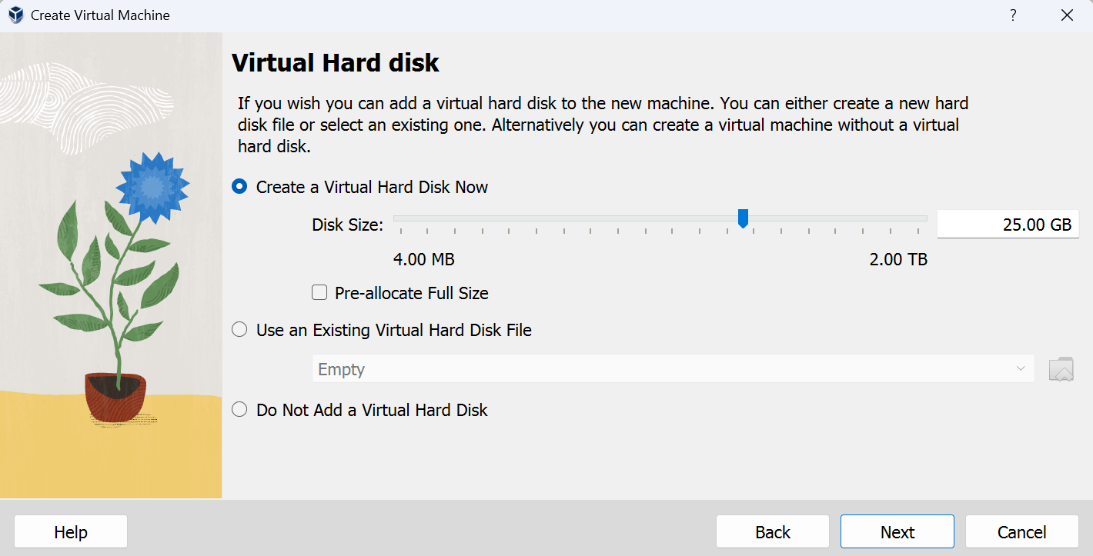

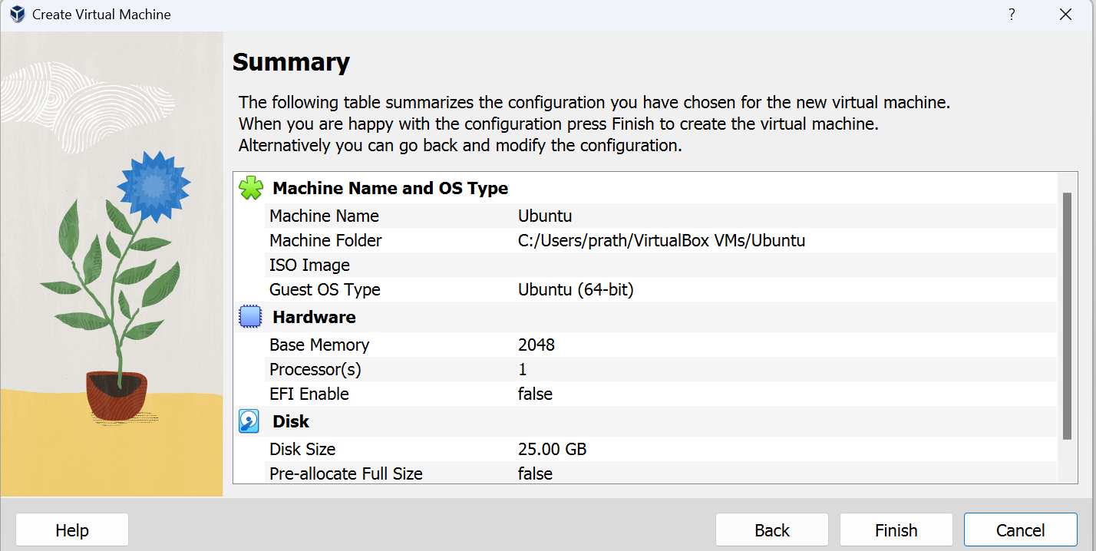

Launch the iso file of Ubuntu operating system into the virtual machine.

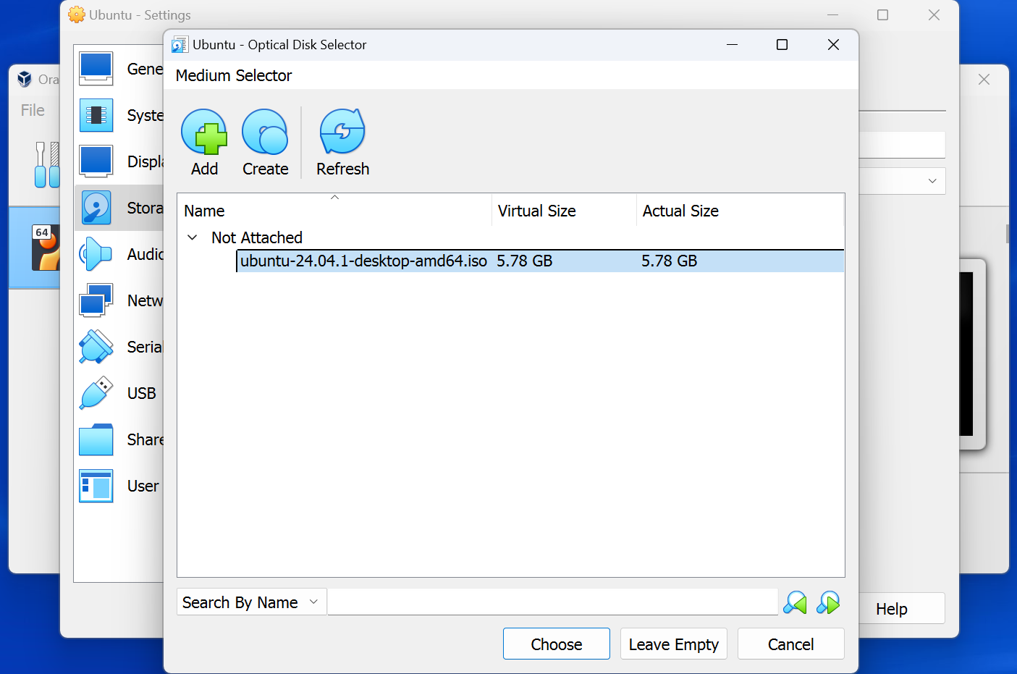

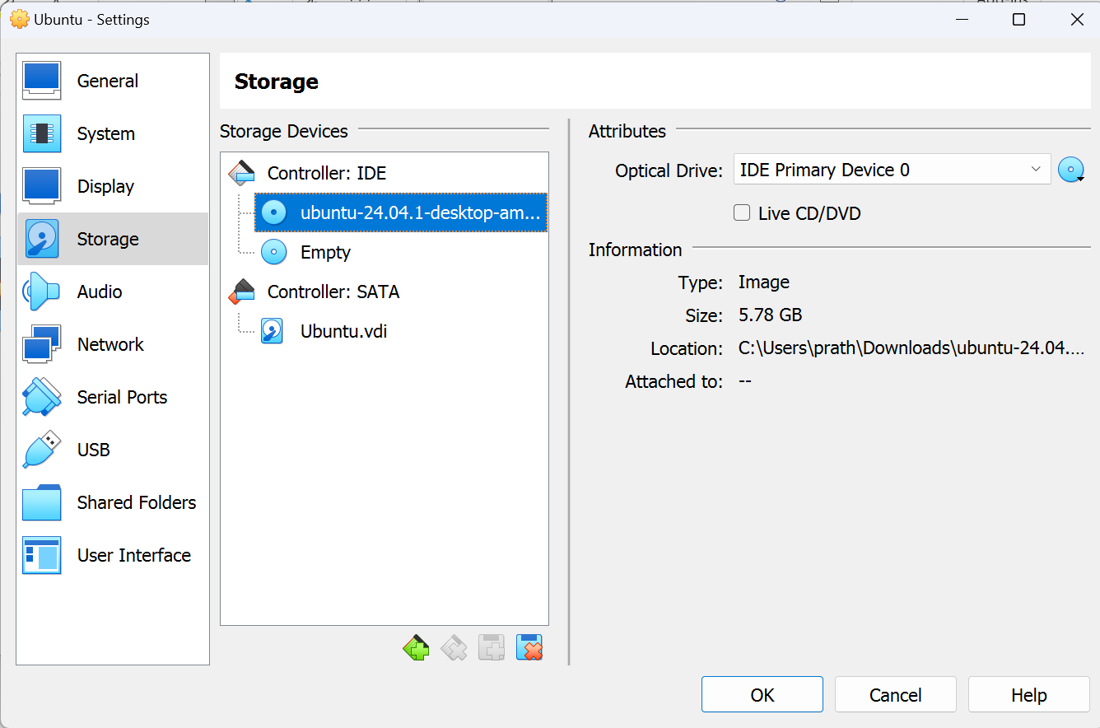

Start the virtual machine

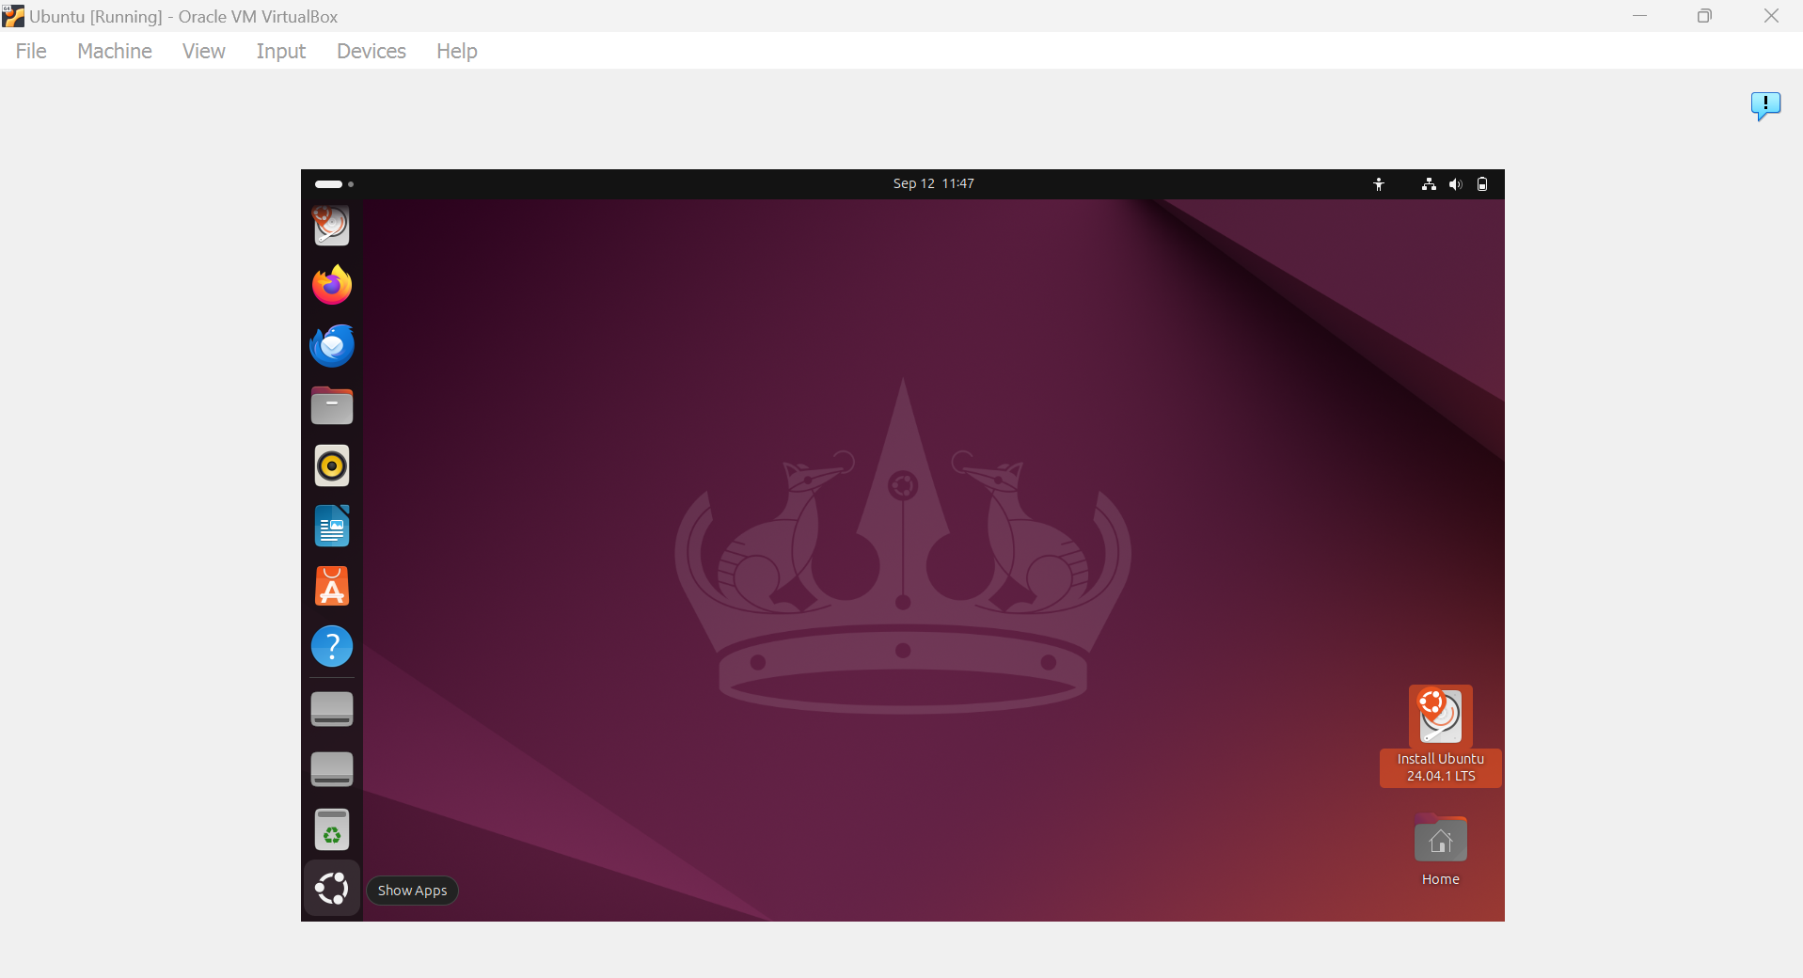

Open terminal and install vim using the command:

sudo apt install vim

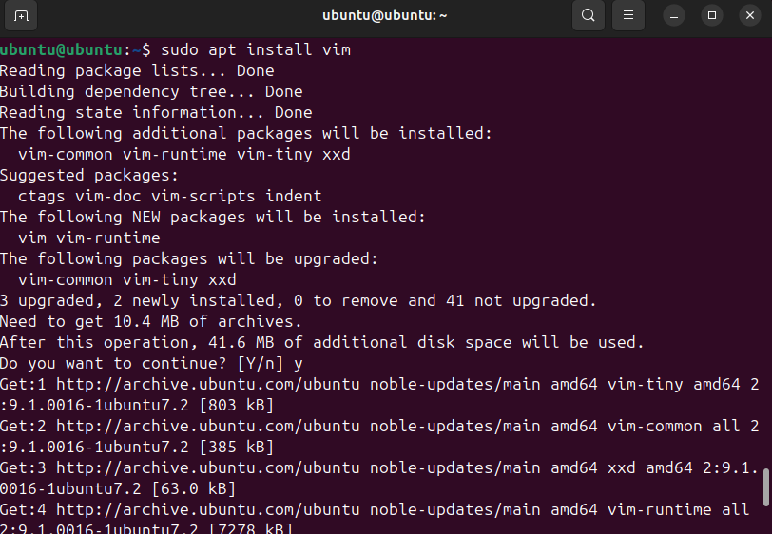

Create a Python program and execute it

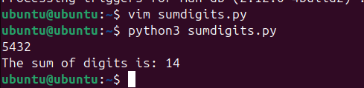

**RESULT:**

A virtual machine is created using Virtual Box and a simple program is executed on the virtual machine.