Ex. No. 2

**CONFIGURATION AND CREATION OF VIRTUAL MACHINE**

**AIM:**

To configure a virtual machine using VMware and execute a simple program

**PROCEDURE:**

1. Launch VMware

2. Create new virtual machine

3. Customize the set-up

4. Set username and password

5. Browse for .iso file of an operating system

6. Configure the hardware capacity

7. Finish and power on the VM

8. Install C or PYTHON OR JAVA Compiler and execute a simple program

**OUTPUT:**

Download and install VMware Workstation Pro

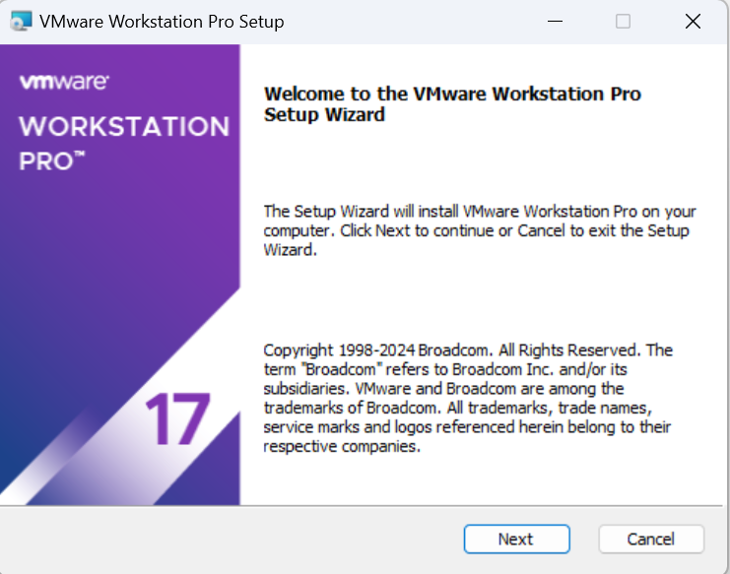

Open VMware Workstation Pro and create a new virtual machine

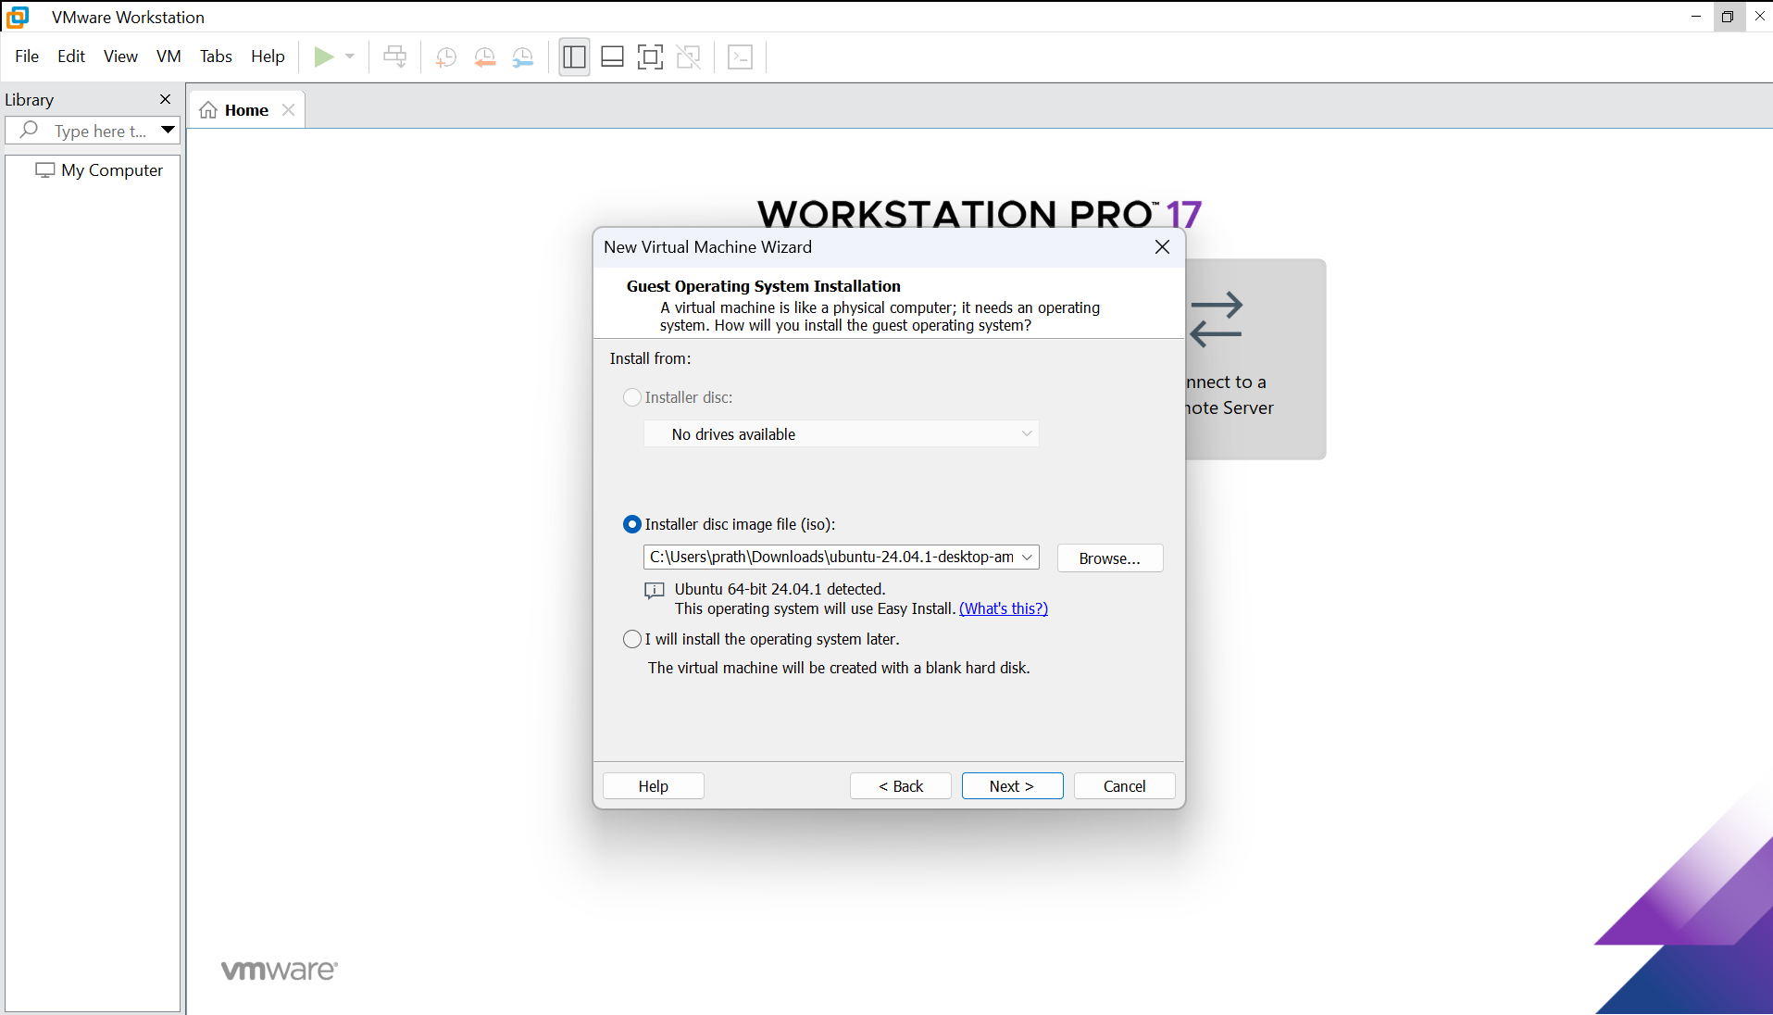

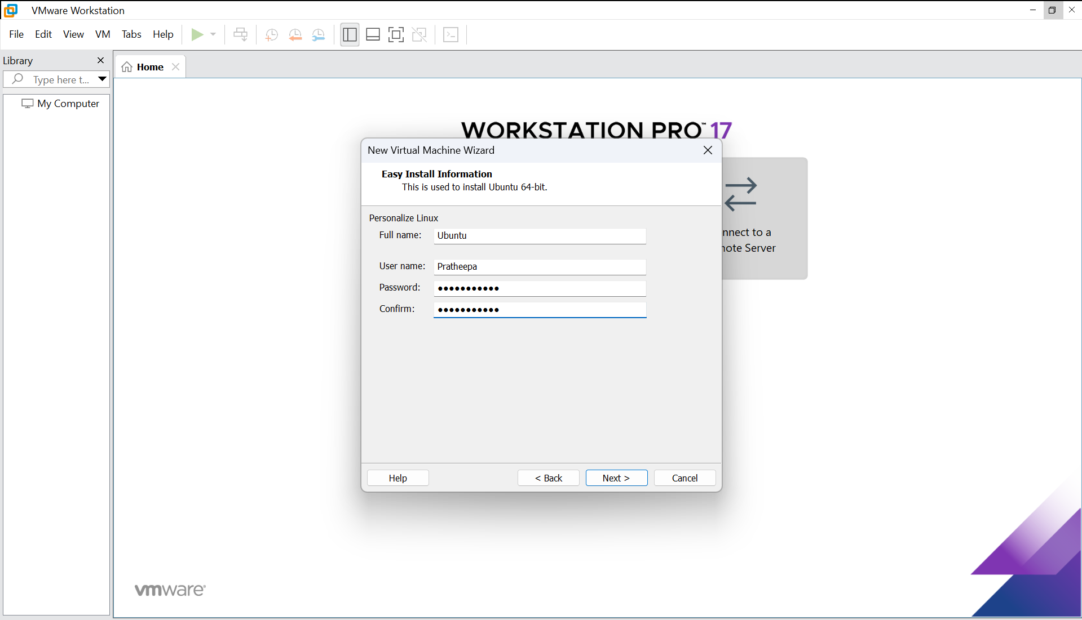

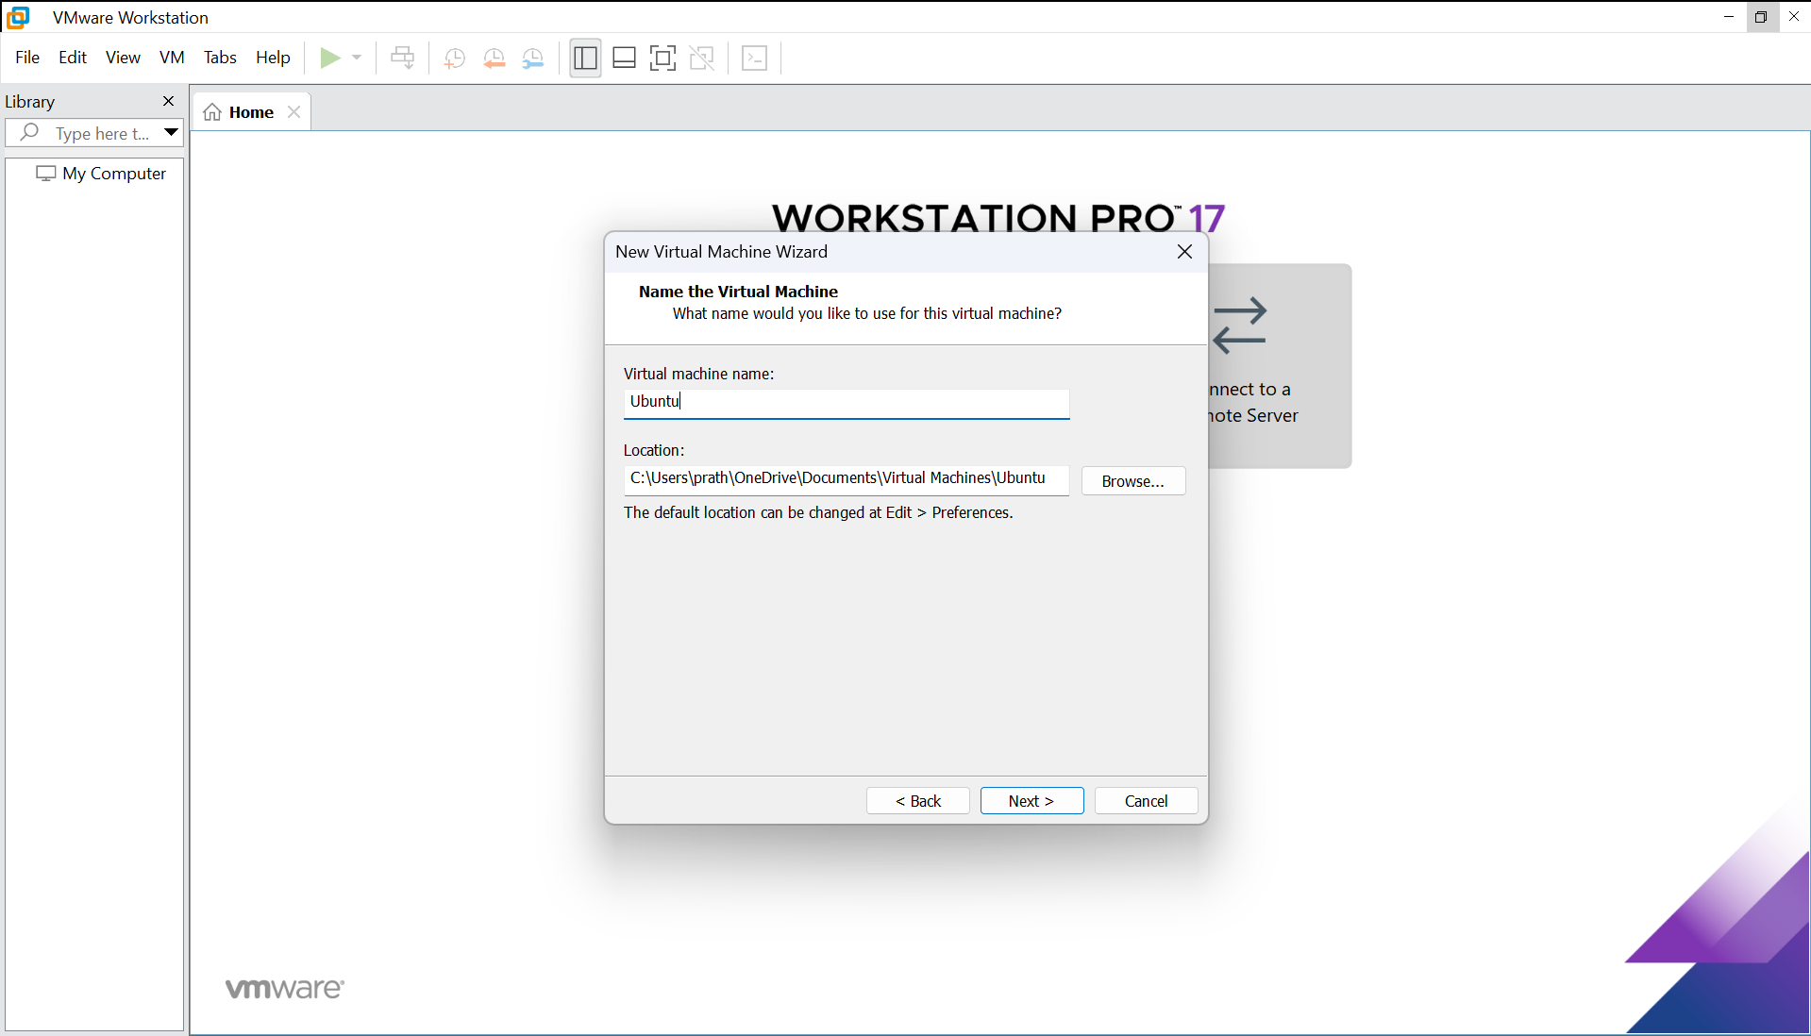

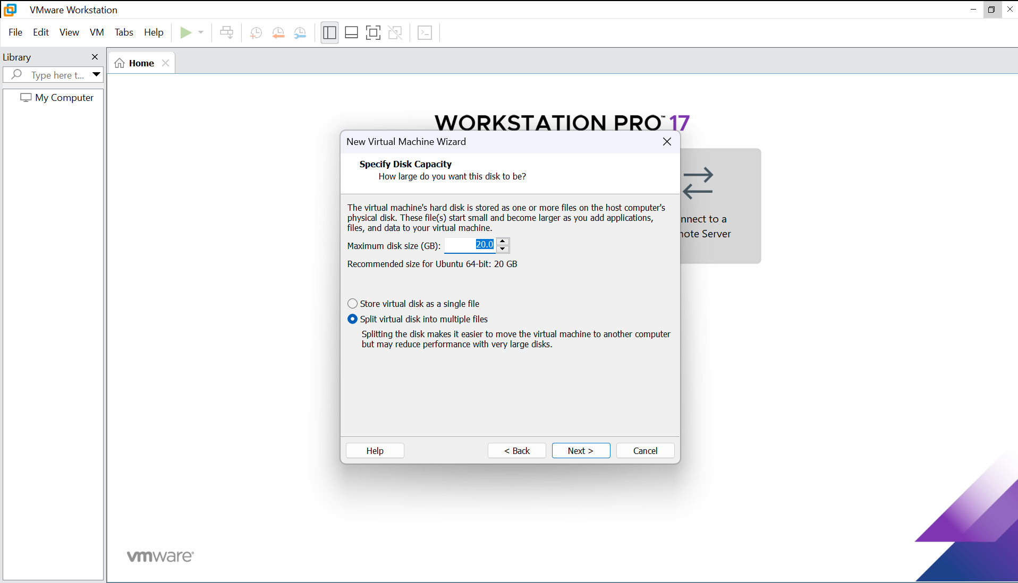

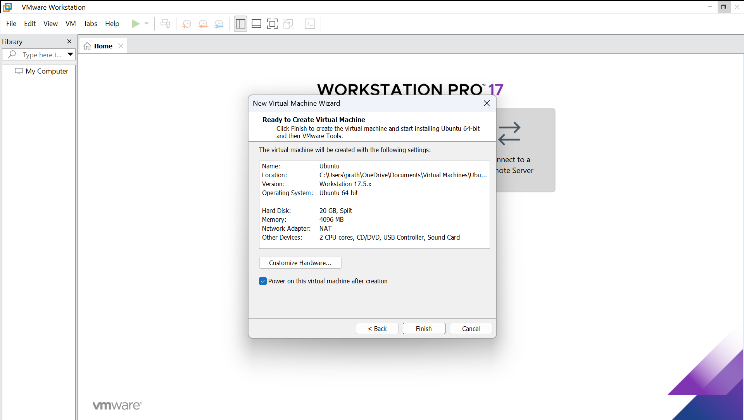

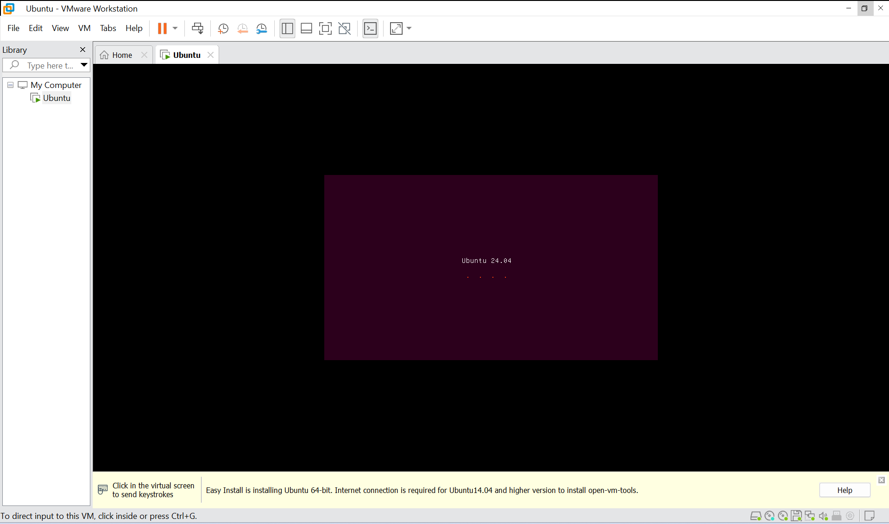

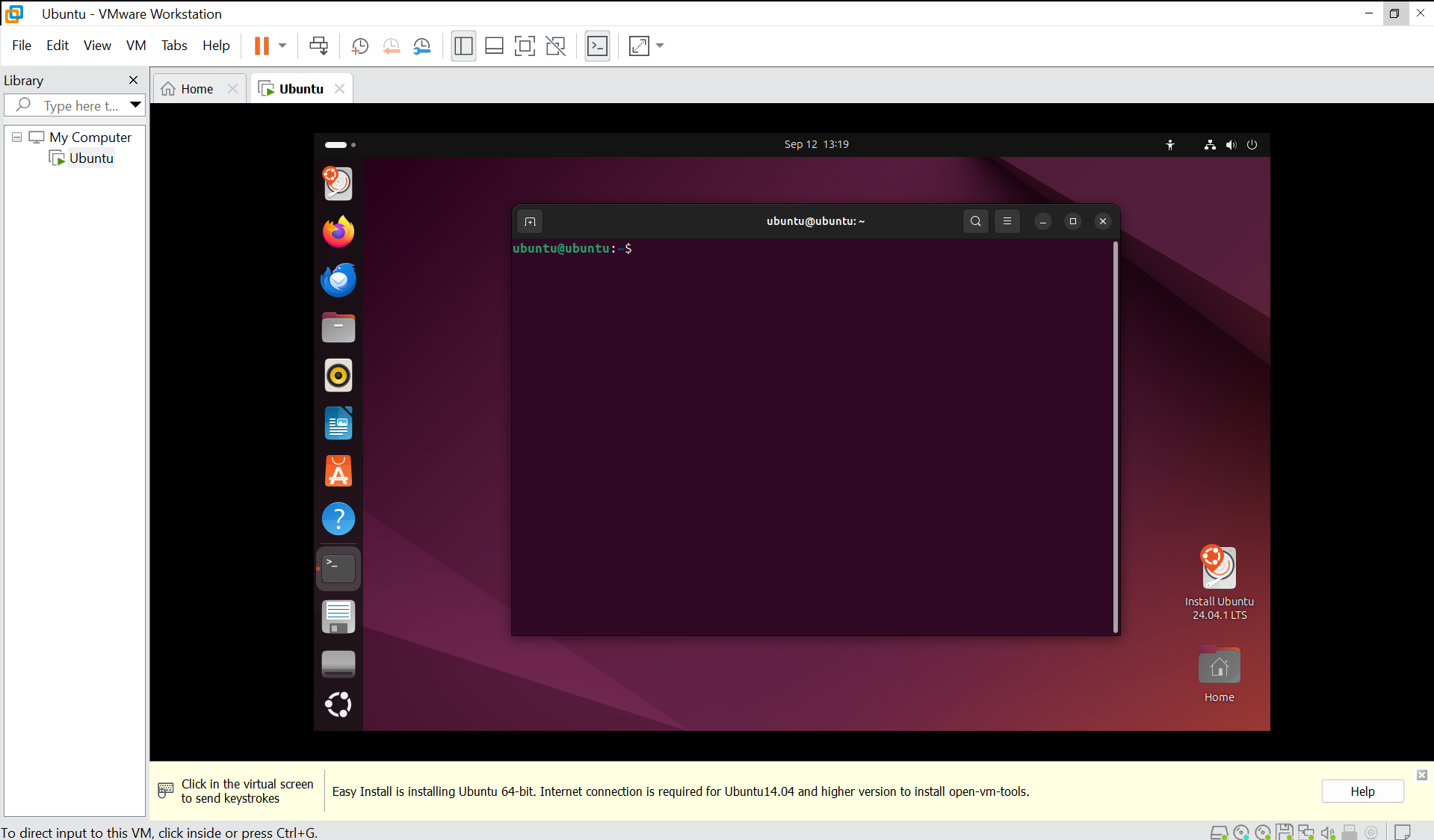

Create a Python program

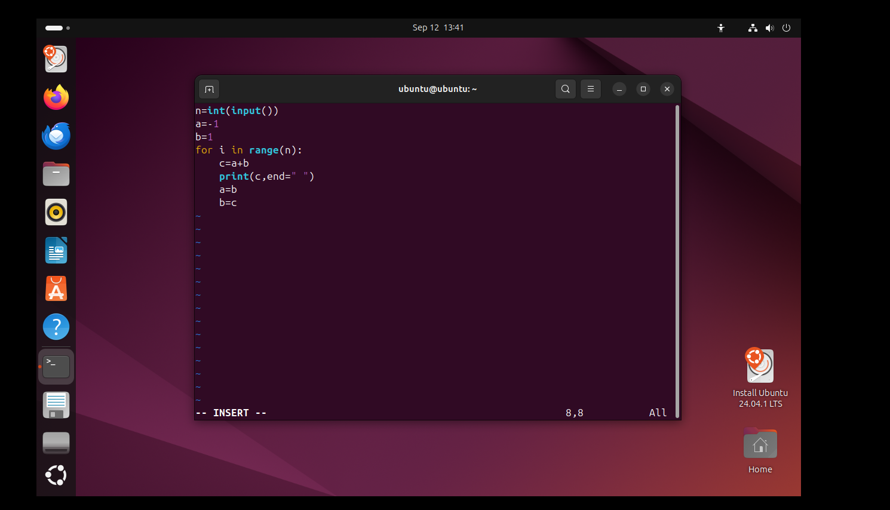

Run the program

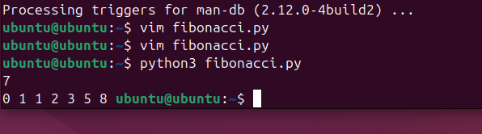

**RESULT:**

A virtual machine is created using VMware Workstation Pro and a simple program is executed on the virtual machine.