Ex. No. 5

**INSTALLATION AND CONFIGURATION OF CLOUDSIM IN ECLIPSE IDE**

**AIM:**

To install and configure the CloudSim in Eclipse IDE and run a java program in it.

**PROCEDURE:**

**1. Java Installation**

a. Check java in your system.

b. If java not installed then download Java.

c. Install java setup.

d. Set path variable for java.

**2. Download CloudSim and additional jar file**

a. Download CloudSim 3.0.3

b. Download Commons math 3 jar file.

**3. Eclipse IDE Installation**

a. If java 64 bit Installed then download 64-bit Eclipse otherwise java 32 bit then download 32 eclipse.

b. Install Eclipse IDE.

**4. Run CloudSim in Eclipse**

a. Put up commons-math-3-3.6.1.jar file into jar folder of Cloudsim3.0.3

b. Build a new java project with Cloudsim3.0.3 folder.

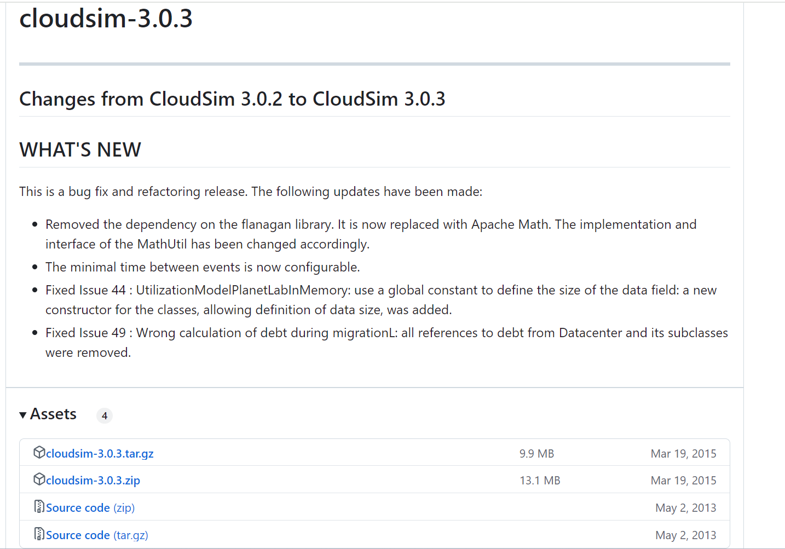

Download the .zip file

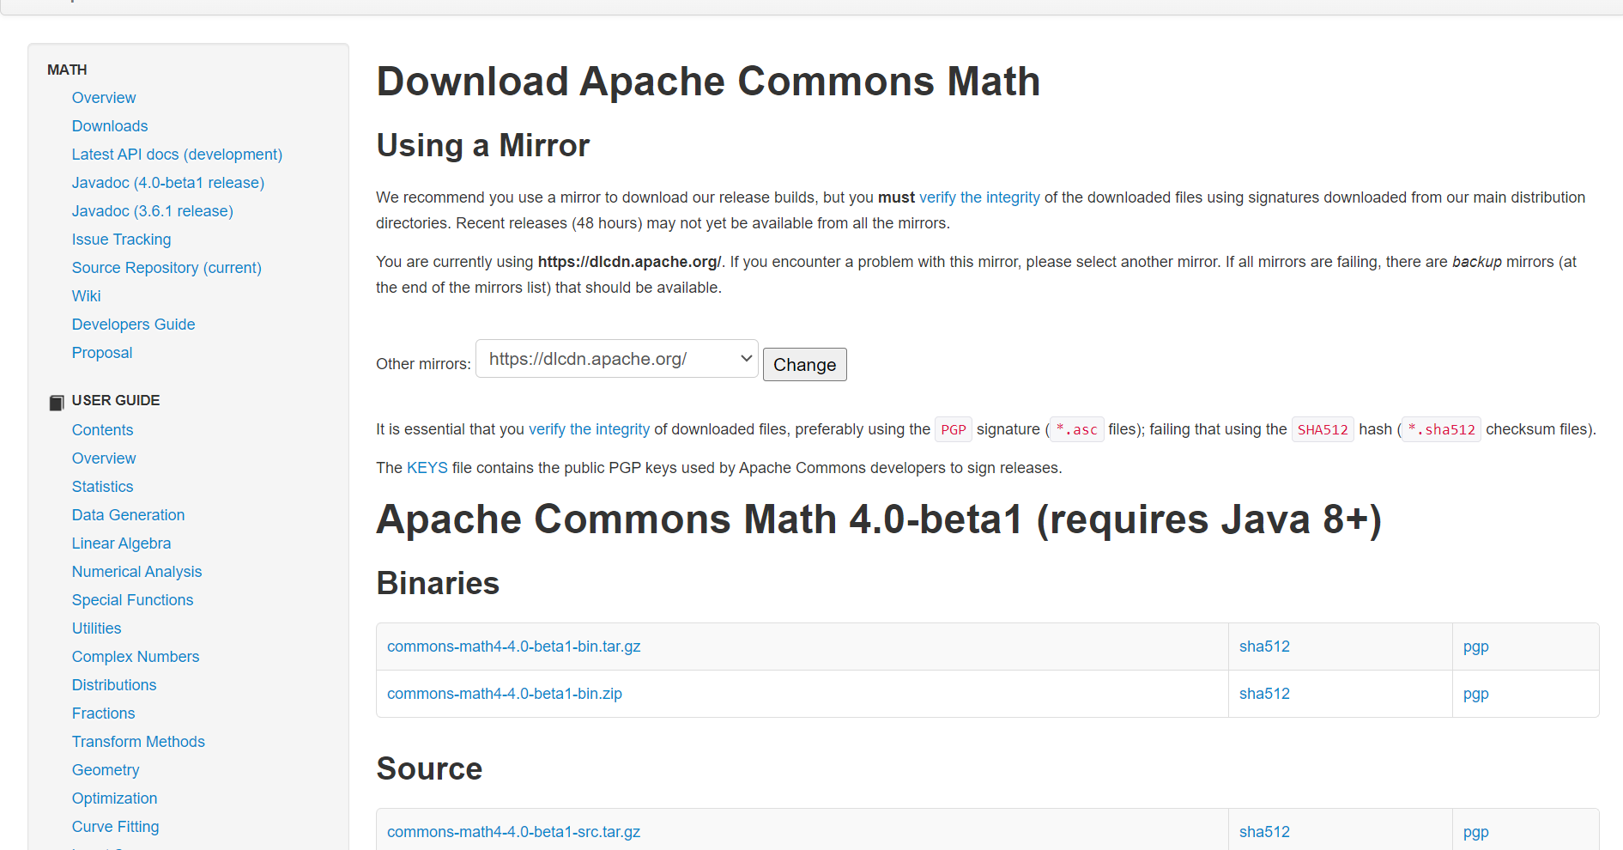

Download the .zip file

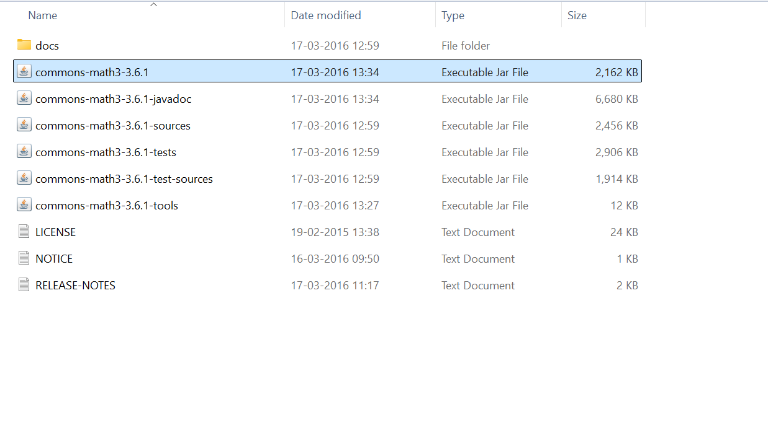

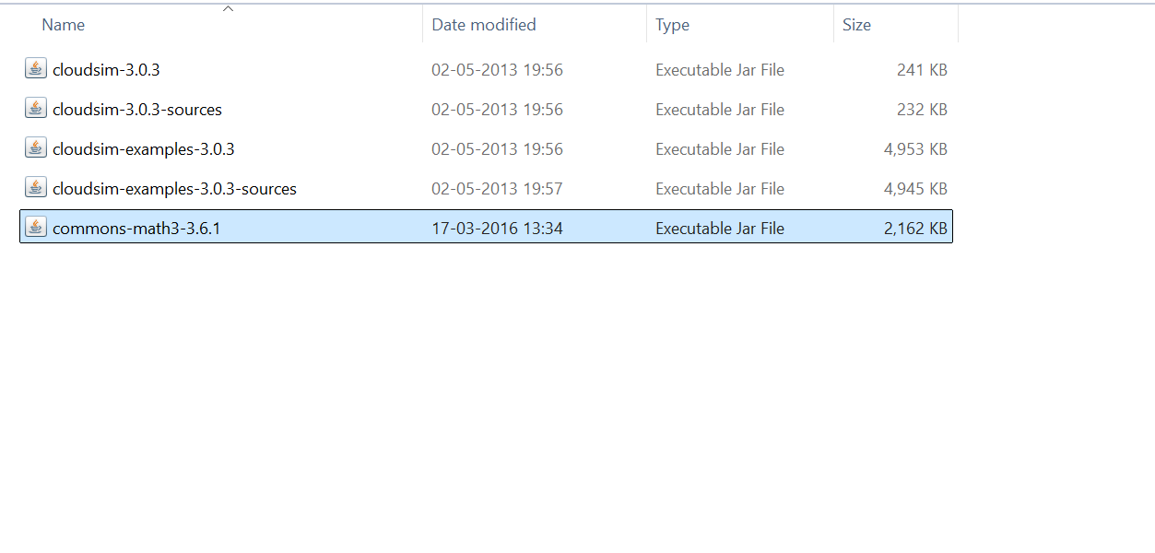

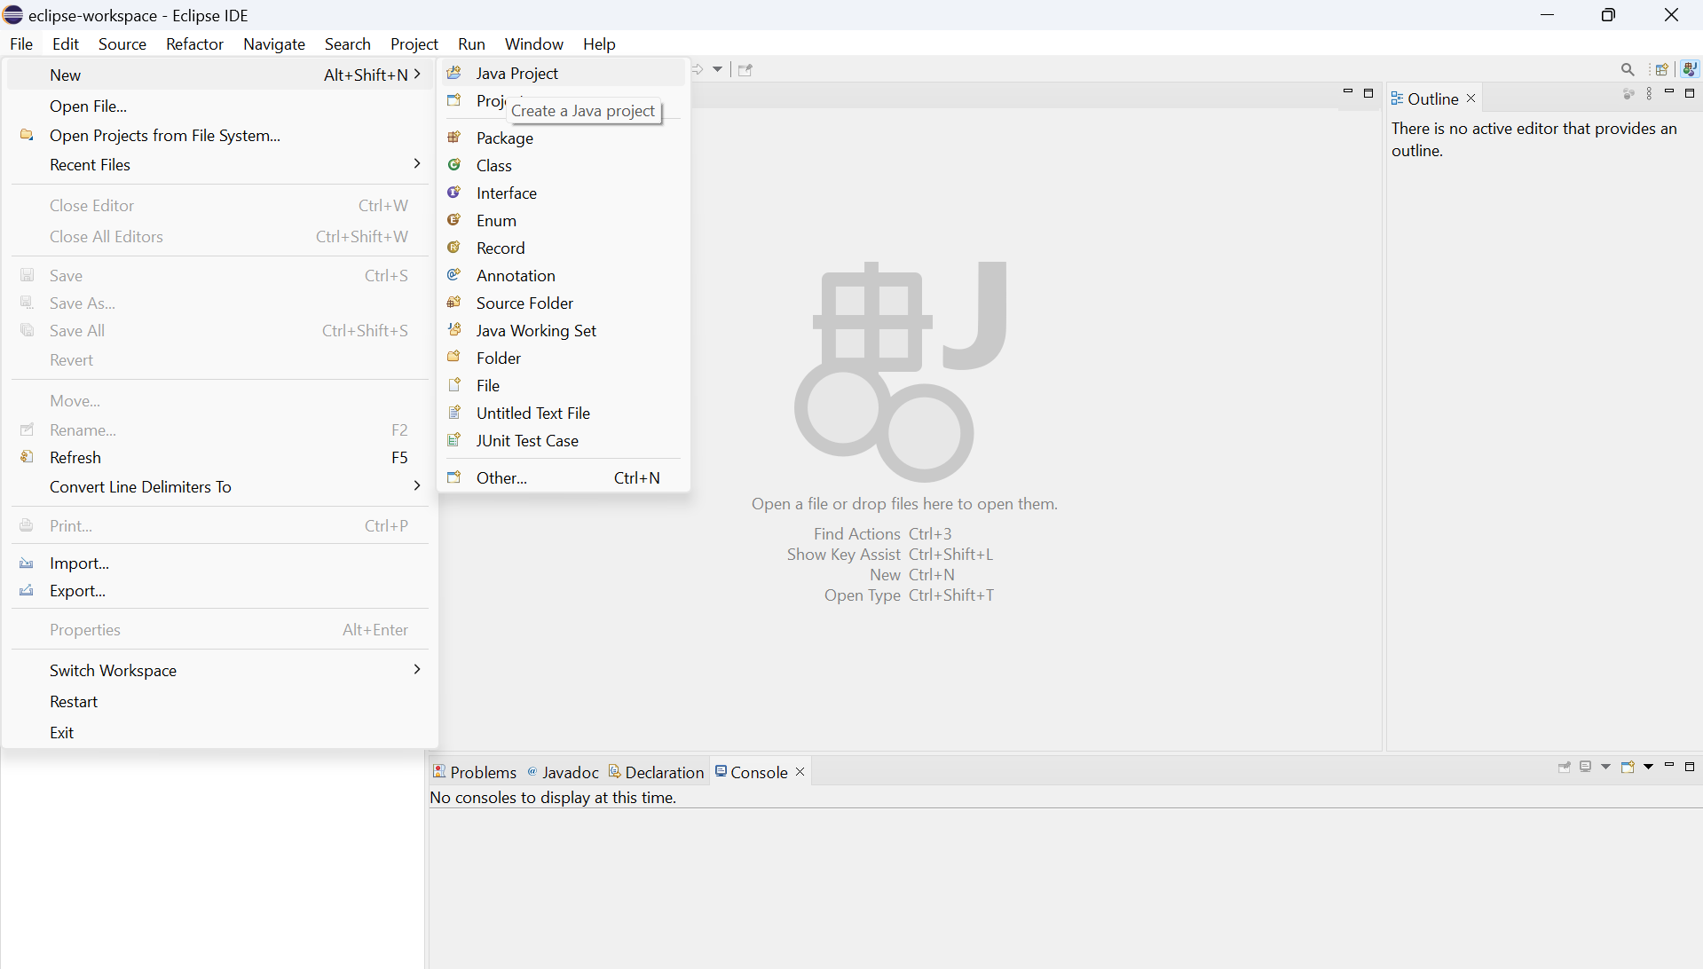

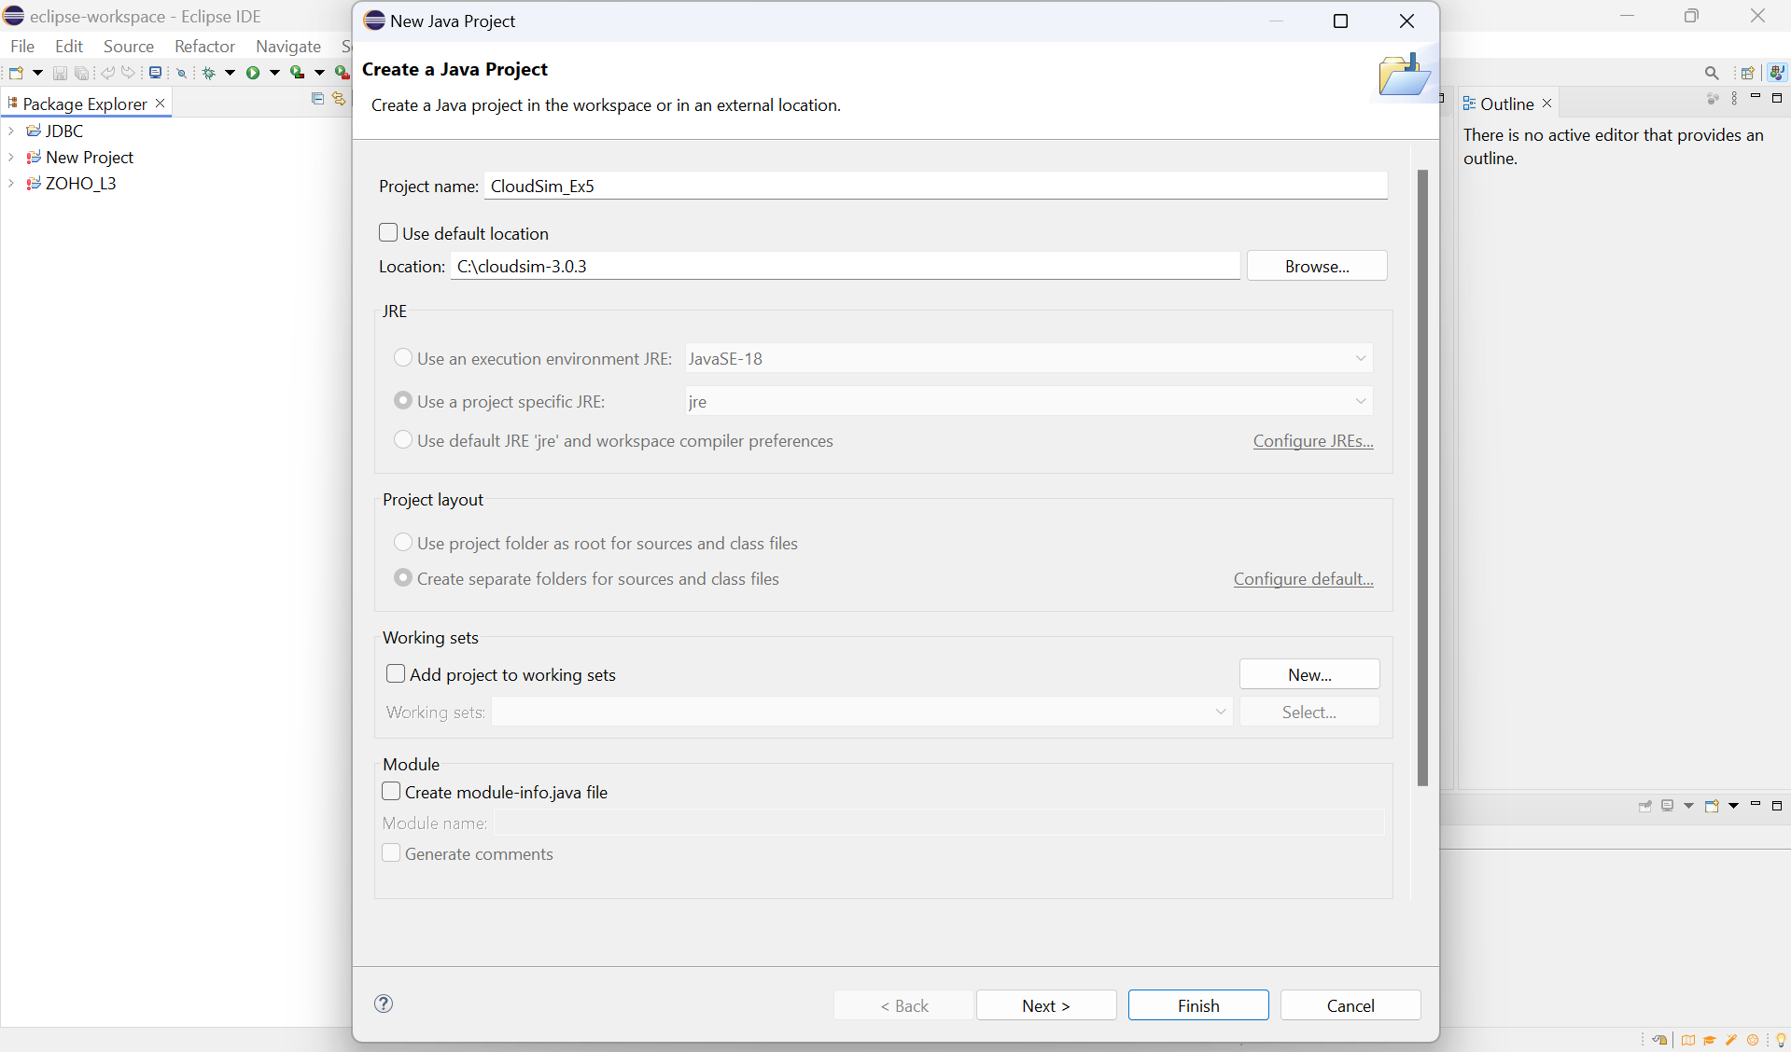

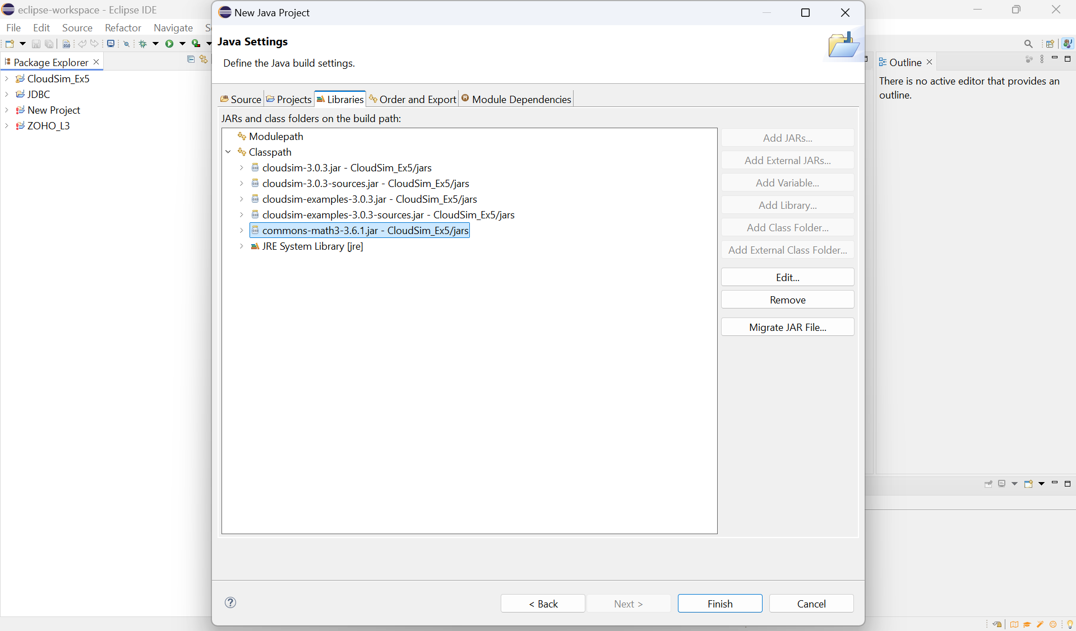

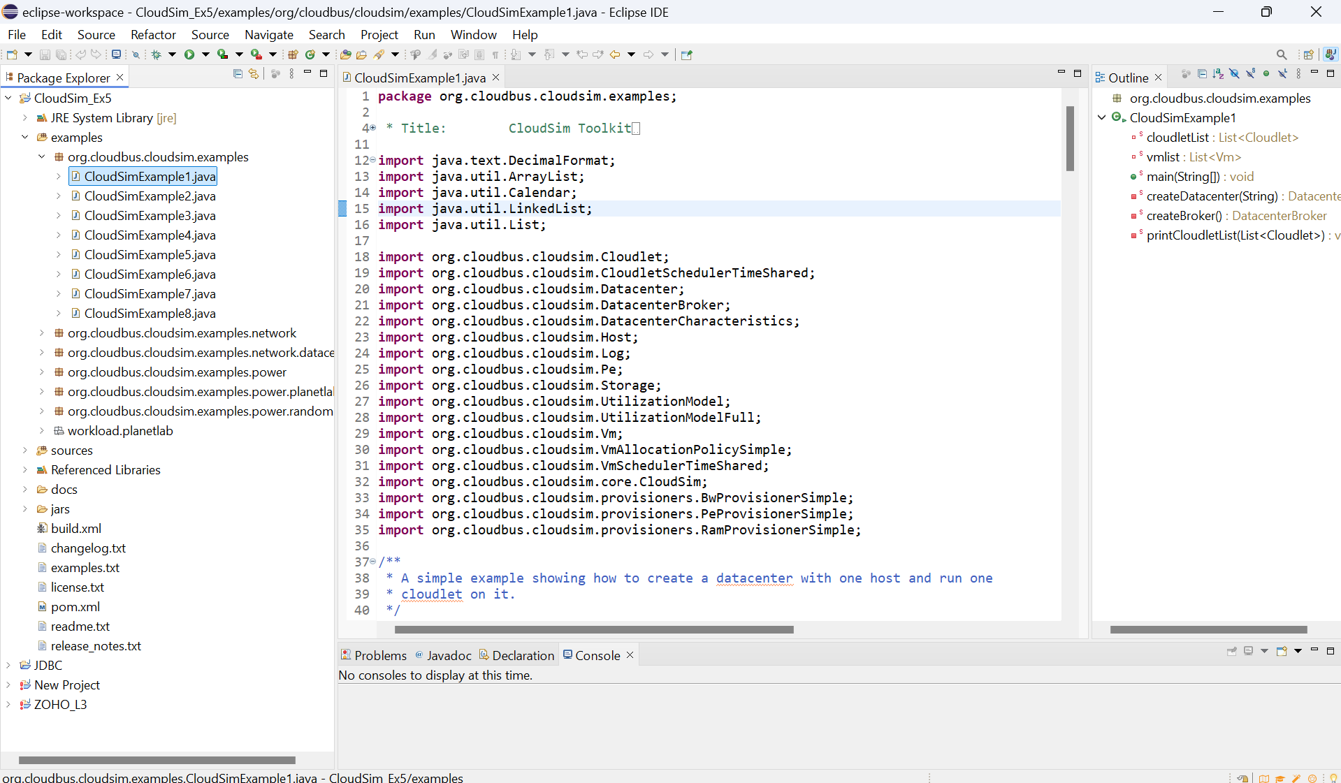

**PROGRAM:**

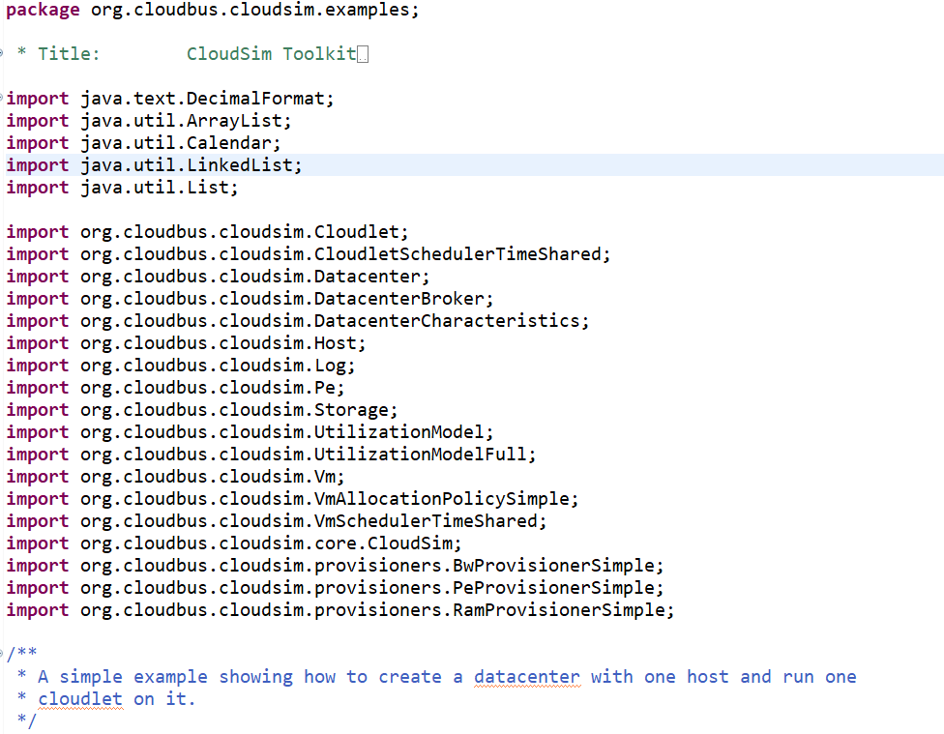

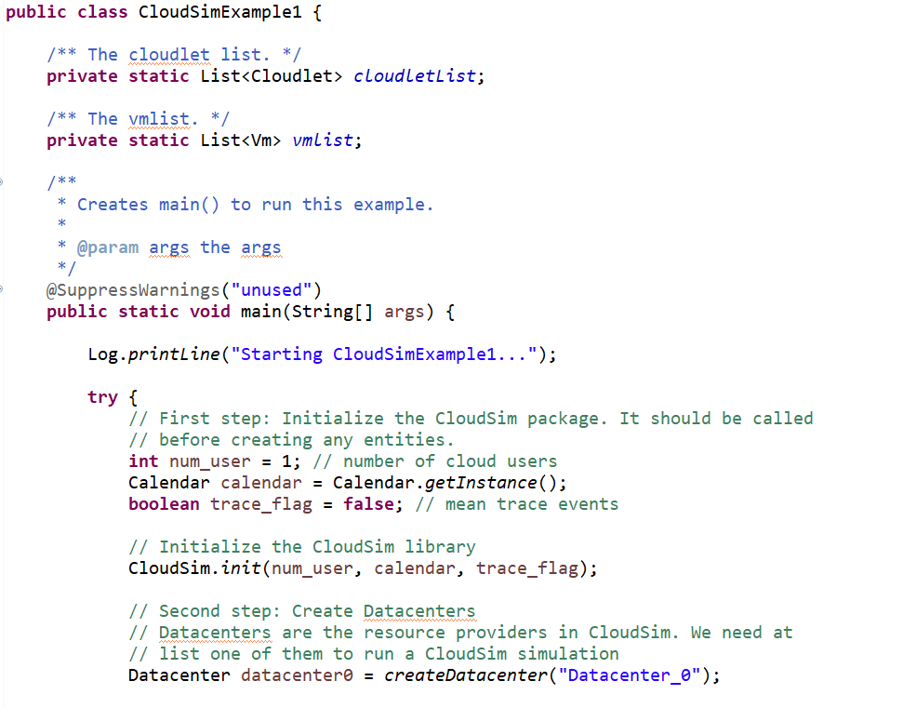

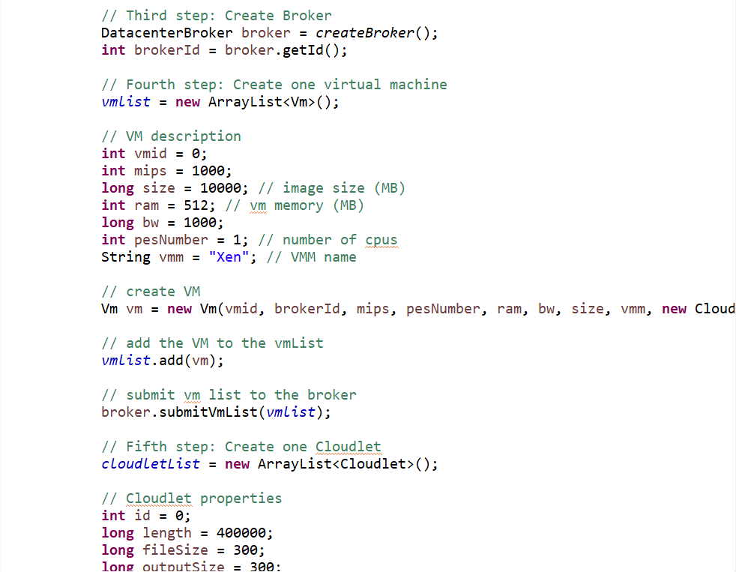

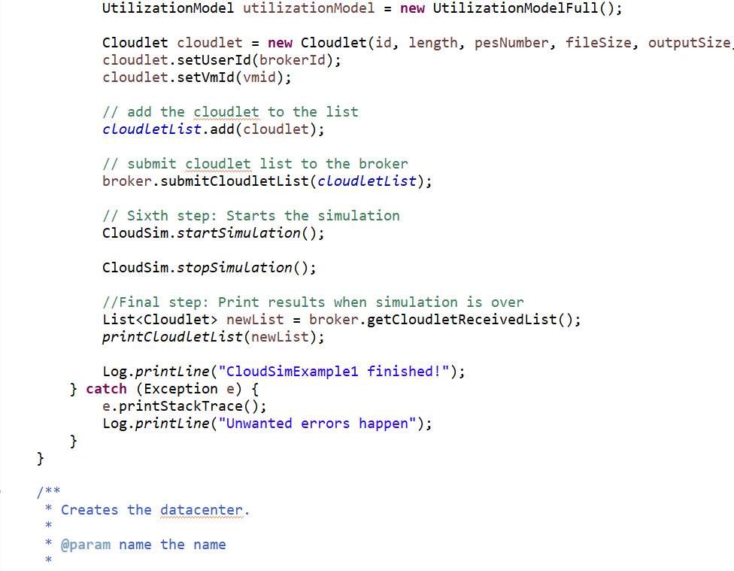

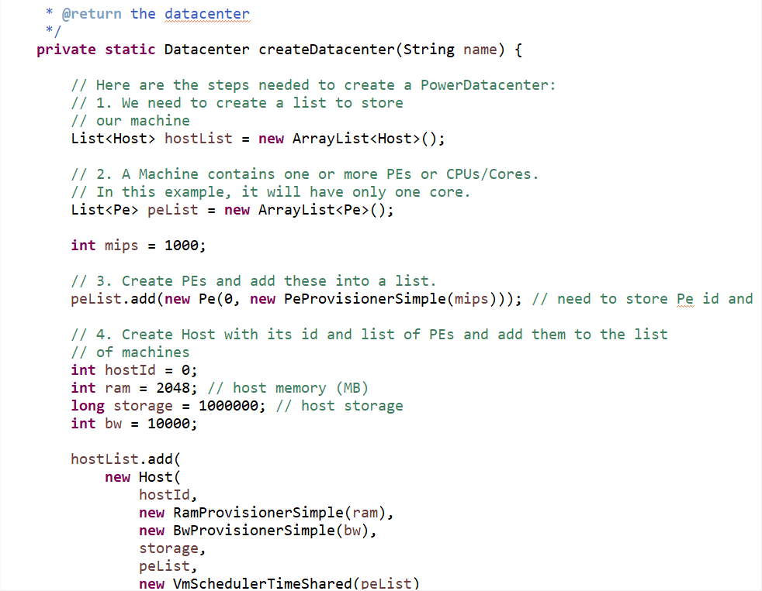

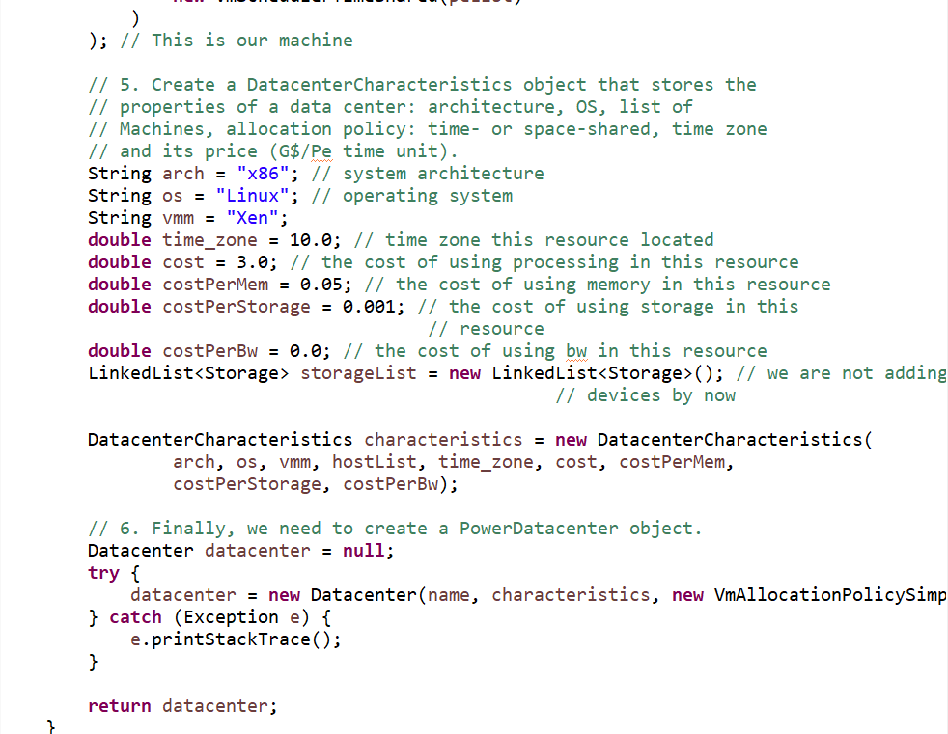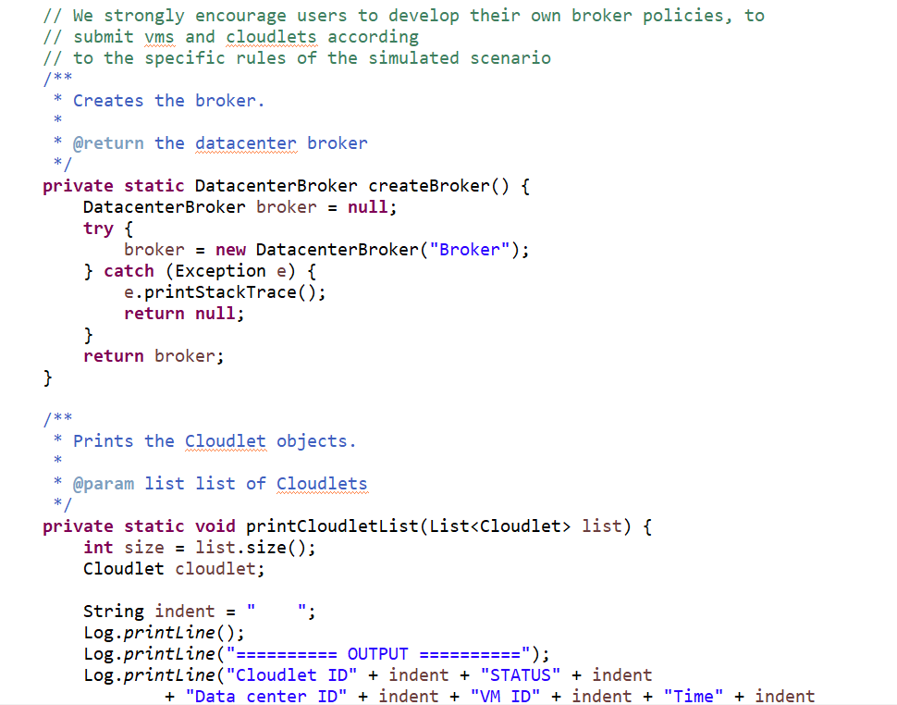

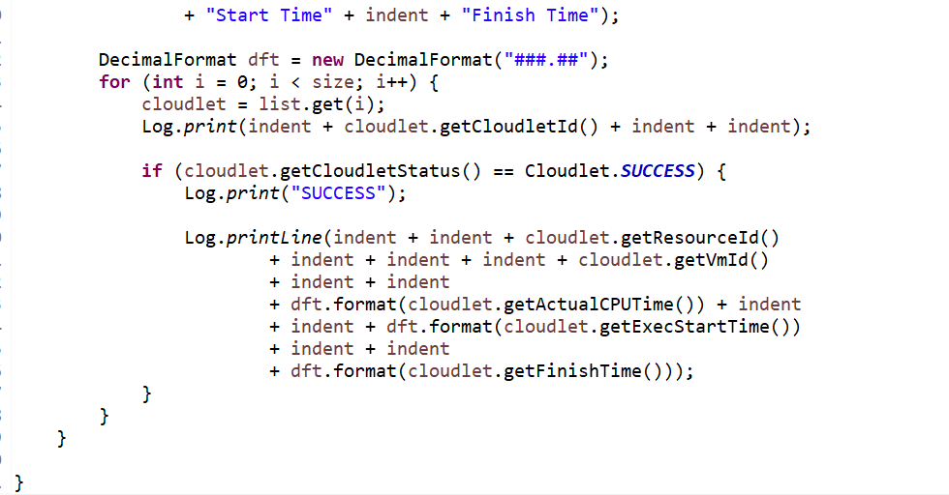

**OUTPUT:**

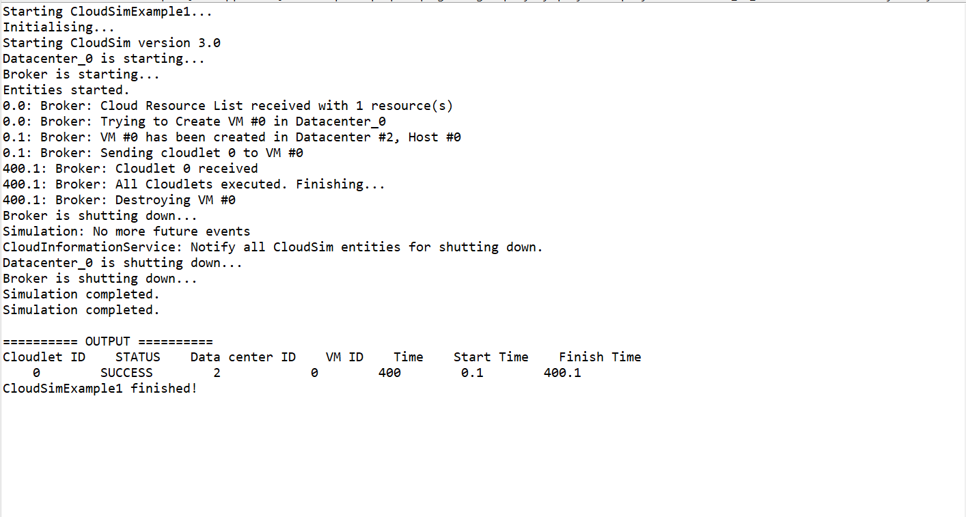

**RESULT:**

Thus, the installation and configuration of CloudSim in Eclipse IDE has been successfully completed.