Week 4 Task
Predictive Modeling and Optimization in Logistics Systems
Logistics Data Analyst Internship – Yuva Intern (NSDC Platform)
Submitted by: Pratheksha S
Report Date: August 27, 2026

1. Objective
This report documents Week 4 of the Logistics Data Analyst internship, which applies predictive modeling and optimization techniques to a logistics operations problem. Building on the Week 3 dataset and exploratory findings, the goal here is to forecast delivery time for a shipment before it moves, evaluate how reliable that forecast is, and then use the model itself — not just historical averages — to test a concrete optimization: what happens if certain Road shipments are reassigned to Rail.

2. Problem Definition and Data Simulation
Prediction problem: forecast delivery_time_days, a continuous target, for a shipment using only information a dispatcher would actually have at booking time — before the shipment has moved and before its true delivery time or cost is known.
The same 1,200-shipment logistics dataset simulated in Week 3 was reused here for continuity, since it already contains realistic, non-random relationships between distance, mode of transport, and delivery time. Seven booking-time features were selected as predictors; fields that are only known after delivery — delay_days, on_time_delivery, customer_rating, transportation cost, and cost_per_km — were deliberately excluded to avoid data leakage.

2.1 Features and Target
Field | Role | Description
distance_km | Feature | Distance to be travelled, in km
shipment_volume_units | Feature | Number of units in the shipment
mode_of_transport | Feature | Road, Rail, Air, or Sea
destination_region | Feature | North, South, East, West, Central
origin_warehouse | Feature | Origin warehouse (WH-1 to WH-6)
promised_time_days | Feature | Service-level target for that mode
ship_month_num | Feature | Calendar month of dispatch (seasonality)
delivery_time_days | Target | Actual delivery time, in days — the value being forecast

The dataset was split 80/20 into training and test sets (960 vs. 240 shipments, random_state = 42) so that model performance is always reported on shipments the model never saw during training.
FEATURES = ['distance_km', 'shipment_volume_units', 'mode_of_transport',
'destination_region', 'origin_warehouse', 'promised_time_days',
'ship_month_num']
TARGET = 'delivery_time_days'
X_train, X_test, y_train, y_test = train_test_split(
X, y, test_size=0.2, random_state=42)

3. Model Selection and Implementation
Three candidate models were trained and compared on identical preprocessing so the comparison would be fair:
- Linear Regression — a simple, interpretable baseline; a sensible first choice given several roughly-linear cost/time relationships observed in Week 3.
- Decision Tree Regressor — can capture non-linear interactions (e.g., a distance effect that behaves differently by mode) that linear regression would miss.
- Random Forest Regressor — an ensemble of decision trees; usually more accurate and more stable than a single tree, and the natural choice for the “ensemble methods” requirement of this task.
Categorical fields (mode_of_transport, destination_region, origin_warehouse) were one-hot encoded inside a scikit-learn ColumnTransformer, wrapped in a Pipeline together with each model so that preprocessing is always fitted on the training data only.
preprocessor = ColumnTransformer(transformers=[
('cat', OneHotEncoder(handle_unknown='ignore'), CATEGORICAL)],
remainder='passthrough')

candidates = {
'Linear Regression': LinearRegression(),
'Decision Tree': DecisionTreeRegressor(max_depth=6, random_state=42),
'Random Forest': RandomForestRegressor(n_estimators=300, max_depth=10,
random_state=42),
}

3.1 Initial Model Comparison (test set)
Model | RMSE (days) | MAE (days) | R²
Linear Regression | 1.032 | 0.599 | 0.576
Random Forest | 1.068 | 0.642 | 0.546
Decision Tree | 1.162 | 0.669 | 0.463

Linear Regression narrowly outperformed both tree-based models on the test set. This is a genuinely useful finding rather than a disappointing one: it suggests delivery time in this dataset is driven mainly by additive, roughly-linear effects (which mode, how far, what was promised) rather than complex interactions that would justify a more complex model. Section 4 checks this result with cross-validation and confirms it by attempting to tune the ensemble method specifically.

4. Evaluation and Validation
Model quality was assessed with three complementary metrics: RMSE (root mean squared error, in days — penalizes large misses more heavily), MAE (mean absolute error, in days — the typical size of a miss), and R² (the share of variance in delivery time the model explains).

4.1 Cross-Validation
A single train/test split can be lucky or unlucky, so the Linear Regression baseline was re-evaluated with 5-fold cross-validation on the training set:
cv = KFold(n_splits=5, shuffle=True, random_state=42)
cv_rmse = -cross_val_score(pipe, X_train, y_train, cv=cv,
scoring='neg_root_mean_squared_error')
# Fold RMSE: [0.914, 1.160, 1.007, 0.917, 1.194]
# Mean RMSE: 1.038 | Std: 0.118
A mean RMSE of 1.038 days with a standard deviation of only 0.118 across folds confirms the test-set result was not a fluke — the model's error is consistently around one day, regardless of which shipments happened to land in the test set.

4.2 Hyperparameter Tuning (Ensemble Method)
Since the task specifically calls for tuning, GridSearchCV was run over the Random Forest's key hyperparameters (number of trees, tree depth, minimum samples per leaf) using 3-fold cross-validation:
param_grid = {
'model__n_estimators': [150, 300],
'model__max_depth': [6, 10, None],
'model__min_samples_leaf': [1, 3],
}
grid = GridSearchCV(rf_pipe, param_grid, cv=3,
scoring='neg_root_mean_squared_error', n_jobs=-1)
# Best params: max_depth=6, min_samples_leaf=3, n_estimators=300
# Best CV RMSE (tuned Random Forest): 1.032
Tuning brought the Random Forest's cross-validated RMSE down to 1.032 — effectively matching, but not beating, the untuned Linear Regression baseline. Given that Linear Regression is also simpler and easier to explain to a non-technical logistics stakeholder, it was retained as the final model. This is a deliberate, evidence-based choice rather than a default: the more complex ensemble method was given a fair chance via tuning and still did not justify its added complexity.

4.3 Final Model Performance
Metric | Value
RMSE | 1.032 days
MAE | 0.599 days
R² | 0.576

On average, the model's delivery-time forecast is off by about 0.6 days, and it explains roughly 58% of the variation in delivery time across shipments — useful enough to flag likely-late shipments proactively, while leaving room for improvement from features not available in this dataset (e.g., live traffic, weather, or carrier-level performance history).
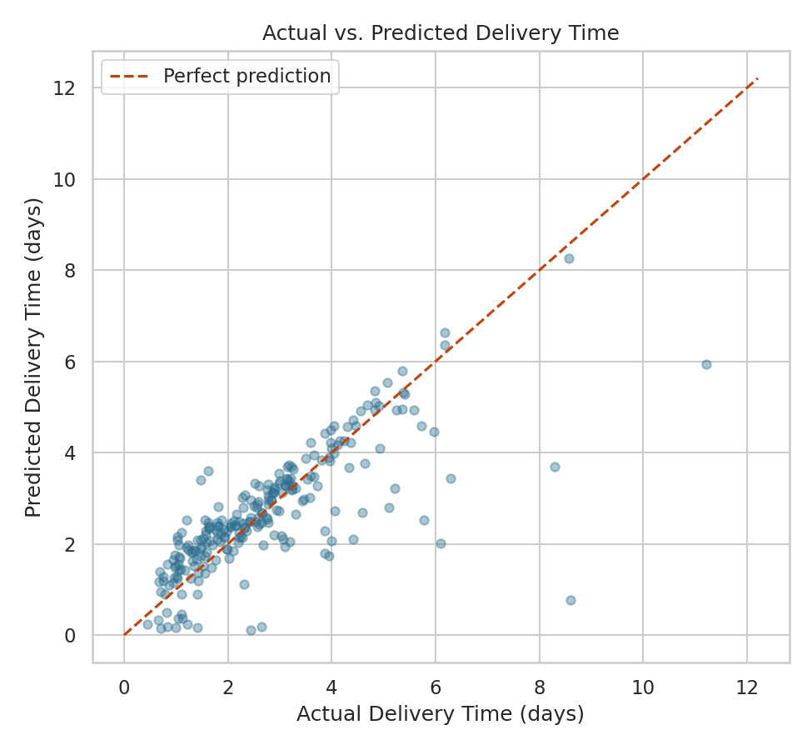
Figure 1: Predicted vs. actual delivery time on the held-out test set. Points near the dashed line are accurate forecasts; the model is close for most shipments but under-predicts a handful of unusually slow deliveries.
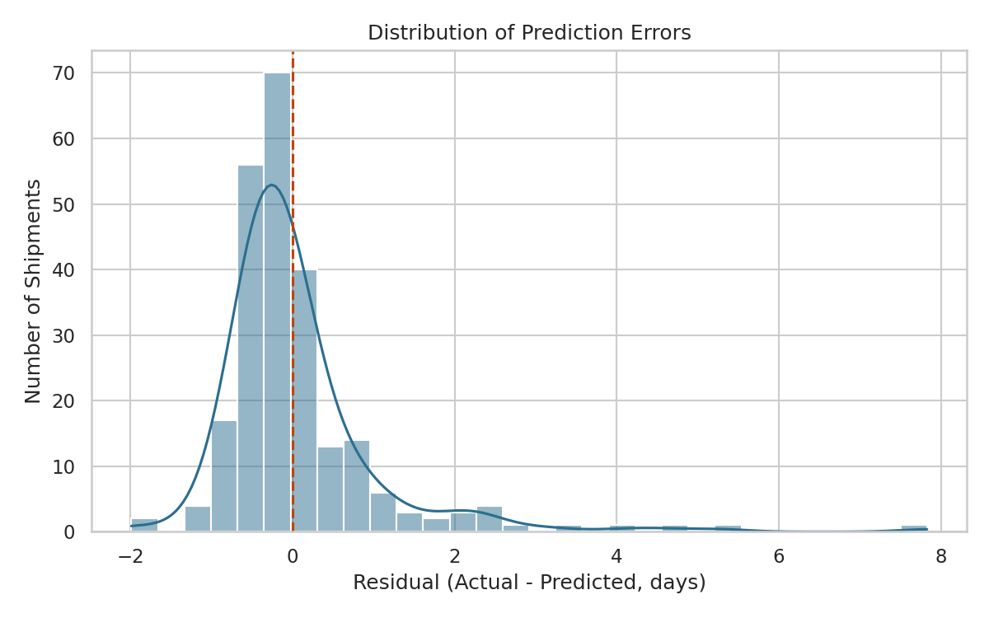
Figure 2: Distribution of prediction errors (actual − predicted). Errors are centered near zero and roughly symmetric, with a mild right tail matching the slow-delivery outliers seen in Figure 1.
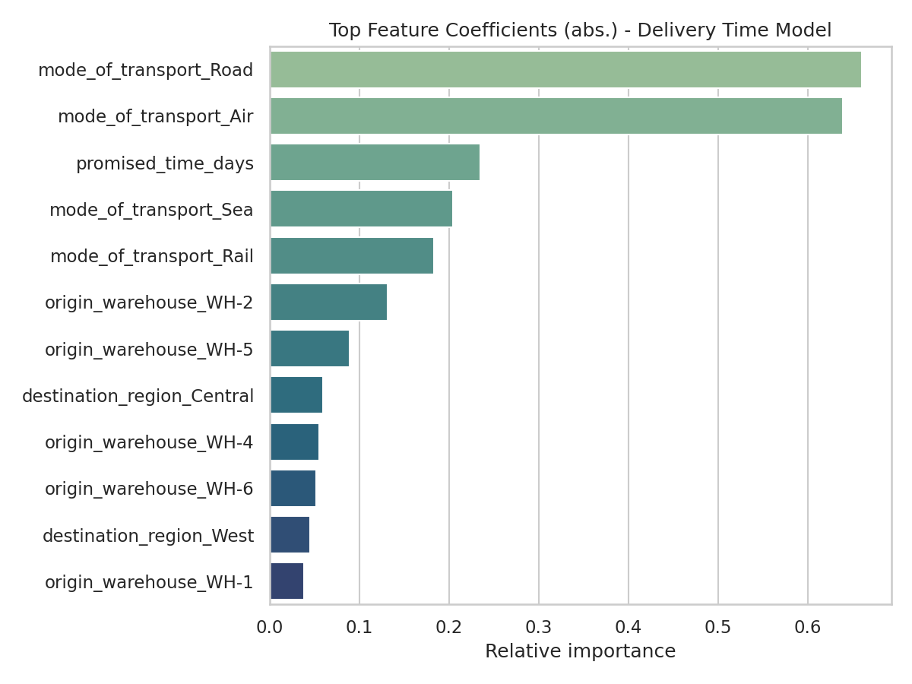
Figure 3: Relative importance of each feature in the final model. Mode of transport (Road, Air) and the promised delivery window dominate — confirming the Week 3 finding that mode, not shipment size, is the primary driver of delivery outcomes.

5. Optimization Strategies
Beyond forecasting, the trained model was used to run two model-driven optimization checks rather than relying on historical averages alone.

5.1 Proactive Delay-Risk Flagging
Every shipment in the dataset was scored with the model, and any shipment whose predicted delivery time exceeded its promised window by more than one day was flagged as high delay-risk:
df['predicted_delivery_days'] = model.predict(df[FEATURES])
df['predicted_delay_risk'] = df['predicted_delivery_days'] - df['promised_time_days']
high_risk = df[df['predicted_delay_risk'] > 1.0]
# 53 of 1,200 shipments flagged (4.4%) — 41 Road, 7 Air, 5 Rail
This turns the model into an operational tool: rather than reviewing delivery performance after the fact, these 53 shipments (mostly Road) could be flagged for expedited handling or an alternate carrier at the time of booking, before they become a late delivery.

5.2 Resource Reallocation: Simulated Road → Rail Reassignment
For every shipment currently sent by Road, the model was asked to re-predict delivery time under a counterfactual where the same shipment (same distance, volume, warehouse, region, and promised window) was instead sent by Rail:
road_as_rail = road.copy()
road_as_rail['mode_of_transport'] = 'Rail'
road['predicted_if_rail'] = model.predict(road_as_rail[FEATURES])
# Predicted on-time rate as Road: 91.6%
# Predicted on-time rate as Rail: 93.9%
# Shipments flipping from late to on-time: 16 (2.4% of all Road shipments)
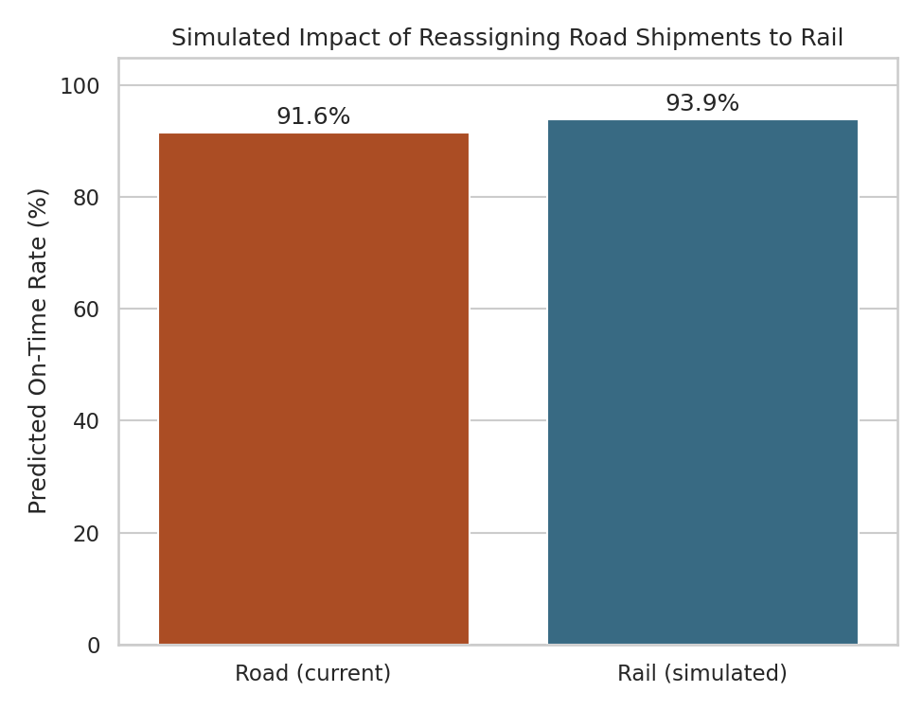
Figure 4: Simulated predicted on-time rate for the same Road shipments, actual mode vs. a counterfactual Rail assignment.
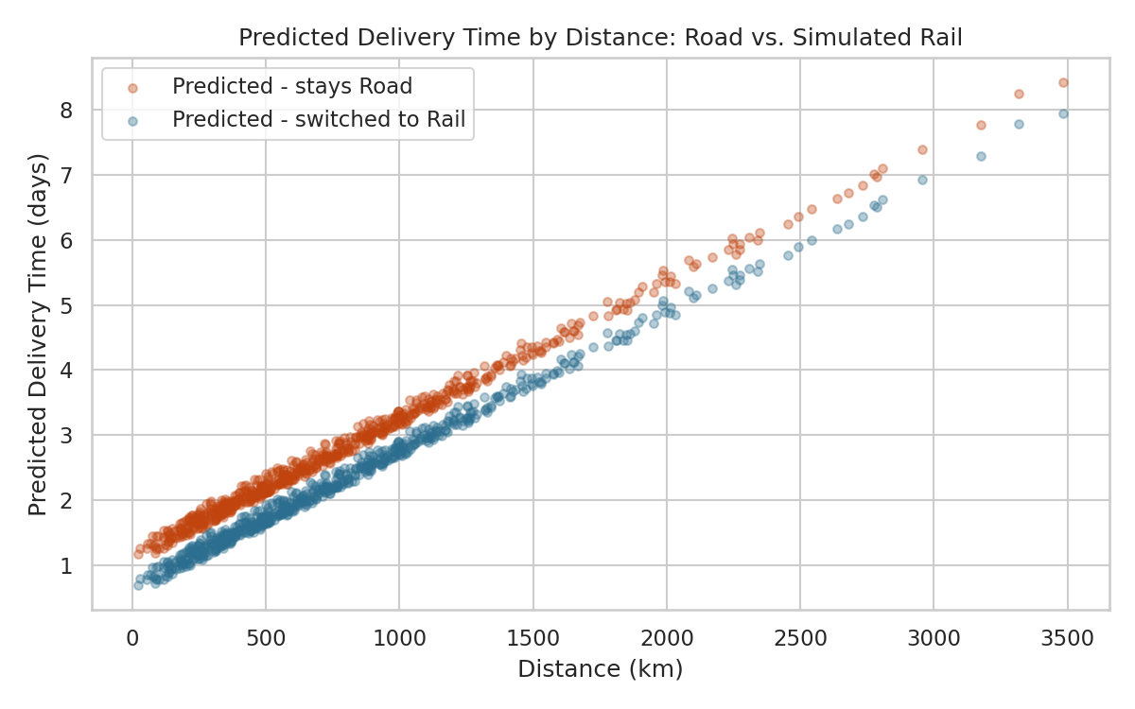
Figure 5: Predicted delivery time by distance for Road shipments under their actual mode versus the simulated Rail assignment. The gap narrows at shorter distances, suggesting Rail's advantage is strongest on longer Road routes.
Combined with the Week 3 finding that Rail costs roughly half of Road per kilometre, this simulation gives a concrete, testable recommendation: shifting longer-distance Road shipments to Rail is likely to improve both cost and reliability at the same time, rather than trading one for the other.

6. Analytical Insights and Recommendations

6.1 What the Model Confirms and Adds
- Mode of transport remains the single biggest lever on delivery outcomes, now confirmed through feature importance rather than just grouped averages.
- A simple, well-validated model outperformed more complex ones here — a reminder that model complexity should be justified by evidence (cross-validation, tuning), not assumed.

6.2 Optimization Recommendations
- Use the delay-risk score at booking time to flag the ~4% of shipments (mostly Road) likely to miss their promised window, and route them for expedited handling before dispatch rather than after a customer complaint.
- Pilot a Road-to-Rail reassignment for longer-distance Road routes specifically — the simulation shows this improves predicted on-time performance while Week 3's cost analysis shows it should also reduce cost.
- Retrain and re-validate this model periodically as new shipments accumulate; a 0.6-day average error is workable for triage today but should be monitored for drift as operating conditions change.
- Treat the current R² of 0.58 as a floor, not a ceiling — incorporating features not present in this simulated dataset (real-time traffic, weather, carrier-specific reliability) is the most promising next step for improving forecast accuracy.

7. Methodology and Tools
All work was done in Python using pandas for data handling and scikit-learn for modeling: ColumnTransformer and Pipeline for leakage-safe preprocessing, LinearRegression / DecisionTreeRegressor / RandomForestRegressor as candidate models, KFold and cross_val_score for validation, and GridSearchCV for hyperparameter tuning. Matplotlib and seaborn were used for the evaluation and optimization charts, and joblib was used to persist the trained pipeline between the training, evaluation, and optimization scripts.
The full pipeline is split across four scripts, included separately: 01_data_preparation.py (problem definition and train/test split), 02_model_training.py (model comparison), 03_model_evaluation.py (cross-validation, tuning, diagnostic plots), and 04_optimization_strategy.py (the risk-flagging and mode-reassignment simulation).

8. Conclusion
This week's task extended the Week 3 exploratory work into a validated predictive model and, more importantly, into a concrete optimization test. Rather than stopping at 'the model achieves an R² of 0.58,' the model was put to work: scoring every shipment for delay risk and simulating a resource-reallocation decision (Road to Rail) before recommending it. The exercise reinforced that model selection should be evidence-driven — the simplest model that performs well, validated by cross-validation and a fair hyperparameter search on the alternative, is the right choice here — and that a predictive model's real value in logistics comes from the decisions it can drive, not the metric alone.

