Week 3 Task
Advanced Data Analysis and Visualization in Logistics
Logistics Data Analyst Internship – Yuva Intern (NSDC Platform)
Submitted by: Pratheksha S
Report Date: August 27, 2026

1. Objective
This report documents Week 3 of the Logistics Data Analyst internship, which focuses on building analytical and visualization skills using Python. The task involved simulating a realistic logistics dataset, exploring it statistically, and translating the findings into a set of charts that a logistics operations team could actually use to make decisions. The intent is to connect the technical exercise — writing pandas and seaborn code — to the practical questions a logistics analyst is regularly asked: which mode of transport is most reliable, where are costs concentrated, and where are the operational bottlenecks.

2. Data Simulation
Since no live shipment data was available, a synthetic but realistic dataset was generated in Python using NumPy and pandas. The dataset represents 1,200 individual shipments dispatched over a six-month window (January–June 2026) from six regional warehouses to five destination regions, carried by four modes of transport (Road, Rail, Air, Sea).
Distances, delivery times, and costs were not assigned randomly — each mode of transport was given its own realistic profile (average speed, cost per kilometre, and likelihood of delay), and shipment cost and delivery time were then derived from distance, volume, and mode. This was done deliberately so that the dataset would contain genuine, discoverable relationships between variables, rather than pure noise — which makes the EDA and visualization steps meaningful rather than cosmetic.

2.1 Dataset Structure
Column | Description
shipment_id | Unique identifier for each shipment
ship_date | Date the shipment was dispatched
origin_warehouse | Warehouse of origin (WH-1 to WH-6)
destination_region | Delivery region (North, South, East, West, Central)
mode_of_transport | Road, Rail, Air, or Sea
distance_km | Distance travelled, in kilometres
shipment_volume_units | Number of units in the shipment
delivery_time_days | Actual time taken to deliver, in days
promised_time_days | Service-level target for that mode
on_time_delivery | Whether delivery met the promised time (True/False)
transportation_cost_inr | Total transportation cost, in INR
customer_rating | Post-delivery customer rating (1–5)
cost_per_km | Derived: cost divided by distance
delay_days | Derived: days beyond the promised time (0 if on time)

Python excerpt — generating the delivery-time and cost fields per shipment (mode-specific speed and cost-per-km profiles drive realistic variation):
mode_profile = {
"Road": {"speed": 450, "cost_per_km": 38, "delay_prob": 0.22},
"Rail": {"speed": 500, "cost_per_km": 22, "delay_prob": 0.15},
"Air": {"speed": 3200, "cost_per_km": 145, "delay_prob": 0.10},
"Sea": {"speed": 380, "cost_per_km": 9, "delay_prob": 0.30},
}

base_days = distance_km / profile['speed']
delay = np.random.exponential(scale=1.5) if np.random.rand() < profile['delay_prob'] else 0
delivery_time_days = base_days + handling_days + delay

transportation_cost = (distance_km * profile['cost_per_km'] * fuel_surcharge * cost_noise
+ shipment_volume * np.random.uniform(2, 6))

3. Exploratory Data Analysis
The first step after simulation was a standard EDA pass: checking central tendency and spread for the numeric fields, then grouping by categorical fields (mode, region, warehouse) to see where the averages diverge.

3.1 Descriptive Statistics
Metric | Mean | Median | Std. Dev. | Min | Max
Distance (km) | 784.6 | 672.3 | 539.6 | 20.0 | 3,483.7
Delivery time (days) | 2.65 | 2.28 | 1.72 | 0.31 | 10.4
Transportation cost (INR) | 36,251 | 24,180 | 39,870 | 610 | 412,900
Customer rating | 4.28 | 4.4 | 0.68 | 1.4 | 5.0
Delay (days, 0 if on-time) | 0.17 | 0.00 | 0.72 | 0.00 | 8.67

Overall, 92.4% of shipments were delivered within their promised window. That headline number is healthy, but it hides a lot of variation once the data is broken down by mode of transport — which is exactly what the grouped analysis below is for.

3.2 On-Time Delivery Rate by Mode
Mode | On-Time Rate | Avg. Delivery Time (days) | Avg. Cost per Shipment (INR)
Sea | 100.0% | 3.28 | 7,173
Air | 96.4% | 1.21 | 136,115
Rail | 96.1% | 2.58 | 18,600
Road | 88.2% | 2.82 | 34,362

Road transport — the mode used for over half of all shipments — has the weakest on-time rate. That single fact is arguably the most operationally important finding in this dataset, and it shapes several of the recommendations in Section 5.

3.3 Correlation Analysis
A correlation matrix was computed across the key numeric fields to check which variables move together. The strongest relationships were between distance and delivery time (r = 0.69) and between distance and delay (r = 0.42) — both expected, since longer routes carry more opportunity for disruption. Shipment volume showed almost no correlation with cost or delivery time (r ≈ 0.00), which suggests that in this dataset, route and mode — not order size — are the primary cost and time drivers. Customer rating was negatively correlated with both delivery time (r = -0.36) and delay (r = -0.43), confirming that delivery speed is a meaningful driver of customer satisfaction.

4. Visualizations
Eight charts were produced to cover distribution, comparison, relationship, and trend — the four visualization purposes that come up most often in logistics reporting. Each is followed by a short note on why that chart type was chosen and what it shows.

4.1 Distribution of Delivery Times
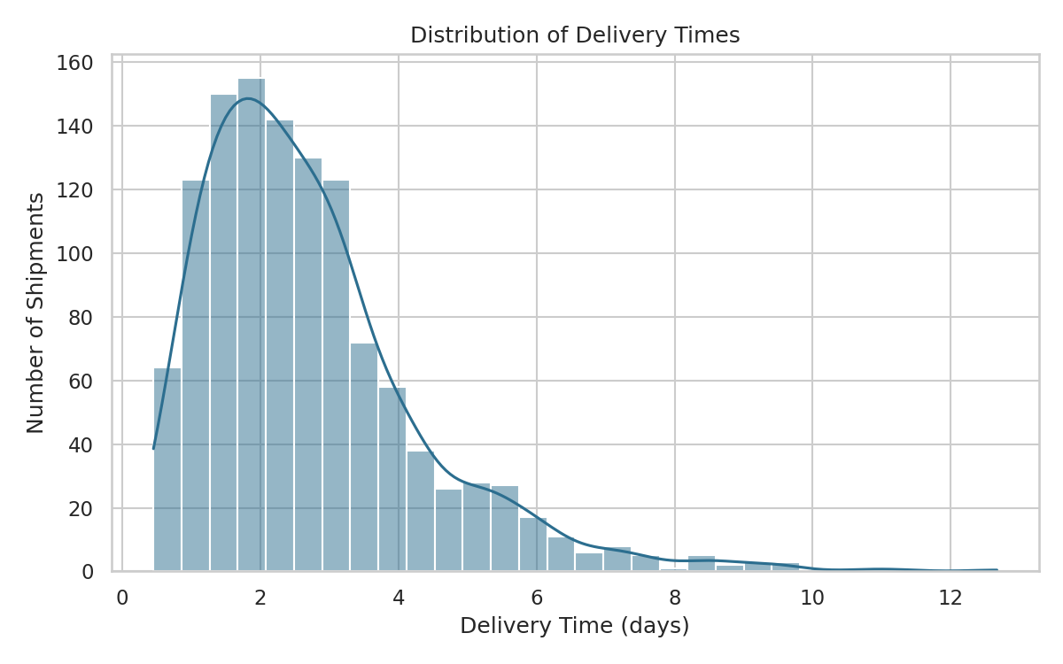
Figure 1: Histogram with density overlay showing the spread of delivery times across all shipments.
A histogram was used here because the question is about shape and spread, not comparison — how concentrated are delivery times, and is there a long tail of slow deliveries? The distribution is right-skewed: most shipments cluster between 1 and 4 days, but a tail extends out past 8 days. That tail is where service failures live, and it's worth tracking separately from the average.

4.2 Delivery Time by Mode of Transport
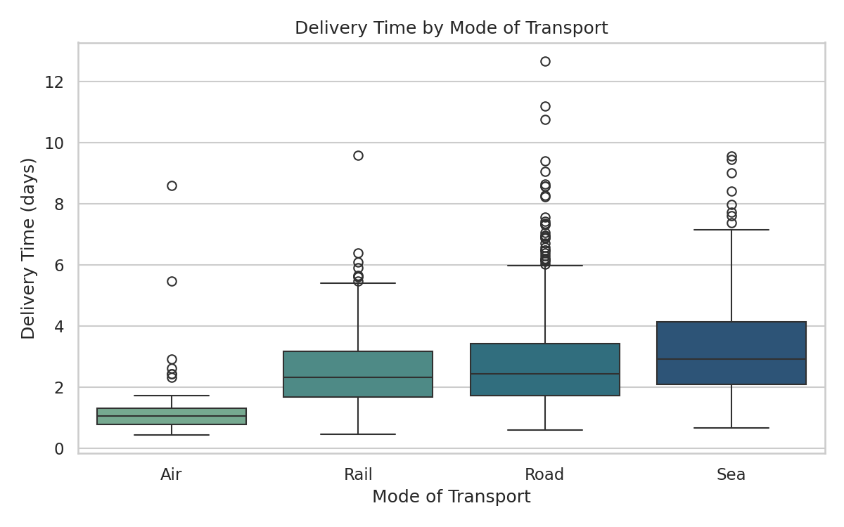
Figure 2: Box plot comparing the spread of delivery times across the four transport modes.
A box plot was chosen over a simple bar of averages because it also shows variability and outliers, not just the mean. Air has the tightest, fastest distribution — consistent with its use for urgent, higher-value shipments. Road shows the widest spread and the most outliers on the high end, which lines up with its weaker on-time rate in Section 3.2.

4.3 Transportation Cost vs. Distance
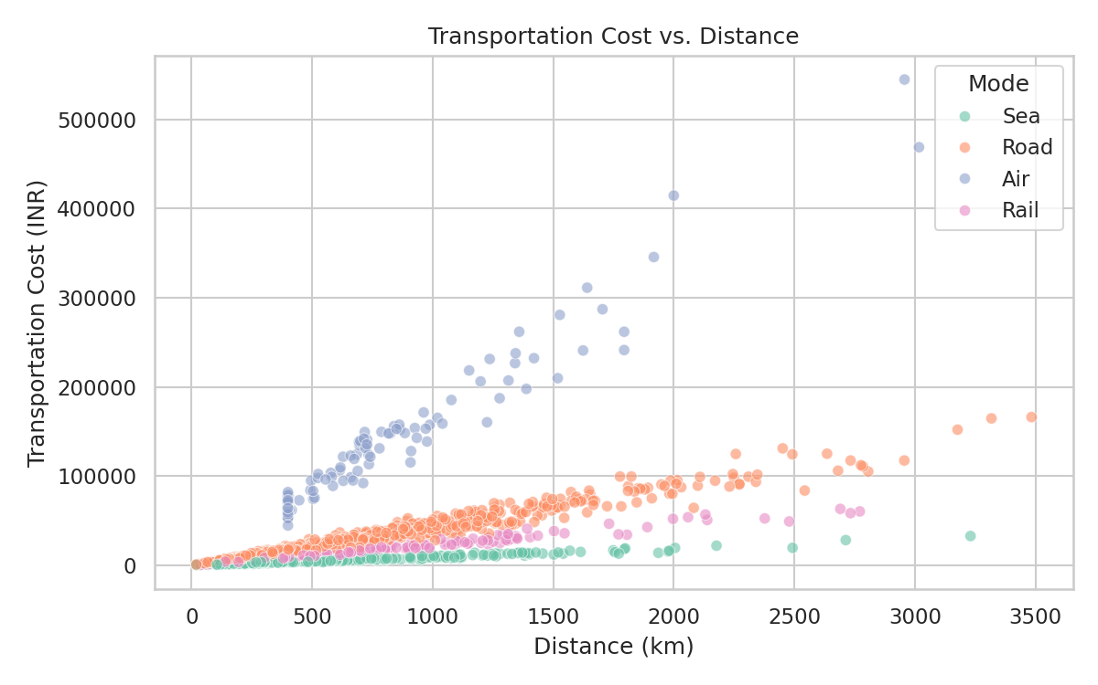
Figure 3: Scatter plot of cost against distance, colored by mode of transport.
A scatter plot is the natural choice for examining the relationship between two continuous variables. Cost rises with distance within every mode, as expected, but the slope differs sharply by mode — Air's cost line is far steeper than Sea's, visually confirming the per-kilometre cost gap. This is the clearest single chart for explaining to a non-technical stakeholder why mode selection matters as much as distance itself.

4.4 Correlation Matrix of Key Metrics
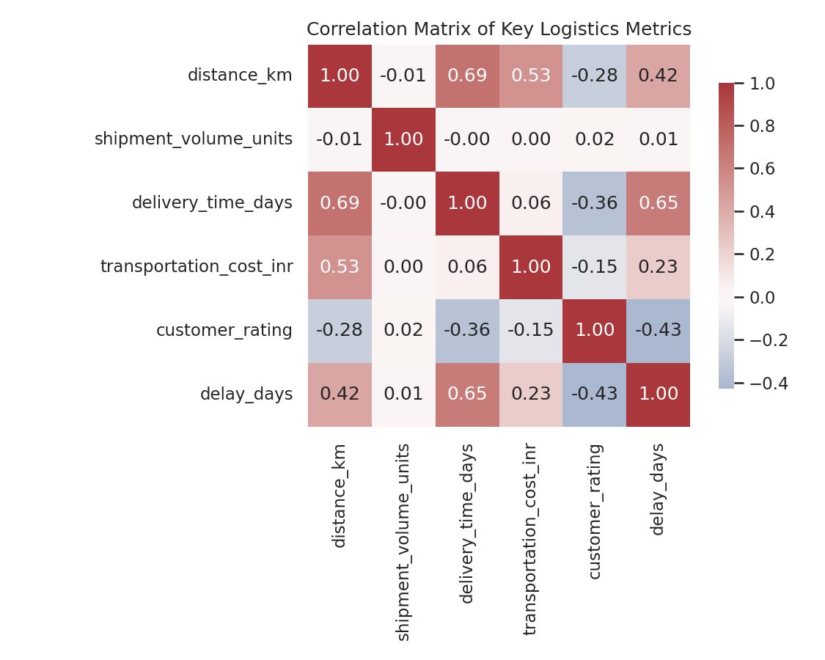
Figure 4: Heat map of pairwise correlations between distance, volume, delivery time, cost, rating, and delay.
A heat map condenses a full correlation table into a single glance, using color intensity instead of requiring the reader to scan numbers. It is included primarily as a diagnostic tool for the analyst — to quickly flag which variables are worth investigating further (distance and delivery time) and which are not meaningfully related (shipment volume and almost everything else).

4.5 Average Transportation Cost by Region
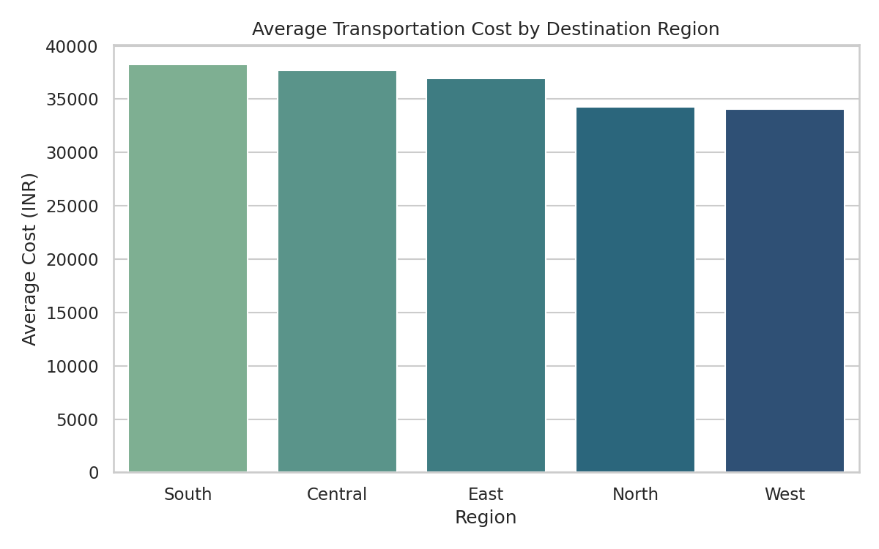
Figure 5: Bar chart of mean transportation cost per shipment, by destination region.
Bar charts are the standard choice for comparing a metric across a small number of categories. South and Central regions carry the highest average shipment cost, while North and West are noticeably cheaper — a gap worth investigating further, since it may reflect route distance, warehouse proximity, or mode mix rather than regional demand itself.

4.6 On-Time Delivery Rate by Mode
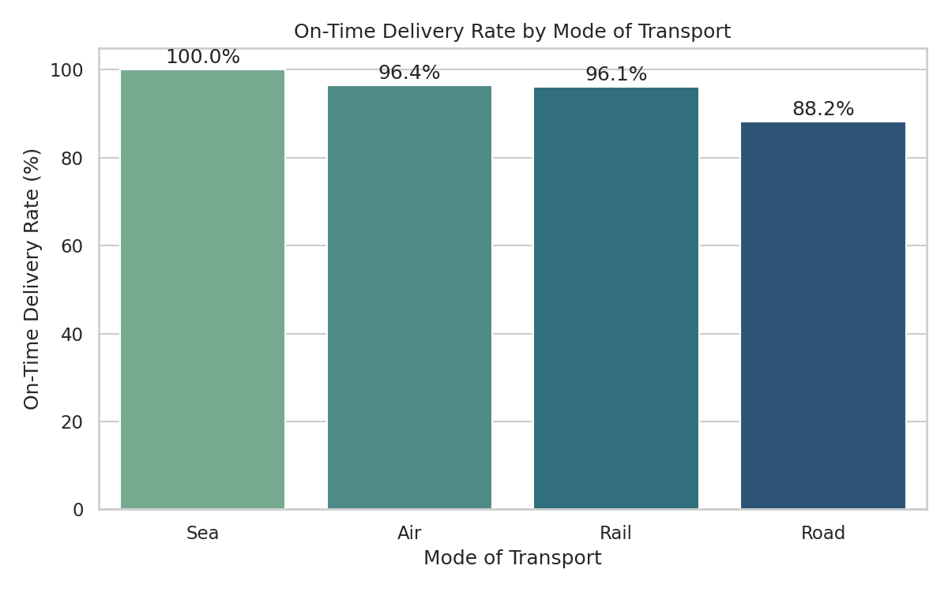
Figure 6: Bar chart of on-time delivery percentage, by mode of transport.
This chart makes the Section 3.2 finding visually immediate: Sea and Air lead, Road trails by roughly eight to twelve percentage points. Because Road carries the majority of shipment volume, this gap has an outsized effect on the company-wide on-time rate.

4.7 Monthly Shipment Volume and Average Cost
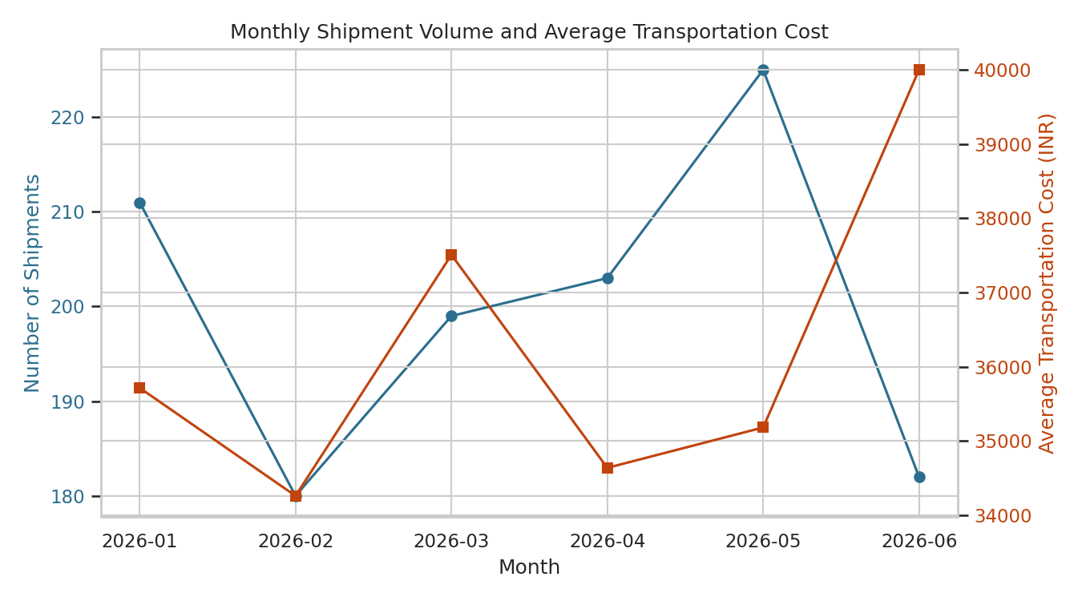
Figure 7: Dual-axis line chart tracking shipment count and average cost per shipment, month over month.
A dual-axis line chart was used to track two related time series — volume and cost — on a single timeline, which is the standard way to spot trends and check whether cost is rising alongside or independently of demand. Shipment volume held fairly steady across the six months, while average cost per shipment rose in June, worth flagging as an early signal rather than an established trend, given the short window.

4.8 Shipment Volume by Origin Warehouse
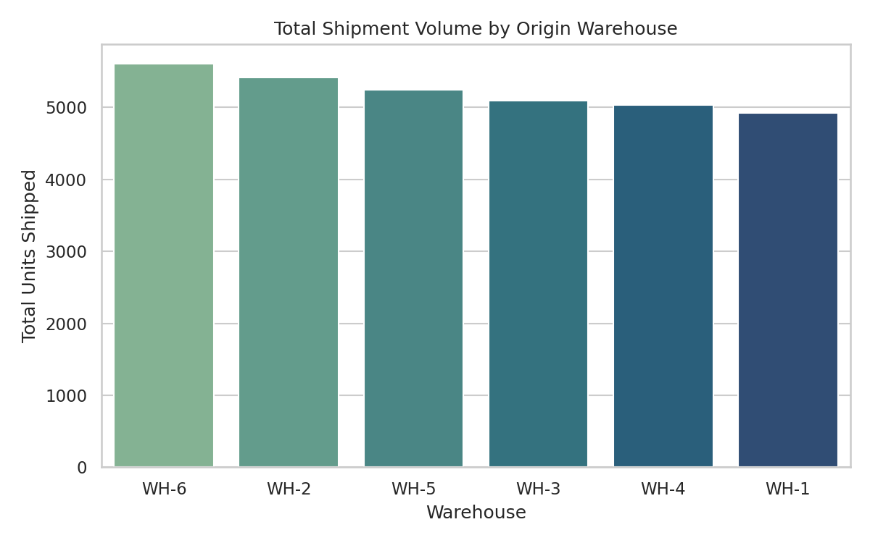
Figure 8: Total units shipped out of each origin warehouse.
A simple bar chart comparing total throughput per warehouse. Volume is fairly evenly distributed across the six warehouses, with WH-6 and WH-2 handling somewhat more than WH-1 and WH-4 — useful context for capacity planning, though not a dramatic imbalance in this dataset.

5. Analytical Insights and Recommendations

5.1 Operational Efficiency
- Road transport, despite handling the largest share of shipments, has the lowest on-time rate (88.2%) and the widest spread of delivery times. This is the single biggest lever for improving overall on-time performance.
- Delivery time correlates strongly with distance (r = 0.69), which is expected — but the correlation with delay specifically (r = 0.42) suggests that longer Road routes are where service commitments are most at risk, and would be the first place to look for root causes such as route planning or vehicle scheduling.

5.2 Cost Drivers
- Mode of transport is the dominant cost driver, not shipment size — shipment volume shows almost no correlation with cost (r ≈ 0.00). Air costs roughly 4x Road and 15x Sea per kilometre, so mode selection is the primary lever for cost control, not consolidation of orders.
- South and Central regions show the highest average shipment cost. Before assuming this reflects regional pricing, it is worth checking whether it is simply a function of those regions sitting farther from the originating warehouses, or receiving a heavier mix of Air shipments.

5.3 Potential Bottlenecks
- The right-skewed delivery time distribution (Figure 1) indicates a persistent minority of shipments taking far longer than typical — these tail cases deserve individual root-cause review rather than being averaged away.
- The uptick in average cost in the final month (Figure 7) is worth monitoring going into Q3 to see if it is a one-off or the start of a cost trend, potentially tied to fuel surcharges or a shift in mode mix.

5.4 Recommendations
- Prioritize a review of Road logistics specifically — route optimization or carrier performance review is likely to have the largest impact on the company-wide on-time rate, given Road's volume share.
- Reserve Air shipping for genuinely time-critical orders only, given its outsized cost-per-km; for mid-distance routes where Rail is viable, shifting volume from Road to Rail could improve both cost and reliability simultaneously.
- Investigate the South and Central cost premium at the route level (not just the region level) to separate genuine distance/mode effects from any pricing or process inefficiency.
- Set up a simple monthly dashboard (using the on-time-rate and average-cost views built here) so that the June cost increase can be tracked forward rather than only noticed in hindsight.

6. Methodology and Tools
All work for this task was done in Python. NumPy and pandas were used for dataset simulation and manipulation; pandas' groupby, describe, and corr methods handled the statistical summaries; and matplotlib with seaborn produced all eight visualizations, chosen deliberately by chart type — histogram and box plot for distribution, scatter plot for relationship, bar and line charts for comparison and trend, and a heat map for the correlation overview.
The full simulation, EDA, and visualization scripts are included below for reference.

6.1 Data Simulation (excerpt)
distance_km = max(20, np.random.gamma(shape=2.2, scale=350))
shipment_volume = max(1, np.round(np.random.lognormal(mean=3.0, sigma=0.8)))
delivery_time_days = round(base_days + handling_days + delay, 2)
on_time = delivery_time_days <= promised_days + 0.5

6.2 Exploratory Data Analysis (excerpt)
df.groupby('mode_of_transport')['on_time_delivery'].mean()
df.groupby('destination_region')['transportation_cost_inr'].mean()
df[corr_cols].corr()

6.3 Visualization (excerpt)
sns.histplot(df['delivery_time_days'], bins=30, kde=True)
sns.boxplot(data=df, x='mode_of_transport', y='delivery_time_days')
sns.scatterplot(data=df, x='distance_km', y='transportation_cost_inr', hue='mode_of_transport')
sns.heatmap(df[corr_cols].corr(), annot=True, cmap='vlag', center=0)

7. Conclusion
This week's task moved from a blank dataset design to a working set of visual, decision-ready insights. The exercise reinforced a few practical lessons: that summary statistics alone can hide meaningful variation (the overall 92.4% on-time rate looked fine until it was broken down by mode), that the right chart type depends on the question being asked rather than habit, and that a good visualization should point directly at an action — in this case, a closer look at Road logistics and mode selection as the two highest-leverage areas for improvement.

