**HelpDesk**

**HomePage**

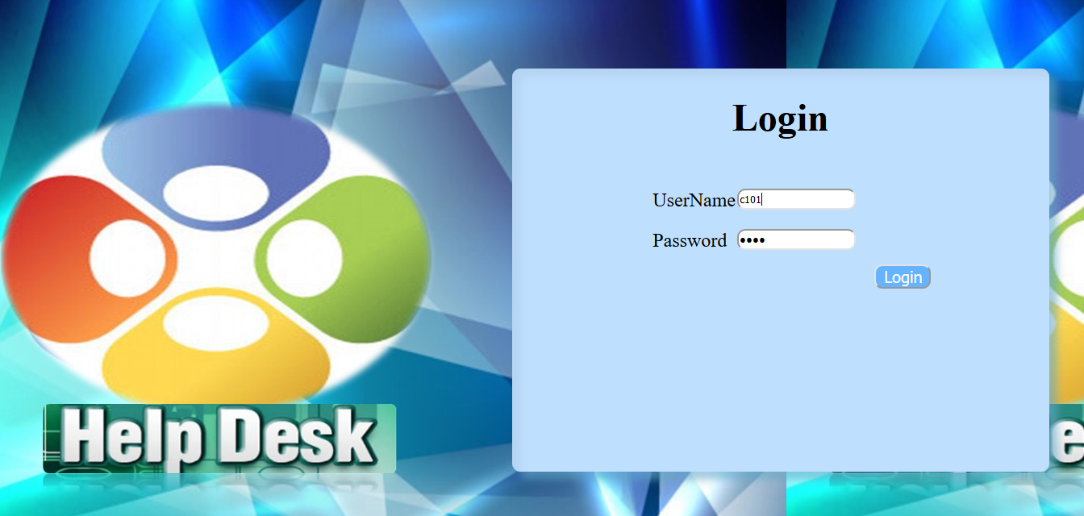

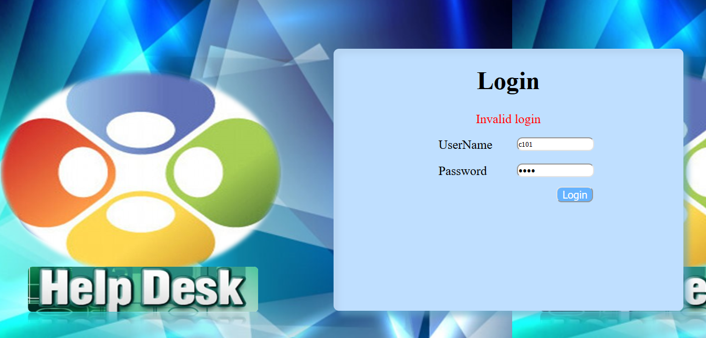

**ClientHomePage**

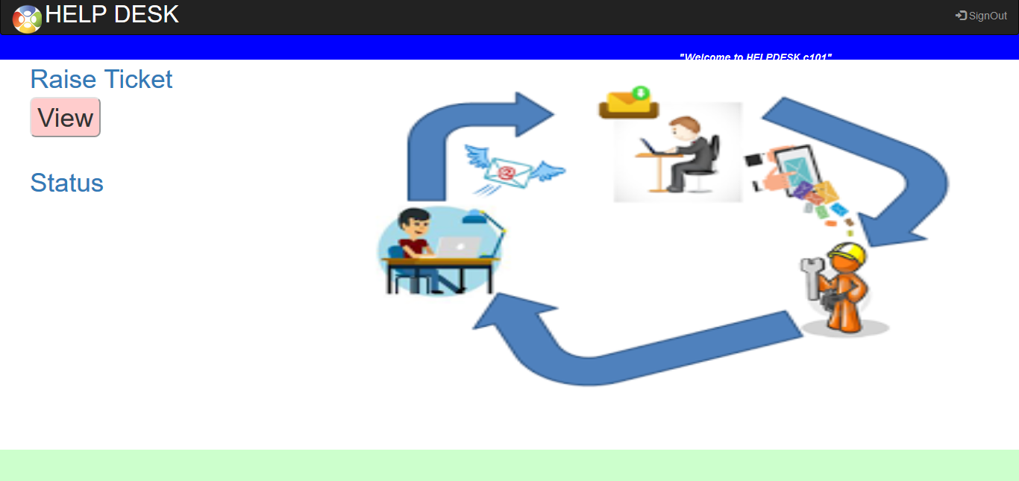

**Client can raise tickets**

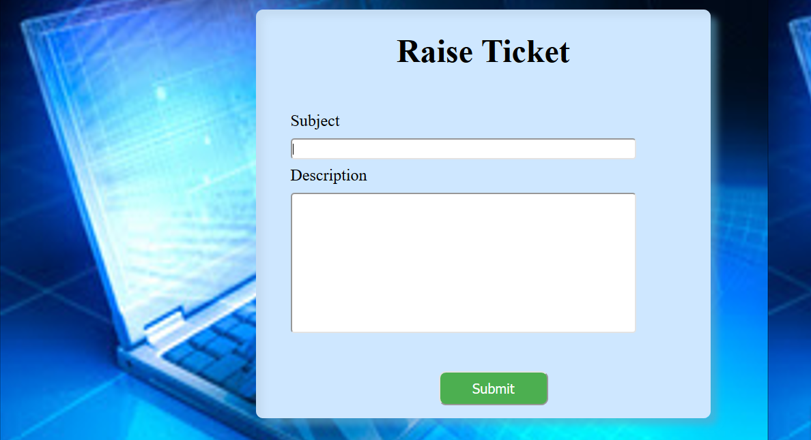

**Status of the all the tickets raised by the client**

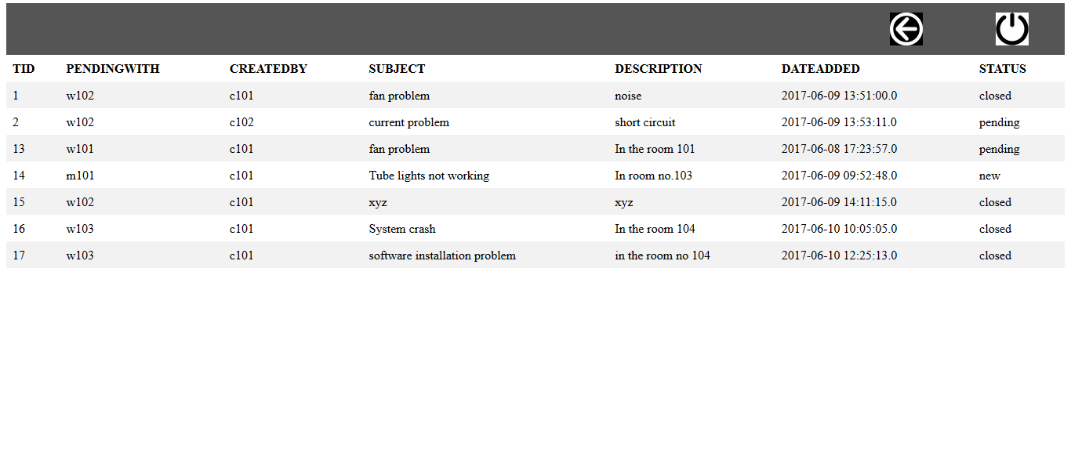

**AdminHomePage**

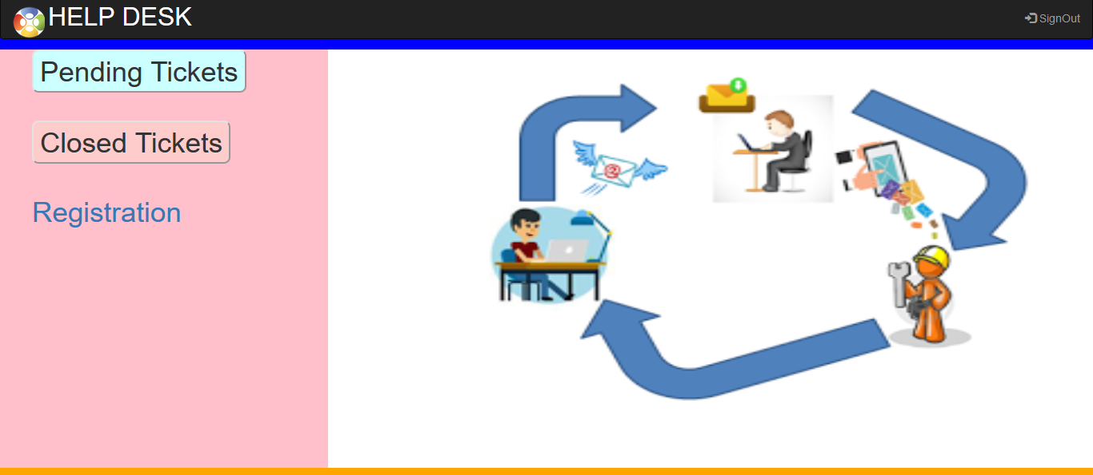

**Allocation of the tickets to the respective resolver**

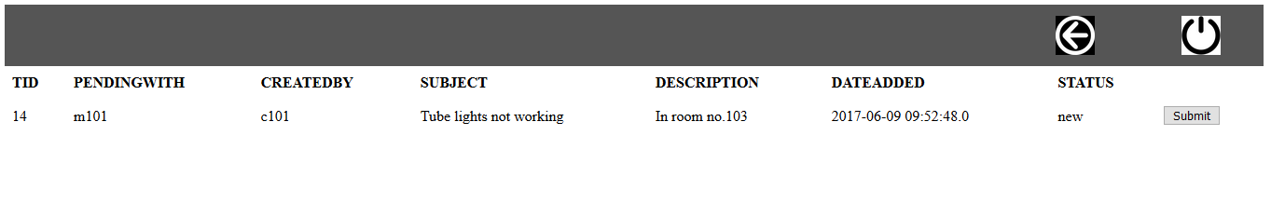



**Assigned tickets can be reviewed by the admin**

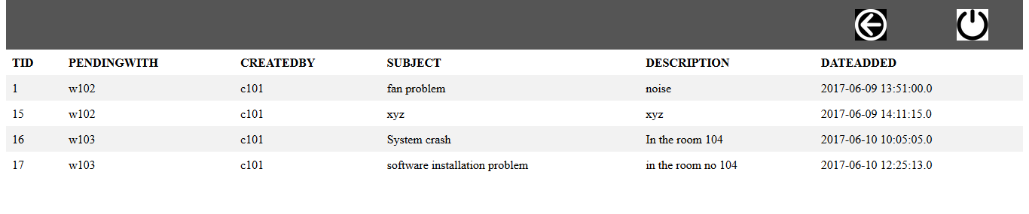

**Admin has the right to add new user**

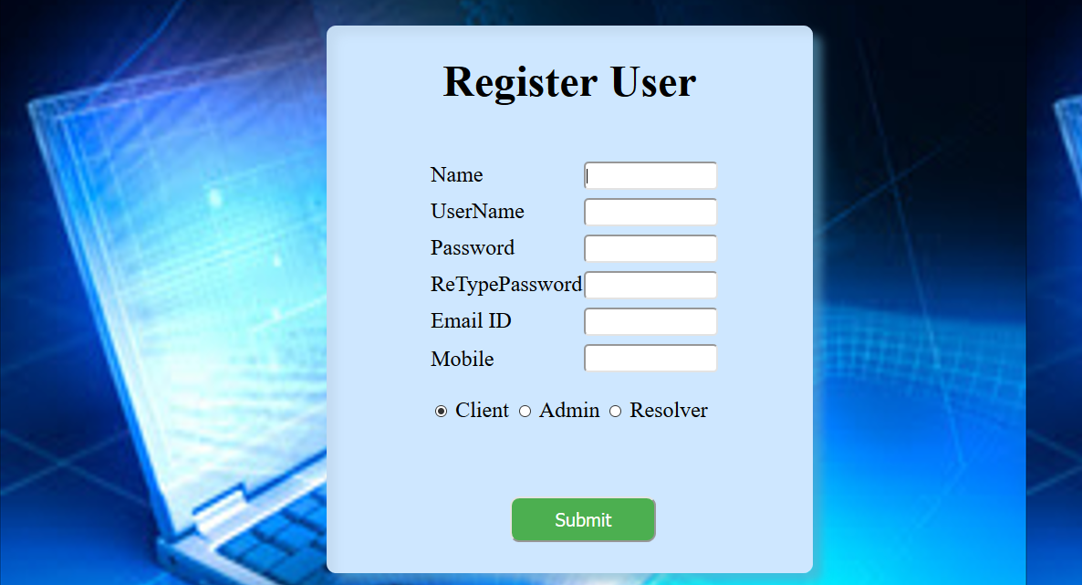

**ResolverHomePage**

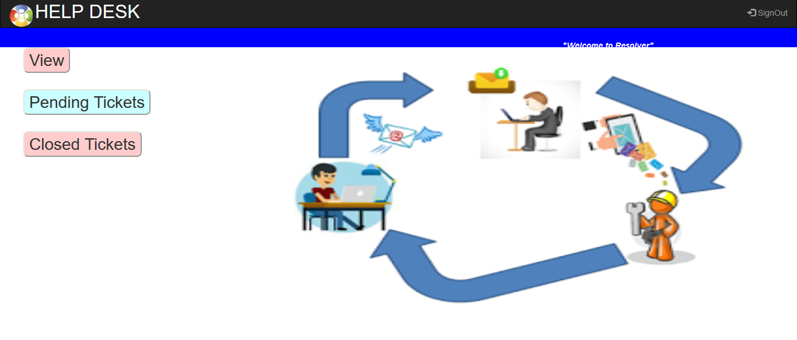

**Resolver can view his new tasks**

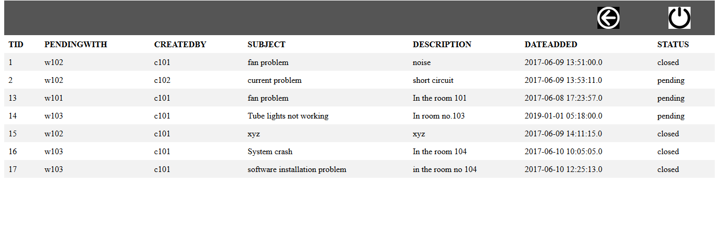

**Whenever the resolver completes the task, he can close the ticket**

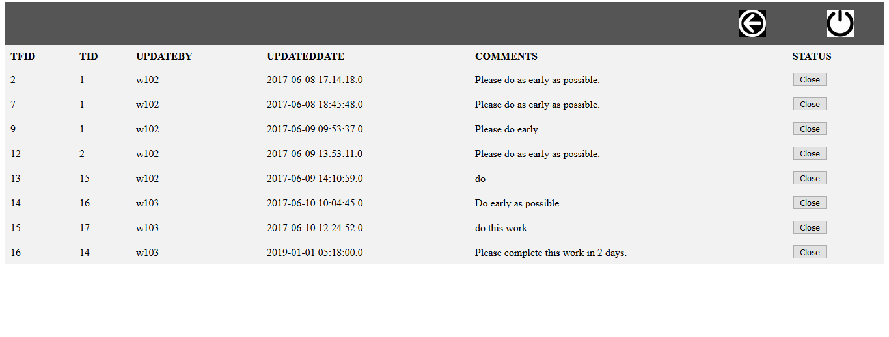

**He view all the tasks solved by him**

