## PONDICHERRY UNIVERSITY

#### (A CENTRAL UNIVERSITY)



**SCHOOL OF ENGINEERING AND TECHNOLOGY DEPARTMENT OF COMPUTER SCIENCE**

**M.SC.COMPUTER SCIENCE**

## PONDICHERRY UNIVERSITY

NAME : PRATHIBA P REGISTER NO : 23370084 SEMESTER : 3ndSEMESTER

SUBJECT : ISM(IT Asset management assignment)

|  |  |
| --- | --- |
| **S.no** | **Asset** |
| **1** | PERSONALCOMPUTER |
| **2** | PATCHCABLE |
| **3** | PROJECTOR |
| **4** | SMART BOARD |
| **5** | BIOMATRIC SCANNER |
| **6** | UPS |
| **7** | CISCOWIRELESSACCESSPOINT |
| **8** | HDMICABLE |
| **9** | PRINTER(CANON) |
| **10** | CCTV |

**PERSONAL COMPUTER (SYSTEM NO.49)**

## ABOUT:

A personal computer, often referred to as a PC, is a computer designed for individual use. It is typically used for tasks such as word processing, internet browsing, email, multimedia playback, and gaming. Personal computers are intended to be operated directly by an end user, rather than by a computer expert or technician. Unlike large, costly minicomputers and mainframes, time-sharing by many people at the same time is not used with personal computers.

## Tech Specs:

**Processor**

12th Gen Intel® Core™ i3-1215U (10 MB cache, 6 cores, 8 threads, up to 4.4 GHz Turbo)

**Operating System**

Windows 11 Home Single Language, English

**Video Card**

Intel® UHD Graphics

**Display**

15.6", Non-Touch, FHD 1920x1080, 120Hz, WVA, Anti-Glare, 250 nit, Narrow Border, LED-Backlit

**Memory**

8 GB: 1 x 8 GB, DDR4, 2666 MT/s

**Storage**

512GB M.2 PCIe NVMe Solid State Drive

**Color**

Carbon Black

**Microsoft Office**

Microsoft Office Home and Student 2021

**Security Software**

McAfee Live Safe 5-device 1-year

**Support Services**

1Y Basic Onsite Service after remote diagnosis with Hardware-Only Support

**Accidental Damage Protection**

NONE

##### Network information:

**Ethernet Adapter Ethernet 1**

* Description: Real tekPCI e GBE Family Controller
* Physical Address (MAC):C4-65-16-21-C1-CA
* IPv4 Address:10.10.32.37(Preferred)
* Subnet Mask:255.255.254.0
* Default Gateway :10.10.31.8
* DNS Servers :8.8.8.8, 10.14.139.5

##### Ethernet Adapter Ethernet 2 (Virtual Box Host-Only)

* Description: Virtual Box Host-Only Ethernet Adapter
* Physical Address (MAC):A4-00-27-00-08-09
* IPv4 Address:192.168.63.1(Preferred)
* Subnet Mask:255.255.255.0

##### Wireless LAN Adapter Wi-Fi

* Description: RealtekRTL8821CE802.11acPCIeAdapter
* Physical Address(MAC)**:A4-FC-77-24-61-E7
* Media State: Disconnected

|  |  |
| --- | --- |
| **RISK**   * **Data Loss**: Accidental deletion, hardware failure, or software corruption can lead to the loss of critical lab data. * **Cyber security Threats**: PCs are vulnerable to malware, ransom ware, and unauthorized access, potentially compromising sensitive data. * **Physical Damage**: Equipment can be damaged due to mishandling, spills, or power surges, affecting functionality | **VULNERABILITIES**   * Weak password sand lack of multi- factor authentication * Out dated operating system sand software * Unlatched security vulnerabilities * Lack of firewall and antivirus protection * Inadequate network security (e.g., open or unsecured Wi-Fi) * Physical access vulnerabilities (e.g., unlocked workstations) |
| **MITIGATION**   * **Cyber security**: Mitigating risks associated with personal computers (PCs) in terms of malware, data breaches, or security vulnerabilities. * **Environmental Science**: Mitigation strategies related to the environmental impact of personal computers and technology. * **Finance or Economics**: Mitigating financial risks associated with personal computing, like data loss or unauthorized access to financial information. | **ASSET MANAGEMENT POLICY**   * **PC Inventory Management**: All personal computers (PCs) must be registered in an asset inventory, including details like serial numbers, owners, and locations. Regular audits should be conducted to keep this information current. * **Security Measures**: PCs must have up-to-date antivirus software, enabled firewalls, and security patches applied promptly. Access should be secured with strong passwords and multi-factor authentication. |

## REFERNCE:

NISTSP800-53-Security and Privacy Controls for Information Systems and Organizations

# PATCH CABLE

## ABOUT:

A patch cable, patch cord or patch lead is an electrical or fiber-optic cable used to connect ("patch in") one electronic or optical device to another for signal routing. Devices of different types (e.g., a switch connected to a computer, or a switch to a router) are connected with patch cords.

## Features:

* CAT6A foil-screened twisted pair (FTP, aka F/UTP) shielded patch cable
* 650 MHz high-bandwidth design supports 10GBASE-T at 100 meters (330 feet)
* Flexible 26 AWG stranded FTP wire
* Molded PVC jacket with low-profile snagless boot for added durability
* Future-proof and reverse compatible with CAT6/CAT5e
* Fully certified to 10GBASE-T TIA/EIA-562-B.2-10 specifications
* True shielded CAT6A rated RJ45 connectors with gold plated contacts
* ISO/IEC compliance reduces near end cross talk (NEXT) by 3 dB (50%)
* Integrated x-type pair separator further reduces interference from cross-talk
* 100% foil shield coverage for excellent alien cross talk (ANEXT) rejection
* 28% smaller diameter than unshielded (UTP) CAT6A cables

|  |  |
| --- | --- |
| **RISK**   * **Connection Failure**: Patch cables are susceptible to wear and tear, which can lead to connection issues and disrupt network communication. * **Data Interception**: Unsecured or damaged cables may allow unauthorized access to transmitted data. * **Physical Damage**: Patch cables can be damaged by foot traffic, spills,ormisplacement,impacting functionality. | **VULNERABILITIES**   * **Cable Wear**: Constant plugging and unplugging, or improper handling, can cause cable degradation. * **Unsecured Connections**: Patch cables not properly secured can result in network disruptions. * **Environmental Exposure**: Exposure to extreme temperatures, moisture, or chemicals can deteriorate the cable’s integrity. |
| **MITIGATION**   * **Regular Inspection**: Periodically inspect patch cables for any signs of wear or damage and replace them if needed. * **Proper Cable Management**: Implement cable management practices to prevent tangling and damage. * **Environmental Protection**: Use cable covers or conduits to shield cables from environmental hazards and reduce physical wear | **ASSETMANAGEMENT POLICY**   * **Inventory Management**: Label each patch cable and record it in aninventorywithinformationlike type, length, location, and purchase date. * **Maintenance Schedule**: Include patch cables in regular audits and maintenance schedules to ensure they are functional and properly connected. * **Security Measures**: Ensure all cables are securely connected to prevent accidental disconnections and unauthorized access to the network. |

#### REFERNCE:

* ISO55001:2014,
* ISO/IEC 27001:2013
* ISO55001:2014,

## PROJECTOR

#### ABOUT:

A projector or image projector is an optical device that projects an image (or moving images) onto a surface, commonly a projection screen. Most projectors create an image by shining a light through a small transparent lens, but some newer types of projectors can project the image directly, by using lasers. A virtual retinal display, or retinal projector, is a projector that projects an image directly on the retina instead of using an external projection screen.

#### SPECIFICATION:

|  |  |
| --- | --- |
| **Type of display** | Poly-silicon TFT active matrix |
| **Resolution** | **Bright Link 480i**: 1024 × 768 pixels (XGA)  **Bright Link 475Wi/485Wi**: 1280 × 800 pixels (WXGA) |
| **Lens** | F= 1.80  Focal length: 3.71 mm |
| **Color reproduction** | Full color, 16.77 million colors |
| **Brightness** | **BrightLink 475Wi**:  Normal Power Consumption mode:  White light output 2600 lumens (ISO 21118 standard)  Color light output 2600 lumens  ECO Power Consumption mode:  White light output 1800 lumens (ISO 21118 standard) |
|  | **Bright Link 480i**:  Normal Power Consumption mode:  White light output 3000 lumens (ISO 21118 standard)  Color light output 3000 lumens  ECO Power Consumption mode:  White light output 1800 lumens (ISO 21118 standard) |
|  | **Bright Link 485Wi**:  Normal Power Consumption mode:  White light output 3100 lumens (ISO 21118 standard)  Color light output 3100 lumens  ECO Power Consumption mode:  White light output 1800 lumens (ISO 21118 standard) |
| **Contrast ratio** | 3000 to 1 with Auto Iris on and Normal Power Consumption mode |

**warranty:**

Out of warranty.

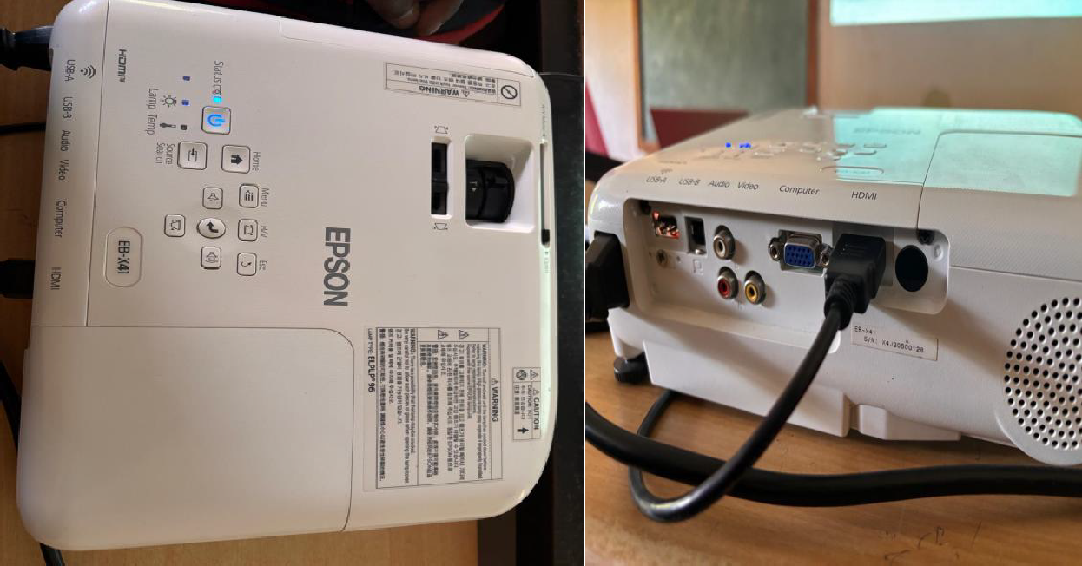

|  |  |
| --- | --- |
| **RISK**   * **Image Quality Degradation**: Dust accumulation on the lens or internal components may reduce image clarity. * **Overheating**: Extended use without proper ventilation canlead to overheating, potentially damaging internal parts. * **Electrical Surge**: Power surges may damage the projector’s circuits, affecting functionality | **VULNERABILITIES**   * **Physical Damage**: The projector lens or housing may get damaged due to falls, knocks, or mishandling. * **Unsecured Access**: Projectors with unsecured network connections are vulnerable to unauthorized access or tampering. * **Firmware Vulnerabilities**: Outdatedfirmware canexposethe projector to security vulnerabilities, especially if connected to a network. |
| **MITIGATION**   * **Regular Cleaning**:Cleanthe lens and air filters periodically to maintain image quality and airflow. * **Ventilation Check**: Ensure the projector is placed in a well- ventilated area to prevent overheating. | **ASSETMANAGEMENT**   * **Inventory Management**: Register the projector in the asset inventory,notingthemodel, serial number, location, and purchase date. * **Maintenance Schedule**: Include the projector in routine maintenance schedules to check for dust buildup, firmware updates, and functionality. * **Reference**:ANSI/TIA-568-C.2 |

# New lines mart Board

## ABOUT:

A Smart Board is an interactive whiteboard. It lets you control a computer using touch, a stylus, or gestures. Unlike traditional whiteboards, Smart Boards allow you to interact with digital content in real-time. You can write, draw, click, drag, and drop items just like you would on a tablet or smartphone.

#### SPECIFICATION:

##### HardwareSpecifications:

* **Device**: New line Smart Board
* **Display Resolution**: Likely 4K UltraHD (common for New line models)
* **Operating System Compatibility** : Supports both Android and Windows
* **Touch Technology**: Multi-touch ,enabling multiple users to interact simultaneously

##### SoftwareSpecifications:

* **AndroidOS** :Built-in, allowing access to core features and applications without external devices.
* · **Windows OS**: Available when connected to an OPS (Open Pluggable Specification) computer or external device, offering a full Windows experience.

##### Network Information:

###### DNS Servers:

* + Primary:8.8.8.8(Google Public DNS)
  + Secondary:14.139.5.5(local or custom DNS)
  + Tertiary:4.2.2.2(Level3 DNS)
* **Wi-Fi Adapter** :Intel(R)Wi-Fi6AX201160MHz
  + **Status**: Disconnected
  + **Physical Address (MAC)**:5C-E4-2A-F7-BE-A8
  + **DHCP**: Enabled
  + **Auto-configuration**: Enabled
* **Additional Network Adapters**: Microsoft Wi-Fi Direct Virtual Adapter and Wi-

Fi Direct Virtual Adapter#2

* + **Status**: Disconnected

###### Physical Addresses (MAC):

* + - Adapter1:5C-E4-2A-F7-BE-A9
    - Adapter2:5E-E4-2A-F7-BE-A8
  + **DHCP**: Enabled
  + **Auto-configuration**: Enabled

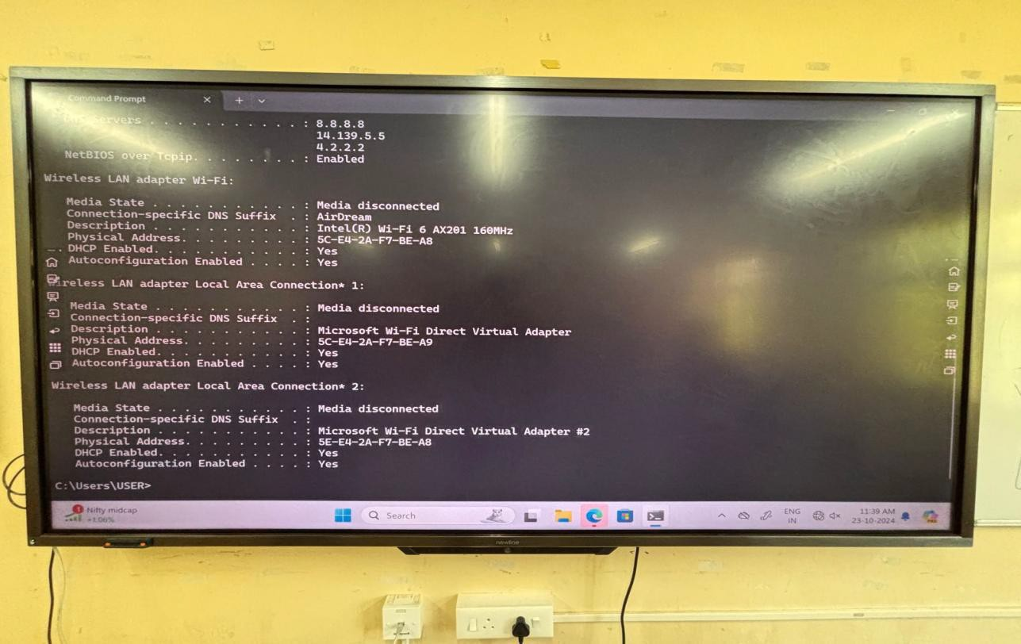

|  |  |
| --- | --- |
| **Mitigation**   * **Access Control**: Implement passwordprotectionanduser roles to restrict access. * **Network Security**: Use WPA3 encryption and VPNs for secure connections. * **Regular Updates**: Enable automatic updates for OS and apps. * **Endpoint Protection**: Install antivirus and firewall on Windows OS. * **Data Encryption**: Encrypt stored files and use secure cloud storage | **Vulnerabilities**   * **Unauthorized Access**: Risk of unauthorized users accessing settings or data. * **Malware Attacks**: Vulnerable to malware in Windows OS environment. * **Network Breaches**: Potential access by unauthorized devices. * **Data Leakage**: Risk of accidental exposure via unsecured cloudstorage. * **OutdatedSoftware**:Riskofexploits due to unpatched vulnerabilities. |
| **Risk**   * **Unauthorized Access**:   ·Risk of unauthorized users accessing sensitive settings, files, or networked resources on the smart board, leading to data breaches or misuse.   * **Malware Infection**:   ·The smart board, particularly with Windows-based OPS (Open Plug gable Specification) modules ,may be susceptible to malware or viruses if not properly secured, potentially compromising network security. | **Policies**   * **User Authentication Policy**: Require unique logins and enable two-factor authentication. * **Data Privacy Policy**: Limit access to sensitive data and enforce encryption. * **Acceptable Use Policy**: Define acceptable use and restrict unapproved app downloads. * **Incident Response Policy**: Set protocols for identifying and responding to security incidents. * **Device Management Policy**: Regularly update software and conduct system audits |

#### REFERNCE:

* **ISO55000**:This standard provides an overview of asset management and outlines the principles and terminology.
* **ISO 55001**: This specifies requirements for an asset management system, helping organizations effectively manage their assets throughout their lifecycle.

# BIO MATRIC SCANNER

## ABOUT:

Biometric scanners in laboratories are advanced devices that identify individualsthroughuniquebiologicaltraits, suchasfingerprints,facialfeatures,oriris patterns. Theyenhance securitybyensuring that onlyauthorized personnelcanaccess sensitive areas and equipment, reducing the risk of data breaches. Additionally, biometric systems improve operational efficiency by streamlining authentication processes, allowing quick access without the need for passwords or ID cards.

#### SPECIFICATION:

##### Hardware:

* ·**Model**:XYZ-500
* ·**Processor**:Dual-CoreARMCortex A7
* ·**Memory**: 512MBRAM,4GBFlashMemory
* ·**Display**:3.5-inchTFTLCD,320x240 pixels
* ·**BiometricSensor**:Opticalfingerprint sensor, 500DPI,storesupto10,000 templates
* ·**CardReader**:RFID/MIFARE/EM, upto10,000cardtemplates
* ·**Network**:Ethernet(10/100Mbps),optionalWi-Fi(2.4 GHz)
* ·**Interfaces**:USB2.0,RS232/RS485
* ·**Power**:DC12V/1.5A,2000mAhbatterybackup

##### Software :

* ·**Software**:Linux-basedOS,customattendancesoftware,HR/payroll integration support
* ·**AttendanceModes**:Fingerprint,Card,Password, Face(optional)
* ·**CommunicationProtocols**:TCP/IP, USB-host,RS232/RS485
* ·**OperatingEnvironment**:-10°Cto50°C,20%-80% humidity
* ·**Certifications**:CE,FCC,RoHS

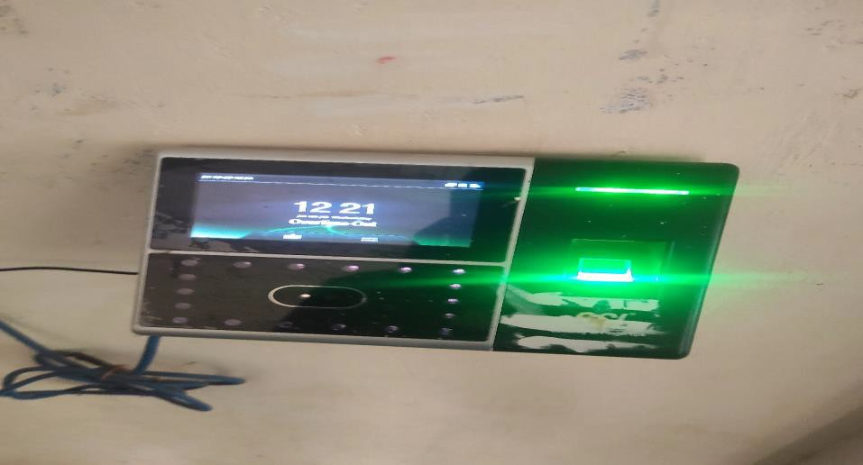

|  |  |
| --- | --- |
| **Risks**   * **DataBreaches**:Unauthorizedaccess to biometric data can lead to identity theft. * **Spoofing Attacks**: Biometricsystems can be tricked by fake fingerprints, facial recognitionmasks, or voice recordings. * **Privacy Concerns**: The collection and storage of biometric data raise significant privacy issues. * **System Failure**: Biometric systems may fail to recognize legitimateusers, leading to denial of access | **Vulnerabilities**   * **Insecure Storage**: Biometric data that is not securely encrypted can be exposed. * **Limited Authentication**: Some biometric systems may only use a single factor (e.g., fingerprints), making them less secure. * **User Behavior**: Users may share or expose their biometric traits, intentionally or unintentionally. |
| **MitigationStrategies**   * **Encryption**: Ensure all biometric data is encrypted both at rest and in transit. * **Multi-Factor Authentication**: Combine biometrics with other authentication methods (e.g., passwords, tokens). * **Regular Audits**: Conductperiodic security audits and vulnerability assessments on biometric systems. | **Policies**   * **Data Protection Policy**: Establish clear guidelines on the collection, storage, and sharing of biometric data. * **Access Control Policy**: Define who has access to biometric systems and data, ensuring access is limited to authorized personnel. * **Incident Response Policy**: Create a protocol for responding to security breachesorincidentsinvolvingbiometric data. |

**REFERNCE:** ISO/IEC19795-1:2006,ISO/IEC29100:2011

UPS(NumericDigital1000Plus-V)

### About:

This is a Numeric Digital 1000 Plus-V uninterruptible power supply (UPS) designed to provide backup power and protect electronic devices from power fluctuations. It is rated for 1000 VA, suitable for supporting computers, networking devices, and other sensitive equipment. The UPS includes an automatic voltage regulator (AVR) to stabilize the output power during low or highvoltage conditions. The LED indicatorsonthe front panelshow the operationalstatus and batterycharge level.Hardwarefeaturestypicallyincludeasealedlead-acidbattery, input andoutput ports, and cooling vents

#### SPECIFICATION:

##### HardwareSpecifications

1. **PowerCapacity**:1000VA/600W,suitableforsupportingmultipledeviceslike computers, routers, and small servers.
2. **BatteryType**:Sealedlead-acidbattery,designedforlonglifeandhighreliability, with typically a 5–10 minute backup duration for moderate loads.
3. **AutomaticVoltageRegulation(AVR)**:Stabilizesincomingpower,protecting against surges, sags, and brownouts without depleting the battery.
4. **LEDIndicator**:LEDlightsforindicatingpowerstatus,batterymode,andfaults, providing at-a-glance operational insights.
5. **CoolingSystem**:Ventilationslotstopreventoverheating,ensuringconsistent performance and prolonged device life.
6. **Input/OutputPorts**:Includespowerinput andmultipleoutputsocketsfor connected devices, possibly with overload protection.

##### SoftwareSpecifications

1. **PowerManagementSoftware:** Compatiblesoftware(ifprovidedorcompatible with third-party UPS monitoring software) enables real-time monitoring and management.
2. **CommunicationInterface:** USBorserialconnectivityforconnectingtheUPStoa computer, allowing automated actions like safe shutdown during extended outages.
3. **EventLogging:**Softwaremayincludeoptionsforloggingeventssuchaspower outages, battery status, and system faults for easy troubleshooting.
4. **BatteryHealthMonitoring:**Real-timebatteryhealthandchargelevelmonitoring to alert users of any issues

Self-Test Functionality:Softwareoronboardcontrolsmayenableperiodicself-tests to ensure battery health and overall UPS functionality.

.

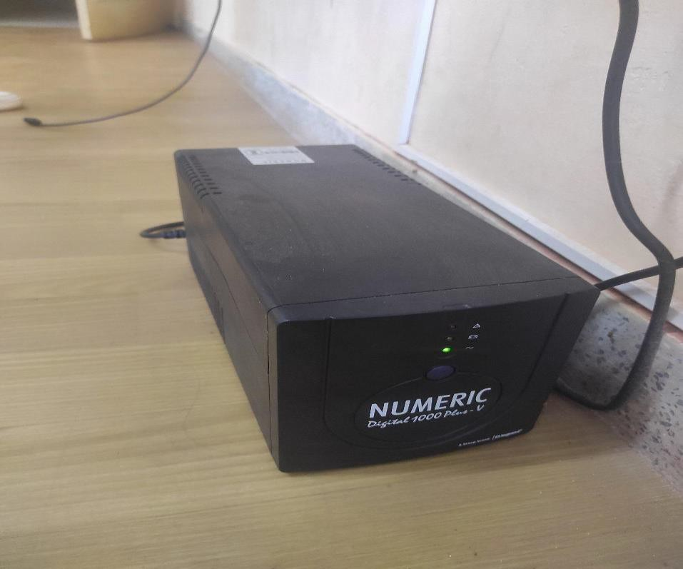

|  |  |
| --- | --- |
| **Risks**   * **Power Outages:** Sudden loss of power can lead to equipmentfailure and data loss. * **Battery Failure:** Batteries may degrade over time, resulting in reduced runtime and reliability. * **Overloading:** Connecting more devices than the UPS can handle can lead to overheating and potential failure. * **Environmental Factors:** High temperatures,humidity,ordustcan affect UPS performance. | **Vulnerabilities**   * **Aging Equipment:** Older UPS systems may be more prone to failures. * **Inadequate Capacity Planning:** Failure to assess future power needs can result in insufficientUPS capacity. * **Physical Access:** Unauthorized physical access to the UPS canlead to tampering or sabotage. * **Firmware Issues:** Outdated firmware can expose the system to security vulnerabilities |
| **MitigationStrategies**   * **Regular Testing and Maintenance:** Schedule routine inspections and testing of the UPS and its batteries to ensure proper operation. * **Load Management:**Calculateand monitor the total load connected to the UPS, ensuring it does not exceed its capacity. * **Environmental Controls:** Install the UPS in a controlled environment withadequatecooling and dust filtration. * **Battery Replacement:** Establish a schedule for replacing batteries based on manufacturer recommendations or performance monitoring. | **Policies**   * **UPS Usage Policy:** Define guidelines for the appropriate use of UPS systems, including acceptable load limits and device connections. * **Maintenance Policy:** Establish a maintenanceschedulethat includes regular inspections, testing, and battery replacement. * **IncidentResponsePolicy:**Outline procedures for responding to UPS failures or power outages,including communication plansand escalation procedures. * **AccessControlPolicy:**Implement restrictions on physical access to UPS systems to prevent unauthorized tampering. |

#### REFERNCE:

* + ·ISO/IEC19795-1:2006,focusingonstandardizedperformancetestingand operation.
  + ISO/IEC29100:2011,addressingaspectsofprivacyandsecuritymanagement relevant to network-connected UPS systems

# CISCOWIRELESSACCESSPOINT

#### ABOUT:

Cisco wireless access point installed alongside a lighting fixture, likely providingnetworkcoveragewithinanindoorenvironment.Suchconfigurationsare essential for ensuring comprehensive wireless network connectivity in spaces like offices, schools, or other facilities. The integration of wired and wireless infrastructure withina shared physicalspace reflectsthe effort to maintain network accessibility and support a variety of internet-enabled devices.

#### SPECIFICATION:

##### Hardware

* + **CiscoAccessPoint(AP)**:Provides Wi-Ficoverage, poweredviaEthernet(PoE).
  + **Cabling:** Ethernet cables supply data and power,minimizing clutter. LightingFixtureFluorescenttubenearby;might cause minorinterference.

##### Software

* + **CiscoOS**: PowerstheAP withfeatureslikeuser authenticationandsecureaccess.
  + **ManagementTools:**ManagedviaCiscoDNACenterformonitoring, configuration, and security.
  + **SecurityFeatures**:SupportsWPA3,userauthentication,andnetwork segmentation for protection.

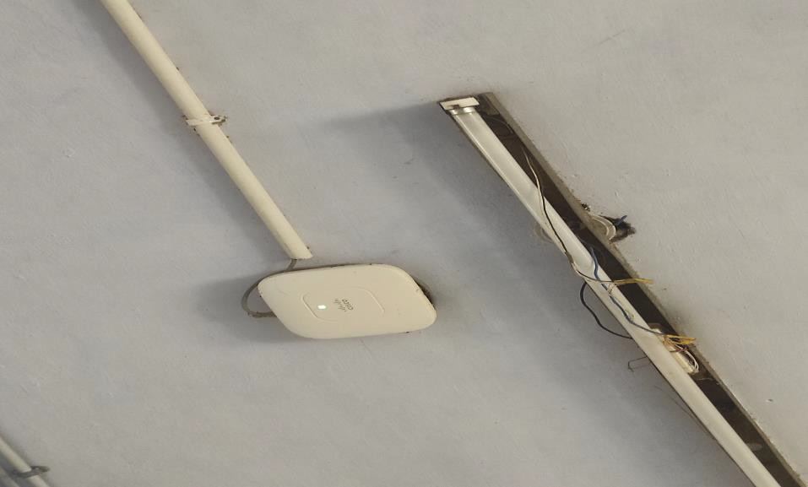

|  |  |
| --- | --- |
| **Risks**   * **Unauthorized Access**: Intruders may gain access to the network through unsecured or poorly configured WAPs. * **Data Interception**: Sensitive data maybeinterceptedwithout proper encryption. * **Firmware Vulnerabilities**: Outdated firmware increases the risk of exploitation. * **Network Overload**: Excessive connections can lead to performance degradation or outages. * **Physical Tampering**: Unauthorized physical access can lead to malicious reconfiguration or downtime. | **Mitigations**   * **Strong Authentication**: Implement WPA3 and restrict access using MAC filtering or enterprise authentication. * **Encryption**: Enforce WPA3 or stronger encryption standards to protect data. * **Firmware Updates**: Regularly updatefirmwareto protect against vulnerabilities. * **Load Management**: Monitor network traffic and apply load- balancing to handle peak usage. * **Physical Security**: Place WAPsin secure, limited-access areas to prevent tampering |
| **Vulnerabilities**   * **Outdated Firmware**: Increases susceptibility to known security exploits. * **Weak or No Encryption**: Inadequate encryption opens the network to data interception. * **Default Configurations**: Using default settings (e.g., SSID, passwords) creates potential security gaps. | **Policies**   * **Access Control Policy**: Require WPA3 or enterprise authentication for all connections; disable unsecured access. * **Firmware Management Policy**: Maintain an update schedule in alignment with Cisco’s latest security patches. * **Encryption Policy**: Enforce WPA3 encryption; prohibit deprecated protocols (e.g., WEP). * **Network Segmentation Policy**: Segment guest and internal networks; disable SSID broadcasting on sensitive networks. |

#### REFERNCE:

* + **ISO/IEC19795-1:2006**:Aligningwithstandardizedperformancetestingandsecurity validation.

# HDMICABLE

## ABOUT:

HDMI, or High-Definition Multimedia Interface, is a widelyused technology for transmitting high-quality video and audio between devices. HDMI cables enable seamlessconnectionsbetweensourcedevices(like gamingconsoles, Blu-rayplayers, or computers) and display units (like TVs, monitors, or projectors), delivering both audio and video signals over a single cable. The HDMI standard was first introduced in2002 and has since evolved withvarious versions that offer increasinglyadvanced features.

#### SPECIFICATION:

* + **Resolution**:Upto10K@120Hz(HDMI2.1).
  + ·**Bandwidth**:48Gbpsmax(HDMI2.1).
  + **Audio**:SupportsDolbyTrueHD,DTS-HD,andupto32audio channels (eARC for higher fidelity).
  + ·**HDRSupport**:HDR10,DolbyVision,HDR10+.
  + ·**VRR(VariableRefreshRate)**:Reducesscreentearing, idealfor gaming.
  + ·**CableTypes**:
    - *Standard*:Upto 1080p.
    - *High-Speed*:Upto4K@30Hz.
    - *PremiumHigh-Speed*:4K@60Hzwith HDR.
    - *UltraHigh-Speed*:4K@120Hz,8K@60Hz,required forHDMI 2.1.
  + **Compatibility**:BackwardcompatiblewitholderHDMIversions.

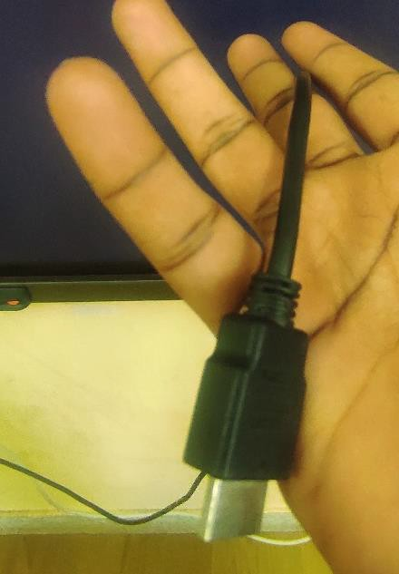

|  |  |
| --- | --- |
| **Risk**   1. **Data Breaches**: Unauthorized access leading to loss or theft of sensitive information. 2. **System Failures**: Hardware or software malfunctions causing operational downtime. 3. **Phishing Attacks:** Attempts to deceive employees into revealing confidential information | **Mitigation**   1. **Encryption:** Protects data by converting it into a secure format, accessible only by authorized users. 2. **Access Control**: Limits user access based on roles to minimize exposure to sensitive information. 3. **Regular Security Audits**: Periodic assessments to identify and address vulnerabilities. |
| **Vulnerability**   1. **Outdated Software**: Lacks the latest security patches, making it prone to exploitation. 2. **Weak Passwords:** Increases the risk of unauthorized access to systems and accounts. 3. **Unsecured Networks:** Allows hackers to intercept data on unprotected connections. | **Policy**   1. **Access Control Policy**: Defines who has access to specificsystems and data. 2. **Incident Response Plan**:Outlines steps for handling and reporting security incidents. 3. **Data Protection Policy:** Ensures data confidentiality, integrity, and compliance with regulations |

# PRINTER (CANON)

## ABOUT:

The Canon imageRUNNER series is designed for reliable, high-volume document handling, supporting functions such as copying, scanning, and printing. Known for their durability, these copiers are often found in office settings where consistent, efficient performance is needed. This specific model combines straightforwardcontrolwithCanon'squalityimagingtechnology,allowingusersto handle typical document workflows effectively

**Specifications:**

##### Functionality:

1. Copying:High-resolutiondocumentreproduction.
2. Printing:Supportformonochromeprinting.
3. ***Scanning*:**Basicscanfunctions forarchivingordigitaltransfer.

##### PaperHandling:

1. Supportsa varietyofpapersizesandtypes.
2. Hasanautomaticdocumentfeederforbulkcopying.
3. Multiplepapertraystohandlehigh-volumetasks.

##### User Interface:

1. BasicLCDdisplaywithphysicalbuttonsfor operation.
2. Optionsforadjustingprintandcopysettings.
3. Simplifiedcontrolpanel, suitablefornon-technical users.

#### FEATURES:

* + **Multi-Functionality**:Capableofcopying,printing,andbasicscanning, making it a versatile choice for everyday office tasks.
  + **User-FriendlyInterface**:SimplecontrolpanelwithanLCDscreenandphysical buttons, allowing easy access to core functions for users with minimal technical skills.

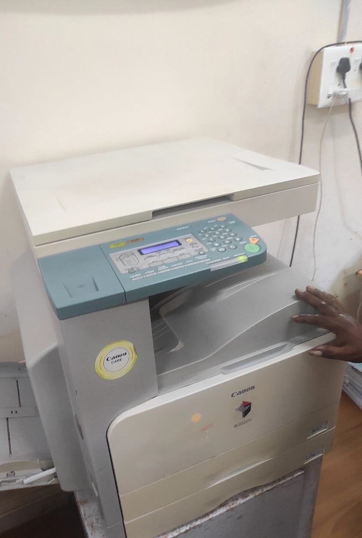

|  |  |
| --- | --- |
| **RISK**   * **SecurityRisks**:Theycanbehacked, leading to data breaches. * **CompatibilityIssues**:Theymaynot work well with all operating systems or software. * **HighSupplyCosts**:Inkandtoner can be expensive. | **Vulnerabilities**   * **Enhance Security**: Use strong passwords,keepfirmwareupdated,and configure security settings to prevent unauthorized access. * **Check Compatibility**: Before purchasing, verify that the printer is compatiblewithyouroperatingsystemand software. Regularly update drivers as needed. |

|  |  |
| --- | --- |
| **Mitigation**   * **EnhanceSecurity**:   + Use strong, unique passwords for network access.   + Regularly update the printer's firmwareto patch any security vulnerabilities.   + Configure network security settings,such as enabling firewalls and disabling unused services. * **CheckCompatibility**:   + Before purchasing a printer, verify compatibilitywith your operatingsystem and software applications.   + Regularlycheckfordriverupdatesonthe Canon website to ensure optimal performance | **Policy**   * **Security**:   + Usestrongpasswordsfor printers.   + Keepprinterfirmwareupdated.   + Set up firewalls and disable unnecessary features. * **Compatibility**:   + Check compatibility with systems before buying a printer.   + Updateprinterdriversregularly. * **SupplyManagement**:   + Usehigh-yieldinkortonercartridges.   + Getapprovalbeforeusingthird-party cartridges.   + Monitorprintingvolumetocontrolcosts |

#### REFERNCE:

* **ISO/IEC 27001:2013** - Information security management systems — Requirements. This standard provides a framework for establishing, implementing, maintaining,andcontinuallyimprovinginformationsecuritymanagementwithinthe organization.
* • **ISO 9001:2015** - Quality management systems — Requirements. This standardoutlinesthecriteriaforaqualitymanagementsystem, focusingonmeeting customer expectations and delivering customer satisfaction.

# CCTV(Closed-CircuitTelevision)

### About:

CCTV(Closed-Circuit Television) systemsplaya vitalrole inenhancingsecurityand monitoring within laboratory environments. These systems help ensure the safety of personnel, protect sensitive equipment, and secure valuable research data. By providing real-time surveillance and recording capabilities, laboratory CCTV can deter unauthorized access, monitor compliance with safety protocols, and support incident investigation. This document outlines the specifications and features of a typical laboratoryCCTV system, emphasizing its importance in maintaining a secure and efficient working environment.

### Specifications:

**Model**: CanonNetworkSecurityCamera(Model:VB-H43)

###### CameraType:

1. **Type**:IPCamera
2. **Resolution**: 1920x1080(FullHD)
3. **Lens**:3.5-8.5mmvarifocallens

###### VideoPerformance:

1. **FrameRate**:30fpsatfullresolution
2. **Compression**:H.264,H.265,andMJPEGformats
3. **NightVision**:InfraredLEDforlow-lightconditions

###### Connectivity:

1. **NetworkInterface**:Ethernet(RJ-45)
2. **WirelessCapability**:Optional(Wi-Fi)
3. **Protocols**:IPv4, IPv6, HTTP,HTTPS, RTSP,andONVIFcompatible

###### Storage:

1. **LocalStorage**: MicroSDcardslot(supportsupto128GB)
2. **RemoteStorage**:CompatiblewithNVR(NetworkVideoRecorder)

###### Features:

1. **MotionDetection**:Customizablesensitivityanddetectionareas
2. **Alerts**:Emailnotificationsandpushalertsforsuspiciousactivity
3. **UserAccessControl**: Multi-leveluserauthenticationfor secureaccess

###### PowerSupply:

1. **PowerSource**:PoE(PoweroverEthernet)orDCpower supply

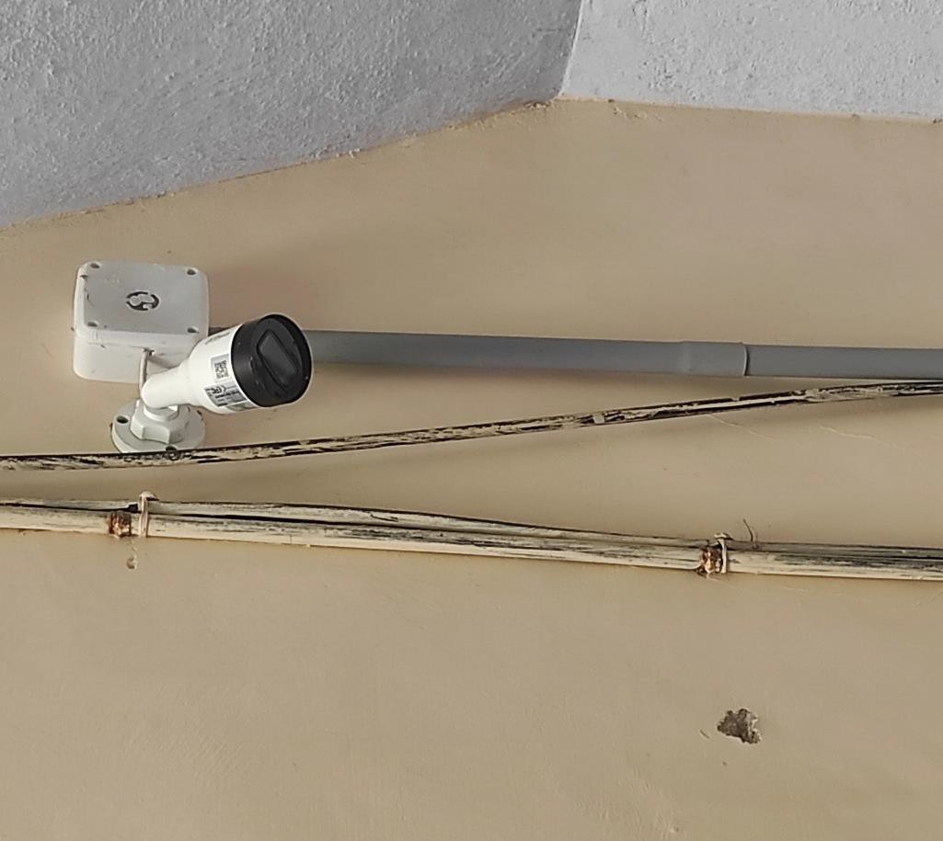

**Risk**

* **PrivacyConcerns**:CCTV mayinfringeontheprivacyofemployees, especiallyif cameras are placed in sensitive areas.
* **DataSecurityRisks**:Videofootagecanbevulnerableto hackingor unauthorized access, potentially exposing sensitive information.
* **SystemMalfunctions**:Camerascanfailduetotechnicalissues, leadingto gaps in surveillance and security.

|  |  |
| --- | --- |
| **Mitigation**  **PrivacyConcerns**:   * Clearly define areas where cameras willbe installed to avoid monitoring private spaces (e.g., restrooms, break rooms). * Inform employees about the presence of CCTV and the purpose of surveillance to foster transparency.   **DataSecurityRisks**:   * Implement strong passwords and encryption for accessing CCTV footage. * Regularly update software and firmware to protect against vulnerabilities.   **SystemMalfunctions**:   * Schedule regular maintenance and inspections to ensure all cameras and equipment are functioning correctly. * Install backup systems or redundant cameras to cover critical areas. | **Vulnerabilities**  **UnauthorizedAccess**:   * CCTV systems can be susceptible to unauthorized access if passwords are weak ornotregularlyupdated,allowingintruders to view live feeds or recorded footage.   **NetworkVulnerabilities**:   * If the CCTV system is connected to a network, it may be exposed to cyberthreats such as hacking, malware, ordenial-of-serviceattacks,compromisingthe entire system.   **InsufficientEncryption**:   * Lack of proper encryption for videofeeds and stored footage can make sensitive data susceptible to interception during transmission or unauthorizedaccess. |

**Policy:**

**AccessControl**:

* Accesstolivefeedsandrecordedfootagewillberestrictedtoauthorizedpersonnelonly.Strong passwords and multi-factor authentication will be implemented to protect access.

**DataProtection**:

* All video footagemust be stored securely,withencryption applied to bothin-transit andat-rest data, in compliance with **GDPR** (General Data Protection Regulation) and other relevant data protection laws.

**REFERNCE:** ISO/IEC19795-1:2006,ISO/IEC29100:2011