PRODUCT REQUIREMENTS DOCUMENT
Spotify Privacy & Consent Experience
Bringing consent and data-rights management in line with India's DPDP Act, 2023
Prepared for: Vedantu — PM Intern Hiring Assignment
Author: Prathiba P · Version 1.0 ·
Companion documents: Product Thinking Deck · Clickable Prototype

Executive Summary

Vision
A Spotify where giving up personal data feels like a choice, not a toll for entry — consent that's specific enough to trust and simple enough to actually use.

Mission
Bring Spotify India's consent and data-rights experience into alignment with the DPDP Act, 2023, without adding friction that costs the product the engagement it depends on.

Business Problem
Bundled, non-itemised consent and the absence of self-serve data rights create direct regulatory exposure under DPDP (penalties of up to ₹250 crore per instance) and an avoidable trust liability in a market where Spotify competes on user goodwill as much as catalogue.

User Problem
Users cannot see what's collected, cannot easily say no to parts of it, and cannot withdraw consent as easily as they gave it — and parents have no verified say in what's collected from their children.

Product Opportunity
A well-designed consent experience is a trust product, not just a compliance one: done right, it can reduce support burden, strengthen retention among privacy-conscious users, and position Spotify ahead of competitors still running bundled consent in India.

Expected Business Outcomes
- Reduced regulatory exposure and legal risk in the India market
- Lower privacy-related support ticket volume within two quarters of launch
- Neutral-to-positive impact on Premium conversion and retention (guardrails, not growth levers)

Success Definition
Success is a Consent Health Rate at or above 92%, sustained without regressing onboarding completion or Premium conversion, and zero regulatory incidents — detailed in Section 2 and the companion Product Thinking Deck.

Competitive Angle
Most competing services in India still rely on bundled, one-time consent. A granular, transparent, self-serve consent experience is a differentiator Spotify can point to directly — not just a defensive compliance move.

1. Document Overview

1.1 Purpose
This PRD defines the functional scope of the Spotify Privacy & Consent Experience: what each feature must do, for whom, and how success is measured. It is written from the product management vantage point — it specifies behavior and outcomes, and it explicitly flags where engineering, legal, and security ownership begins rather than presuming to author that work.

1.2 Audience
Design and engineering leads scoping this work; Legal/Privacy Counsel reviewing DPDP alignment; Analytics partners instrumenting success metrics; and reviewers of this case study.

1.3 Scope
In scope: the end-to-end consent and data-rights experience for Spotify India, covering onboarding, ongoing consent management, data access/deletion, and Spotify Kids parental verification.
Out of scope for this document: backend service architecture, database schema, API design, and security implementation. These require dedicated engineering ownership and are listed as open questions in Section 9, not authored here — a PRD should specify what the product needs to do, not how engineering builds it.
A note on scope: an earlier draft of this project was asked to include invented database schemas, microservice diagrams, and API specifications. Those are deliberately excluded here. Presenting fabricated engineering architecture as part of a product case study would misrepresent what a PM role owns, and it isn't something I'd be able to defend in a technical conversation — which defeats the purpose of a hiring exercise built to evaluate my own thinking.

2. Problem & Goals
Spotify's current India consent experience bundles all data collection behind a single sign-up checkbox, with personalisation on by default, no in-app record of what was agreed to, and no self-serve way to exercise data rights. India's DPDP Act, 2023 requires consent that is free, specific, informed, and itemised, alongside verifiable parental consent for minors and self-serve access, correction, and erasure rights. Full context, personas, and current-experience audit are covered in the companion Product Thinking Deck.

2.1 Goals
- Bring the consent and data-rights experience into alignment with DPDP, 2023
- Preserve onboarding completion and Premium conversion within existing tolerances
- Make consent genuinely legible — a user should be able to explain what they agreed to
- Reduce, not increase, privacy-related support burden over time

2.2 North Star Metric (recap)
Consent Health Rate — the percentage of active users with valid, current, purpose-specific consent on file. Target: ≥ 92%. Full metrics tree, guardrails, and success criteria are defined in the Product Thinking Deck, Section 05.

3. Users
Two primary personas anchor this PRD; full persona detail (goals, pain points, JTBD, trust expectations) lives in the Product Thinking Deck, Slide 3.
- Ananya, 24 — Free-tier daily listener. Wants control over personalisation without losing what makes recommendations good.
- Rahul, 41 — Parent of a 9-year-old on Spotify Kids. Wants to be verifiably asked before any child data is collected.

4. Functional Requirements
Thirteen features make up the experience, each specified below with priority, user story, acceptance criteria, edge cases, success metric, and dependencies. Priorities: P0 = required for launch; P1 = high-value, can follow within the first release cycle if needed.

FR-01 — Privacy Onboarding
A short, sequential first-run walkthrough (why we collect data → nutrition label → granular consent → summary) shown before any optional data collection begins.
Priority | P0 — Launch blocker
User Story | As a new user, I want to understand what Spotify collects and why before I agree to anything, so that my consent is actually informed.
Acceptance Criteria | - No optional permission is requested before the user completes or explicitly exits onboarding  - Flow is completable in under 60 seconds for a user who takes no action beyond tapping Continue  - Every screen states a clear purpose in plain language, no legal jargon  - Existing users are shown a one-time re-consent version of this flow, not silently migrated
Edge Cases | - User force-quits mid-flow — must resume at the same step next session, not restart  - User has no internet during onboarding — flow must degrade gracefully and retry
Success Metric | Onboarding completion rate ≥ 90%; median time-to-complete ≤ 45 seconds
Dependencies | FR-02, FR-03, FR-05

FR-02 — Privacy Nutrition Label
A scannable, per-data-type label (purpose, shared-with, retention, essential vs. optional) shown during onboarding and referenced from the Privacy Dashboard.
Priority | P0 — Launch blocker
User Story | As a user, I want a quick, standardized view of what each data type is used for, so I don't have to read a privacy policy to make a decision.
Acceptance Criteria | - Every data type collected by the product is represented — none omitted  - Essential vs. Optional is visually distinct and never mislabeled  - Retention period is stated as a concrete duration or explicit trigger, never "varies"  - Label content is reused verbatim on the Consent Summary and Dashboard for consistency
Edge Cases | - A data type's retention policy changes after launch — label must version and reflect the update  - A data type is essential for Premium but optional for Free — label must reflect plan-specific status
Success Metric | ≥ 80% of surveyed users can correctly state one data type's purpose after viewing (post-launch research)
Dependencies | None — foundational content for FR-01, FR-05, FR-06

FR-03 — Granular Consent Toggles
Individual, purpose-specific switches (personalisation, analytics, marketing, location, microphone, contacts, notifications), off by default, changeable at any time from onboarding or the Dashboard.
Priority | P0 — Launch blocker
User Story | As a user, I want to allow some data uses and not others, so my consent reflects what I'm actually comfortable with.
Acceptance Criteria | - All optional toggles default to OFF on first render, with no pre-checked state  - Toggling any permission fires FR-04 (Impact Preview) before the state is treated as final  - A change made on the Dashboard takes effect and is reflected app-wide within 5 seconds  - "Select all" exists as a convenience action but is never pre-selected or nudged as default
Edge Cases | - User rapidly toggles the same switch on/off — must debounce writes without dropping the final state  - Two devices change the same permission near-simultaneously — last-write-wins, both devices reconcile on next sync
Success Metric | Granular opt-in rate per permission tracked individually — no single toggle should be a reused proxy for "consent"
Dependencies | FR-04

FR-04 — Consent Impact Preview
A short, non-blocking sheet shown immediately after any toggle change, listing what's gained and what's lost in plain language.
Priority | P1 — High priority
User Story | As a user changing a permission, I want to see exactly what changes, so I can make an informed choice instead of guessing.
Acceptance Criteria | - Sheet appears within 300ms of the toggle change and never blocks the toggle from taking effect  - Copy is specific to the exact permission changed — never a generic "settings updated" message  - Sheet has exactly one action ("Continue") — it informs, it never re-prompts or asks the user to confirm again  - Dismissing the sheet in any way (tap outside, swipe down, Continue) keeps the toggle change intact
Edge Cases | - User changes a second permission while the first sheet is still open — queue, don't stack, sheets  - A permission has no user-facing feature tied to it yet — sheet must have a sensible fallback copy, not break
Success Metric | Sheet dismissal rate ≥ 98% within 3 seconds (i.e., it's read, not fought)
Dependencies | FR-03

FR-05 — DPDP Consent Summary
A single plain-language screen, shown at the end of onboarding, stating exactly what was agreed to across all permissions before the user can proceed.
Priority | P0 — Launch blocker
User Story | As a user, I want a final, honest recap of my choices before they're locked in, so I know exactly what I agreed to.
Acceptance Criteria | - Every permission's current state (allowed/off) is listed, sourced live from FR-03 state — never a static copy  - "Accept" records a timestamped consent version; "Customise" returns to FR-03 without discarding prior choices  - Expandable FAQ sections do not block or delay the primary Accept action  - This screen's exact copy is what gets stored as the legal record of consent — content changes require legal sign-off
Edge Cases | - User accepts, then immediately changes a toggle from the Dashboard — the two consent events must both be logged distinctly, not merged
Success Metric | 100% of accepted consents are retrievable with a timestamp and version number, no exceptions
Dependencies | FR-02, FR-03

FR-06 — Privacy Dashboard
A permanent, always-accessible hub showing current consent status, all permission toggles, and entry points to data rights and family controls.
Priority | P0 — Launch blocker
User Story | As a user, I want one place to see and change everything about my privacy, so I'm never more than two taps from control.
Acceptance Criteria | - Reachable from account settings within 2 taps from anywhere in the app  - Reflects the true current state of every permission — no caching stale values for more than 5 seconds  - Shows consent renewal date and current status clearly, without requiring the user to dig  - Every action taken here is functionally identical to the same action taken during onboarding
Edge Cases | - User has no permissions enabled at all — dashboard must still render meaningfully, not show an empty/broken state
Success Metric | ≥ 25% of users visit the Dashboard at least once within 90 days of launch (an engagement signal, not a target to inflate)
Dependencies | FR-03, FR-07, FR-08, FR-09

FR-07 — Consent Timeline
A searchable, filterable, chronological record of every consent-related action the user has taken.
Priority | P1 — High priority
User Story | As a user, I want to see the history of my privacy choices, so I can verify nothing changed without my knowledge.
Acceptance Criteria | - Every consent change, data request, and parental-consent event appears within 5 seconds of occurring  - Entries are grouped by day and filterable by category (consent, data rights, family, account)  - Search matches on entry label text, case-insensitive  - Timeline is exportable in a portable format on request
Edge Cases | - User has zero history (new account) — must show a clear empty state, not a blank screen  - An entry references a permission that no longer exists in the product — must still render historically, labeled as legacy
Success Metric | N/A (transparency feature — success is the absence of related support tickets, tracked under FR-06's guardrail)
Dependencies | FR-03, FR-08, FR-09, FR-11

FR-08 — Data Download (Access & Portability)
Self-serve request flow that packages the user's personal data (profile, listening history, playlists, consent log) into a downloadable export.
Priority | P0 — Launch blocker
User Story | As a user, I want to get a copy of my data without contacting support, so exercising my rights doesn't require friction.
Acceptance Criteria | - Request is initiated with a single confirmed action from the Dashboard  - User receives a status update (in-app and email) when the export is ready  - Export includes, at minimum, the categories listed on the Nutrition Label as "stored"  - Repeated requests are rate-limited to prevent abuse, with the limit clearly communicated
Edge Cases | - User deletes their account while an export is in progress — export should still complete and be deliverable, or the user should be told clearly why not
Success Metric | Export delivered within 48 hours for ≥ 95% of requests
Dependencies | FR-06, FR-02

FR-09 — Data Deletion (Erasure)
Self-serve flows for both partial deletion (listening history) and full account deletion, with clear, honest confirmation of consequences.
Priority | P0 — Launch blocker
User Story | As a user, I want to delete my data or account without needing to argue with support, so withdrawal is as easy as consent was to give.
Acceptance Criteria | - Confirmation copy states precisely what is and isn't deleted (e.g., billing records retained per legal obligation)  - Full account deletion completes within the DPDP-mandated window, targeted well inside the legal maximum  - User retains Premium access until the point of deletion — no early loss of paid benefit before confirming  - Deletion cannot be triggered by a single accidental tap — one explicit confirmation step, no more, no fewer
Edge Cases | - User has an active dispute or fraud investigation open — deletion should be flagged for legal review rather than silently blocked or silently allowed
Success Metric | Deletion turnaround ≤ 7 days for ≥ 95% of requests; zero cases exceeding the legal 30-day maximum
Dependencies | FR-06

FR-10 — Where Your Data Goes (Sharing Transparency)
A dedicated Dashboard page listing every third party that receives user data, its purpose, retention, and whether the user can revoke access.
Priority | P1 — High priority
User Story | As a user, I want to know who else sees my data, so "transparency" means something concrete, not just a policy statement.
Acceptance Criteria | - Every active data-sharing relationship is represented — none omitted for being "minor"  - Partners gated behind a specific consent (e.g., advertising behind Marketing) visibly show as locked when that consent is off  - Each partner entry states purpose, data shared, retention, and revocability in consistent structure  - Page content is kept in sync with actual vendor relationships — owned jointly by Privacy and Legal, not left to go stale
Edge Cases | - A vendor relationship ends — entry should be removed or archived, not silently left showing outdated info
Success Metric | Zero factual disputes/complaints about undisclosed sharing post-launch
Dependencies | FR-03, FR-06

FR-11 — Verifiable Parental Consent
OTP plus a lightweight ID check required before any Spotify Kids profile is created or linked to a parent account.
Priority | P0 — Launch blocker
User Story | As a parent, I want to prove I'm the adult authorizing this, so my child's account isn't created on a false declaration.
Acceptance Criteria | - A Kids profile cannot be created or activated without both steps completing successfully  - ID data is used only for age/identity verification and is not retained after the check completes  - Parent can revoke consent and unlink the child profile at any time from the Dashboard  - Failure of either verification step blocks profile creation with a clear, actionable error
Edge Cases | - OTP is sent to a number no longer in the parent's possession — must offer an alternative verification path, not a dead end  - The same adult tries to verify multiple child profiles — should be supported without re-verifying identity each time
Success Metric | 100% of active Kids profiles have a completed, logged verification event on file
Dependencies | FR-12

FR-12 — Spotify Kids Controls
Parent-facing controls for a linked child profile: content restriction level, daily time limit, and privacy settings that are locked off by default.
Priority | P0 — Launch blocker
User Story | As a parent, I want data collection and content exposure for my child capped by default, so I'm not relying on remembering to configure it myself.
Acceptance Criteria | - Personalisation and marketing data collection are locked off for Kids profiles and cannot be enabled by the child or via dark-pattern-style prompts  - Explicit content filtering cannot be disabled from the child profile under any setting  - Time limit and restriction level changes take effect on the child's next session at the latest  - Weekly summary email to the parent is opt-out, not opt-in, given the safety context
Edge Cases | - Child profile is used on a shared/parent device — restrictions must apply to the profile, not the device
Success Metric | Zero instances of a Kids profile with personalisation or marketing data collection enabled
Dependencies | FR-11

FR-13 — Consent Renewal
Periodic (proposed: annual) re-confirmation of consent, surfaced in-app ahead of expiry rather than silently lapsing.
Priority | P1 — High priority
User Story | As a user, I want to be asked again periodically rather than have an old, stale consent used indefinitely, so my consent stays current and meaningful.
Acceptance Criteria | - User is notified at least 14 days before their consent's renewal date  - Renewal can be completed in-app in under 30 seconds if no changes are desired  - Lapsed (unrenewed) consent defaults optional permissions to OFF, never to "keep previous state" silently  - Renewal date is visible on the Dashboard at all times, not just when it's approaching
Edge Cases | - User's app is uninstalled and reinstalled after their renewal date lapsed — must re-trigger onboarding-equivalent consent, not restore stale state
Success Metric | ≥ 85% of users complete renewal within the 14-day notice window, without lapsing to defaults
Dependencies | FR-03, FR-05

5. Non-Functional Requirements
These are product-level expectations engineering should design against — not a prescription for how to meet them.
- Performance: consent state changes must be reflected across client and Dashboard within 5 seconds of the change.
- Availability: core playback must never be blocked by consent-service availability — privacy features degrade gracefully, playback does not degrade at all.
- Accessibility: all consent and privacy screens meet WCAG 2.1 AA, including no reliance on color alone to indicate toggle state.
- Localization: available at launch in every language Spotify India currently supports — consent is not informed if it isn't understood.
- Data retention: retention windows are defined per data type (see Nutrition Label, FR-02) and enforced as a hard deletion job, not a manual process.
- Auditability: every consent change is timestamped and immutable once logged — history is append-only.

6. Ownership & Governance
Naming who owns what, and where product ownership ends, keeps this document honest about scope.
Area | Primary Owner | Key Partners
Onboarding and consent capture (FR-01 to FR-05) | Product Manager | Design, Privacy Counsel
Privacy Dashboard and data rights (FR-06 to FR-10) | Product Manager | Engineering, Privacy Counsel
Parental consent and Kids controls (FR-11, FR-12) | Product Manager | Trust and Safety, Security, Legal
Consent renewal (FR-13) | Product Manager | Engineering, Analytics
System design and data architecture | Engineering (Staff/Lead) | Product supplies requirements only
DPDP legal sign-off | Privacy Counsel | Product, Design

7. Conceptual System Overview
This section describes what needs to exist from a product-planning perspective, to align design, engineering, and legal on scope. It is not an engineering architecture -- actual service boundaries, data stores, and APIs should be designed and owned by engineering.

7.1 Capability Map
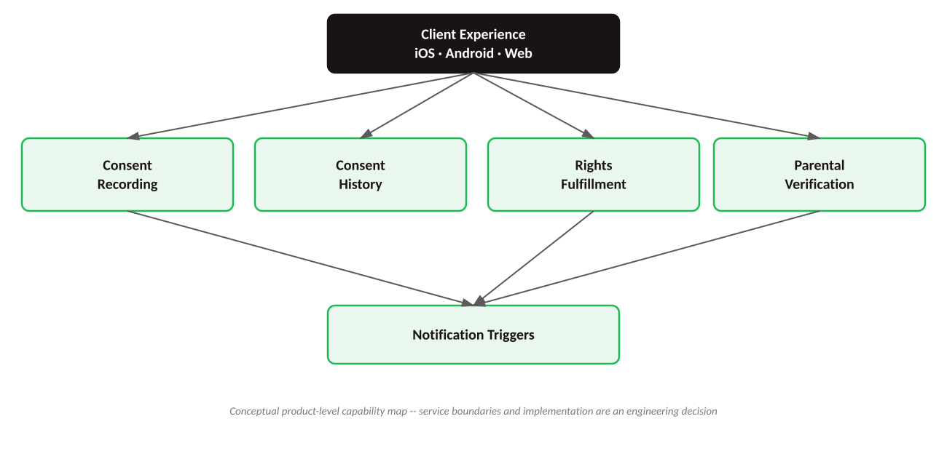
- Client experience -- the onboarding, Dashboard, and Kids-control surfaces on iOS, Android, and Web (FR-01 through FR-07, FR-12).
- Consent recording -- the system of record for what each user has currently agreed to, per purpose (supports FR-03, FR-05, FR-06).
- Consent history -- an append-only log of every change, independent of current state (supports FR-07).
- Rights fulfillment -- handling for download and deletion requests, including status tracking (supports FR-08, FR-09).
- Parental verification -- OTP and ID-check flow gating Kids profile creation (supports FR-11).
- Notification triggers -- renewal reminders, export-ready alerts, deletion confirmations (supports FR-08, FR-09, FR-13).

7.2 Illustrative Flow -- Consent Capture
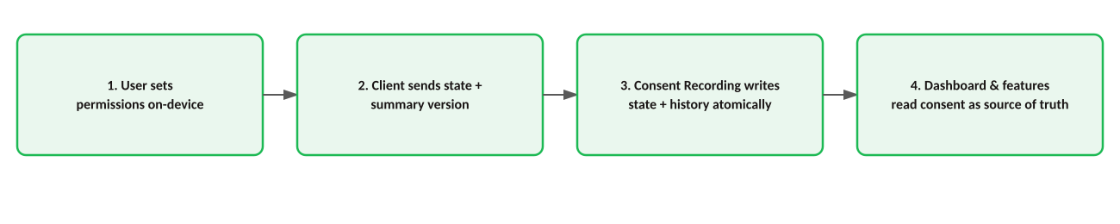
- 1. User completes onboarding and sets permission states on-device.
- 2. On Accept, the client sends the full permission set plus a summary-version identifier to consent recording.
- 3. Consent recording writes current state and appends a history entry in the same transaction, so the two can never disagree.
- 4. Dashboard and any feature checking permission state (e.g., recommendations) read from consent recording as the single source of truth.

7.3 Illustrative Flow -- Deletion Request
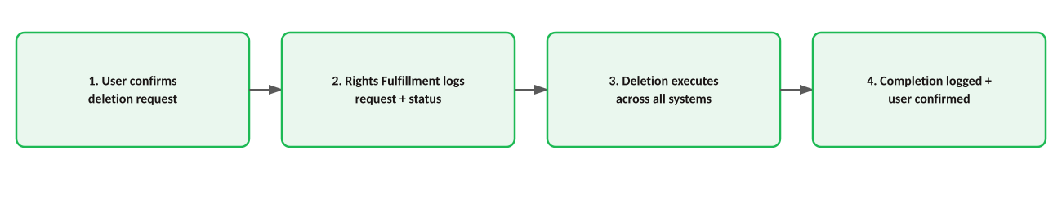
- 1. User confirms deletion from the Dashboard (FR-09).
- 2. Rights fulfillment records the request and its status, and notifies the user it's in progress.
- 3. Deletion executes against all systems holding the user's data, within the target turnaround window.
- 4. Completion is logged to consent history and confirmed to the user.

8. Conceptual Data Model (Product View)
Entities and attributes below describe what the product needs to track, for cross-team alignment -- not a database schema. Field types, keys, and storage design are an engineering decision.

8.1 Entity Relationships
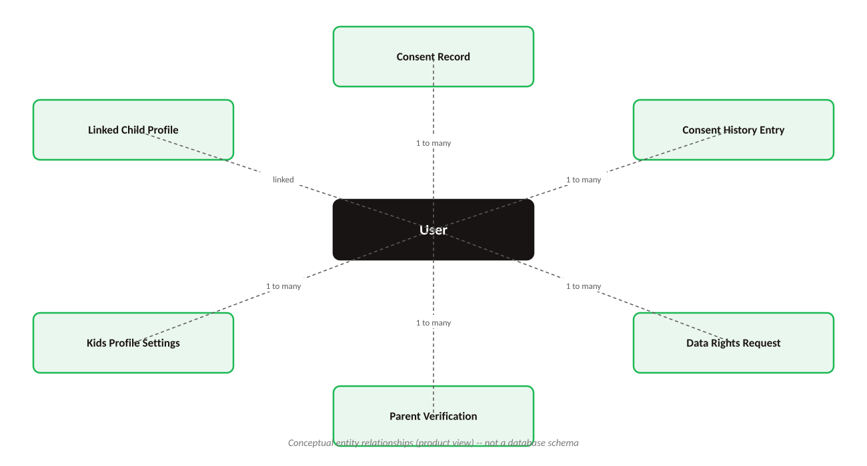

8.2 Entity Reference
Entity | Represents | Key Attributes (illustrative) | Used By
User | The Spotify account holder | User ID, account type, region, linked child profiles (if any) | Consent Service, Kids Service, Support
Consent Record | Current state of one purpose for one user | User ID, purpose, state (on/off), version, last-changed timestamp | Dashboard, Onboarding, Recommendation logic
Consent History Entry | Immutable log of a single consent change | User ID, purpose, prior state, new state, timestamp, source (onboarding/dashboard/renewal) | Consent Timeline, Legal/audit requests
Data Rights Request | A download or deletion request and its status | User ID, request type, status, requested-at, completed-at | Dashboard, Support, Legal
Parent Verification | Record of a completed parental consent check | Parent user ID, child profile ID, verification method, verified-at | Kids Service, Consent Timeline
Kids Profile Settings | Configuration for a linked child profile | Child profile ID, parent user ID, restriction level, time limit, locked flags | Kids Dashboard, Content delivery

9. Open Questions for Engineering, Legal & Security
A PRD's job includes surfacing what it doesn't know. These are flagged rather than guessed at:

9.1 For Engineering
- How should consent state synchronize across multiple logged-in devices in near-real-time?
- What's the right approach for consent state during logged-out or anonymous sessions, if those exist?
- Can rights fulfillment (download/delete) reuse existing account-deletion infrastructure, or does DPDP's turnaround requirement need a dedicated path?

9.2 For Legal & Privacy Counsel
- Is registering with a DPDP "Consent Manager" required at launch, or can it follow in a later phase?
- What is the legally defensible minimum retention window for billing and transaction data?
- What exact language must appear in the Consent Summary (FR-05) to constitute valid notice under DPDP?

9.3 For Security
- What existing vendor (if any) can be reused for the ID-verification step in parental consent (FR-11)?
- What's the retention and deletion policy for the ID image itself, given it must not be stored post-verification?

9.4 For Analytics
- Can Consent Health Rate be computed from current event instrumentation, or does it require new event definitions?
- What's the existing support-ticket taxonomy, and does it already tag "privacy" as a category for the guardrail metric?

10. Appendix A — DPDP Requirement Mapping
DPDP, 2023 Requirement (general) | Addressed By
Purpose limitation & itemised notice | FR-02 (Nutrition Label), FR-05 (Consent Summary)
Free, specific, informed consent | FR-01 (Onboarding), FR-03 (Granular Toggles)
Consent as easy to withdraw as to give | FR-06 (Privacy Dashboard)
Right to access & data portability | FR-08 (Data Download)
Right to correction & erasure | FR-09 (Data Deletion)
Verifiable parental consent for children's data | FR-11 (Parental Consent), FR-12 (Kids Controls)
Data minimisation for children | FR-12 (Kids Controls — locked-off defaults)
Transparency in third-party sharing | FR-10 (Where Your Data Goes)
Auditability of consent decisions | FR-07 (Consent Timeline)
Consent currency / periodic reaffirmation | FR-13 (Consent Renewal)
This mapping reflects a general, non-legal reading of the Act's themes for product-planning purposes. It is not legal advice and should be validated against the final Act rules and Privacy Counsel's review before launch.

11. Appendix B — Related Documents
- Product Thinking Deck — problem framing, personas, current-experience audit, metrics, diagnostic scenario, dashboard mock-up, rollout plan, and risk/trade-off analysis.
- Clickable Prototype — end-to-end happy-path flow implementing FR-01 through FR-13.

