Nov 11

CROSS JOIN:

create database Nov11;
use nov11;
create table class(ID int not null primary key, Name varchar(50), Course varchar(50));
Insert into class (ID, Name, Course) VALUES (1, "Prathi", "BCA"), (2, "Bala", "MSC"), (3, "Kalai", "ECE");
select * from class;
select * from class CROSS JOIN class info;

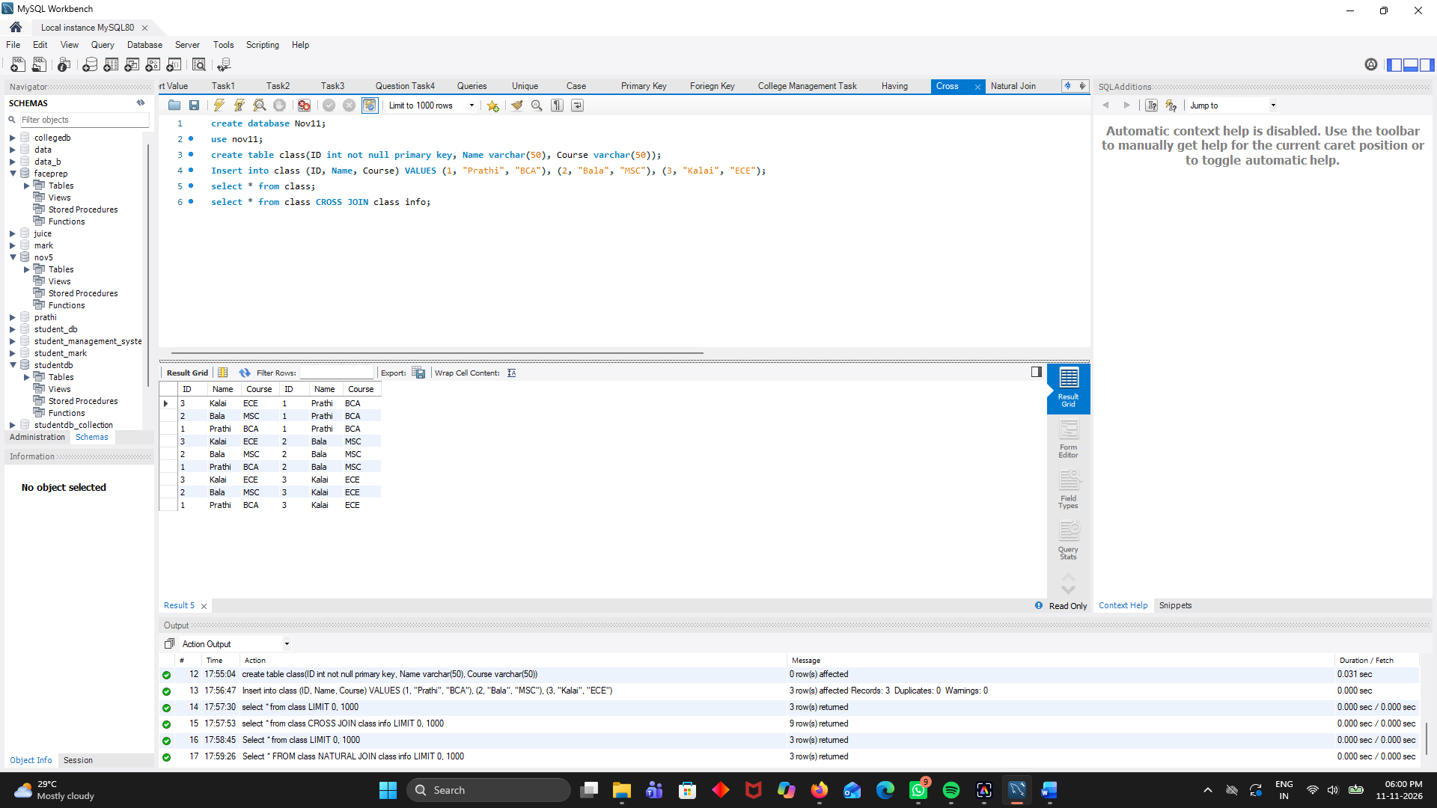

NATURAL JOIN:

use nov11;
Select * from class;
Select * FROM class NATURAL JOIN class info;

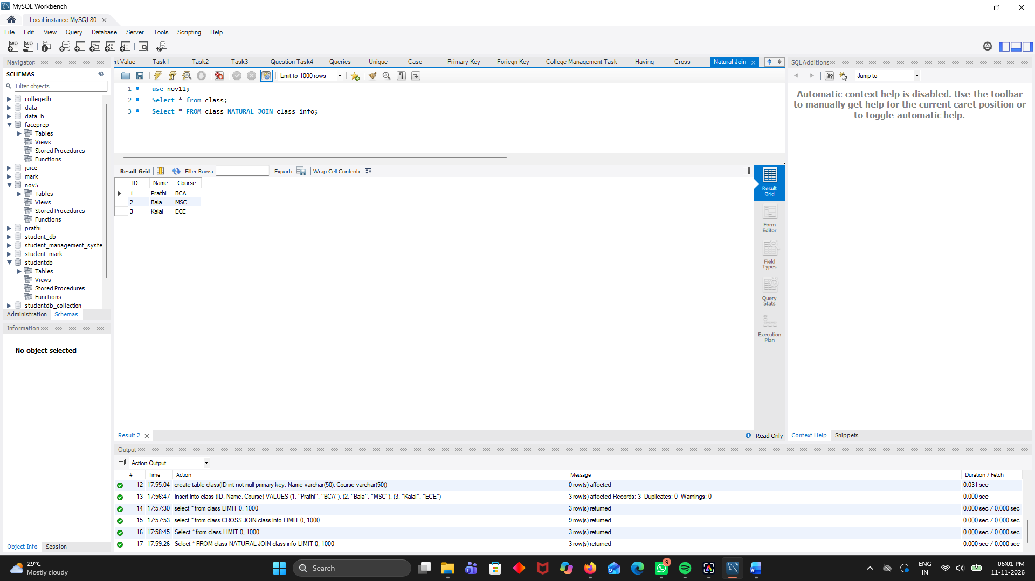

OUTER JOIN:

use nov11;
Left Outer Join:

SELECT * FROM class LEFT OUTER JOIN info ON class.ID = info.ID;
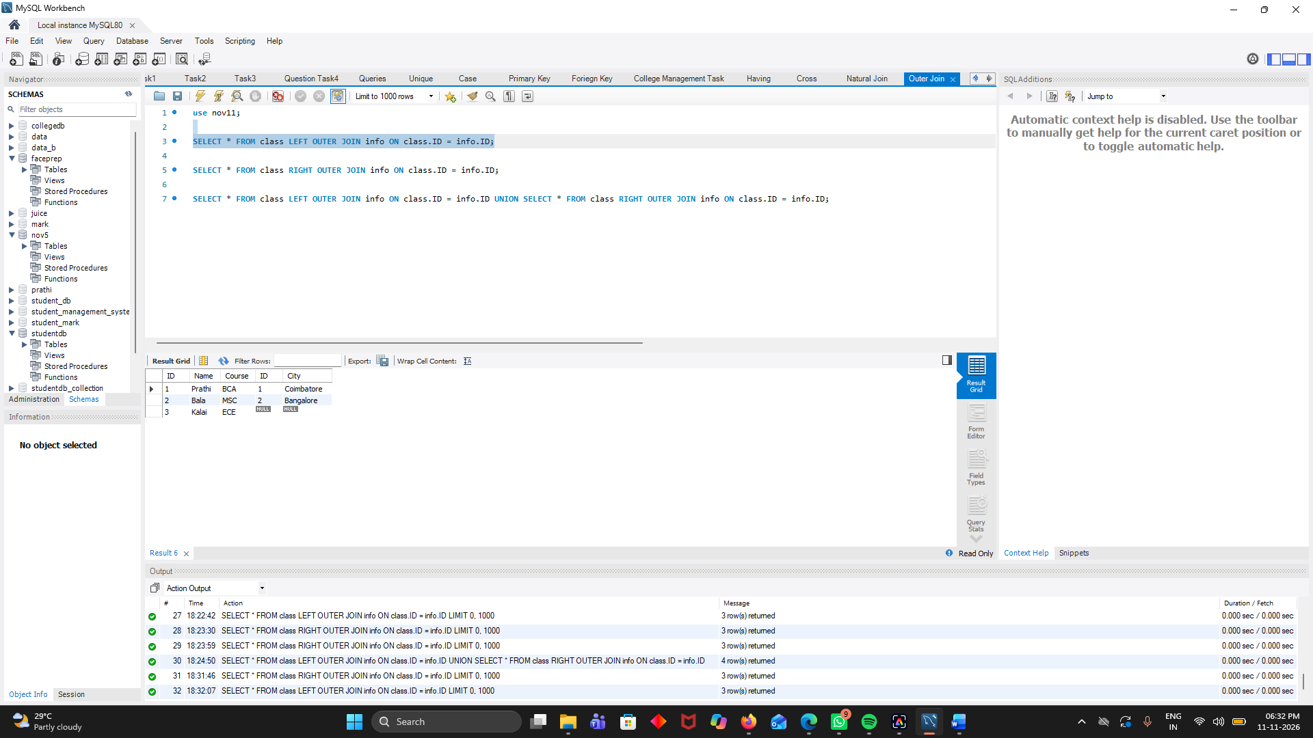
Right Outer Join:

SELECT * FROM class RIGHT OUTER JOIN info ON class.ID = info.ID;
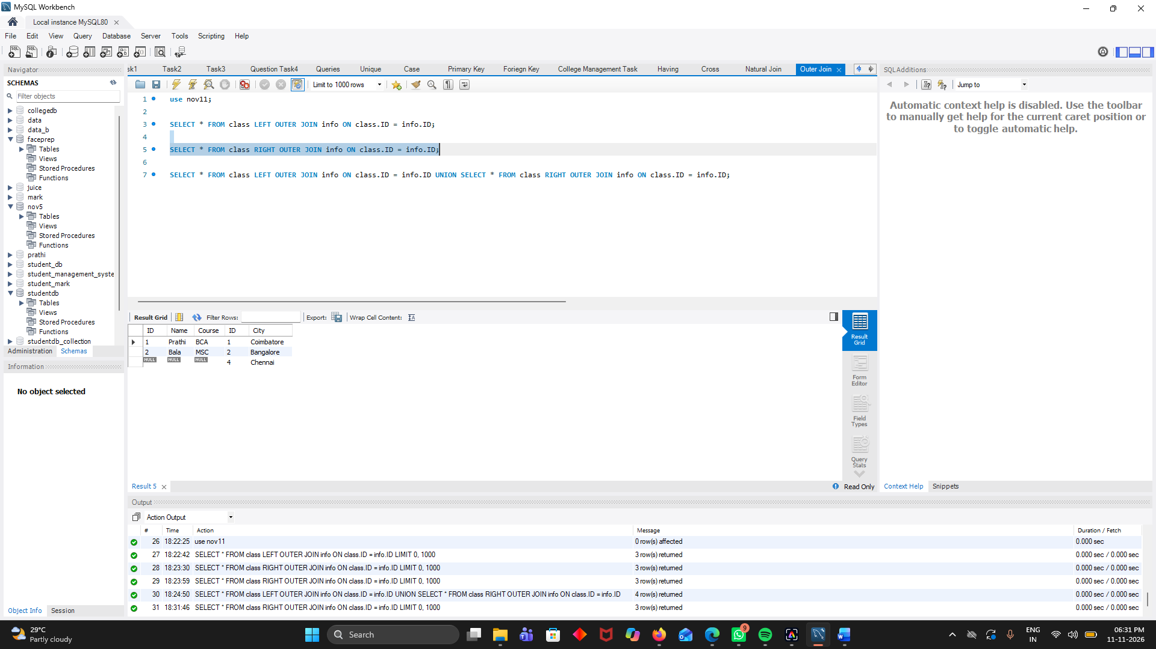
Full Outer Join:

SELECT * FROM class LEFT OUTER JOIN info ON class.ID = info.ID UNION SELECT * FROM class RIGHT OUTER JOIN info ON class.ID = info.ID;

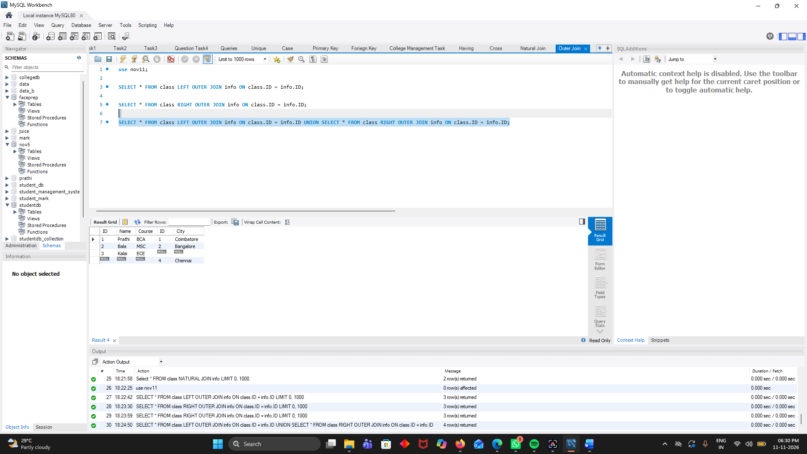

TASK:
INNER JOIN – Employee Department Details

use nov11;

SELECT Employees.emp_id, Employees.emp_name, Employees.salary, Departments.dept_name FROM Employees INNER JOIN Departments ON Employees.dept_id = Departments.dept_id;
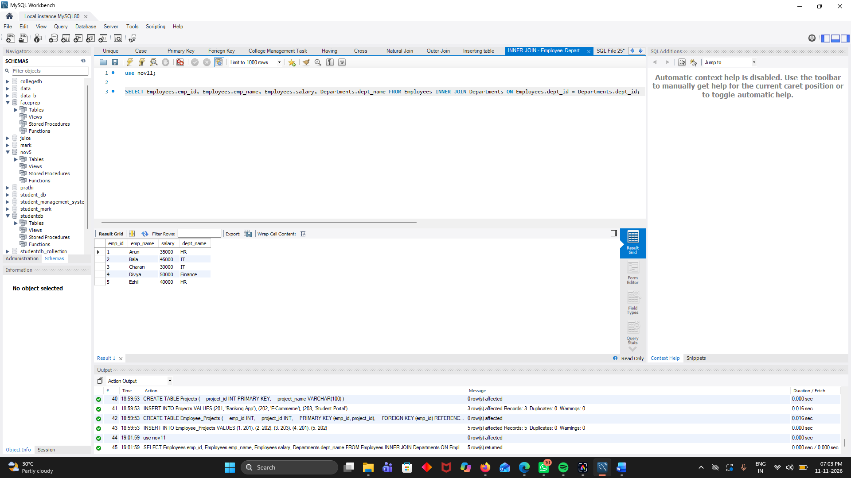

LEFT JOIN – All Employees
use nov11;

SELECT Employees.emp_id, Employees.emp_name, Employees.salary, Departments.dept_name FROM Employees LEFT JOIN Departments ON Employees.dept_id = Departments.dept_id;

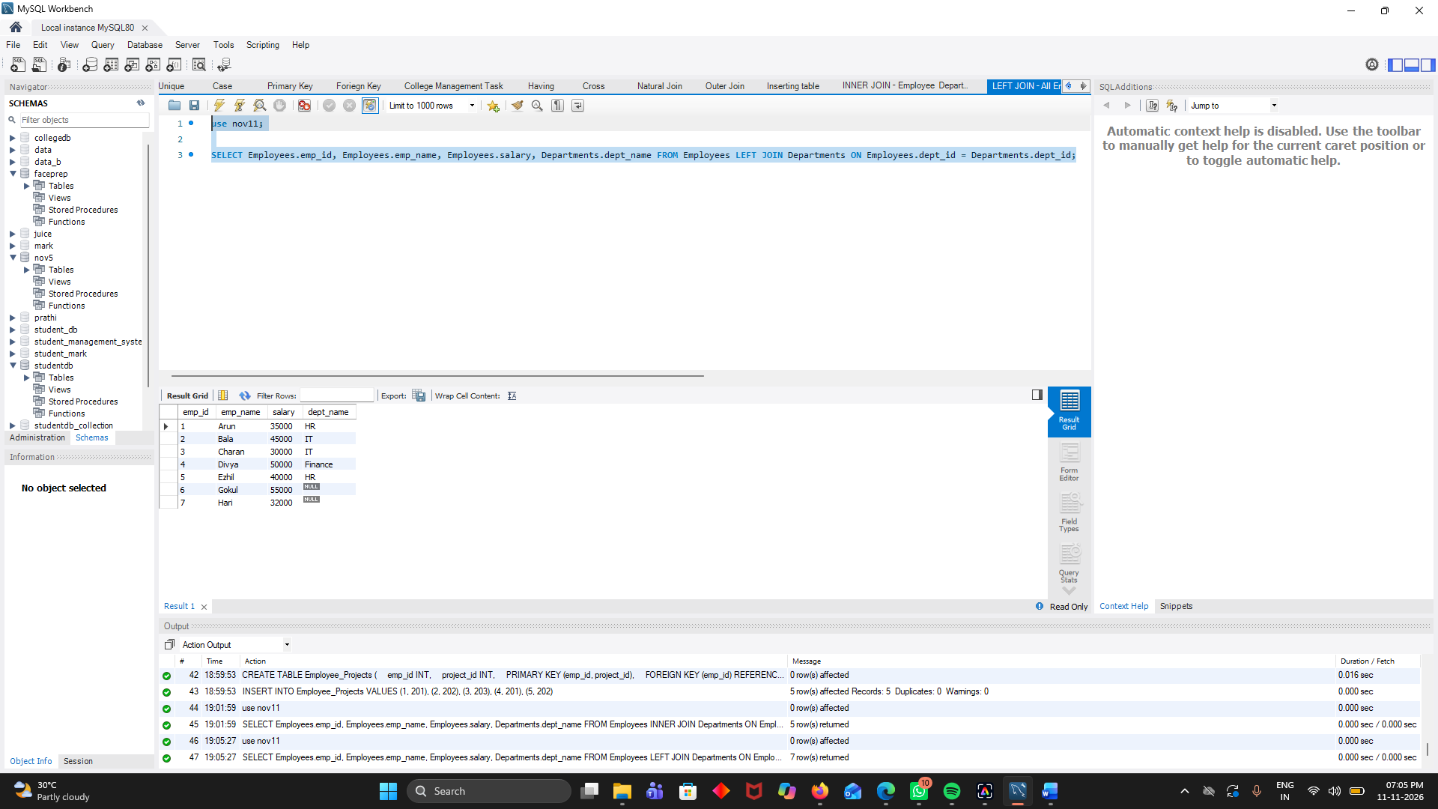

RIGHT JOIN – All Departments
use nov11;

SELECT Employees.emp_id, Employees.emp_name, Employees.salary, Departments.dept_name FROM Employees RIGHT JOIN Departments ON Employees.dept_id = Departments.dept_id;



