Nov4 Works:

Unique All:
use FACEPrep;

SELECT DISTINCT course FROM emp;

SELECT DISTINCT name FROM emp;

SELECT DISTINCT name, course FROM emp;

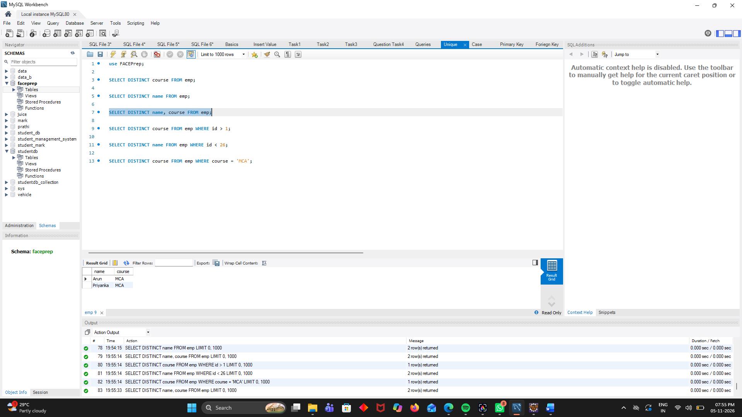

Unique WHERE:

Use FACEPrep;
SELECT DISTINCT course FROM emp WHERE id > 1;

SELECT DISTINCT name FROM emp WHERE id < 26;

SELECT DISTINCT course FROM emp WHERE course = 'MCA';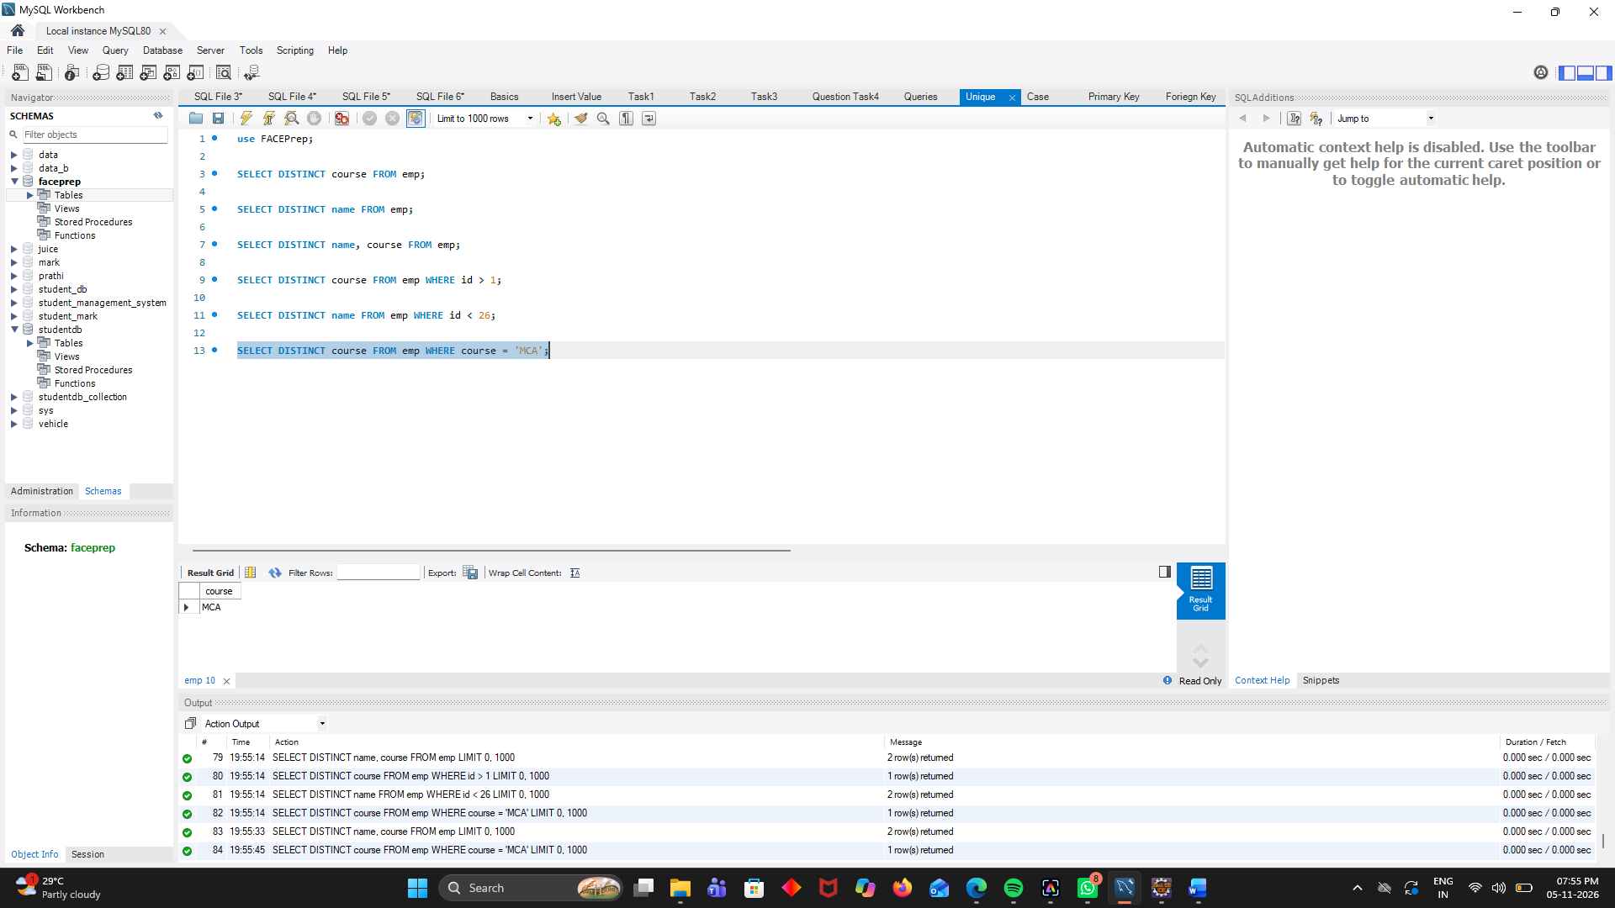

CASE:
use FACEPrep;

SELECT id, name, course,
CASE
WHEN course = 'MBA' THEN 'Management'
WHEN course = 'MCA' THEN 'Computer Application'
WHEN course = 'M.com' THEN 'Commerce'
ELSE 'Other'
END AS COURSE_TYPE
FROM emp;

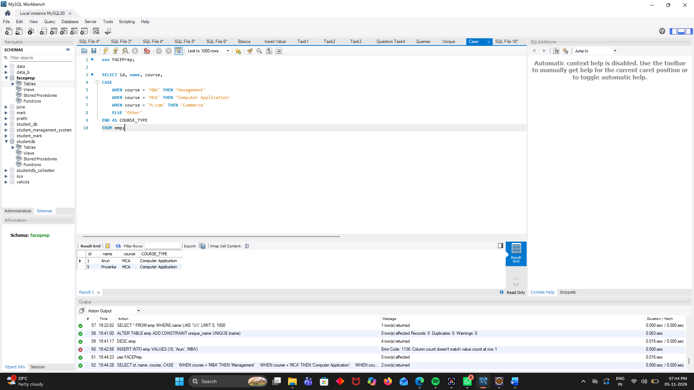

Primary Key:

use FACEPrep;

DESC emp;

CREATE TABLE Datatable (
id INT PRIMARY KEY,
name VARCHAR(50),
course VARCHAR(50)
);



Foreign Key:
use FACEPrep;
Drop table course;
CREATE TABLE course (
course_name VARCHAR(50) PRIMARY KEY
);

INSERT INTO course VALUES
('MBA'),
('MCA'),
('M.com');

ALTER TABLE emp ADD CONSTRAINT fk_course FOREIGN KEY (course) REFERENCES course(course_name);

SELECT * FROM emp;

SELECT * FROM course;
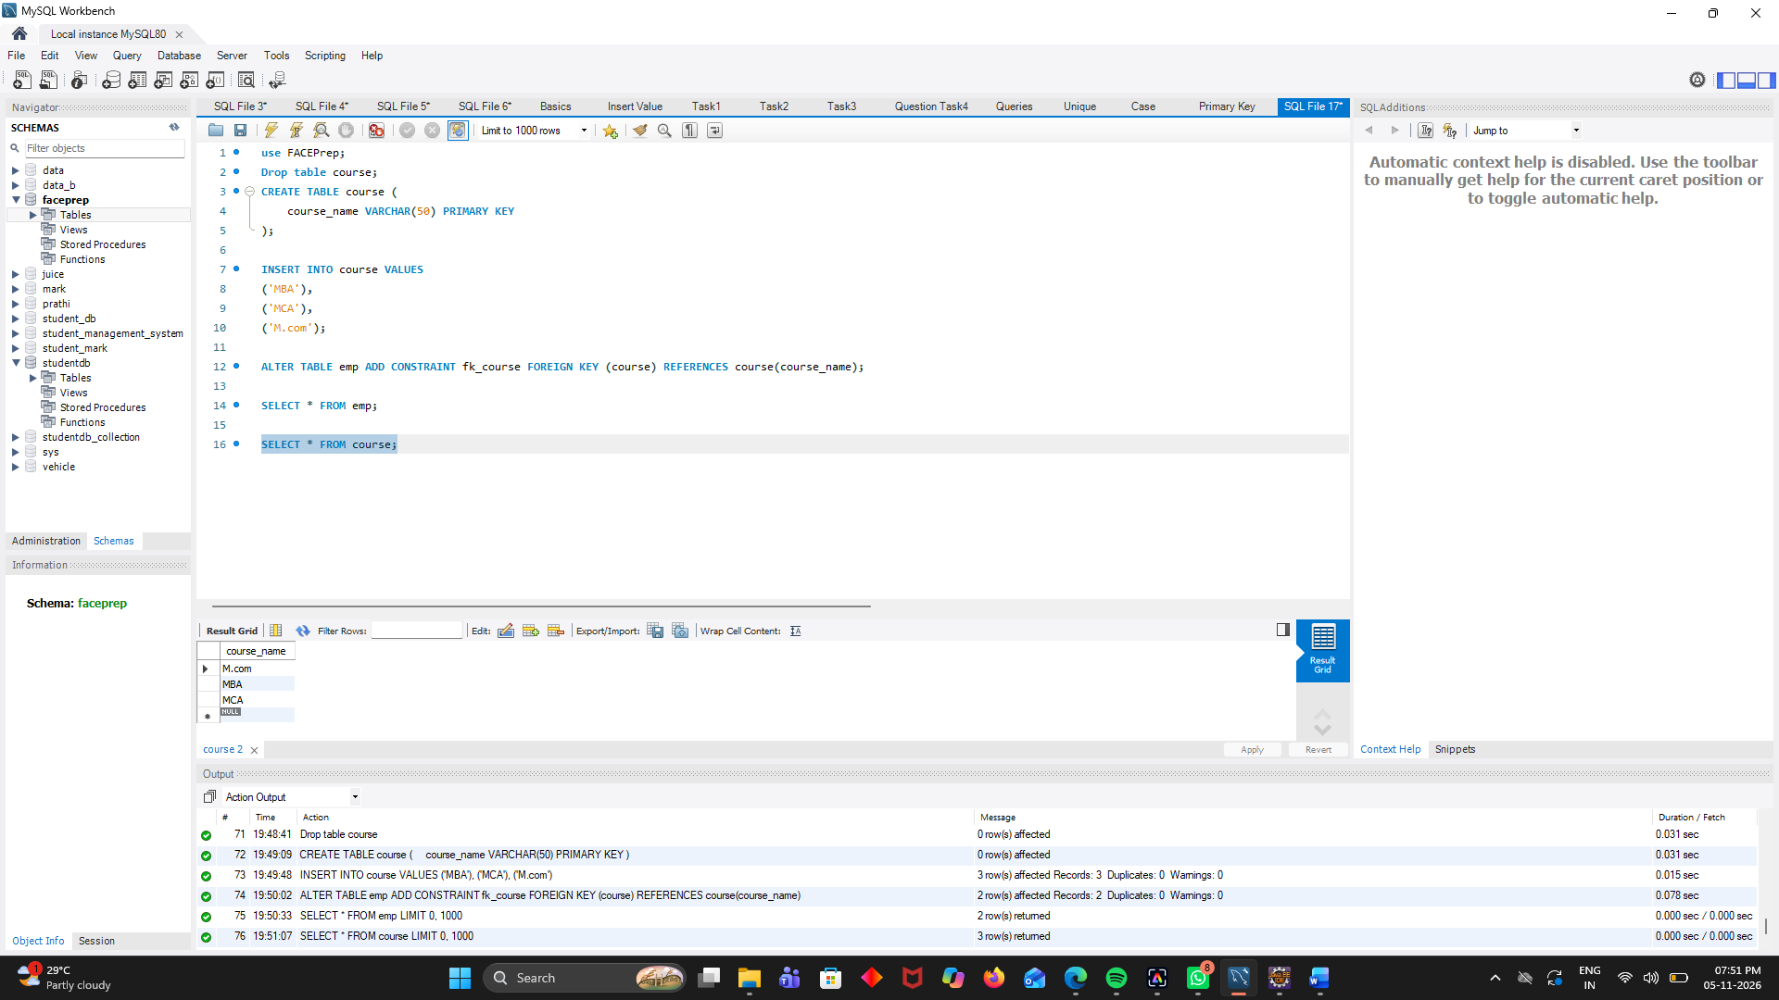

Task:
CREATE DATABASE CollegeDB;

USE CollegeDB;

CREATE TABLE Department (
dept_id INT PRIMARY KEY,
dept_name VARCHAR(50)
);

CREATE TABLE Student (
student_id INT PRIMARY KEY,
student_name VARCHAR(50),
dept_id INT,
FOREIGN KEY (dept_id) REFERENCES Department(dept_id)
);

INSERT INTO Department VALUES
(101, 'Computer Science'),
(102, 'Electronics'),
(103, 'Mechanical');

INSERT INTO Student VALUES
(1, 'Arun', 101),
(2, 'Priya', 102),
(3, 'Karthik', 101),
(4, 'Divya', 103);

SELECT
Student.student_id,
Student.student_name,
Department.dept_name
FROM Student
INNER JOIN Department
ON Student.dept_id = Department.dept_id;



