A Novel Graphical Password Authentication Scheme with Improved Usability

In this project we per your request we have added multi authentication scheme where user can signup by using basic username and password login details and then upload their iris image with watermark messages and application will embed message to given iris image and then saved at server.

While login user has to enter login details with original iris and watermark image and then application will check username and password and then check registered and login iris image and if matched found then it will extract watermark message and then compare with login message and if all details matched then user will get authentication successful. If any authentication failed then system will stop user from login

To extract iris we are using Daugman algorithm.

To run project first create database in MYSQL by copying content from DB.txt and paste in MYSQL and then double click on ‘run.bat’ file to start python DJANGO server and get below output

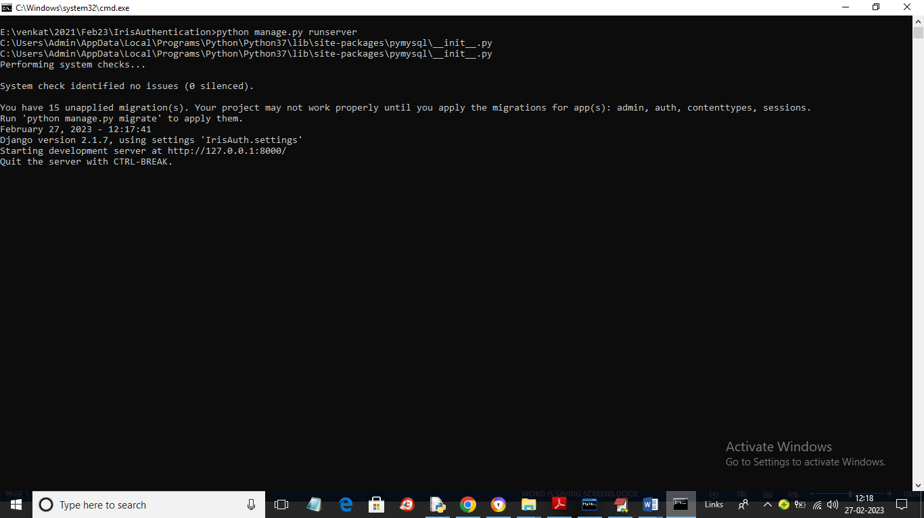

In above screen server started and now open browser and enter URL as <http://127.0.0.1:8000/index.html> and press enter key to get below page

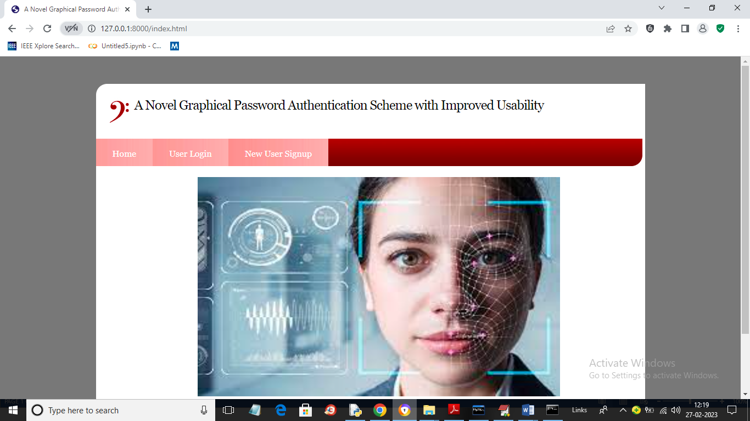

In above screen click on ‘New User Signup’ link to get below screen

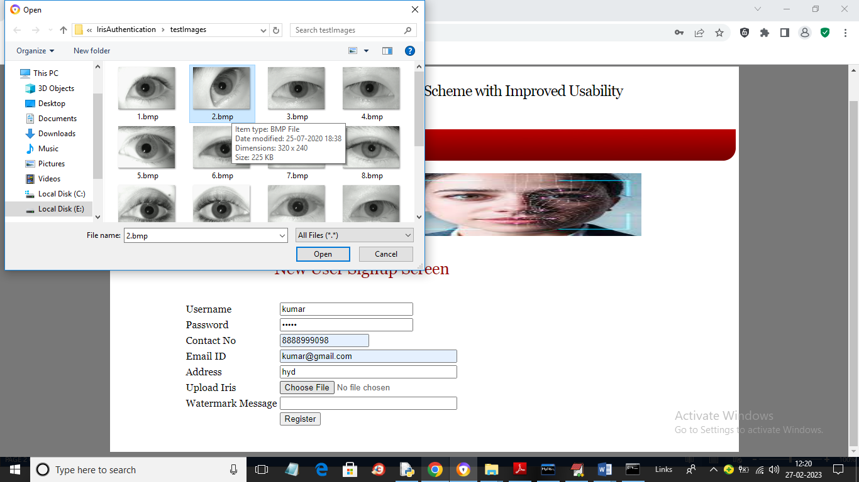

In above screen entering signup data and then upload iris image and this images available inside ‘testImages’ folder and then click on ‘Open’ button to load image and get below output

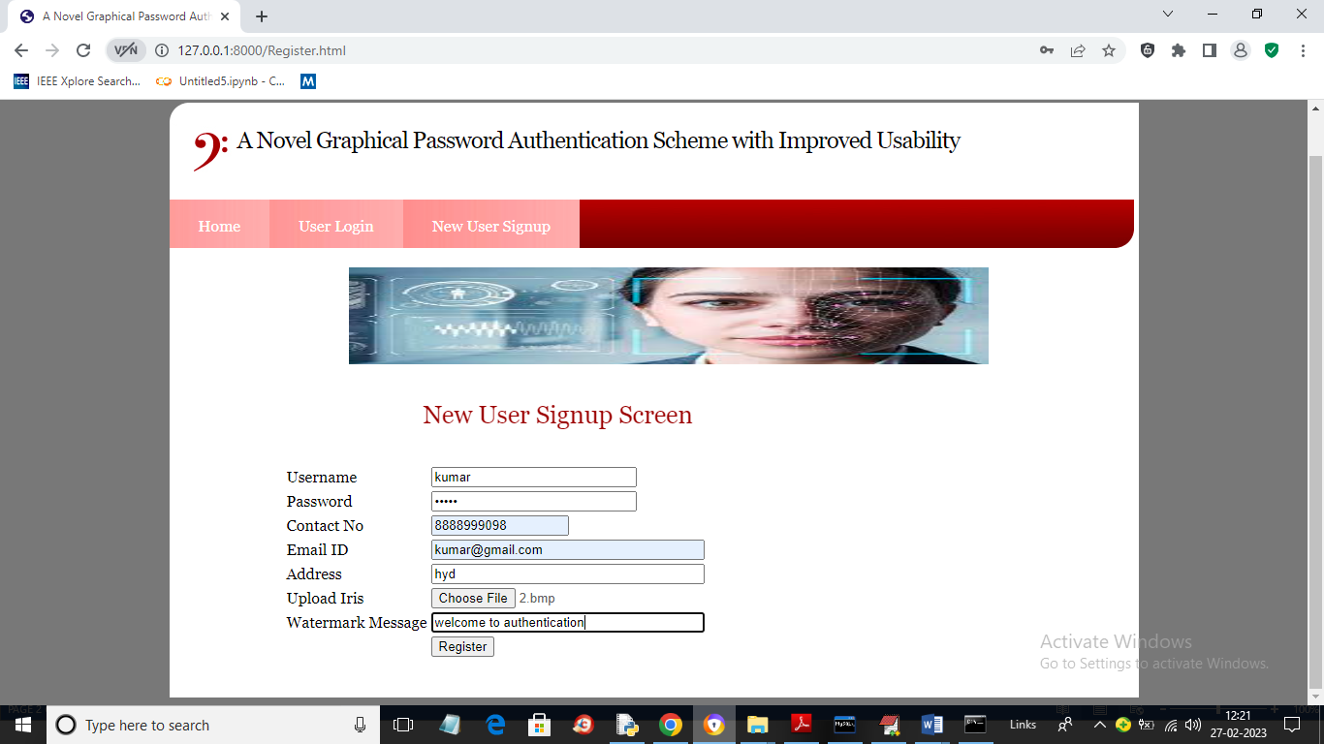

In above screen in last field I entered some watermark messages and then click on ‘Register’ button to get below page

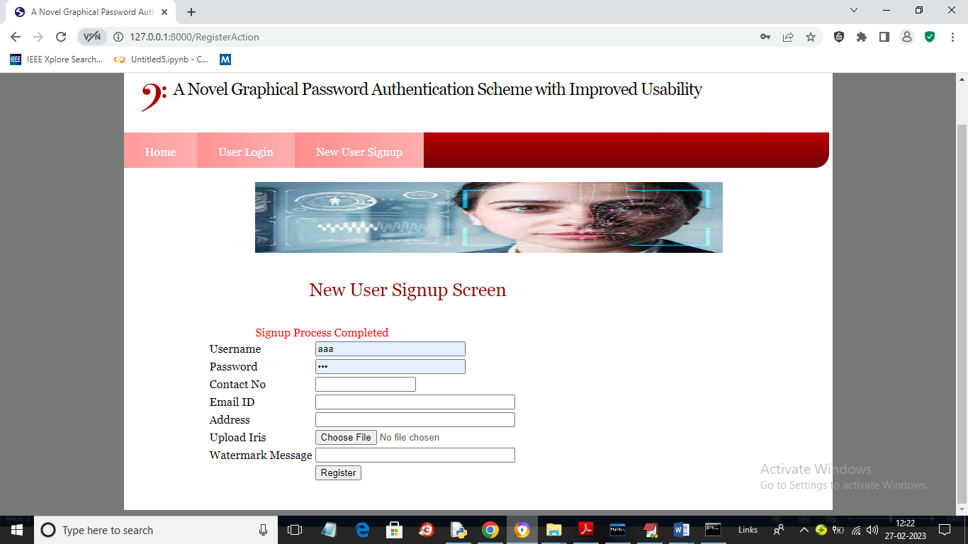

In above screen signup details completed and now click on ‘User Login’ link to get below output

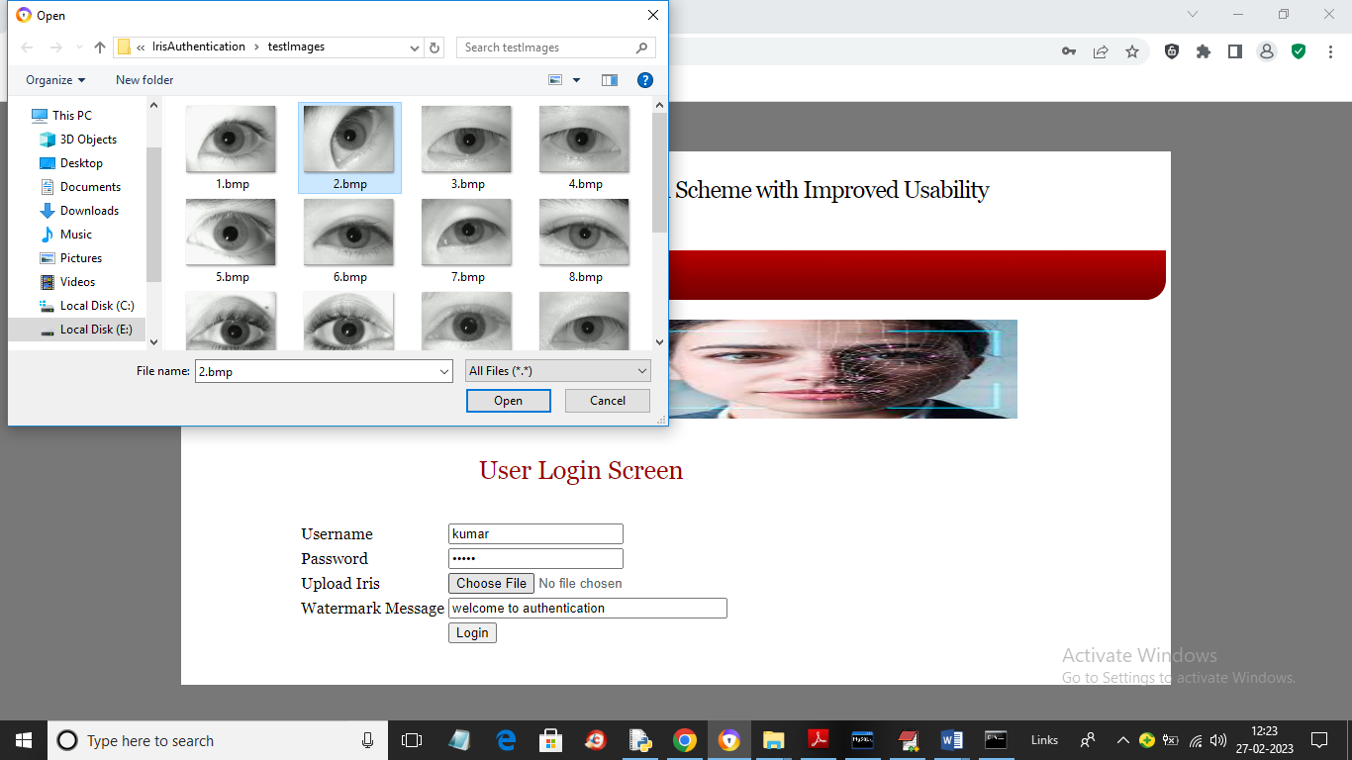

In above screen while login I am entering all login details correctly and uploading correct image also as 2.bmp and then click on ‘Open’ and Login button to get below output

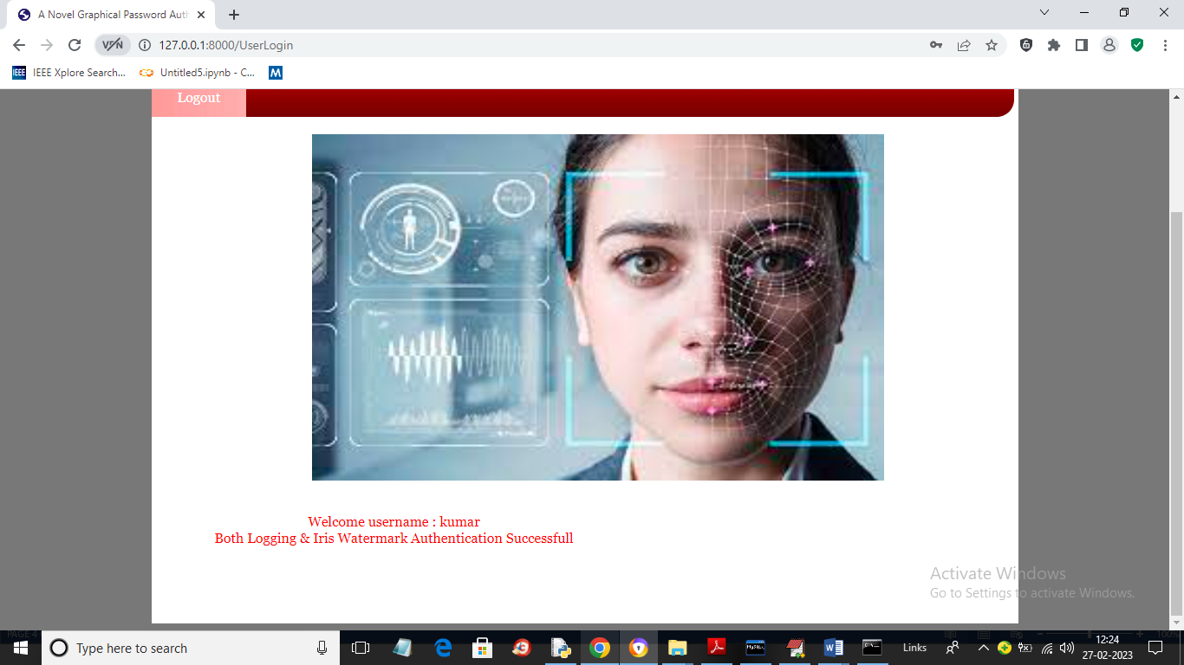

In above screen I got message as welcome saying authentication successful and in below screen I will enter wrong watermark message

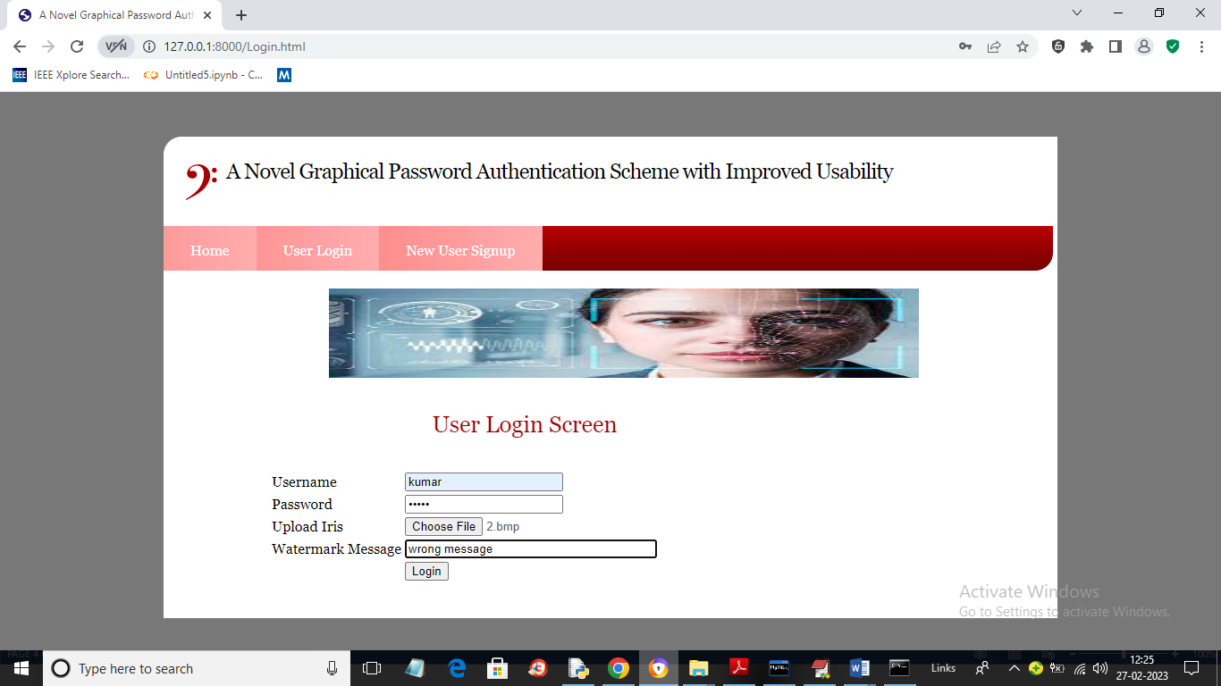

In above screen I entered wrong watermark message and after pressing buttin will get below page

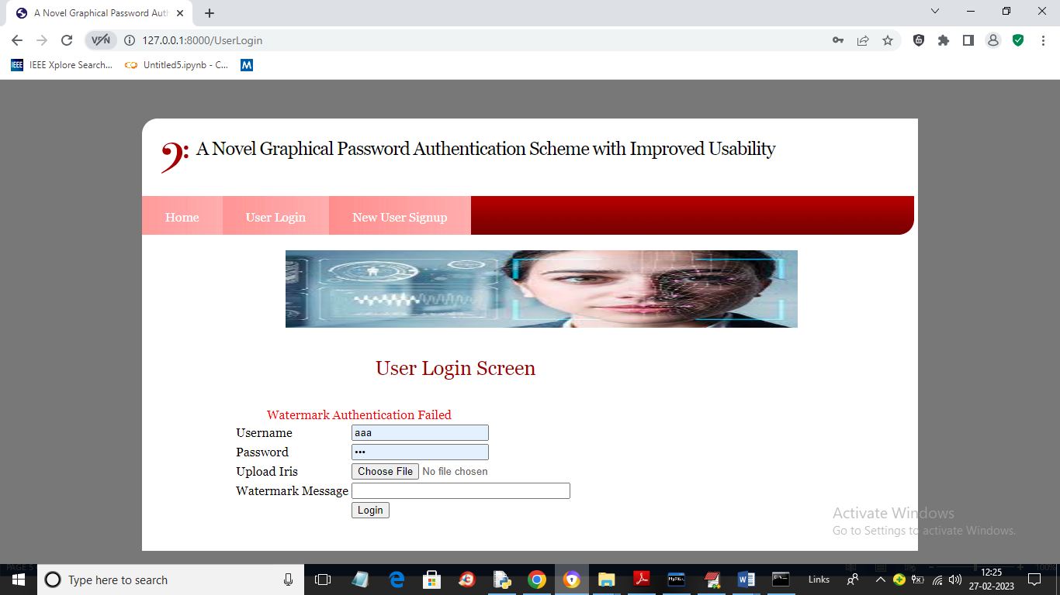

In above screen we can see watermark authentication failed and similarly if u give wrong username or password then you will get message as ‘invalid login’

Similarly you can upload iris, signup, login and test application