**CREATING A MULTIBOOT USB DRIVE BY SIMPLY COPYING ISO IMAGES TO IT**

**STEP 1: Download Ventoy from https://www.ventoy.net/en/download.html 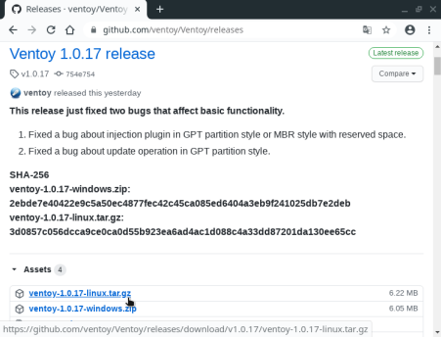STEP 2: Mount pendrive**

**STEP 3: Open ventoy folder and open ventoyDisk2.exe file**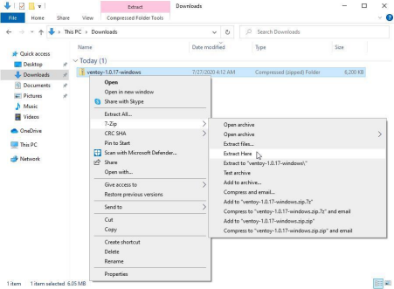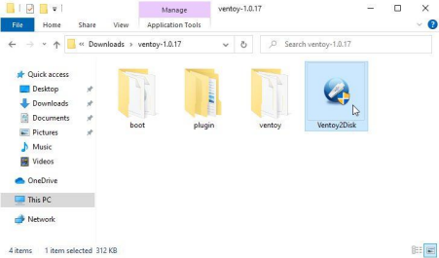

**STEP 4: Select the device that should be converted as a bootable device and click the install button**

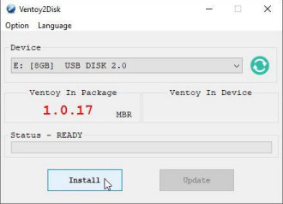

**STEP 5: Double check you are formatting the right device and click Yes**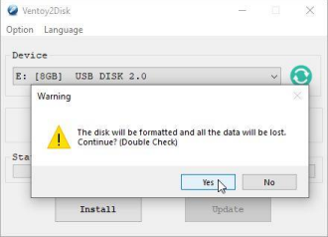

**STEP 6: When the installation process is completed the device will be converted into a bootable device**

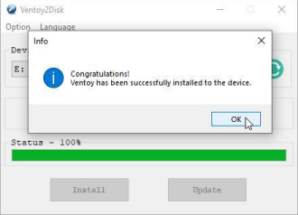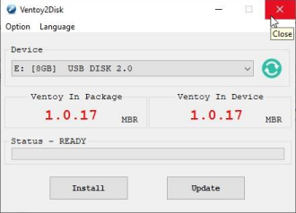

**STEP 7: Copy the iso file to the newly created bootable device 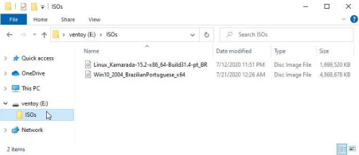STEP 8: The device is now ready**

**ADVANTAGE OF USING VENTOY**

∙ **Multiple iso(such as Linux , Windows etc..) can be copied to the newly created bootable device**

**WINDOWS INSTALLATION**

**Steps to install Windows 10 Pro**

1. First input the windows 10 installer media you are using (USB-HDD).

2. Then turn on the computer, then go first to the BIOS to set up First Boot. The way when the new computer is on, press the F2 key, or some existing computer uses the DEL key to enter the BIOS. Just adjust it. After setting the first boot, press F10, save and restart.

3. The computer will boot through the Windows 10 installer media, and if the prompt ***Type any key to boot from USB or HDD*** appears, press any key directly.Then the process will be continued soon.

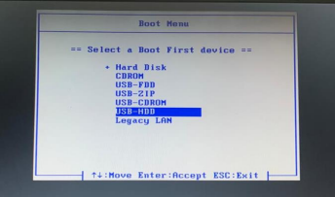

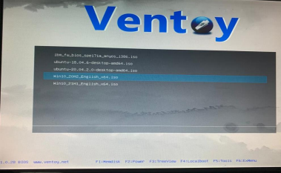

4. Select Language to install, ***Time and currency format***, and ***Keyboard or input method***. If it is selected, click ***next***.

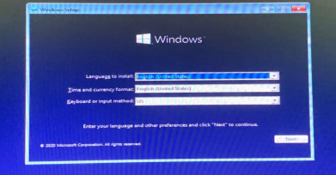Then click **Install now**.

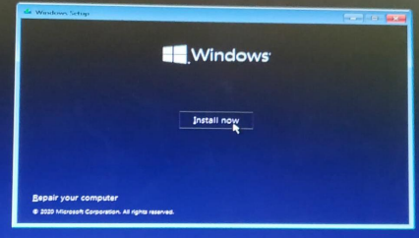**Setup is starting**, wait for the process to continue at the next stage.

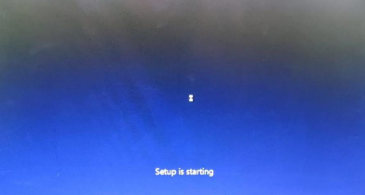Then enter the **serial number** that you have. If you don’t have it, just click **skip**.

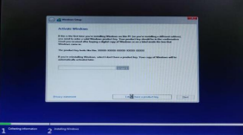

In this section, you can customize the Windows 10 that you will install. Adjust it to each of your choices or needs! If it is selected, click **Next**.

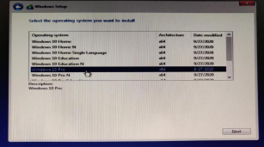

Then check the **I accept the license terms** section. Then click **Next**.



In this section, there are two options, which you can choose between upgrade or custom. Since we will reinstall our computer or laptop, then I choose **custom**.



Then we will continue with a split of partitions. If it’s wrong, your data might be lost (therefore, don’t forget to **backup data** before reinstalling the computer/laptop).



In this example, the hard drive that I have is already split into several partitions. That means I have to make sure that I will install it on the Disk Drive that I prepared for the OS. **Remember!** don’t get the wrong choice between **Local Disk C** and other **Local Disks** that store your data! If your computer already has an operating system, you only need to format the partition where the system was installed..





Next are the steps in the process of allocating Windows files from the installer media to the hard disk. Wait for the process to finish.



Then the computer will ask to restart itself. Just click **Restart now.**







If the computer has restarted, you can remove/unplug the installer media from the computer. Then wait for the whole process to be completely finished. In this process, the computer may restart several times. Let it to be done, the computer is customizing the system to the existing hardware. Wait until a **window** like below appears.

Windows will ask you to connect to a wireless network if you were unable to connect to a wired internet connection prior to installation.

Select the appropriate wireless network from the list and click Connect. Windows will prompt you for the network key or password if it is a Secure network.



If you are unable to connect to the internet at all, select “I don’t have internet” in the bottom left corner.

Windows will tout the benefits of connecting to the internet on the next screen. Click “Continue with limited setup” in the bottom left corner.

Pick your username when the next screen appears.

This can be your real name but does not have to be. Click Next when you are satisfied with your new name.

You’ll be prompted to create a password next.

Type in a secure password that you will remember and click on Next. You can also just click Next if you do not wish to create a password at this time.

Windows will prompt for confirmation to some initial privacy settings.

Leave the “Location” setting On.

Change the “Online speech recognition” setting to Off.

Change the “Find my device” setting to Off.

Change the “Inking & typing” setting to Off.

Change the “Advertising ID” setting to Off.

Change the “Diagnostic data” setting to Basic.

Change the “Tailored experiences” setting to Off.

Click Accept to proceed.

Choose No on the next screen when asked to send your Activity History to Microsoft.

Choose Not now for Cortana since an offline account was set up.



Wait for the process for a moment. Soon you will be on the desktop Windows 10.

You will be greeted and reassured by words on a black screen that things are being made ready.

A blue screen will fade in and say that it might take several more minutes. Don’t turn off your PC.

After all that, the Windows Desktop will load and Windows 10 Pro will have finished installing.



You have successfully installed windows 10 on your computer or laptop



Click Network and Sharing Center.



The Network and Sharing Center page appears.

Click Ethernet.

Ethernet page appears.

Right-click the connection that you want to configure and then choose Properties from the contextual menu that appears.



Choose Internet Protocol Version 4(TCP/IPv4) properties.



If necessary, we can manually specify a static IP address (select 'Use the following IP address' and enter the IP address and mask in the 'IP address' and 'Subnet mask' fields, respectively).

The computer’s IP address must belong to the same subnet as the LAN IP address of the router.

For example, if it has an IP address of 192.168.1.1 (set by default) with a mask of 255.255.255.0, the computer's IP address must be between 192.168.1.2 and 192.168.1.254 with the same mask.



For example, if it has an IP address of 172.16.127.61(set by default) with a mask of 255.255.248.0, the computer’s IP address must be between 172.16.127.254 and 172.16.127.253 with the same mask.



UBUNTU INSTALLATION

STEP 1:BOOT UP UBUNTU FROM USB

◆ Turn off your system. Make sure you remove all other USB devices, such as printers, memory cards, etc.

◆ Insert the Ubuntu USB drive into the system and turn on your machine.

◆ There are two possible scenarios:

• The computer boots the USB drive automatically.

• You need to manually configure USB booting in the Boot Menu or BIOS/UEFI.

◆ To manually configure the boot order, tap the boot menu key about once or twice per second as soon as the computer powers on.

◆ The boot menu key may be different depending on your computer manufacturer.  Once you see your boot menu, use the arrows to pick the Ubuntu media to boot from  Then choose ubuntu







STEP 2:RUN UBUNTU

◆ You can test Ubuntu 20.04 before you commit to installing it. The .iso includes a live mode that only runs in memory.

◆ Launch this mode by clicking **Try Ubuntu**.



STEP 3: INSTALL UBUNTU 20.04 LTS DESKTOP

⮚ To begin the installation, click **Install Ubuntu**.



STEP 4: CHOOSE KEYBOARD LAYOUT

◆ By default, the system will select English and English.

◆ If you have a non-standard keyboard, you can select it in the list. Alternately, click **Detect Keyboard Layout** and the system will automatically choose your keyboard. If you need to test your keyboard, use the labeled field.

◆ When you’re ready, click **Continue**.



STEP 5:CHOOSE STARTING APPLICATIONS

◆ **Normal Installation** – This is the full Ubuntu Desktop experience, with office software, games, and media players.

◆ **Minimal Installation –** Choose this to save disk space, especially if you won’t be using media players or productivity software

◆ **Download updates while installing Ubuntu** – This does the work of downloading large package files during the installation. Once the installation finishes, the packages will be ready to apply as updates.

◆ **Install third-party software for graphics and Wi-Fi hardware and additional media formats –** Some hardware, like graphics cards and wi-fi cards, do not have open-source driver support. Also, some media formats, such as .wmv, do not fall under the GPL license. If you need support for these, you’ll need to agree to additional terms of use.



STEP 6:DISK PARTITIONING

◆ Next, you’ll be presented with an **Installation Type** dialog. You can wipe the hard drive clean prior to installing Ubuntu by clicking **Erase disk and install Ubuntu**. If you go this route, skip ahead to the next step.

◆ f you’d rather create your own hard drive partitions, click **Something Else**.

◆ The next screen will allow you to create your own partition table and logical drives. This lets you divide a physical hard drive into different partitions. The operating system sees partitions as individual drives.

◆ Click **Continue** to apply your changes to the drive partitions.

◆ You’ll be asked to **Write changes to disks?** None of the options you’ve selected are permanent until you click **Continue** on this

screen. Click **Continue** to proceed.





STEP 7: SELECT TIME ZONE

◆ Type the nearest large city into the box, and the system will **set your local time zone**.



STEP 8:CREATE USER ACCOUNT

◆ you’ll need to configure a user account. Fill in the following fields: ❑ **Name:** Your actual name.

❑ **Computer name:** This is the hostname or network name.

❑ **Username:** The user account name you want to use.

❑ **Password:** Enter and confirm a strong password – the installer will automatically evaluate your password strength.

❑ **Log in automatically:** This is not recommended for publicly accessible servers.

❑ **Require my password to log in:** This is recommended for publicly accessible servers.

◆ Click **Continue** to install Ubuntu.

◆ Once the installer finishes, remove the Ubuntu installation media. You’ll be prompted to **Restart Now**.

