

Prathibha B M

INTRODUCTION

MongoDB is an open-source document-oriented database that is designed to store a large scale of data and also allows you to work with that data very efficiently. It is categorized under the NoSQL (Not only SQL) database because the storage and retrieval of data in the MongoDB are not in the form of tables.

The MongoDB database is developed and managed by MongoD .Inc under SSPL(Server Side Public License) and initially released in February 2009. It also provides official driver support for all the popular languages like C, C++, C#, and .Net, Go, Java, Node.js, Perl, PHP, Python, Motor, Ruby, Scala, Swift, Mongoid. So, that you can create an application using any of these languages. Nowadays there are so many companies that used MongoDB like Facebook, Nokia, eBay, Adobe, Google, etc. to store their large amount of data.

**What is Database?**

**Structured Data:** The information is typically organized in a specific format, often using tables with rows and columns. This makes it easier to search, filter, and analyze the data.

**Database Management System (DBMS):** This is the software that acts like the filing cabinet manager. It allows you to store, retrieve, update, and manage all the data within the database.

**Data Types:** Databases can hold various kinds of information, including text, numbers, images, videos, and more.

**Hence DB Software like Oracle, Mongo**



1. **Database softwares are like rack builders**
2. **Oracle, Mongo builds and gives you just use it**

**SQL  VS NO-SQL**

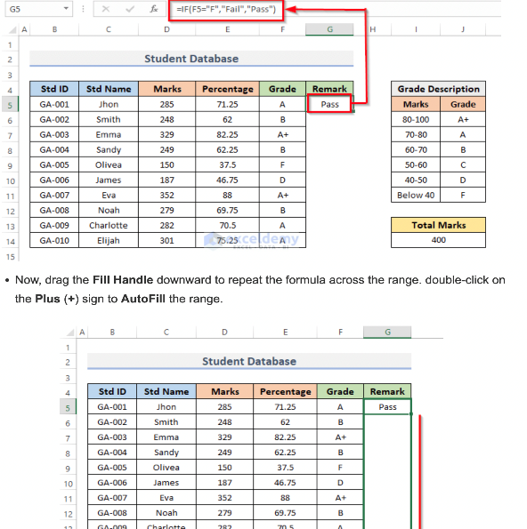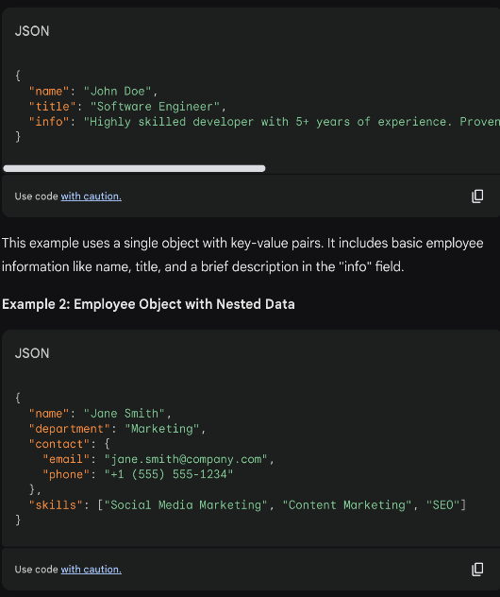

SQL databases are used to store structured data while NoSQL databases like MongoDB are used to save unstructured data. MongoDB is used to save unstructured data in JSON format. MongoDB does not support advanced analytics and joins like SQL databases support.

**No-SQL  VS SQL**

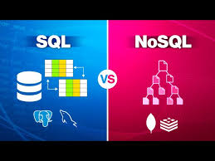

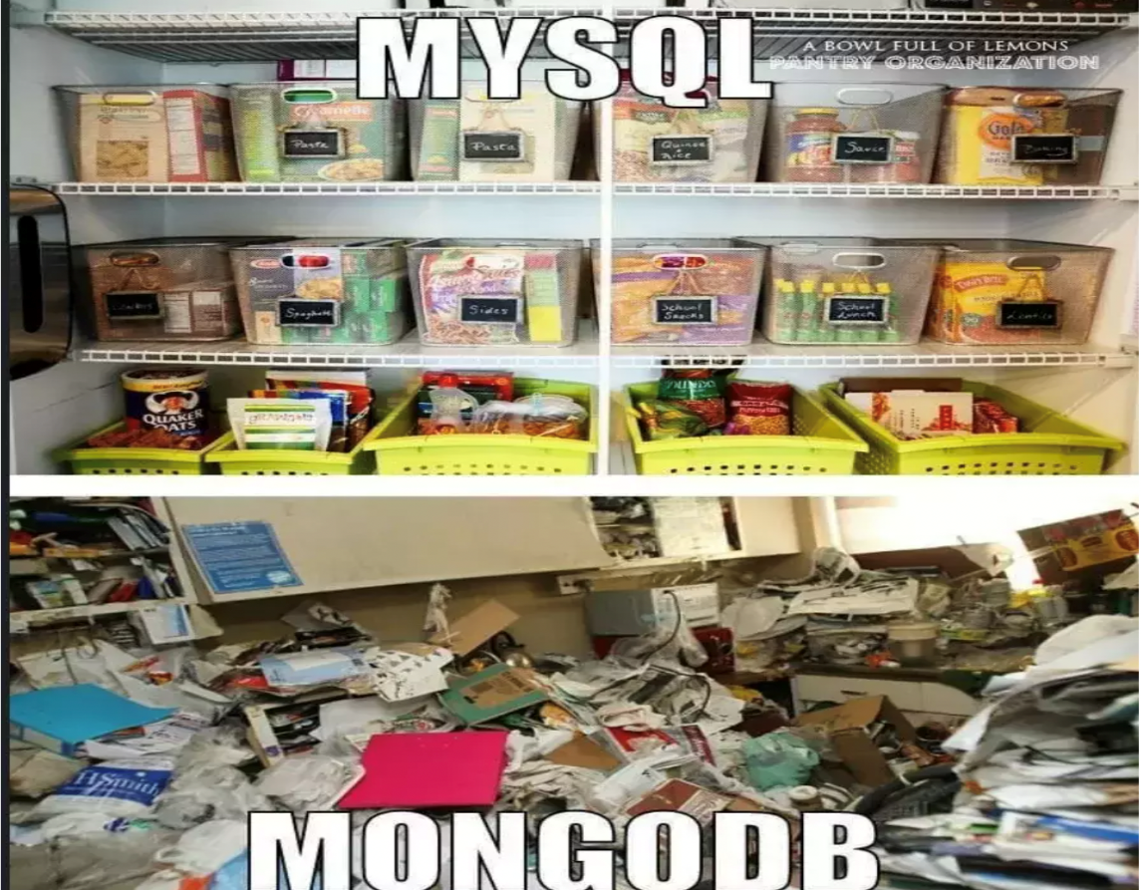

**What is MongoDB?**

MongoDB is a document-oriented NoSQL database system that provides high scalability, flexibility, and performance. Unlike standard relational databases, MongoDB stores data in a JSON document structure form. This makes it easy to operate with dynamic and unstructured data and MongoDB is an open-source and cross-platform database System.

Database

* Database is a container for collections.
* Each database gets its own set of files.
* A single MongoDB server can has multiple databases.

**Collection**

* Collection is a group of documents.
* Collection is equivalent to RDBMS table.
* A collection consist inside a single database.
* Collections do not enforce a schema.
* A Collection can have different fields within a Documents.

**Where to Use MongoDB?**

1. Mobile and Social Infrastructure
2. Data Hub
3. Previous Pag
4. Big Data
5. User Data Management
6. Content Management and Delivery

**Why Use MongoDB?**

Document Oriented Storage − Data is stored in the form of JSON documents.

* **Index on any attribute**: Indexing in MongoDB allows for faster data retrieval by creating a searchable structure on selected attributes, optimizing query performance.
* **Replication and high availability**: MongoDB’s replica sets ensure data redundancy by maintaining multiple copies of the data, providing fault tolerance and continuous availability even in case of server failures.
* **Auto-Sharding**: Auto-sharding in MongoDB automatically distributes data across multiple servers, enabling horizontal scaling and efficient handling of large datasets.
* **Big Data and Real-time Application**: When dealing with massive datasets or applications requiring real-time data updates, MongoDB’s flexibility and scalability prove advantageous.
* **Rich queries**: MongoDB supports complex queries with a variety of operators, allowing you to retrieve, filter, and manipulate data in a flexible and powerful manner.
* **Fast in-place updates**: MongoDB efficiently updates documents directly in their place, minimizing data movement and reducing write overhead.
* **Professional support by MongoDB**: MongoDB offers expert technical support and resources to help users with any issues or challenges they may encounter during their database operations.
* **Internet of Things (IoT) Applications:** Storing and analyzing sensor data with its diverse formats often aligns well with MongoDB’s document structure.

INSTALLATION

**MongoDB**is an open-source document-oriented database. It is categorized under the **NoSQL(Not only SQL)**database because the storage and retrieval of data in MongoDB are not in the form of tables. This is the general introduction to MongoDB now we will learn **how to install MongoDB in Windows.**

You can install MongoDB using MSI. Let’s see a step-by-step instruction guide for installing MongoDB in Windows using MSI. Let’s see the MongoDB requirements for the installation of Windows.

Requirements to Install MongoDB on Windows

**MongoDB 4.4** and later only support **64-bit** versions of Windows.

MongoDB 7.0 Community Edition supports the following 64-bit versions of Windows on x86_64 architecture:

**Windows Server 2022**

**Windows Server 2019**

**Windows 11**

Ensure that the user is running **mongod** and **mongos** has the necessary permissions from the following groups:

Performance Monitor Users

Performance Log Users

[Follow steps here](https://www.geeksforgeeks.org/how-to-install-mongodb-on-windows/?ref=ml_lbp) :

<https://www.geeksforgeeks.org/how-to-install-mongodb-on-windows/?ref=ml_lbp>

<https://www.mongodb.com/docs/manual/tutorial/install-mongodb-on-windows/#std-label-install-mdb-community-windows>

How to import data into collection in MongoDB compass

You can use MongoDB Compass to import and export data to and from collections. Compass supports import and export for both JSON and CSV files. To import or export data to or from a collection, navigate to the detailed collection view by either selecting the collection from the Databases tab or clicking the collection in the left-side navigation.

MongoDB Compass can import data into a collection from either a **JSON** or **CSV** file.

**Limitations**

* Importing data into a collection is not permitted in **MongoDB Compass Readonly Edition**.
* Importing data is not available if you are connected to a [Data Lake.](https://www.mongodb.com/docs/atlas/data-lake/)

**Format Your Data**

Before you can import your data into MongoDB Compass you must first ensure that it is formatted correctly.

JSON

CSV

When importing data from a **JSON** file, you can format your data as:

* Newline-delimited documents, or
* Comma-separated documents in an array.

**Procedure**

To import your formatted data into a collection:

**1.**Connect to the deployment containing the [collection](https://www.mongodb.com/docs/compass/current/collections/) you wish to import data into.

To learn how to connect to a deployment, see [Connect to MongoDB.](https://www.mongodb.com/docs/compass/current/connect/#std-label-connect-run-compass)

**2.**Navigate to your target collection.

You can either select the collection from the [Collections](https://www.mongodb.com/docs/compass/current/collections/) tab or click the collection in the left-hand pane.

**3.**Click the ***Add Data*** dropdown and select ***Import JSON or CSV file***.

**4.**Select the appropriate file type.

Select either a JSON or CSV file to import and click **Select**.

If you are importing a CSV file, you may specify fields to import and the types of those fields under **Specify Fields and Types**.

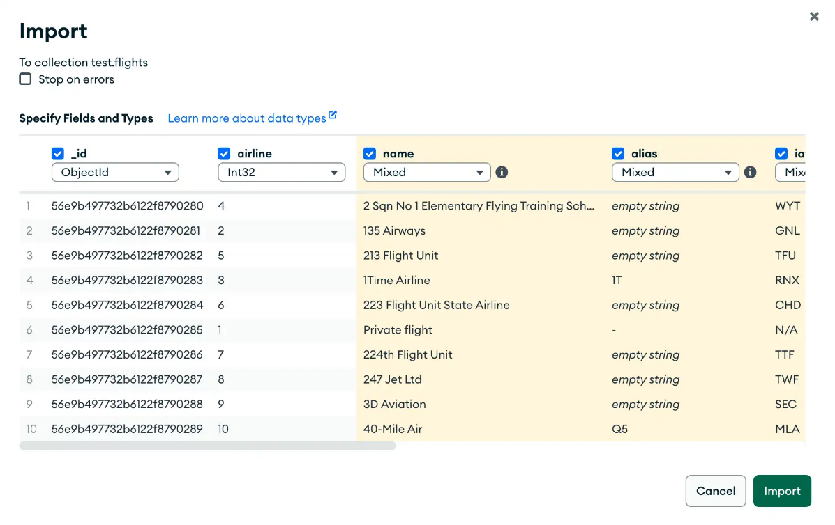

To exclude a field from a CSV file you are importing, uncheck the checkbox next to that field name. To select a type for a field, use the dropdown menu below that field name.

**5.**Configure import options.

Under **Options**, configure the import options for your use case.

If you are importing a CSV file, you may select how your data is delimited.

For both JSON and CSV file imports, you can toggle **Ignore empty strings** and **Stop on errors**:

* If checked, **Ignore empty strings** drops fields with empty string values from your imported documents. The document is still imported with all other fields.
* If checked, **Stop on errors** prevents any data from being imported in the event of an error. If unchecked, data is inserted until an error is encountered and successful inserts are not rolled back. The import operation will not continue after encountering an error in either case.

**6.**Click *Import*.

A progress bar displays the status of the import. If an error occurs during import, the progress bar turns red and an error message appears in the dialog. To see all errors, click **View Log**.

After successful import, the dialog closes and Compass displays the collection page containing the newly imported documents.

**Lets Load the document**

* Download the student csv from this [link](https://drive.google.com/file/d/1L3FhU59Tw-a-o-8esmKrhb4GhXGW_soe/view?usp=sharing)
* Import the data to the collection created [link](https://www.mongodb.com/docs/compass/current/import-export/)
* You should be able to see the uploaded data in mongo compass

**Installation of Mongo Shell OR Studio3t**

* Mongo Shell download [link](https://www.mongodb.com/docs/v4.4/mongo/)
* All the work is expected to do it in mongo shell not in mongo compass

OR

* You can also install [Studio3T](https://studio3t.com/download/)
* Connect to mongodb://localhost:27017

**Few Commands to test after connections**

|  |  |  |
| --- | --- | --- |
| **Command** | **Expected Output** | **Notes** |
| show dbs | admin 40.00 KiB  config 72.00 KiB  db 48.00 KiB  ds 56.00 KiB  laps 8.00 KiB  local 72.00 KiB | All Databases are shown |
| use db | switched to db db | Connect and use db |
| show  collections | student | Show all tables |
| db.foo.insert({"bar" : "baz"}) |  | Insert a record to collection. Create Collection if not exists |
| db.foo.batchInsert([{"_id" : 0}, {"_id" : 1}, {"_id" : 2}]) |  | Insert more than one document |
| db.foo.find() |  | Print all rows |
| db.foo.remove() |  | Remove foo table |

**Documents, Collections, Database**

**Documents:**

At the heart of MongoDB is the document:

an ordered set of keys with associated values.

The representation of a document varies by programming language, but most languages have a data structure that is a natural fit, such as a map, hash, or dictionary.

***{"greeting" : "Hello, world!"}***

**Collections:**

 Collections A collection is a group of documents.

 If a document is the MongoDB analog of a row in a relational database, then a collection can be thought of as the analog to a table.

**Database:**

MongoDB groups collections into databases.

A single instance of MongoDB can host several databases, each grouping together zero or more collections.

A database has its own permissions, and each database is stored in separate files on disk.

 A good rule of thumb is to store all data for a single application in the same database.

Datatype

Basically each document will be in JSON format which will be as follows. Where each attributes inside can be of multiple data types.

**1.String**: This is the most commonly used data type in MongoDB to store data, BSON strings are of UTF-8. So, the drivers for each programming language convert from the string format of the language to UTF-8 while serializing and de-serializing BSON. The string must be a valid UTF-8.

**2. Integer:** In MongoDB, the integer data type is used to store an integer value. We can store integer data type in two forms 32 -bit signed integer and 64 – bit signed integer.

**3. Double:**The double data type is used to store the floating-point values.

**4. Boolean:**The boolean data type is used to store either true or false.

**5.Null:**The null data type is used to store the null value.

**6.Array:**The Array is the set of values. It can store the same or different data types values in it. In MongoDB, the array is created using square brackets([]).

**7.Object:**Object data type stores embedded documents. Embedded documents are also known as nested documents. Embedded document or nested documents are those types of documents which contain a document inside another document.

**8. Object Id:**Whenever we create a new document in the collection MongoDB automatically creates a unique [object id](https://www.geeksforgeeks.org/what-is-objectid-in-mongodb/) for that document(if the document does not have it). There is an _id field in MongoDB for each document. The data which is stored in Id is of hexadecimal format and the length of the id is 12 bytes which consist:

* 4-bytes for Timestamp value.
* 5-bytes for Random values. i.e., 3-bytes for machine Id and 2-bytes for process Id.
* 3- bytes for Counter

You can also create your own id field, but make sure that the value of that id field must be unique.

**9.Undefined:**This data type stores the undefined values.

**10.Binary Data:** This datatype is used to store binary data.

**11. Date:**Date data type stores date. It is a 64-bit integer which represents the number of milliseconds. BSON data type generally supports UTC datetime and it is signed. If the value of the date data type is negative then it represents the dates before 1970. There are various methods to return date, it can be returned either as a string or as a date object. Some method for the date:

* **Date():**It returns the current date in string format.
* **new Date():**Returns a date object. Uses the ISODate() wrapper.
* **new ISODate():**It also returns a date object. Uses the ISODate() wrapper.

**12. Min & Max key:**Min key compares the value of the lowest BSON element and Max key compares the value against the highest BSON **13. 13.Symbol:** This data type similar to the string data type. It is generally not supported by a mongo shell, but if the shell gets a symbol from the database, then it converts this type into a string type.element. Both are internal data types.

**14.Regular Expression:** This datatype is used to store regular expressions.

**15.JavaScript**: This datatype is used to store JavaScript code into the document without the scope.

**16. JavaScript with Scope:** This MongoDB data type store JavaScript data with a scope. This data type is deprecated in MongoDB 4.4.

**17. Timestamp:**In MongoDB, this data type is used to store a timestamp. It is useful when we modify our data to keep a record and the value of this data type is 64-bit. The value of the timestamp data type is always unique.

**18. Decimal:** This MongoDB data type store 128-bit decimal-based floating-point value. This data type was introduced in MongoDB version 3.4

“This course was packed with amazing and well-organized content! The project-based approach of this course made it even better to understand concepts faster. Also the instructor in the live classes is really good and knowledgeable.”

**Where, AND, OR & CRUD**

* Given a Collection you want to FILTER a subset based on a condition. That is the place WHERE is used.

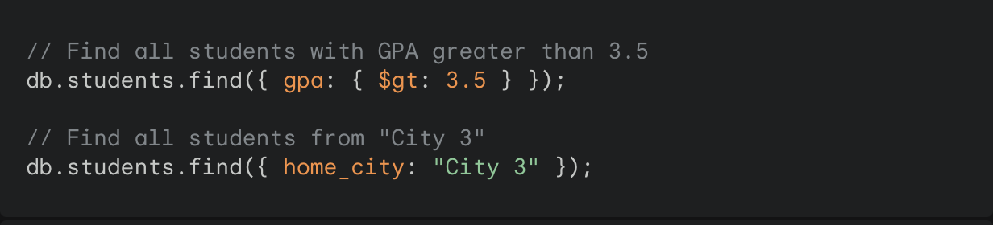

**Output**