**Session 4**

**Projection, Limit & Selectors**

* Use the projection document as the second argument to the find method.
* Include field names with a value of 1 to specify fields to be returned.
* Omit fields or set them to 0 to exclude them from the results.

**Get Selected Attributes**

* Given a Collection you want to FILTER a subset of attributes. That is the place Projection is used.

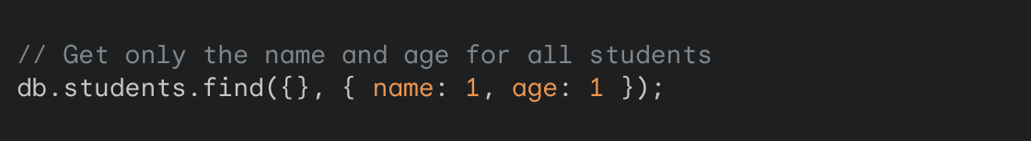

Ignore Attributes

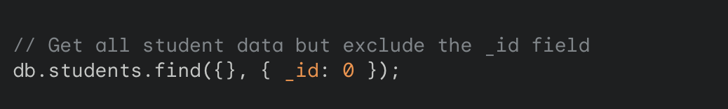

Retrieving Specific Fields from Nested Objects

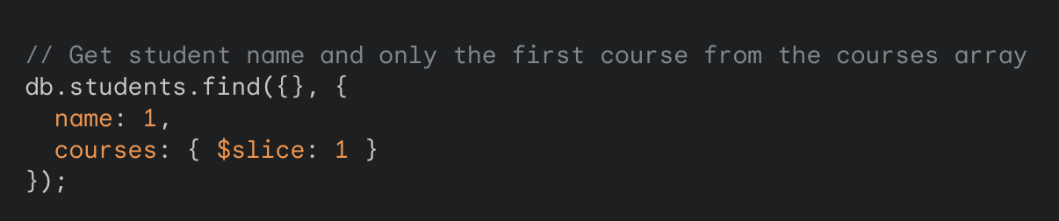

**Benefits of Projection**

* Reduces data transferred between the database and your application.
* Improves query performance by retrieving only necessary data.
* Simplifies your code by focusing on the specific information you need.

**Limit**The limit operator is used with the find method.

It's chained after the filter criteria or any sorting operations.

Syntax: db.collection.find({filter},{projection}).limit(number)

**Get First 5 document**

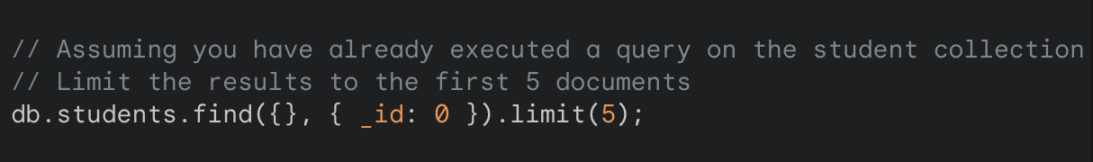

**Limiting Results**

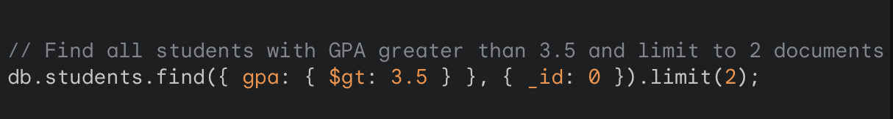

**I want Top 10 Results**

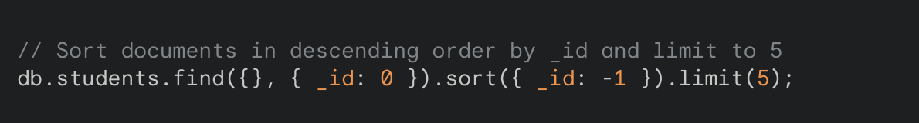

**Experiment 3 - Selectors**

**Comparison gt lt**

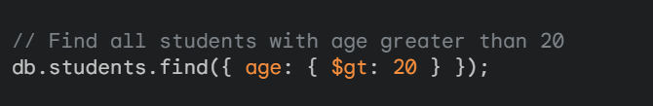

**AND operator**

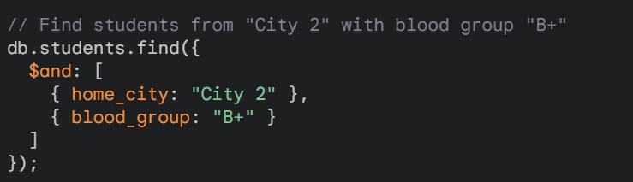

**OR operator**

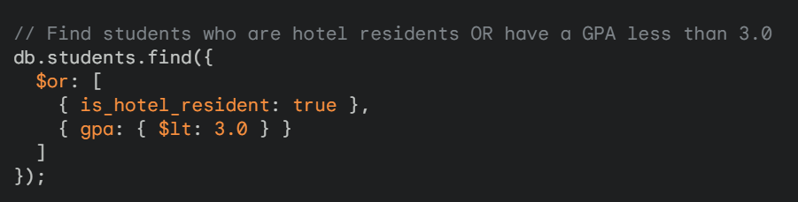

**Let’s Take new Data set**

* New Students Permission dataset [link](https://drive.google.com/file/d/1SM6UZS5GHAeZXGP62u7nNKGM8T_EZfcg/view?usp=sharing)

Explanation: Collection name: students_permission

name: Student's name (string)

age: Student's age (number)

permissions: Bitmask representing user permissions (number)

**Bitwise Value**

* In our example its a 32 bit each bit representing different things
* Bitwise value 7 means all access 7 -> 111

|  |  |  |
| --- | --- | --- |
| Bit 3 | Bit 2 | Bit 1 |
| cafe | campus | lobby |

**Bitwise Types**

**Bitwise Types**

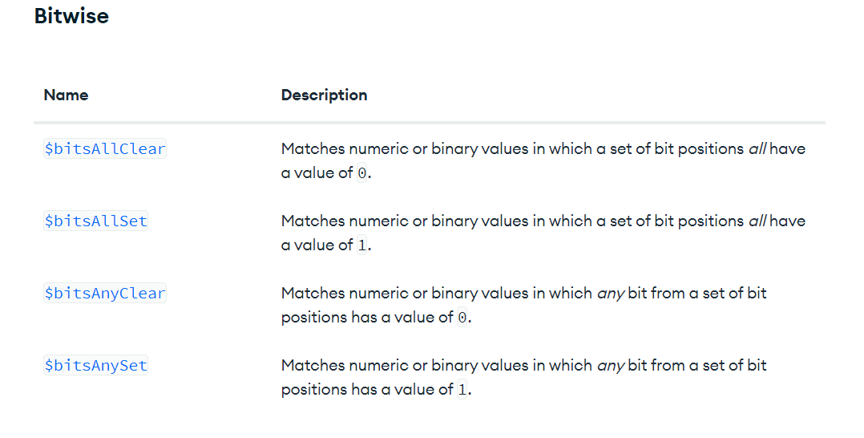

**Query**

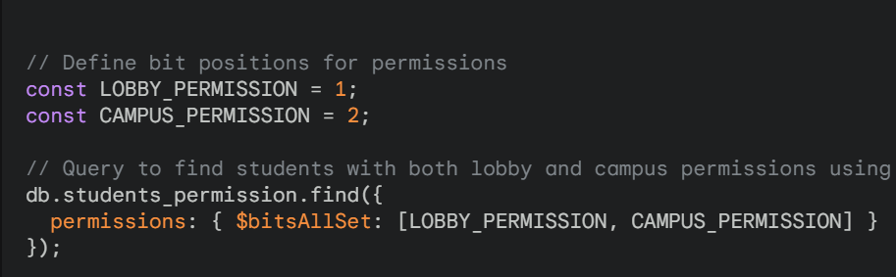

**Geospatial**

* Official Documentation [link](https://www.mongodb.com/docs/manual/geospatial-queries/)
* Create collection called “locations”
* Upload the dataset using json [link](https://drive.google.com/file/d/14M66QrNUDia2-XKsz9k1GUtzdJHztO_Z/view?usp=drive_link)

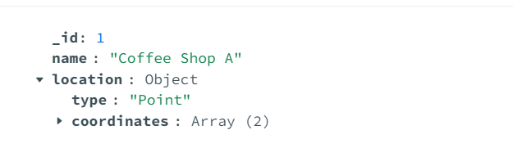**Geospatial Query**

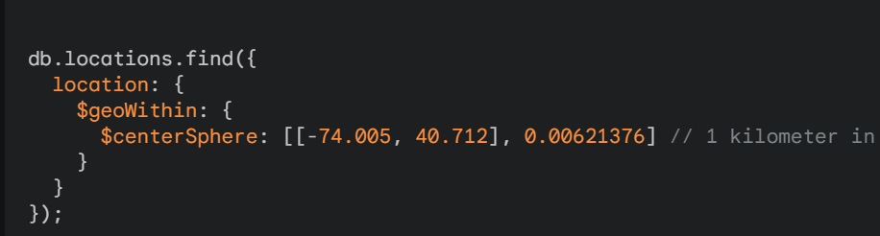

**Output**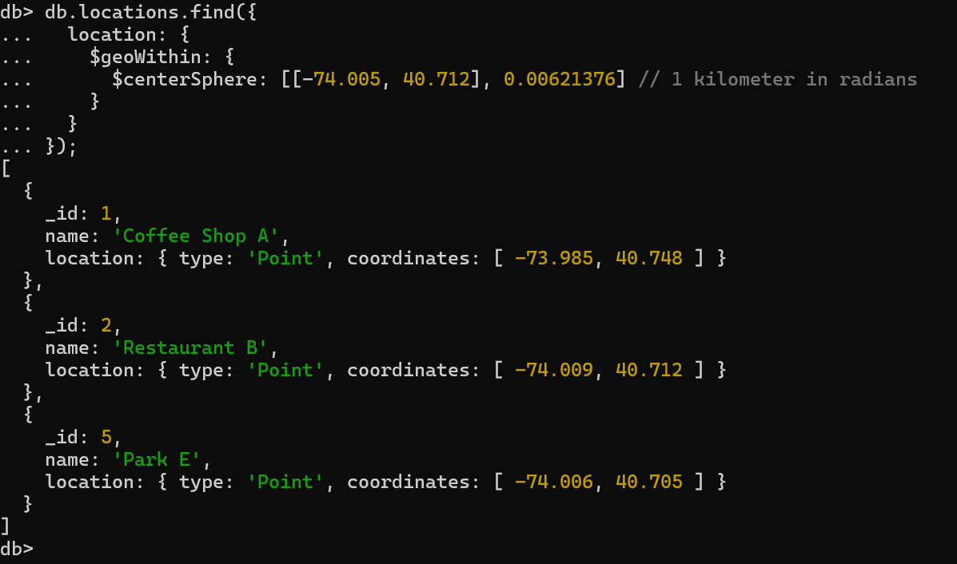

**Data types and Operations**

**DataType**

* + Point
  + Line String
  + Polygon

**Data types and Operations**

