**CHAPTER 3**

**DESIGN**

The chapter of the report describes the structure of the project, followed by Data Flow Diagram.

**3.1 DATA FLOW DIAGRAM AND ITS NOTATIONS**

A data flow diagram (DFD) is a graphical representation of the “flow” of the data through an information system, modeling its process aspects. A DFD is often used as preliminary step to create an overview of the system without going into great detail, which can later be elaborated. DFDs can also be used for the visualization of data processing.

A DFD shows what kind of information will be input to and output from the system, and where the data will be stored. It does not show information about processing timing whether processes will operate in sequence or in parallel, unlike a traditional structured flow chart which focuses on control flow, or a UML activity workflow diagram, which presents both control and data, flows as a unified model.

All data flow diagram include four main elements: entity, data store and data flow.

**External Entity** - Also known as actors, sources or sinks, and terminators, external entities produces and consume data that flows between the entity and the system being diagrammed. These data flows are the inputs and outputs of the DFD. Since they are external to the system being analyzed, these entities are typically placed at the boundaries of the diagram. They can represent another system or indicate a subsystem.

**Process** - An activity that changes or transforms data flows. Since they transform incoming data to outgoing data, all processes must have inputs and outputs on a DFD. This symbol is given a simple name based on its function, such as “Ship Order”, rather than being labeled “process” on a diagram. In Game-Sarson notation, a rectangular box is used and may be labeled with a reference number, location of where in the system the process occurs and a short title that describes its function. Processes are typically oriented from top to bottom and left to right on a data flow diagram.

**Data Store** - A data does not generate any operation but simply holds data for later access. Data stores could consist of files held long term or a batch of documents stored briefly while they wait to be processed. Input flows to a data store include information or operations that change stored data. Output flows would be data from the store.

**Data Flow –** Movement of data between external entities, processes and data stores is represented with a arrow symbol, which indicates the direction of flow. The data could be electronic, written or verbal. Input and output data flows are labelled based on the type of data or its associated process or data store, and this name is written alongside the arrow.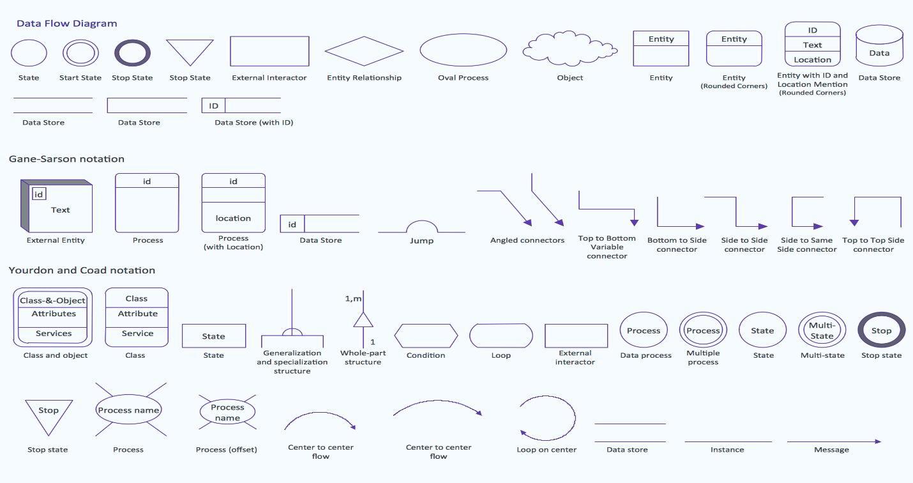

**Figure 3.1 Notations for Data Flow Diagram**

**3.1.1 DATA FLOW DIAGRAM EXAMPLE**

Database

Customer

input output

**3.1.2 DATA FLOW DIAGRAM**

DATABASE

USER

**Figure: Design Structure**