**CHAPTER 1**

**INTRODUCTION**

**1. FILE STRUCTURE**

File Structures is the Organization of Data in Secondary Storage Device in such a way

that minimize the access time and the storage space. A File Structure is a combination of

representations for data in files and of operations for accessing the data. A File Structure

allows applications to read, write and modify data. It might also support finding the data that

matches some search criteria or reading through the data in some particular order.

**1.1 GENERAL GOLAS OF FILE STRUCTURE**

• Get the information we need with one access to the disk.

• If that’s not possible, then the information with as few accesses as possible.

• Group information so that we are likely to get everything we need with only one trip

to the disk.

**2. BUFFER MANAGEMENT**

Buffering means working with large chunks of data in main memory so the number of

accesses to secondary storage is reduced.

“Buffer” is a place in memory (variable, object) that accumulates large chunks of data to be

later written to disk as a chunk.

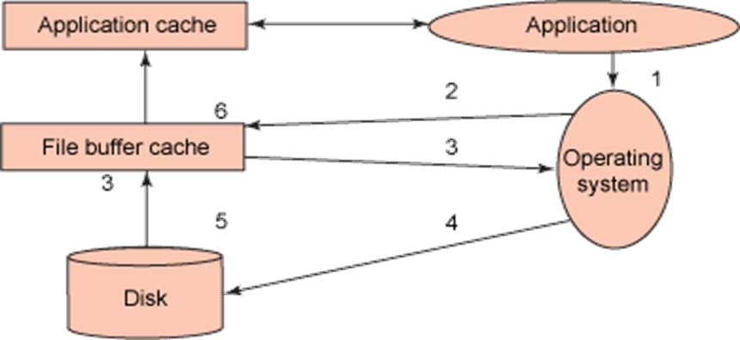

**3. SPACE RECLAMATION**

Space reclamation completes the process of freeing space from the storage system that

has been freed in the host file system. When a file is deleted in the host file system, the file

system metadata is updated to mark that file’s blocks as free space.

**3.1 Deleting Fixed-Length Records and Reclaiming Space**

How to use the space of deleted records for storing records that are added later?

Use an “avail list”, a linked list of available records.

• a header record (at the beginning of the file) stores the beginning of the avail list (-1 can

represent the null pointer).

• when a record is deleted, it is marked as deleted and inserted into the avail list. The record

space is in the same position as before, but it is logically placed into avail list.

Ex.: After deletions the file may look like:

List head → 4

|Edwards | Williams|*-1|Smith|*2|Sethi|

0 1 2 3 4 5

If we add a record, it can go to the first available spot in the avail list (RRN=4).