**INTRODUCTION TO COMPUTER HARDWARE**

Computer hardware includes the physical parts of a computer, such as the case, central processing unit (CPU), monitor, mouse, keyboard, computer data storage, graphics card, sound card, speakers and motherboard. By contrast, software is the set of instructions that can be stored and run by hardware.

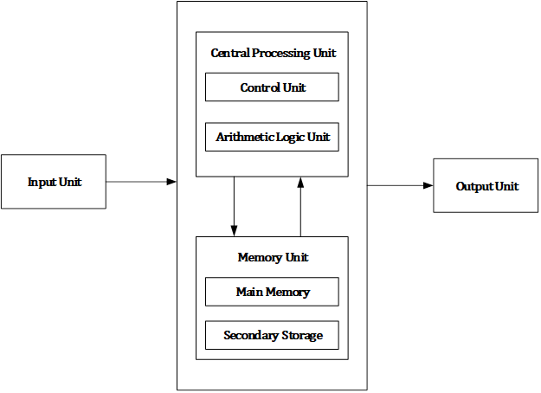

Computer hardware consists of different functional units: input unit, central processing unit (CPU) which consists arithmetic logic unit (ALU) and control unit (CU), memory unit and output unit.

**MAJOR COMPONENTS OF A COMPUTER SYSTEM**

1. **MOTHERBOARD**

The motherboard serves as a single platform to connect all of the parts of a computer

together. It connects the CPU, memory, hard drives, optical drives, video card, sound card, and other ports and expansion cards directly or via cables. It can be considered

as the backbone of a computer.

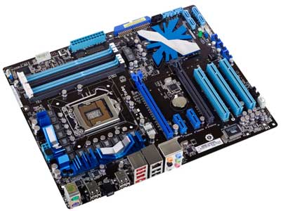

Features of Motherboard:

A motherboard comes with following features −

* Motherboard varies greatly in supporting various types of components.
* Motherboard supports a single type of CPU and few types of memories.
* Video cards, hard disks, sound cards have to be compatible with the motherboard to function properly.
* Motherboards, cases, and power supplies must be compatible to work properly together.

## Popular Manufacturers:

Following are the popular manufacturers of the motherboard.

* Intel
* ASUS
* AOpen
* ABIT
* Biostar
* Gigabyte
* MSI

1. **RAM MODULES**

A narrow printed circuit board that holds memory chips (RAM chips). The common

architecture for desktop computers is the dual inline memory module (DIMM), which

transfers 64 bits at a time. Because of space limitations, laptops use small outline

DIMMs (SODIMMs). The modules are keyed with notches in different places so they

cannot be inserted into the wrong slots

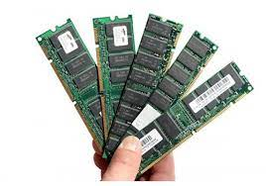

1. **DAUGHTER CARDS**

A daughter card or daughterboard is a type of circuit board that gets added to an existing one. Its name is appropriate for its use, since it is connected to a “motherboard” or “mainboard.” The motherboard is the primary circuit board for a device. It is usually in the device as it is shipped from the factory.

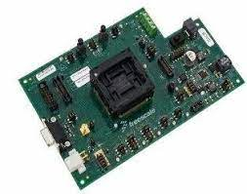

1. **BUS SLOTS**

Alternatively known as a bus slot or expansion port, an expansion slot is a connectionor port inside a computer on the motherboard or riser card. It provides an installation point for a hardware expansion card to be connected.

Different types of expansion slots:

* PCI Express – Video card.
* AGP – Video card.
* ISA – Network card, Sound card, Video card.
* AMR – Modem, Sound card.
* CNR – Modem, Network card, Sound card.

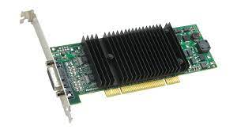

**5.SMPS**

SMPS is **Switched Mode Power Supply** also known as **Switching Mode Power Supply.** SMPS is an electronic power supply system that makes use of a switching regulator to transfer electrical power effectively. It is a PSU (power supply unit) and is usually used in computers to change the voltage to the appropriate range for the computer.

### Benefits of SMPS:

* The switch-mode power source is small in scale.
* The SMPS is very lightweight.
* SMPS power consumption is typically 60 to 70 per cent, which is ideal for use.
* SMPS is strongly anti-interference.
* The SMPS production range is large.

### Limitations of SMPS:

* The complexity of SMPS is very large.
* The production reflection is high and its control is weak in the case of SMPS.
* Use of SMPS can only be a step-down regulator.
* In SMPS, the voltage output is just one.

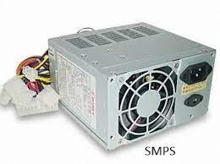

**6. INTERNAL STORAGE DEVICES**

Internal storage devices mean devices that are embedded in your computer or the storage devices that were given to you in your computer during its manufacturing.

Most computers have some form of internal storage. The most common type of internal storage is the hard disk. At the most basic level, internal storage is needed to hold the operating system so that the computer is able to access the input and output devices.

It will also be used to store the applications software that you use and more than likely, the original copies of your data files.

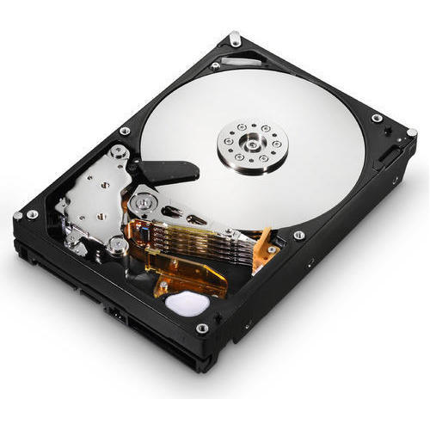

**7. INTERFACING PORTS**

This can connect all kinds of external USB devices, like external hard disk, printer, scanner, mouse, key board, etc. There are minimum of two USB Ports provided in most of the computer systems.

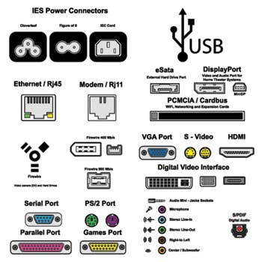

Types of Computer Ports:

1. Serial port.
2. Parallel port.
3. USB port.
4. PS/2 port.
5. VGA port.
6. Modem port.
7. FireWire Port.
8. Sockets.
9. Game port
10. Modem port
11. Digital video interface port
12. Ethernet port
13. Display port
14. Audio port
15. HDMI

**SPECIFICATIONS OF DESKTOP AND SERVER CLASS COMPUTERS**

### **Server Classes:**

When multithreaded operating system processes are not available, a good alternative is to use a set of processes to emulate a pool of threads. That is, instead of having one multithreaded process, the system uses a set of single-threaded processes, all of which are running the same program. This often is called a **server class**. In this case, for each server program, there is a set of server processes that runs it.

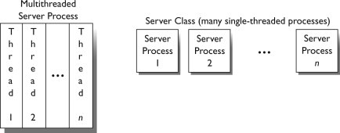

[Server Class](https://www.lawinsider.com/dictionary/server-class) means a host that is primarily designed to act as a server, accepting and servicing network requests from multiple clients. The operating system on such hosts is typically designed to handle server workloads. For Microsoft Windows, server class operating systems are typically identified by year (e.g. Windows 2012); for SUSE Linux, by name (e.g. SUSE Linux Enterprise Server); other vendors may use similar designations.

### **PC Desktop Hardware Specifications:**

* **Motherboard:** Gigabyte B560M-DS3H Motherboard
* **Power Supply:**Scaled appropriately to support delivered system with reasonable growth potential (In Win CE685 PC case with 300 watt 80PLUS certified power supply)
* **Case:**In Win CE685 PC case with 300 watt 80PLUS certified power supply
* **CPU:** Intel Core i5-11400 Processor
* **RAM:**8GB DDR4 2666 (PC4 21333) RAM (1 8GB DIMM)
* **NIC:**On-board 10/100/1000 Mbps based Ethernet NIC
* **HDD:** 250 GB Western Digital M.2 NVMe SSD Part # WDS250G2B0C
* **Video:**Integrated Intel HD Graphics with DVI Digital Output Interface
* **Optical Drive:** (optional)
* **Audio:** Onboard HD audio
* **Externally powered Satellite Speakers:**(optional)
* **6 External Powered USB Ports and 2 on front of case**
* **Operating System:**Microsoft Windows 7 Home Basic(or other least expensive Microsoft Windows operating system)
* **All appropriate cables necessary**
* **HIDs:** USB Optical mouse, mouse pad, USB keyboard, all necessary cables
* **3 year parts and labor warranty on all components**
* **Monitor:** 20″ Wide Screen LCD Monitor (1920×1080 native resolution) with DVI Digital Input Interface

### **PC Laptop Specifications:**

There is currently 1 laptop model specified for new purchases

* Intel Core i5-1135G7 Processor
* 8GB DDR4 2666 RAM
* 250 GB M.2 NVMe Solid State Drive
* 15.6″ Wide Screen Display
* Microsoft Windows Windows 7 Pro(or other least expensive Microsoft Windows operating system)
* On board 10/100/1000 Mbps Ethernet NIC
* On board Wireless NIC
* On board HD Audio
* 2 External powered USB Ports
* Padded Carry Case appropriate for delivered model
* Appropriate American Power Conversions Notebook Surge Suppressor for delivered model
* All appropriate cables necessary
* 3 year parts and labor warranty on all components

Any laptop purchase should also include a case.