
RAJALAKSHMI INSTITUTE OF TECHNOLOGY
BELIEVE IN THE POSSIBILITIES
(AN AUTONOMOUS INSTITUTION)

RAJALAKSHMI INSTITUTE OF TECHNOLOGY
(An Autonomous Institution, Affiliated to Anna University, Chennai)

DEPARTMENT OF CSE (ARTIFICIAL INTELLIGENCE AND MACHINE LEARNING)
ACADEMIC YEAR 2025 – 2026 SEMESTER III

OBJECT ORIENTED PROGRAMMING MINI PROJECT REPORT

REGISTER NUMBER | 2117240030103
NAME | J.K. PRATHICK
PROJECT TITLE | CAFETERIA BILLING SYSTEM
DATE OF SUBMISSION
FACULTY IN-CHARGE | Mrs. A. Lizy

Signature of Faculty In-charge: _______________________

PO–PSO Mapping Table
PO1 | PO2 | PO3 | PO4 | PO5 | PO6 | PO7 | PO8 | PO9 | PO10 | PO11 | PO12 | PSO1 | PSO2 | PSO3
3 | 3 | 3 | 2 | 2 | 1 | - | 3 | 2 | 2 | - | - | 3 | 2 | 1

PSO JUSTIFICATION
PSO | Relevance | Justification
PSO1 – Apply fundamental computing knowledge | 3 | Implements object-oriented concepts with database connectivity for real-world use
PSO2 – Design and implement software systems | 2 | Builds a modular billing system with item management and order tracking.
PSO3 – Use modern tools and technologies | 1 | Uses MySQL Workbench and Swing libraries to create a fully functional billing application.

PO JUSTIFICATION
PO | Relevance | Justification
PO1 – Engineering Knowledge | 3 | Applies Java programming and database connectivity principles to design a real-time billing system
PO2 – Problem Analysis | 3 | Identifies the problem of manual billing and proposes an automated solution using Swing and MySQL.
PO3 – Design/Development of Solutions | 3 | Designs a GUI that dynamically interacts with the backend to generate accurate bills.
PO4 – Conduct Investigations of Complex Problems | 2 | Tests system behaviour under various scenarios like multiple orders and invalid inputs.
PO5 – Modern Tool Usage | 2
  Utilizes VS Code, JDBC, and MySQL for integration and testing.
PO6 – The Engineer and Society | 1 | Promotes digital transactions and paperless billing.
PO8 – Ethics | 3 | Ensures transparency and accuracy in billing operations.
PO9 – Individual and Team Work | 2 | Demonstrates collaborative development between GUI and database modules.
PO10 – Communication | 2 | Provides clear, interactive messages through dialog boxes and documentation.

INTRODUCTION:
The Cafeteria Billing System is a desktop application designed using Object-Oriented Programming principles in Java. It automates the billing process in cafeterias by providing an easy-to-use graphical user interface built with Java Swing and MySQL for backend storage.
The system allows users to select menu items, specify quantities, and generate bills automatically, minimizing manual errors. The use of JDBC ensures smooth communication between the GUI and database.
This project demonstrates the integration of programming logic with database operations using modular class structures, encapsulation, and event-driven programming. It helps reduce billing time and ensures data accuracy, offering an efficient digital solution for small food outlets and cafeterias.
PROJECT DISTRIBUTION:
The Cafeteria Billing System simplifies daily operations by automating menu management and bill generation. The system retrieves available items from the MySQL database and displays them in the Swing interface for selection.
When a user selects an item and quantity, the application calculates the total cost and displays it on the bill panel. The program also maintains records of orders for future tracking.
Developed using Java Swing, it features a responsive interface, multiple control buttons (Add, Clear, Total), and an integrated database connection via JDBC. The project demonstrates OOP concepts like classes, objects, constructors, and methods while ensuring secure database interaction and real-time computation.

SYSTEM ARCHITECTURE:

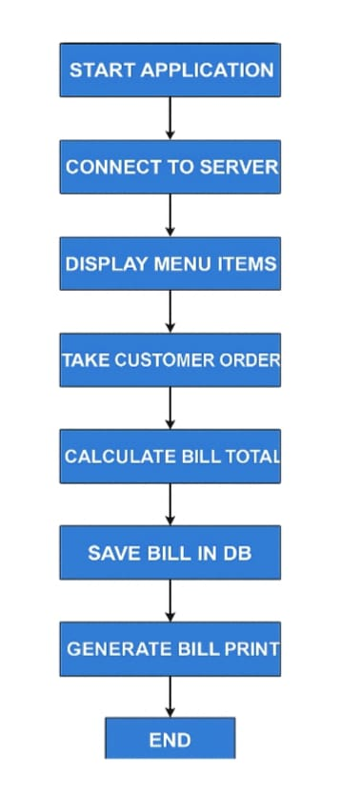

PROCEDURE:
- Launch the project from CafeteriaBillingSystem.java main class in VS Code.
- The GUI window loads, connecting automatically to the MySQL database.
- Menu items are fetched from the database and displayed in a drop-down list.
- The user selects items and quantities, then clicks Add Item.
- The item is added to the bill area with price details.
- Clicking Total computes the final bill amount.
- The Clear button resets the fields for a new order.
- Database records are updated accordingly to maintain item data.

CODE:
1.Database Setup (MySQL):
CREATE DATABASE cafedb;
USE cafedb;

CREATE TABLE items (
id INT AUTO_INCREMENT PRIMARY KEY,
name VARCHAR(100),
price DOUBLE
);
INSERT INTO items (name, price) VALUES
('Coffee', 25),
('Tea', 20),
('Sandwich', 50),
('Burger', 70),
('Juice', 40);

2. Main.java:
package RSVP;

import javax.swing.*;
import java.awt.*;
import java.awt.event.*;
import java.sql.*;

public class EventRSVPGUI extends JFrame implements ActionListener {
JTextField nameField, emailField, eventField, dateField;
JButton addBtn, rsvpBtn, viewParticipantsBtn, viewRSVPBtn;
JTextArea displayArea;
Connection con;

public EventRSVPGUI() {
con = DBConnection.getConnection();
setTitle("Online Event RSVP System");
setSize(520, 420);
setLayout(new FlowLayout());
setDefaultCloseOperation(EXIT_ON_CLOSE);

add(new JLabel("Name:"));
nameField = new JTextField(15);
add(nameField);

add(new JLabel("Email:"));
emailField = new JTextField(15);
add(emailField);

addBtn = new JButton("Add Participant");
addBtn.addActionListener(this);
add(addBtn);

add(new JLabel("Event Name:"));
eventField = new JTextField(10);
add(eventField);

add(new JLabel("RSVP Date (YYYY-MM-DD):"));
dateField = new JTextField(10);
add(dateField);

rsvpBtn = new JButton("RSVP Event");
rsvpBtn.addActionListener(this);
add(rsvpBtn);

viewParticipantsBtn = new JButton("View Participants");
viewParticipantsBtn.addActionListener(this);
add(viewParticipantsBtn);

viewRSVPBtn = new JButton("View RSVPs");
viewRSVPBtn.addActionListener(this);
add(viewRSVPBtn);

displayArea = new JTextArea(10, 40);
add(new JScrollPane(displayArea));

setVisible(true);
}

public void actionPerformed(ActionEvent e) {
try {
if (e.getSource() == addBtn) {
String name = nameField.getText();
String email = emailField.getText();

PreparedStatement ps = con.prepareStatement(
"INSERT INTO participants(name, email) VALUES (?, ?)"
);
ps.setString(1, name);
ps.setString(2, email);
ps.executeUpdate();
displayArea.setText("✅ Participant Added!");

} else if (e.getSource() == rsvpBtn) {
String name = nameField.getText();
String event = eventField.getText();
String date = dateField.getText();

// prevent duplicate RSVP for same person & event
PreparedStatement check = con.prepareStatement(
"SELECT * FROM rsvp WHERE participant_name=? AND event_name=?"
);
check.setString(1, name);
check.setString(2, event);
ResultSet rs = check.executeQuery();

if (rs.next()) {
displayArea.setText("⚠️ Already RSVP'd for this event!");
} else {
PreparedStatement ps = con.prepareStatement(
"INSERT INTO rsvp(participant_name, event_name, rsvp_date) VALUES (?, ?, ?)"
);
ps.setString(1, name);
ps.setString(2, event);
ps.setString(3, date);
ps.executeUpdate();
displayArea.setText("✅ RSVP Successful!");
}

} else if (e.getSource() == viewParticipantsBtn) {
Statement st = con.createStatement();
ResultSet rs = st.executeQuery("SELECT * FROM participants");
displayArea.setText("--- Participant List ---\n");
while (rs.next()) {
displayArea.append(rs.getInt(1) + " | " + rs.getString(2) + " | " + rs.getString(3) + "\n");
}

} else if (e.getSource() == viewRSVPBtn) {
Statement st = con.createStatement();
ResultSet rs = st.executeQuery("SELECT * FROM rsvp");
displayArea.setText("--- RSVP List ---\n");
while (rs.next()) {
displayArea.append(rs.getInt(1) + " | " + rs.getString(2) +
" | " + rs.getString(3) + " | " + rs.getString(4) + "\n");
}
}

} catch (Exception ex) {
displayArea.setText("❌ Error: " + ex.getMessage());
}
}

public static void main(String[] args) {
new EventRSVPGUI();
}
}

SCREENSHOTS:

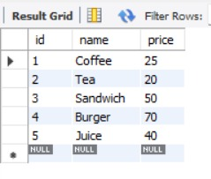
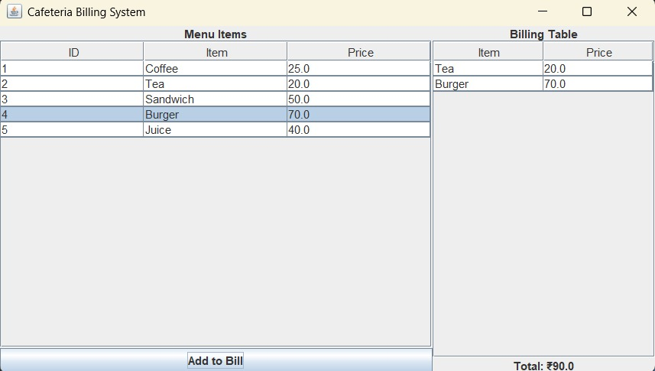

DESCRIPTION:
The Cafeteria Billing System is a Java-based application designed to automate and simplify the billing process in cafeterias. It enables users to select menu items, enter quantities, and generate accurate bills instantly through a user-friendly graphical interface. By reducing manual effort and calculation errors, the system improves efficiency and accuracy in daily operations. With optional MySQL database integration, it can also store menu details and order records, making it a reliable and efficient solution for modern cafeteria management.

CONCLUSION:
The Cafeteria Billing System successfully demonstrates the implementation of object-oriented programming concepts in a real-time application. It automates the manual billing process, improving efficiency, accuracy, and user convenience. The system provides an interactive user interface, seamless database connectivity, and reliable performance.
Through this project, various Java principles such as event handling, GUI design using Swing components, and database integration using JDBC were effectively applied. It showcases how software solutions can replace traditional manual processes with digital systems, reducing errors and improving productivity.

FUTURE WORK:
The project can be further enhanced by adding more advanced features such as:
- Admin Login System – to allow authorized staff to manage menu items, update prices, and view reports.
- Daily Sales Report Generation – to automatically record all transactions and generate printable reports.
- Inventory Management Module – to track ingredient stock levels and update quantities in real time.
- Digital Payment Integration – enabling UPI or card-based payments within the system.
- Multi-user Access and Cloud Storage – allowing multiple billing counters to operate simultaneously with centralized data storage.
- Web or Mobile Version – extending the system into an online platform for greater accessibility.

GITHUB LINK :

