22CST41 – Database Management Systems
ASSIGNMENT – 3
SQL Query Practice
Student Name: Kanishk AM
Register Number: 732924CSR070
Course Name: Database Management System
Assignment Title: Assignment_3 - SQL Query Practice

Sample Table: Employee
Table Creation & Data Insertion SQL:
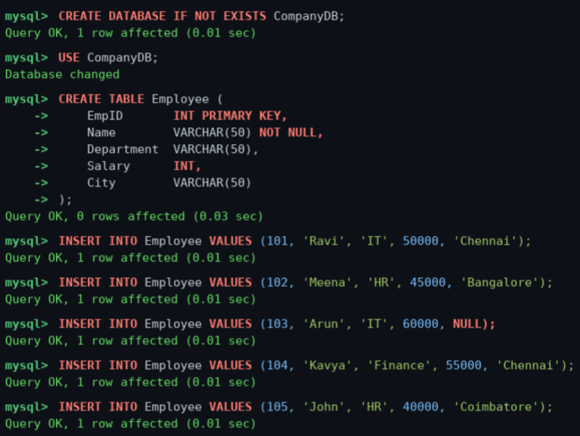

SQL Practice Questions – Query Execution
Query 1: Display all records from the Employee table
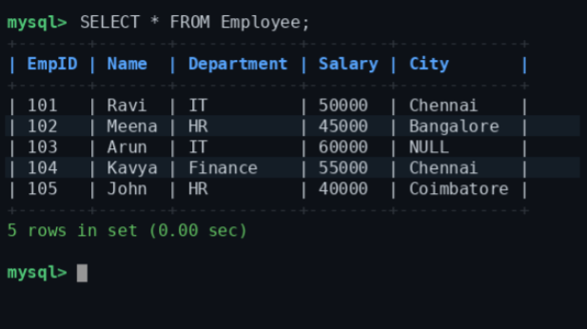

Query 2: Display only the Name and Salary of employees

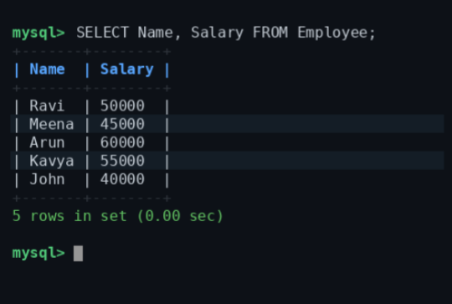

Query 3: Display employees whose salary is greater than 50,000

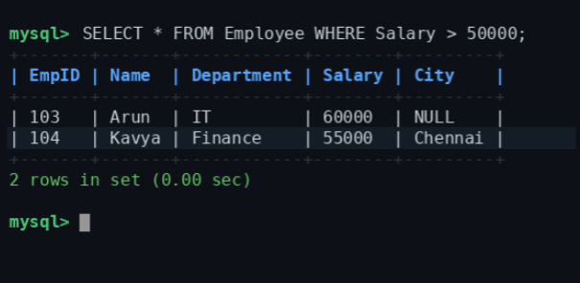

Query 4: Display employees who belong to the IT department

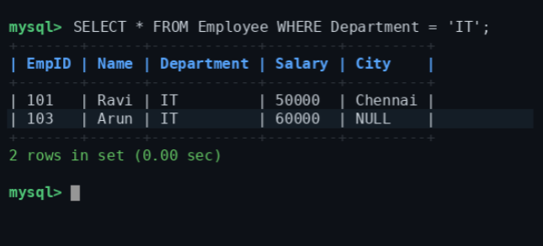

Query 5: Display employees whose city is Chennai
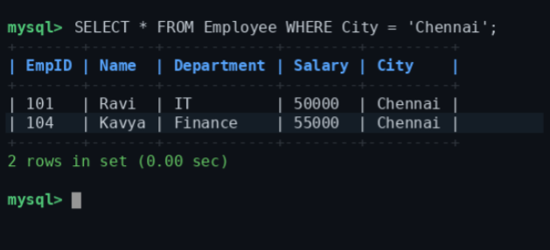

Query 6: Display employees whose salary is between 40,000 and 60,000

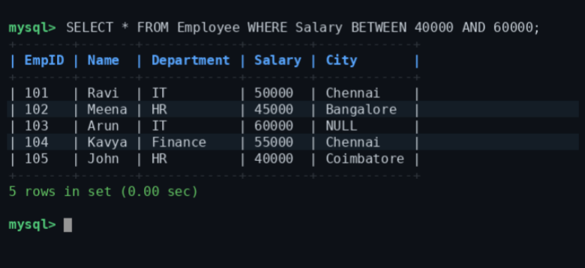

Query 7: Display employee names that start with the letter 'A' using LIKE

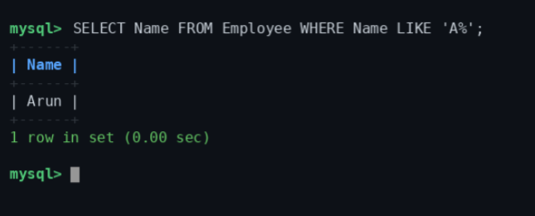

Query 8: Display distinct departments from the Employee table

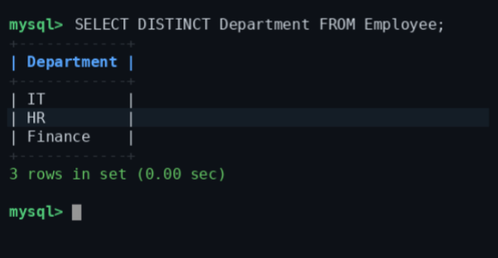

Query 9: Display employees whose City value is NULL

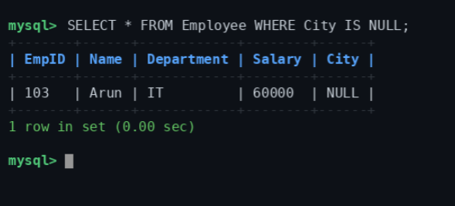

Query 10: Find the total salary paid to all employees

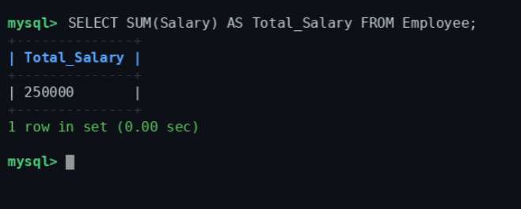

Query 11: Find the average salary of employees in the IT department

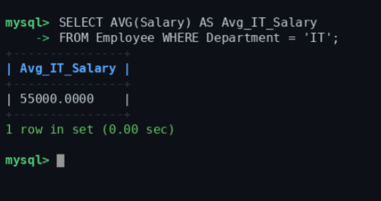

Query 12: Count the number of employees in each department using GROUP BY

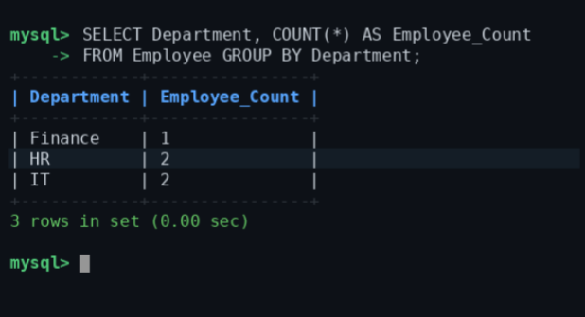

Query 13: Display employees whose salary is greater than the average salary

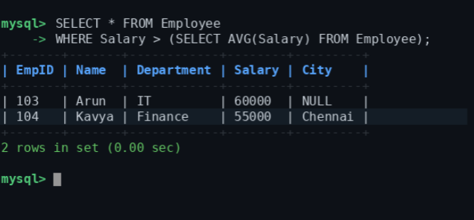

Query 14: Insert a new employee record

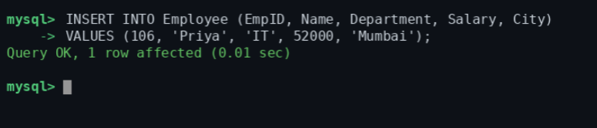

Query 15: Update the salary of employee with EmpID = 105 to 48000

