Full Paper Title
Author Name  Department, Institution,  Country  author@email.com | Author Name  Department, Institution,  Country  author@email.com | Author Name  Department, Institution,  Country  author@email.com | Author Name  Department, Institution,  Country  author@email.com
Author Name  Department, Institution,  Country  author@email.com | Author Name  Department, Institution,  Country  author@email.com | Author Name  Department, Institution,  Country  author@email.com | Author Name  Department, Institution,  Country  author@email.com

Manuscript length, including references and all figures/tables, must not exceed 12 pages when formatted with this template.

Abstract - The Abstract and Index Terms text should be 10-point Times New Roman, bold italic, fully justified, and contained within one paragraph. Begin the Abstract with the word “Abstract.” Do not indent. Use a hyphen, not a long dash, after the word “Abstract.” The Abstract should be about 150–250 words. Do not cite references or use abbreviations in the Abstract. Replace this placeholder with your own abstract text before submission.
INSTRUCTIONS: Leave one blank line between the Abstract and Index Terms. Keep it in the same pattern.
Index Terms - About four to six key words or phrases, in alphabetical order, separated by commas, with only the first term capitalized.

I. INTRODUCTION
INSTRUCTIONS: Two-column formatting is mandatory from this point through the References. Columns are 3.25 in wide with a 5/16 in gap, text fully justified in 10-pt Times New Roman, single-spaced.
Replace this paragraph with your introduction text. State the problem, motivation, and the specific contribution of the work. Provide enough background for a reader outside your immediate sub-field to follow the significance of the research gap being addressed. Introductions typically run 400–700 words across two to four paragraphs.
The final paragraph of the Introduction should summarize your contributions, ideally as a short list, followed by a one-sentence outline of the remaining sections, e.g. “Section II

Received 10th March 2026; revised 29th July 2026; accepted 02th August 2026.
Corresponding author name & Email:
Fabio Pareschi.
author@email.com
reviews related work; Section III describes the proposed method; Section IV presents results; Section V concludes the paper.”

II. RELATED WORK
Summarize prior work relevant to your contribution, grouped thematically rather than described paper by paper. Position your contribution relative to at least two to three distinct threads of prior work. Every claim referencing earlier work must carry an in-text citation, e.g. [1], [2]–[4]. Close this section with one or two sentences that make the gap your paper fills explicit.

III. PAGE LAYOUT AND FORMATTING
The main title (page 1 only) should be centered, 24-point Times New Roman, with the first letter of each major word capitalized. Author names, affiliations, and email addresses are centered beneath the title in 12-point, non-bold Times New Roman; affiliations are italicized. For more than three authors, wrap to a new row rather than compressing the type.
All body text below the Abstract must be set in a two-column format. Each column is 3.25 inches (8.25 cm) wide with a 0.3125-inch (0.8 cm) gap between columns. Body text is 10-point Times New Roman, single-spaced, and fully justified — flush left and flush right. Do not insert extra blank lines between paragraphs; use the first-line indent (approximately 0.17 in) instead.
Top and bottom margins are 1 inch (2.54 cm); left and right margins are 0.75 inch (1.9 cm). Do not write or print anything outside the defined print area. Use automatic hyphenation and check spelling before submission.
INSTRUCTIONS: The manuscript, including the title page, references, and all figures and tables, must not exceed 12 pages total in this two-column format. Manuscripts exceeding 12 pages will be returned for shortening before entering peer review.

IV. FIGURES AND TABLES
Figures and tables must be numbered separately and referenced in the text before they appear, e.g. “as shown in Figure 1” or “see Table I.” Figure captions are centered below the figure in 9-point Times New Roman, using small caps for the label (“FIGURE 1.”) and sentence case for the description. Table titles appear above the table, left-justified, in the same style. Figures are in 300dpi format.
Leave 6 points of space between a figure/table and the surrounding text. If an image or dataset was not originated by the author, credit the source directly beneath the figure in 9-point italic Times New Roman (“Source: …”).
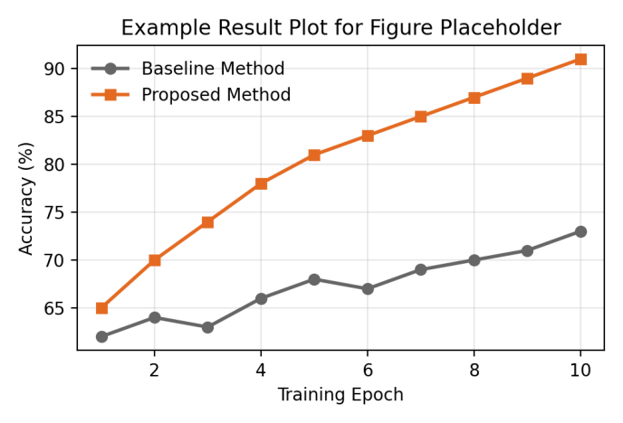
Figure 1. Example result plot — this is a randomly generated sample chart showing how a figure should be sized, centered, and captioned. Replace it with your own figure.
Source: Author’s own work. (Delete this line if the figure is original to this paper.)
Large figures and tables may span both columns if needed for legibility; place spanning elements at the top or bottom of a page, not mid-column. Use PNG or JPEG format for embedded raster images and vector formats (PDF, EPS) for line art and plots wherever possible.

Table I. Example comparison table — baseline vs. Proposed method across seven evaluation metrics, with a shaded header row and alternating row shading for readability.
Metric | Baseline | Proposed | Improvement
Accuracy (%) | 84.2 | 91.6 | +7.4
Precision (%) | 81.5 | 89.3 | +7.8
Recall (%) | 79.8 | 88.1 | +8.3
F1-score (%) | 80.6 | 88.7 | +8.1
Inference time (ms) | 142 | 97 | −45
Model size (MB) | 58.3 | 31.2 | −27.1
Params (millions) | 24.6 | 12.9 | −11.7

V. EQUATIONS AND NOTATION
Number equations consecutively, with the number in parentheses flush with the right margin of the column, as in (1). To keep equations compact, use the solidus (/), the exponential function, or appropriate exponents rather than stacked fractions.
E = mc² (1)
Italicize Roman symbols used for quantities and variables (e.g. m, c); do not italicize Greek symbols. Use an em dash for a range and a minus sign (not a hyphen) for negative values. Every symbol must be defined in text before, or immediately after, the equation in which it first appears. Refer to equations in running text as “(1)” — or “Equation (1)” only at the start of a sentence.
Use a leading zero before decimal points (“0.25,” not “.25”). Spell out units when they appear in running text (“a few henries,” not “a few H”), but use standard abbreviations inside equations and tables.

VI. CITATIONS AND REFERENCES
Cite references in the text by number in square brackets, in the order first cited: [1], [2], [3]–[5]. Do not cite references by author name in running text (e.g. avoid “Smith [3] showed …” unless the sentence specifically discusses that author’s methodology). Every reference listed must be cited at least once in the body text, and every in-text citation must correspond to an entry in the reference list.
Format each reference following IEEE style: author initials and surname, the title of the work in quotation marks, the journal or conference name in italics, volume, issue, page range, and date. See the References section at the end of this template for worked examples.

VII. PROPOSED METHOD

A. System Overview
Describe the overall architecture or approach at a level a reader can follow without consulting external material. A system diagram (Figure 1 style, above) is strongly encouraged here.
1. Discuss if you have multiple sub section using this way.

B. Implementation Details
Describe algorithms, equations, datasets, and design choices in enough detail for another researcher to reproduce the work. Where an algorithm is central to the contribution, present it as numbered pseudocode inside a bordered box, captioned in the same style as a figure (“Algorithm 1. …”).

C. Experimental Setup
State the hardware/software environment, dataset splits, hyperparameters, and evaluation metrics used, so that reported results in Section VIII can be interpreted and reproduced.

VIII. RESULTS AND DISCUSSION
Present results with appropriate figures, tables, and statistical detail (means, standard deviations, confidence intervals, or significance tests as appropriate to the field). Discuss the significance of results in relation to the contributions stated in the Introduction and to the prior work cited in Section II — do not simply restate numbers already shown in a table.
Where applicable, include an ablation or comparison table showing your method against at least one baseline. Clearly state any negative or unexpected results rather than omitting them; a well-discussed limitation strengthens the paper more than an unexplained gap in the results.

IX. CONCLUSION
Summarize the key findings and their implications in three to five sentences. State limitations of the current work honestly, and briefly indicate concrete directions for future work. Do not introduce new results, figures, or citations in this section.

ACKNOWLEDGMENT
Acknowledge funding sources, technical assistance, or institutional support here. This section is optional and, if included, should not exceed 60–80 words.

REFERENCES
INSTRUCTIONS: List references in the order first cited in the text, numbered [1], [2], [3]… with a hanging indent, following IEEE reference style. Do not alphabetize.
- T. Author , S. Author, J. Author, and H. Author, “Full Paper Title,” IJASF , vol. 01, pp. 100–162, Sept. 2026, doi: 10.XX0X/XXXX.2025.XXXXXXX.
- T. Author , S. Author, J. Author, and H. Author, “Full Paper Title,” IJASF , vol. 01, pp. 100–162, Sept. 2026, doi: 10.1XX/XXXX.2025.XXXXXXX.
- T. Author , S. Author, J. Author, and H. Author, “Full Paper Title,” IJASF , vol. 01, pp. 100–162, Sept. 2026, doi: 10.XX0X/XXXX.2025.XXXXXXX.
- T. Author , S. Author, J. Author, and H. Author, “Full Paper Title,” IJASF , vol. 01, pp. 100–162, Sept. 2026, doi: 10.XX0X/XXXX.2025.XXXXXXX.

