**NORMALIZATION**

It is the process of organizing the data in database. Normalization is used to minimize the redundancy from a relation or a set of relations. Normalization divides the larger table into smaller table and links them using relationship.

**TYPES OF NORMALIZATION**

1. 1NF
2. 2NF
3. 3NF
4. **1NF:** A relation is said to be in 1NF if it contains an atomic value.

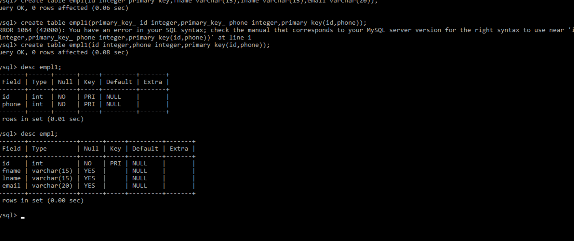

1. **2NF**: A relation will be in 2NF if it is in 1NF and all non-key attributes are fully functional dependent on the primary key.

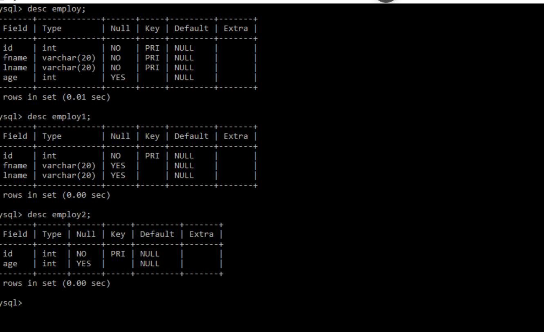

1. **3NF:** A relation will be in 3NF if it is in 2 NF and no transitive dependency exits.

