1. $ uname: Gives the system information
2. S uname –a:

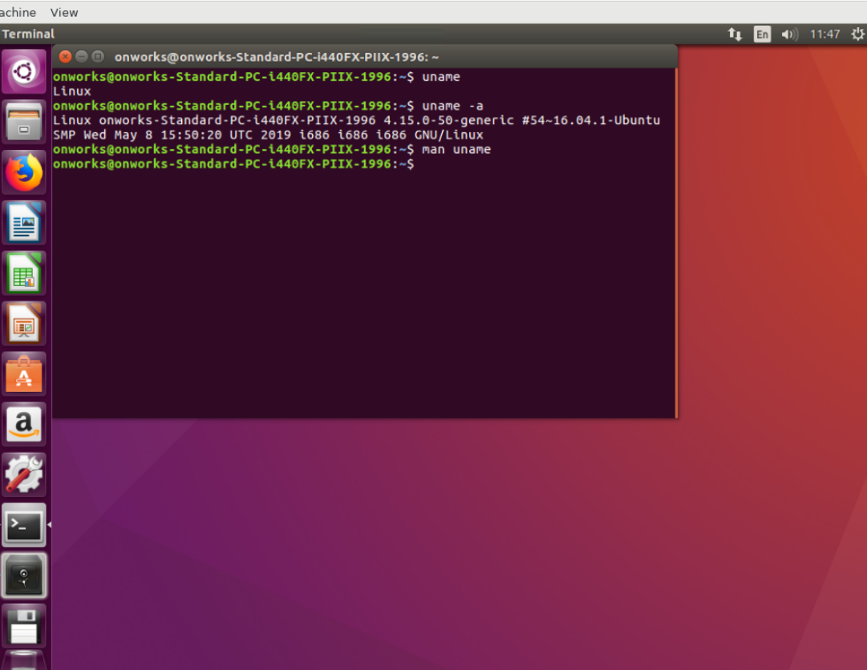

3. $ history: Gives the history which you have typed recently.

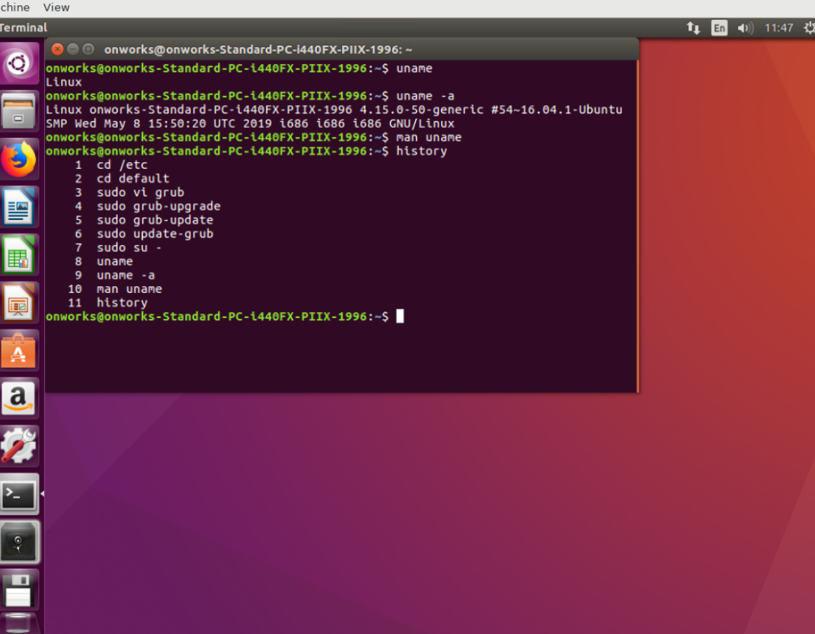

4.$ wget: whet is used to resolve, whether the website is valid or not.

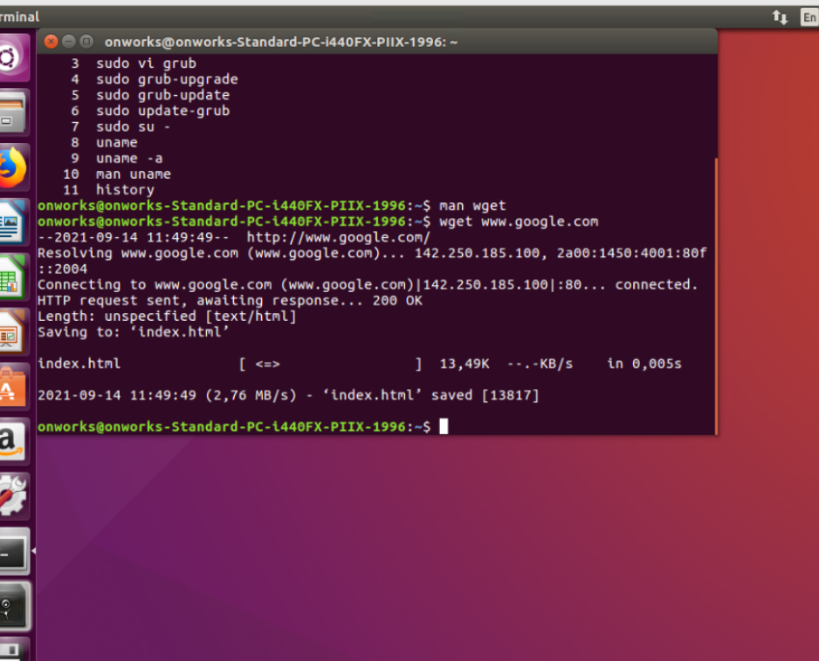

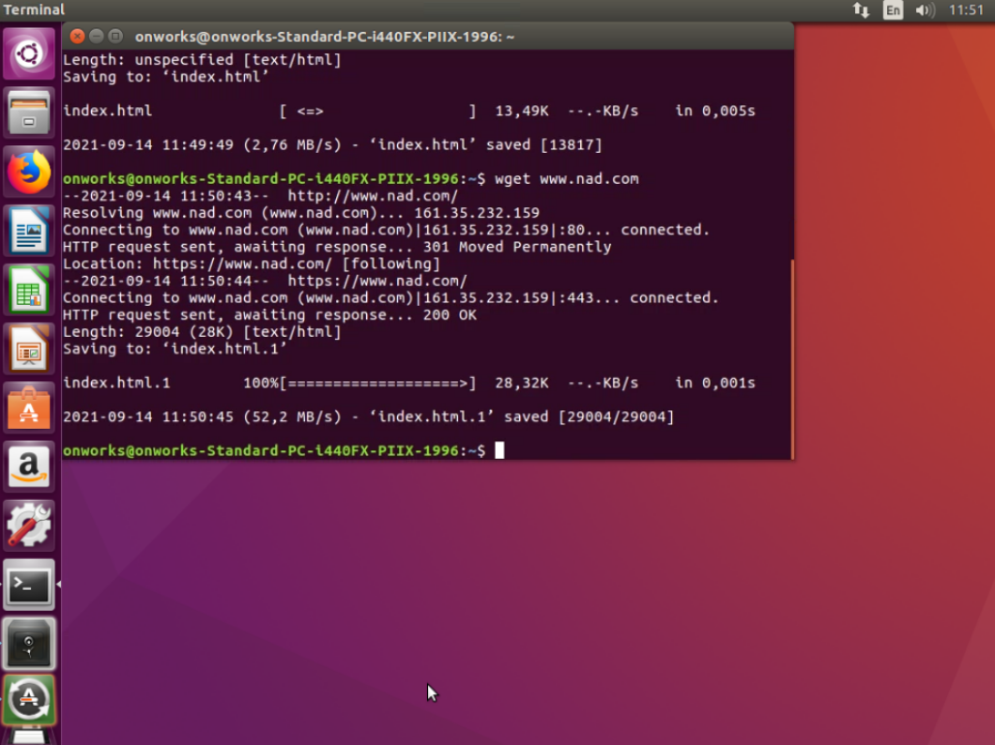

5. $ ifconfig –a: display inetaddress and packets.

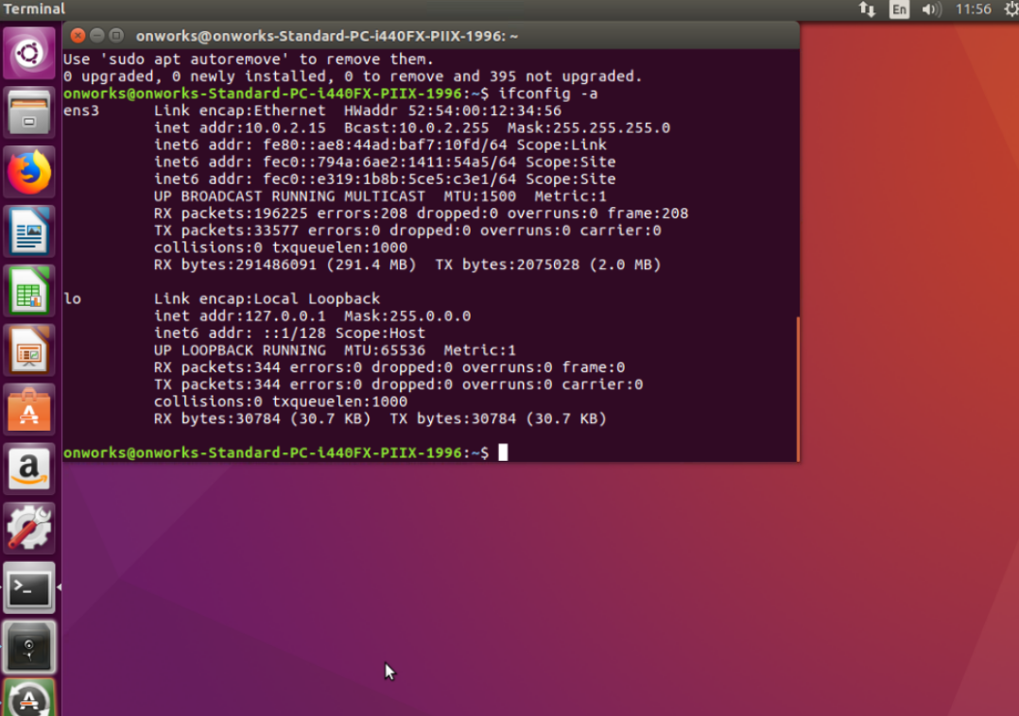

6.$who: shows who logged in.

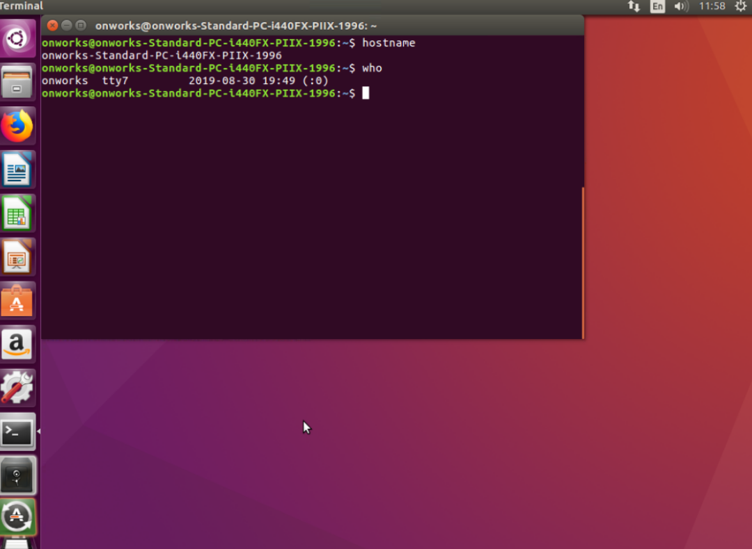

7. $ wc: gives the count I.e. line coumt, word count, and character count.

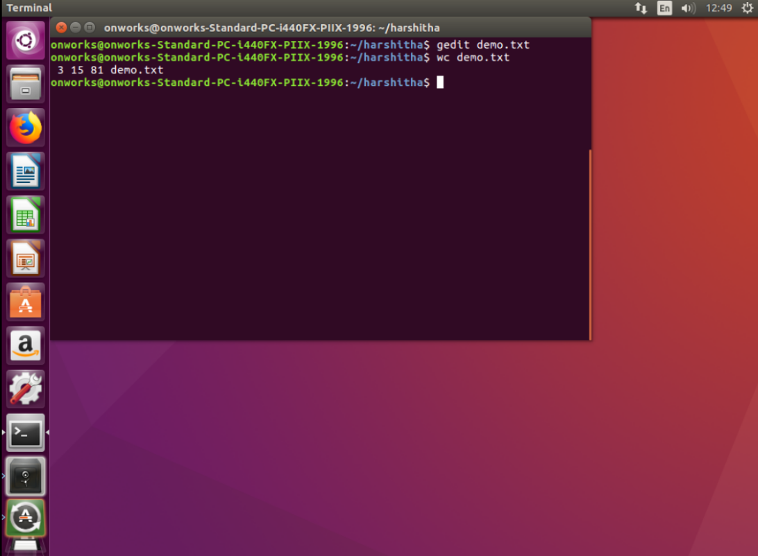

8.$sort name.txt: sort the names in the alphabetical order.

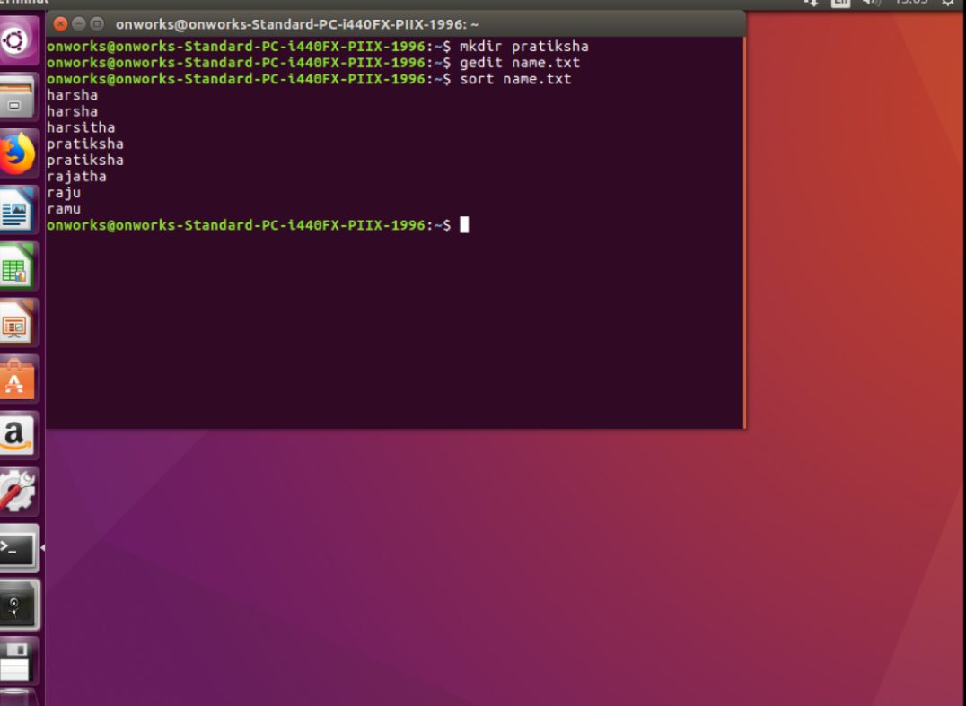

9. $ sort name.txt | uniq: This will sort the name and removes the repeated one.

