SQL statements are

* DDL: Create, Alter, drop
* DML: insert, update, delete
* DQL: select
* DCL: grant, revoke

SQL constraints are:

* Unique key
* Primary key
* Foreign key
* Default
* Check

Aggregate Functions are:

* Count()
* Avg()
* Sum()
* Min()
* Max()

1. Creating and inserting the values in the employee table.

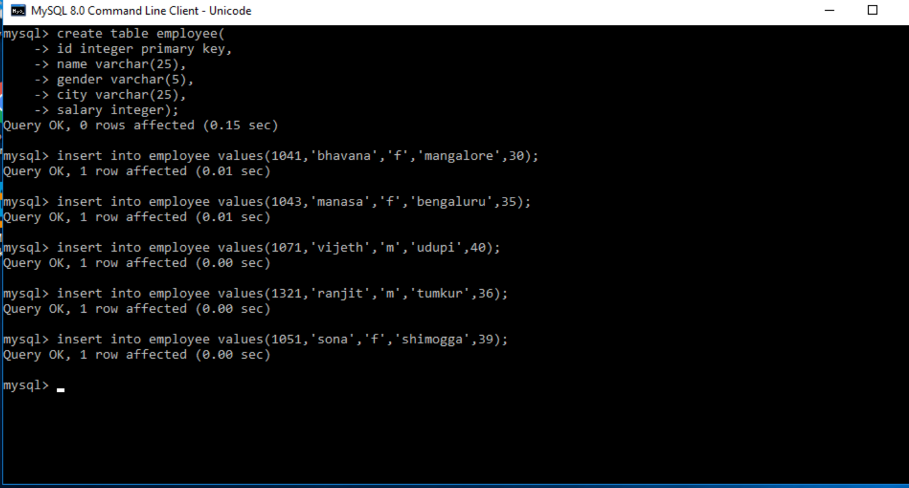

1. Select \* from employee shows the content inside the table.

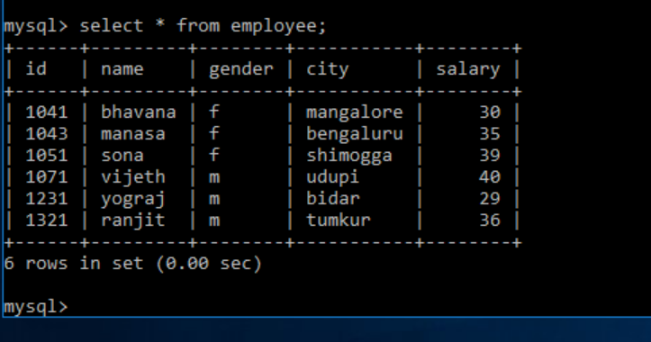

1. Order by clause shows the order in ascending or descending order which we specified.

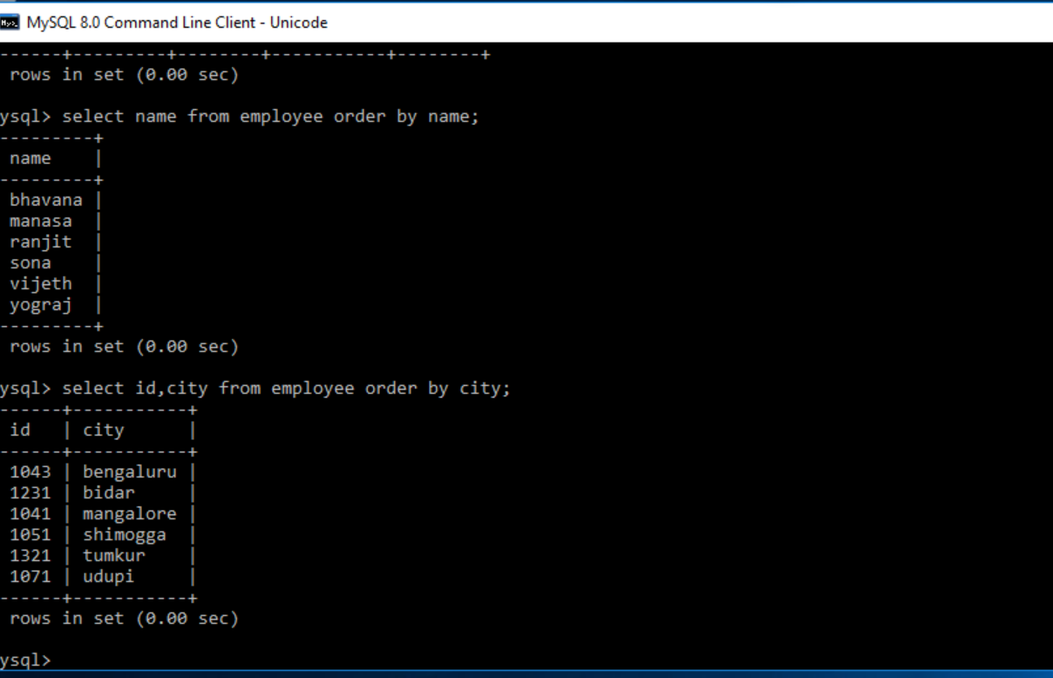

1. Count():



1. Altering the table



1. Updating the table

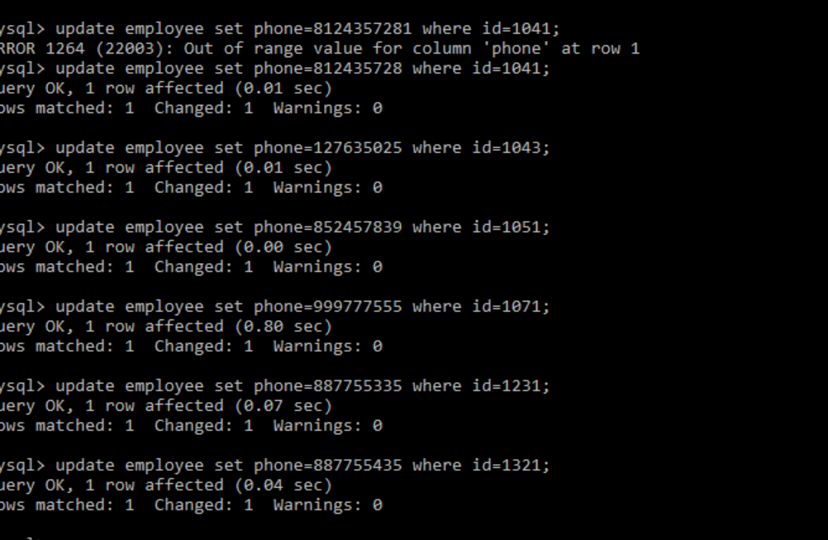

1. Sum(), avg(), count(), min(), max() :

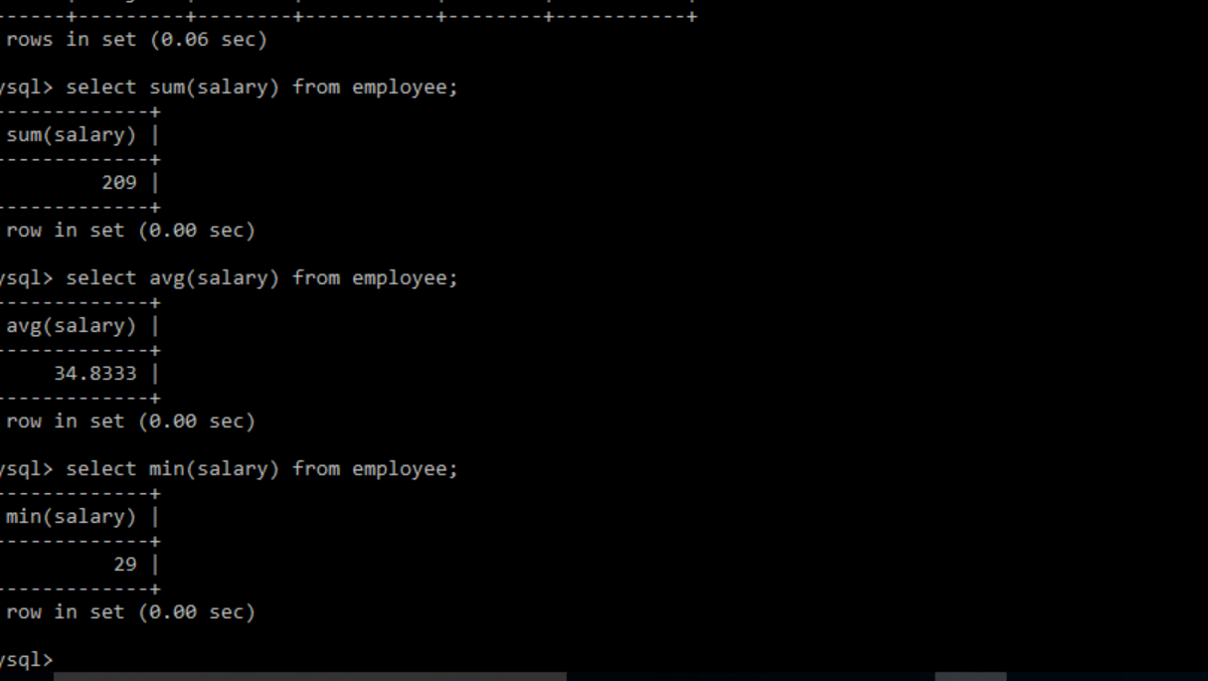

1. Group by clause:

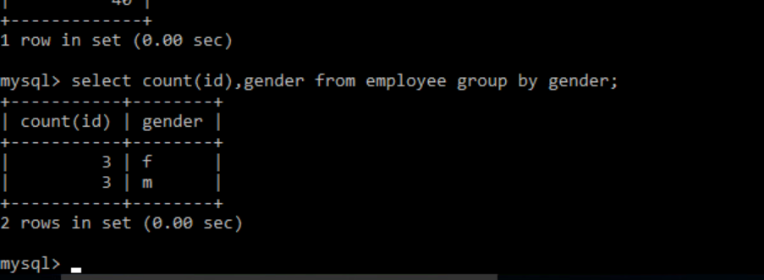

1. Having clause:

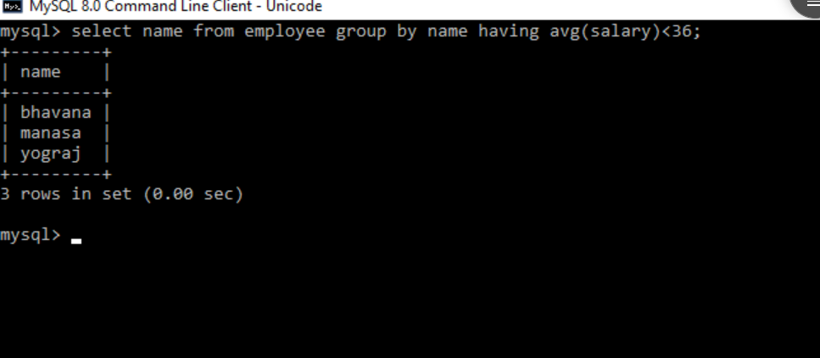

1. Drop: used to delete a whole database or table.

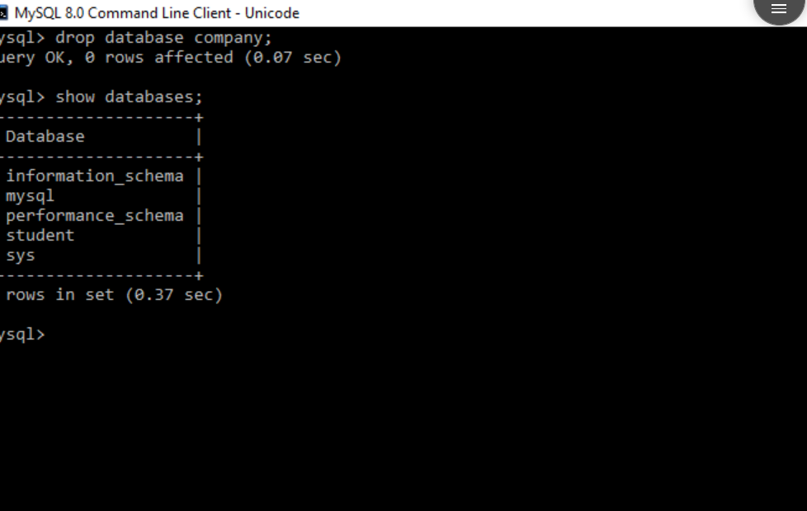

1. Foreign key constraint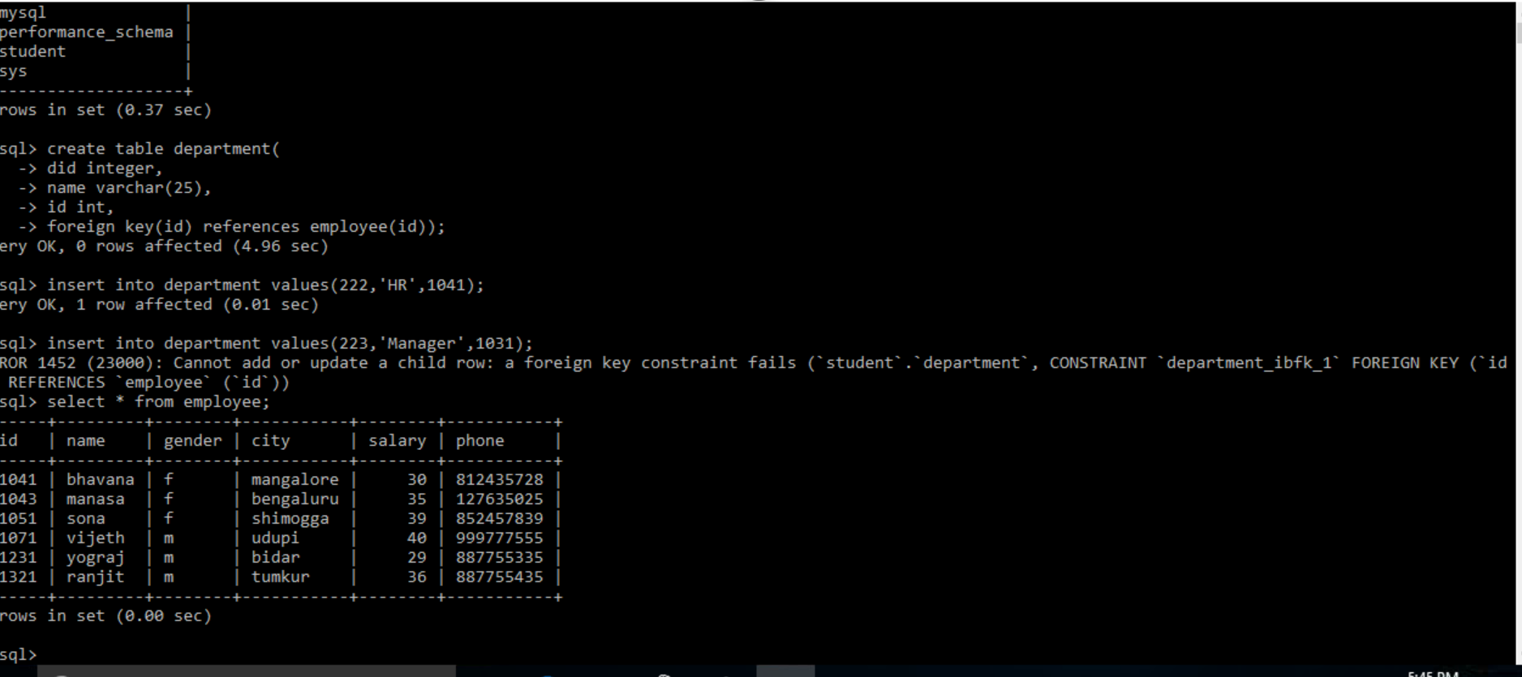
2. Drop:

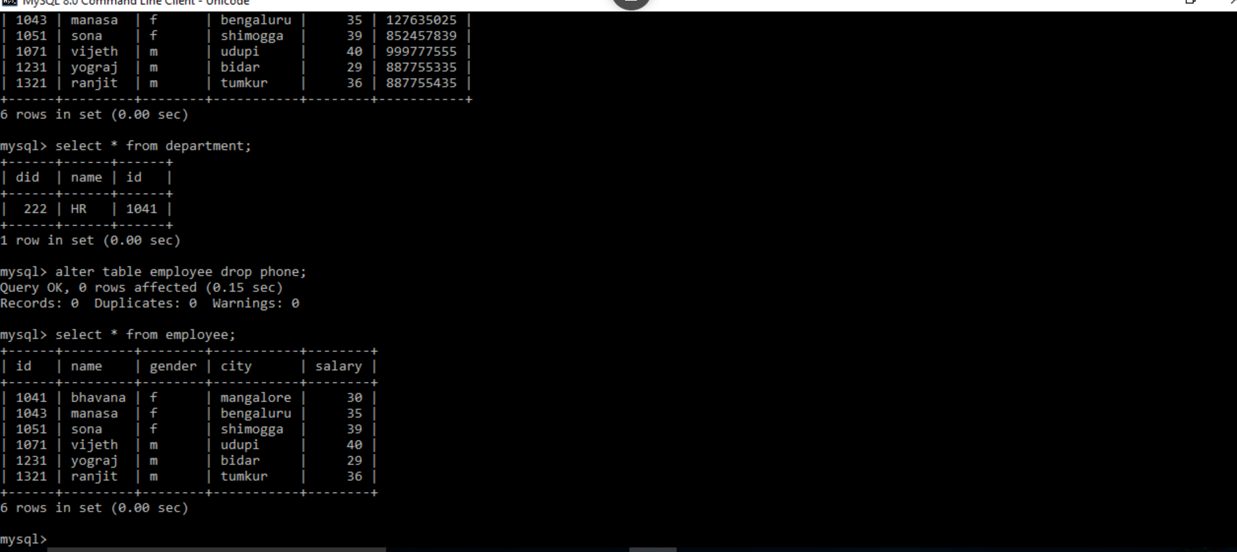

1. Delete



1. Desc of employee and department.

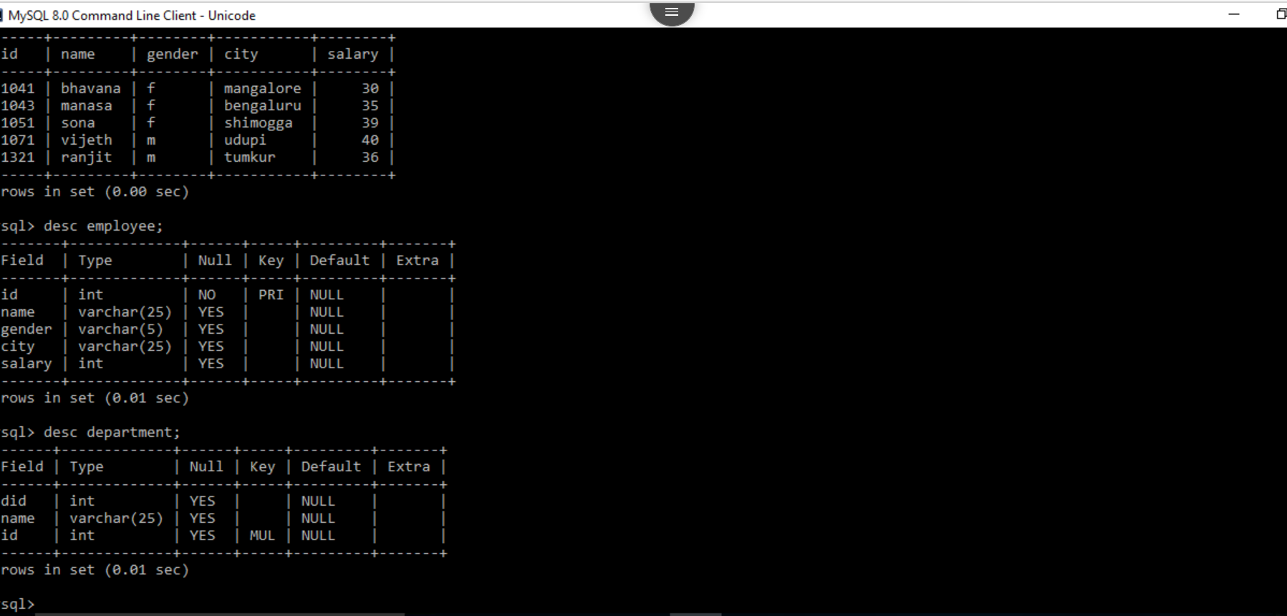

1. Using default constraints:

