High Level Design

|  |  |
| --- | --- |
| Author | Soundarya Prabhu |
| Version | 1.00 |
| Status | in review |
| Reviewer | Sohan, Rakshita |

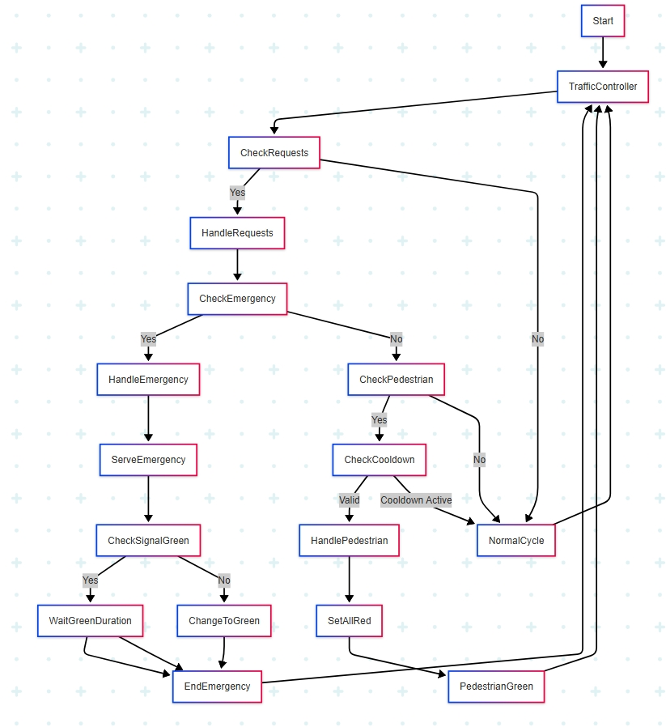

Fig 2 High Level Design

**Description:**

Start and TrafficController

* Start: Entry point into the system.
* Traffic Controller: The main control loop that monitors and responds to traffic conditions.

CheckRequests

* This node checks whether there are any incoming requests (either emergency vehicles or pedestrian crossings).
* If Yes → It goes to HandleRequests.
* If No → It proceeds directly to the NormalCycle (routine traffic light operation).

HandleRequests

* Processes and queues any incoming traffic requests, forwarding to further evaluation steps.

CheckEmergency

* This decision node checks whether any emergency vehicle requests are active.
* If Yes → Prioritizes the emergency via the HandleEmergency flow.
* If No → Checks for pedestrian crossing requests via CheckPedestrian.

Emergency Handling Flow

* HandleEmergency: Initializes emergency response logic.
* ServeEmergency: Manages light control to prioritize the emergency vehicle.
* CheckSignalGreen:
  + If the emergency vehicle already has a green light, it simply Waits for Green Duration.
  + If not, it Changes the light to Green.
* EndEmergency: Finalizes the emergency handling and routes back to the main controller loop.

Pedestrian Handling Flow

* CheckPedestrian: Checks for pedestrian crossing requests.
  + If No → Proceeds to NormalCycle.
  + If Yes → Proceeds to CheckCooldown.
* CheckCooldown: Ensures the pedestrian button hasn't been recently pressed.
  + If Cooldown Active → Proceeds to NormalCycle.
  + If Valid → Goes to HandlePedestrian.
* HandlePedestrian: Prepares pedestrian crossing.
* SetAllRed: All signals are set to red to allow pedestrian passage.
* PedestrianGreen: Pedestrian signal is turned green for safe crossing.

NormalCycle

* This handles routine traffic light switching between East-West and North-South lanes in absence of emergency or pedestrian requests.

System Loopback

* After each major flow (Emergency, Pedestrian, Normal), the system loops back to the TrafficController, checking for new requests.