**Low Level Design**

|  |  |
| --- | --- |
| Author | Nireeksha, Rakshita Patil |
| Version | 1.00 |
| Status | In review |
| Reviewer | Shivraj  & Soundarya |

**Normal Flow of traffic light controller**

, Picture

*Fig1: Normal Flow of traffic*

The image illustrates a finite state machine (FSM) for a basic 2-way traffic light control system, managing traffic flow between the South-North (SN) and West-East (WE) directions. It operates in a continuous loop to ensure safe and orderly movement of vehicles through an intersection. The FSM starts with the SN_GREEN state, where vehicles moving from south to north are allowed to pass for 30 seconds. After that, the signal transitions to SN_YELLOW for 3 seconds, signalling drivers to prepare to stop. Following this, SN_RED is activated, fully stopping the SN direction, and traffic is handed over to the WE_GREEN state.

In the WE_GREEN state, west-east traffic flows for 30 seconds, then shifts to WE_YELLOW for 3 seconds as a warning before turning red. Once the WE_RED state is active, SN is allowed to proceed again, completing the cycle. The transitions are controlled by timers, ensuring that only one direction has a green signal at a time, thereby preventing collisions.

**CASE 1: Emergency vehicles in Traffic**

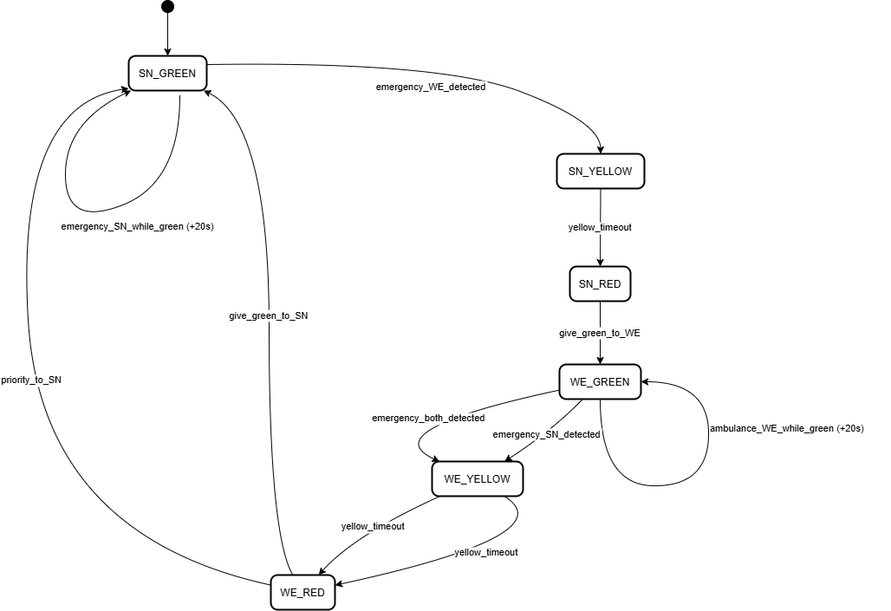

*Fig 2: Emergency vehicles interrupting traffic flow*

**Emergency Case Handling**

**1. Ambulance Detected on WE while SN is Green**

* Transition SN from:
* SN_GREEN → SN_YELLOW → SN_RED
* Then give green to WE:
* WE_GREEN
* Result: SN is stopped, and WE get right-of-way.

**2. Ambulance Detected on SN while WE are Green**

* Transition WE from:
* WE_GREEN → WE_YELLOW → WE_RED
* Then give green to SN:
* SN_GREEN
* Result: WE are stopped, and SN gets right-of-way.

**3. Ambulance Detected in SN while SN is Already Green**

* Extend SN green light by +20 seconds.
* No state change — timer adjustment only.

**4. Ambulance Detected in WE while WE are Already Green**

* Extend WE green light by +20 seconds.
* No state change — timer adjustment only.

**5. Ambulances Detected in Both Directions**

* Priority is given to SN direction.
* If currently in WE_GREEN, the transition is:
* WE_GREEN → WE_YELLOW → WE_RED → SN_GREEN
* SN gets clearance first, WE must wait.

**CASE 2: Pedestrian interrupting the traffic flow**

, Picture

*Fig 3: Pedestrian interrupting the traffic flow*

 Initial State: The system starts with ONE LANE GREEN OTHER LANE RED to manage vehicle traffic in alternate directions.

 Pedestrian Request: When a pedestrian presses the button, the FSM transitions to VEHICLE_YELLOW, warning vehicles with a 3-second yellow light.

All-Red State: After yellow, all traffic lights turn red (ALL_RED) for 30 seconds to allow safe pedestrian crossing.

Pedestrian Cooldown: Once crossing is done, the FSM enters PED_ENABLED, and then a PED_DISABLED state for 3 minutes to prevent repeated interruptions.

Resume Traffic: After pedestrian crossing and cooldown, the system resumes vehicle flow by returning to the initial state.

**CASE 3: Both Emergency & Pedestrian interrupting the traffic flow**  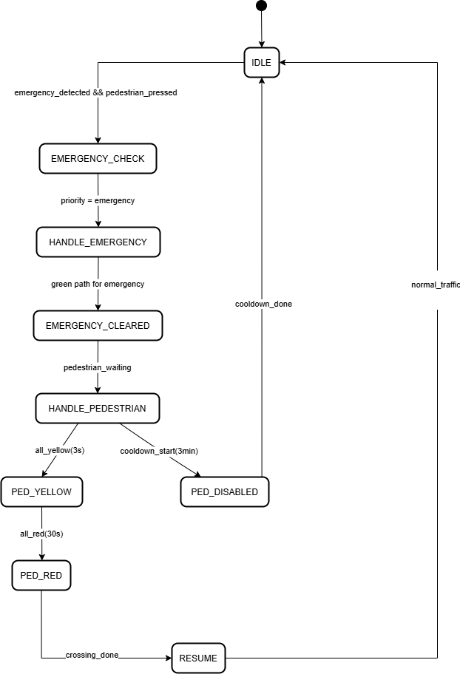

*Fig 3: Emergency & Pedestrian interrupting the traffic flow*

Initial State (IDLE): The system starts in the IDLE state, waiting for either normal traffic flow or special conditions.

Emergency Handling: If both emergency detected and pedestrian pressed, the system enters EMERGENCY_CHECK, assigns emergency priority, and then transitions to HANDLE_EMERGENCY to provide a green path.

Pedestrian Handling: After the emergency is cleared, if a pedestrian is still waiting, the FSM proceeds to HANDLE_PEDESTRIAN.

Pedestrian Crossing:

* Goes to PED_YELLOW for 3 seconds.
* Then PED_RED to stop all vehicles, allowing pedestrian crossing for 30 seconds.

Cooldown: After crossing, the system enters a cooldown state (PED_DISABLED) for 3 minutes to avoid frequent pedestrian interruptions.

Resume Traffic: After the cooldown or crossing is completed, it transitions to RESUME, then returns to IDLE.