**Hardware requirements:-**

1. **Arduino Mega:**

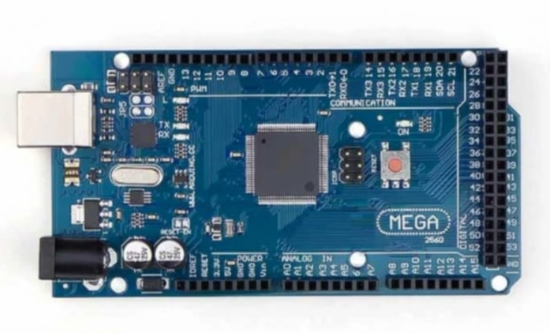

1. **Soil Moisture Sensor**

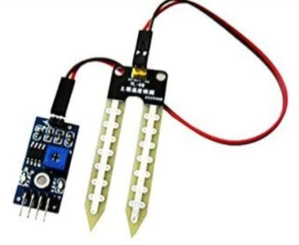

1. **Temperature and humidity Sensor**

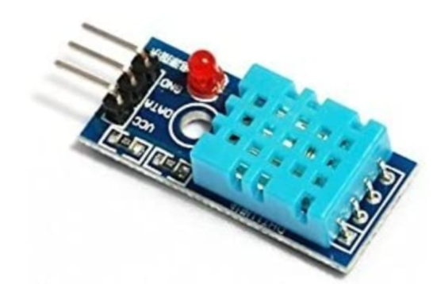

1. **Relay**

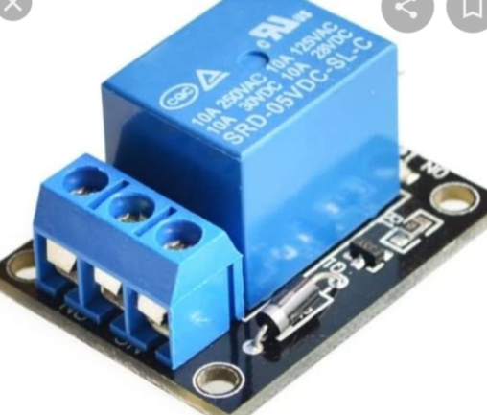

1. **Motor with Sprinkler**

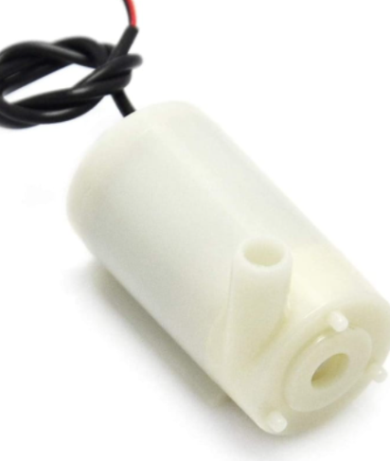

**Software Requirements:-**

1. **Arduino IDE**

