## TABLE OF CONTENTS

**AWS Cloud Setup Guide**

Amazon Web Services (AWS)

* How to create a free AWS Cloud Account
* How to create an Ubuntu VM machine
* Open Port from VPC Networks
* Run commands on the Ubuntu VM

**Summary**

Topics covered

* Road ahead

**AMAZON WEB SERVICES (AWS)**

**What is AWS?**

Amazon Web Services (AWS) is a comprehensive, evolving cloud computing platform provided by Amazon. AWS can be defined as a huge set of on-demand services provided to the customers on cloud with pay-as-you-go pricing model. The technology allows subscribers to have, at their disposal, a virtual cluster of computers, available all the time, through the Internet. Whether it is about configuring a server or running an application, AWS lets you execute your operations on cloud in a similar manner as you would do on a physical computer.

AWS is the pioneer of the cloud computing technology. Way back in 2006, it first offered its cloud solutions and today is way ahead of its competitors. AWS competes primarily with Microsoft Azure, Google and IBM in the public IaaS market*.* Amazon's internal IT resource management built AWS, which expanded and grew into an innovative and cost-effective cloud solution provider.

Back in 2006, cloud might still have been a relatively new phenomenon, but today it is critical to the survival of any business enterprise. Cloud is offering some incredible advantages that on-premise technology just cannot compete with. With this cloud, we need not plan for servers and other IT infrastructure which consumes lot of time in advance. Instead, these services can instantly spin up hundreds or thousands of servers in minutes and deliver results faster. We pay only for what we use with no up-front investment and no long-term commitments, which makes AWS cost efficient.

Today, AWS powers multitude of businesses in 190 countries around the world. AWS offers flexible, reliable, scalable, easy-to-use, and cost-effective solutions and allows enterprises to focus on their core competencies while Amazon takes care of the IT and cloud related issues. Let us understand the impact through an example - Netflix is a popular video streaming service which the whole world uses today. Back in 2008, Netflix suffered a major database corruption, and for three days their operations were halted. The problem was scaling, that is when they realized the need for a highly reliable, horizontally scalable, distributed system in the cloud. They started using AWS, and since then their growth has been off the charts.

AWS provides a mix of infrastructure as a service (IaaS), platform as a service (PaaS) and packaged software as a service (SaaS) offerings. More than 100 services comprise the Amazon Web Services portfolio, including those for compute, databases, infrastructure management, application development and security.

* 1. **What are the top AWS products?**
  2. Amazon **EC2** and Amazon **S3** are the two core Infrastructure as a Service (IaaS) services,

**EC2 :** An EC2 instance is nothing but a virtual server in Amazon Web services terminology. It stands for Elastic Compute Cloud. It is a web service where an AWS subscriber can request and provision a compute server in AWS cloud. EC2 provides you configuration capacity in a seamless manner. With EC2 you have complete control of your computing environment along with high availability, scalability, and cost-effectiveness.

An on-demand EC2 instance is an offering from AWS where the subscriber/user can rent the virtual server per hour and use it to deploy his/her own applications. The instance will be charged per hour with different rates based on the type of the instance chosen. AWS provides multiple instance types for the respective business needs of the user. Thus, you can rent an instance based on your own CPU and memory requirements and use it as long as you want. You can terminate the instance when it’s no more used and save on costs. This is the most striking advantage of an on-demand instance.

**S3 :** This is the Amazon Simple Storage. AWS S3 lets you seamlessly store and retrieve huge amounts of data anytime, anywhere through the web interface. It allows software developers to have access to the data quickly in an inexpensive, reliable and highly scalable manner. You can store all sorts of folders, files, and documents on the AWS S3.

**RDS :** This is the Amazon Relational Database Service. The Amazon RDS is a highly scalable relational database service. It offers a simple, cost-efficient database in the cloud that also automatically does database setup, hardware provisioning, backup and patching. Its advantages include high availability, fast performance, security and compatibility.

**DynamoDB** : This is the Amazon NoSQL database in the cloud that provides extremely high latency at

any scale. It offers highly reliable service that is fully managed, has built-in security, in-memory caching, backup and restoration.

**VPC :** This is the Amazon Virtual Private Cloud which can be thought of as a cloud data center for deploying all your resources. VPC lets you isolate all your resources on the Amazon cloud and thus offer very high security. It gives you complete freedom to work within your virtual networking environment, along with selection of IP addresses, creating subnets, configuring route tables and network gateways. AWS VPC offers logically isolated provisioning on the cloud wherein you can launch your AWS resources.

**Why should you learn AWS?**

Some of the top reasons why you should learn AWS are as follows:

* AWS is an amazing standard of cloud computing and is slowly becoming synonymous with the cloud itself.
* The salaries of AWS professionals are among the best in the IT industry.
* Getting AWS certified is not a big deal; all you need is the right training in AWS.
* There is a huge shortage of certified AWS professionals - thanks to the rapid deployment of AWS.
* There are no prerequisites to learn AWS as anybody can master this top technology.
* AWS is a very vast domain, and anybody can find their niche and excel in their careers.

**How to create a free AWS cloud account?**

**Step 1**: Navigate to ***https://aws.amazon.com/.*** The first screen you will view:

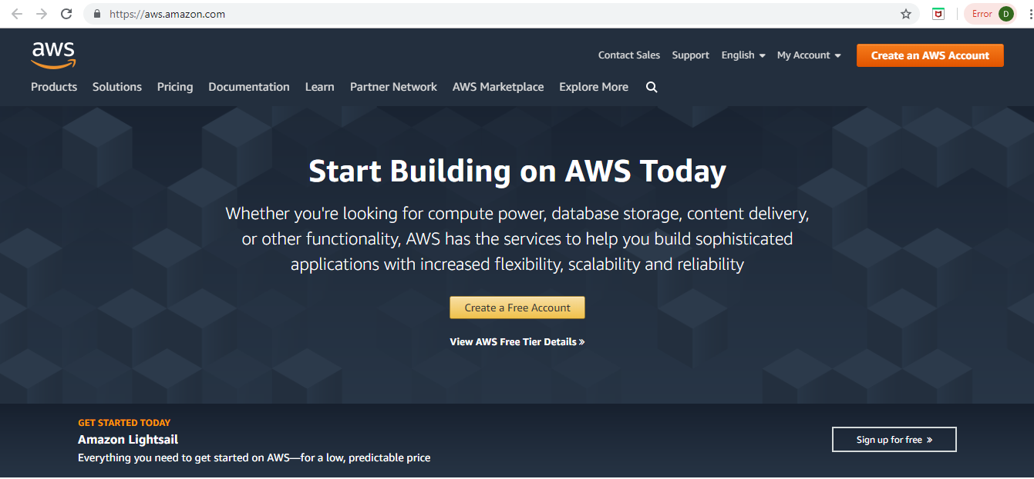

**Step 2**: Go to MyAccount dropdown and click on AWS Management Console.

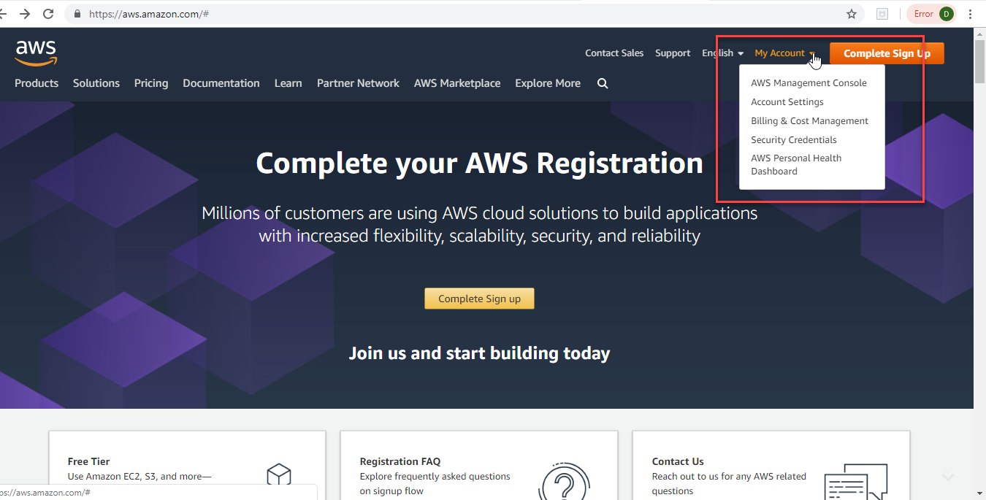

**Step 3:** You landup on this screen to sign in. Click on Create a new AWS account.

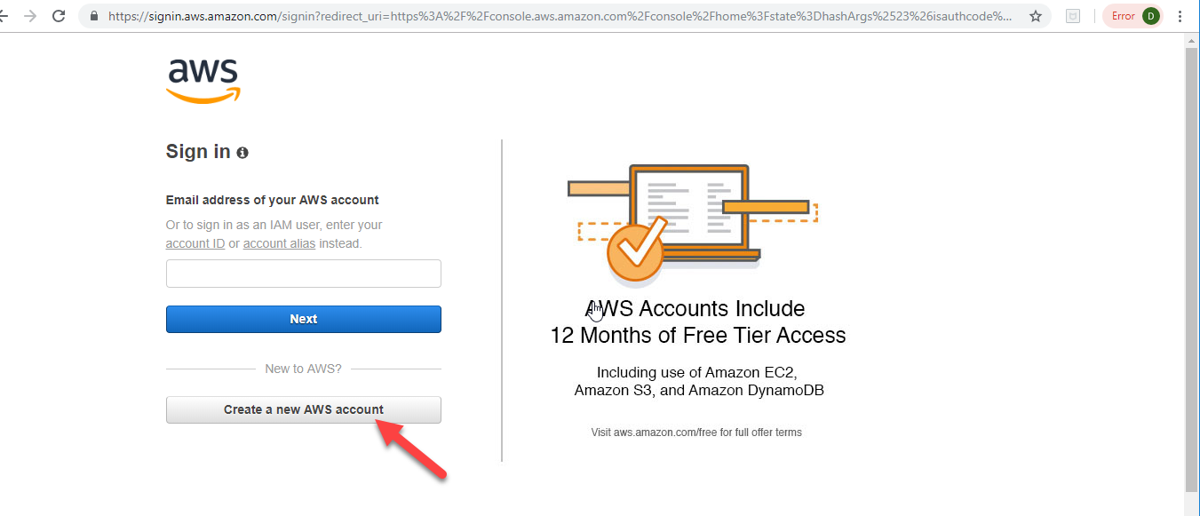

**Step 4:** Enter the details below and click Continue.

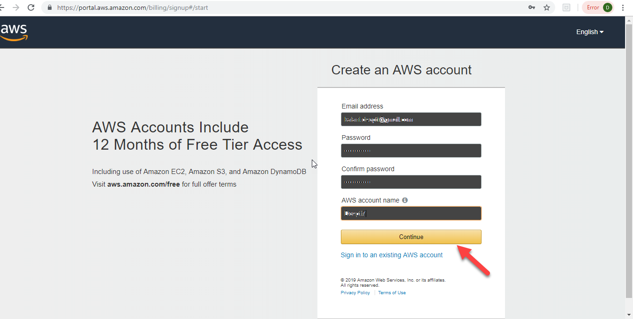

**Step 5:** Select the Account type as Personal and enter the details. Select your Country from the dropdown.

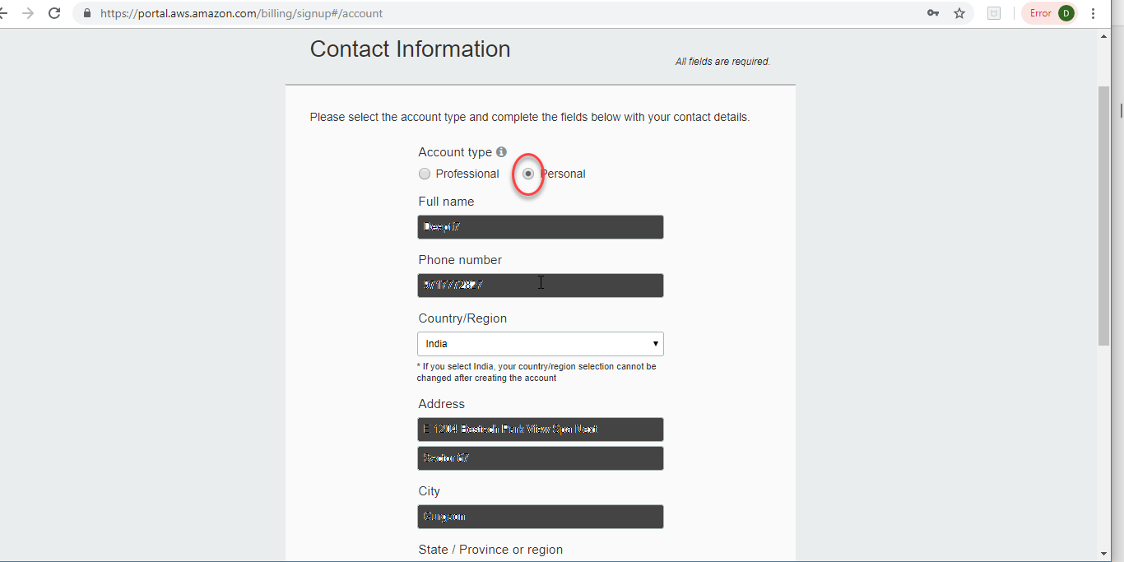

**Step 6:** Enter the details and click the check here checkbox and Create Account and Continue.

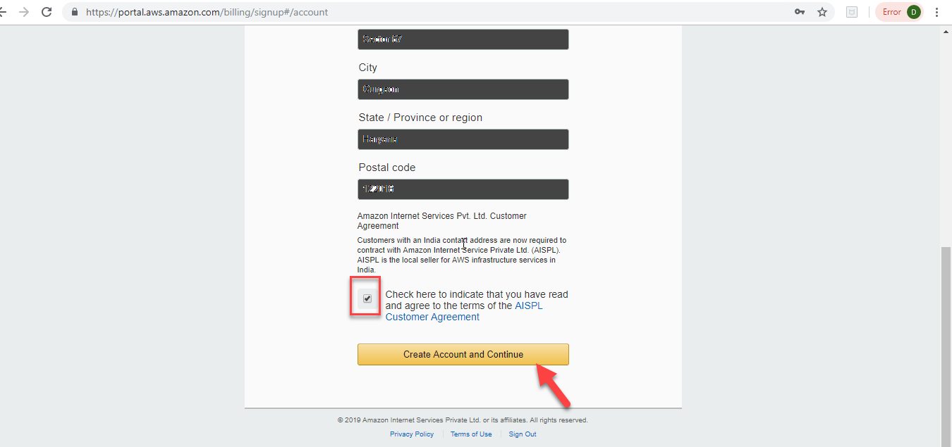

**Step 7:** Complete the Payment Information. Though, it is a free trial account, you need to enter a card details for identification/verification purpose.

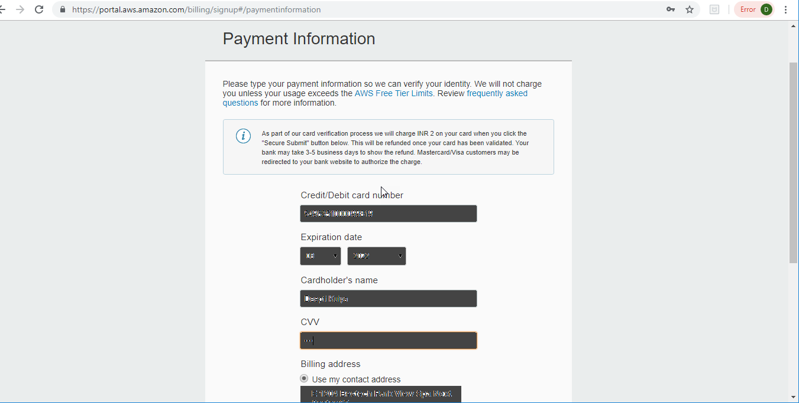

**Step 8:** Fill the required information and click Secure Submit.

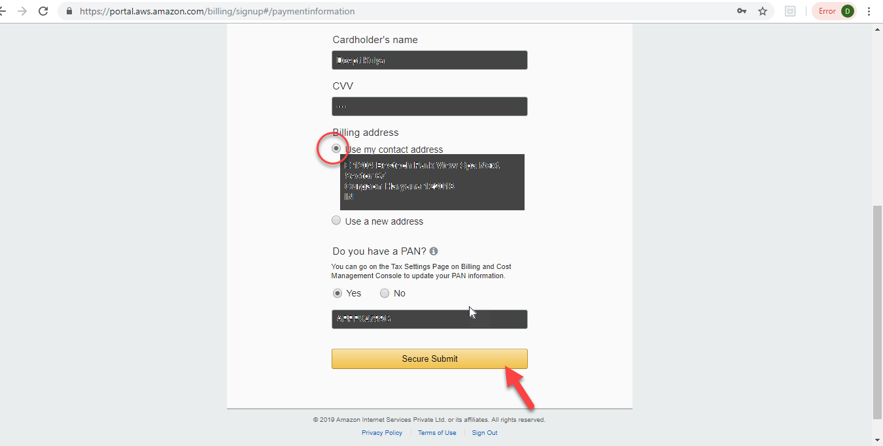

**Step 9:** Once the payment process is completed, you will view this screen. Fill in the appropriate details and click Contact me.

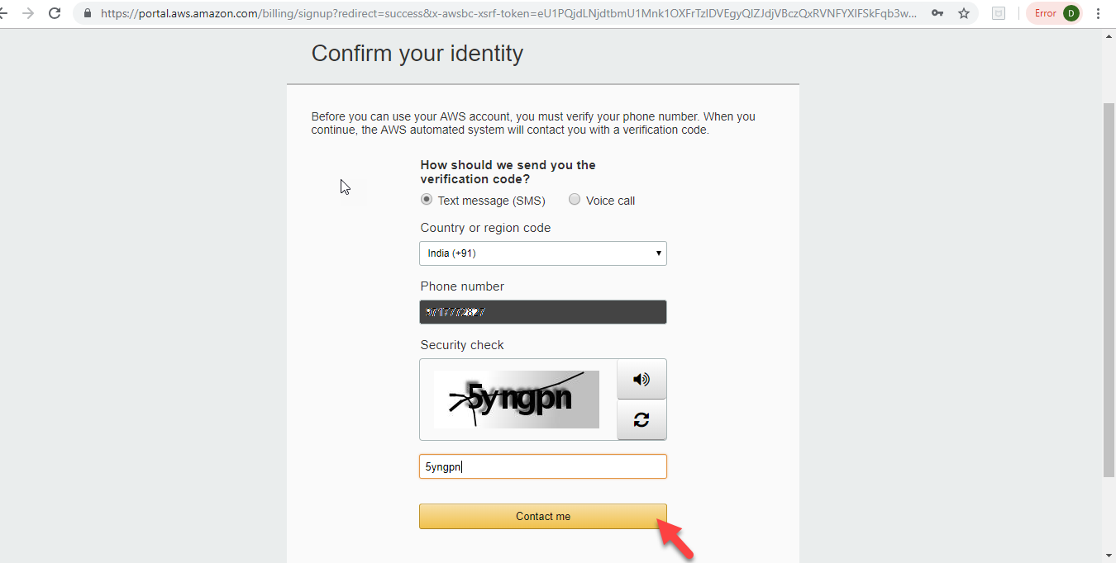

**Step 10:** Enter the verification code as received on the given mobile number and click Verify code.

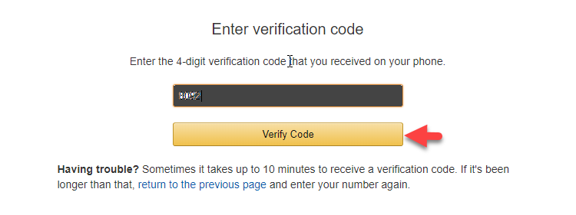

**Step 11:** You will view the below screen.

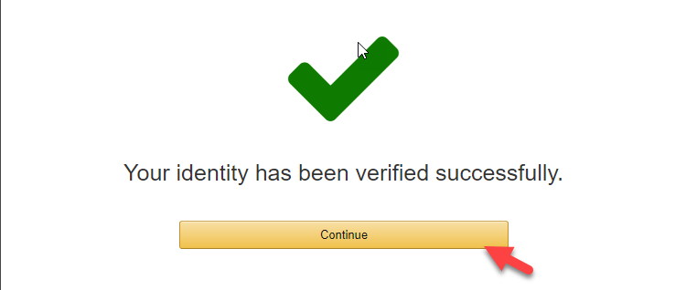

**Step 12**: Choose the Basic Plan by clicking Free button on the screen as below.

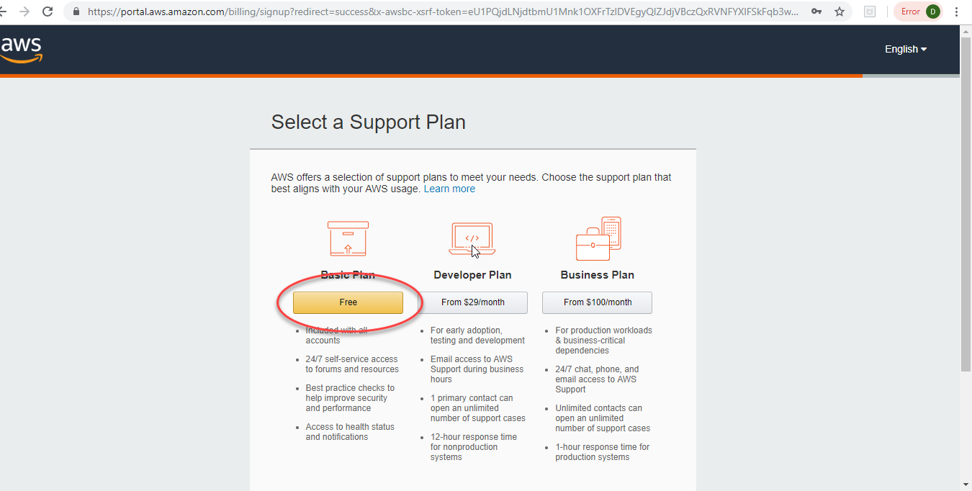

**Step 13:** You have successfully created your AWS free account. You should see this welcome screen.

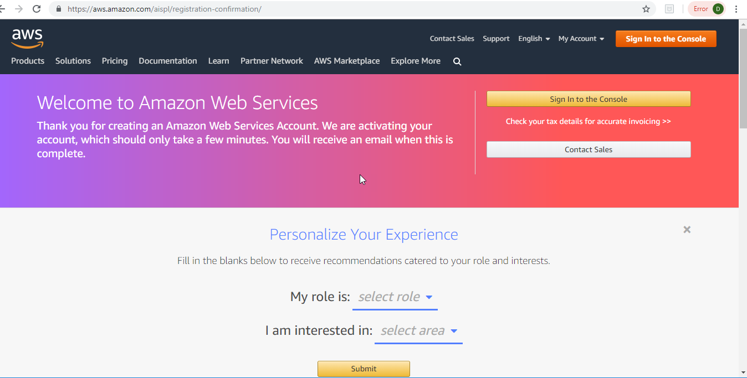

**How to create a new Ubuntu Virtual Machine**

Now, let's create a new VM instance on AWS.

**Step 1: Once you login to the console clicking the *Sign in to the console* button on the welcome screen above using your credentials, you view the AWS console.**

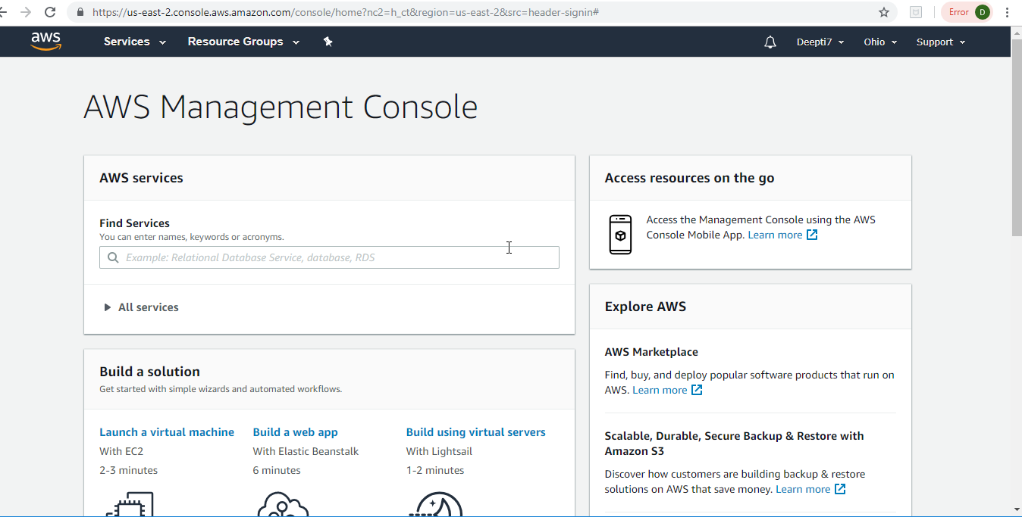

**Step 2: Click on Services & Then on EC2 Service.**

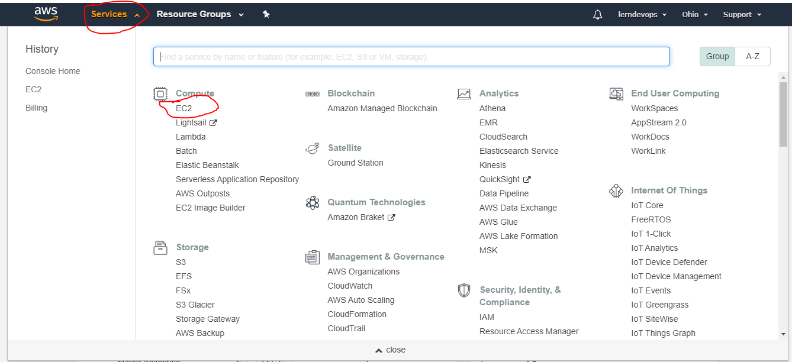

**Step 3: Once you click EC2 Service, you will view the below screen, now on the left side menu Scroll down to see Network & Security Section then Click on Security Groups**

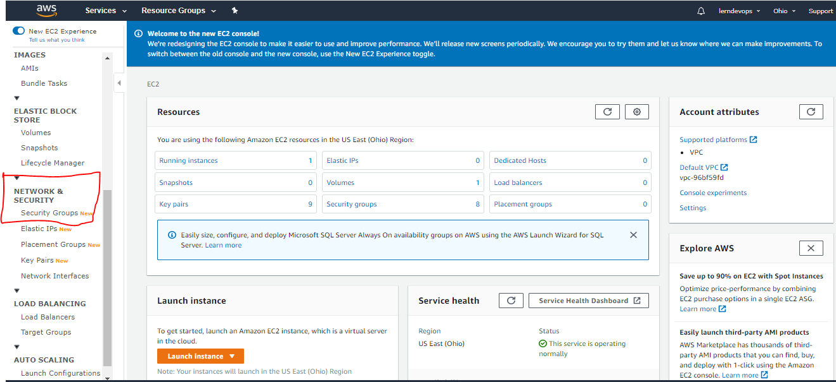

**Step 4: once we click on Security group we will see below screen, Now click on Create Security Group (you may see only default Security Group as you are doing it for first time )**

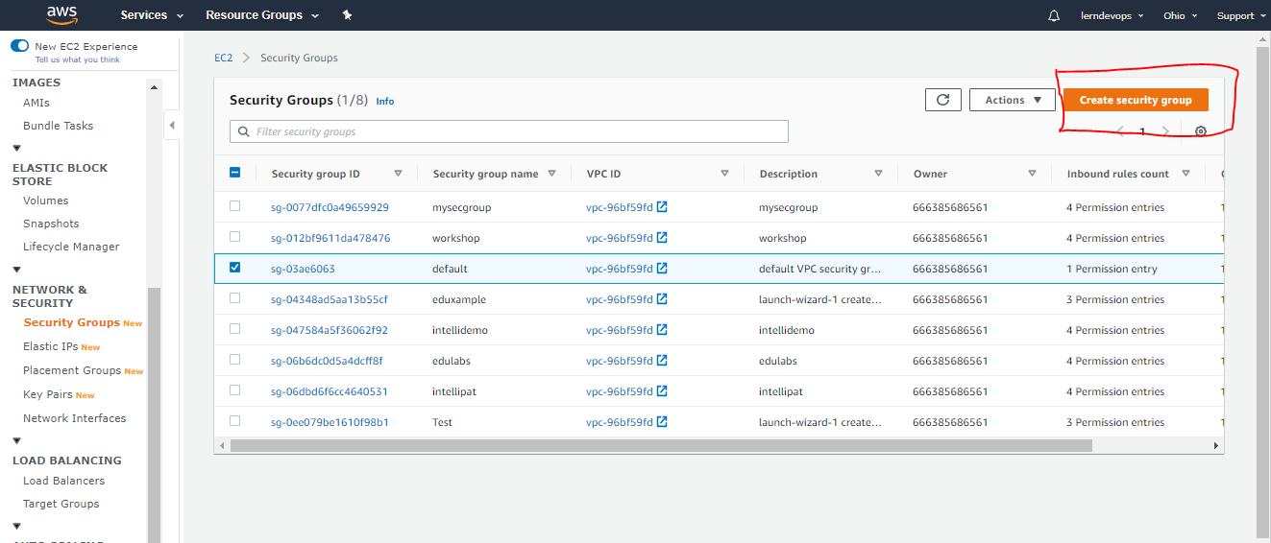

**Step 5: after clicking on Create Security Group you will see below Screen. You can create the Security Group as below**

**Basic Deatails:**

**you can enter any name (ex: demo)**

**you can enter any descript (ex: demo)**

**VPC: leave it as it is don’t change anything**

**Inbound Rules: configure as you see in screen shot.**

**Add rule 🡪 All traffic (source 🡪 change to anywhere )**

**Add rule 🡪 SSH (source 🡪 change to anywhere )**

**Outbout Rules: keep the default**

**After updating all, Create Security Group at the bottom right corner.**

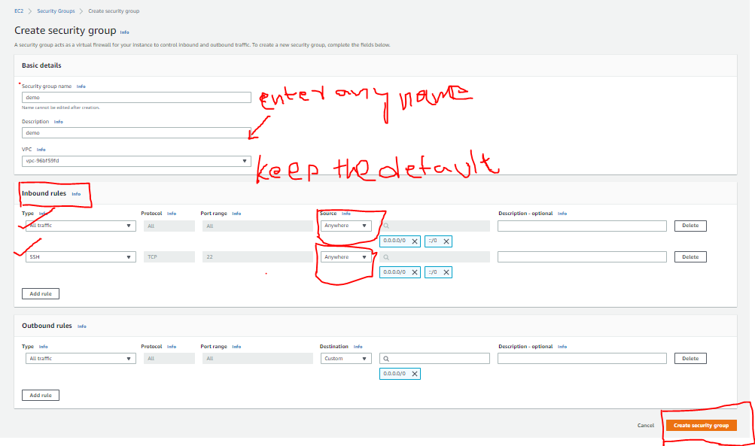

**Ensure the Security Group Create Successfully & rules updated Accordingly.**

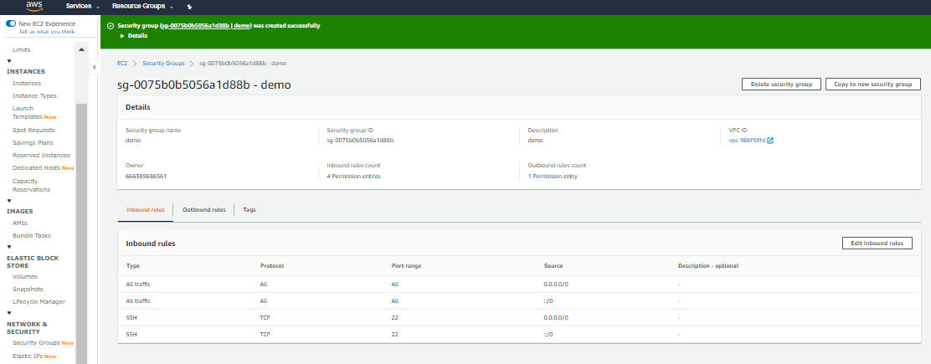

**Step6: Now Lets Satart Creating the Ubuntu Instance**

From above Screen, left side Menu Scroll Up and click on EC2 DashBoard New, you will see below Screen, then click on Launch Instance button as seen in below screen shot.

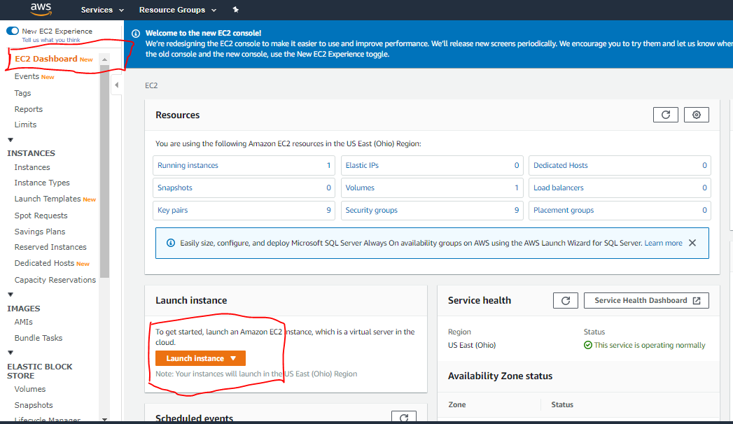

**Step 7: after Clicking on Launch Instance you will see below screen, choose Ubuntu 18.04 LTS & Click on Select button on Right side**

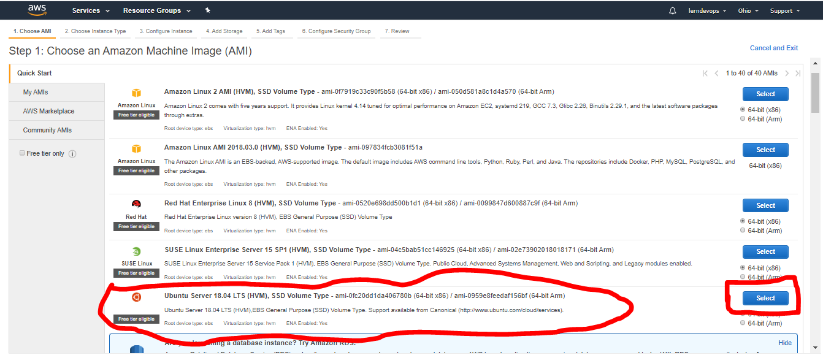

**Step 8:** Choose an Instance type. Le t the default selection remain and click Configure Instance Details.

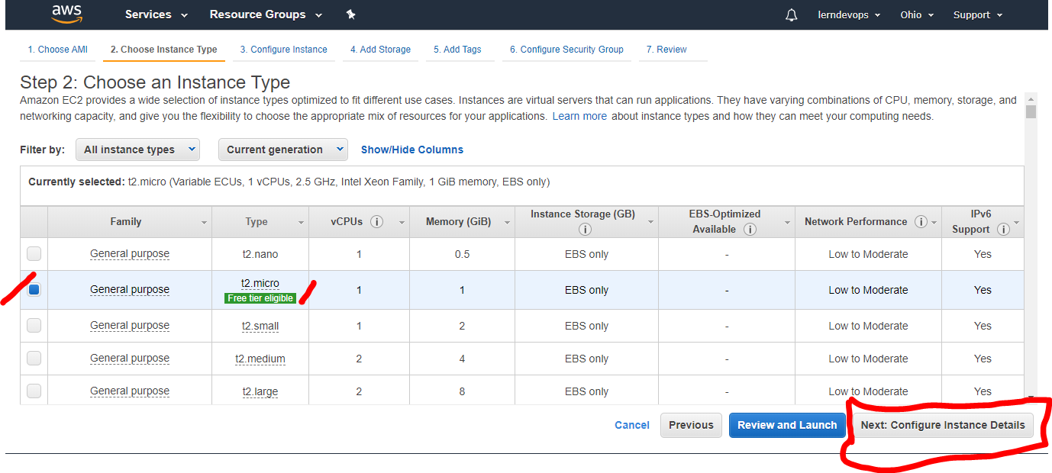

**Step 9: you will see below screen & leave the default values as they are & click on Next: Add Storage.**

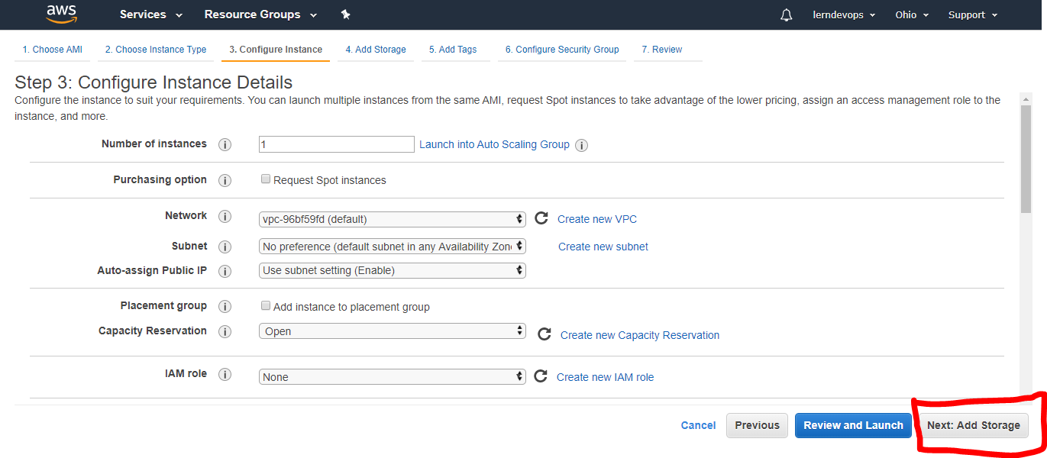

**Step 10: you will see below screen & leave the default values as they are & click on Next: Add Tags.**

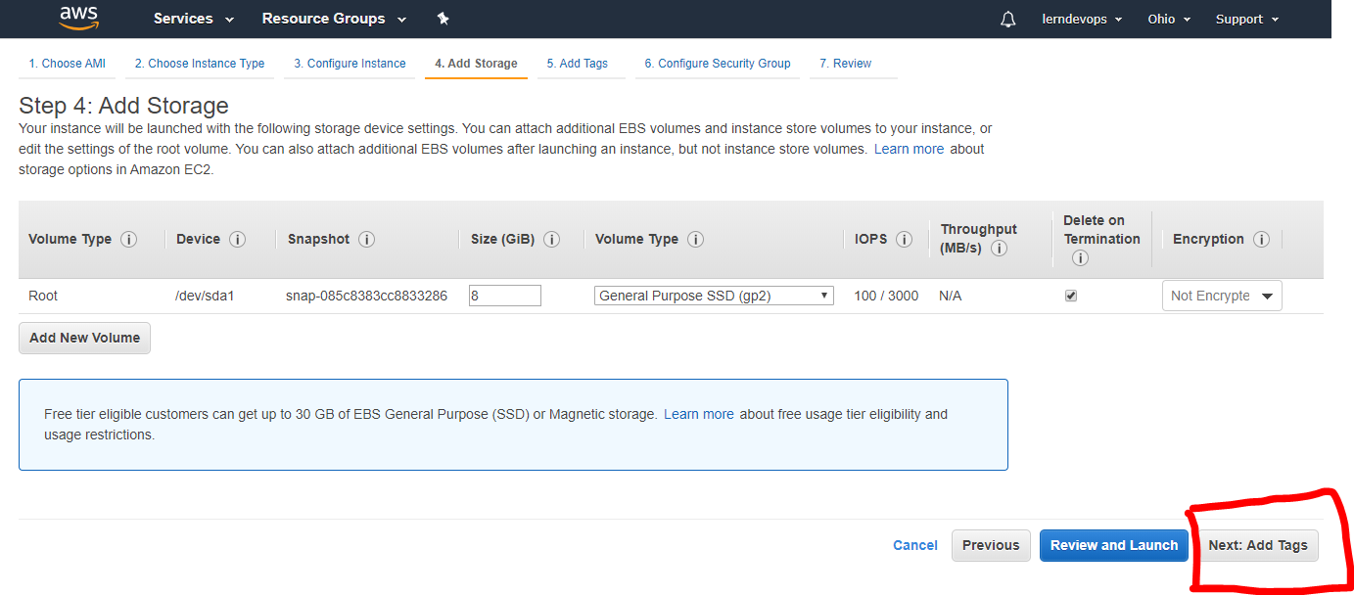

**Step 11: you will see below screen & leave the default values as they are & click on Next: Configure Security Group.**

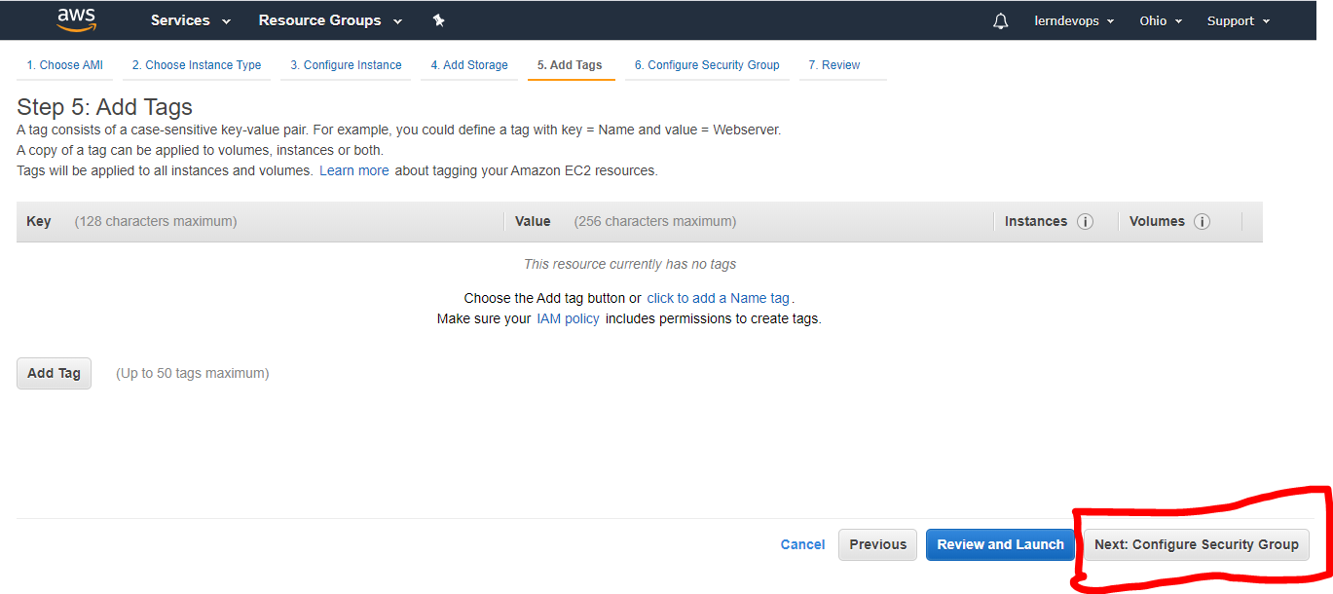

**Step 12: you will see below screen, As below Select existing Security Group radio button & from list below choose the security group you created earlier. Then click on Review and Launch at the right bottom & on the next screen Click on Launch button**

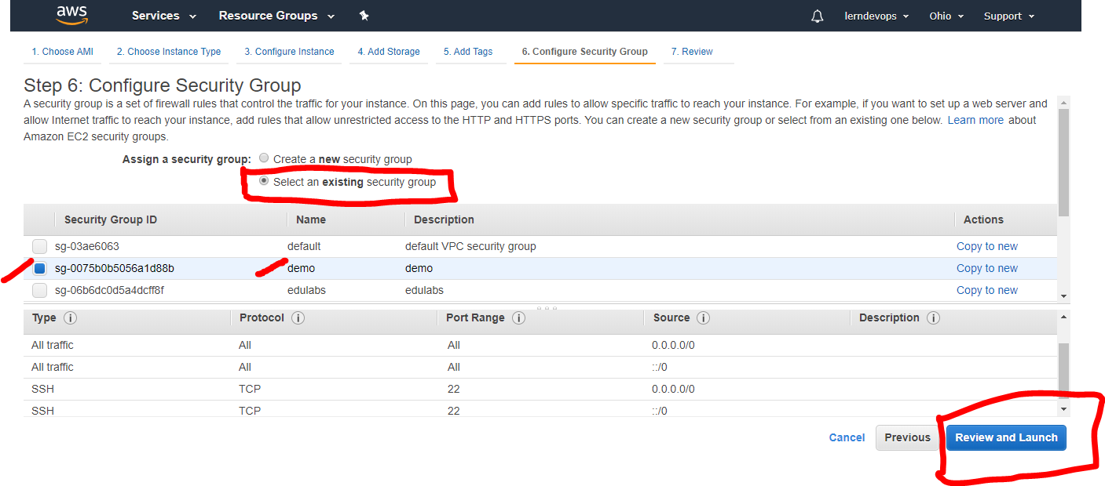

**Step 13: once you click on Launch button you will see a popup as below,**

From the first Drop Down, Select Create a New key pair then below

Key Pair Name field enter any name & then click on Download Key Pair Button

Ensure the Key Pair (demo.pem as below) downloaded successfully

Once the Key Pair is successfully downloaded Click **on Launch Instance**

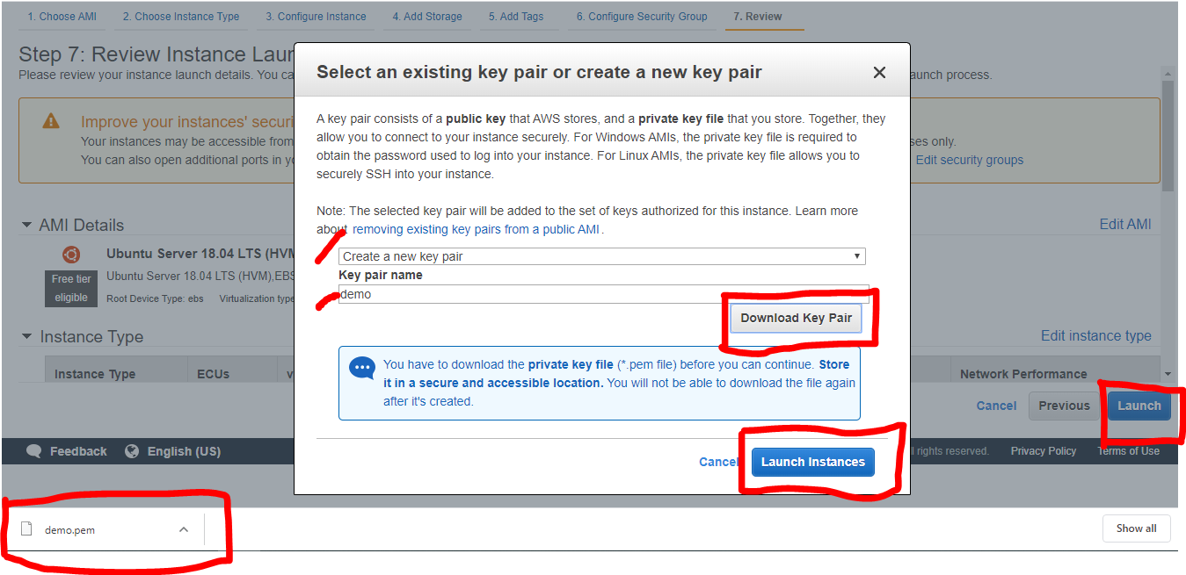

**Step 14: after clicking on Launch Instance you will see below Screen, Click on View Instances button on bottom right corner**

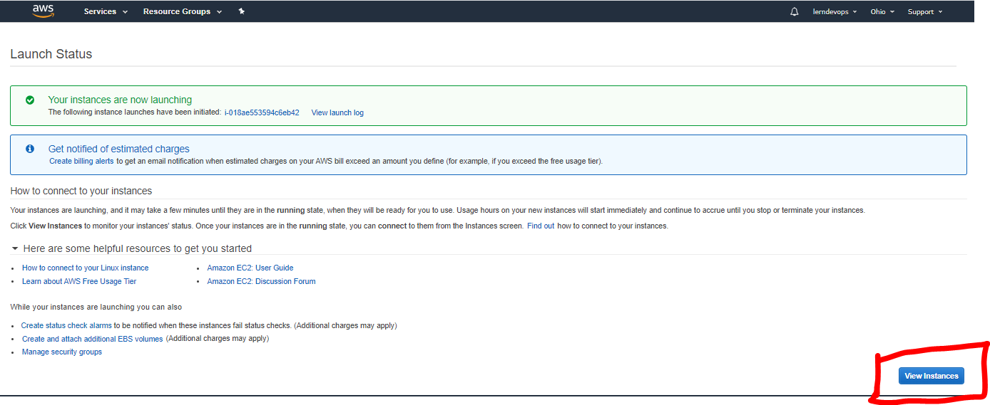

**Step 15: then we will land on below page, wait for couple of minutes you should see your instance in running state.**

**Select the instance and go through the details below what are all the details it shows up.**

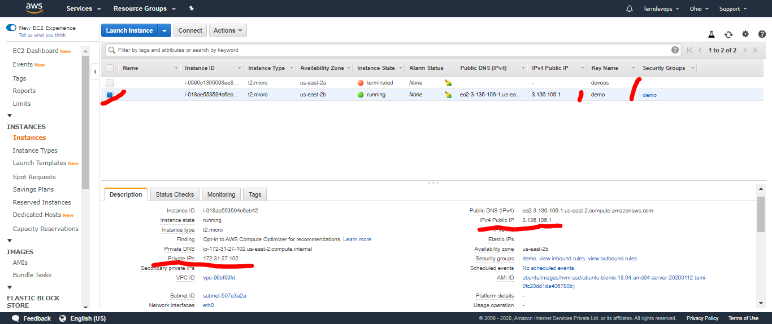

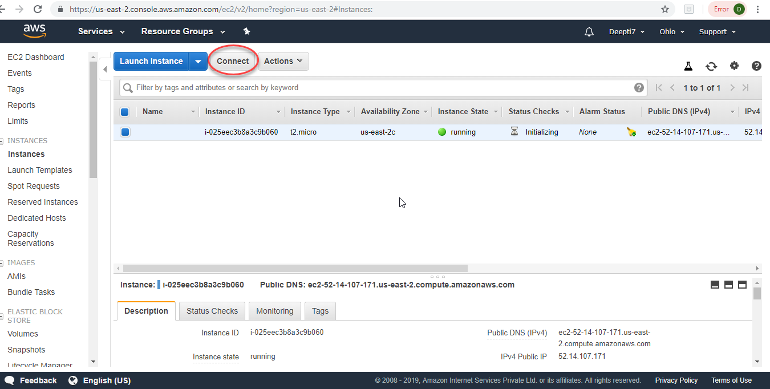**Step 16: Click on Connect on the screen below.**

**Step 17: You will view this popup – Connect to your instance.**

**To connect to the VM, follow the instructions, Copy the ssh line as highlighted below, then click on close**

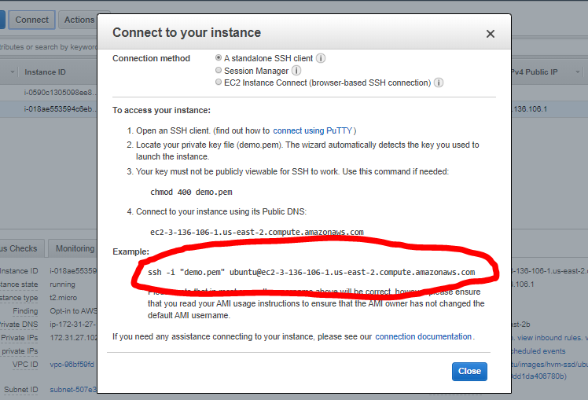

**Step 18: Download & Install Git Bash on your System (you can search “download gitbash in google” & click on the link** <https://git-scm.com/downloads>)

**Click on Windows if you are using windows, it will download an .exe file; install the Git Bash with default setting. After that**

**Go to the folder where you saved the .pem file and do right click and run GitBash Here.**

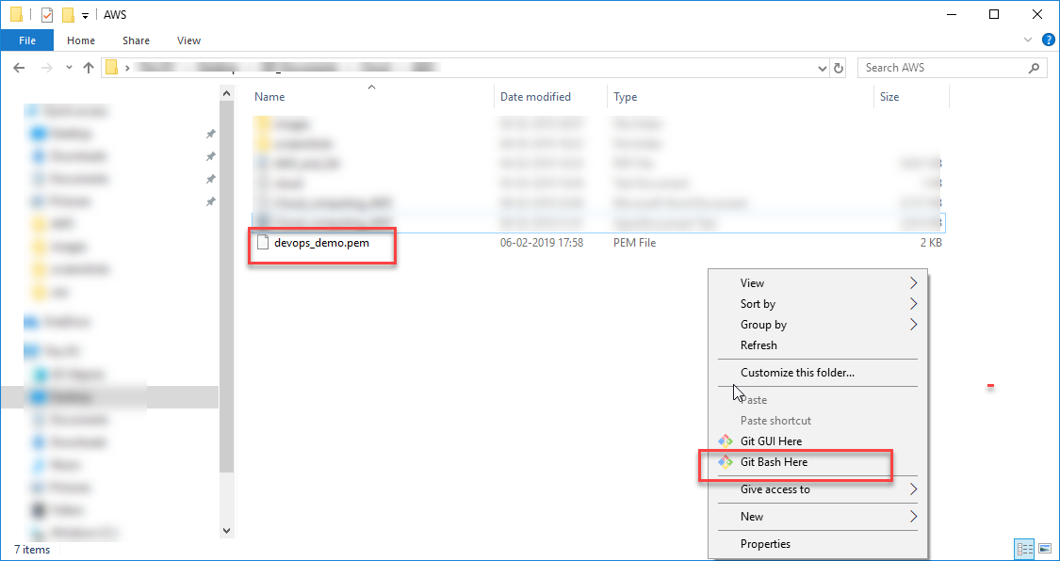

***Note: git bash is required only for windows machine user only. Mac Users can user the terminal on Mac directly***

**Step 19: Once GitBash opens, run the following command to the public VM instance you created.**

***ssh -i "demo.pem" ubuntu@ec2-18-221-249-158.us-east-2.compute.amazonaws.com***

***The connection is established.***

